# Scratch logo and symbol, meaning, history, PNG

1. Register/login at <https://scratch.mit.edu>
2. +New Project
3. Download the Robot Wars arena backdrop at:  
   <https://sa-battle.github.io/code-club/arena.jpg>

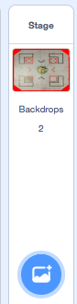

1. Set the stage at the bottom right of the scratch window. Upload the arena backdrop.

**Can you create a sprite that can move about and stay in the arena?**

1. The arena backdrop is the same size as the scratch stage 480 pixels wide by 360 high. We can use “If on edge, bounce”

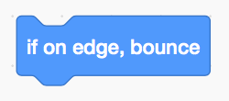

1. You can change the sprite ‘costume’ and adjust its size.

See over the page for one solution…

