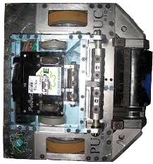

# Scratch logo and symbol, meaning, history, PNG

1. Download bot1 & bot2 designs:
   * <https://sa-battle.github.io/code-club/bot1.png>
   * <https://sa-battle.github.io/code-club/bot1.png>

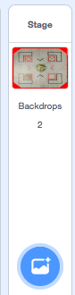

1. Create two identical sprites that bounce around the stage.
2. You can use these images as *costumes* for your sprites.
3. You can adjust the costume size.
4. Can you detect when the two sprites touch?



1. When they touch we can broadcast a message
2. Then when they touch we can perform an action:



Here’s one solution. Each sprite can have the same code:

