# **Scratch logo and symbol, meaning, history, PNGWhac-a-Mole**

**Whac-A-Mole** is a game where moles pop up at random. Points are scored by whacking each mole as it appears.

1. Download mole-up & mole-down graphics:
   * <https://go.uwe.ac.uk/moleup>
   * <https://go.uwe.ac.uk/moledown>
2. 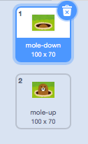Click on **Costumes** for the Scratch cat sprite.
3. Upload the two mole costumes.
4. Delete the existing Scratch cat costumes.
5. Order them so that mole-down comes first.
6. Your code needs to make the mole appear randomly, for a short time (half a second?)  
   There’s an example over the page.
7. To detect when you whack the mole, use the “**when this sprite clicked**” event.
8. Use a **score** variable to count successful whacks.
9. Duplicate the sprite as many times as you need, and put them side-by-side.

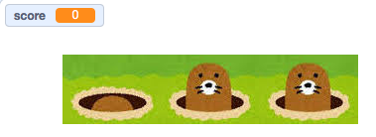

Here’s one solution:

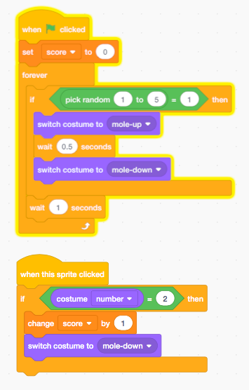

1. Try adding sound effects.