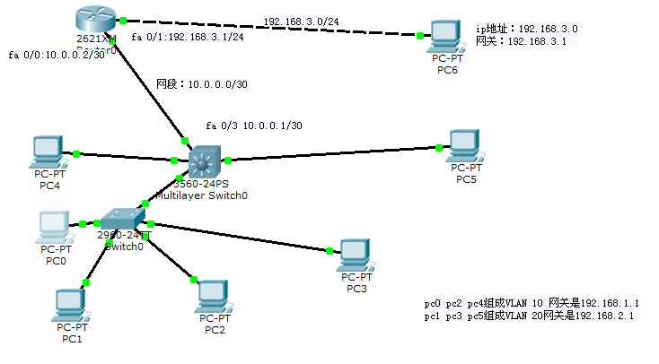
三层交换机fa 0/3端口与路由器fa 0/0连接：
Switch>enable
Switch#config term
Enter configuration commands, one per line. End with CNTL/Z.
Switch(config)#interface fastethernet 0/3
Switch(config-if)#no switchport
Switch(config-if)#ip address 10.0.0.1 255.255.255.252
Switch(config-if)#no shutdown
Switch(config-if)#exit
Switch(config)#exit
Switch#
%SYS-5-CONFIG_I: Configured from console by console

Switch#show ip interface brief
Interface IP-Address OK? Method Status Protocol

FastEthernet0/1 unassigned YES unset up up

FastEthernet0/2 unassigned YES unset up up

FastEthernet0/3 10.0.0.1 YES manual down down

FastEthernet0/4 unassigned YES unset down down

FastEthernet0/5 unassigned YES unset up up

FastEthernet0/6 unassigned YES unset down down

FastEthernet0/7 unassigned YES unset down down

FastEthernet0/8 unassigned YES unset down down

FastEthernet0/9 unassigned YES unset down down

FastEthernet0/10 unassigned YES unset down down

FastEthernet0/11 unassigned YES unset down down

FastEthernet0/12 unassigned YES unset down down

FastEthernet0/13 unassigned YES unset down down

FastEthernet0/14 unassigned YES unset down down

FastEthernet0/15 unassigned YES unset down down

FastEthernet0/16 unassigned YES unset down down

FastEthernet0/17 unassigned YES unset down down

FastEthernet0/18 unassigned YES unset down down

FastEthernet0/19 unassigned YES unset down down

FastEthernet0/20 unassigned YES unset down down

FastEthernet0/21 unassigned YES unset down down

FastEthernet0/22 unassigned YES unset down down

FastEthernet0/23 unassigned YES unset down down

FastEthernet0/24 unassigned YES unset down down

GigabitEthernet0/1 unassigned YES unset down down

GigabitEthernet0/2 unassigned YES unset down down

Vlan1 unassigned YES unset administratively down down

Vlan10 192.168.1.1 YES manual up up

Vlan20 192.168.2.1 YES manual up up
Switch#

路由器的fa 0/0和fa 0/1端口地址设置：
Router>enable
Router#config term
Enter configuration commands, one per line. End with CNTL/Z.
Router(config)#interface fastethernet 0/0
Router(config-if)#ip address 10.0.0.2 255.255.255.252
Router(config-if)#no shutdown

Router(config-if)#
%LINK-5-CHANGED: Interface FastEthernet0/0, changed state to up

%LINEPROTO-5-UPDOWN: Line protocol on Interface FastEthernet0/0, changed state to up

Router(config-if)#exit
Router(config)#exit
Router#
%SYS-5-CONFIG_I: Configured from console by console

Router#show ip interface brief
Interface IP-Address OK? Method Status Protocol

FastEthernet0/0 10.0.0.2 YES manual up up

FastEthernet0/1 unassigned YES unset administratively down down
Router#config term
Enter configuration commands, one per line. End with CNTL/Z.
Router(config)#interface fastethernet 0/1
Router(config-if)#ip address 192.168.3.1 255.255.255.0
Router(config-if)#no shutdown

Router(config-if)#
%LINK-5-CHANGED: Interface FastEthernet0/1, changed state to up

%LINEPROTO-5-UPDOWN: Line protocol on Interface FastEthernet0/1, changed state to up

Router(config-if)#exit
Router(config)#exit
Router#
%SYS-5-CONFIG_I: Configured from console by console

Router#show ip interface brief
Interface IP-Address OK? Method Status Protocol

FastEthernet0/0 10.0.0.2 YES manual up up

FastEthernet0/1 192.168.3.1 YES manual up up
Router#
上述是将三层交换机与路由器连接的网段是10.0.0.0,交换机一端的地址是10.0.0.1,路由器的一端是10.0.0.2（请老师们注意：在为三层交换机的fa 0/3设地址前一定要用 no switchport命令）。
三层交换机是具有路由功能的，下面是为路由器和三层交换机设置静态路由功能
三层交换机的路由设置：
Switch>enable
Switch#config term
Enter configuration commands, one per line. End with CNTL/Z.
Switch(config)#ip route 192.168.3.0 255.255.255.0 10.0.0.2
Switch(config)#exit
Switch#
%SYS-5-CONFIG_I: Configured from console by console
Switch#show ip interface brief
Interface IP-Address OK? Method Status Protocol

FastEthernet0/1 unassigned YES unset up up

FastEthernet0/2 unassigned YES unset up up

FastEthernet0/3 10.0.0.1 YES manual up up

FastEthernet0/4 unassigned YES unset down down

FastEthernet0/5 unassigned YES unset up up

FastEthernet0/6 unassigned YES unset down down

FastEthernet0/7 unassigned YES unset down down

FastEthernet0/8 unassigned YES unset down down

FastEthernet0/9 unassigned YES unset down down

FastEthernet0/10 unassigned YES unset down down

FastEthernet0/11 unassigned YES unset down down

FastEthernet0/12 unassigned YES unset down down

FastEthernet0/13 unassigned YES unset down down

FastEthernet0/14 unassigned YES unset down down

FastEthernet0/15 unassigned YES unset down down

FastEthernet0/16 unassigned YES unset down down

FastEthernet0/17 unassigned YES unset down down

FastEthernet0/18 unassigned YES unset down down

FastEthernet0/19 unassigned YES unset down down

FastEthernet0/20 unassigned YES unset down down

FastEthernet0/21 unassigned YES unset down down

FastEthernet0/22 unassigned YES unset down down

FastEthernet0/23 unassigned YES unset down down

FastEthernet0/24 unassigned YES unset down down

GigabitEthernet0/1 unassigned YES unset down down

GigabitEthernet0/2 unassigned YES unset down down

Vlan1 unassigned YES unset administratively down down

Vlan10 192.168.1.1 YES manual up up

Vlan20 192.168.2.1 YES manual up up
Switch#show ip route
Codes: C - connected, S - static, I - IGRP, R - RIP, M - mobile, B - BGP
D - EIGRP, EX - EIGRP external, O - OSPF, IA - OSPF inter area
N1 - OSPF NSSA external type 1, N2 - OSPF NSSA external type 2
E1 - OSPF external type 1, E2 - OSPF external type 2, E - EGP
i - IS-IS, L1 - IS-IS level-1, L2 - IS-IS level-2, ia - IS-IS inter area
* - candidate default, U - per-user static route, o - ODR
P - periodic downloaded static route

Gateway of last resort is not set

10.0.0.0/30 is subnetted, 1 subnets
C 10.0.0.0 is directly connected, FastEthernet0/3
C 192.168.1.0/24 is directly connected, Vlan10
C 192.168.2.0/24 is directly connected, Vlan20
S 192.168.3.0/24 [1/0] via 10.0.0.2
Switch#
路由器的静态路由设置：
Router>enable
Router#config term
Enter configuration commands, one per line. End with CNTL/Z.
Router(config)#ip route 192.168.1.0 255.255.255.0 10.0.0.1
Router(config)#ip route 192.168.2.0 255.255.255.0 10.0.0.1
Router(config)#exit
Router#
%SYS-5-CONFIG_I: Configured from console by console

Router#show ip route
Codes: C - connected, S - static, I - IGRP, R - RIP, M - mobile, B - BGP
D - EIGRP, EX - EIGRP external, O - OSPF, IA - OSPF inter area
N1 - OSPF NSSA external type 1, N2 - OSPF NSSA external type 2
E1 - OSPF external type 1, E2 - OSPF external type 2, E - EGP
i - IS-IS, L1 - IS-IS level-1, L2 - IS-IS level-2, ia - IS-IS inter area
* - candidate default, U - per-user static route, o - ODR
P - periodic downloaded static route

Gateway of last resort is not set

10.0.0.0/30 is subnetted, 1 subnets
C 10.0.0.0 is directly connected, FastEthernet0/0
S 192.168.1.0/24 [1/0] via 10.0.0.1
S 192.168.2.0/24 [1/0] via 10.0.0.1
C 192.168.3.0/24 is directly connected, FastEthernet0/1
Router#
老师们请注意：虚拟局域网的IP地址设置和各网段的IP地址设与老师的例题不同，但设置方法完全一致，如有问题，请与我联系（18014012401）

