### Use Case Documents

#### Use Case UC-1: Sign Up

| ID & Name: | UC-1: Sign Up |
| --- | --- |
| Primary Actor: | User |
| Description: | User registers for a new account. |
| Trigger: | User decides to create a new account. |
| Pre-conditions: | None. |
| Post-conditions: | User successfully registers for an account. |
| Normal Flow: | 1. User provides required registration information. 2. User clicks on the "Sign Up" button. 3. System creates a new account for the user. 4. System displays a success message. |
| Alternative Flows: | None. |
| Exceptions: | **Exception #1:** User provides incomplete or invalid information. 1. User receives an error message prompting to correct the information. **Exception #2:** User tries to sign up with an existing email or username. 1. User receives an error message indicating the email or username is already in use. |
| Priority: | High |

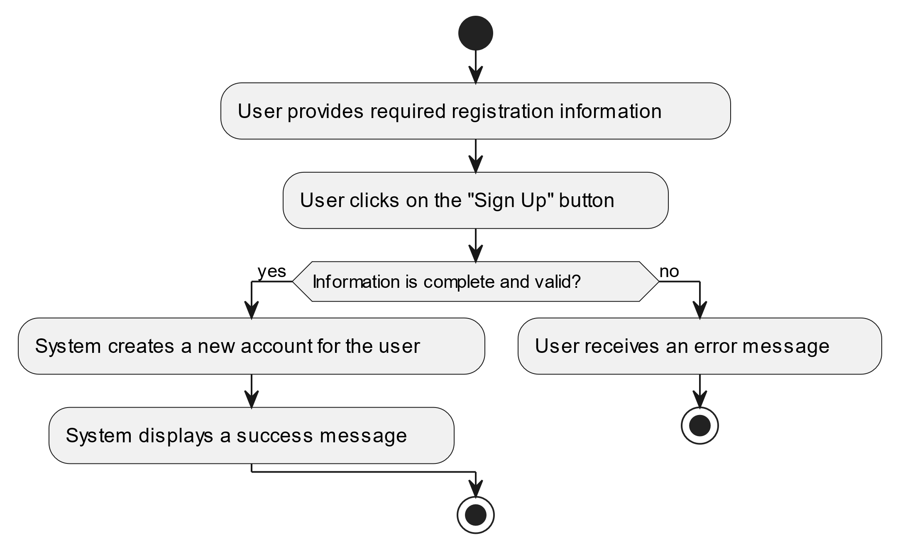

#### Use Case UC-2: Sign In

| ID & Name: | UC-2: Sign In |
| --- | --- |
| Primary Actor: | User |
| Description: | User logs into their account. |
| Trigger: | User decides to log in. |
| Pre-conditions: | User has already registered for an account. |
| Post-conditions: | User successfully logs into their account. |
| Normal Flow: | 1. User enters their username/email and password. 2. User clicks on the "Sign In" button. 3. System verifies the credentials. 4. System logs the user into their account. 5. System redirects the user to their profile page. |
| Alternative Flows: | None. |
| Exceptions: | **Exception #1:** User enters incorrect username/email or password. 1. User receives an error message indicating incorrect credentials. **Exception #2:** User tries to sign in with a deactivated or suspended account. 1. User receives an error message indicating the account is deactivated or suspended. |
| Priority: | High |

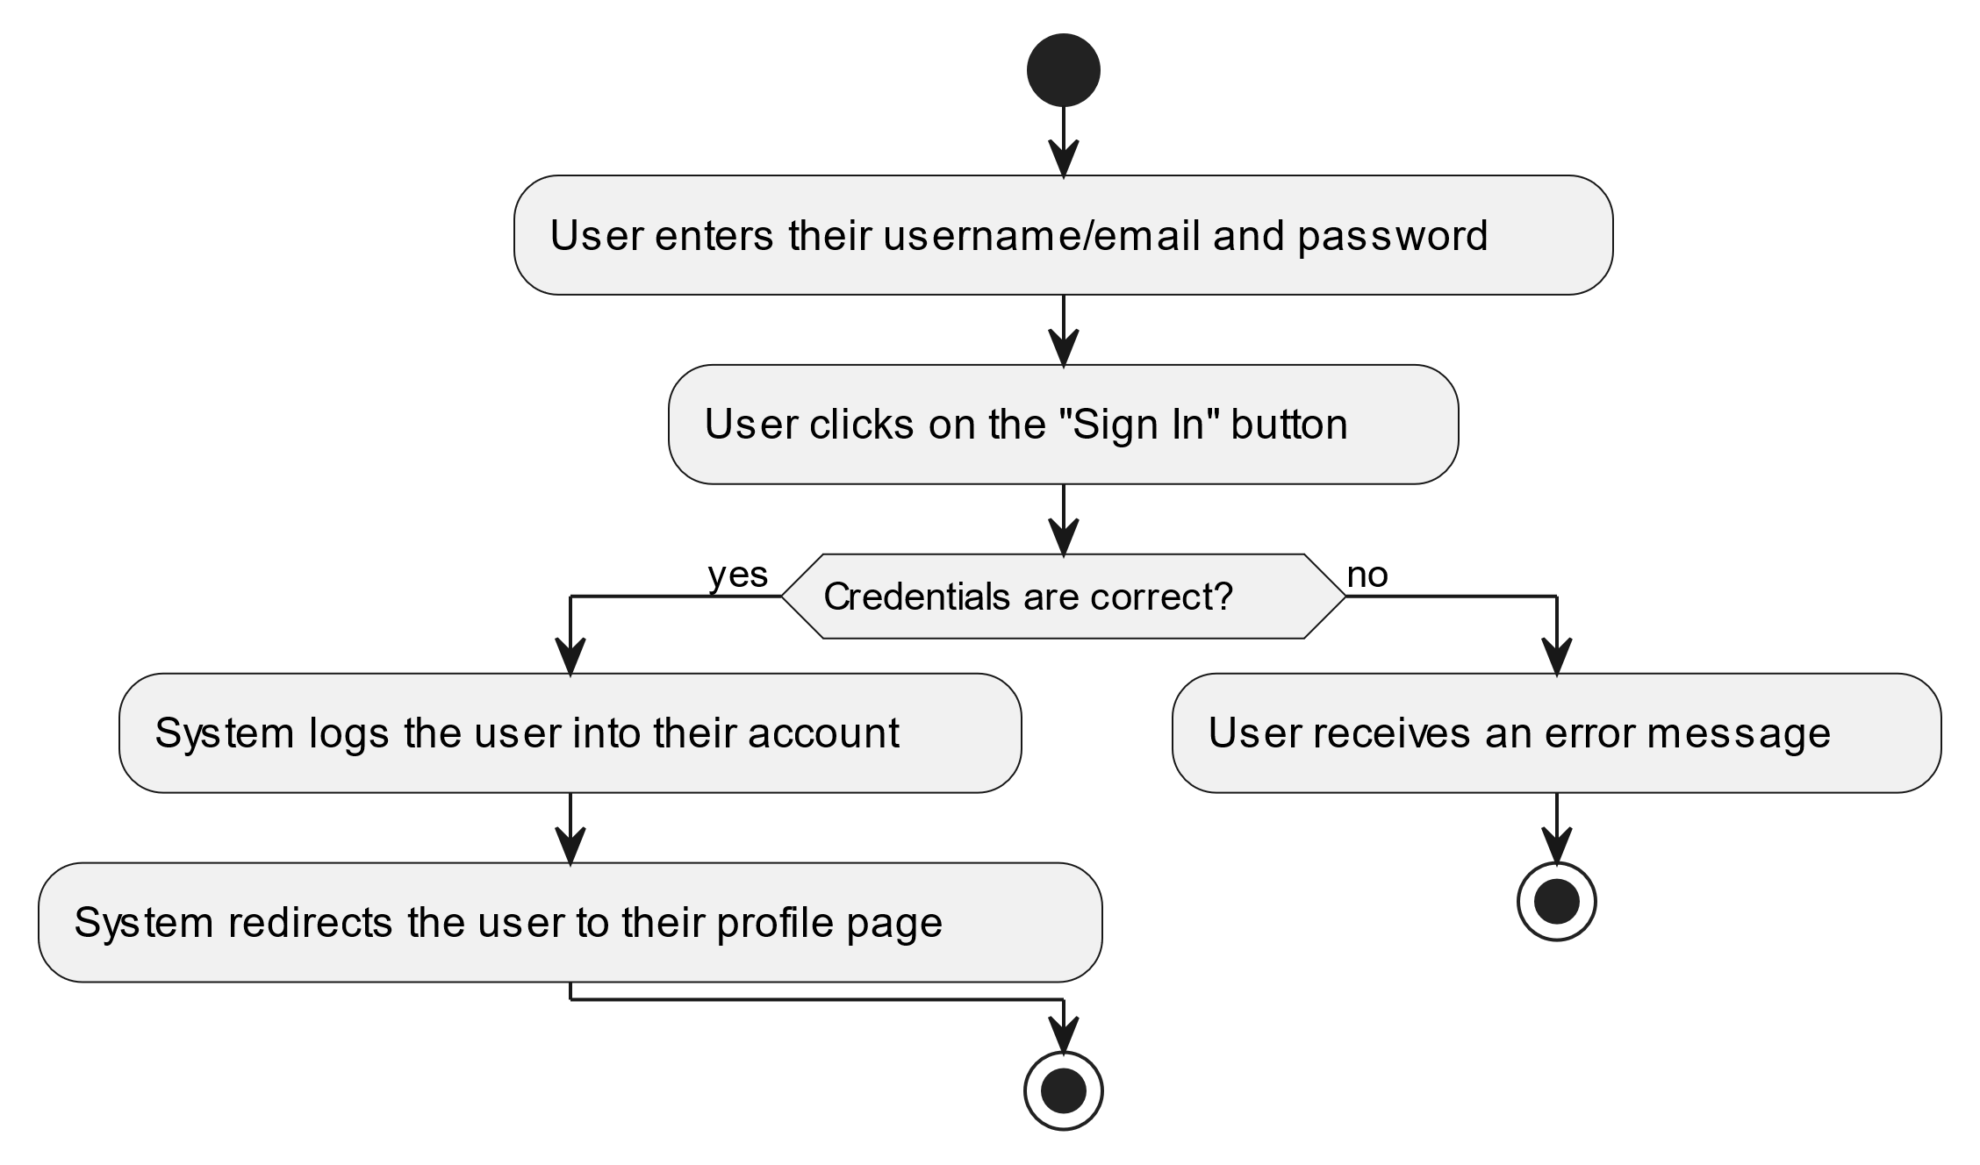

#### Use Case UC-3: View Profile

| ID & Name: | UC-3: View Profile |
| --- | --- |
| Primary Actor: | User |
| Description: | User views their own profile information. |
| Trigger: | User navigates to the profile page. |
| Pre-conditions: | User is logged into their account. |
| Post-conditions: | User successfully views their profile. |
| Normal Flow: | 1. User navigates to the profile page. 2. System retrieves and displays the user's profile information. |
| Alternative Flows: | None. |
| Exceptions: | None. |
| Priority: | Medium |

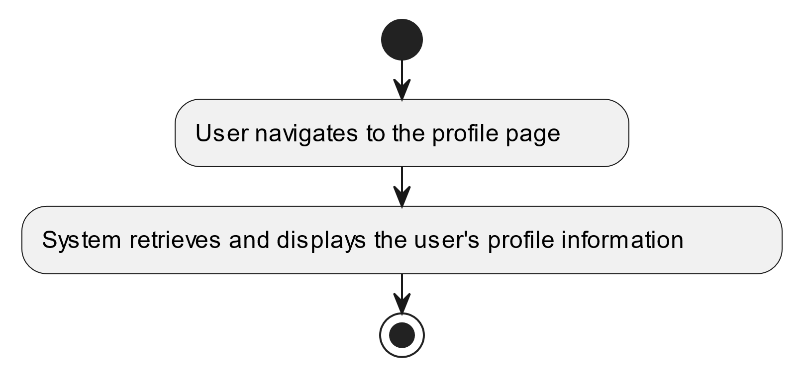

#### Use Case UC-4: Create Post

| ID & Name: | UC-4: Create Post |
| --- | --- |
| Primary Actor: | User |
| Description: | User creates a new post to share with others. |
| Trigger: | User decides to create a new post. |
| Pre-conditions: | User is logged into their account. |
| Post-conditions: | New post is successfully created and visible to others. |
| Normal Flow: | 1. User navigates to the "Create Post" section. 2. User enters post content and attaches media if desired. 3. User clicks on the "Post" button. 4. System saves the post and displays it to the user and others. |
| Alternative Flows: | None. |
| Exceptions: | **Exception #1:** User tries to post without entering any content. 1. User receives an error message prompting to enter post content. **Exception #2:** User encounters a technical issue while posting. 1. User receives an error message indicating the issue and is prompted to try again later. |
| Priority: | High |

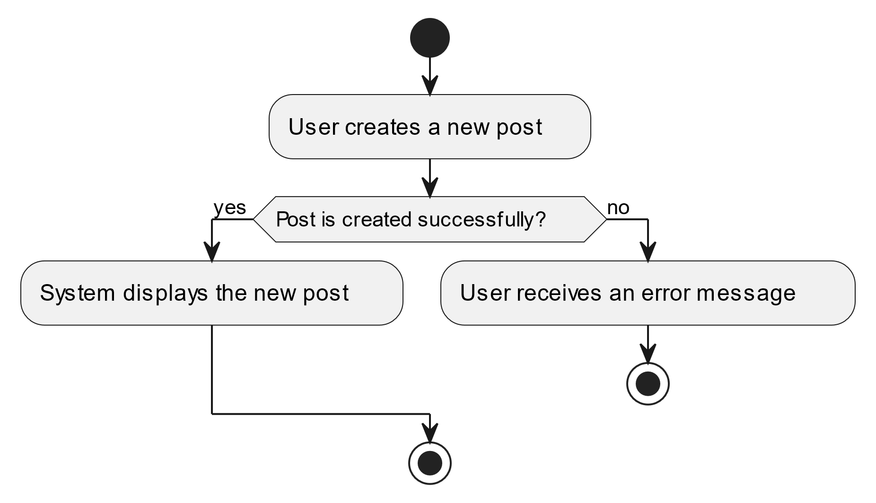

#### Use Case UC-5: Search

| ID & Name: | UC-5: Search |
| --- | --- |
| Primary Actor: | User |
| Description: | User searches for other users or posts based on specific keywords or criteria. |
| Trigger: | User decides to perform a search. |
| Pre-conditions: | User is logged into their account. |
| Post-conditions: | Search results matching the query are displayed to the user. |
| Normal Flow: | 1. User enters keywords or criteria into the search bar. 2. User submits the search query. 3. System retrieves and displays relevant search results. |
| Alternative Flows: | None. |
| Exceptions: | None. |
| Priority: | Medium |

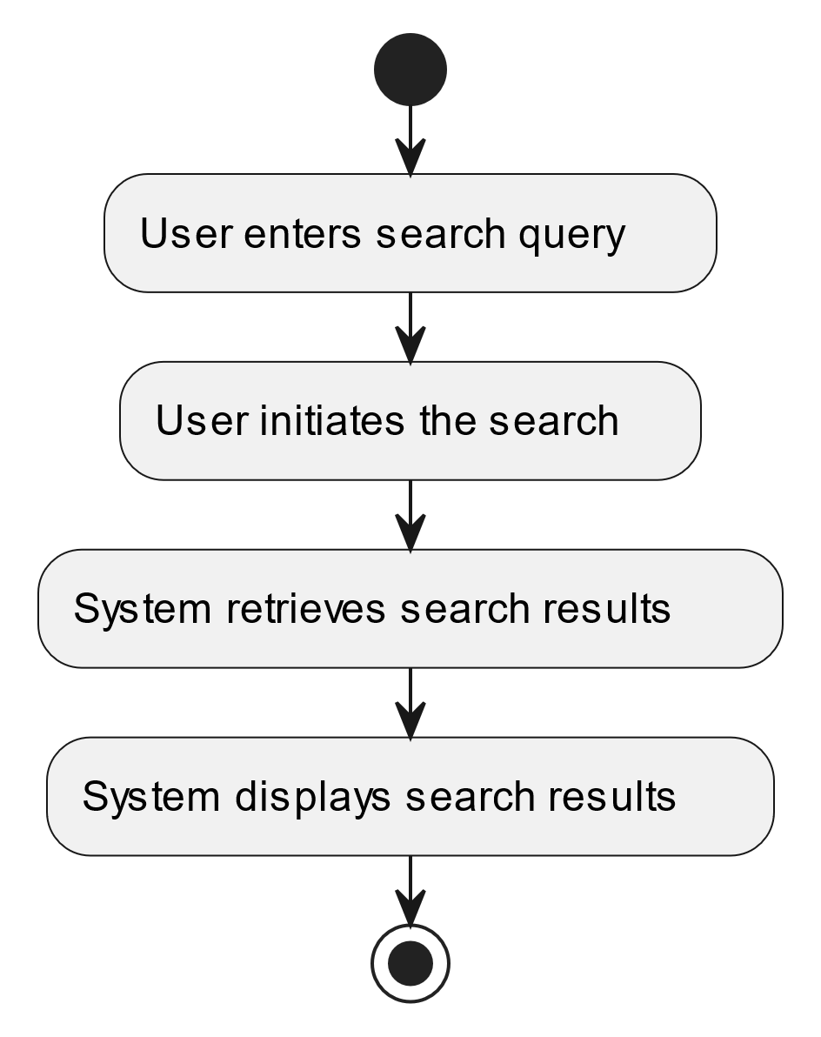

#### Use Case UC-6: View Notifications

| ID & Name: | UC-6: View Notifications |
| --- | --- |
| Primary Actor: | User |
| Description: | User views notifications related to their account activity, such as new followers, likes, comments, or messages. |
| Trigger: | User accesses the notifications section. |
| Pre-conditions: | User is logged into their account. |
| Post-conditions: | User successfully views their notifications. |
| Normal Flow: | 1. User navigates to the notifications section. 2. System retrieves and displays the user's notifications. |
| Alternative Flows: | None. |
| Exceptions: | None. |
| Priority: | Medium |

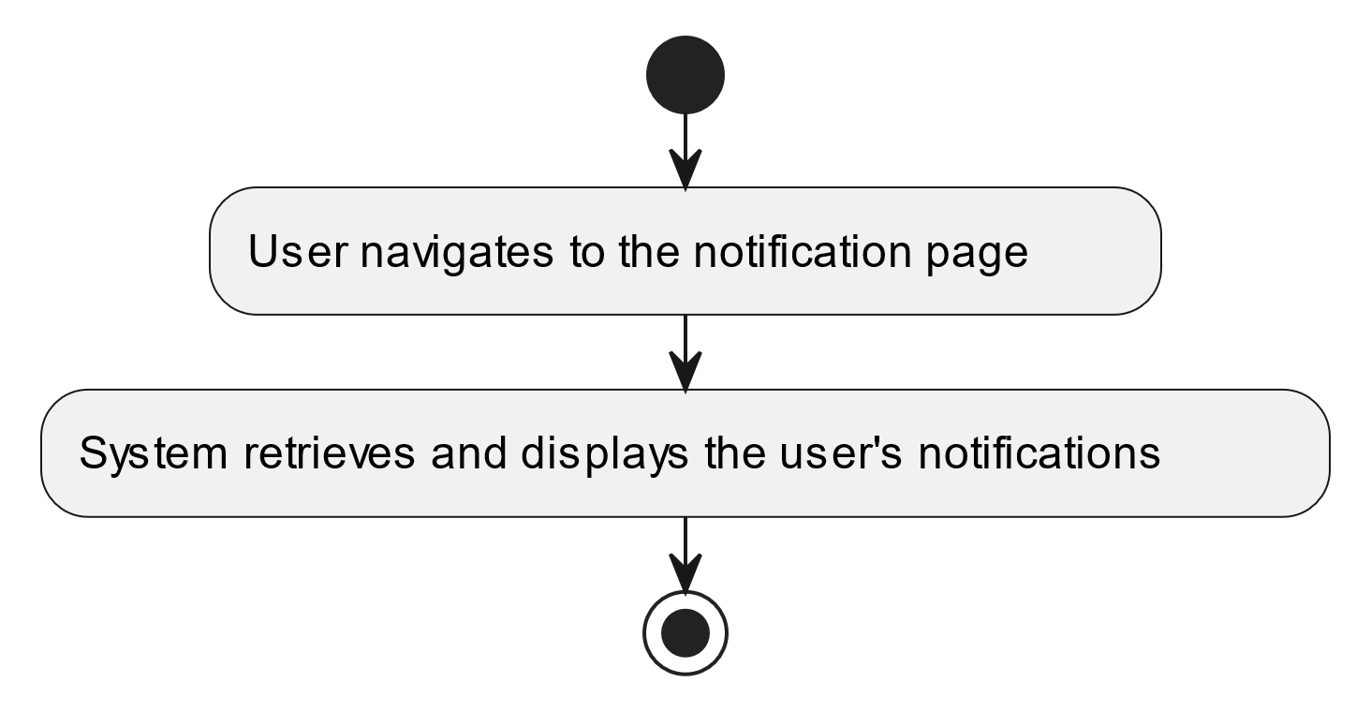

#### Use Case UC-7: Follow User

| ID & Name: | UC-7: Follow User |
| --- | --- |
| Primary Actor: | User |
| Description: | User follows another user to receive updates on their activity. |
| Trigger: | User decides to follow another user. |
| Pre-conditions: | User is logged into their account. |
| Post-conditions: | User successfully follows the selected user. |
| Normal Flow: | 1. User navigates to the profile of the user they want to follow. 2. User clicks on the "Follow" button. |
| Alternative Flows: | None. |
| Exceptions: | None. |
| Priority: | Medium |

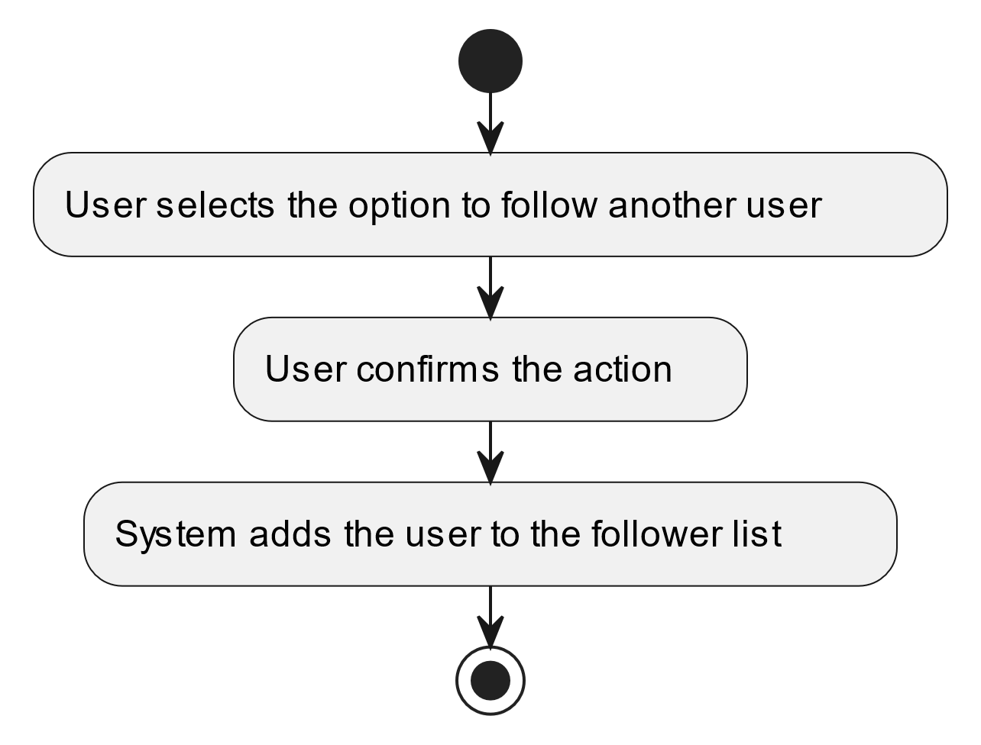

#### Use Case UC-8: Unfollow User

| ID & Name: | UC-8: Unfollow User |
| --- | --- |
| Primary Actor: | User |
| Description: | User unfollows another user, stopping updates on their activity. |
| Trigger: | User decides to unfollow another user. |
| Pre-conditions: | User is logged into their account. |
| Post-conditions: | User successfully unfollows the selected user. |
| Normal Flow: | 1. User navigates to the profile of the user they want to unfollow. 2. User clicks on the "Unfollow" button. |
| Alternative Flows: | None. |
| Exceptions: | None. |
| Priority: | Medium |

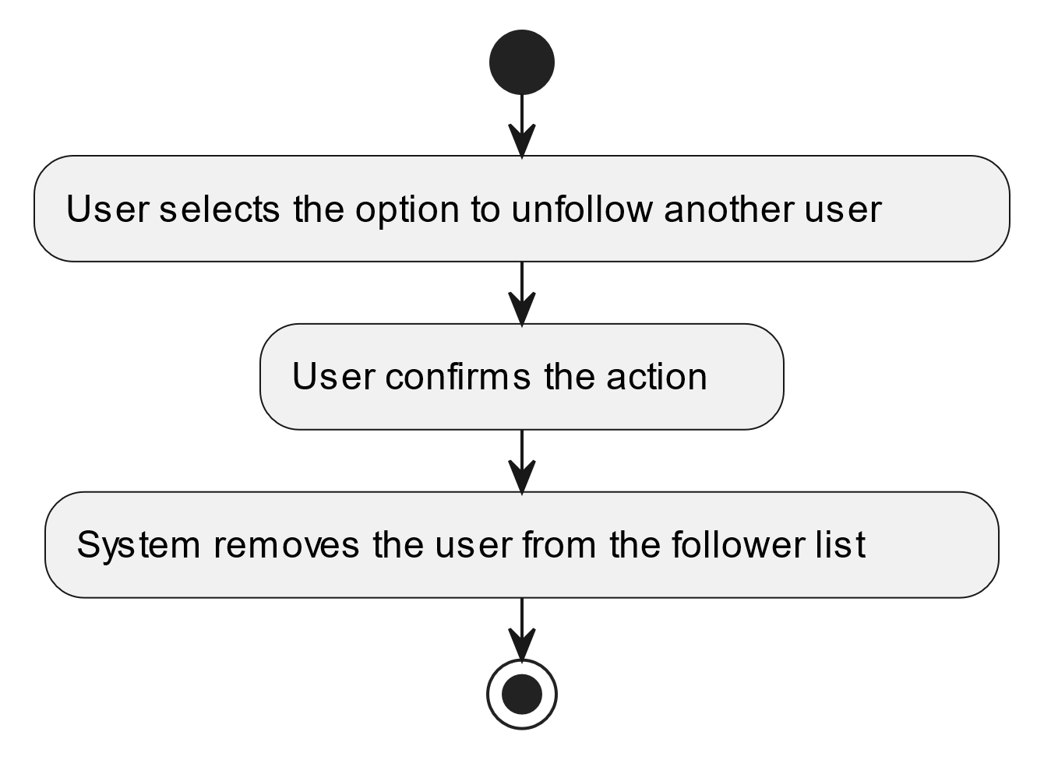

#### Use Case UC-9: Update Profile

| ID & Name: | UC-9: Update Profile |
| --- | --- |
| Primary Actor: | User |
| Description: | User updates their profile information, such as name, bio, profile picture, or settings. |
| Trigger: | User decides to edit their profile. |
| Pre-conditions: | User is logged into their account. |
| Post-conditions: | User successfully updates their profile. |
| Normal Flow: | 1. User navigates to the profile settings or edit profile section. 2. User makes desired changes to their profile information. 3. User saves the changes. |
| Alternative Flows: | None. |
| Exceptions: | **Exception #1:** User encounters errors while saving changes. 1. User receives an error message indicating the issue. 2. User retries the save operation. |
| Priority: | Medium |

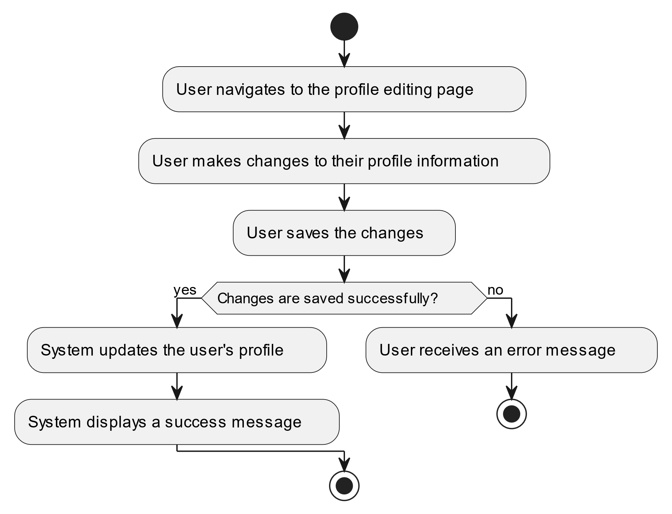

#### Use Case UC-10: View Post

| ID & Name: | UC-10: View Post |
| --- | --- |
| Primary Actor: | User |
| Description: | User views a post along with its associated comments, reactions, and other details. |
| Trigger: | User clicks on a post from the feed or search results. |
| Pre-conditions: | User is logged into their account. |
| Post-conditions: | User successfully views the selected post. |
| Normal Flow: | 1. User clicks on a post from the feed or search results. 2. System retrieves and displays the selected post along with its details. |
| Alternative Flows: | None. |
| Exceptions: | None. |
| Priority: | High |

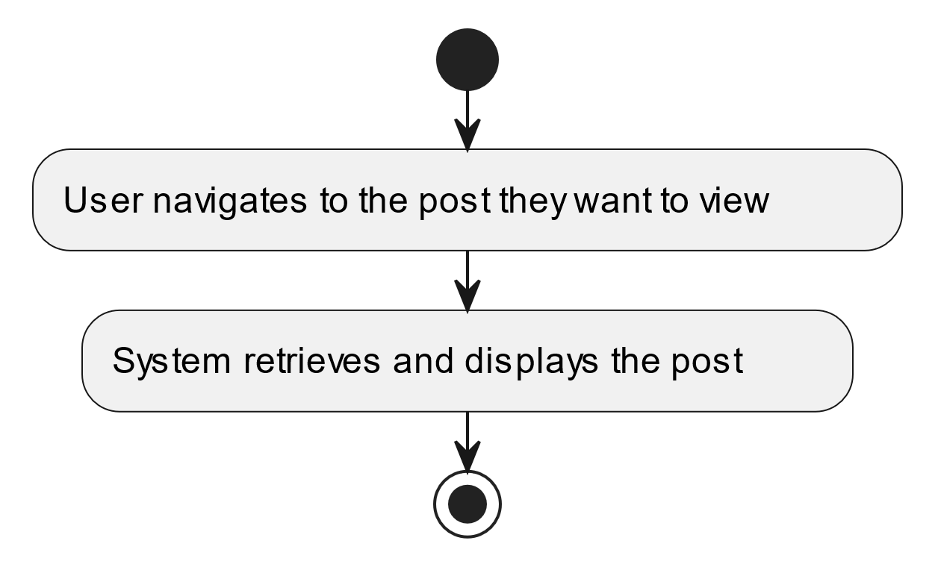

#### Use Case UC-11: Edit Post

| ID & Name: | UC-11: Edit Post |
| --- | --- |
| Primary Actor: | User |
| Description: | User edits one of their existing posts. |
| Trigger: | User decides to edit a post they previously created. |
| Pre-conditions: | User is logged into their account. |
| Post-conditions: | Post is successfully edited and updated with the new content. |
| Normal Flow: | 1. User navigates to the post they want to edit. 2. User clicks on the "Edit" option. 3. User makes desired changes to the post content. 4. User saves the changes. |
| Alternative Flows: | None. |
| Exceptions: | **Exception #1:** User encounters errors while saving changes. 1. User receives an error message indicating the issue. 2. User retries the save operation. |
| Priority: | Medium |

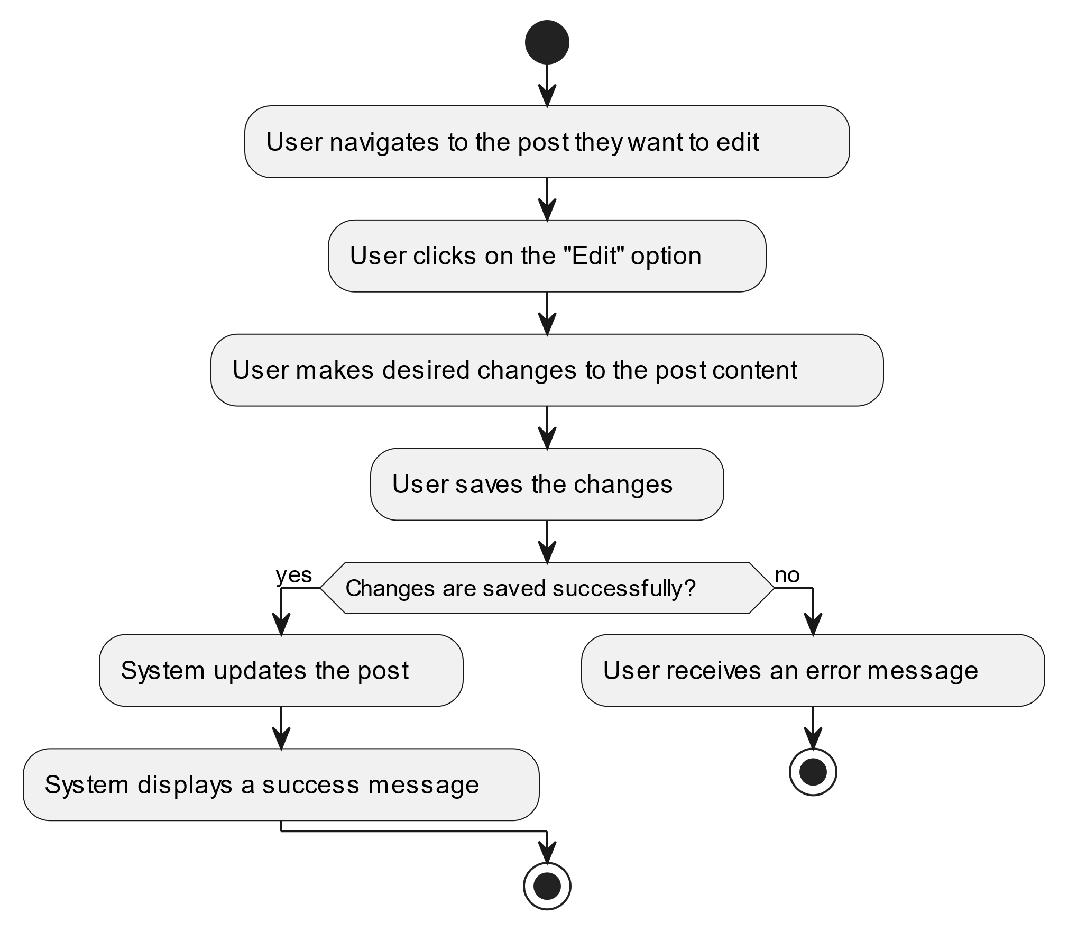

#### Use Case UC-12: Delete Post

| ID & Name: | UC-12: Delete Post |
| --- | --- |
| Primary Actor: | User |
| Description: | User deletes one of their existing posts. |
| Trigger: | User decides to delete a post they previously created. |
| Pre-conditions: | User is logged into their account. |
| Post-conditions: | Post is successfully deleted and removed from the system. |
| Normal Flow: | 1. User navigates to the post they want to delete. 2. User clicks on the "Delete" option. 3. User confirms the deletion. |
| Alternative Flows: | None. |
| Exceptions: | **Exception #1:** User encounters errors while deleting the post. 1. User receives an error message indicating the issue. 2. User retries the delete operation. |
| Priority: | Medium |

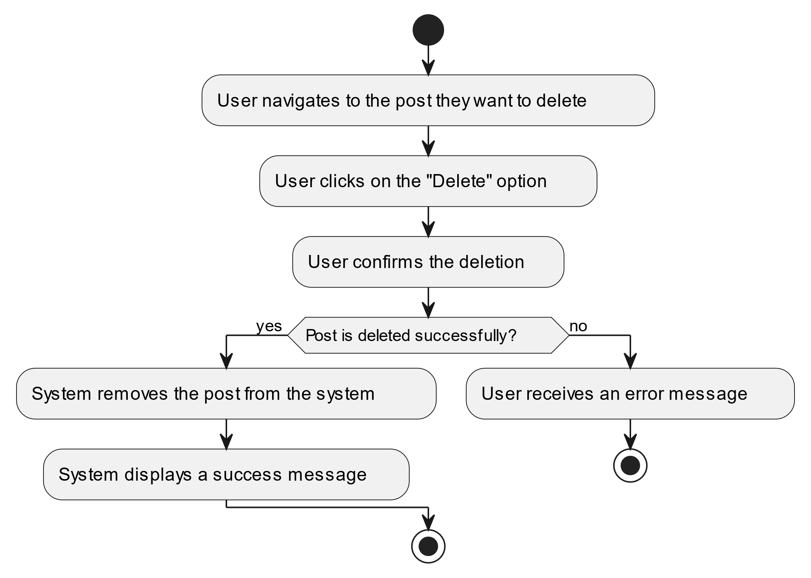

#### Use Case UC-13: Comment on Post

| ID & Name: | UC-13: Comment on Post |
| --- | --- |
| Primary Actor: | User |
| Description: | User adds a comment to an existing post. |
| Trigger: | User decides to comment on a post. |
| Pre-conditions: | User is logged into their account. |
| Post-conditions: | Comment is successfully added to the selected post. |
| Normal Flow: | 1. User navigates to the post they want to comment on. 2. User types their comment in the designated comment section. 3. User clicks on the "Post Comment" button. |
| Alternative Flows: | None. |
| Exceptions: | **Exception #1:** User encounters errors while posting the comment. 1. User receives an error message indicating the issue. 2. User retries the comment operation. |
| Priority: | High |

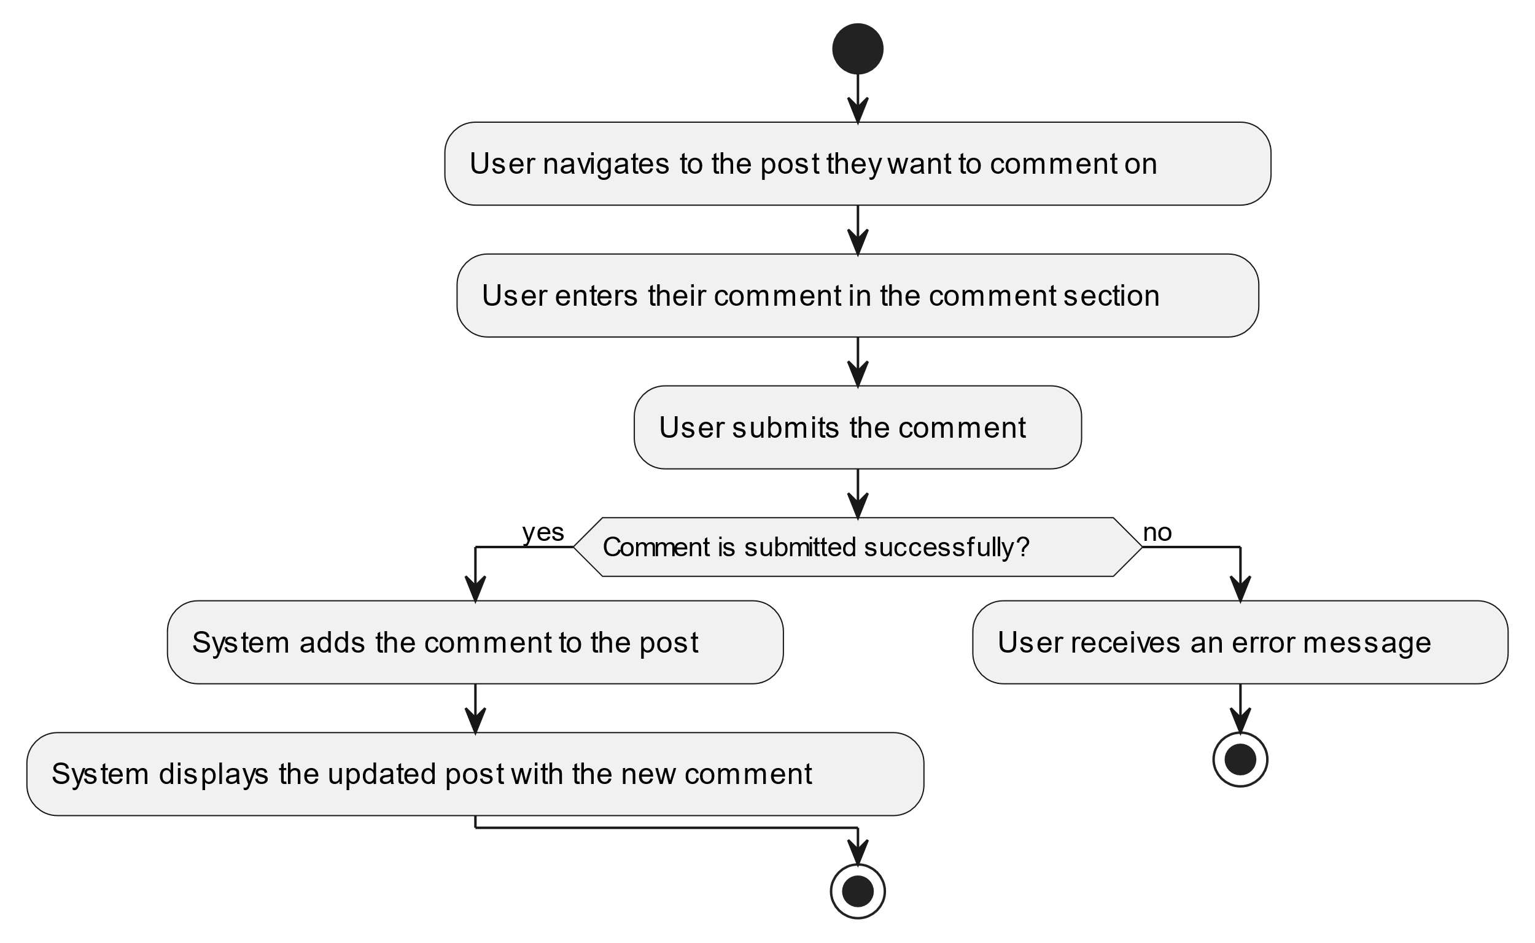

#### Use Case UC-14: Edit Comment

| ID & Name: | UC-14: Edit Comment |
| --- | --- |
| Primary Actor: | User |
| Description: | User edits one of their existing comments on a post. |
| Trigger: | User decides to edit a comment they previously made. |
| Pre-conditions: | User is logged into their account. |
| Post-conditions: | Comment is successfully edited and updated with the new content. |
| Normal Flow: | 1. User navigates to the comment they want to edit. 2. User clicks on the "Edit" option. 3. User makes desired changes to the comment content. 4. User saves the changes. |
| Alternative Flows: | None. |
| Exceptions: | **Exception #1:** User encounters errors while saving changes. 1. User receives an error message indicating the issue. 2. User retries the save operation. |
| Priority: | Medium |

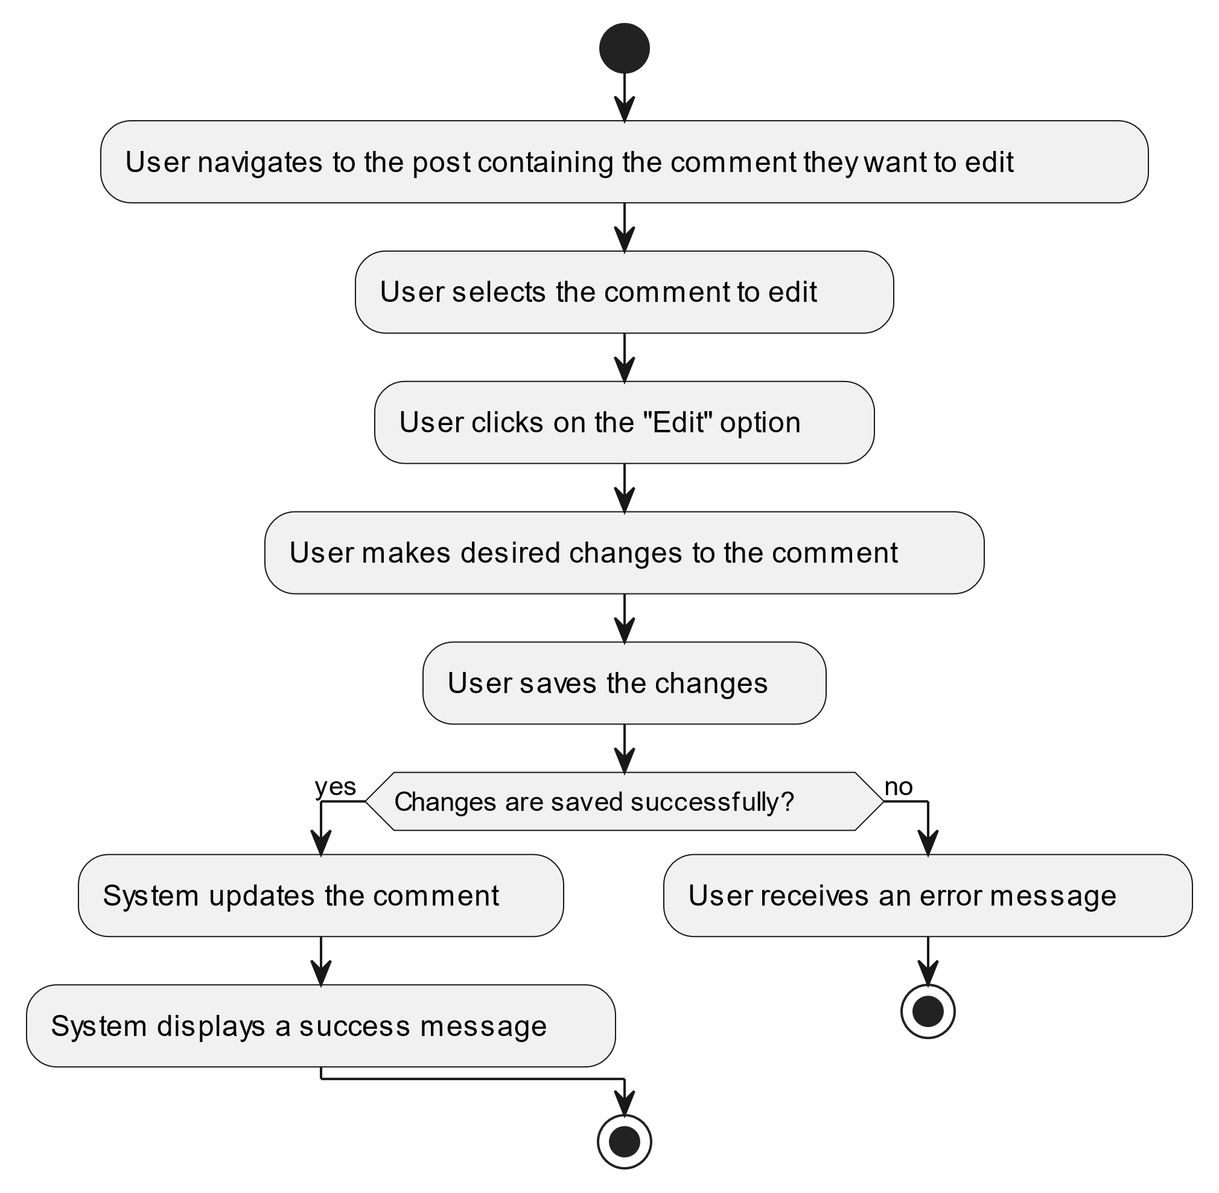

#### Use Case UC-15: Delete Comment

| ID & Name: | UC-15: Delete Comment |
| --- | --- |
| Primary Actor: | User |
| Description: | User deletes one of their existing comments on a post. |
| Trigger: | User decides to delete a comment they previously made. |
| Pre-conditions: | User is logged into their account. |
| Post-conditions: | Comment is successfully deleted and removed from the post. |
| Normal Flow: | 1. User navigates to the comment they want to delete. 2. User clicks on the "Delete" option. 3. User confirms the deletion. |
| Alternative Flows: | None. |
| Exceptions: | **Exception #1:** User encounters errors while deleting the comment. 1. User receives an error message indicating the issue. 2. User retries the delete operation. |
| Priority: | Medium |

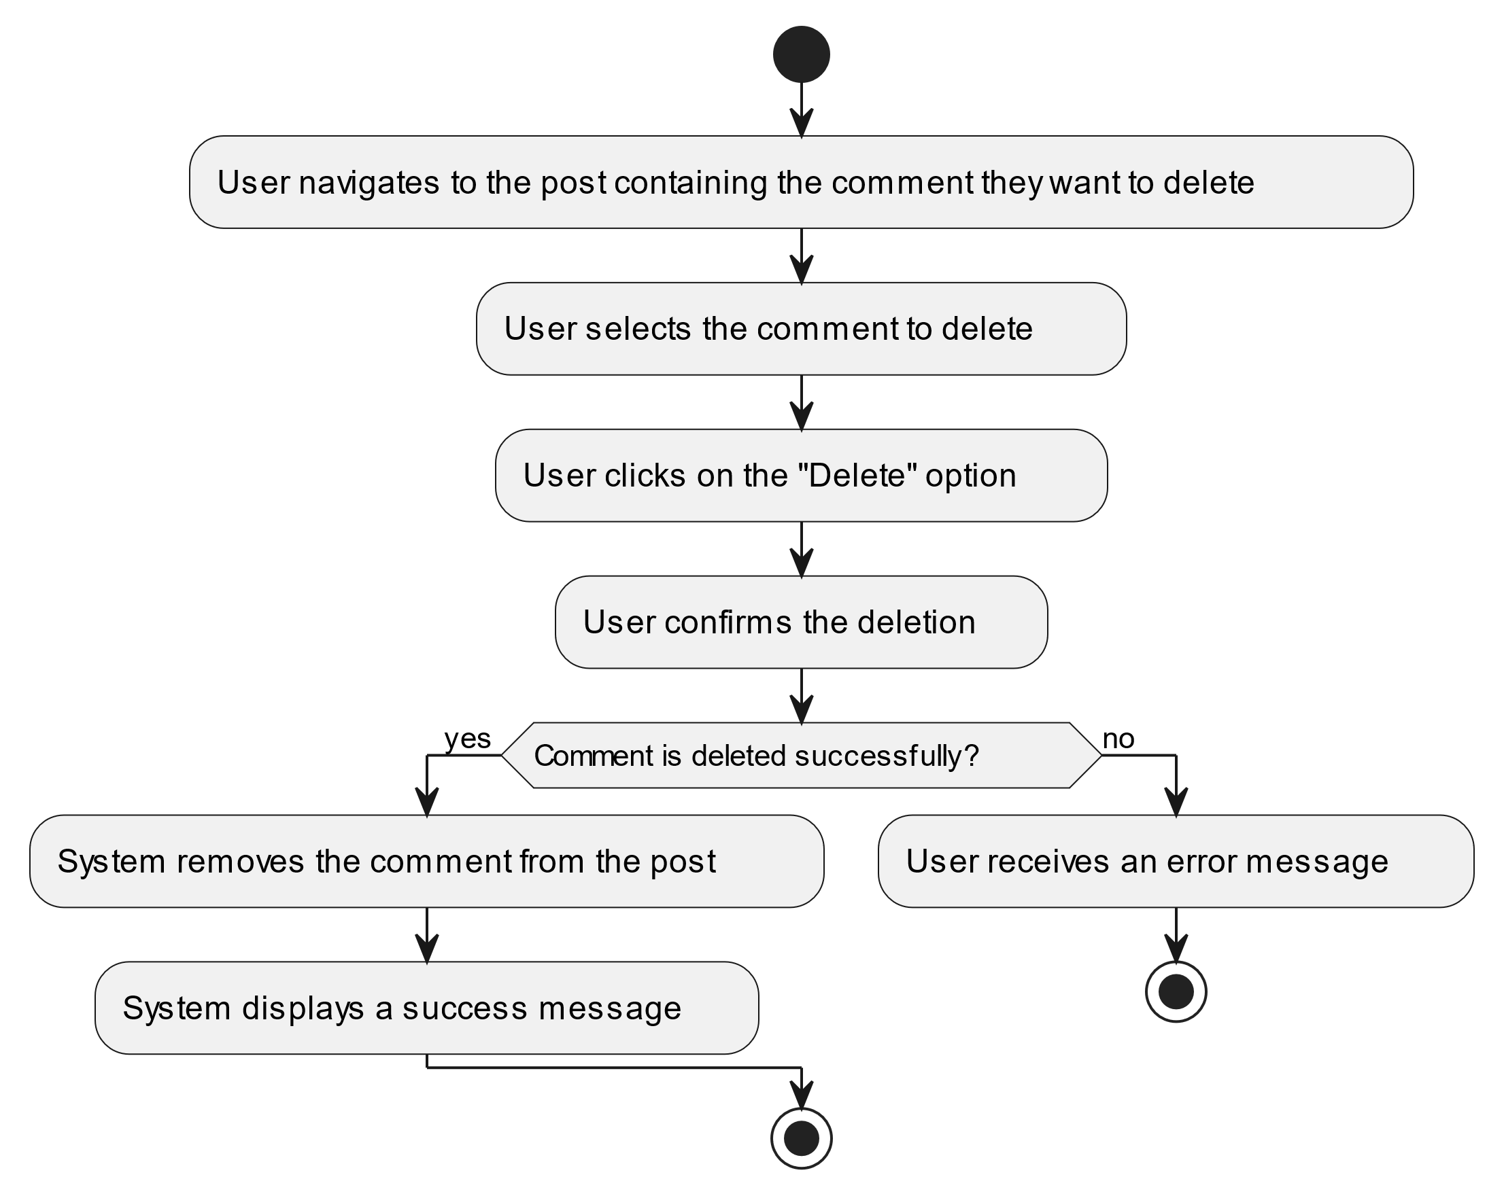

#### Use Case UC-16: React to Post

| ID & Name: | UC-16: React to Post |
| --- | --- |
| Primary Actor: | User |
| Description: | User reacts to a post by adding a like, dislike, or other emotive response. |
| Trigger: | User decides to react to a post. |
| Pre-conditions: | User is logged into their account. |
| Post-conditions: | User's reaction is successfully added to the selected post. |
| Normal Flow: | 1. User clicks on the reaction button (e.g., like, dislike) associated with the post. |
| Alternative Flows: | None. |
| Exceptions: | **Exception #1:** User encounters errors while adding the reaction. 1. User receives an error message indicating the issue. 2. User retries the reaction operation. |
| Priority: | Medium |

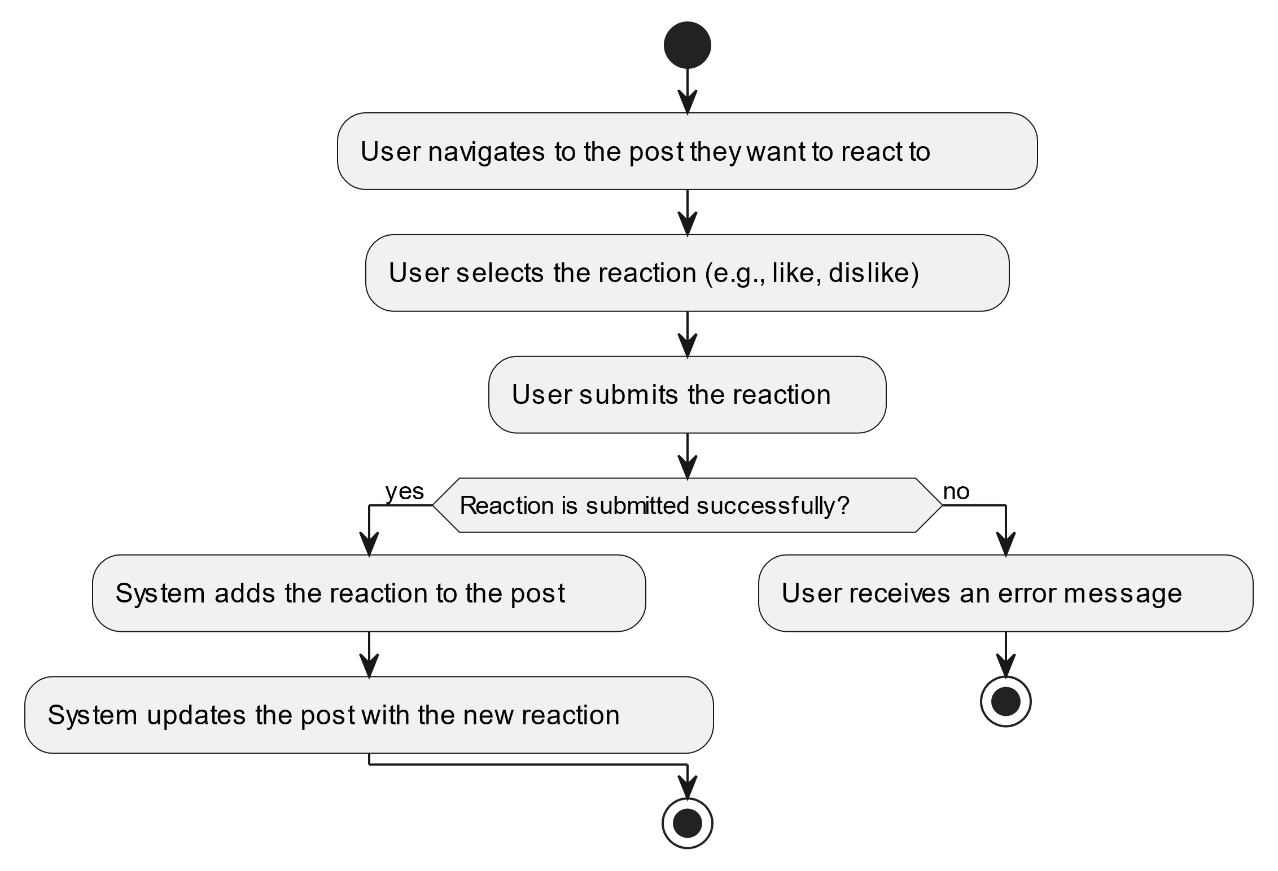

#### Use Case UC-17: Remove Reaction

| ID & Name: | UC-17: Remove Reaction |
| --- | --- |
| Primary Actor: | User |
| Description: | User removes their reaction (like, dislike, etc.) from a post. |
| Trigger: | User decides to remove their reaction from a post. |
| Pre-conditions: | User is logged into their account and has previously reacted to the post. |
| Post-conditions: | User's reaction is successfully removed from the post. |
| Normal Flow: | 1. User clicks on the reaction button (e.g., like, dislike) associated with the post to remove their reaction. |
| Alternative Flows: | None. |
| Exceptions: | **Exception #1:** User encounters errors while removing the reaction. 1. User receives an error message indicating the issue. 2. User retries the removal operation. |
| Priority: | Medium |

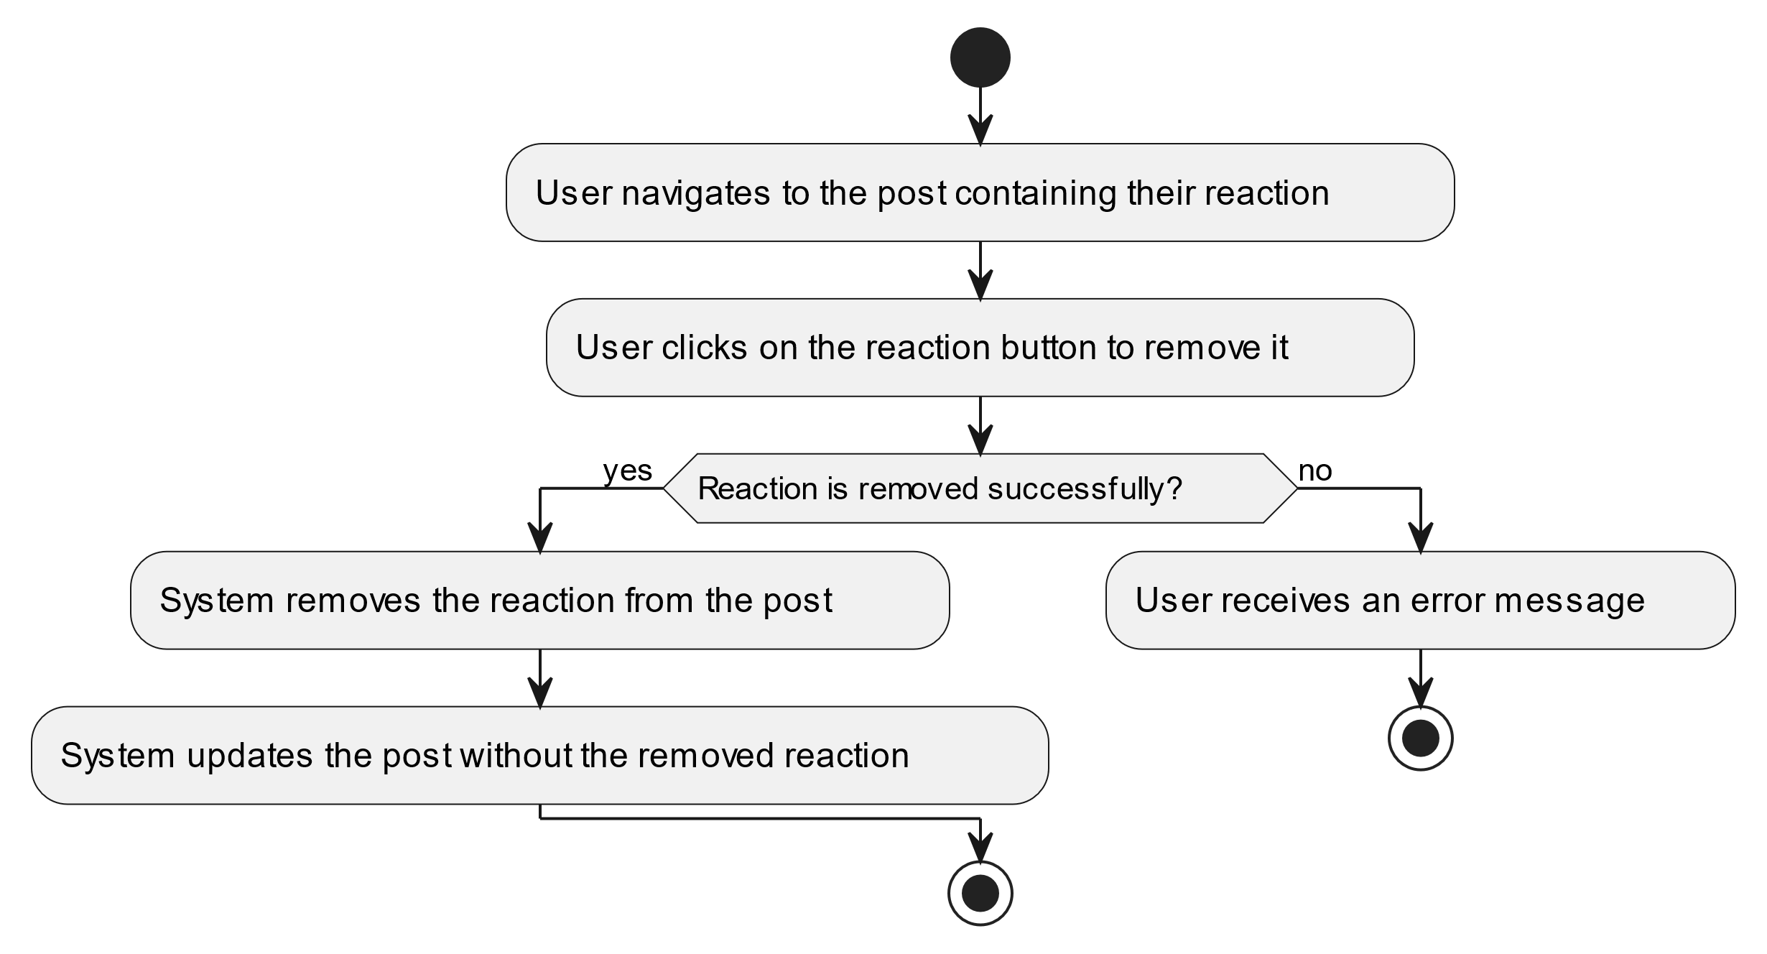

#### Use Case UC-18: Send Message

| ID & Name: | UC-18: Send Message |
| --- | --- |
| Primary Actor: | User |
| Description: | User sends a direct message to another user. |
| Trigger: | User decides to send a message to another user. |
| Pre-conditions: | User is logged into their account. |
| Post-conditions: | Message is successfully sent to the recipient. |
| Normal Flow: | 1. User navigates to the messaging section or user's profile. 2. User selects the recipient. 3. User composes the message. 4. User clicks on the "Send" button. |
| Alternative Flows: | None. |
| Exceptions: | **Exception #1:** User encounters errors while sending the message. 1. User receives an error message indicating the issue. 2. User retries the send operation. |
| Priority: | Medium |

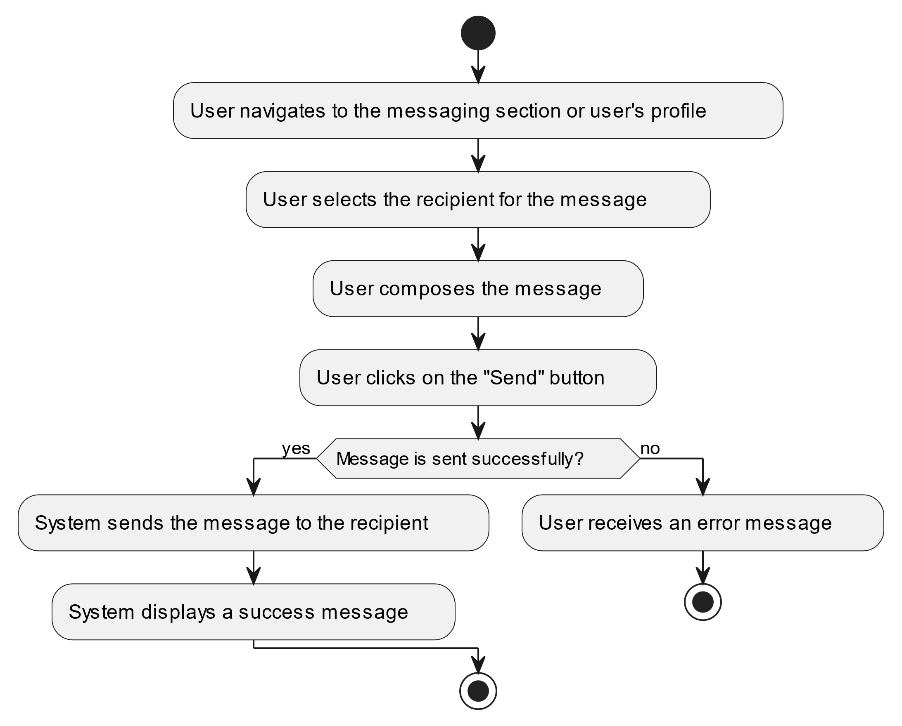

#### Use Case UC-19: View Messages

| ID & Name: | UC-19: View Messages |
| --- | --- |
| Primary Actor: | User |
| Description: | User views their messages, including conversations with other users. |
| Trigger: | User accesses the messaging section. |
| Pre-conditions: | User is logged into their account. |
| Post-conditions: | User successfully views their messages. |
| Normal Flow: | 1. User navigates to the messaging section. 2. System retrieves and displays the user's messages. |
| Alternative Flows: | None. |
| Exceptions: | None. |
| Priority: | Medium |

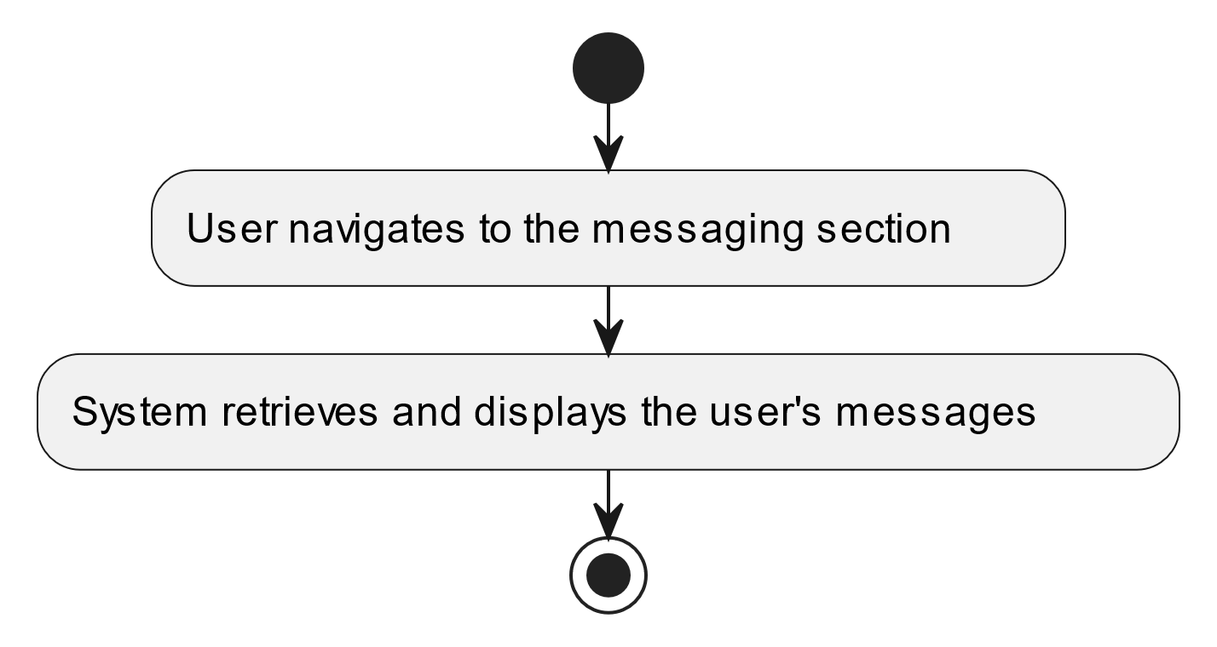

#### Use Case UC-20: Edit Message

| ID & Name: | UC-20: Edit Message |
| --- | --- |
| Primary Actor: | User |
| Description: | User edits a previously sent message. |
| Trigger: | User decides to edit a message they previously sent. |
| Pre-conditions: | User is logged into their account and has previously sent the message. |
| Post-conditions: | Message is successfully edited and updated with the new content. |
| Normal Flow: | 1. User navigates to the conversation containing the message they want to edit. 2. User selects the message to edit. 3. User makes desired changes to the message content. 4. User saves the changes. |
| Alternative Flows: | None. |
| Exceptions: | **Exception #1:** User encounters errors while saving changes. 1. User receives an error message indicating the issue. 2. User retries the save operation. |
| Priority: | Medium |

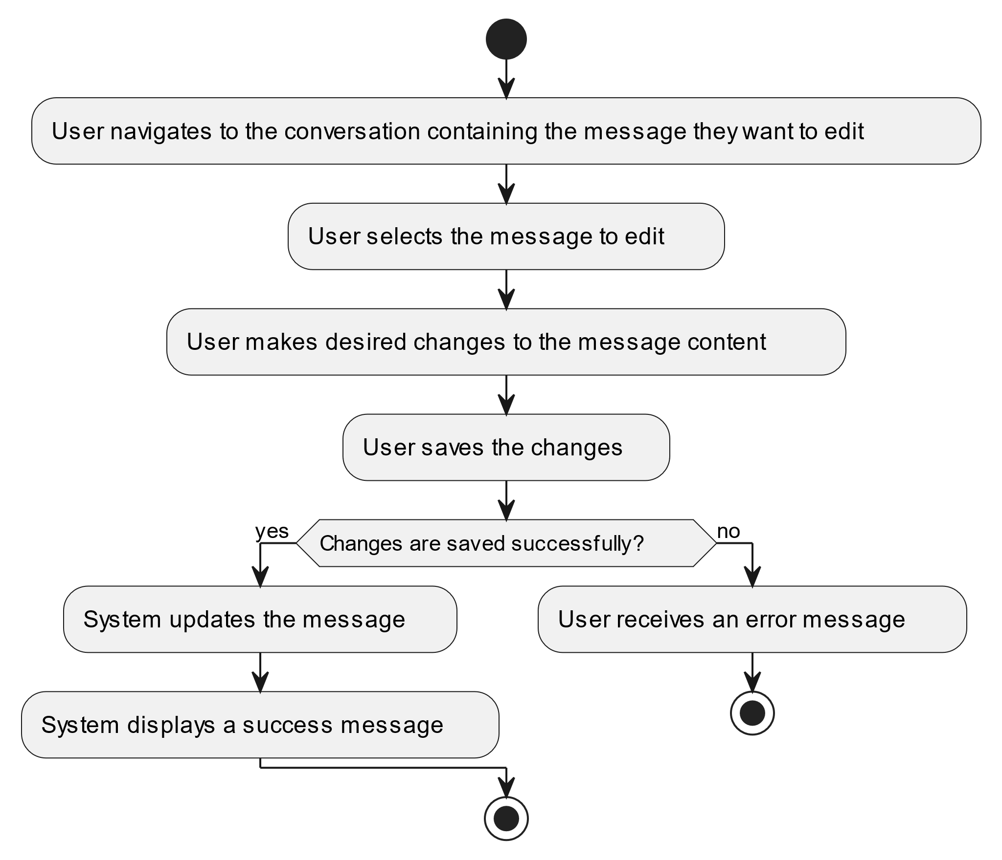

#### Use Case UC-21: Delete Message

| ID & Name: | UC-21: Delete Message |
| --- | --- |
| Primary Actor: | User |
| Description: | User deletes a previously sent message. |
| Trigger: | User decides to delete a message they previously sent. |
| Pre-conditions: | User is logged into their account and has previously sent the message. |
| Post-conditions: | Message is successfully deleted and removed from the conversation. |
| Normal Flow: | 1. User navigates to the conversation containing the message they want to delete. 2. User selects the message to delete. 3. User confirms the deletion. |
| Alternative Flows: | None. |
| Exceptions: | **Exception #1:** User encounters errors while deleting the message. 1. User receives an error message indicating the issue. 2. User retries the delete operation. |
| Priority: | Medium |

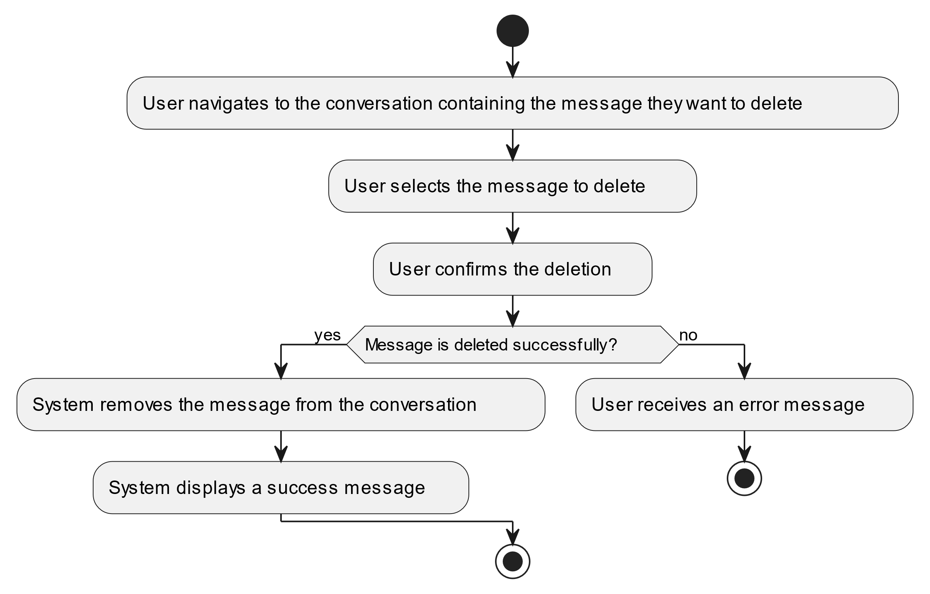

#### Use Case UC-22: Delete Notification

| ID & Name: | UC-22: Delete Notification |
| --- | --- |
| Primary Actor: | User |
| Description: | User deletes a notification from their notification list. |
| Trigger: | User decides to delete a notification. |
| Pre-conditions: | User is logged into their account. |
| Post-conditions: | Notification is successfully removed from the user's notification list. |
| Normal Flow: | 1. User navigates to their notification list. 2. User selects the notification they want to delete. 3. User confirms the deletion. |
| Alternative Flows: | None. |
| Exceptions: | **Exception #1:** User encounters errors while deleting the notification. 1. User receives an error message indicating the issue. 2. User retries the delete operation. |
| Priority: | Medium |

