**Project**

I am creating a Tinder for food app. Currently, the API we are using, Food2Fork, is very outdated and only allows us to get 50 API calls per day. We want to find a new API that will allow us to:

1. Display recipe images and their recipe name on the “swiping” page like in the example below:

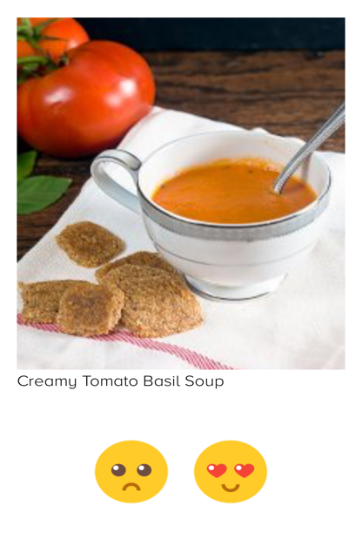

1. Be able to view search results like in the example below:

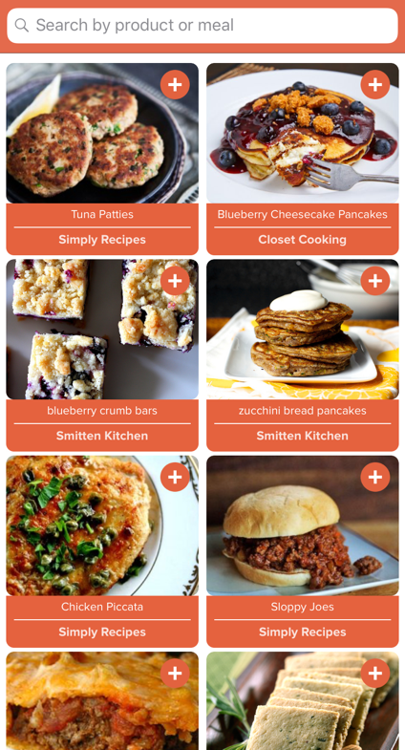

1. Be able to view the Recipe information similar to the screenshot below. I want the user to see tons of information about the recipe so feel free to change this page into something new that you think will be best and show useful information for the user.

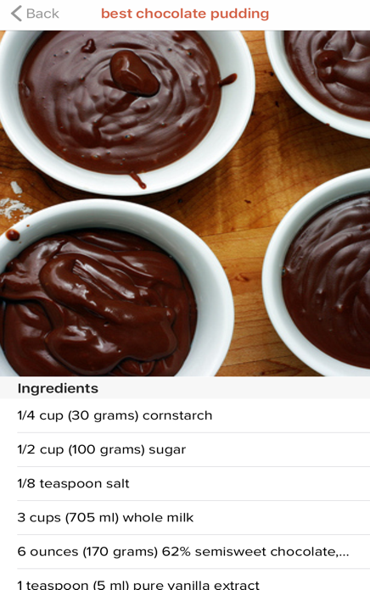

Here are the two API’s we are currently interested in:

<https://spoonacular.com/food-api>

<https://developer.edamam.com>

**Tasks**

1. Let me know which of the two API’s can do the requirements (display images for swiping page, recipe detail page, and search results) for the app. Just pick the API that will fulfill the requirements and you will be able to integrate fully.
2. Replace the old API (Food2Fork) with the new API that you have chosen and make the new API code changes to the swiping page, search page, and recipe detail page.
3. Make sure that the swiping page and search page can still add new recipes to the “My List” page. Currently, when the user swipes right on a recipe image, the recipe name and information is stored in the “My List” page. When the user clicks the add button in the search page, the recipe information is stored in the “My List” page. I want this to be the same with the new API.
4. Make changes to the recipe detail page (page that shows recipe image and the ingredients). Please redo this page and use the information that the API allows you to use. I still want to keep the image and the ingredients of the recipe, but if the API allows you to show more information, please add it.

Extra Notes:  
1) I want the app to look very similar to how it is with the Food2Fork API. I want the API switch to not change any UI looks.

2) There is already a good amount of code, so please use it and take advantage of the existing code.

3) Please use the app first and see how it works so you have a better understanding of what I am asking for.