#### Guiding principles for responsible AI

|  |  |  |
| --- | --- | --- |
| Principle | Definition | Example |
| Fairness | Treating everyone based on situation not on cast, gender and wealth. | Violated: ML model does not grant loans to people of certain gender  Related: evaluating and mitigating the bias introduced by the features of a model |
| Transparency | Transparency provides clarity regarding the purpose of AI solutions, the way they work, as well as their limitations. | Violated: A credit scoring AI that doesn’t provide reasons for a credit denial  Related: Ensuring that there is sufficient information to debug problems with an AI system |
| Accountability | Accountability is focused on ensuring that AI solutions meet ethical and legal standards that are clearly defined. | Related: Having a team that can override decision made by an AI system.  Violated: Deploying the model without checking proper norms. |
| Reliability and safety | AI should work safely even in unavoidable situations. | Violated: More accidents caused by a self-driving car in bad weather  Related: Making sure that the dataset used does not have any errors. |
| Privacy and security | Do not share the personal data without any consent. | Violated: A facial recognition system used without individuals consent.  Related: Securing data used to create the model |
| Inclusiveness | Development should be applicable to all sections of people. | Violated: A speech recognition system might perform poorly for users with certain accents.  Related: AI solutions empower everyone and engage people |

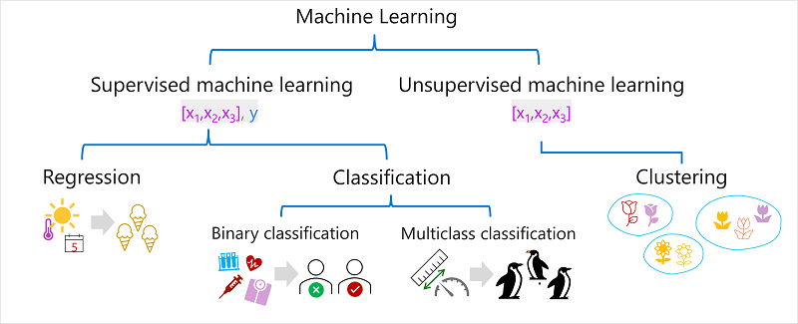

**Features =input(independent)**

**Label =Target(dependent)**

**Data(1000rows)**

**Training(80)**

**Testing/Validation(20)**

|  |  |  |  |
| --- | --- | --- | --- |
| **ML** | **Regression** | **Classification** | **Clustering** |
| **Algorithms** | **linear regression** | Binary classification logistic regression multiclass classification  * One-vs-Rest (OvR) algorithms * Multinomial algorithms | K-Means clustering |
| **Evaluation metric** | **Mean Absolute Error (MAE)** | **Accuracy** | **Average distance to cluster center** |
| **Mean Squared Error (MSE)** | **Recall** | **Average distance to other center** |
| **Root Mean Squared Error (RMSE)** | **Precision** | **Maximum distance to cluster center** |
| **Coefficient of determination (R2)** | **F1-score** | **Silhouette** |
| **Output type** | **Numerical value** | **Categorical value** | **Cluster** |
| **Input** | **features** | **features** | **features** |
| **Target** | **label** | **label** | **No label** |

# Deep learning:

In ml we need features values to train the model but in DL we only need input(image), neural network can automatically fetch the features values.

**Machine learning** - This is often the foundation for an AI system, and is the way we "teach" a computer model to make predictions and draw conclusions from data.

**Computer vision** - Capabilities within AI to interpret the world visually through cameras, video, and images.

**Natural language processing** - Capabilities within AI for a computer to interpret written or spoken language, and respond in kind.

**Document intelligence** - Capabilities within AI that deal with managing, processing, and using high volumes of data found in forms and documents.

**Knowledge mining** - Capabilities within AI to extract information from large volumes of often unstructured data to create a searchable knowledge store.

**Generative AI** - Capabilities within AI that create original content in a variety of formats including natural language, image, code, and more.

**Azure Machine Learning Studio: Azure Machine Learning** service - a cloud-based platform for creating, managing, and publishing machine learning models. offers multiple authoring experiences such as:

**Automated machine learning**: this feature enables non-experts to quickly create an effective machine learning model from data.

1. Create the Job by Identifying the problem - **classification, regression or time-series forecasting.**
2. Specify the source and format of the labelled data
3. Configure the compute
4. Configure the AutoML parameters
5. Submit a training run
6. Review the results

**Azure Machine Learning designer**: a graphical interface enabling no-code development of machine learning solutions.

We can draft the models and used again in further development.

Steps:

1. Drag the dataset
2. Visualize the data
3. Exclude columns
4. Remove missing data or null values
5. Normalization
6. Training

Development steps:

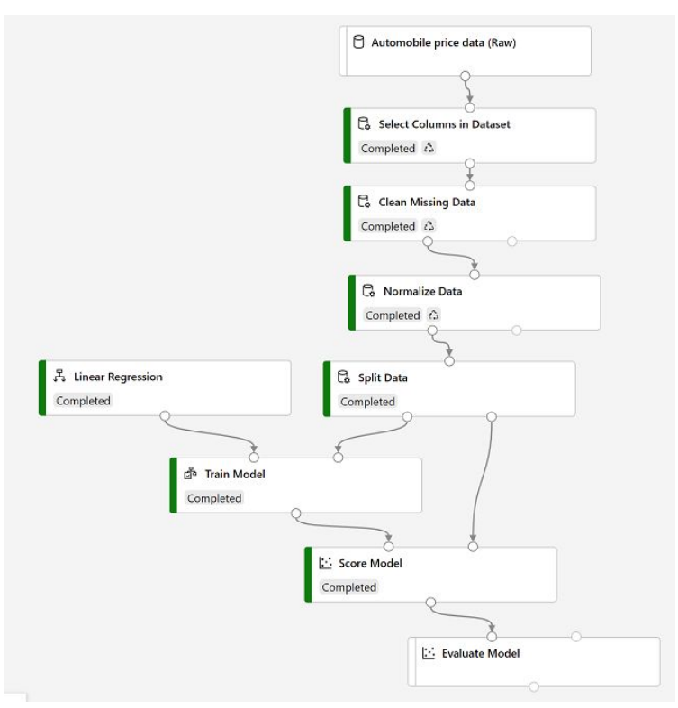

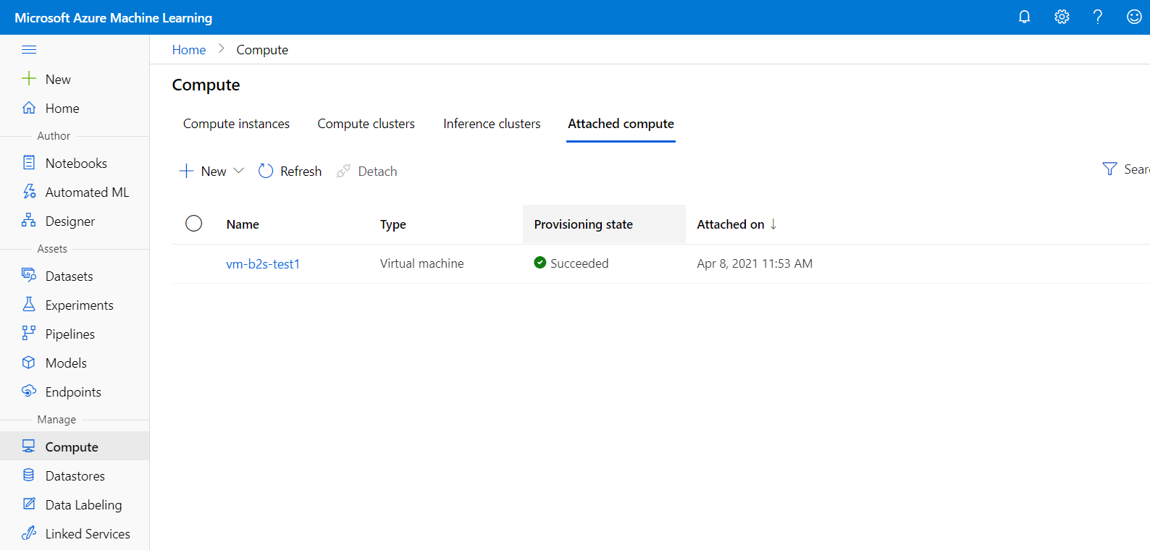

Compute clusters -Training the model.

Inference clusters- deploying the model.

**Data metric visualization**: analyze and optimize your experiments with visualization.

**Notebooks**: write and run your own code in managed Jupyter Notebook servers that are directly integrated in the studio.

**Computer Vision:** **Azure AI Vision**

Separate endpoint for every service

It focuses on single service that is dealing with images and videos.

**Cognitive services:** **Azure AI services**:

Single end point with multiple service

All azure APIs will be under this one, including computer vision.

**Custom Vision:** Building own object detection models with own images.

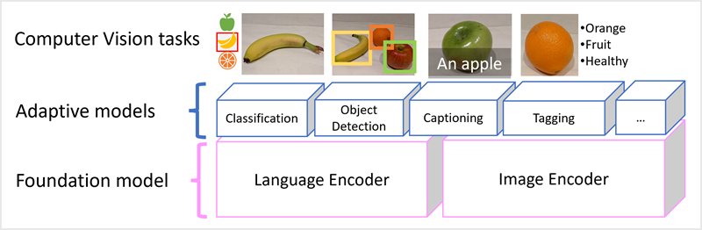

**Image classification:** Classifying whether image is dog or cat

**Object detection:** Detecting objects(car,bus etc) on images with bounding boxes and confidence score.

**Optical character recognition:** extracting text from images.

**Facial detection and facial analysis:**

1. **Group:** It will divide a candidate faces(3-1000) into group based on similarity.
2. **Identify:** 1 to many identification
   1. **Input1: required image**
   2. **Input2: Group of images**
   3. **Output**: it will display all similar images with input1.
3. **Verify:** Two persons same or not

**Image analysis:** creates captions to images

NLP- Understands written and spoken language

**key phrase extraction:** extract important words

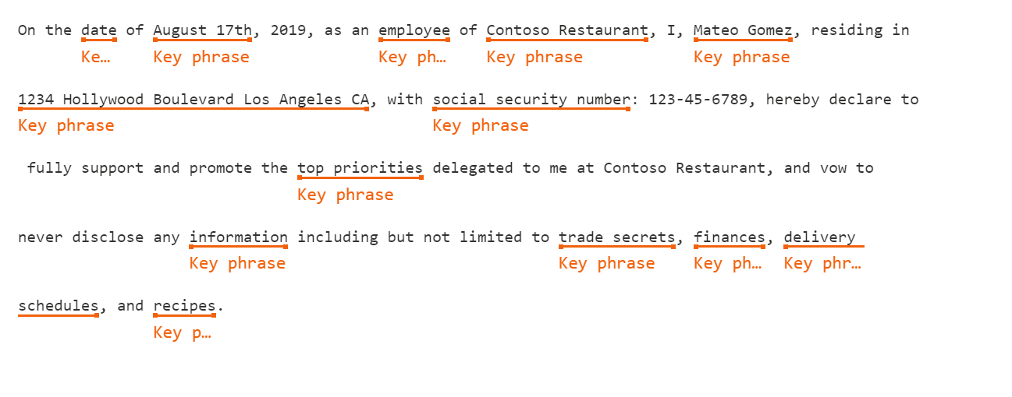

**entity recognition:** It will segregate type and subtype

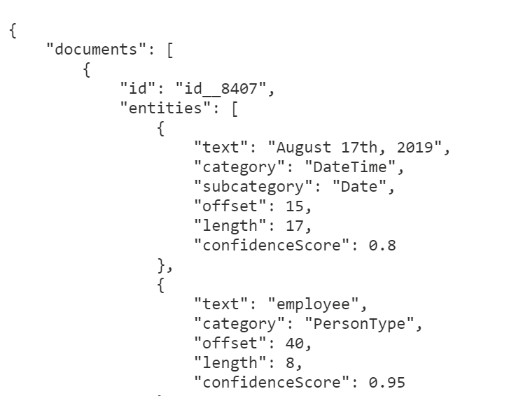

**sentiment analysis:** it has three values positive, neutral and negative.

**language modelling:** Build your own dictionary of the terms in your industry and train language understanding engine for your own use.

**Translation:** Audio (Speech to text and text to speech)

**Translator:** Text (Text to text)

**Speech Recognition:** Speech to text

**Speech synthesis:** Text to speech

**Detect Language:** Output have name, iso6391 and confidence score

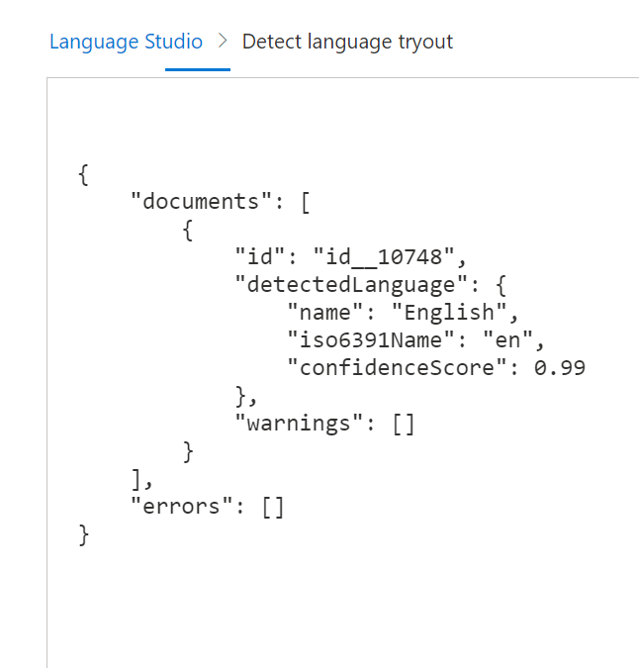

# **Azure AI Document Intelligence** supports features that can analyze documents and forms with prebuilt and custom models.

For example, consider the prebuilt receipt model. It processes receipts by:

* Matching field names to values
* Identifying tables of data
* Identifying specific fields, such as dates, telephone numbers, addresses, totals, and others

Azure AI Search provides the infrastructure and tools to create search solutions that extract data from various structured, semi-structured, and non-structured documents.

# **Generative AI:** Azure OpenAI Service

## Image generation: **DALL-E models**

It can edit the image also

## Code generation: **GPT 3.5 models**

 large language models (LLMs)

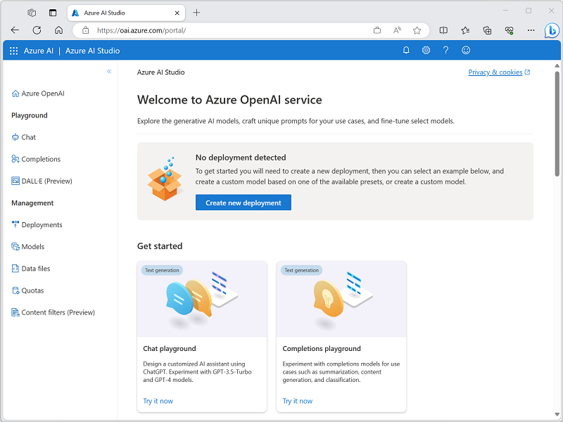

## Copilot: chatbot, pdf summarizer

# Plan a responsible generative AI solution:

To Decrease the risk of potential harm test the developed model before deploying

Identify 🡪Mesure🡪Mitigate🡪Operate

 phased delivery plan that enables you to release the solution initially to restricted group of users.

Content filters:

user prompt is verified with filters (hate,sexual,violence,selfharm)

with different levels **safe**, **low**, **medium**, and **high** before producing the output.

It will produce the output only when all filters is safe and sometimes low