TUNING IN TO KIDS
EMOTIONALLY INTELLIGENT PARENTING

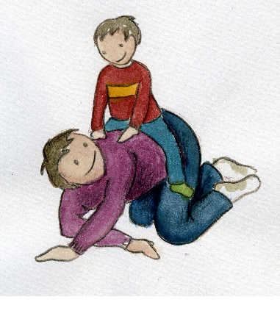
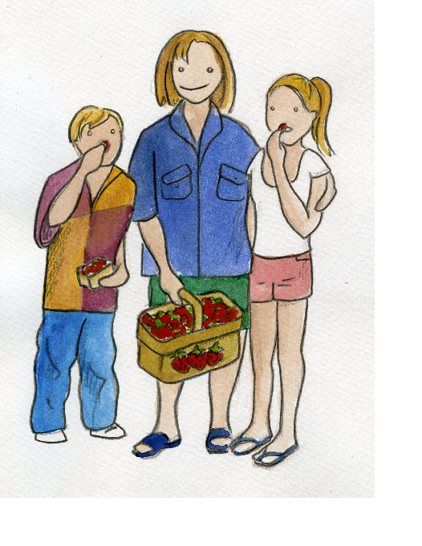

A FIVE session parenting program for
parents of PRE-SCHOOL – PRIMARY-SCHOOL AGED children

Would you like to learn how to:
- be better at talking with your child?
- be better at understanding your child?
- help your child learn to manage their emotions?
- help to prevent behaviour problems in your child?
- teach your child to deal with conflict?

Tuning in to Kids shows you how to help your child develop emotional intelligence.
VENUE: Chatswood Community Health Centre
57 Hercules St, Chatswood
DATES: Thursday 22nd May – Thursday 19th June (5 weeks)
TIME: 7.00pm – 9.30pm
COST: $165pp ($140 concession)

PLEASE PHONE 9887 5830 TO BOOK YOUR PLACE IN THIS COURSE

The 5 session course will be facilitated by a qualified Parent Educator from
Child and Adolescent Parenting, Northern Sydney Local Health District.

www.nslhd.health.nsw.gov.au/Services/CAP

