AGENT EDGE
Multi-Site Edge Intelligence System

Technical Documentation for AI Futures Lab

Pedro Falcao Costa
February 2026
Pure Edge | No Cloud | A2A + MCP Protocols | LFM 2.5 Reasoning

Table of Contents
1. The Vision: Edge Agentic AI
1.1 Agents Are the New APIs
1.2 The A2A Protocol: Interoperability at Scale
1.3 AI at the Edge: Beyond the Cloud
2. System Architecture
2.1 Architecture Overview
2.2 Data Flow
2.3 Anomaly Detection Sequence
3. Hardware & Sensor Module
3.1 ENS160+AHT21 Sensor Module
3.2 Arduino Integration
4. Protocol Stack
4.1 MCP: Agent-to-System Integration
4.2 A2A: Agent-to-Agent Collaboration
4.3 Message Types & Schemas
5. Agent Design
5.1 Jetson Agent (Site A)
5.2 Mac Mini Agent (Control Center)
5.3 LFM 2.5 Integration
6. Small Language Models & On-Device Intelligence
6.1 The Case for Edge Intelligence
6.2 Liquid AI: Leading the SLM Revolution
6.3 Liquid Foundation Models (LFM)
6.4 Capgemini and Liquid AI Partnership
6.5 Why LFM for Agent Edge
7. Dashboard
8. Anomaly Detection & Thresholds
9. Deployment
10. Demo Scenario
11. References & Further Reading

1. The Vision: Edge Agentic AI
We are witnessing a fundamental shift in how distributed systems are designed and operated. The era of passive microservices responding to predetermined API calls is giving way to a new paradigm: autonomous, intelligent agents that perceive their environment, reason about it, and collaborate with peers to make decisions—all without cloud dependency.
Agent Edge is a demonstration of this vision. It brings together three converging trends that are reshaping enterprise and industrial AI:
- Agents as the new APIs: Agent-Oriented Architectures replacing traditional SOA and microservices
- Interoperability protocols: Google’s A2A protocol enabling cross-vendor, cross-device agent collaboration
- Edge-native intelligence: Small, powerful language models (LFM2.5-1.2B-Thinking) running inference locally on edge hardware
This system is not a prototype of the future. It is a working demonstration of what is possible today, using off-the-shelf hardware and open protocols.

1.1 Agents Are the New APIs
Traditional Service-Oriented Architectures defined rigid contracts between services: fixed endpoints, predetermined request/response schemas, brittle integrations that break when any component changes. Agent-Oriented Architectures introduce intelligent, autonomous agents capable of proactively perceiving, adapting, and dynamically interacting with their environment.
In this new paradigm, agents serve as intelligent intermediaries that:
- Act as secure gatekeepers between disparate systems
- Breathe new life into legacy infrastructure without costly replacements
- Enable seamless communication between diverse components through natural language and structured protocols
- Maintain system integrity while fostering innovation
The implications for IoT and Industry 4.0 are profound. We are moving from the Internet of Things—passive sensor networks that merely transmit data—to the Internet of Agents: dynamic systems where entities actively communicate, negotiate, and coordinate. Industrial devices adapt autonomously to operational conditions. Autonomous vehicle fleets negotiate routes in real time. Power grids self-balance supply and demand. Smart cities become truly intelligent.
Agent Edge demonstrates this concretely: an environmental sensor does not just report numbers. An agent reasons about those numbers, detects anomalies, and collaborates with a peer agent to reach a decision—all at the edge, in real time.
Full article: https://www.linkedin.com/pulse/agents-new-apis-pedro-falc%C3%A3o-costa-1ydpf/

1.2 The A2A Protocol: Interoperability at Scale
Google’s Agent-to-Agent (A2A) protocol is a major step toward the distributed, modular, and collaborative AI architectures that the industry needs. For the first time, AI agents from different vendors, clouds, and devices can communicate using a shared language.
A2A solves the fundamental isolation problem: agents trapped in proprietary runtimes can finally work together across organizational boundaries. The protocol provides:
- Standardized message types for discovery, observation, analysis, and decision-making
- Built-in security safeguards for collaborative agent networks
- Scalability from single-agent to multi-agent ecosystems
- Edge AI integration for IoT devices and isolated systems
Consider the practical implications: an AI-enabled coffee machine detects performance issues and autonomously contacts maintenance agents, triggering scheduling and parts ordering without human intervention. Solar farm agents monitoring panel output, battery storage, and weather forecasting collaborate in real time to optimize energy management.
Agent Edge implements A2A as its core inter-agent communication layer, demonstrating that this protocol works today on real hardware at the edge.
Full article: https://www.linkedin.com/pulse/a2a-protocol-google-here-changes-everything-pedro-falc%C3%A3o-costa-fggff/

1.3 AI at the Edge: Beyond the Cloud
The release of compact, high-quality language models has fundamentally changed what is possible at the edge. Models like LFM2.5-1.2B-Thinking can run entirely on local hardware—a Jetson Orin Nano, a Mac Mini—with no cloud dependency, no data leaving the premises, and no per-token API costs.
This opens transformative possibilities:
- Extreme environments: How can AI function in minimal-infrastructure environments?
- Privacy and security: Models operating entirely offline with no cloud data transmission
- Cost reduction: Eliminating per-query cloud costs for continuous monitoring
- Latency elimination: AI reasoning at the point of data generation, not in a distant data center
Innovation isn’t just about technology. It’s about reimagining what’s possible. Agent Edge extends AI capability to scenarios where traditional cloud infrastructure is impractical: factory floors, remote facilities, mobile platforms, and anywhere that demands real-time local intelligence.
Original post: https://www.linkedin.com/posts/pedrofalcaocosta_ai-innovation-edgecomputing-activity-7250913453186441216-vAiO

2. System Architecture
Agent Edge is a distributed system with two autonomous agents coordinating via A2A protocol. The Jetson Orin Nano (Site A) reads environmental sensors through an Arduino via MCP protocol and performs anomaly detection. The Mac Mini M2 (Control Center) provides historical analysis and hosts the real-time dashboard. Both agents run LFM2.5-1.2B-Thinking locally for reasoning.

2.1 Architecture Overview
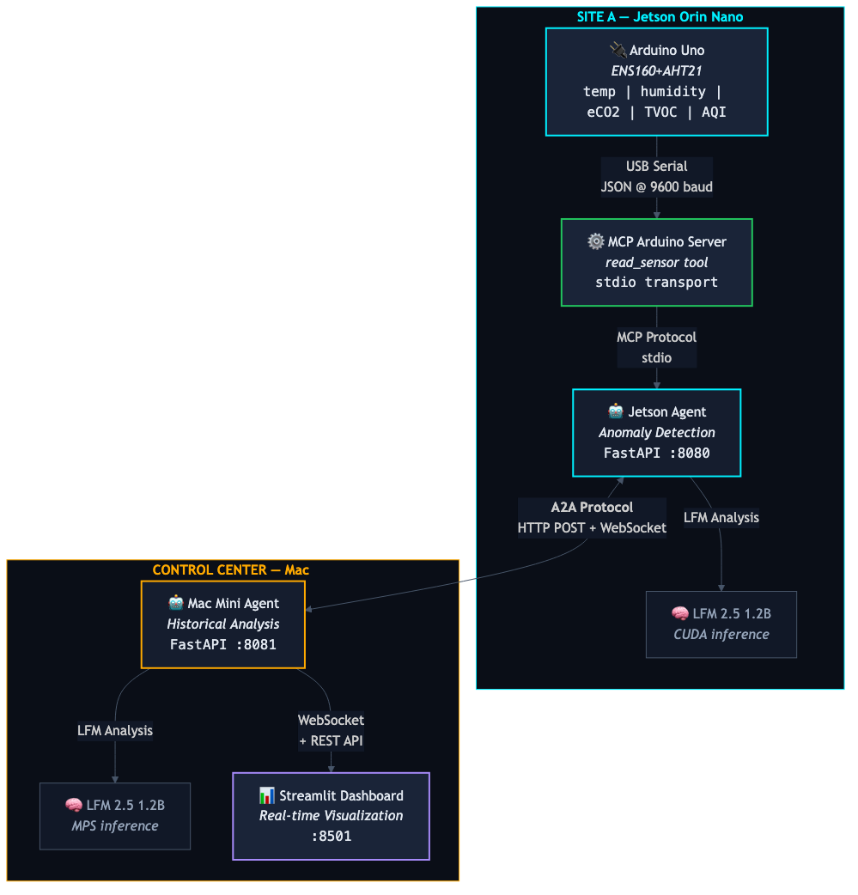
Figure 1: Agent Edge System Architecture
The system uses two complementary protocols:
- MCP (Model Context Protocol): Agent-to-System integration. The Jetson agent communicates with the Arduino sensor hardware through an MCP server that exposes a read_sensor tool via stdio transport.
- A2A (Agent-to-Agent): Agent-to-Agent collaboration. The Jetson and Mac Mini agents exchange structured messages over HTTP POST endpoints, with real-time streaming via WebSocket.

2.2 Data Flow
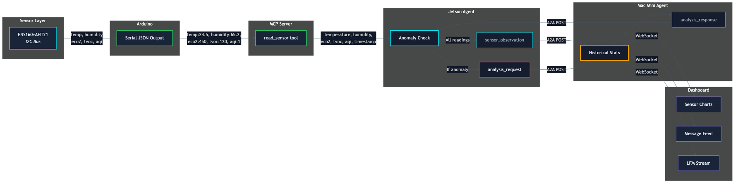
Figure 2: Sensor Data Flow Through All Layers
Sensor data flows as a consistent JSON schema through every layer of the system. The ENS160+AHT21 module produces five fields—temperature, humidity, eCO2, TVOC, and AQI—which are preserved from the Arduino serial output through the MCP server, A2A messages, and into the dashboard visualization.

2.3 Anomaly Detection Sequence
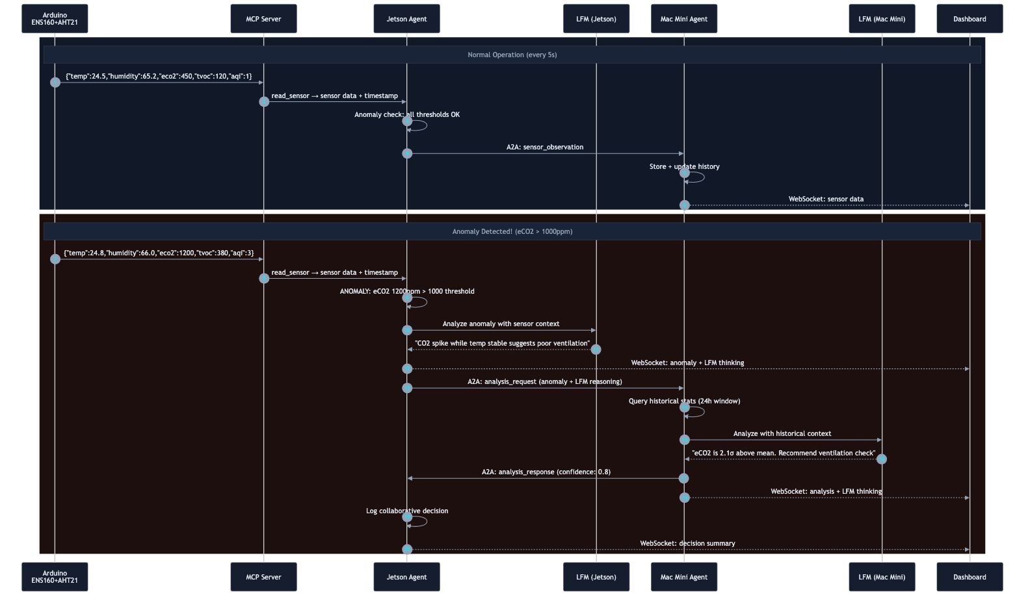
Figure 3: Anomaly Detection and Collaborative Analysis Sequence
The sequence diagram above illustrates both normal operation (top) and the full anomaly collaboration flow (bottom). When an anomaly is detected—such as eCO2 exceeding 1000ppm—the Jetson agent runs local LFM analysis, then requests historical context from the Mac Mini agent. Both agents’ LFM reasoning is streamed to the dashboard in real time.

3. Hardware & Sensor Module

3.1 ENS160+AHT21 Sensor Module
The system uses an ENS160+AHT21 combo module connected to an Arduino via I2C (SDA/SCL). This module provides five environmental parameters:
Parameter | Sensor | Unit | Range
Temperature | AHT21 | °C | -40 to +85
Humidity | AHT21 | % RH | 0 to 100
eCO2 | ENS160 | ppm | 400 to 65000
TVOC | ENS160 | ppb | 0 to 65000
AQI | ENS160 | 1–5 scale | 1 (Good) to 5 (Unhealthy)

The ENS160 requires approximately 1 minute of warm-up time after power-on, and approximately 1 hour for full calibration. During warm-up, readings may be unreliable.

3.2 Arduino Integration
The Arduino reads both sensors via I2C and outputs JSON over serial at 9600 baud every 2 seconds:
{"temp":24.5,"humidity":65.2,"eco2":450,"tvoc":120,"aqi":1}
Required Arduino libraries:
- ScioSense_ENS160 — eCO2, TVOC, AQI readings via I2C
- Adafruit_AHTX0 — Temperature and humidity readings via I2C
- Wire.h — I2C communication
The AHT21 temperature and humidity readings are fed to the ENS160 for environmental compensation, improving the accuracy of the air quality measurements.

4. Protocol Stack

4.1 MCP: Agent-to-System Integration
The Model Context Protocol (MCP) provides a standardized way for AI agents to interact with external tools and data sources. In Agent Edge, the MCP Arduino Server exposes the sensor hardware as a tool that the Jetson agent can invoke.
- MCP Tool: read_sensor — returns current sensor readings with timestamp
- Transport: stdio (subprocess communication)
- Return format: JSON with schema: temperature, humidity, eco2, tvoc, aqi, timestamp

4.2 A2A: Agent-to-Agent Collaboration
The A2A protocol enables peer-to-peer agent communication. Each agent exposes:
- /a2a/message — HTTP POST endpoint for receiving structured messages
- /stream — WebSocket endpoint for real-time event streaming
- /health — Agent Card and status endpoint

4.3 Message Types & Schemas
Message Type | Direction | Purpose
agent_card | Broadcast | Agent discovery and capability advertisement
sensor_observation | Jetson → Mac Mini | Sensor reading with all 5 fields + location
analysis_request | Jetson → Mac Mini | Anomaly detected, requesting historical analysis
analysis_response | Mac Mini → Jetson | Historical context and LFM reasoning
decision | Both agents | Collaborative decision logged by both
heartbeat | Bidirectional | Periodic health check (every 10s)

Sensor observation payload schema:
{
"type": "sensor_observation",
"from": "jetson-site-a",
"to": "macmini-control",
"message_id": "uuid",
"timestamp": "ISO8601",
"payload": {
"sensor": "ENS160+AHT21",
"temperature": 24.5,
"humidity": 65.2,
"eco2": 450, // ppm
"tvoc": 120, // ppb
"aqi": 1, // 1-5 scale
"location": "Site A - Server Room"
}
}

5. Agent Design

5.1 Jetson Agent (Site A)
The Jetson Orin Nano runs the Site A monitoring agent. It is responsible for sensor reading, anomaly detection, and initiating collaborative analysis.
Responsibilities:
- Startup: Initialize MCP client to Arduino sensor server
- Sensor loop: Read sensor every 5 seconds via MCP, send observations to Mac Mini
- Anomaly detection: Check 4 thresholds on every reading; trigger LFM analysis if any exceeded
- A2A handling: Process analysis responses, log collaborative decisions
Configuration:
AGENT_ID = "jetson-site-a"
AGENT_PORT = 8080
SENSOR_POLL_INTERVAL = 5 # seconds
TEMP_DELTA_THRESHOLD = 5.0 # degrees C
ECO2_THRESHOLD = 1000 # ppm
TVOC_THRESHOLD = 500 # ppb
AQI_THRESHOLD = 4 # 1-5 scale

5.2 Mac Mini Agent (Control Center)
The Mac Mini M2 runs the Control Center agent. It maintains historical sensor data, performs statistical analysis, and provides context for anomaly evaluation.
Responsibilities:
- Maintain rolling window of sensor readings (all 5 fields, last 24 hours)
- Calculate per-field statistics: mean, standard deviation, min, max
- Provide multi-parameter context (e.g., “CO2 spiking while temperature stable”)
- Run LFM analysis with historical context when analysis requests arrive
- Host dashboard data APIs and WebSocket streams

5.3 LFM 2.5 Integration
Both agents run Liquid AI’s LFM2.5-1.2B-Thinking model locally. The Jetson uses CUDA acceleration; the Mac Mini uses Apple’s MPS (Metal Performance Shaders). The LFM client supports:
- Token-by-token streaming for real-time dashboard visualization
- Structured prompts for anomaly detection, historical analysis, and collaborative reasoning
- GPU-accelerated inference with automatic device detection (CUDA/MPS/CPU)

6. Small Language Models & On-Device Intelligence
The AI industry has spent the last several years in a relentless pursuit of scale: larger models, bigger clusters, more parameters. But a parallel revolution has been quietly gaining momentum—one that may ultimately prove more consequential for how AI is actually deployed in the real world. Small Language Models (SLMs) are redefining what is possible at the edge, on device, and in environments where cloud connectivity is a luxury, not a given.
Agent Edge is built on a fundamental conviction: the future of AI is not exclusively in the cloud. It is at the edge. It is on the device. It is wherever decisions need to be made—fast, private, and without dependency on a data center thousands of kilometers away.

6.1 The Case for Edge Intelligence
Cloud-based AI has an undeniable role, but it comes with constraints that are unacceptable in many real-world scenarios:
- Latency: Every API call is a round trip. For real-time monitoring, autonomous vehicles, and industrial control, even 100ms of latency is too much.
- Privacy: Sensitive sensor data, patient records, factory telemetry—organizations increasingly cannot or will not send this data to external servers.
- Connectivity: Factory floors, offshore platforms, remote facilities, vehicles in tunnels—many critical environments have intermittent or no connectivity.
- Cost: Continuous inference through cloud APIs creates compounding costs that make always-on monitoring economically impractical.
- Sustainability: The energy footprint of routing billions of inference requests through hyperscale data centers is unsustainable at global scale.
On-device intelligence eliminates these constraints entirely. When a 1.2B parameter model runs locally on a Jetson Orin Nano or a Mac Mini, inference is instantaneous, data never leaves the premises, and the system operates independently of network conditions. This is not a compromise—for edge use cases, it is superior architecture.

6.2 Liquid AI: Leading the SLM Revolution
Liquid AI, a spin-off from MIT’s Computer Science and Artificial Intelligence Laboratory (CSAIL), has taken a fundamentally different approach to foundation models. Rather than competing in the parameter arms race, Liquid AI has focused on building the most efficient models at every scale—models that are designed from the ground up for on-device deployment.
The core innovation is Liquid Neural Networks (LNNs): a new class of neural architecture that is more robust, computationally smaller, and less memory-intensive than traditional transformer models. Where conventional LLMs require massive GPU clusters, Liquid’s models achieve competitive quality while running on CPUs, NPUs, and embedded processors with minimal memory footprint.
Liquid AI’s decision to release open-weight models was a pivotal strategic move. By making LFM weights available on Hugging Face, they have enabled an entire ecosystem of developers, researchers, and enterprises to build on their technology. This openness, combined with native support for llama.cpp, MLX, vLLM, and ONNX across Apple, AMD, Qualcomm, and NVIDIA hardware, positions Liquid AI to lead the SLM space in a way that closed-model providers cannot.
I firmly believe that Liquid AI will be a defining force in the Small Language Model space. Their combination of MIT-grade research, open weights, hardware-optimized architectures, and a clear focus on the edge makes them uniquely positioned to enable the next generation of on-device intelligence—from wearables and mobile phones to autonomous vehicles and industrial IoT.

6.3 Liquid Foundation Models (LFM)
The LFM2.5 family represents the latest generation of Liquid Foundation Models, with extended pretraining from 10 trillion to 28 trillion tokens and significantly scaled post-training via reinforcement learning.
The LFM2.5 model family includes:
Model | Parameters | Capability
LFM2.5-1.2B-Base | 1.17B | Pretrained checkpoint for fine-tuning
LFM2.5-1.2B-Instruct | 1.17B | General-purpose instruction following
LFM2.5-1.2B-Thinking | 1.17B | On-device reasoning under 1GB
LFM2.5-1.2B-JP | 1.17B | Japanese language optimization
LFM2.5-VL-1.6B | 1.6B | Vision-language understanding
LFM2.5-Audio-1.5B | 1.5B | End-to-end audio and text generation
LFM2-8B-A1B | 8B (1B active) | Mixture-of-experts efficiency

Key technical characteristics:
- Architecture: 16-layer hybrid architecture: 10 double-gated LIV convolution blocks + 6 GQA attention blocks
- Context length: 32,768 tokens, enabling complex RAG tasks and long-form data extraction
- Inference speed: 2,975 tok/s prefill, 116 tok/s decode on AMD Ryzen AI 9; 335 tok/s prefill on Snapdragon Gen4 mobile CPU
- Languages: English, Arabic, Chinese, French, German, Japanese, Korean, Spanish
- Deployment targets: Vehicles, mobile devices, laptops, IoT devices, embedded systems, edge servers
The LFM2.5-1.2B-Thinking variant is particularly relevant for Agent Edge: it enables on-device reasoning in under 1GB of memory, making it feasible to run chain-of-thought analysis on edge hardware for anomaly detection and collaborative decision-making.

6.4 Capgemini and Liquid AI Partnership
Capgemini and Liquid AI have established a strategic collaboration to build next-generation AI solutions for enterprises. Capgemini’s Corporate VC fund (ISAI Cap Venture) participated in Liquid AI’s $37.6 million seed round in 2023, and the partnership has since deepened into a joint effort to bring on-device AI to production at enterprise scale.
The collaboration focuses on deploying smaller, more sustainable generative AI models compatible with offline and edge devices, with applications spanning manufacturing, healthcare, finance, and industrial IoT. As Andrew Vickers, CTO Generative AI at Capgemini Engineering, stated:
“We’re thrilled to be continuing our relationship with Liquid AI, a relationship born from our Strategic University Research Partnership Program with MIT. Liquid AI brings amazing technology to the market, in tune with the needed trends of simplicity, efficiency and sustainability.”
Ramin Hasani, Co-Founder and CEO of Liquid AI, added:
“Our cooperation with Capgemini allows us to combine our cutting-edge AI technology with Capgemini’s global reach and expertise, ultimately benefiting organizations across various industries to develop and deploy private, reliable and best-in-class domain-specific and generalist AI systems.”
Agent Edge is a direct expression of this partnership’s vision: Liquid AI’s models running on edge hardware, orchestrated by Capgemini’s expertise in distributed systems and agent architectures, demonstrated through Capgemini’s AI Futures Lab (Generative AI Lab).
Capgemini AI Futures (Generative AI Lab): https://www.capgemini.com/about-us/who-we-are/innovation-ecosystem/aifutures/
Capgemini and Liquid AI Partnership: https://www.capgemini.com/capgemini-and-liquid-ai/
Liquid AI Collaboration Announcement: https://www.liquid.ai/blog/liquid-ai-announces-collaboration-with-capgemini-to-build-next-generation-ai-solutions-for-enterprises

6.5 Why LFM for Agent Edge
Agent Edge uses the LFM2.5-1.2B model on both agents for a set of deliberate reasons:
- Right-sized for edge hardware: At 1.17B parameters, the model fits comfortably on the Jetson Orin Nano (CUDA) and Mac Mini M2 (MPS) with memory to spare for the agent runtime.
- Streaming inference: Token-by-token streaming enables the dashboard to show AI reasoning in real time—the key differentiator for the demo.
- Quality at scale: The model handles anomaly detection prompts, historical analysis, and collaborative reasoning with sufficient quality for the monitoring use case.
- True edge deployment: No cloud dependency means the demo works anywhere—conference halls, factory floors, air-gapped environments.
- Open and reproducible: Open weights on Hugging Face mean the audience can reproduce and extend the demo with their own hardware.
This is the promise of on-device intelligence made tangible: two agents, on two different hardware platforms, running local language models, collaborating through open protocols, reasoning about real sensor data—all without a single byte leaving the room.

7. Dashboard
The Streamlit dashboard provides a real-time “Edge Operations Center” view of the entire system. It connects to both agents via HTTP and WebSocket, displaying sensor data, agent status, A2A message flow, and LFM reasoning streams.
Dashboard components:
- Agent Status: Live connection indicators with Agent Card details for both agents
- Sensor Visualization: Real-time Plotly charts for Temperature+Humidity and eCO2+TVOC, plus an AQI gauge indicator (1–5 scale) with anomaly markers
- A2A Message Flow: Scrolling, color-coded message feed showing all inter-agent communication
- LFM Reasoning Stream: Token-by-token display of LFM analysis with anomaly trigger context and cross-parameter reasoning
The dashboard aesthetic is “industrial precision meets data-viz clarity”—a dark theme with electric cyan for live data, amber for warnings, and crimson for alerts. Typography uses JetBrains Mono for data and Outfit for headers.

8. Anomaly Detection & Thresholds
The Jetson agent evaluates every sensor reading against four independent thresholds. If any single threshold is exceeded, the full anomaly analysis pipeline is triggered.
Parameter | Threshold | Condition | Meaning
Temperature | > 5°C delta | vs. previous reading | Rapid temperature change
eCO2 | > 1000 ppm | absolute value | Poor indoor air quality
TVOC | > 500 ppb | absolute value | Elevated volatile organic compounds
AQI | ≥ 4 | absolute value | Unhealthy air quality (ENS160 scale)

When triggered, the anomaly pipeline:
- Jetson runs local LFM analysis with current + previous sensor readings
- Jetson sends analysis_request to Mac Mini with anomaly context and LFM reasoning
- Mac Mini queries 24-hour historical statistics for all sensor fields
- Mac Mini runs LFM analysis with historical context
- Mac Mini returns analysis_response with confidence score
- Both agents log the collaborative decision
- All reasoning is streamed to the dashboard in real time

9. Deployment

Project Structure
agent-edge/
├── arduino/sensor_reader/sensor_reader.ino
├── mcp_servers/arduino/server.py
├── shared/
│ ├── a2a_protocol.py
│ ├── agent_card.py
│ ├── lfm_client.py
│ └── storage.py
├── agents/
│ ├── jetson/ (agent.py, config.py, mcp_client.py)
│ └── macmini/ (agent.py, config.py)
├── dashboard/
│ ├── app.py
│ └── components/ (sensor_viz, a2a_conversation, lfm_reasoning, agent_status)
├── scripts/ (setup_jetson.sh, setup_macmini.sh, run_demo.sh)
└── tests/

Quick Start
Jetson Orin Nano (Site A):
bash scripts/setup_jetson.sh
export MACMINI_AGENT_URL=http://<macmini-ip>:8081
export SERIAL_PORT=/dev/ttyACM0
python -m agents.jetson.agent
Mac Mini M2 (Control Center):
bash scripts/setup_macmini.sh
export JETSON_AGENT_URL=http://<jetson-ip>:8080
python -m agents.macmini.agent
streamlit run dashboard/app.py

Technology Stack
Component | Technology
Language | Python 3.10+
Web Framework | FastAPI + Uvicorn
Agent Communication | A2A Protocol (HTTP POST + WebSocket)
Tool Integration | MCP (Model Context Protocol)
LLM | Liquid AI LFM2.5-1.2B-Thinking (HuggingFace Transformers)
Dashboard | Streamlit + Plotly
Storage | JSON Lines (append-only, no database)

10. Demo Scenario
The following scenario demonstrates the full Agent Edge system in action:

Act 1: System Online
Both agents start and discover each other. The dashboard shows green status indicators. Sensor data begins flowing: temperature around 24°C, humidity 65%, eCO2 around 450ppm, AQI 1 (Good). The audience sees real data on real hardware.

Act 2: Normal Monitoring
Every 5 seconds, the Jetson reads the sensor via MCP and sends an A2A observation to the Mac Mini. The dashboard charts fill with data. The A2A message feed scrolls. Everything is within normal thresholds.

Act 3: Anomaly Triggers
CO2 levels begin rising (simulated by breathing near the sensor or using a CO2 source). When eCO2 crosses 1000ppm, the Jetson’s anomaly detector fires. The dashboard turns amber.

Act 4: Collaborative Intelligence
The Jetson runs LFM analysis locally: “CO2 spike while temperature is stable suggests poor ventilation rather than a heat source.” It sends an analysis request to the Mac Mini. The Mac Mini queries its 24-hour history, computes statistics, and runs its own LFM analysis: “eCO2 is 2.1 standard deviations above the historical mean. Recommend checking ventilation.”
The audience watches both LFM reasoning streams appear token-by-token on the dashboard. Two agents, on two different hardware platforms, collaborating to reach a decision—all at the edge, no cloud involved.

Act 5: Resolution
The collaborative decision is logged by both agents. The dashboard shows the decision history. As CO2 levels return to normal, the system resumes routine monitoring.

Key talking points for the audience:
- Pure edge: zero cloud dependency, zero data leaving the room
- Open protocols: A2A and MCP are interoperability standards, not proprietary
- Visible reasoning: the audience can watch AI think, not just see outputs
- Real hardware: Jetson + Arduino + real sensors, not a simulation
- Practical: same architecture scales to industrial monitoring, smart buildings, fleet management

11. References & Further Reading

Articles by Pedro Falcao Costa
Agents Are the New APIs: https://www.linkedin.com/pulse/agents-new-apis-pedro-falc%C3%A3o-costa-1ydpf/
The A2A Protocol: Google Is Here and Changes Everything: https://www.linkedin.com/pulse/a2a-protocol-google-here-changes-everything-pedro-falc%C3%A3o-costa-fggff/
AI, Innovation & Edge Computing: https://www.linkedin.com/posts/pedrofalcaocosta_ai-innovation-edgecomputing-activity-7250913453186441216-vAiO

Protocols & Standards
- Model Context Protocol (MCP) — Anthropic, https://modelcontextprotocol.io
- Agent-to-Agent Protocol (A2A) — Google, https://google.github.io/A2A/

Liquid AI & Capgemini
Liquid AI: https://www.liquid.ai/
Liquid Foundation Models: https://www.liquid.ai/models
LFM2.5 Announcement: https://www.liquid.ai/blog/introducing-lfm2-5-the-next-generation-of-on-device-ai
Capgemini and Liquid AI Partnership: https://www.capgemini.com/capgemini-and-liquid-ai/
Capgemini AI Futures (Generative AI Lab): https://www.capgemini.com/about-us/who-we-are/innovation-ecosystem/aifutures/
What Are Liquid Neural Networks? (Capgemini): https://www.capgemini.com/insights/expert-perspectives/what-are-liquid-neural-networks-and-why-should-you-care/
LFM2.5-1.2B-Instruct on Hugging Face: https://huggingface.co/LiquidAI/LFM2.5-1.2B-Instruct

Hardware & Sensors
- ENS160 Digital Multi-Gas Sensor — ScioSense
- AHT21 Temperature & Humidity Sensor — Aosong
- NVIDIA Jetson Orin Nano — NVIDIA

