URLS :-
What are microservices?
In order to understand microservices, we need to understand what are monolithic applications and what led us to move from monolithic applications to microservices in recent times.
Monolithic applications
If all the functionalities of a project exists in a single codebase, then that application is known as monolithic application. We all must have designed a monolithic application in our lives in which we were given a problem statement and were asked to design a system with various functionalities. We design our application in various layers like presentation, service and persistence and then deploy that codebase as single jar/war file. This is nothing but a monolithic application where “mono” represents the single codebase containing all the required functionalities.
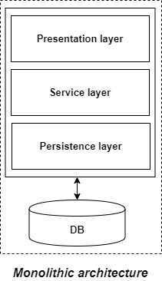
But if we were using monolithic applications already then what led us to microservices?
Disadvantages of Monolithic applications:
It becomes too large in size with time and hence, difficult to manage.
We need to redeploy the whole application even for a small change.
As the size of the application increases, its start-up and deployment time also increases.
For any new developer joining the project, it is very difficult to understand the logic of large Monolithic application even if his responsibility is related to a single functionality.
Even if a single part of the application is facing a large load/traffic, we need to deploy the instances of the whole application in multiple servers. It is very inefficient and takes up more resources unnecessarily. Hence, horizontal scaling is not feasible in monolithic applications.
It is very difficult to adopt any new technology which is well suited for a particular functionality as it affects the whole application, both in terms of time and cost.
It is not very reliable as a single bug in any module can bring down the whole monolithic application.
Advantages of monolithic applications:
Simple to develop relative to microservices where skilled developers are required in order to identify and develop the services.
Easier to deploy as only a single jar/war file is deployed.
Relatively easier and simple to develop in comparison to microservices architecture.
The problems of network latency and security are relatively less in comparison to microservices architecture.
Microservices -
It is an architectural development style in which the application is made up of smaller services communicating with each other directly using light weight protocols like HTTP “Microservices are the small services that work together.”
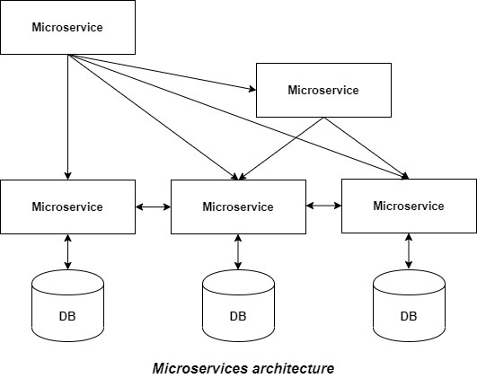
The Microservice architecture has a significant impact on the relationship between the application and the database. Instead of sharing a single database with other microservices, each microservice has its own database. It often results in duplication of some data but having a database per microservice is essential if you want to benefit from this architecture as it ensures loose coupling. Another advantage of having separate database per microservice is that each microservice can use the type of database best suited for its needs.
Advantages of microservices:
It is easy to manage as it is relatively smaller in size.
If there’s any update in one of the microservices, then we need to redeploy only that microservice.
Microservices are self-contained and hence, deployed independently. Their start-up and deployment time are relatively less.
It is very easy for a new developer to on-board the project as he needs to understand only a particular microservice providing the functionality he will be working on and not the whole system.
If a particular microservice is facing a large load because of the users using that functionality in excess then we need to scale out that microservice only. Hence, microservices architecture supports horizontal scaling.
Each microservice can use different technology based on the business requirements.
If a particular microservice goes down due to some bug, then it doesn’t affect other microservices and the whole system remains intact, continues providing other functionalities to the users.
Disadvantages of microservices:
Being a distributed system, it is much more complex than the monolothic applications. Its complexity increases with the increase in number of microservices.
Skilled developers are required to work with microservices architecture which can identify the microservices and manage their inter-communications.
Independent deployment of microservices is complicated.
Microservices are costly in terms of network usage as they need to interact with each other and all these remote calls results into network latency.
Microservices are less secure relative to monolithic applications due to the inter-services communication over the network.
Debugging is difficult as the control flows over many microservices and to point out why and where exactly the error occurred is a difficult task.

Principles of Microservices
Now let’s examine the “must-have” principles of a microservice.
Single responsibility principle
The single responsibility principle is one of the principles defined as part of the SOLID design pattern. It implies that a unit, either a class, a function, or a microservice, should have one and only one responsibility.
At no point in time, one microservice should have more than one responsibility.
Built around business capabilities
Microservices should focus on certain business functions and ensure that it helps in getting things done. A microservice shall never restrict itself from adopting appropriate technology stack or backend database storage which is most suitable for solving the business purpose.
This is often the constraint when we design monolithic applications where we try to solve multiple business solutions with some compromises in some areas. Microservices enable you to choose what’s best for the problem at hand.
You build it, you own it!
Another important aspect of such design is related to responsibilities pre-and-post development. In a large organization, usually one team develops the app location, and after some knowledge transfer sessions it hand over the project to the maintenance team. In microservices, the team which builds the service – owns it, and is responsible for maintaining it in the future.
This ownership brings developers into contact with the day-to-day operation of their software and they better understand how their built product is used by customers in the real world.
Infrastructure Automation:-
Preparing and building infrastructure for microservices is another very important need. A service shall be independently deployable and shall bundle all dependencies, including library dependencies, and even execution environments such as web servers and containers or virtual machines that abstract physical resources.
One of the major differences between microservices and SOA is in their level of autonomy. While most SOA implementations provide service-level abstraction, microservices go further and abstract the realization and execution environment.
In traditional application developments, we build a WAR or an EAR, then deploy it into a JEE application server, such as with JBoss, WebLogic, WebSphere, and so on. We may deploy multiple applications into the same JEE container. In an ideal scenario, in the microservices approach, each microservice will be built as a fat Jar, embedding all dependencies and run as a standalone Java process.

Design for Failure:-
A microservice shall be designed with failure cases in mind. What if the service fails, or go down for some time. These are very important questions and must be solved before actual coding starts – to clearly estimate how service failures will affect the user experience.
Fail fast is another concept used to build fault-tolerant, resilient systems. This philosophy advocates systems that expect failures versus building systems that never fail. Since services can fail at any time, it’s important to be able to detect the failures quickly and, if possible, automatically restore service.
Microservice applications put a lot of emphasis on real-time monitoring of the application, checking both architectural elements (how many requests per second is the database getting) and business relevant metrics (such as how many orders per minute are received). Semantic monitoring can provide an early warning system of something going wrong that triggers development teams to follow up and investigate.

Deploy independently
Microservices are platform agnostic. It means we can design and deploy them independently without affecting the other services

Design Patterns for Microservices
Microservice architecture has become the de facto choice for modern application development. Though it solves certain problems, it is not a silver bullet. It has several drawbacks and when using this architecture, there are numerous issues that must be addressed. This brings about the need to learn common patterns in these problems and solve them with reusable solutions. Thus, design patterns for microservices need to be discussed.
Adhering to the above principles brings several challenges and issues while bring your solution or system to live. Those problems are common for many solutions. Those can overcome with using correct and matching design patterns. There are design patterns for microservices and those can be divided into five Patterns. Each contains many patterns.

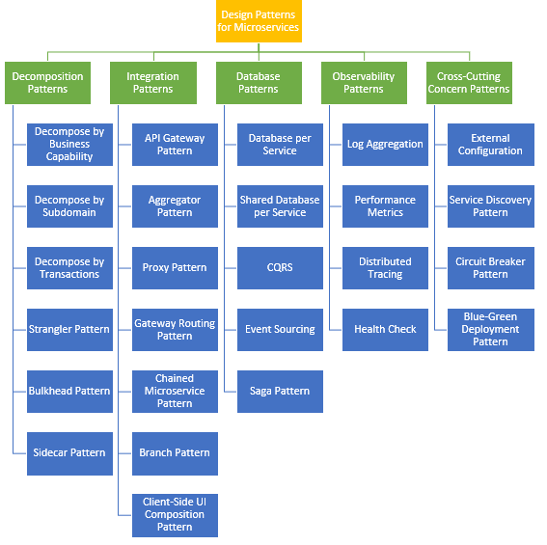
1.

- Decomposition Patterns
Decompose by Business Capability
Problem
Microservices is all about making services loosely coupled, applying the single responsibility principle. However, breaking an application into smaller pieces has to be done logically. How do we decompose an application into small services?
Solution
One strategy is to decompose by business capability. A business capability is something that a business does in order to generate value. The set of capabilities for a given business depend on the type of business. For example, the capabilities of an insurance company typically include sales, marketing, underwriting, claims processing, billing, compliance, etc. Each business capability can be thought of as a service, except it’s business-oriented rather than technical.
b. Decompose by Subdomain
Problem
Decomposing an application using business capabilities might be a good start, but you will come across so-called "God Classes" which will not be easy to decompose. These classes will be common among multiple services. For example, the Order class will be used in Order Management, Order Taking, Order Delivery, etc. How do we decompose them?
Solution
For the "God Classes" issue, DDD (Domain-Driven Design) comes to the rescue. It uses subdomains and bounded context concepts to solve this problem. DDD breaks the whole domain model created for the enterprise into subdomains. Each subdomain will have a model, and the scope of that model will be called the bounded context. Each microservice will be developed around the bounded context.
Note: Identifying subdomains is not an easy task. It requires an understanding of the business. Like business capabilities, subdomains are identified by analyzing the business and its organizational structure and identifying the different areas of expertise.
c. Strangler Pattern
Problem
So far, the design patterns we talked about were decomposing applications for greenfield, but 80% of the work we do is with brownfield applications, which are big, monolithic applications. Applying all the above design patterns to them will be difficult because breaking them into smaller pieces at the same time it's being used live is a big task.
Solution
The Strangler pattern comes to the rescue. The Strangler pattern is based on an analogy to a vine that strangles a tree that it’s wrapped around. This solution works well with web applications, where a call goes back and forth, and for each URI call, a service can be broken into different domains and hosted as separate services. The idea is to do it one domain at a time. This creates two separate applications that live side by side in the same URI space. Eventually, the newly refactored application “strangles” or replaces the original application until finally you can shut off the monolithic application.
The strangler pattern allows software teams to retire legacy systems incrementally and avoid the pitfalls of major rewrites. We examine this pattern and detail the steps involved.
Migration from a legacy application system often requires heavy code rewrite processes. But rather than do a complete overhaul and take the system offline, it might be possible to implement a pattern that slowly deprecates a legacy system over time while incrementally adding new functionality.
Rather than completely disassemble an application system and rewrite its code, this pattern offers development teams a way to incrementally update sections of code and functionality without the need to completely shut the system down. Eventually, all the services and components will be refactored to integrate with a new application system, and the legacy system can retire.

This means that the migration process can proceed as an iterative process rather than a complex rip-and-replace scramble. Development teams do not have to worry so much about implementing a second code base, but rather can focus on refactoring one service or function at a time. It also eliminates the need to create two separate teams -- one that manages the old code and another that manages the new code.

Sidecar Pattern-
In microservice architecture, it’s very common to have multiple services/apps often require common functionalities like logging, configuration, monitoring & networking services. These functionalities can be implemented and run as a separate service within the same container or in a separate container.

Implementing Core logic and supporting functionality within the same application:

When they are implemented in the same application, they are tightly linked & run within the same process by making efficient use of the shared resources. In this case, these components are not well segregated and they are interdependent which may lead to failure in one component can in-turn impacts another component or the entire application.

Implementing Core logic and supporting functionality in a separate application:

When the application is segregated into services, each service can be developed with different languages and technologies best suited for the required functionality. In this case, each service has its own dependencies \libraries to access underlying platform and the shared resources with the primary application. It also adds latency to the application when we deploy two applications on different hosts and add complexity in terms of hosting, deployment and management.
Example Real Case
Sidecar concept in Kubernetes is getting popular and .Its a common principle in container world, that container should address a single concern & it should do it well. The Sidecar pattern achieves this principle by decoupling the core business logic from additional tasks that extends the original functionality.
Sidecar pattern is a single node pattern made up of two containers.
The first is the application container which contains the core logic of the application (primary application). Without this container, application wouldn’t exist.
In addition, there is a Sidecar container used to extend/enhance the functionalities of the primary application by running another container in parallel on the same container group (Pod). Since sidecar runs on the same Pod as the main application container it shares the resources — filesystem, disk, network etc.,
It also allows the the deployment of components (implemented with different technologies) of the same application into a separate, isolated & encapsulated containers. It proves extremely useful when there is an advantage to share the common components across the microservice architecture (eg: logging, monitoring, configuration properties etc..)
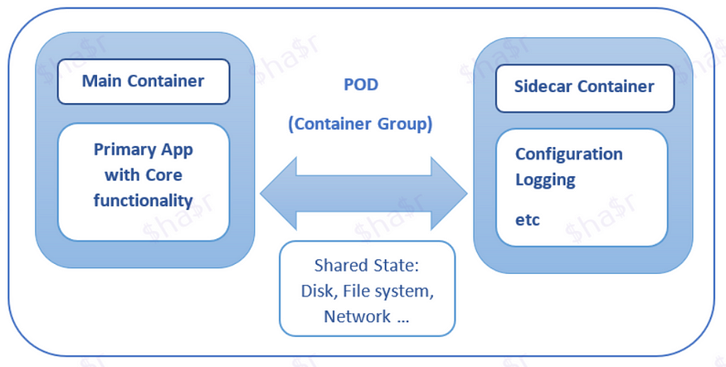

2. Integration Patterns
a. API Gateway Pattern
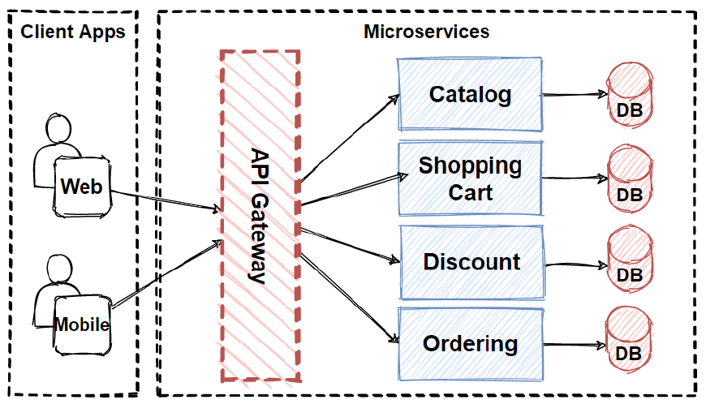
Problem
When an application is broken down to smaller microservices, there are a few concerns that need to be addressed:
How to call multiple microservices abstracting producer information.
On different channels (like desktop, mobile, and tablets), apps need different data to respond for the same backend service, as the UI might be different.
Different consumers might need a different format of the responses from reusable microservices. Who will do the data transformation or field manipulation?
How to handle different type of Protocols some of which might not be supported by producer microservice.
Solution
An API Gateway helps to address many concerns raised by microservice implementation, not limited to the ones above.
An API Gateway is the single point of entry for any microservice call.
It can work as a proxy service to route a request to the concerned microservice, abstracting the producer details.
It can fan out a request to multiple services and aggregate the results to send back to the consumer.
One-size-fits-all APIs cannot solve all the consumer's requirements; this solution can create a fine-grained API for each specific type of client.
It can also convert the protocol request (e.g. AMQP) to another protocol (e.g. HTTP) and vice versa so that the producer and consumer can handle it.
It can also offload the authentication/authorization responsibility of the microservice.
As you can see that we have added to single API Gateway in our application.
This will handle the client requests and route the internal microservices, also aggregate multiple internal microservices into a single client request and performs cross-cutting concerns like Authentication and authorization, Rate limiting and throttling and so on..
We will continue to evolve our architecture, but please look at the current design and think how we can improve design ?
As we said that there are several client applications connect to single API Gateway in here. We should careful about this situation, because if we put here a single API Gateway, that means its possible to single-point-of-failure risk in here. If these client applications increase, or adding more logic to business complexity in API Gateway, it would be anti-pattern.
The cross-cutting functionalities can be;
Authentication and authorization
Service discovery integration
Response caching
Retry policies, circuit breaker, and QoS
Rate limiting and throttling
Load balancing
Logging, tracing, correlation
Headers, query strings, and claims transformation
IP allowlisting

b. Aggregator Pattern
Problem
We have talked about resolving the aggregating data problem in the API Gateway Pattern. However, we will talk about it here holistically. When breaking the business functionality into several smaller logical pieces of code, it becomes necessary to think about how to collaborate the data returned by each service. This responsibility cannot be left with the consumer, as then it might need to understand the internal implementation of the producer application.
Solution
he aggregator design pattern describes a service that gets a request, then makes several requests to different services, combines the results, and then responds to the initial request.
The Aggregator pattern helps to address this. It talks about how we can aggregate the data from different services and then send the final response to the consumer. This can be done in two ways:
1. A composite microservice will make calls to all the required microservices, consolidate the data, and transform the data before sending back.
2. An API Gateway can also partition the request to multiple microservices and aggregate the data before sending it to the consumer.
It is recommended if any business logic is to be applied, then choose a composite microservice. Otherwise, the API Gateway is the established solution.

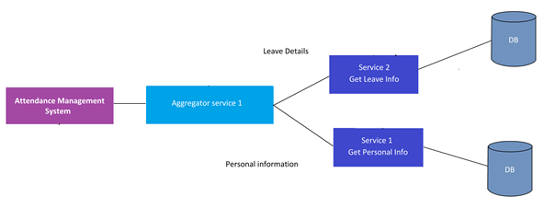
Proxy Pattern –

The proxy microservice design pattern is slightly similar to the aggregator. But according to the proxy design pattern, we do not need an aggregator on the consumer, but we create a microservice to invoke other services based on the business requirements. Let’s understand the proxy pattern with the below example.
Example:
▪ ️Assume your company currently having a monolithic application. So now you need to move to microservice architecture. So when you are deploying microservices maybe you need to change the services.
▪️ Consider, you have a microservice to get the leave information of employees. So the consumers need to pass the empCode to get leave information.

▪️ But with the new restructure, you have decided to keep empID as a relational key for all the records.
▪️ So now you deployed your new restructured Employee service (New version). But unfortunately, the consumers who are already consuming your previous service of Employee Service will affect

▪️ Because those consumers will pass the “empCode”. But the newer version of the service needs the empID. So at the time, you update the current service to the new version, your consumers will break.
As a solution for this, we can use the Proxy Design pattern here.
▪️ You can solve this by creating a separate proxy service as shown below.
▪️ Accordingly, the consumers will invoke the Proxy service. And you can modify it as
If the consumer passes the empID ➩ call version 2 (New version)
If the consumer passes the empCode➩ call version 1(Old version)
So in this way, you can independently deploy the service without affecting the consumer. When there’s no traffic, and schema 1 does not receive requests from the consumers, you can decommission service 1 and keep service 2 (new version). Here, semantic versioning is much important.
However, there are other important things we have to consider when talking about the Proxy design pattern.

