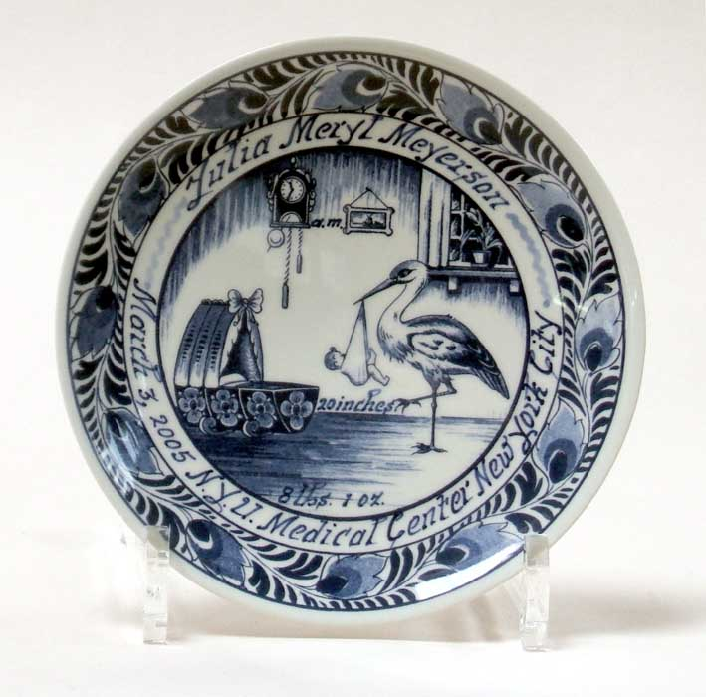

JOHN BRAAT AND COMPANY

Fine Imported Delft Blue Birth Plates

