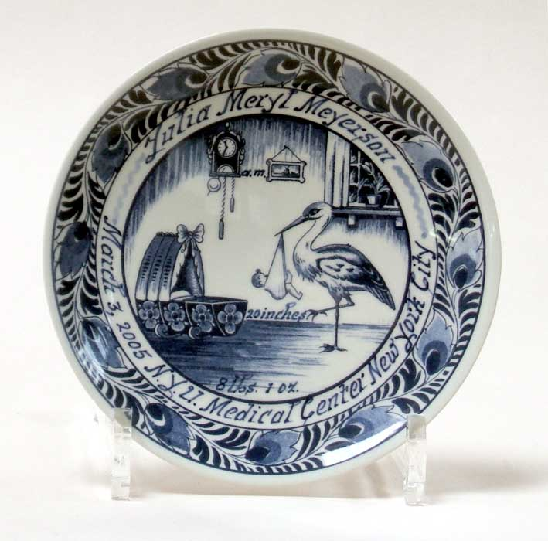

JOHN BRAAT AND COMPANY

Fine Imported Delft Blue Birth Plate and Wedding Plates

