CampusCart
Student Marketplace Web Application
PROJECT DOCUMENTATION
Project Type | Full-Stack Web Application
Academic Year | 2025–2026
Date | April 13, 2026

Department of Computer Science & Engineering

1. Title & Student Details

Project Information

Project Title | CampusCart – Student Marketplace Web Application
Project Type | Full-Stack Web Application
Academic Year | 2025–2026
Date Created | April 13, 2026
Application Version | 1.0.0
Status | Production Ready

Student Details

Name | Abhinav Gupta
Roll Number | 23BCE7424
College | VIT-AP
Department | Computer Science & Engineering
Email | abhinav.23bce7424@vitapstudent.ac.in
Guided By | Talam Naga Raju
Submitted To | Department of Computer Science & Engineering

2. Problem Statement

Campus-based peer-to-peer marketplace platforms are essential in modern educational institutions. However, many students lack a centralized platform to buy, sell, and exchange used items such as textbooks, electronics, furniture, and clothing within their campus community.

Key Challenges Addressed

1. Discoverability
✓ Students struggle to find used items available within their campus
✓ No centralized marketplace for student-to-student transactions
✓ Limited visibility into product availability and pricing

2. Trust & Safety
✓ No verified seller profiles or buyer protection mechanisms
✓ Risk of fraudulent transactions or product disputes
✓ Lack of communication channels between buyer and seller

3. Inventory Management
✓ No centralized database for tracking available items
✓ Difficulty in categorizing products (books, electronics, furniture, etc.)
✓ No wishlist or saved items feature for later purchases

4. User Experience
✓ Fragmented solutions (WhatsApp groups, physical notices)
✓ No search, filter, or sort functionality
✓ Limited product information and images

Objectives of CampusCart

✓ Create a unified, user-friendly online marketplace for campus community
✓ Enable simplified buying/selling of used college essentials
✓ Provide product categorization and advanced search capabilities
✓ Facilitate direct communication between buyers and sellers
✓ Implement a wishlist system for interested buyers
✓ Display products with detailed information and high-quality images

3. Work Flow Architecture

System Architecture

CLIENT SIDE (Frontend)

HTML5 (Structure) | CSS3 (Responsive Design & Styling) | Vanilla JavaScript
Pages: index.html • add-product.html • product-details.html • my-listings.html • wishlist.html
↓ API Calls ↓
BACKEND API (Express.js Server – Port 5000)

Routes: /api/items • /api/wishlist • /api/messages
Features: Product CRUD • Search & Filter • Wishlist Management • Message Thread Handling
↓ Database Queries ↓
DATABASE (MongoDB Atlas – Cloud)

Collections: items • wishlists • messages
SSL Encryption: Enabled (TLS Certificate Validation) | Cloud-hosted NoSQL

User Flow Diagram

Buyer Flow  Browse Marketplace →  Search / Filter Products →  View Product Details →  Save to Wishlist →  Message Seller → Transaction | Seller Flow  Go to Sell Page →  Fill Product Details →  Upload Image URL →  Submit → Database Update →  Manage Listings → View Messages

4. Functional & Non-Functional Requirements

Functional Requirements

1. User Interface & Navigation
✓ Responsive navbar with logo and navigation buttons
✓ Search bar for product searching
✓ Home, Sell, My Listings, Wishlist navigation links
✓ Category filtering (Books, Electronics, Furniture, Clothing, Sports)
✓ Sort functionality (Latest, Price Low-to-High, Price High-to-Low)

2. Marketplace Functionality
✓ Display all products in grid/card layout
✓ Show product image, title, category, location, seller name, price
✓ View button to see detailed product information
✓ Save button to add products to wishlist

3. Product Management
✓ Add new product (title, price, category, description, image URL, location)
✓ View my listings page with edit/delete options
✓ Delete product functionality
✓ Product persistence in MongoDB database

4. Wishlist Management
✓ View all wishlist items
✓ Remove items from wishlist
✓ View product details from wishlist
✓ Persistent storage in database

5. Messaging System
✓ Send messages to sellers
✓ View conversation threads
✓ Capture buyer name and contact information
✓ Message history persistence

6. Search & Filtering
✓ Search by product name/title
✓ Filter by category
✓ Sort by price (ascending/descending) and by date (latest first)
✓ Combined search functionality

Non-Functional Requirements

Category | Specification
Performance | Page load < 3s • Image fallback CDN • DB index optimization • Smooth animations
Scalability | 1000+ concurrent users • Cloud MongoDB • RESTful API for easy expansion
Security | HTTPS/SSL • .env credentials • Input validation & sanitization
Reliability | 99% uptime • Auto backup • Toast notifications • Graceful image fallback
Usability | Intuitive UI • Consistent branding • Clear navigation • Mobile-responsive
Maintainability | Clean code • Modular design • MVC pattern • Git version control
Compatibility | All modern browsers • Cross-platform • iOS Safari & Android Chrome

5. Project Structure

Directory Layout

CampusCart/
├── backend/ # Express.js Backend Server
│ ├── config/db.js # MongoDB connection configuration
│ ├── models/ # Item.js • Wishlist.js • Message.js
│ ├── controllers/ # itemController.js • wishlistController.js • messageController.js
│ ├── routes/ # items.js • wishlist.js • messages.js
│ ├── server.js # Express server setup & startup
│ └── loadSampleData.js # Sample data seed script
├── frontend/ # Frontend Client Application
│ ├── index.html # Marketplace homepage
│ ├── add-product.html # Add product form page
│ ├── product-details.html # Detailed product view
│ ├── my-listings.html # User's listed products
│ ├── wishlist.html # User's wishlist
│ ├── css/style.css # Global styles (1200+ lines)
│ └── js/ # app.js • api.js • utils.js
└── Documentation/ # README, ARCHITECTURE, API_DOCS, SETUP

Database Schema

items | wishlists | messages
_id: ObjectId  title: String  price: Number  category: String  description: String  image: String (URL)  sellerName: String  contact: String  location: String  createdAt: Date | _id: ObjectId  itemId: ObjectId  (ref: items)  addedAt: Date | _id: ObjectId  itemId: ObjectId  (ref: items)  senderName: String  senderContact: String  message: String  createdAt: Date

6. Technologies Used

Layer | Technology | Purpose
Frontend | HTML5 | Semantic markup & structure
Frontend | CSS3 | Responsive design with media queries
Frontend | JavaScript (ES6) | DOM manipulation, async/await
Frontend | Font Awesome | Icon library
Frontend | Google Fonts | Typography
Backend | Node.js | JavaScript runtime environment
Backend | Express.js | Web server framework
Backend | Mongoose | MongoDB ODM
Backend | dotenv | Environment variable management
Backend | CORS | Cross-origin resource sharing
Database | MongoDB Atlas | Cloud NoSQL database
Database | SSL/TLS | Secure encrypted connections
Dev Tools | npm / Git | Package manager & version control
Dev Tools | Postman | API testing
Dev Tools | Nodemon | Development auto-reload

Installation & Setup

1 | Clone Repository  git clone [repository-url] then cd CampusCart
2 | Backend Setup  cd backend → npm install → Create .env → npm run seed → npm start
3 | Frontend Setup  cd frontend → python -m http.server 8000
4 | Access Application  Open http://localhost:8000 in your browser

7. Output Screenshots

Screen 1 – Marketplace Homepage (index.html)

The homepage displays all available products in a responsive grid layout. Users can search, filter by category, and sort items. Each product card shows the image, title, category badge, location, seller name, price, and action buttons.

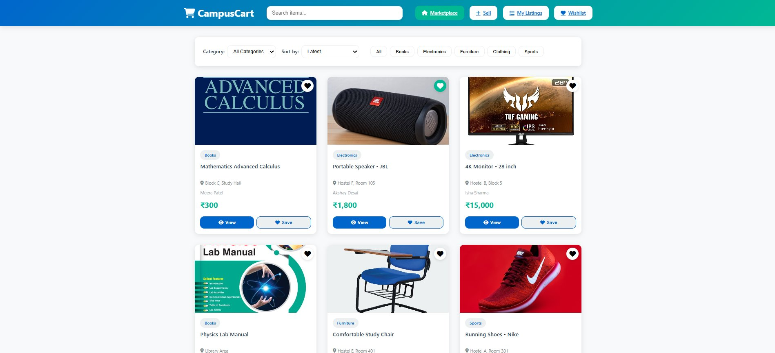

Screen 2 – My Wishlist (wishlist.html)

The Wishlist page shows all items saved by the user. Products can be removed from the wishlist or viewed in full detail. An empty state message is displayed when no items are saved.

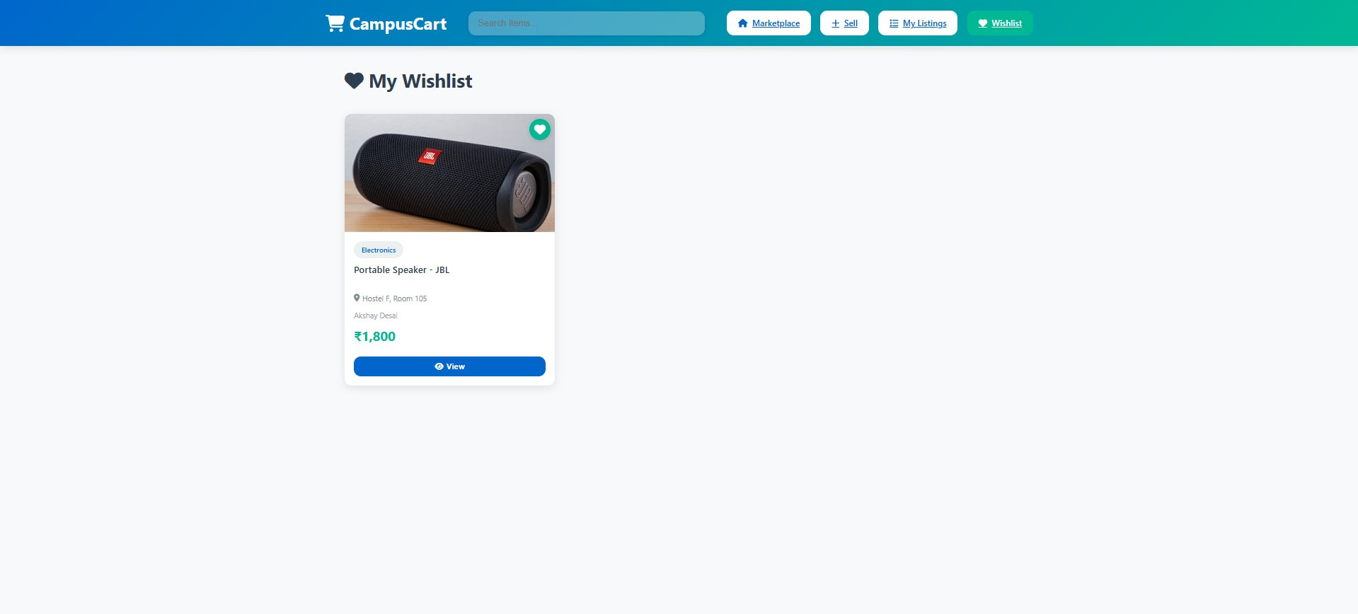

Screen 3 – My Listings (my-listings.html)

The My Listings page shows all products posted by the current seller. Each card includes a View button to see the full details and a Delete button to remove the listing from the marketplace and database.

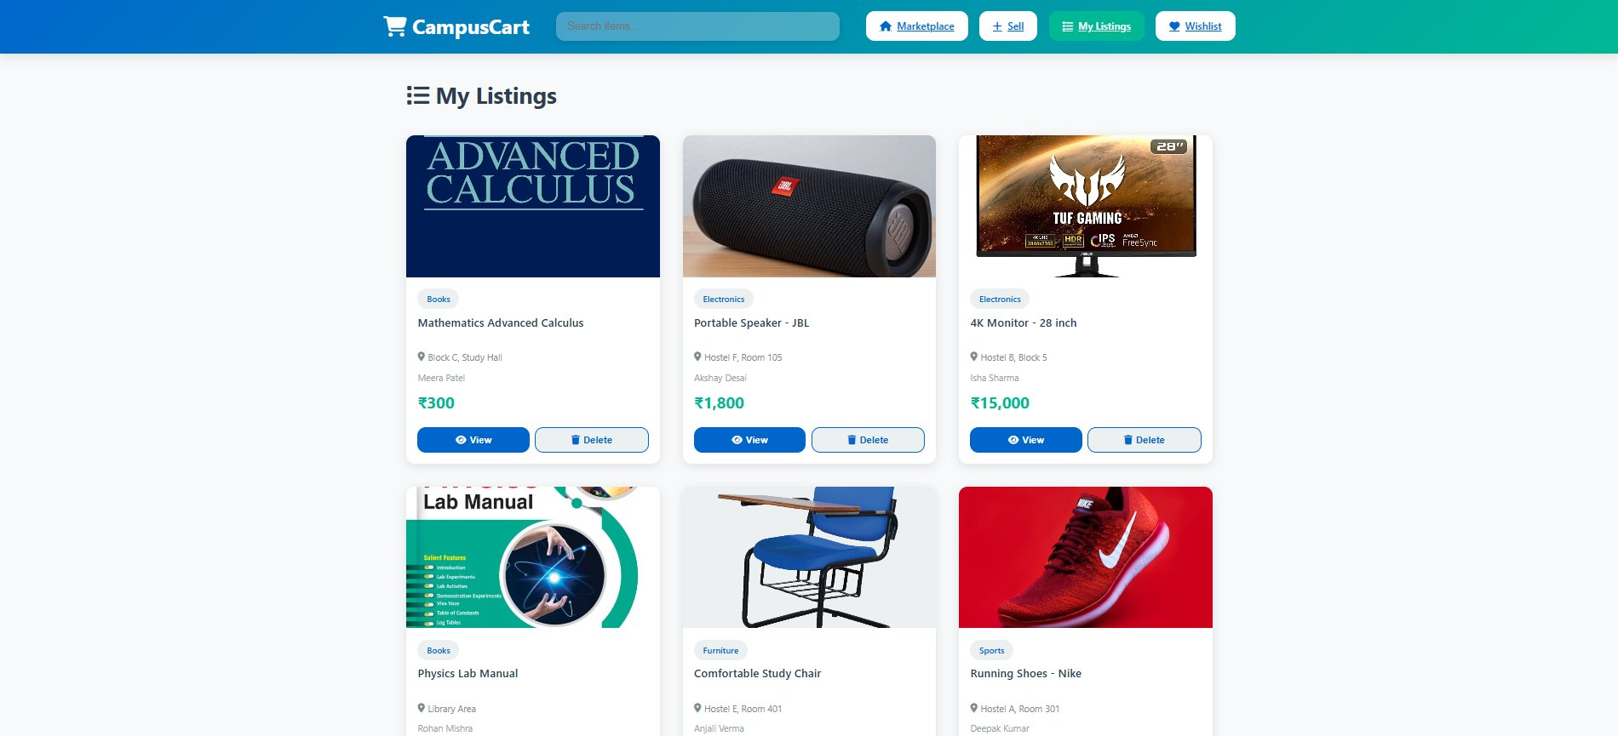

8. Functional Test Cases

# | Test Case | Steps | Expected Result
T1 | Browse Products | Open http://localhost:8000 → View all 12 sample products | ✓ All products visible with proper images and styling
T2 | Search Functionality | Type 'textbook' in search bar → View filtered results → Clear | ✓ Real-time filtering shows only matching products
T3 | Filter by Category | Click 'Books' → See books only → Switch to 'Electronics' | ✓ Category filtering works correctly
T4 | Add to Wishlist | Click 'Save' on any product → Go to Wishlist page | ✓ Product appears in wishlist page
T5 | View Product Details | Click 'View' on any product → See full details page | ✓ All product info and seller contact displayed
T6 | Add New Product | Go to 'Sell' → Fill form → Submit → Check marketplace | ✓ New product successfully added and visible
T7 | Send Message | Open product details → Fill message form → Click Send | ✓ Message saved and displayed in thread

9. Project Completion Status

Completed Features

✓ Full-stack web application architecture
✓ Responsive design for all devices
✓ 12 sample products pre-loaded
✓ Advanced search and filtering
✓ Product listing and management
✓ Wishlist functionality
✓ Messaging system
✓ Image fallback system
✓ MongoDB Atlas integration
✓ RESTful API endpoints
✓ Error handling and validation
✓ Toast notifications
✓ Cloud database with SSL encryption

Status: ✓ PRODUCTION READY

10. Conclusion

CampusCart is a fully functional student marketplace web application that solves the problem of scattered peer-to-peer transactions within campus communities. It provides a professional, scalable, and secure platform for students to buy, sell, and exchange items seamlessly.

Key Achievements

✓ Complete end-to-end web application with professional UI/UX design
✓ Scalable backend architecture with cloud-based database solution
✓ Real product images, data, and comprehensive documentation

Future Enhancements

- User authentication and profile management
- Payment gateway integration
- Rating and review system
- Advanced analytics dashboard
- Mobile app (iOS & Android)
- Email notifications
- Video product demonstrations
- Real-time order tracking

The application is ready for deployment and can be scaled to support thousands of users within an educational institution.

─────────────────────────────────────────────
Document Generated: April 13, 2026

