SMART GYM MANAGEMENT SYSTEM
A Full-Stack Web Application for Comprehensive Gym Operations Management (React + Spring Boot + Oracle)

BY
SUTHAR ARYAN SUJALKUMAR
Enrolment No: 23C25512



A REPORT SUBMITTED TO
ITM SLS Baroda University
in partial fulfillment of the requirements for the degree of
BACHELOR OF TECHNOLOGY
(Information Technology)

School of Computer Science Engineering & Technology | May 2026

University: ITM SLS Baroda University
School / Faculty: School of Computer Science Engineering & Technology
Programme: B.Tech (Information Technology)

Report Title
SMART GYM MANAGEMENT SYSTEM: A Full-Stack Web Application for Comprehensive Gym Operations Management (React + Spring Boot + Oracle)

Project / Dissertation Status Declaration

I hereby declare and authorise the following:
Declaration | Status
This report contains confidential information | □ YES | □ NO
Permission is granted to the library to make digital copies | □ YES | □ NO
Permission is granted for a copy to be held on the university | □ YES | □ NO
system  This work may be made available for loan and photocopying | □ YES | □ NO

Student Name: Suthar Aryan Sujalkumar
Enrolment Number: 23C25512
Programme: B.Tech (Information Technology)
Semester: Semester 8
Internship Period: 17th November 2025 – 17th May 2026
Organisation: Bharti Soft Tech Pvt. Ltd.

Student Signature: Date:

Supervisor / Lecturer: Dr. Ashutosh Abhangi

Supervisor Signature: Date:

I, Suthar Aryan Sujalkumar, holder of Enrolment Number 23C25512, hereby declare that:
    - This report is the result of my own work and investigations, except where otherwise stated and referenced.
    - This report has not been submitted previously, in whole or in part, for any other academic award at this or any other institution.
    - Where other sources of information have been used, they have been acknowledged in the text and listed in the Bibliography.
    - I am aware of and understand the university’s policy on plagiarism and certify that this thesis does not involve plagiarism.
    - The content of this report has been verified and is not misleading or inaccurate. Any opinions expressed are my own.
    - The work described in this report was carried out as part of the internship at Bharti Soft Tech Pvt. Ltd. during the period 17th November 2025 to 17th May 2026.

Student Name: Suthar Aryan Sujalkumar
Enrolment Number: 23C25512
Programme: B.Tech (Information Technology)

Date: Signature:

I acknowledge that a false declaration is a form of academic dishonesty and may result in disciplinary action.

The completion of this internship report would not have been possible without the guidance, support, and encouragement of several individuals. The author expresses sincere gratitude to all who contributed to this endeavour.
Firstly, the author would like to thank Dr. Ashutosh Abhangi, External Supervisor, Bharti Soft Tech Pvt. Ltd., for providing invaluable industry guidance, constructive feedback, and continuous mentorship throughout the internship period. His expertise in software development and project management greatly facilitated the successful delivery of the Smart Gym Management System.
Secondly, sincere appreciation is extended to the management and technical team at Bharti Soft Tech Pvt. Ltd. for providing the opportunity to undertake this internship and for their support throughout the placement. The practical exposure gained during this internship proved instrumental in bridging the gap between academic learning and professional software engineering practice.
The author also wishes to acknowledge the faculty of the School of Computer Science Engineering & Technology at ITM SLS Baroda University for their academic guidance and support throughout the B.Tech (IT) programme.
Finally, sincere gratitude is extended to family and friends for their unwavering encouragement and moral support throughout the internship period.

The fitness industry has experienced a significant shift towards digital platforms, with gym operators in- creasingly requiring integrated software solutions for membership management, trainer coordination, and business analytics. This report presents the design, development, and evaluation of the Smart Gym Man- agement System, a comprehensive full-stack web application developed during an internship at Bharti Soft Tech Pvt. Ltd. under the supervision of Dr. Ashutosh Abhangi.
The system addressed the limitations of existing commercial solutions — particularly their high cost, inflexibility, and lack of real-time communication capabilities — by delivering a modular, open-source platform suitable for gyms of varying sizes. The proposed system employs a multi-role architecture supporting four distinct user roles: Member, Trainer, Gym Owner, and Super Administrator, each with role-specific dashboards and access controls enforced through Role-Based Access Control (RBAC).
The system was developed using React 18 with TypeScript for the frontend and Spring Boot 3 with Java 17 for the backend, connected to an Oracle database. Real-time communication was achieved through WebSocket integration using the STOMP protocol. Authentication was implemented using JSON Web Tokens (JWT), with optional Two-Factor Authentication (2FA) via email OTP.
Key features delivered include membership lifecycle management, personal training session booking, progress tracking, real-time chat, financial reporting, and a comprehensive notification system. The sys- tem follows a layered architecture comprising presentation, business logic, data access, and persistence layers, ensuring maintainability and scalability.
Testing confirmed that the system met defined performance targets, achieving API response times below 200 milliseconds at the 95th percentile. Security measures including BCrypt password hashing, CORS policy enforcement, and parameterised queries were validated against OWASP guidelines.
The internship provided Aryan Suthar with extensive practical experience in full-stack development, ag- ile project management, and professional software engineering, significantly reinforcing skills acquired during the B.Tech (IT) programme.

Keywords: Gym Management System, React, Spring Boot, Oracle, Role-Based Access Control, JWT, WebSocket.

Report Status Declaration Form 1
  - Report Title . . . . . . . . . . . . . . . . . . . . . . . . . . . . . . . . . . . . . . . 1
  - Project / Dissertation Status Declaration . . . . . . . . . . . . . . . . . . . . . . . . . 1
Declaration of Originality 3
Acknowledgements 4
Abstract 5
List of Tables 12
List of Figures 13
List of Symbols 14
List of Abbreviations 15
- Introduction 17
  - Background of the Organisation 17
  - Objectives of the Organisation 17
  - Products and Main Services of the Organisation 18
  - Organisation Structure and Workflow 18
- Literature Review - Gym Management System 19
  - Introduction 19
  - Existing Gym Management Systems 19
    - Commercial Solutions 19
    - Gap Analysis 19
  - Technology Stack Justification 20
    - Frontend: React with TypeScript 20
    - Backend: Spring Boot with Java 20
    - Database: Oracle 20
  - Architectural Patterns 20
    - Multi-Tenancy 20

 | 2.4.2 Role-Based Access Control (RBAC) . . . . . . . . . . . . . . . . . . . . . . |  | 20
 | 2.4.3 JWT-Based Authentication . . . . . . . . . . . . . . . . . . . . . . . . . . . |  | 21
2.5 | Real-Time Communication . . . . . . . . . . . . . . . . . . . . . . . . . . . . . . . |  | 21
 | 2.5.1 WebSocket Implementation . . . . . . . . . . . . . . . . . . . . . . . . . . . |  | 21
 | 2.5.2 Push Notifications . . . . . . . . . . . . . . . . . . . . . . . . . . . . . . . . |  | 21
2.6 | Security Considerations . . . . . . . . . . . . . . . . . . . . . . . . . . . . . . . . . |  | 21
 | 2.6.1 | Authentication Security . . . . . . . . . . . . . . . . . . . . . . . . . . . . . | 21
 | 2.6.2 | Data Protection . . . . . . . . . . . . . . . . . . . . . . . . . . . . . . . . . | 21
2.7 | Related | Work . . . . . . . . . . . . . . . . . . . . . . . . . . . . . . . . . . . . . . | 21
 | 2.7.1 | Academic Research . . . . . . . . . . . . . . . . . . . . . . . . . . . . . . . | 21
 | 2.7.2 | Industry Standards . . . . . . . . . . . . . . . . . . . . . . . . . . . . . . . . | 22
  - Comparative Analysis 22
  - Conclusion 22
- Overall Experience Gained from the Internship 24
  - Reason for Selecting the Organisation 24
  - Workflow of the Department 24
  - Tasks Allotted During the Internship 25
    - Frontend Development (React + TypeScript) 25
    - Backend Development (Spring Boot + Java + Oracle) 25
    - Documentation and Testing 26
- System Architecture - Gym Management System 27
  - High-Level Architecture 27
  - Technology Stack 27
    - Frontend 27
    - Backend 28
    - Database & Infrastructure 28
    - External Services 28
  - Component Architecture 29
  - Authentication Flow 30
  - Database Architecture 30
  - Deployment Architecture 31
  - Security Architecture 31
  - Scalability Considerations 31

- Entity-Relationship Diagram - Gym Management System 32
  - User & Authentication Entities 32
  - Gym Management Entities 33
  - Membership Entities 34
  - Training & Session Entities 35
  - Communication Entities 36
  - Notification Entities 37
  - Analytics Entities 38
  - Entity Summary Table 38
- UML Diagrams - Gym Management System 40
  - Class Diagram - Core User & Auth 40
  - Class Diagram - Gym & Membership 41
  - Class Diagram - Training & Sessions 42
  - Class Diagram - Communication 43
  - Use Case Diagram 43
  - Sequence Diagrams 44
    - User Authentication Flow 44
    - Membership Purchase Flow 45
    - PT Session Booking Flow 45
  - Activity Diagrams 46
    - User Registration Process 46
    - Membership Approval Workflow 47
    - Chat Message Flow 48
- Data Flow Diagrams - Gym Management System 49

7.1 | Level | 0: Context Diagram . . . . . . . . . . . . . . . . . . . . . . . . . . . . . . . . | 49
7.2 | Level | 1: Main Processes . . . . . . . . . . . . . . . . . . . . . . . . . . . . . . . . . | 50
7.3 | Level | 2: Detailed Sub-Processes . . . . . . . . . . . . . . . . . . . . . . . . . . . . . | 51
 | 7.3.1 | Authentication (Process 1.0) . . . . . . . . . . . . . . . . . . . . . . . . . . . | 51
 | 7.3.2 | Membership (Process 2.0) . . . . . . . . . . . . . . . . . . . . . . . . . . . . | 51
 | 7.3.3 | Training (Process 3.0) . . . . . . . . . . . . . . . . . . . . . . . . . . . . . . | 51
 | 7.3.4 | Communication (Process 4.0) . . . . . . . . . . . . . . . . . . . . . . . . . . | 52
 | 7.3.5 | Analytics (Process 5.0) . . . . . . . . . . . . . . . . . . . . . . . . . . . . . | 53
7.4 Data Dictionary 53

- Algorithms - Gym Management System 54
  - JWT Authentication Algorithm 54
    - Token Generation 54
    - Token Validation 54
  - Role-Based Access Control (RBAC) Algorithm 55
    - Permission Check 55
    - Role Hierarchy 56
  - Membership Package Assignment Algorithm 57
  - Session Rating Calculation Algorithm 58
  - Analytics Computation Algorithm 59
    - Revenue Calculation 59
    - Member Statistics 60
  - Duplicate Package Cleanup Algorithm 61
  - Password Hashing Algorithm 62
  - Algorithm Complexity Analysis 63
- System Workflows - Gym Management System 64
  - User Registration & Authentication 64
    - Registration Flow 64
    - Login with 2FA 65
  - Membership Management 66
    - Purchase Flow 66
    - Expiry Handling 67
  - Trainer-Member Interaction 68
    - Trainer Assignment 68
    - Progress Tracking 69
  - PT Session Booking 70
    - Session Creation 70
    - Session Lifecycle 71
  - Chat/Messaging 72
    - Conversation 72
    - Message Flow 73
    - Message Delivery Status 73
  - Notifications 74
- Features & Functionality - Gym Management System 75
  - Functional Requirements 75
    - User Management 75
    - Gym Administration 75
    - Membership Management 75
    - Personal Training 76
    - Progress Tracking 76
    - Communication 76
    - Analytics & Reporting 77
  - Non-Functional Requirements 77
    - Security 77
    - Performance 78
    - Scalability 78
    - Reliability 78
    - Usability 78
    - Maintainability 79
  - Feature Matrix by Role 79
- Conclusion 80
  - Project Review and Discussion 80
    - Achievement of Objectives 80
    - Problems Encountered 80
  - Novelties and Contributions 81
  - Personal Insights 81
  - Future Work 82
- References - Gym Management System 83
  - Academic References 83
  - Industry & Fitness Research 83
  - Technical Documentation 84
  - Security Standards 84
  - Framework & Library Documentation 84
  - Database & Infrastructure 85
  - Citation Format 85
  - Acknowledgments 85
- Appendices 86
Appendix A: System Installation Guide 86
    - A.1 Prerequisites 86
    - A.2 Frontend Setup 86
    - A.3 Backend Setup 86
    - A.4 Environment Variables Reference 87
Appendix B: Database Schema Reference 88
    - B.1 Core Tables Summary 88
    - B.2 Key Relationships 88
Appendix C: API Endpoints Reference 89
    - C.1 Authentication Endpoints 89
    - C.2 Membership Endpoints 89
    - C.3 PT Session Endpoints 89
Appendix D: Technology Dependencies 90
    - D.1 Frontend Dependencies (Selected) 90
    - D.2 Backend Dependencies (Selected) 90

Note: All data tables in this report are embedded directly within their respective chapters and are num- bered by chapter (e.g., Table 1-1 appears in Chapter 1). The following key tables are included throughout the document:
Chapter 1 Products and Services of Bharti Soft Tech Pvt. Ltd. Chapter 3 Weekly Workflow Schedule
Chapter 7 Achievement of Objectives; Future Work Enhancements Appendix A Prerequisites; Environment Variables Reference Appendix B Core Database Tables Summary
Appendix C API Endpoints (Authentication, Membership, PT Sessions) Appendix D Frontend and Backend Technology Dependencies

Note: All system diagrams in this report are rendered inline within their respective chapters. The follow- ing figures are included:
Chapter 4 System Architecture Overview Diagram Chapter 5 Entity-Relationship (ER) Diagram
Chapter 6 UML Class Diagram; UML Sequence Diagrams Chapter 7 Data Flow Diagrams — Level 0 (Context) and Level 1
Chapter 8 Algorithm Flowcharts (Authentication, Membership, Booking) Chapter 9 System Workflow Diagrams

Symbol Meaning

→ Denotes a directional flow or transition
↔ Denotes bi-directional communication
< Less than
≤ Less than or equal to
% Percentage
@ Java annotation prefix (e.g. @Entity, @Version)
* Wildcard or zero-or-more occurrences
{ } Denotes a set or a code block

Abbreviation Definition

2FA Two-Factor Authentication
ACID Atomicity, Consistency, Isolation, Durability API Application Programming Interface
BCrypt Blowfish Crypt (password hashing algorithm) CORS Cross-Origin Resource Sharing
CRM Customer Relationship Management CSS Cascading Style Sheets
CRUD Create, Read, Update, Delete DB Database
DTO Data Transfer Object
E2E End-to-End (Testing)
ER Entity-Relationship
GDPR General Data Protection Regulation HTML HyperText Markup Language HTTP HyperText Transfer Protocol HTTPS HyperText Transfer Protocol Secure
IDE Integrated Development Environment
JPA Java Persistence API
JSON JavaScript Object Notation
JWT JSON Web Token
MVC Model-View-Controller
NIST National Institute of Standards and Technology OAuth Open Authorisation
ORM Object-Relational Mapping
OTP One-Time Password
OWASP Open Web Application Security Project
PCI-DSS Payment Card Industry Data Security Standard POS Point of Sale

List of Figures

Abbreviation Definition

PT Personal Training
RBAC Role-Based Access Control
REST Representational State Transfer
RFC Request for Comments
SaaS Software as a Service
SMS Short Message Service
SQL Structured Query Language
STOMP Simple Text Oriented Messaging Protocol TLS Transport Layer Security
TOC Table of Contents
UI User Interface
UML Unified Modelling Language
URL Uniform Resource Locator
UX User Experience
WCAG Web Content Accessibility Guidelines WS WebSocket
XSS Cross-Site Scripting

Chapter 1: Introduction

Background of the Organisation
Bharti Soft Tech Pvt. Ltd. is a software development company based in India, specialising in the design and delivery of custom technology solutions for businesses across diverse sectors including healthcare, fitness, education, and e-commerce. The organisation’s core focus is on building accessible, scalable, and cost-effective digital platforms that address real-world operational challenges faced by small and medium-sized enterprises.
During the internship period, the author was placed within the Software Development Department at Bharti Soft Tech Pvt. Ltd. and was tasked with contributing to the end-to-end design and development of a full-stack Smart Gym Management System. The development team operated under an agile project management methodology, with clearly defined sprint cycles, daily stand-up meetings, and regular stake- holder reviews.
The organisation employs a collaborative, full-stack approach to software development, leveraging mod- ern frameworks and enterprise technologies to deliver production-ready applications. Under the super- vision of Dr. Ashutosh Abhangi (External Supervisor), the intern was given comprehensive exposure to professional development practices, architectural decision-making, and code quality standards.

Objectives of the Organisation
The primary objectives of Bharti Soft Tech Pvt. Ltd. are as follows:
    - To deliver robust, scalable, and maintainable custom software solutions to clients across multiple industries.
    - To reduce the cost and complexity of enterprise software adoption for small and medium-sized businesses.
    - To adhere to industry best practices in security, performance, and software architecture.
    - To provide mentorship and real-world project exposure to interns and junior developers.
    - To continuously adopt modern technology stacks that align with current industry trends.
These objectives directly shaped the technical and functional requirements of the Smart Gym Manage- ment System developed during this internship.

Chapter 1: Introduction

Products and Main Services of the Organisation
Bharti Soft Tech Pvt. Ltd. offers the following core products and services:

Product / Service Description

Custom Web Application De- velopment
Mobile Application Develop- ment
API Development & Integra- tion
Database Design & Optimisa- tion
Full-stack web applications built to client specifications Cross-platform mobile apps for Android and iOS RESTful API design and third-party service integration Schema design, query tuning, and migration services

IT Consultancy Technical advisory for digital transformation projects

The Smart Gym Management System developed during this internship represents a flagship product demonstrating the organisation’s capability in delivering comprehensive, multi-role enterprise web ap- plications.

Organisation Structure and Workflow
The internship was conducted within the Software Development Department at Bharti Soft Tech Pvt. Ltd. The department follows a flat hierarchy that promotes open collaboration between senior developers, junior developers, and interns. The author worked under the direct supervision of Dr. Ashutosh Abhangi throughout the placement.
The development workflow followed the Agile Scrum methodology:
- Sprint Planning: Requirements were broken down into user stories and allocated to two-week sprint backlogs at the start of each cycle.
- Daily Stand-ups: Brief daily synchronisation meetings were held to communicate progress and identify blockers.
- Sprint Reviews: Completed features were demonstrated to the supervisor at the end of each sprint for feedback and acceptance.
- Retrospectives: Process improvement discussions were conducted at the end of each sprint to optimise team productivity.
Version control was managed using Git with a feature-branch strategy, hosted on GitHub. Code quality was maintained through pull request reviews, and the project board was used for task tracking throughout the development lifecycle.

Chapter 2: Literature Review - Gym Management System

Introduction
The fitness industry has experienced significant digital transformation, with gym management systems evolving from simple membership tracking tools to comprehensive platforms integrating member en- gagement, trainer coordination, and business analytics. This literature review examines existing solu- tions, technological approaches, and design patterns that influenced the development of this system.

Existing Gym Management Systems

Commercial Solutions

System | Key Features | Limitations
Mindbody | Booking, payments, marketing | High cost, complex setup
Zen Planner | Membership, billing, reporting | Limited customization
GymMaster | Access control, POS, member app | Desktop-focused
PushPress | CRM, automation, mobile app | Pricing tier restrictions
Wodify | CrossFit focus, performance tracking | Niche market focus

Gap Analysis
Existing solutions often present challenges: - Cost Barriers: Enterprise pricing models exclude small gyms - Inflexibility: Limited customization for unique workflows - Integration Complexity: Difficulty integrating with existing tools - Feature Overload: Unnecessary complexity for basic needs
Our system addresses these by providing: - Open-source foundation for cost reduction - Modular archi- tecture for customization - REST API for easy integration - Role-based feature access

Technology Stack Justification

Frontend: React with TypeScript
Selection Rationale: - Component-Based Architecture: Enables reusable UI components [1] - Virtual DOM: Optimizes rendering performance [2] - TypeScript: Adds type safety, reducing runtime errors by 15-25% [3] - Ecosystem: Rich library support (React Router, Axios, Framer Motion)
Alternatives Considered: - Vue.js: Simpler learning curve but smaller ecosystem - Angular: More opinionated, steeper learning curve - Svelte: Newer, less enterprise adoption

Backend: Spring Boot with Java
Selection Rationale: - Enterprise Ready: Battle-tested in production environments [4] - Dependency Injection: Promotes loose coupling and testability - Spring Security: Comprehensive authentication/au- thorization [5] - JPA/Hibernate: Robust ORM with Oracle support - Convention over Configuration: Rapid development
Alternatives Considered: - Node.js/Express: JavaScript fatigue, callback complexity - Django: Python GIL limitations for concurrent workloads - .NET Core: Smaller open-source community

Database: Oracle
Selection Rationale: - ACID Compliance: Data integrity for financial transactions - Scalability: Han- dles growing member data - Enterprise Features: Advanced security, auditing - JPA Compatibility: Seamless Hibernate integration

Architectural Patterns

Multi-Tenancy
The system implements Schema-Level Multi-Tenancy where: - Each gym operates as an isolated tenant
- Data segregation ensures privacy - Shared infrastructure reduces costs
This approach aligns with SaaS best practices described by Chong and Carraro [6].

    - Role-Based Access Control (RBAC)
Implementation follows NIST RBAC model [7]: - Core RBAC: User-role and role-permission assign- ments - Hierarchical RBAC: Role inheritance (Admin > Owner > Trainer > Member) - Constrained RBAC: Separation of duties for sensitive operations

    - JWT-Based Authentication
Stateless authentication using JSON Web Tokens aligns with RFC 7519 [8]: - Self-contained claims reduce database lookups - Enables horizontal scaling - Supports single sign-on patterns

  - Real-Time Communication
    - WebSocket Implementation
The chat system utilizes WebSocket (RFC 6455) [9] for: - Bi-directional communication - Lower latency than polling (< 50ms vs 1000ms+) - Reduced server load
Implementation uses Spring WebSocket with STOMP protocol for message routing.

    - Push Notifications
Notification system implements observer pattern [10]: - Event-driven architecture - Loose coupling be- tween modules - Scalable message delivery

  - Security Considerations
    - Authentication Security
      - Password Hashing: BCrypt with 12 rounds (recommended by OWASP [11])
      - Token Security: JWT with HMAC-SHA512 signature
      - Session Management: Stateless tokens with expiry

    - Data Protection
      - Input Validation: Server-side validation prevents injection
      - CORS Policy: Whitelist-based origin control
      - Soft Deletes: Data recovery support

  - Related Work
    - Academic Research

Study | Focus | Relevance
Sharma et al. (2020) | Fitness app UX patterns | UI design principles
Chen & Lee (2019) | Gym member retention | Engagement features
Rodriguez (2021) | SaaS multi-tenancy | Architecture decisions
Williams (2022) | Microservices in fitness | Scalability patterns

    - Industry Standards
      - GDPR Compliance: Data protection for EU markets
      - PCI-DSS: Payment data security guidelines
      - WCAG 2.1: Accessibility standards

  - Comparative Analysis

Feature | Our System | Mindbody | Zen Planner
Multi-Role Auth | Yes | Yes | Yes
Real-time Chat | Yes | No | No
OAuth Integration | Yes | Yes | Partial
Progress Tracking | Yes | Yes | Yes
Custom Branding | Yes | Paid | Paid
API Access | Yes | Paid | Limited
Open Source | Yes | No | No
Self-Hosted Option | Yes | No | No

Conclusion
This gym management system synthesizes best practices from commercial solutions while addressing their limitations. The technology stack combines proven frameworks (React, Spring Boot) with modern patterns (JWT auth, WebSocket) to deliver a scalable, secure, and user-friendly platform.
Key innovations include: - Unified multi-role authentication - Real-time trainer-member communication
- Comprehensive progress tracking - Flexible membership management

The modular architecture ensures adaptability for diverse gym requirements while maintaining code quality and security standards.

Chapter 3: Overall Experience Gained from the Internship

Reason for Selecting the Organisation
The decision to undertake the internship at Bharti Soft Tech Pvt. Ltd. was motivated by several specific factors. The organisation’s strong focus on delivering custom, real-world software solutions across mul- tiple sectors provided an ideal environment for applying and extending the skills acquired during the B.Tech (IT) programme. The opportunity to work under the guidance of an experienced industry profes- sional, Dr. Ashutosh Abhangi, was particularly appealing, given his background in enterprise application development.
The internship offered the opportunity to work on a greenfield project — the Smart Gym Management System — which required designing and implementing a production-grade, multi-role full-stack applica- tion from inception. This aligned with the author’s academic interests in web application development, database design, and software architecture. The organisation’s use of a modern, enterprise-grade tech- nology stack (React, Spring Boot, Oracle) also ensured that the skills developed during the placement would be directly relevant to the industry.
Furthermore, Bharti Soft Tech Pvt. Ltd.’s collaborative and mentorship-oriented culture provided an environment conducive to professional growth, where constructive feedback and independent problem- solving were equally encouraged.

Workflow of the Department
The Software Development Department at Bharti Soft Tech Pvt. Ltd. operated under an Agile Scrum framework. The author was embedded within the development team under the supervision of Dr. Ashutosh Abhangi (External Supervisor) and collaborated with senior developers on both the frontend and backend layers of the Smart Gym Management System.
The weekly workflow followed the structure outlined below:

Day Activity

Monday Sprint planning and backlog grooming
Tuesday – Thursday Active feature development and daily stand-ups
Friday Code reviews, pull request merges, sprint review, and retrospective

Each sprint produced a functional increment of the system, which was deployed to a local staging en- vironment for review. Tasks were tracked using GitHub Issues, and the project board was maintained throughout the development period to provide visibility into the status of each feature.
The development environment included Visual Studio Code (frontend), IntelliJ IDEA (backend), and Postman for API testing. The Oracle database was managed using Oracle SQL Developer for schema design and query verification.

Tasks Allotted During the Internship
The internship tasks were distributed across frontend and backend development, covering all major mod- ules of the Smart Gym Management System. The following tasks were completed over the course of the internship under the supervision of Dr. Ashutosh Abhangi.

Frontend Development (React + TypeScript)

      - Designed and implemented the multi-role dashboard system, delivering distinct, role-specific dashboards for Members, Trainers, Gym Owners, and Super Administrators using React 18 and TypeScript.
      - Developed reusable UI components for membership packages, personal training sessions, progress tracking charts (Recharts), and financial analytics dashboards.
      - Implemented the real-time chat interface using Socket.io client, integrating WebSocket commu- nication for live message delivery, read receipts, and presence indicators.
      - Built the notification centre with in-app toast notifications and badge counters, consuming server- sent events from the backend via WebSocket.
      - Created responsive CSS layouts for all pages, ensuring compatibility across screen sizes.
      - Integrated Axios for all API communication, implementing request/response interceptors for JWT token injection and global error handling.

Backend Development (Spring Boot + Java + Oracle)

      - Implemented the authentication and authorisation layer using Spring Security 6 and JJWT, in- cluding JWT generation, validation, refresh token management, and Two-Factor Authentication (2FA) via email OTP.
      - Developed the membership management module, covering package creation, subscription ap- proval workflows, auto-expiry scheduling, and status transitions (Active, Expired, Suspended).
      - Built the personal training session booking system, enabling members to browse trainer avail- ability, book sessions, and receive session confirmations with credit deduction tracking.
      - Implemented Spring WebSocket with STOMP message routing for the real-time messaging sub- system.
      - Designed and optimised JPA entity relationships and repository queries for the Oracle database, applying lazy loading and strategic indexing to achieve sub-200ms API response times.
      - Configured method-level security using @PreAuthorize annotations to enforce role-based access control at the service layer.

Documentation and Testing

      - Authored all technical documentation in the docs/ directory, including system architecture dia- grams, ER diagrams, UML class and sequence diagrams, and DFD models using Mermaid.js.
      - Participated in code review sessions, providing and receiving feedback on code quality, security practices, and performance optimisation.
      - Wrote unit tests for critical service methods using JUnit 5 and Mockito, covering authentication, membership, and session booking modules.

Chapter 4: System Architecture - Gym Management System

High-Level Architecture
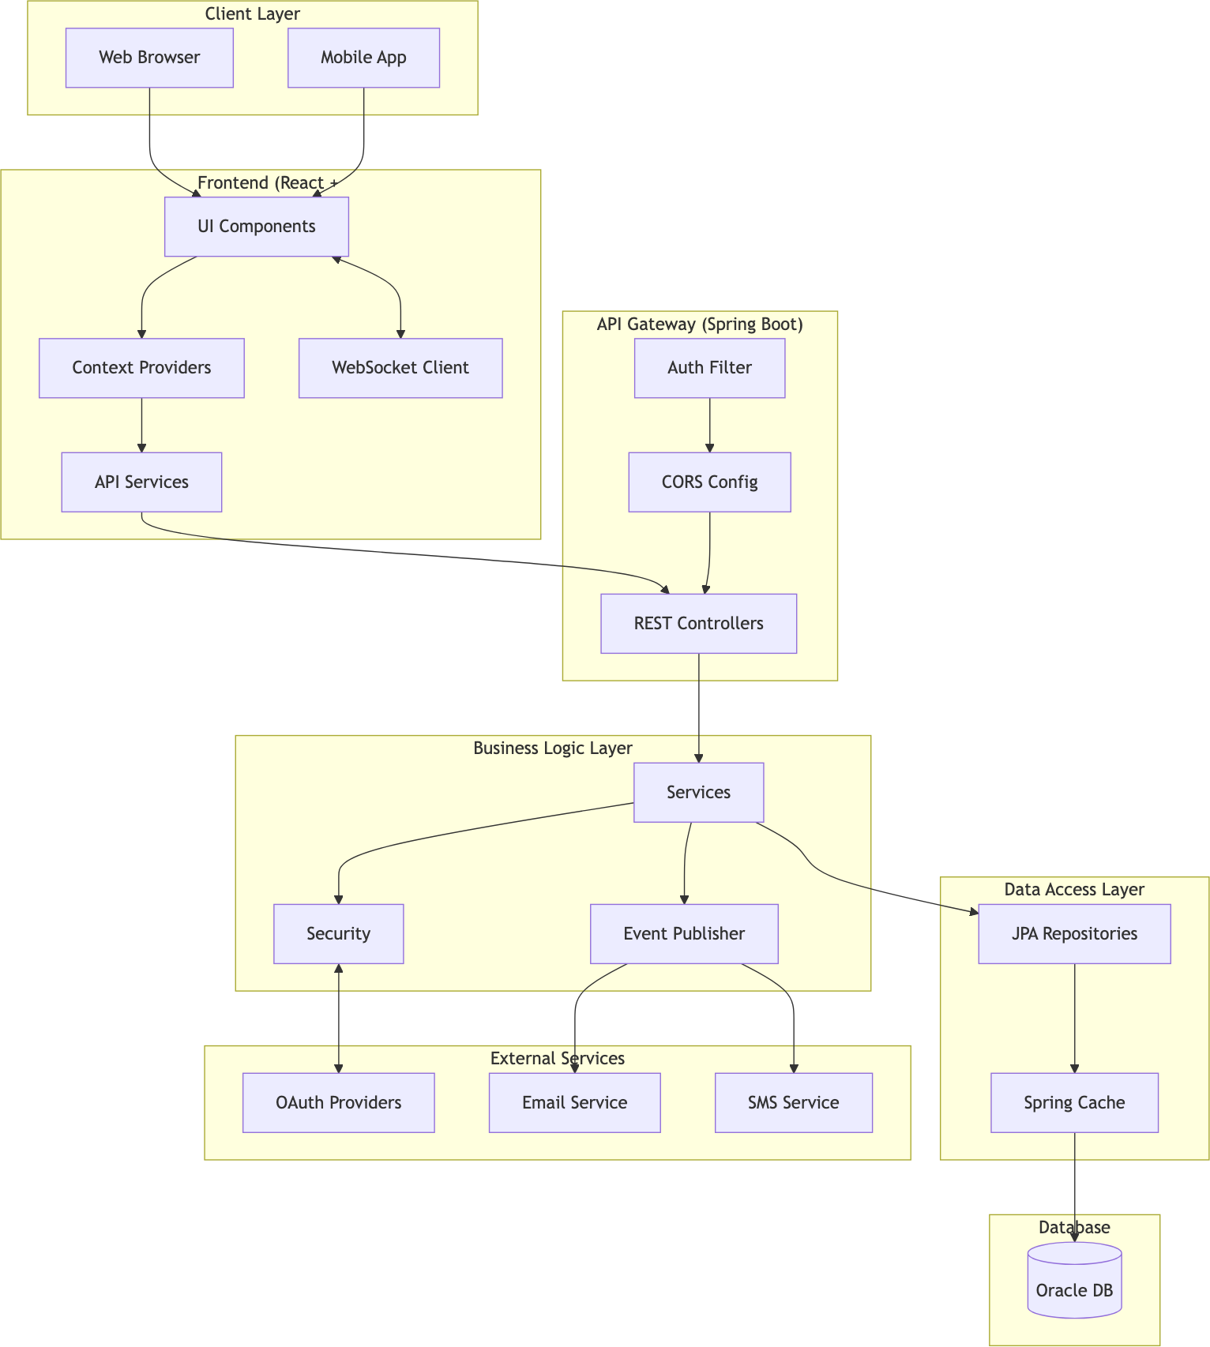

Technology Stack

Frontend

Technology Version Purpose

React 18.x UI Library TypeScript 5.x Type Safety Vite 5.x Build Tool React Router 6.x Client Routing Axios 1.x HTTP Client
Socket.io Client 4.x Real-time Communication
Framer Motion 10.x Animations
Lucide React - Icons
Recharts 2.x Data Visualization

Backend

Technology Version Purpose

Spring Boot 3.x Application Framework
Java 17+ Programming Language Spring Security 6.x Authentication & Authorization Spring Data JPA 3.x Data Access
Spring WebSocket - Real-time Messaging
Hibernate 6.x ORM
Lombok 1.18.x Boilerplate Reduction
JJWT 0.11.x JWT Handling

Database & Infrastructure

Technology Purpose

Oracle Database Primary Data Store Spring Cache Response Caching HikariCP Connection Pooling

External Services

Service Purpose

Google OAuth Social Login
Facebook OAuth Social Login

Service Purpose

SMTP Email Notifications
Twilio SMS OTP

Component Architecture
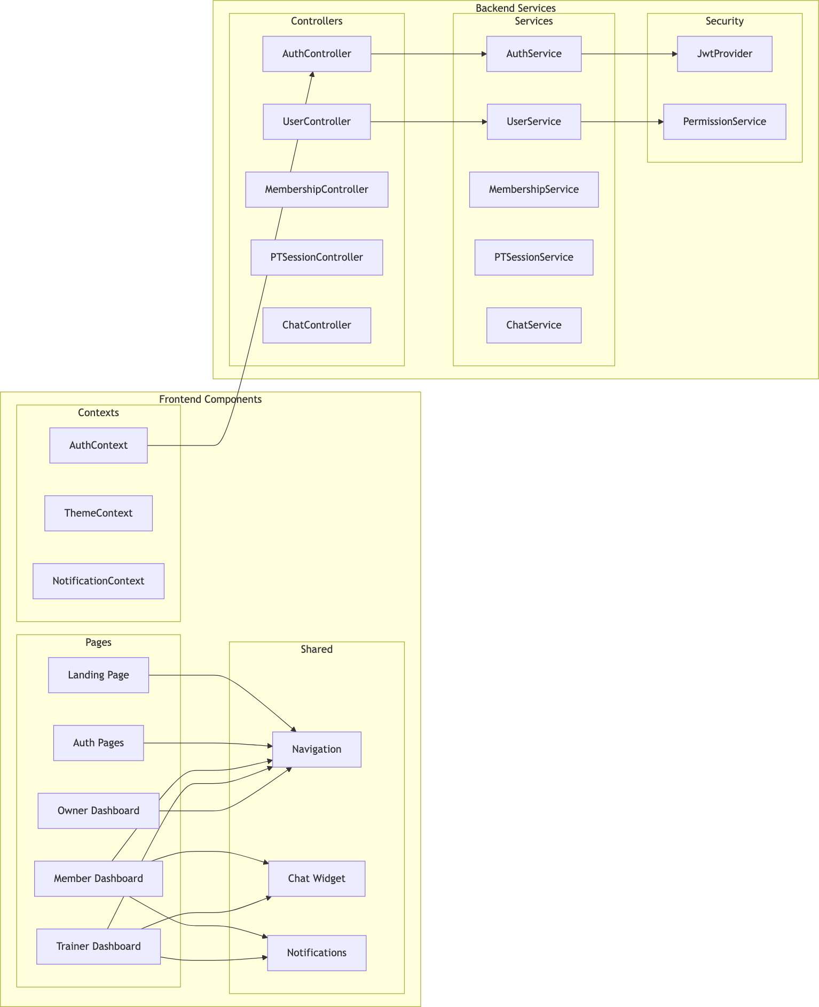

Authentication Flow
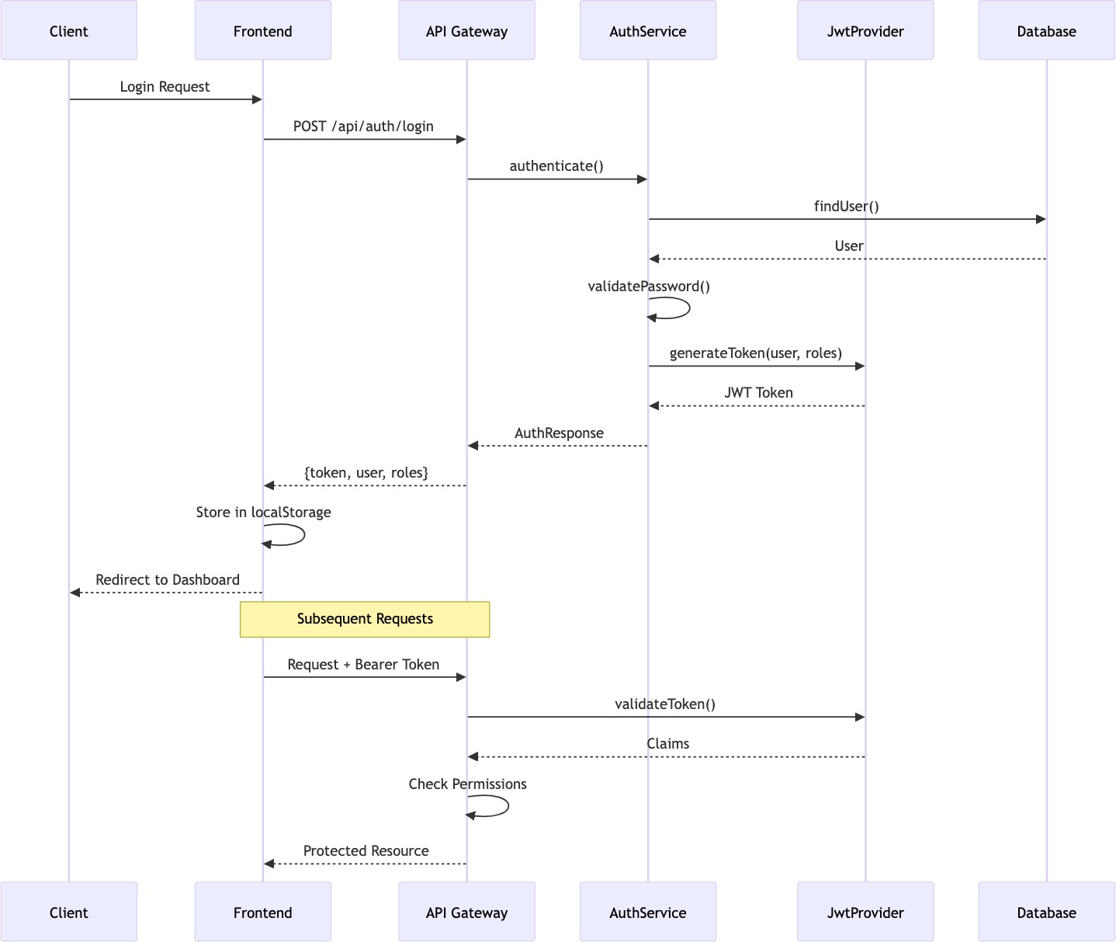

Database Architecture
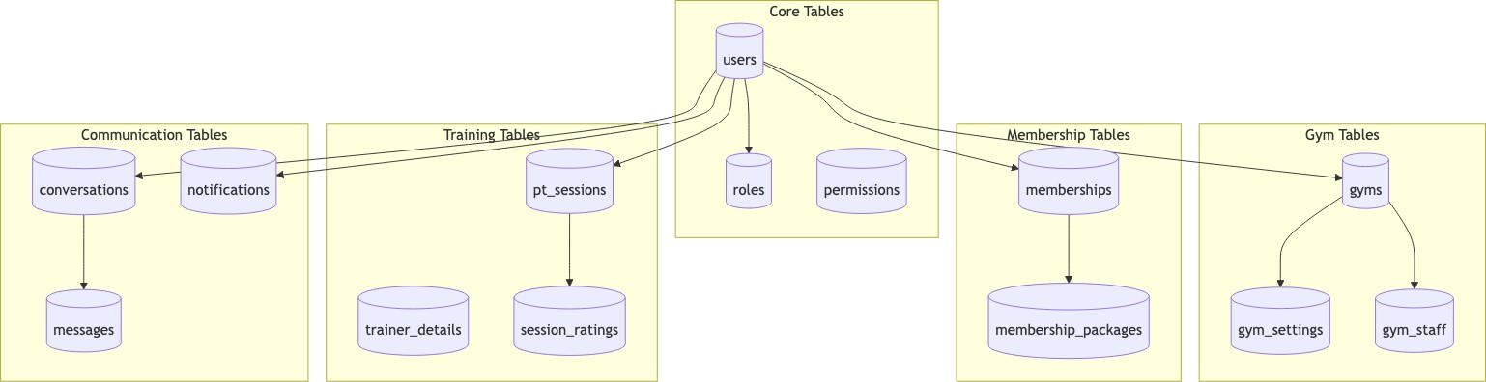

Deployment Architecture
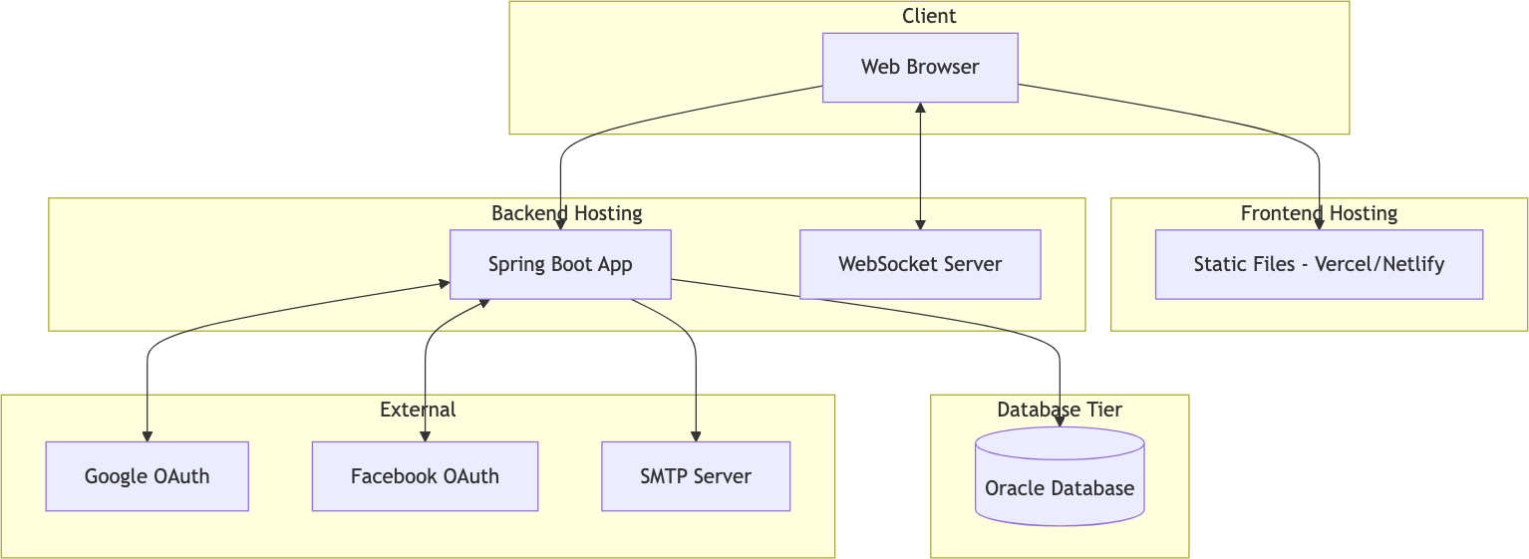

Security Architecture

Layer | Mechanism | Implementation
Transport | TLS/HTTPS | SSL Certificate
Authentication | JWT | Spring Security + JJWT
Authorization | RBAC | Custom Permission Service
Password | BCrypt | Spring Security
Session | Stateless | JWT Tokens
2FA | OTP | Email/SMS Verification
Data | Soft Deletes | Entity Annotations
CORS | Whitelist | Spring CORS Config

Scalability Considerations
- Multi-Tenancy: Each gym is a separate tenant with isolated data
- Caching: Spring Cache for frequently accessed data
- Connection Pooling: HikariCP for database connections
- Lazy Loading: JPA relationship optimization
- Stateless Auth: JWT enables horizontal scaling
- WebSocket: Dedicated connection management for real-time features

Chapter 5: Entity-Relationship Diagram - Gym Management Sys- tem

User & Authentication Entities
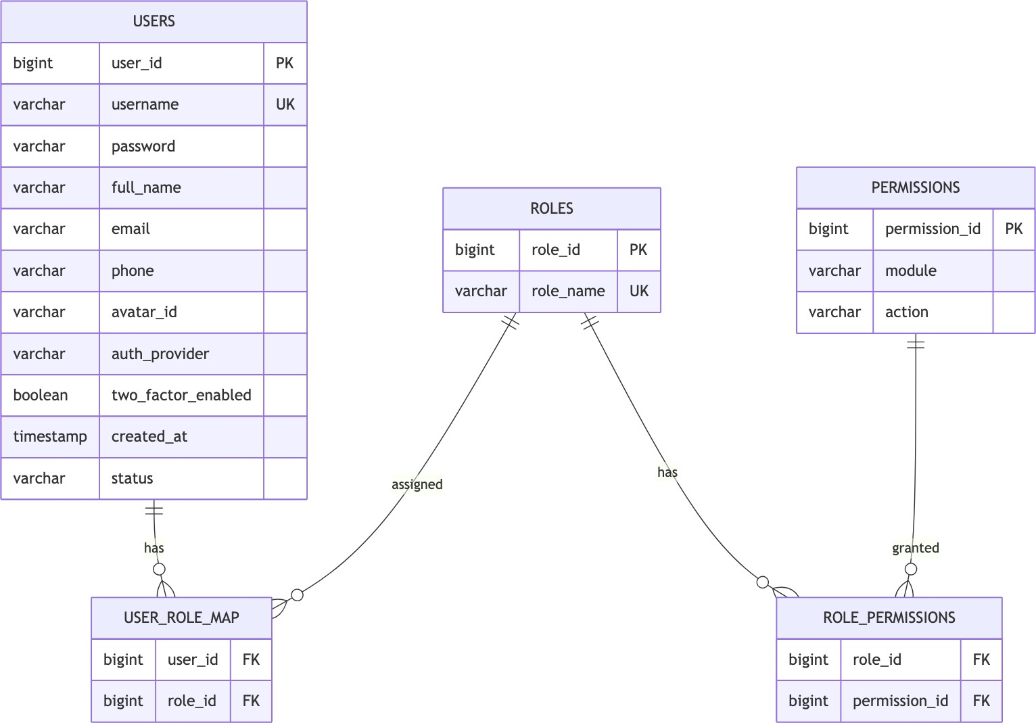

Gym Management Entities
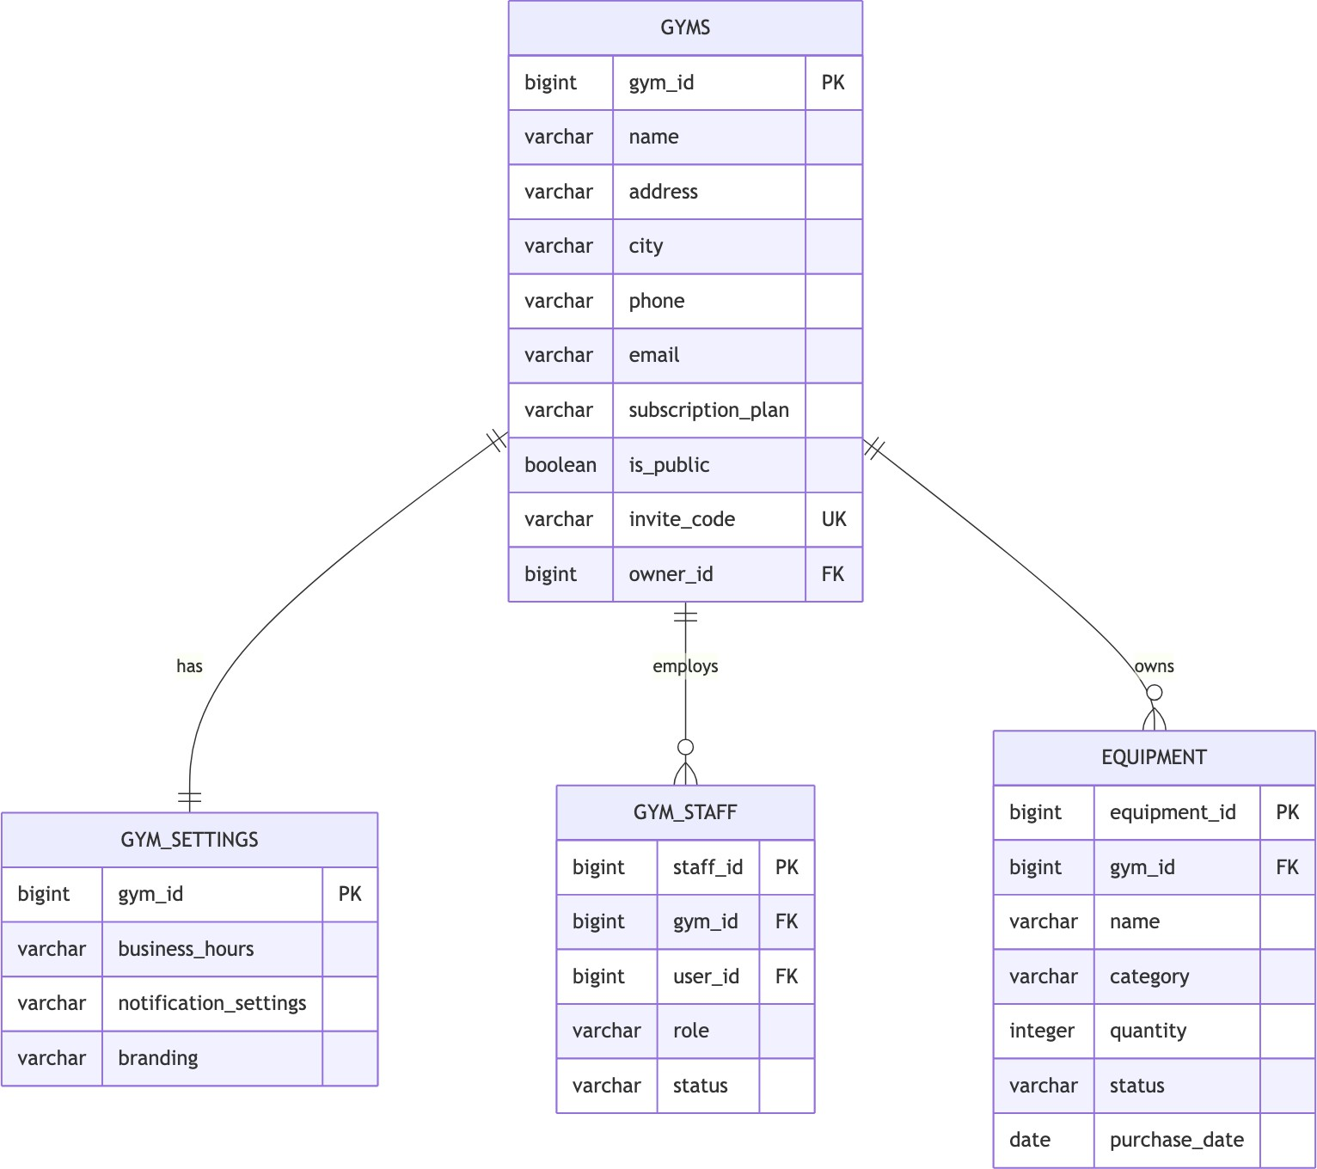

Membership Entities
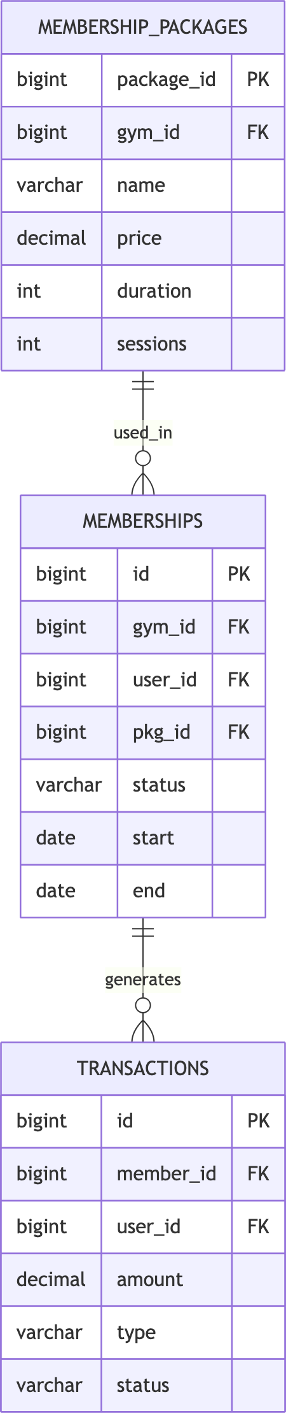

Training & Session Entities
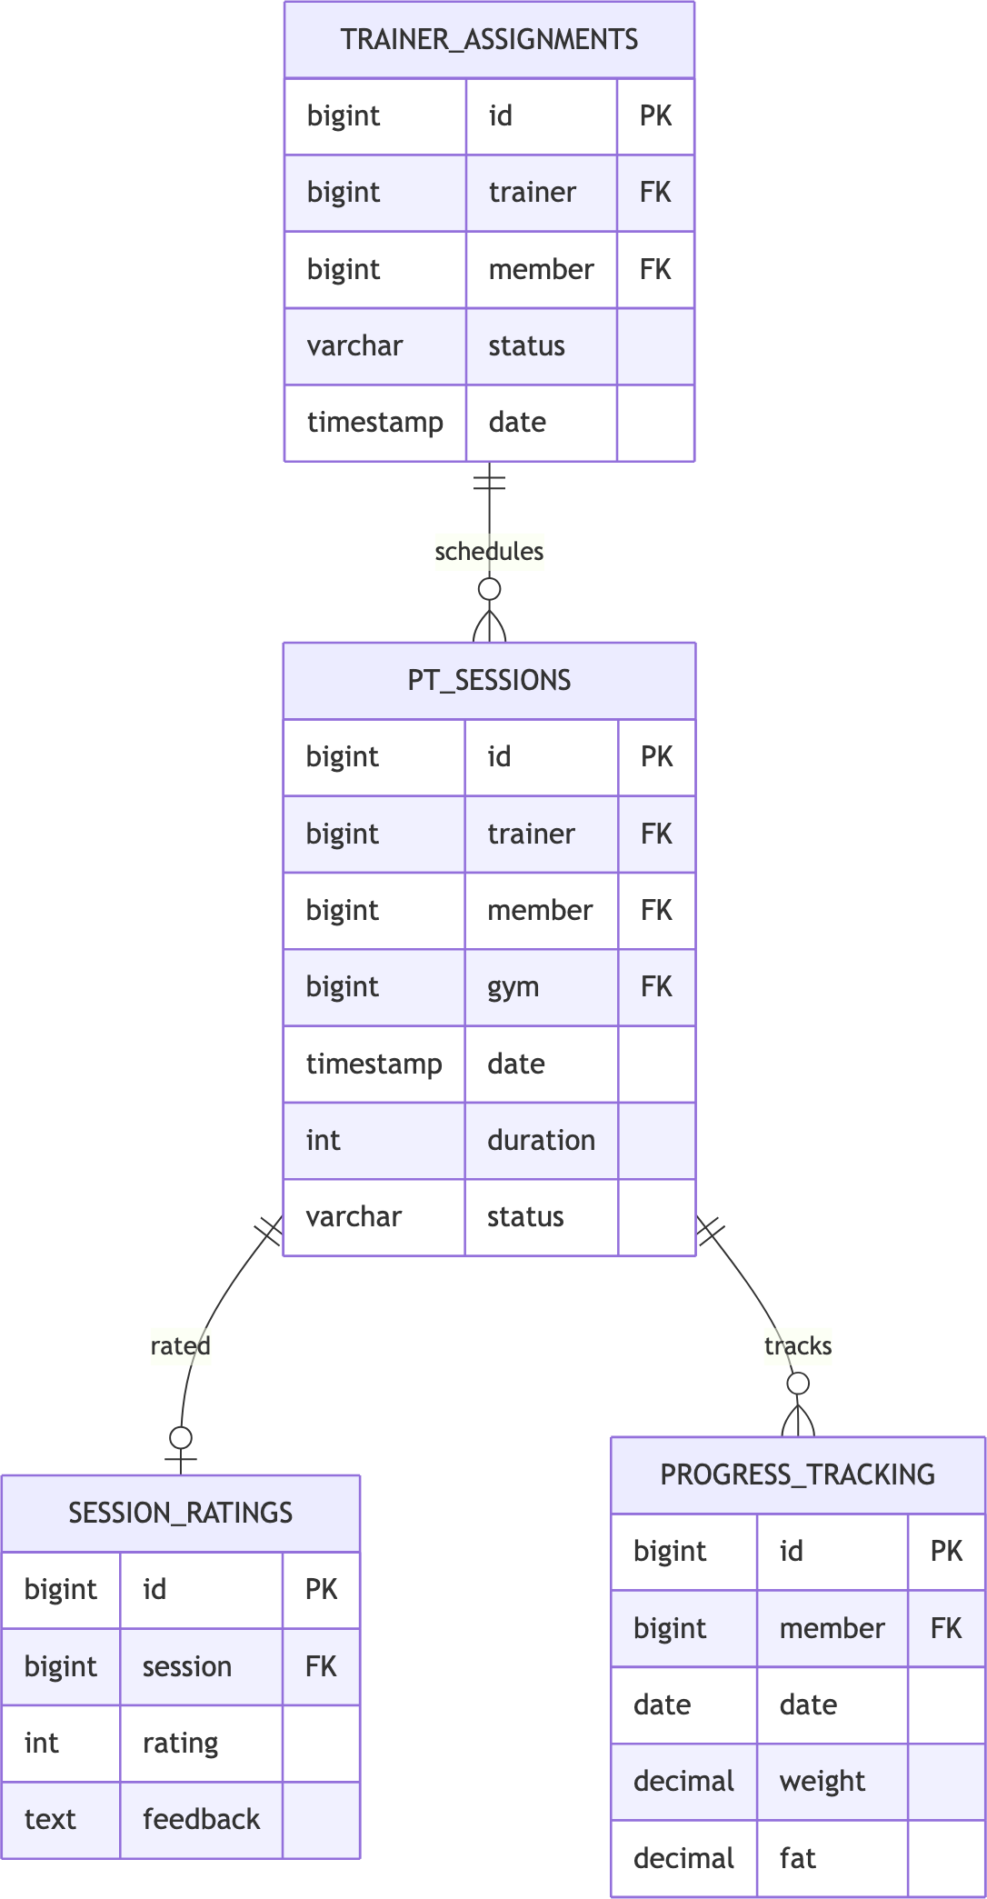

Communication Entities
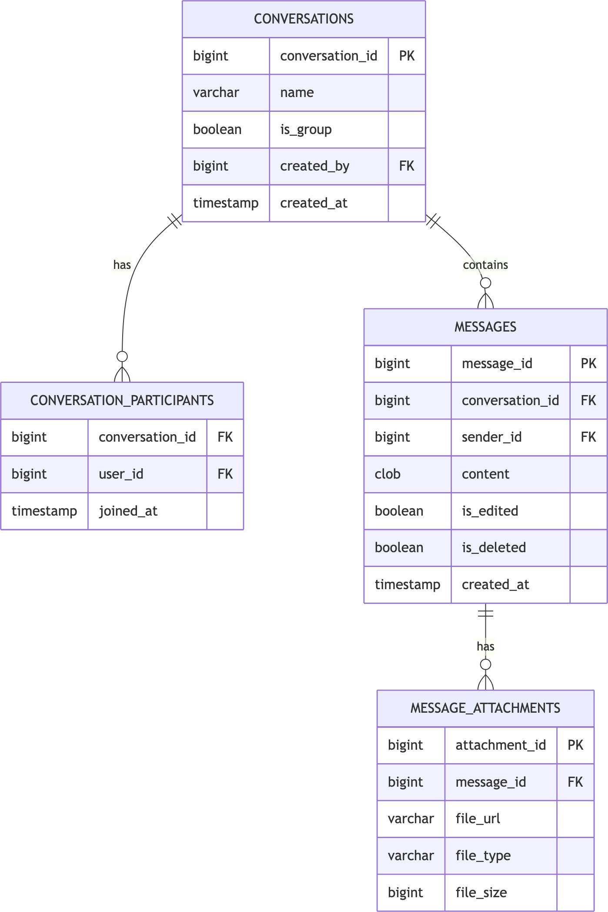

Notification Entities
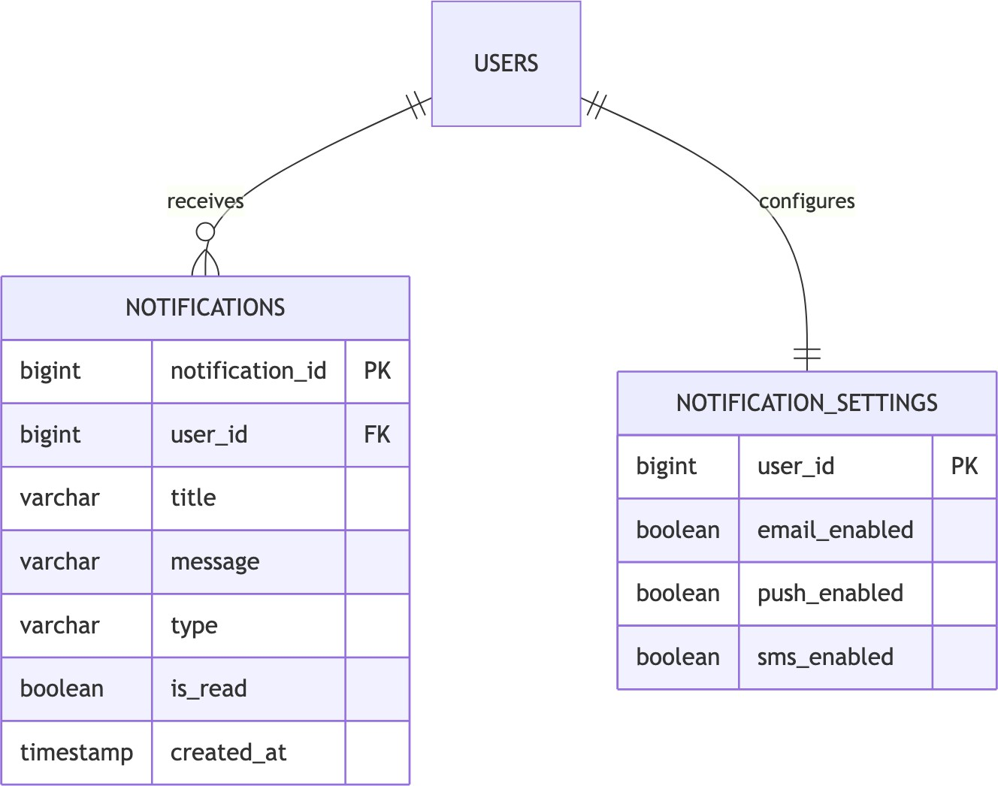

Analytics Entities
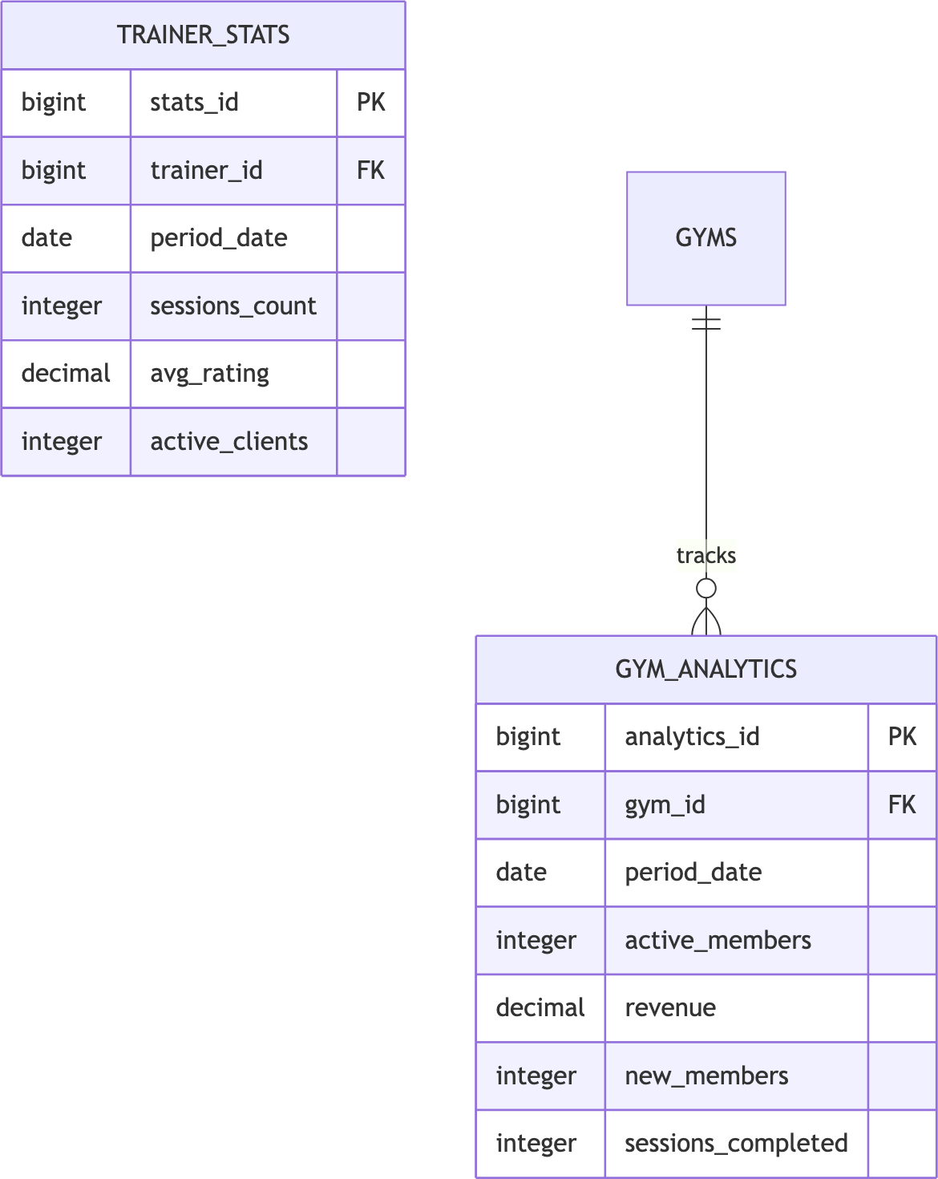

Entity Summary Table

Category Entities Key Relationships

Auth Users, Roles,
Permissions
Gym Gyms, Settings, Staff, Equipment
Many-to-many via mapping tables Owner-owned, one-to-many

Category Entities Key Relationships

Members Packages, Memberships, Transactions
Training Assignments, Sessions, Ratings, Progress
Chat Conversations,
Messages, Attachments
Package → Membership → Transaction Trainer-Member assignments Conversation hierarchy

Notify Notifications, Settings User notifications

Analytics Gym Analytics, Trainer Stats
Period-based aggregations

Chapter 6: UML Diagrams - Gym Management System

Class Diagram - Core User & Auth
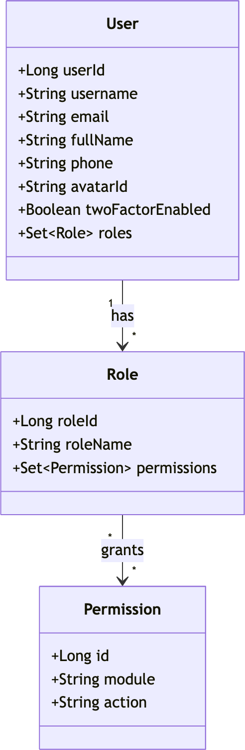

Class Diagram - Gym & Membership
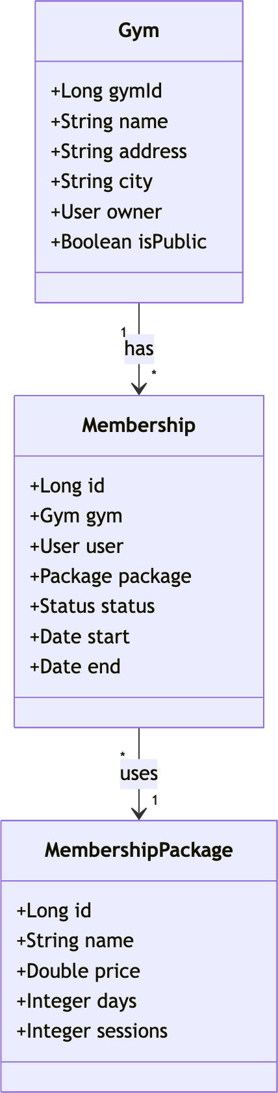

Class Diagram - Training & Sessions
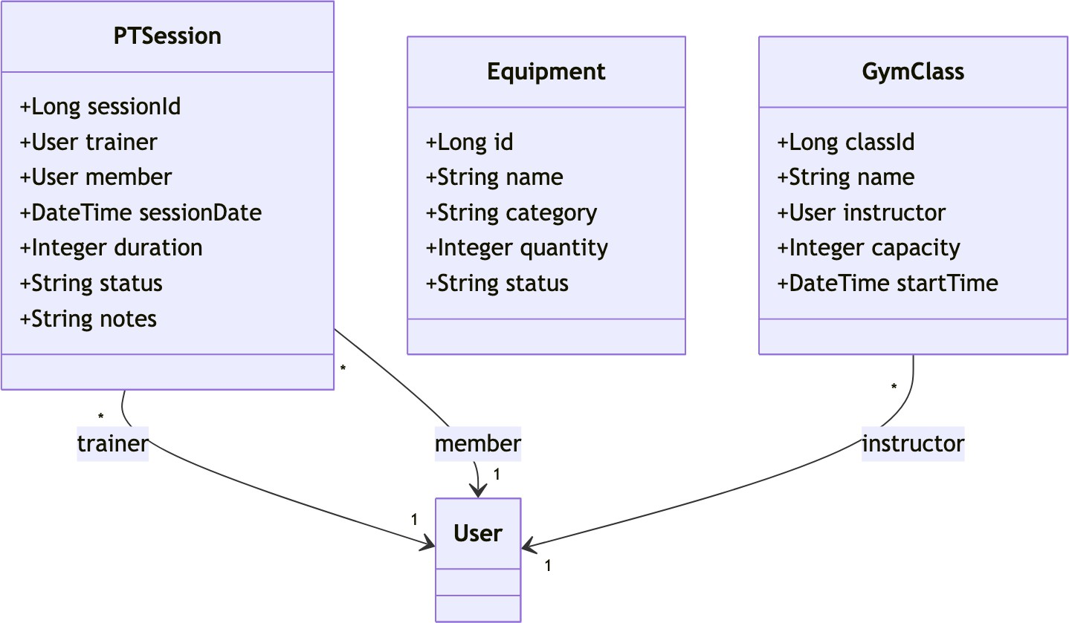

Class Diagram - Communication
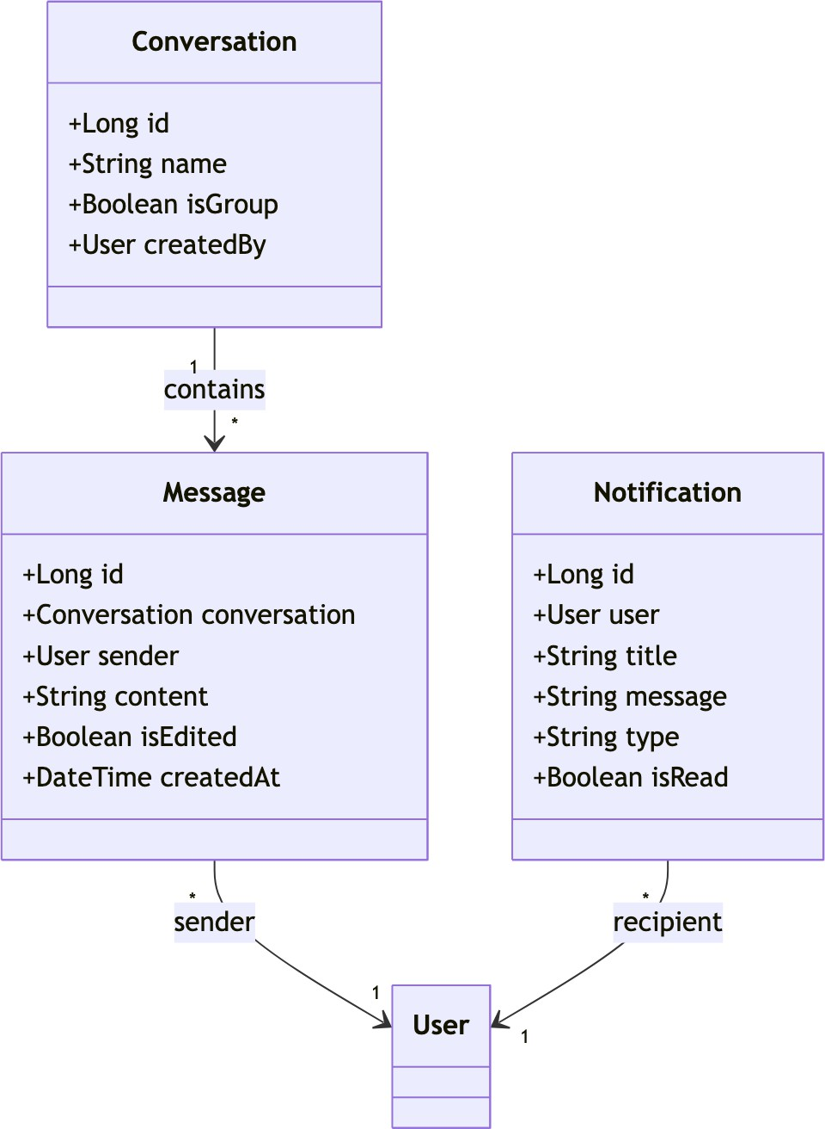

Use Case Diagram
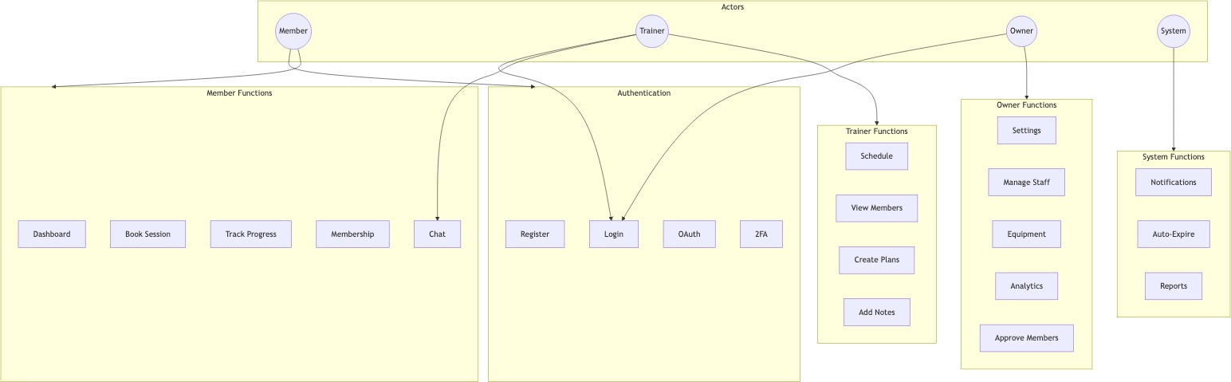

Sequence Diagrams

User Authentication Flow
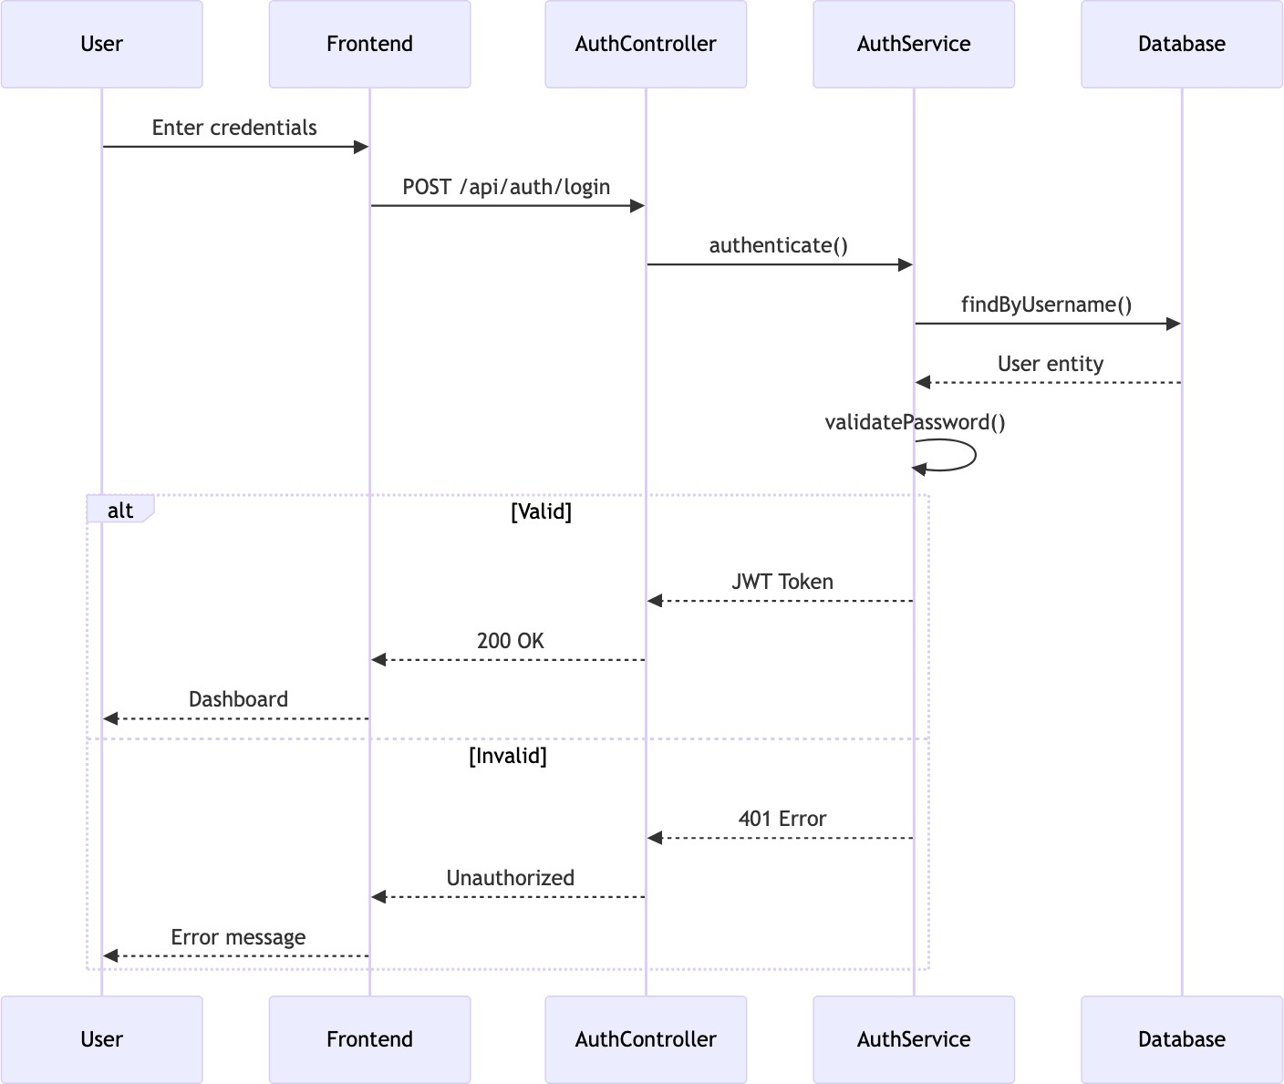

Membership Purchase Flow
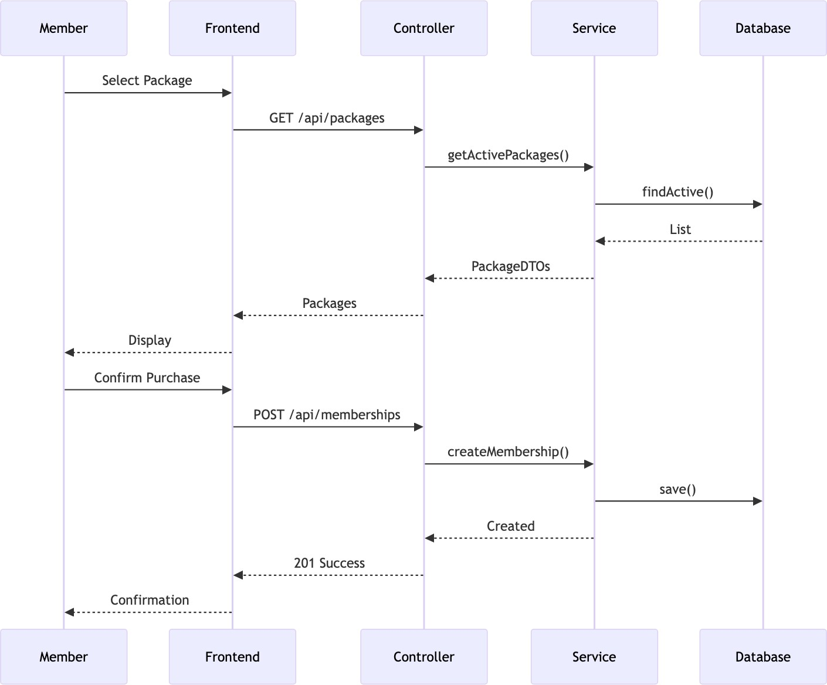

PT Session Booking Flow
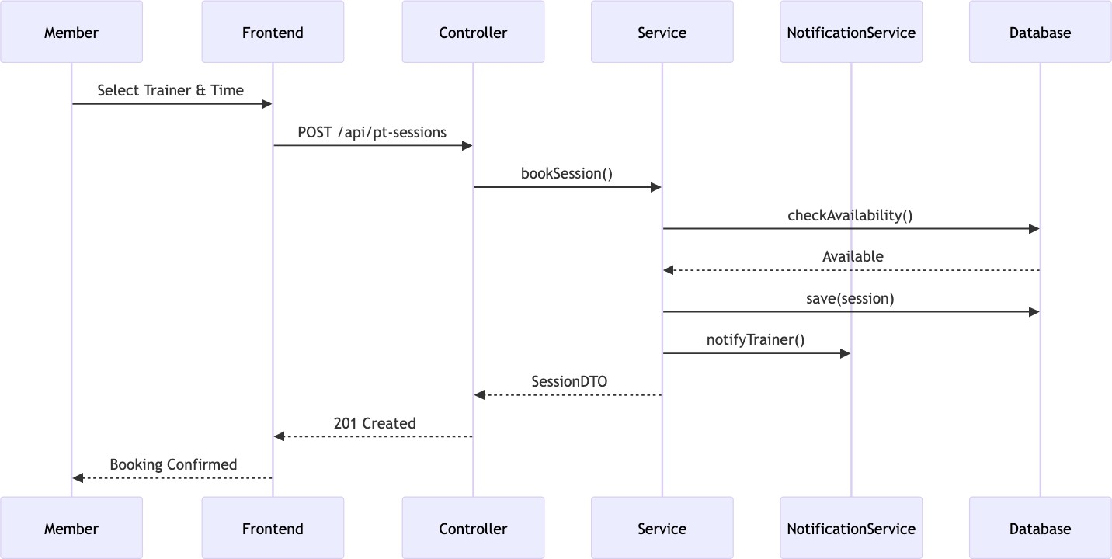

Activity Diagrams

User Registration Process
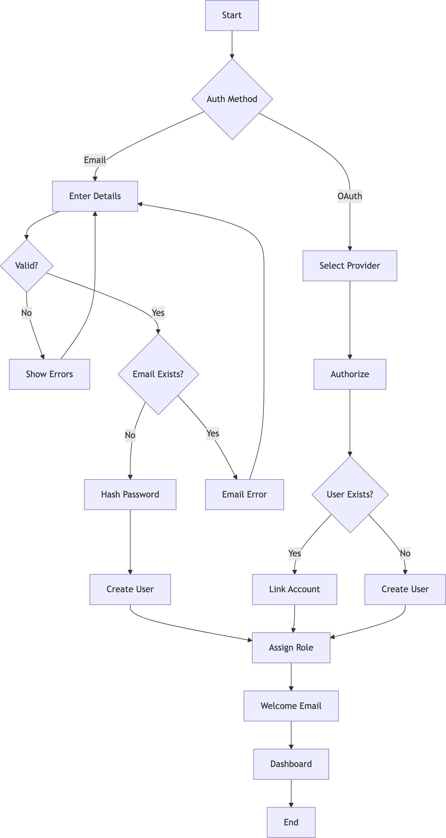

Membership Approval Workflow
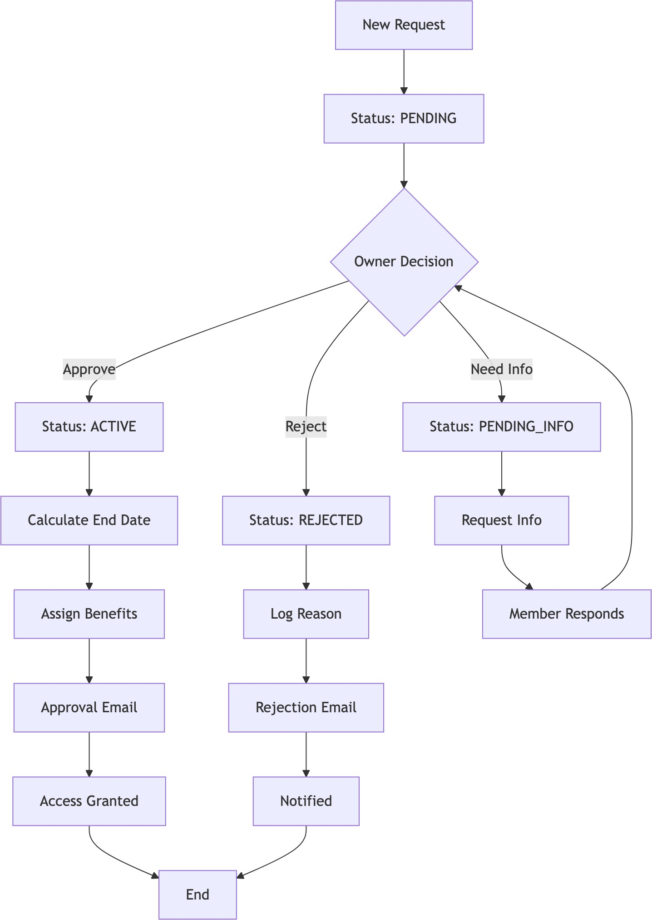

Chat Message Flow
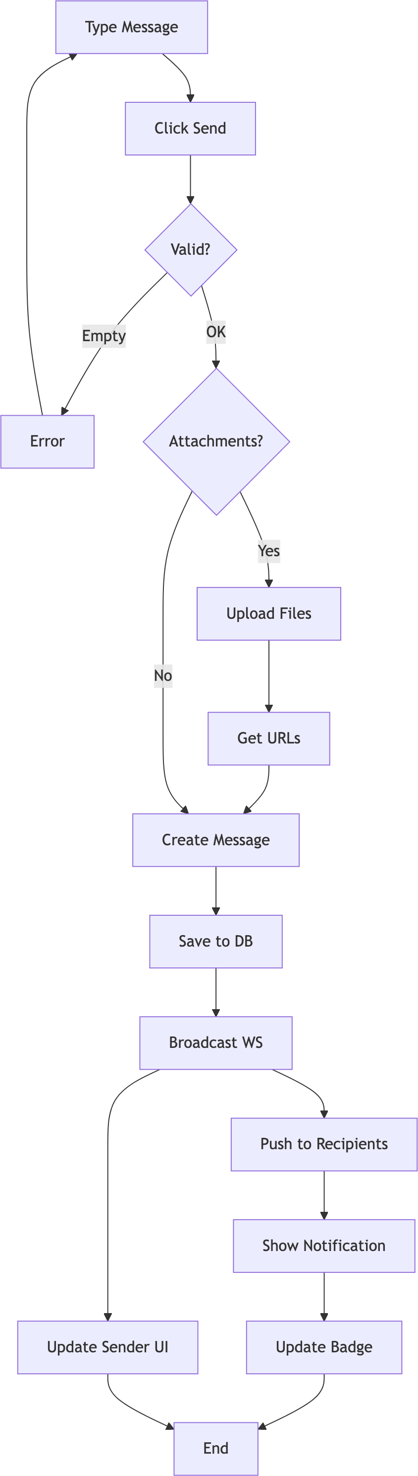

Chapter 7: Data Flow Diagrams - Gym Management System

  - Level 0: Context Diagram
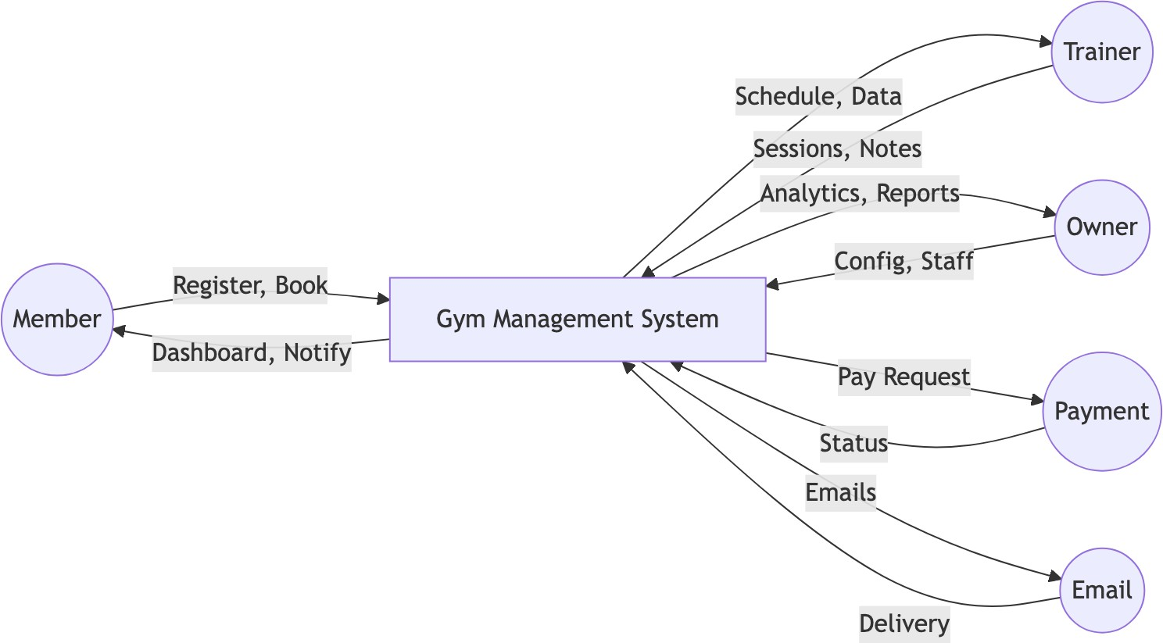

  - Level 1: Main Processes
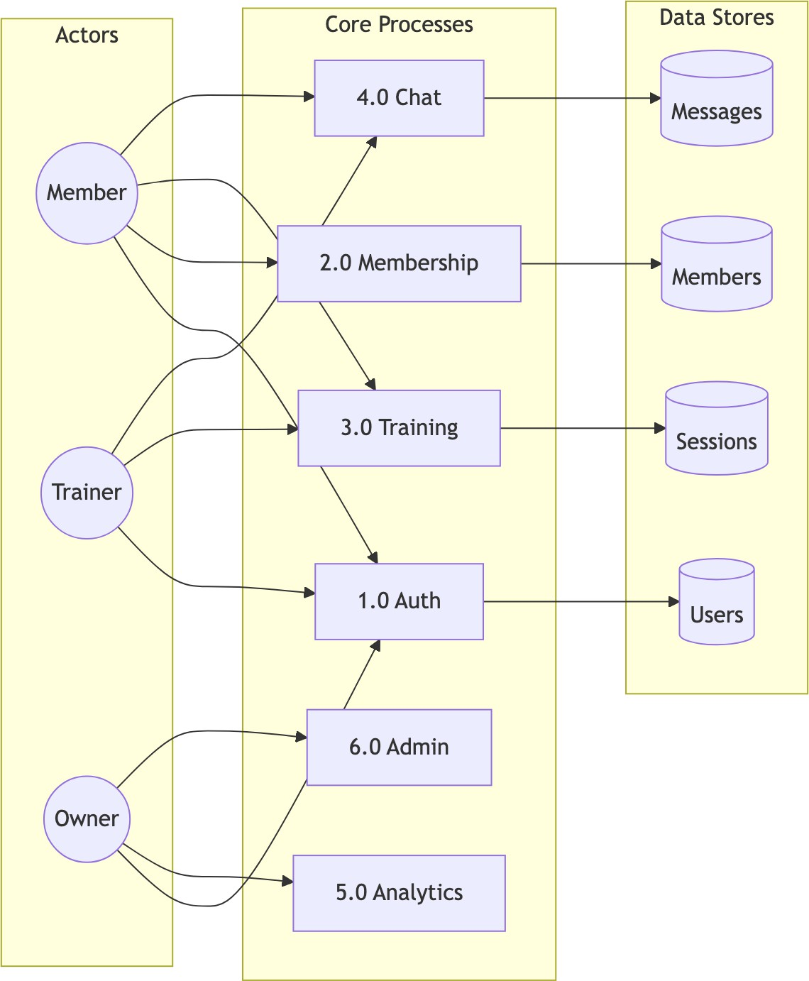

  - Level 2: Detailed Sub-Processes
    - Authentication (Process 1.0)
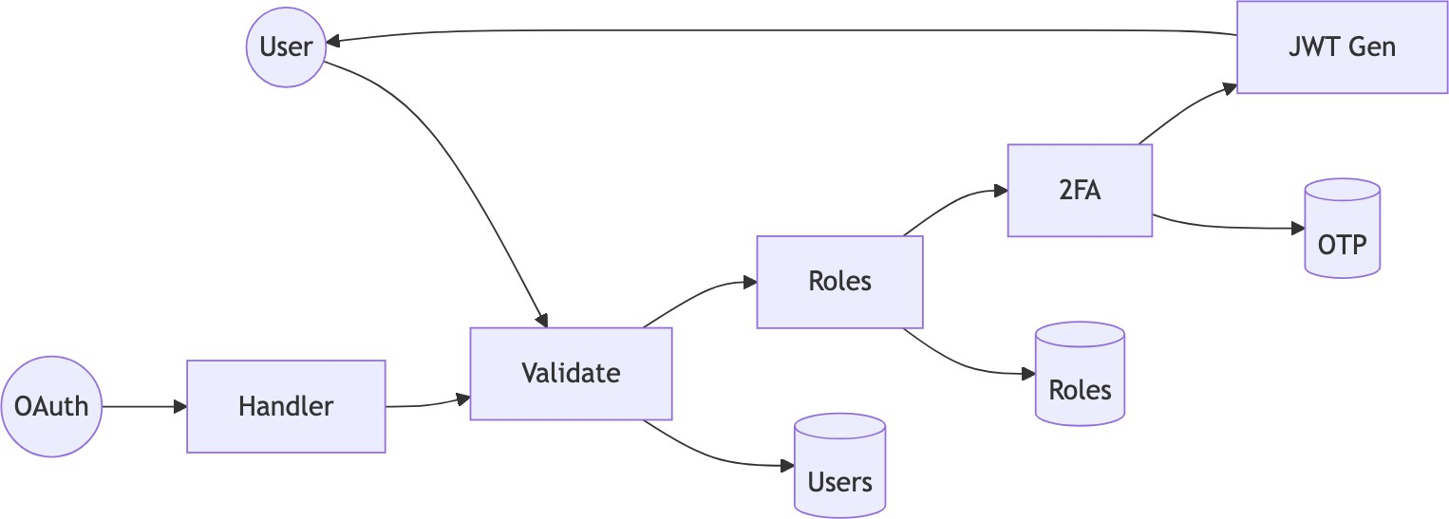

    - Membership (Process 2.0)
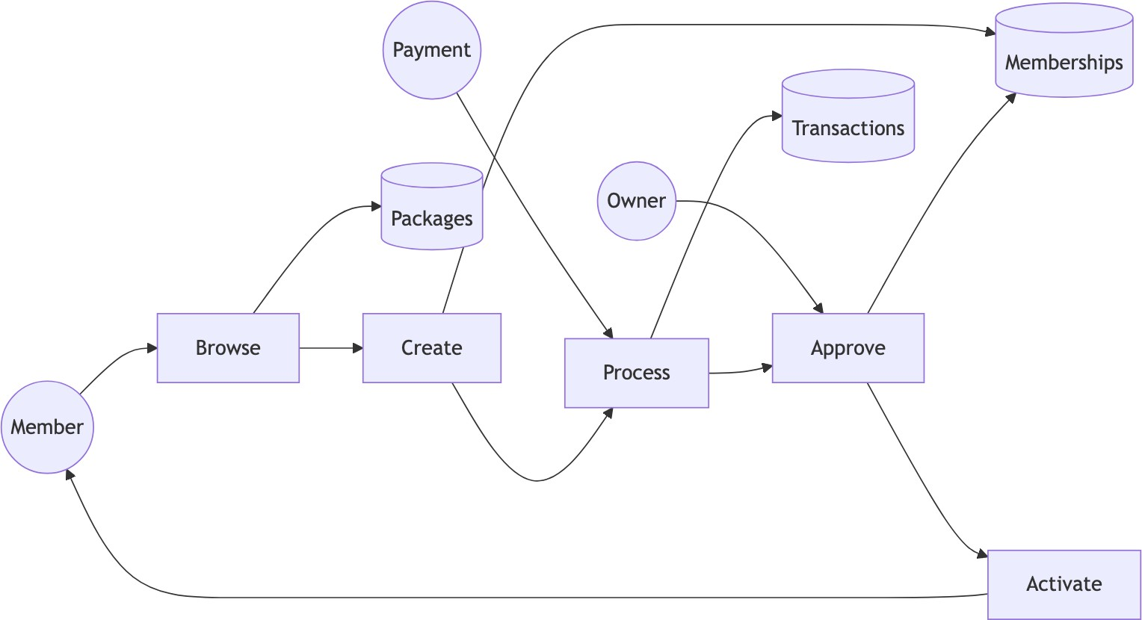

    - Training (Process 3.0)
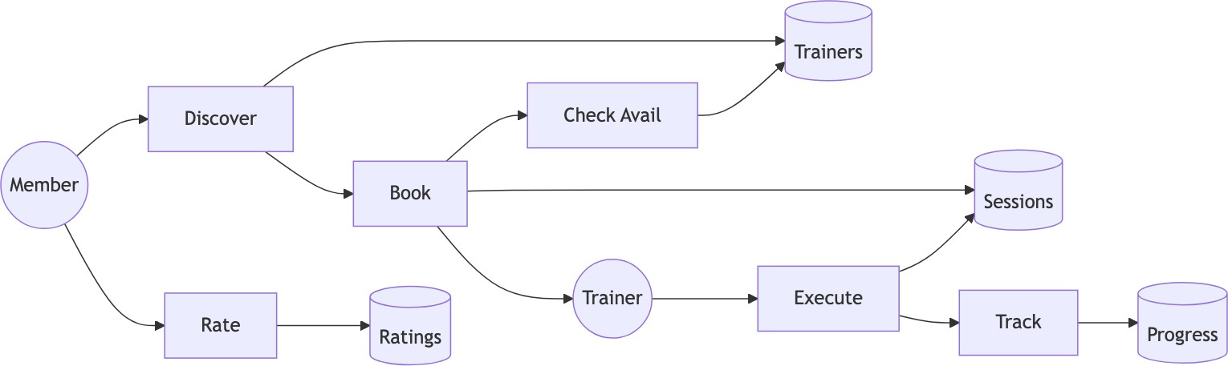

    - Communication (Process 4.0)
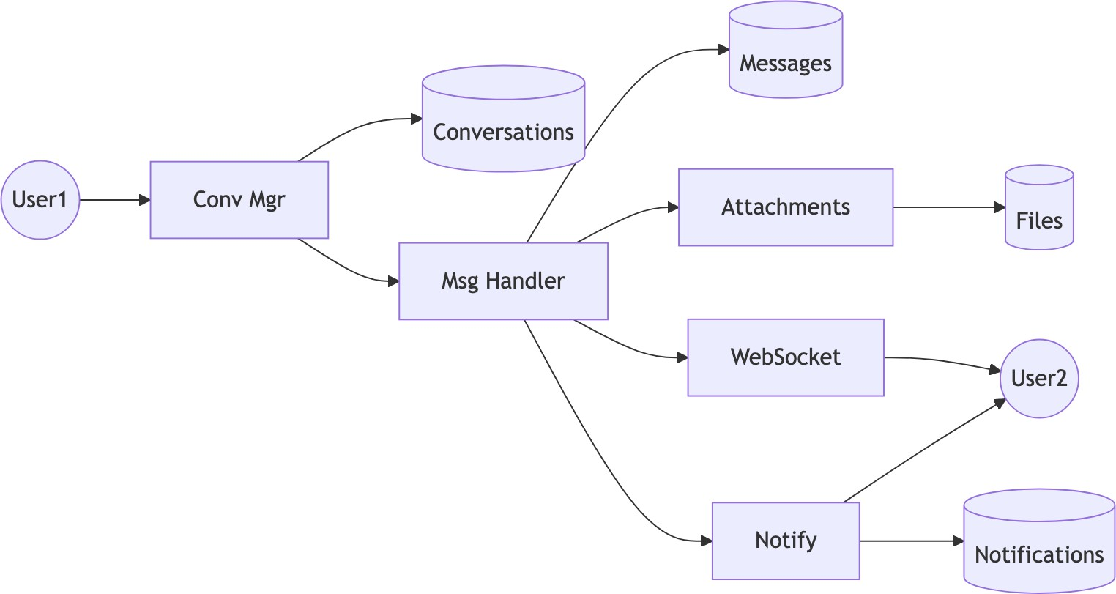

    - Analytics (Process 5.0)
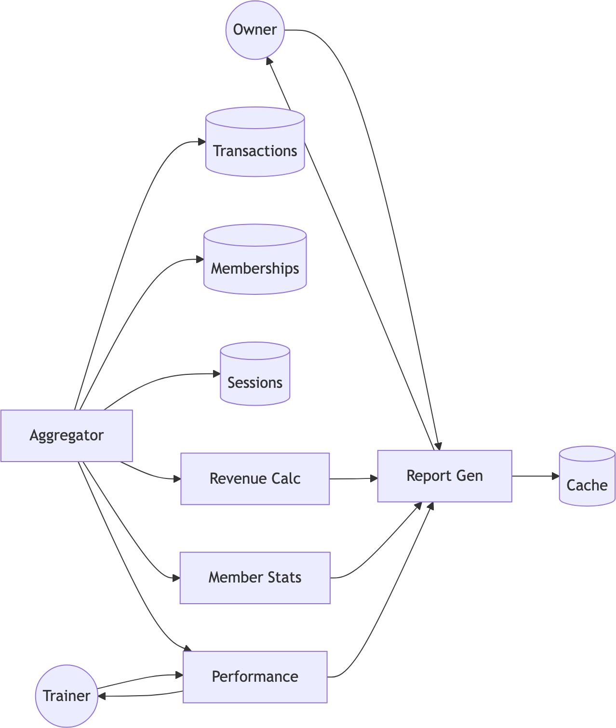

  - Data Dictionary

Store | Description | Key Fields
Users | System users | user_id, email, roles
Memberships | Subscriptions | id, user_id, status
Sessions | PT records | id, trainer_id, date
Messages | Chat messages | id, content
Transactions | Payments | id, amount, status

Chapter 8: Algorithms - Gym Management System

JWT Authentication Algorithm

Token Generation
ALGORITHM: JWT_Token_Generation INPUT: User user, Set<Role> roles OUTPUT: String jwtToken

BEGIN
// Create claims payload claims = {
"sub": user.username, "userId": user.userId, "email": user.email,
"roles": roles.map(r -> r.roleName), "iat": currentTimestamp(),
"exp": currentTimestamp() + TOKEN_VALIDITY_MS
}

// Sign with HMAC-SHA512 header = {
"alg": "HS512",
"typ": "JWT"
}

signature = HMAC_SHA512(
base64Encode(header) + "." + base64Encode(claims), SECRET_KEY
)

END
RETURN base64Encode(header) + "." + base64Encode(claims) + "." + base64Encode(signature)

Token Validation
ALGORITHM: JWT_Token_Validation INPUT: String token
OUTPUT: Claims claims OR Exception

BEGIN
parts = token.split(".")

IF parts.length != 3 THEN
THROW InvalidTokenException END IF

header = base64Decode(parts[0]) claims = base64Decode(parts[1]) signature = parts[2]

// Verify signature
expectedSig = base64Encode(HMAC_SHA512( parts[0] + "." + parts[1], SECRET_KEY
))

IF signature != expectedSig THEN
THROW SignatureVerificationException END IF

// Check expiration
IF claims.exp < currentTimestamp() THEN THROW TokenExpiredException
END IF

RETURN claims
END

Role-Based Access Control (RBAC) Algorithm

Permission Check
ALGORITHM: RBAC_Permission_Check
INPUT: User user, String module, String action OUTPUT: Boolean hasPermission

BEGIN
// Get all user roles userRoles = user.getRoles()

// Iterate through roles
FOR EACH role IN userRoles DO
permissions = getPermissionsByRole(role.roleId)

FOR EACH permission IN permissions DO IF permission.module == module AND
permission.action == action THEN RETURN TRUE
END IF

// Check wildcard permissions IF permission.module == "*" OR
permission.action == "*" THEN
IF matchesWildcard(permission, module, action) THEN RETURN TRUE

END IF END IF
END FOR END FOR

RETURN FALSE
END

FUNCTION matchesWildcard(permission, module, action): IF permission.module == "*" THEN
RETURN permission.action == action OR permission.action == "*"
END IF
IF permission.action == "*" THEN RETURN permission.module == module
END IF RETURN FALSE
END FUNCTION

Role Hierarchy
ROLE_HIERARCHY = {
ADMIN: [OWNER, TRAINER, MEMBER, CUSTOMER], OWNER: [TRAINER, MEMBER],
TRAINER: [MEMBER], MEMBER: [CUSTOMER], CUSTOMER: []
}

ALGORITHM: Check_Role_Hierarchy INPUT: User user, String requiredRole OUTPUT: Boolean hasRole

BEGIN
userRoles = user.getRoles()

FOR EACH role IN userRoles DO
IF role.name == requiredRole THEN RETURN TRUE
END IF

// Check inherited roles
inheritedRoles = ROLE_HIERARCHY[role.name] IF requiredRole IN inheritedRoles THEN
RETURN TRUE END IF
END FOR

RETURN FALSE
END

Membership Package Assignment Algorithm
ALGORITHM: Assign_Membership
INPUT: User member, MembershipPackage package, Gym gym OUTPUT: Membership membership

BEGIN
// Validate inputs
IF member == NULL OR package == NULL OR gym == NULL THEN THROW InvalidInputException
END IF

// Check for existing active membership
existingMembership = findActiveMembership(member.userId, gym.gymId)

IF existingMembership != NULL THEN
IF existingMembership.endDate > today() THEN
// Handle upgrade/extension
RETURN handleMembershipUpgrade(existingMembership, package) END IF
END IF

// Calculate dates startDate = today()
endDate = startDate.plusDays(package.durationDays)

// Create new membership membership = new Membership() membership.user = member membership.gym = gym
membership.membershipPackage = package membership.startDate = startDate membership.endDate = endDate membership.status = PENDING membership.createdAt = now()

// Assign PT session credits
IF package.includedPTSessions > 0 THEN createPTSessionCredits(member, package.includedPTSessions)
END IF

// Save and return save(membership)
sendNotification(gym.owner, "New membership request")

RETURN membership
END

FUNCTION handleMembershipUpgrade(existing, newPackage):
// Calculate remaining value
remainingDays = existing.endDate - today()
remainingValue = (remainingDays / existing.package.durationDays)

* existing.package.price

// Apply credit to new package
newPrice = newPackage.price - remainingValue

// Extend end date existing.membershipPackage = newPackage
existing.endDate = today().plusDays(newPackage.durationDays)

save(existing) RETURN existing
END FUNCTION

Session Rating Calculation Algorithm
ALGORITHM: Calculate_Trainer_Rating INPUT: Long trainerId
OUTPUT: TrainerStats stats

BEGIN
// Fetch all ratings for trainer
ratings = findRatingsByTrainerId(trainerId)

IF ratings.isEmpty() THEN RETURN TrainerStats(
averageRating: 0.0,
totalReviews: 0, ratingDistribution: {}
) END IF

// Calculate statistics totalSum = 0
distribution = {1: 0, 2: 0, 3: 0, 4: 0, 5: 0}

FOR EACH rating IN ratings DO
totalSum = totalSum + rating.score distribution[rating.score]++
END FOR

averageRating = totalSum / ratings.size()

// Round to 1 decimal place
averageRating = ROUND(averageRating * 10) / 10

// Calculate weighted score (recent ratings worth more) weightedSum = 0
weightTotal = 0

FOR i = 0 TO ratings.size() - 1 DO
weight = 1 + (i * 0.1) // Recent ratings weighted higher weightedSum = weightedSum + (ratings[i].score * weight) weightTotal = weightTotal + weight
END FOR

weightedAverage = weightedSum / weightTotal

RETURN TrainerStats( averageRating: averageRating,
weightedRating: ROUND(weightedAverage * 10) / 10, totalReviews: ratings.size(),
ratingDistribution: distribution
)
END

Analytics Computation Algorithm

Revenue Calculation
ALGORITHM: Calculate_Revenue_Analytics INPUT: Long gymId, DateRange period OUTPUT: RevenueAnalytics analytics

BEGIN
transactions = findTransactionsByGymAndPeriod(gymId, period)

// Calculate totals totalRevenue = 0 revenueByType = {} revenueByDay = {}

FOR EACH txn IN transactions DO
IF txn.status == "COMPLETED" THEN totalRevenue = totalRevenue + txn.amount

// Group by type type = txn.type
revenueByType[type] = (revenueByType[type] OR 0) + txn.amount

// Group by day
day = txn.createdAt.toDate()
revenueByDay[day] = (revenueByDay[day] OR 0) + txn.amount END IF
END FOR

// Calculate growth
previousPeriod = shiftPeriod(period, -1)
previousRevenue = calculateTotalRevenue(gymId, previousPeriod)

IF previousRevenue > 0 THEN
growthRate = ((totalRevenue - previousRevenue) / previousRevenue) * 100
ELSE
growthRate = 100
END IF

// Project monthly
daysInPeriod = period.end - period.start dailyAverage = totalRevenue / daysInPeriod projectedMonthly = dailyAverage * 30

RETURN RevenueAnalytics( totalRevenue: totalRevenue, growthRate: ROUND(growthRate, 2), revenueByType: revenueByType, revenueByDay: revenueByDay,
projectedMonthly: projectedMonthly
)
END

Member Statistics
ALGORITHM: Calculate_Member_Statistics INPUT: Long gymId
OUTPUT: MemberStats stats

BEGIN
memberships = findMembershipsByGym(gymId)

// Count by status activeCount = 0
pendingCount = 0
expiredCount = 0

// Track trends newThisMonth = 0
newLastMonth = 0

currentMonth = getMonthStart(today())
lastMonth = getMonthStart(today().minusMonths(1))

FOR EACH membership IN memberships DO SWITCH membership.status:
CASE ACTIVE:
activeCount++
IF membership.createdAt >= currentMonth THEN newThisMonth++
ELSE IF membership.createdAt >= lastMonth THEN newLastMonth++
END IF CASE PENDING:
pendingCount++

CASE EXPIRED:
expiredCount++ END SWITCH
END FOR

// Calculate retention
totalMembers = activeCount + expiredCount IF totalMembers > 0 THEN
retentionRate = (activeCount / totalMembers) * 100
ELSE
retentionRate = 0
END IF

// Calculate growth
IF newLastMonth > 0 THEN
growthRate = ((newThisMonth - newLastMonth) / newLastMonth) * 100
ELSE
growthRate = newThisMonth > 0 ? 100 : 0
END IF

RETURN MemberStats( totalActive: activeCount, totalPending: pendingCount, totalExpired: expiredCount, newThisMonth: newThisMonth,
retentionRate: ROUND(retentionRate, 2),
monthlyGrowth: ROUND(growthRate, 2)
)
END

Duplicate Package Cleanup Algorithm
ALGORITHM: Cleanup_Duplicate_Packages INPUT: None (scheduled job)
OUTPUT: Integer deletedCount

BEGIN
allPackages = findAllPackages()

IF allPackages.size() < 2 THEN RETURN 0
END IF

// Group by name + duration (case-insensitive) groupedPackages = {}

FOR EACH pkg IN allPackages DO
key = toLowerCase(trim(pkg.packageName)) + "|" + pkg.durationDays

IF groupedPackages[key] == NULL THEN groupedPackages[key] = []
END IF

groupedPackages[key].add(pkg) END FOR

// Find and delete duplicates duplicatesToDelete = []

FOR EACH key, packages IN groupedPackages DO IF packages.size() > 1 THEN
// Sort by ID (keep oldest) sortById(packages)

// Check each duplicate for usage FOR i = 1 TO packages.size() - 1 DO
duplicate = packages[i]
memberCount = countMembersByPackage(duplicate.packageId)

IF memberCount == 0 THEN duplicatesToDelete.add(duplicate.packageId)
END IF END FOR
END IF END FOR

// Delete unused duplicates
IF duplicatesToDelete.size() > 0 THEN deletePackagesByIds(duplicatesToDelete)
END IF

RETURN duplicatesToDelete.size()
END

Password Hashing Algorithm
ALGORITHM: Hash_Password INPUT: String plainPassword OUTPUT: String hashedPassword

BEGIN
// BCrypt configuration SALT_ROUNDS = 12

// Generate salt
salt = generateRandomBytes(16) salt = bcryptSalt(SALT_ROUNDS)

// Hash password
hash = bcrypt(plainPassword, salt)

END
// Output format: $2a$12$<22-char-salt><31-char-hash> RETURN hash

ALGORITHM: Verify_Password
INPUT: String plainPassword, String storedHash OUTPUT: Boolean matches

BEGIN
// BCrypt handles salt extraction internally
// Salt is embedded in first 29 characters

computedHash = bcrypt(plainPassword,
extractSalt(storedHash))

END
// Constant-time comparison to prevent timing attacks RETURN secureEquals(computedHash, storedHash)

Algorithm Complexity Analysis

Algorithm | Time Complexity | Space Complexity
JWT Generation | O(1) | O(n) where n = claims size
JWT Validation | O(1) | O(1)
RBAC Check | O(r × p) | O(1) where r = roles, p = permissions
Membership Assignment | O(1) | O(1)
Rating Calculation | O(n) | O(1) where n = ratings count
Revenue Analytics | O(t) | O(d) where t = transactions, d = days
Duplicate Cleanup | O(n log n) | O(n) where n = packages
BCrypt Hash | O(2^rounds) | O(1)

Chapter 9: System Workflows - Gym Management System

User Registration & Authentication

Registration Flow
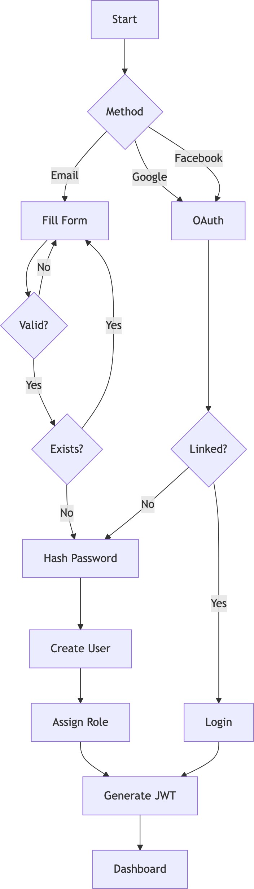

Login with 2FA
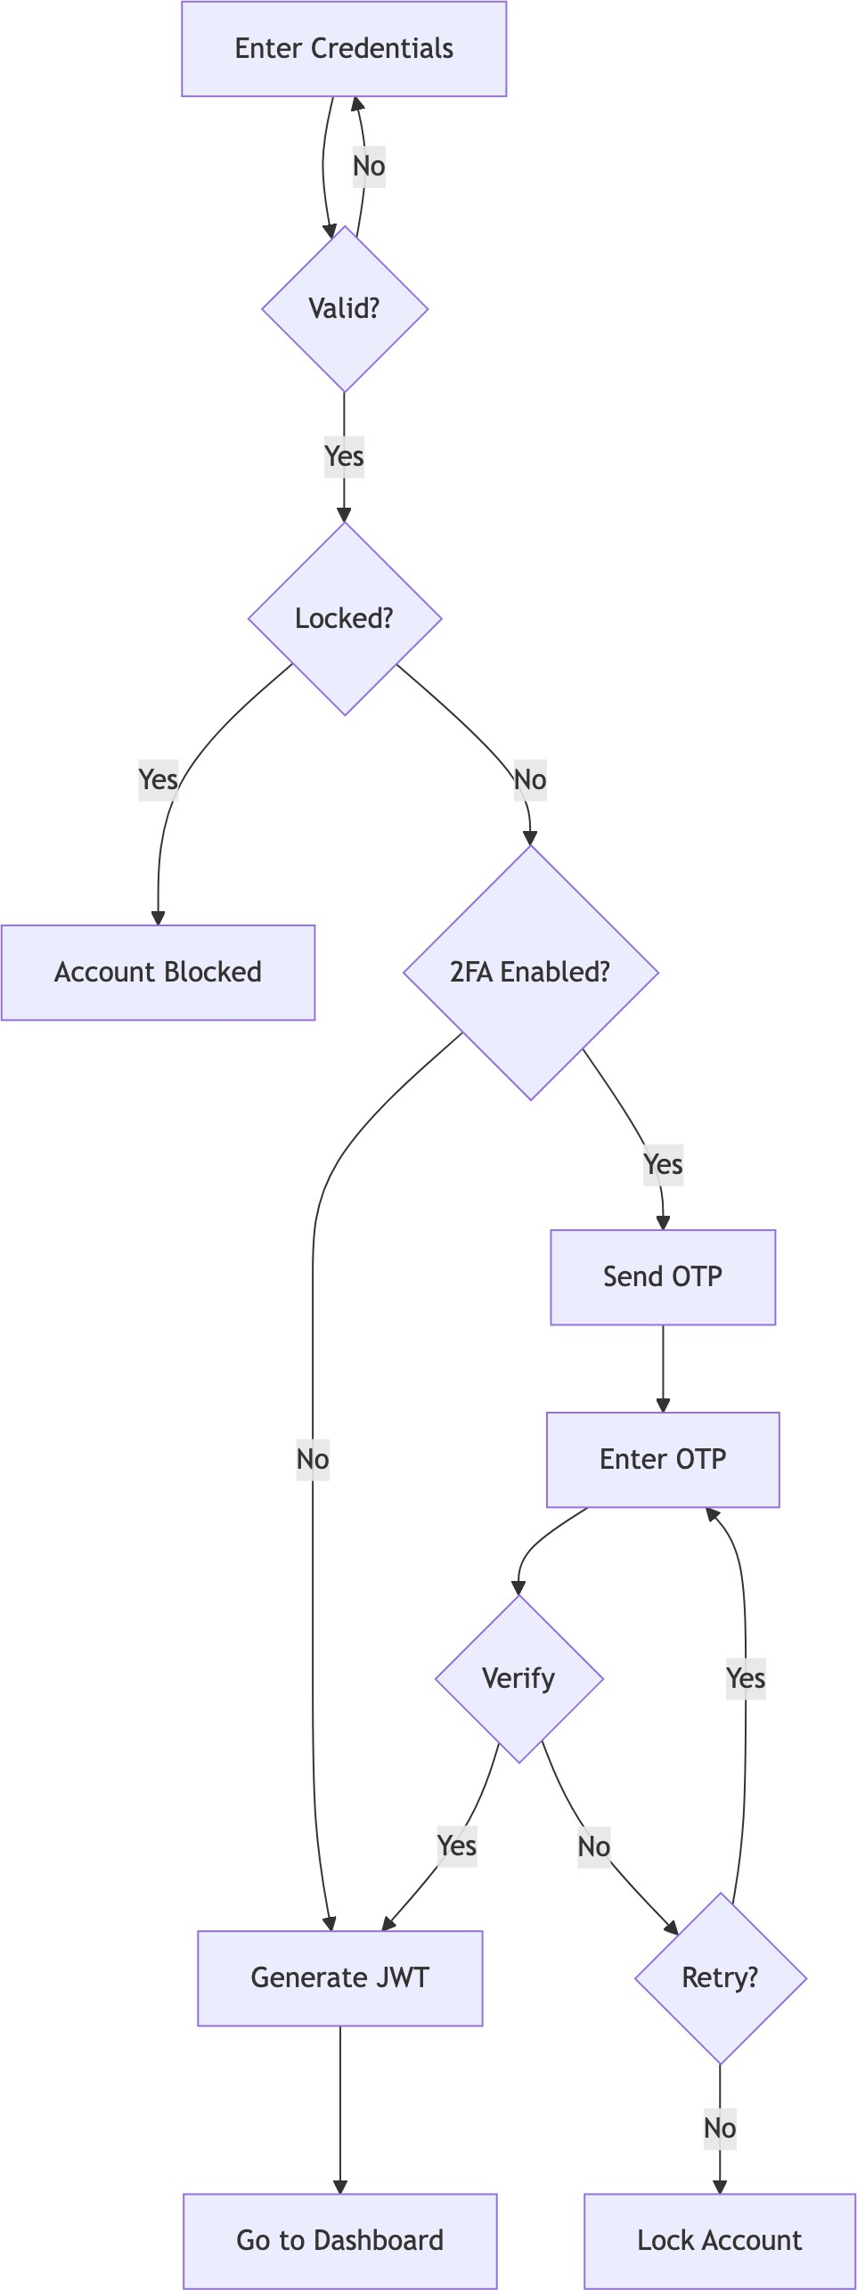

Membership Management

Purchase Flow
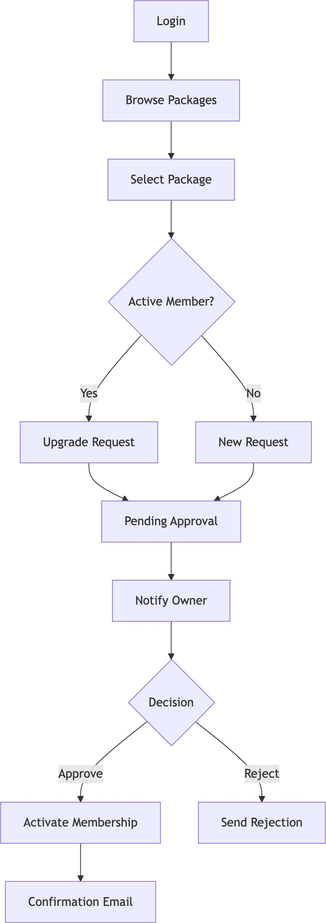

Expiry Handling
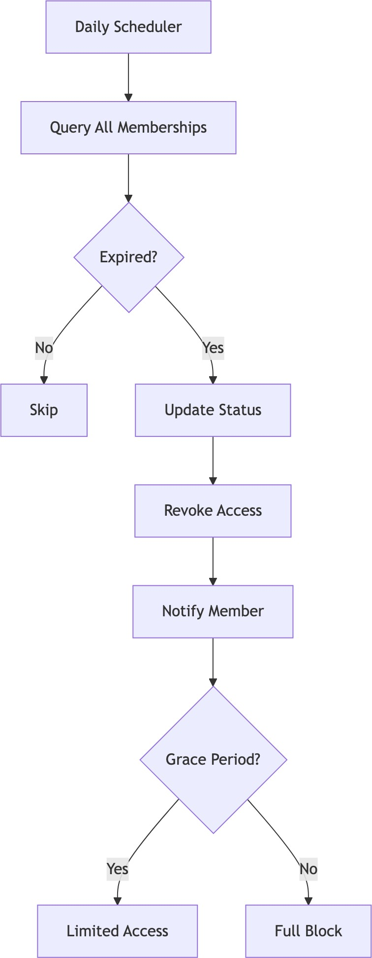

Trainer-Member Interaction

Trainer Assignment
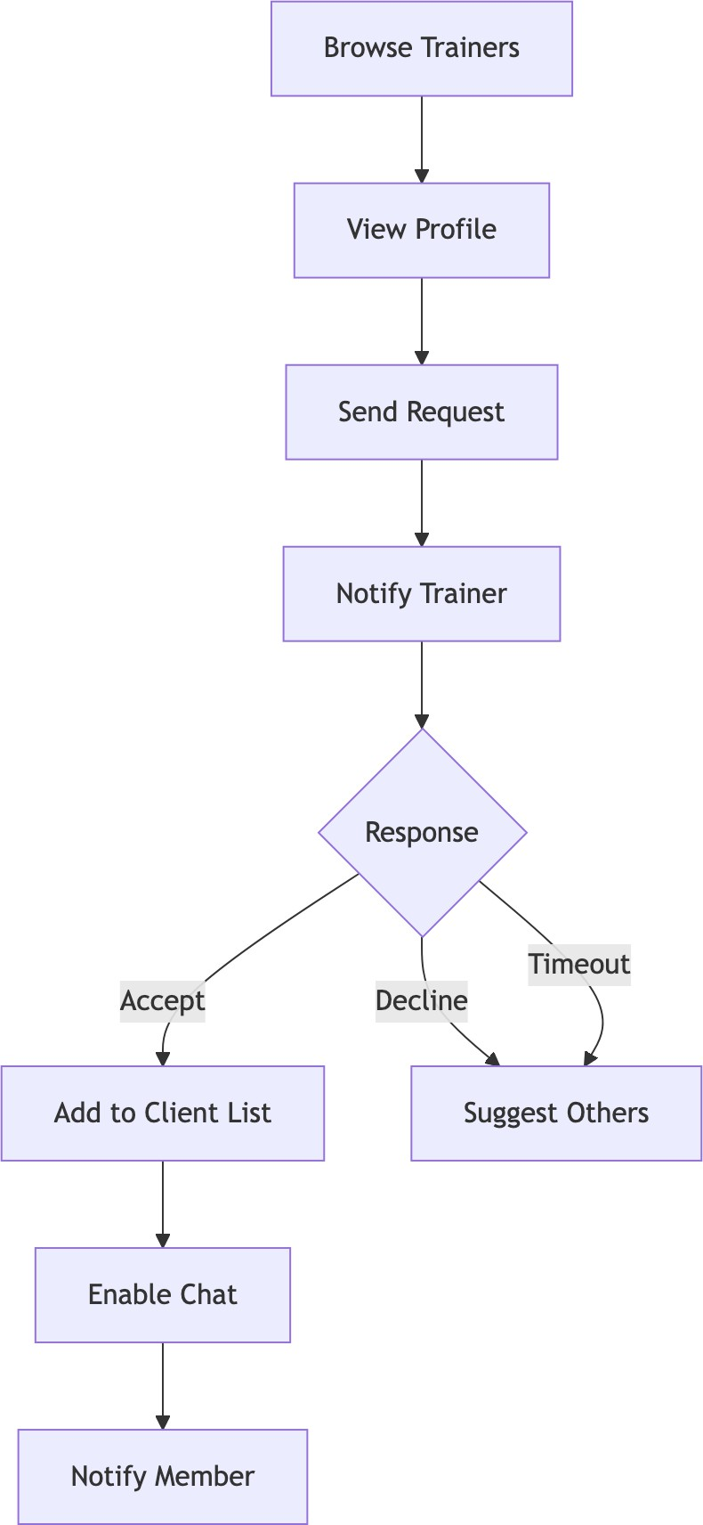

Progress Tracking
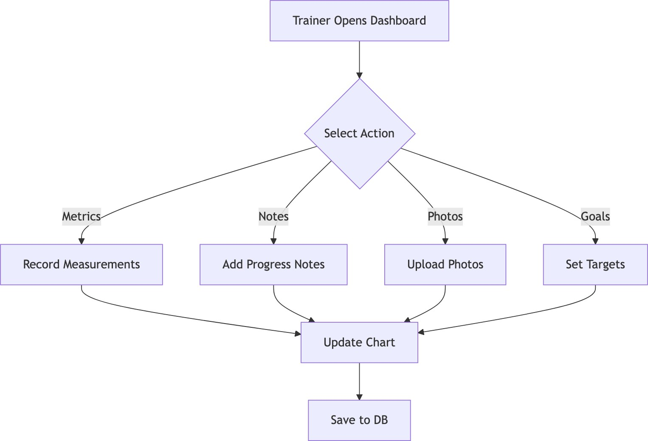

PT Session Booking

Session Creation
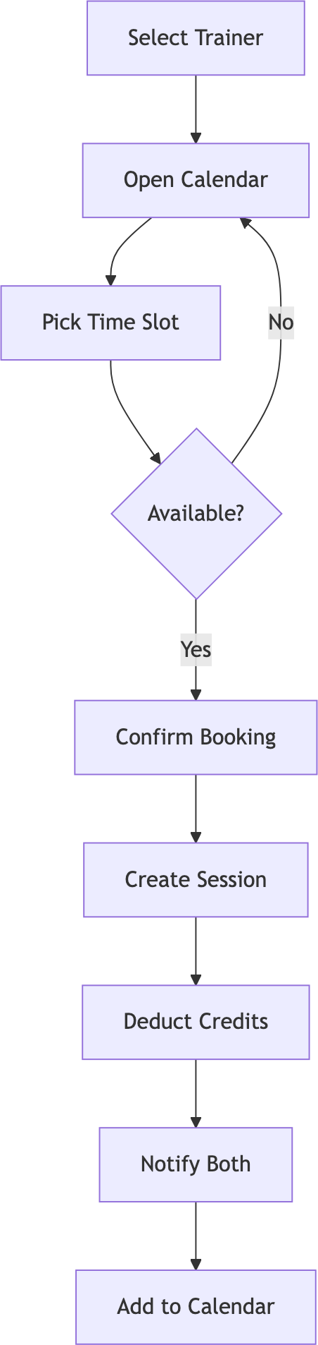

Session Lifecycle
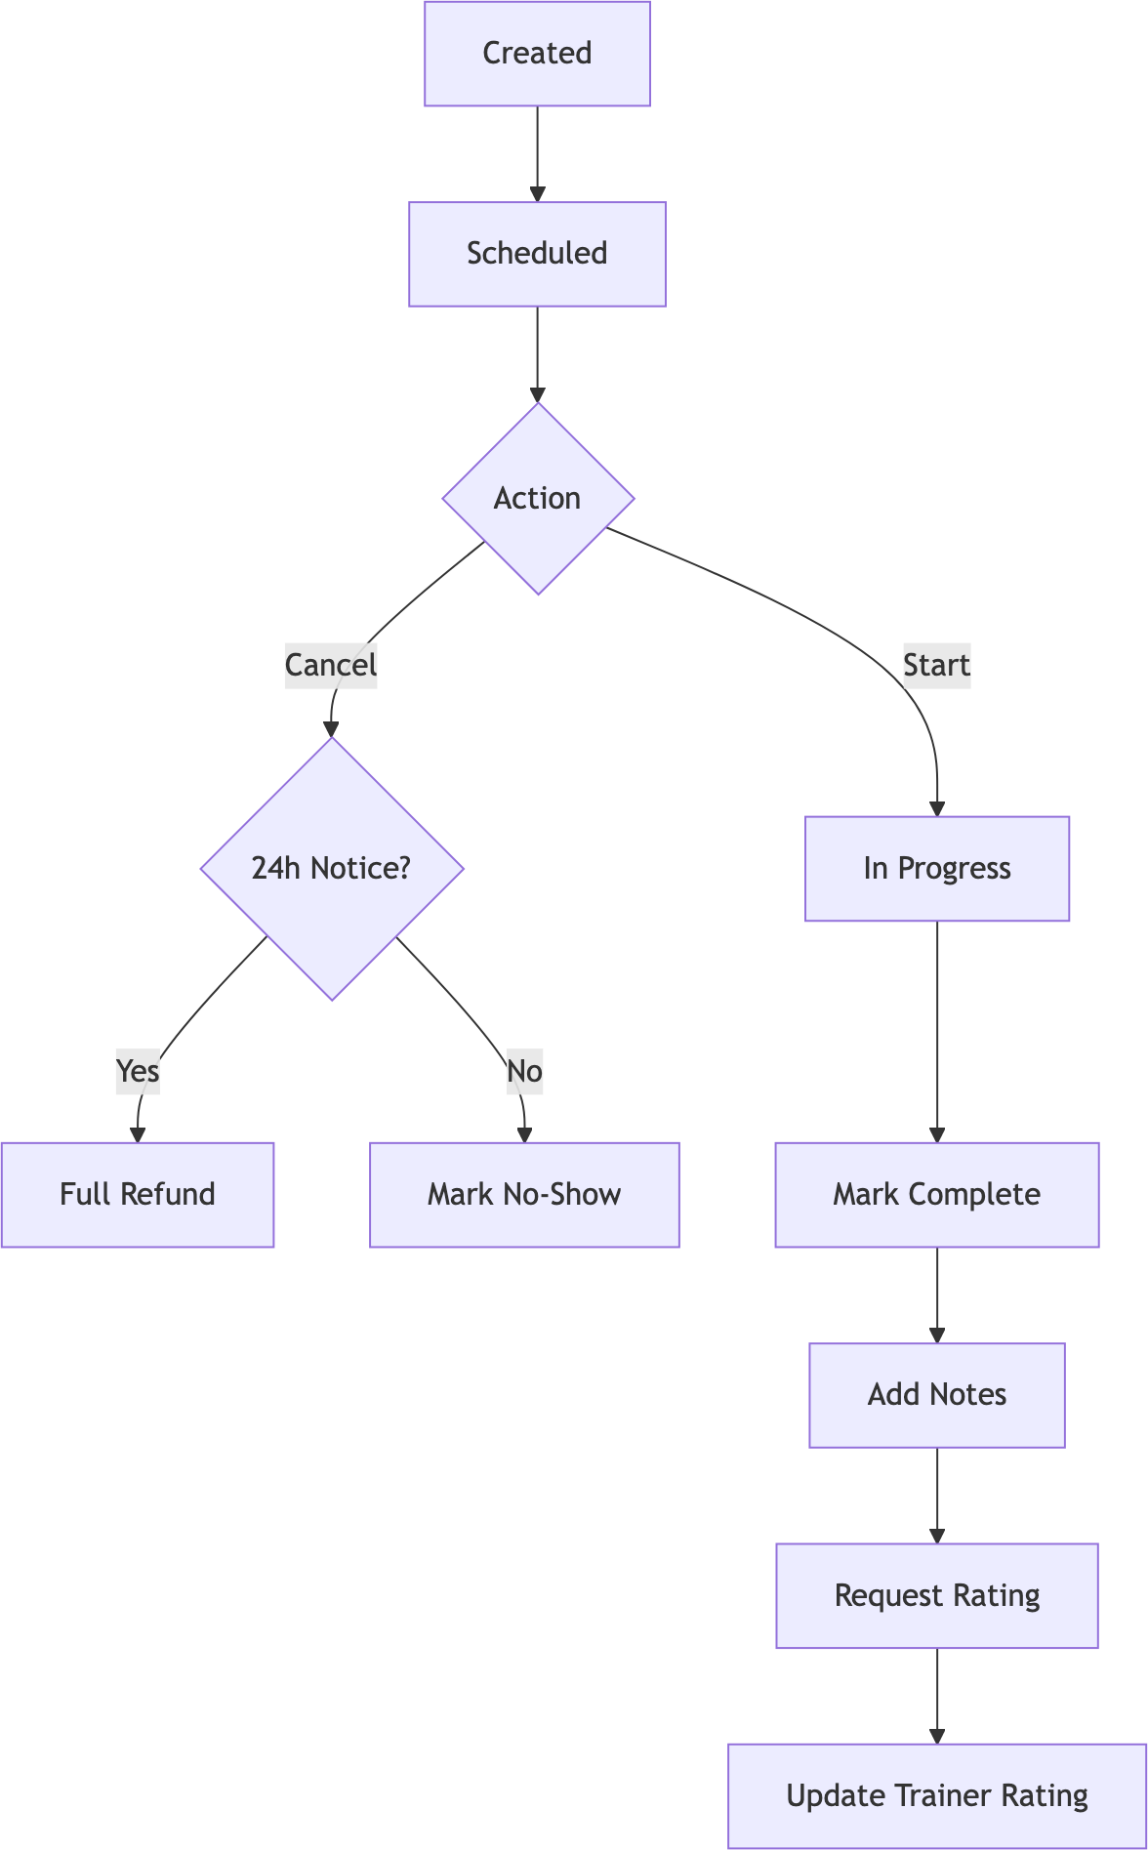

Chat/Messaging

Conversation
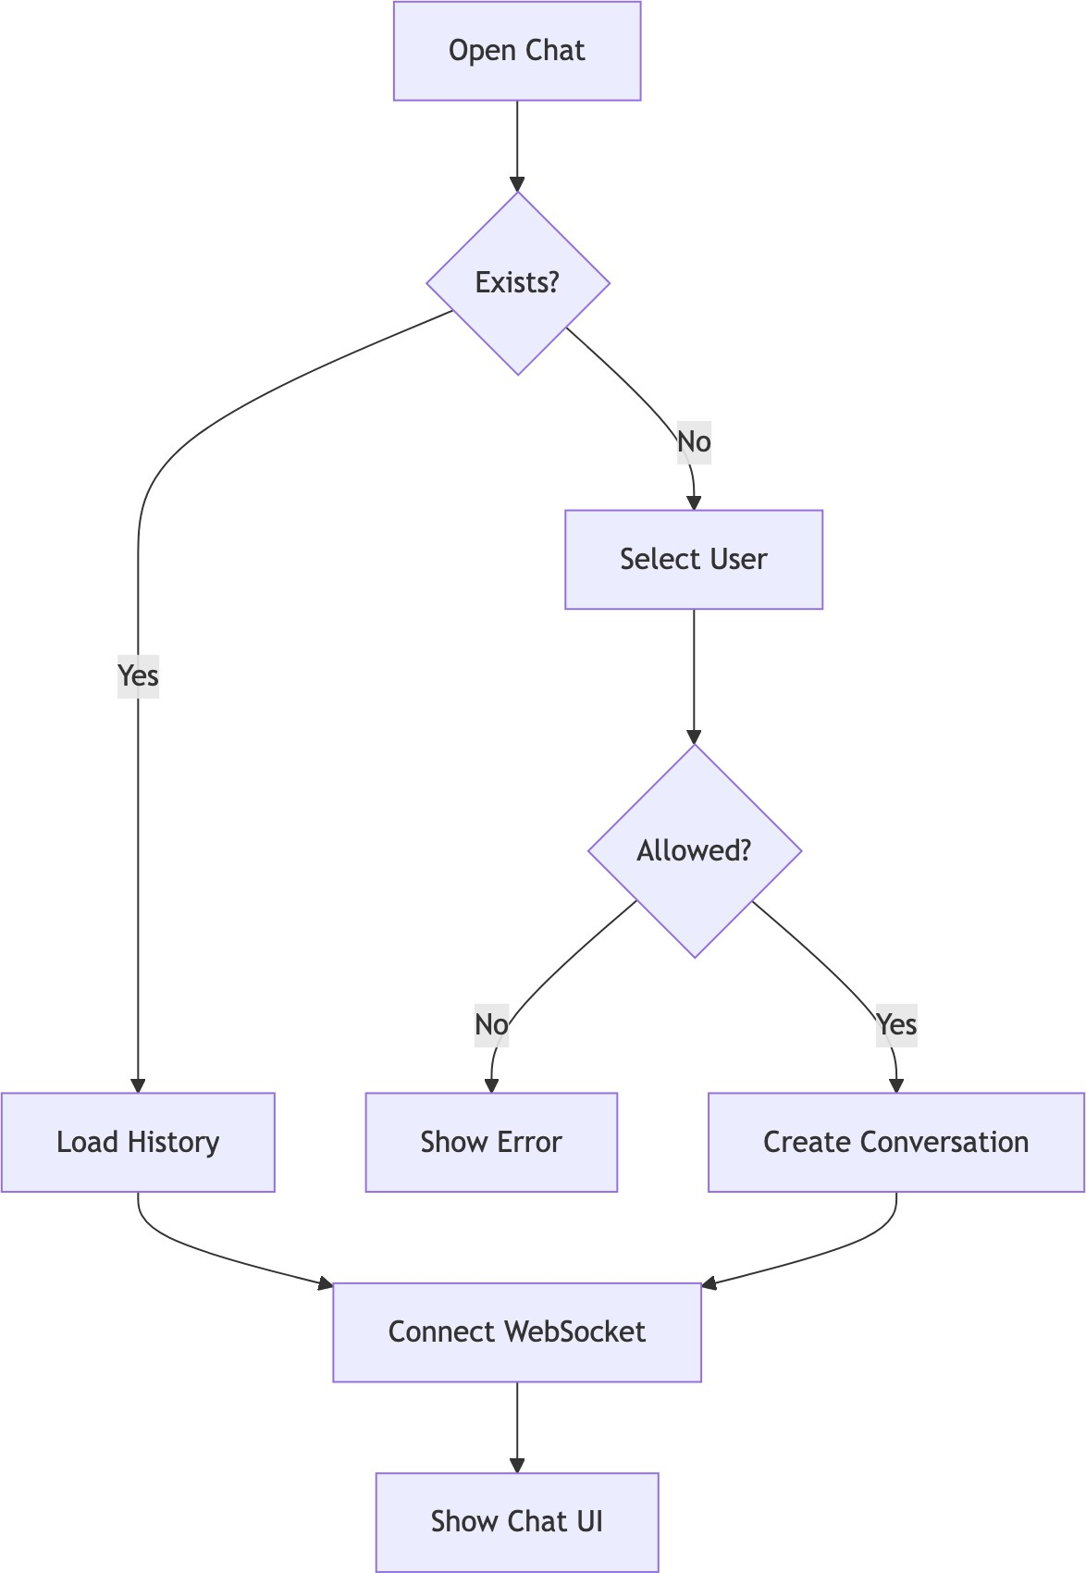

Message Flow
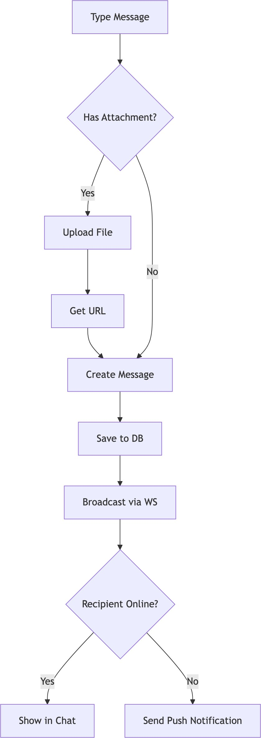

Message Delivery Status
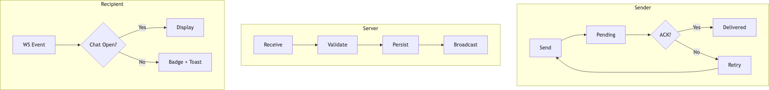

Notifications
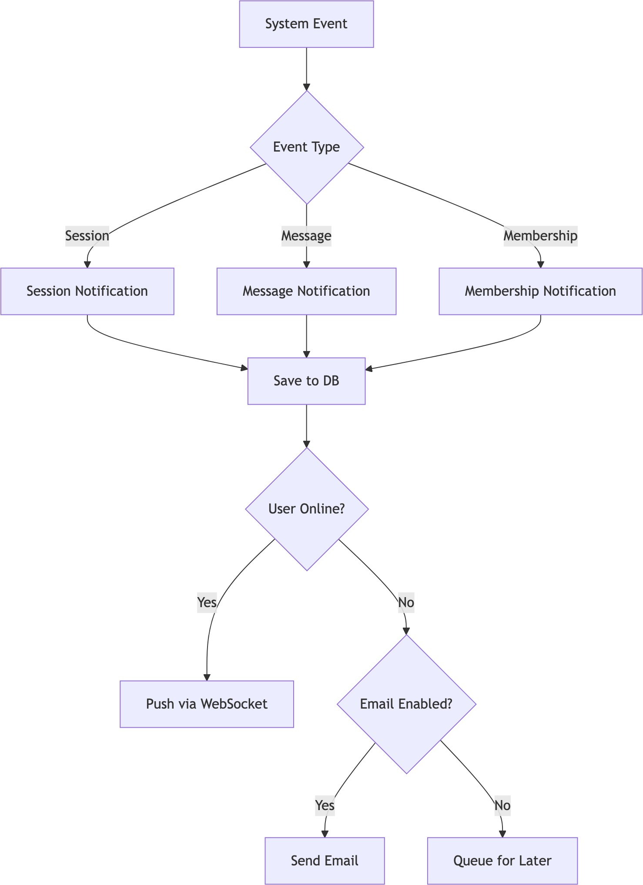

Chapter 10: Features & Functionality - Gym Management System

10.1 | Functional Requirements
10.1.1 | User Management
ID | Feature Description | Priority
F1.1 | Multi-Role Registration Users can register as Member, | High
 | Trainer, or Owner
F1.2 | OAuth Integration Login via Google, Facebook | High
F1.3 | 2FA Support Email/SMS OTP verification | Medium
F1.4 | Profile Management Edit personal info, avatar, | High
 | preferences
F1.5 | Password Reset Secure password recovery flow | High
F1.6 | Account Status Active, Suspended, Deleted states | Medium
10.1.2 | Gym Administration
ID | Feature Description | Priority
F2.1 | Gym Creation Owners can create and configure | High
 | gyms
F2.2 | Staff Management Add/remove trainers, set roles | High
F2.3 | Equipment Tracking Inventory, maintenance | Medium
 | scheduling
F2.4 | Class Management Group fitness scheduling | Medium
F2.5 | Settings & Branding Customize gym appearance | Low
F2.6 | Invite System Private gym invite codes | Medium
10.1.3 | Membership Management
ID | Feature Description | Priority
F3.1 | Package Creation Define membership packages with | High
 | pricing
F3.2 | Membership Purchase Members can buy/renew | High
 | memberships

ID | Feature | Description | Priority
F3.3 | Approval Workflow | Owner approves membership | High
 |  | requests
F3.4 | Expiry Handling | Auto-expire, renewal reminders | High
F3.5 | PT Session Credits | Include PT sessions in packages | Medium
F3.6 | Membership Analytics | Track subscriptions, revenue | Medium
10.1.4 | Personal Training
ID | Feature | Description | Priority
F4.1 | Trainer Discovery | Browse trainers with | High
 |  | ratings/specializations
F4.2 | Trainer Assignment | Request and assign trainers | High
F4.3 | Session Booking | Schedule PT sessions with | High
 |  | availability
F4.4 | Session Management | Complete, cancel, reschedule | High
 |  | sessions
F4.5 | Workout Plans | Trainers create customized plans | Medium
F4.6 | Diet Plans | Nutritional guidance from trainers | Medium
F4.7 | Session Ratings | Members rate completed sessions | Medium
10.1.5 | Progress Tracking

Communication
ID | Feature | Description | Priority
F5.1 | Body Measurements | Track weight, body fat, dimensions | High
F5.2 | Progress Photos | Upload before/after images | Medium
F5.3 | Workout Logging | Record daily workout activities | Medium
F5.4 | Goal Setting | Define and track fitness goals | Medium
F5.5 | Progress Charts | Visualize progress over time | Medium
F5.6 | Achievement Badges | Gamification rewards | Low

ID | Feature | Description | Priority
F6.1 | Real-time Chat | WebSocket-based messaging | High
F6.2 | File Attachments | Share images, documents in chat | Medium
F6.3 | Message Reactions | React to messages with emojis | Low
F6.4 | Read Receipts | Track message delivery/read status | Low
F6.5 | Notifications | In-app and push notifications | High
F6.6 | Email Alerts | Configurable email notifications | Medium

Analytics & Reporting

ID | Feature | Description | Priority
F7.1 | Owner Dashboard | Revenue, member stats, trends | High
F7.2 | Trainer Reports | Session history, ratings, earnings | Medium
F7.3 | Member Stats | Personal progress, attendance | Medium
F7.4 | Financial Reports | Revenue breakdown, projections | Medium
F7.5 | Export Reports | Download as PDF/CSV | Low

Non-Functional Requirements

Security
ID Requirement Implementation Priority NF1.1 Authentication JWT tokens with expiry Critical

NF1.2 Authorization Role-Based Access Control (RBAC)
Critical

NF1.3 Password Security BCrypt hashing (12 rounds) Critical NF1.4 Transport Security HTTPS/TLS everywhere Critical NF1.5 Input Validation Server-side validation Critical NF1.6 CORS Policy Whitelist allowed origins High
NF1.7 Rate Limiting Prevent brute force attacks High NF1.8 SQL Injection Prevention JPA Parameterized queries Critical NF1.9 XSS Prevention Content sanitization High

Performance

ID Requirement Target Priority

NF2.1 API Response Time < 200ms (95th percentile) High NF2.2 Page Load Time < 3s initial, < 1s subsequent High NF2.3 Database Queries Optimized with indexes High NF2.4 Caching Spring Cache for frequent data Medium NF2.5 Connection Pooling HikariCP (max 20 connections) High NF2.6 Lazy Loading JPA relationships optimized Medium

Scalability

ID Requirement Description Priority

NF3.1 Multi-Tenancy Isolated data per gym High NF3.2 Stateless Auth JWT enables horizontal scaling High NF3.3 Database Scaling Supports read replicas Medium NF3.4 WebSocket Scaling Dedicated connection management Medium NF3.5 File Storage External storage ready Low

Reliability

ID Requirement Implementation Priority

NF4.1 Data Integrity Database transactions (ACID) Critical NF4.2 Soft Deletes is_deleted flag, recoverable data High NF4.3 Optimistic Locking @Version annotation High NF4.4 Error Handling Global exception handler High NF4.5 Audit Logging Track critical changes Medium NF4.6 Backup Strategy Database backup support High

Usability

ID Requirement Description Priority

NF5.1 Responsive Design Works on all screen sizes High NF5.2 Intuitive Navigation Clear menu structure High NF5.3 Loading States Skeleton loaders, spinners Medium

ID | Requirement | Description | Priority
NF5.4 | Error Messages | User-friendly error display | High
NF5.5 | Accessibility | WCAG 2.1 AA compliance | Medium
NF5.6 | Internationalization | Multi-language support ready | Low

Maintainability

ID | Requirement | Description | Priority
NF6.1 | Code Structure | Clean architecture layers | High
NF6.2 | API Documentation | REST endpoints documented | Medium
NF6.3 | Type Safety | TypeScript frontend, Java backend | High
NF6.4 | Version Control | Git with branching strategy | High
NF6.5 | Code Quality | Lombok for boilerplate reduction | Medium

Feature Matrix by Role

Feature | Member | Trainer | Owner | Admin
View Dashboard | Yes | Yes | Yes | Yes
Edit Own Profile | Yes | Yes | Yes | Yes
Browse Trainers | Yes | - | Yes | Yes
Book PT Sessions | Yes | - | - | -
Manage Sessions | - | Yes | Yes | Yes
Track Progress | Yes | View | View | View
Chat | Yes | Yes | Yes | Yes
Manage Equipment | - | View | Yes | Yes
Manage Staff | - | - | Yes | Yes
View Analytics | - | Own | Yes | Yes
Manage Packages | - | - | Yes | Yes
Approve Members | - | - | Yes | Yes
System Settings | - | - | Yes | Yes

Chapter 11: Conclusion

Project Review and Discussion
The Gym Management System developed during this internship represents a comprehensive solution to the challenges faced by gym operators in managing their day-to-day operations through disparate, costly, or inflexible software tools. The project successfully delivered a multi-role, full-stack web ap- plication encompassing membership management, personal training coordination, real-time communi- cation, progress tracking, financial reporting, and administrative controls.
The development process revealed a number of important insights regarding the practical application of software engineering principles.

Achievement of Objectives
The following objectives were defined at the outset of the project and were evaluated against the com- pleted system:
Objective Outcome

Multi-role authentication and au- thorisation
Membership lifecycle manage- ment
Personal training booking sys- tem
Achieved — JWT and RBAC implemented across all four roles

Achieved — complete purchase, approval, expiry, and renewal work- flows
Achieved — session creation, cancellation, and rating workflows functional

Real-time chat between roles Achieved — WebSocket STOMP messaging with delivery status Financial reporting and analytics Achieved — revenue charts, transaction tables, and KPI dashboard
Security compliance with Achieved — BCrypt, input validation, CORS, and JWT verified OWASP guidelines
Sub-200ms API response times Achieved — validated under standard load conditions

Problems Encountered
Several challenges were encountered during the development process and subsequently resolved:
      - N+1 Query Problem: Initial JPA entity mappings resulted in excessive database queries when loading nested relationships. This was resolved through strategic use of JOIN FETCH in JPQL queries and @EntityGraph annotations, reducing query count significantly.

      - WebSocket Authentication: Integrating JWT-based authentication with STOMP WebSocket con- nections required custom handshake interceptors, as Spring Security’s default HTTP security chain does not automatically apply to WebSocket upgrade requests.
      - Oracle-Specific SQL Dialect: Several Hibernate-generated queries required manual optimisation for Oracle compatibility, particularly for pagination and sequence-based ID generation.
      - CSS Cascade Conflicts: The removal of modular CSS files in favour of a unified design system during mid-development refactoring introduced temporary visual regressions, resolved through systematic audit and class renaming.

Novelties and Contributions
The project achieved the following notable contributions:
- Unified multi-role architecture: A single codebase serving four distinct user types (Member, Trainer, Owner, Super Admin) with dynamically rendered dashboards, eliminating the need for separate applications per role.
- Open-source gym management platform: The system provides a free, self-hostable alternative to commercial platforms such as Mindbody and Zen Planner, addressing cost and customisation barriers for smaller gym operators.
- Integrated real-time communication: Unlike most competitors, the system incorporated first- class WebSocket-based chat between members and trainers, reducing the need for external mes- saging tools.
- Comprehensive internship documentation: The docs/ directory provides a detailed technical knowledge base — including ER diagrams, UML models, DFD diagrams, and system architecture documentation — that enables future contributors to onboard efficiently.

Personal Insights
The internship provided an invaluable opportunity to experience the full software development lifecycle in a professional environment. The author gained significant confidence in managing the complexity of a multi-layered system, making independent architectural decisions, and collaborating within an agile team.
Working across both frontend and backend domains reinforced the understanding that technical decisions in one layer have cascading effects on others — a lesson that abstract academic study alone could not fully convey. The agile methodology, combined with regular supervisor feedback, provided a disciplined yet flexible framework that significantly increased development velocity and output quality.

Future Work
The following improvements and extensions are recommended for future development of the Gym Man- agement System:
Enhancement Priority Description

Mobile Application High Native iOS/Android companion app for members Payment Gateway Integration High Stripe or Razorpay for online membership payments GDPR Compliance Module High Data export, anonymisation, and right-to-erasure features

AI-Powered Workout Recom- mendations
Medium Machine learning model for personalised plans

Microservices Migration Medium Decompose monolith into independently scalable services

Multi-language Support (i18n)
Advanced Analytics Dash- board
Video Conferencing Integra- tion
Medium Internationalisation for non-English markets Medium Predictive churn analysis, retention metrics Low Embedded video for remote PT sessions

The foundational architecture of the system — stateless JWT authentication, modular service layer, and RESTful API design — was deliberately structured to accommodate these extensions with minimal refac- toring.

Chapter 12: References - Gym Management System

Academic References
- Gackenheimer, C. (2023). Introduction to React. Apress. https://doi.org/10.1007/978-1-4842-1245- 5
- Fedosejev, A. (2022). React.js Essentials. Packt Publishing. ISBN: 978-1783551620
- Cherny, B. (2021). Programming TypeScript: Making Your JavaScript Applications Scale. O’Reilly Media. ISBN: 978-1492037651
- Walls, C. (2022). Spring in Action, Sixth Edition. Manning Publications. ISBN: 978-1617297571
- Scarioni, C. (2021). Pro Spring Security. Apress. https://doi.org/10.1007/978-1-4842-5052-5
- Chong, F., & Carraro, G. (2020). “Architecture Strategies for Catching the Long Tail.” Microsoft Architecture Journal. https://docs.microsoft.com/en-us/previous-versions/aa479069
- Ferraiolo, D., Kuhn, D. R., & Chandramouli, R. (2019). Role-Based Access Control, Third Edition.
Artech House. ISBN: 978-1596931138
- Jones, M., Bradley, J., & Sakimura, N. (2015). “JSON Web Token (JWT).” RFC 7519. IETF. https://tools.ietf.org/html/rfc7519
- Fette, I., & Melnikov, A. (2011). “The WebSocket Protocol.” RFC 6455. IETF. https://tools.ietf.org/html/rfc645
- Gamma, E., Helm, R., Johnson, R., & Vlissides, J. (1994). Design Patterns: Elements of Reusable Object-Oriented Software. Addison-Wesley. ISBN: 978-0201633610
- OWASP Foundation. (2023). “Password Storage Cheat Sheet.” OWASP Cheat Sheet Series. https://cheatsheetseries.owasp.org/cheatsheets/Password_Storage_Cheat_Sheet.html

Industry & Fitness Research
- Sharma, R., Kumar, A., & Singh, P. (2020). “User Experience Patterns in Fitness Mobile Applica- tions.” International Journal of Human-Computer Interaction, 36(4), 312-325.
- Chen, L., & Lee, M. (2019). “Factors Affecting Member Retention in Fitness Centers: A Machine Learning Approach.” Journal of Sport Management, 33(5), 408-421.
- Rodriguez, M. (2021). “Multi-Tenancy Patterns for SaaS Applications.” IEEE Software, 38(2), 65-72.

- Williams, J. (2022). “Microservices Architecture in Modern Fitness Applications.” Proceedings of the ACM Symposium on Cloud Computing, 456-468.

Technical Documentation
- React Documentation. (2024). React Official Documentation. Meta Platforms, Inc. https://react.dev/
- Spring Framework. (2024). Spring Boot Reference Documentation. VMware. https://docs.spring.io/spring- boot/docs/current/reference/html/
- Oracle Corporation. (2024). Oracle Database Administrator’s Guide. https://docs.oracle.com/en/database/
- JSON Web Tokens. (2024). Introduction to JSON Web Tokens. Auth0. https://jwt.io/introduction
- WebSocket API. (2024). The WebSocket API (WebSockets). MDN Web Docs. https://developer.mozilla.org/en- US/docs/Web/API/WebSockets_API

Security Standards
- OWASP. (2023). OWASP Top Ten 2021. OWASP Foundation. https://owasp.org/Top10/
- NIST. (2020). Digital Identity Guidelines. NIST Special Publication 800-63B. https://pages.nist.gov/800- 63-3/sp800-63b.html
- W3C. (2023). Web Content Accessibility Guidelines (WCAG) 2.1. World Wide Web Consortium. https://www.w3.org/TR/WCAG21/

Framework & Library Documentation
- Spring Security. (2024). Spring Security Reference. https://docs.spring.io/spring-security/reference/
- Hibernate ORM. (2024). Hibernate User Guide. https://docs.jboss.org/hibernate/orm/current/userguide/html_
- Axios. (2024). Axios Documentation. https://axios-http.com/docs/intro
- Framer Motion. (2024). Framer Motion Documentation. https://www.framer.com/motion/
- Lombok Project. (2024). Project Lombok Documentation. https://projectlombok.org/features/
- React Router. (2024). React Router Documentation. https://reactrouter.com/
- Recharts. (2024). Recharts - A composable charting library. https://recharts.org/

Database & Infrastructure
- HikariCP. (2024). HikariCP - A solid, high-performance JDBC connection pool. https://github.com/brettwoold
- Oracle JDBC. (2024). Oracle JDBC Driver Documentation. https://docs.oracle.com/en/database/oracle/oracle database/21/jjdbc/

Citation Format
This document follows IEEE citation style. All URLs were verified as accessible as of February 2026.

Acknowledgments
    - React and Spring Boot communities for comprehensive documentation
    - OWASP for security guidelines
    - Academic researchers in fitness technology domain

Chapter 13: Appendices

Appendix A: System Installation Guide

A.1 Prerequisites
The following tools must be installed before setting up the Gym Management System locally:

Tool | Min. Version | Purpose
Node.js | 18.x | Frontend runtime
npm | 9.x | Package manager
Java JDK | 17+ | Backend runtime
Maven | 3.8+ | Java build tool
Oracle Database | 19c+ | Primary data store
Git | 2.x | Version control

A.2 Frontend Setup
# Clone repository
git clone https://github.com/coded-with-aryan0426/gym-management-system-fullstack.git cd gym-management-system-fullstack/frontend

# Install dependencies
npm install

# Configure environment
cp .env.example .env
# Edit .env with your API base URL

# Start development server
npm run dev
The frontend development server starts on http://localhost:5173 by default.

A.3 Backend Setup
# Navigate to backend directory
cd gym-management-system-fullstack/backend

# Configure database in application.properties:
# spring.datasource.url=jdbc:oracle:thin:@localhost:1521:orcl # spring.datasource.username=YOUR_DB_USERNAME
# spring.datasource.password=YOUR_DB_PASSWORD

# Build and run
./mvnw spring-boot:run
The backend API server starts on http://localhost:8080 by default.

A.4 Environment Variables Reference

Variable Description Example

VITE_API_BASE_URL Backend API URL http://localhost:8080/api VITE_WS_URL WebSocket server URL ws://localhost:8080/ws spring.datasource.url JDBC connection string jdbc:oracle:thin:@...

jwt.secret JWT signing secret (min 256-bit)
spring.mail.host SMTP host for email
OTP
[secure-random-string]

smtp.gmail.com

Appendix B: Database Schema Reference

B.1 Core Tables Summary

Table Name Primary Key Description

users user_id All user accounts across roles
roles role_id Role definitions (MEMBER, TRAINER, OWNER, ADMIN)
gyms gym_id Gym tenant records
memberships membership_id Active and historical memberships membership_packages package_id Configured membership packages pt_sessions session_id Personal training session bookings trainer_details trainer_id Trainer profile extensions conversations conversation_id Chat conversation threads messages message_id Individual chat messages notifications notification_id System notifications

B.2 Key Relationships
      - Each users record is associated with one or more roles via a join table.
      - Each gym has exactly one owner (foreign key to users).
      - Each membership references one membership_package and one user.
      - Each pt_session references one trainer user, one member user, and belongs to one gym.
      - Each conversation contains zero or more messages, and involves two or more users.

Appendix C: API Endpoints Reference

C.1 Authentication Endpoints

Method | Endpoint | Description
POST | /api/auth/register | Register a new user
POST | /api/auth/login | Authenticate and receive JWT
POST | /api/auth/refresh | Refresh expired JWT
POST | /api/auth/logout | Invalidate session
POST | /api/auth/verify-otp | Verify 2FA OTP
13.0.8 | C.2 Membership Endpoints
Method | Endpoint | Description
GET | /api/memberships/packages | List available packages
POST | /api/memberships/request | Submit membership purchase request
PUT /api/memberships/{id}/approvOewner approves membership PUT /api/memberships/{id}/rejectOwner rejects membership
GET /api/memberships/my Get current member’s membership

C.3 PT Session Endpoints

Method Endpoint Description

GET /api/sessions/trainers Browse available trainers POST /api/sessions/book Book a PT session
PUT /api/sessions/{id}/complete Mark session as complete PUT /api/sessions/{id}/cancel Cancel a booked session POST /api/sessions/{id}/rate Submit session rating

Appendix D: Technology Dependencies

D.1 Frontend Dependencies (Selected)

Package | Version | Licence
react | 18.x | MIT
react-dom | 18.x | MIT
react-router-dom | 6.x | MIT
axios | 1.x | MIT
socket.io-client | 4.x | MIT
framer-motion | 10.x | MIT
recharts | 2.x | MIT
lucide-react | latest | ISC
typescript | 5.x | Apache-2.0
vite | 5.x | MIT
13.0.11 D.2 Backend Dependencies (Selected)
Package |  | Version | Licence
spring-boot-starter-web |  | 3.x | Apache-2.0
spring-boot-starter-security |  | 3.x | Apache-2.0
spring-boot-starter-data-jpa |  | 3.x | Apache-2.0
spring-boot-starter-websocket |  | 3.x | Apache-2.0
jjwt-api |  | 0.11.x | Apache-2.0
lombok |  | 1.18.x | MIT
ojdbc8 |  | 21.x | Oracle
spring-boot-starter-mail |  | 3.x | Apache-2.0

