 | FULL-STACK  GYM MANAGEMENT SYSTEM
Brief Description
This is a robust, event-driven, full-stack platform designed to streamline and modernize daily fitness center operations. Leveraging an advanced Next.js/React frontend and a highly secure Spring Boot backend, the system offers a user-friendly digital environment for gym administrators, trainers, and members. It automates critical workflows including subscription management, attendance tracking, secure payment processing, and role-based data isolation. By integrating real-time notifications and scalable background processing, the platform ensures high operational efficiency and fosters elevated member engagement.
Principle
• Event-Driven Architecture: Utilizes continuous background event processors to trigger real-time notifications, payment reminders, and systemic audit logs asynchronously without blocking primary user workflows.
• Role-Based Access Control (RBAC): Adopts enterprise-grade security protocols utilizing JSON Web Tokens (JWT) and 2FA, enforcing strict data boundaries so Super Admins, Trainers, and Members access only authorized information.
• Stateless Scalability: Engineered with a decoupled React/Spring Boot microservice-inspired architecture, allowing the API and User Interface to be independently scaled, maintained, and deployed on modern edge networks.• Data-Driven Analytics: Processes raw operational metrics (attendance, revenue, active subscriptions) into compre-
hensive visual dashboards, empowering decision-makers with actionable insights.
Beneficiaries | Benefits
≻ Center Owners & Operators  ≻ Admins and Front-desk Staff  ≻ Personal Trainers & Coaches  ≻ Gym Members & Subscribers  ≻ Financial Auditors & Maintainers | ≻ Significantly Reduced Administrative Overhead  ≻ Automated Subscription & Revenue Tracking  ≻ Enhanced Transparency via Tamper-proof Audit Logs≻ Improved Stakeholder Communication (Real-time)≻ Scalable Architecture for Multi-Branch Expansion
System Architecture |  | Enterprise Architectural & Security Highlights
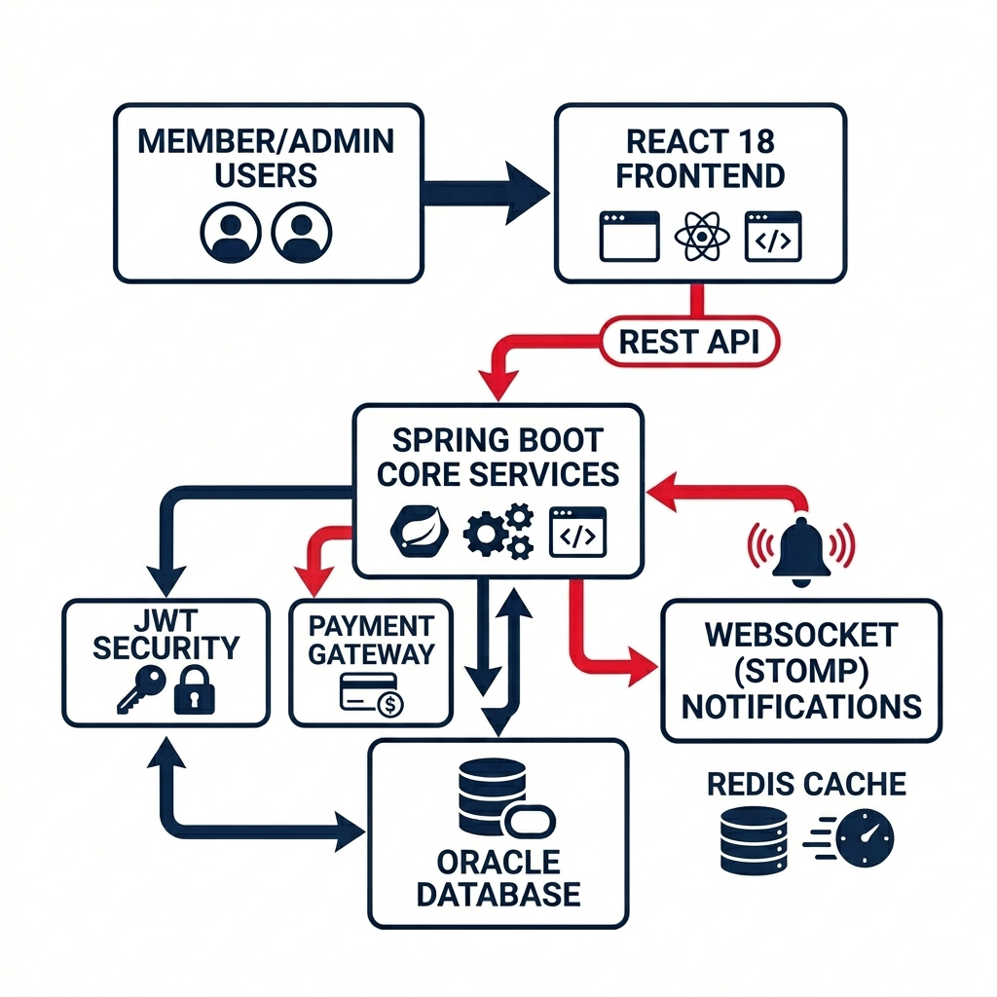 |  | High-Performance Implementation  • Rapid Client UI: Built with React 18, TypeScript, and func-  tional components ensuring seamless engagement.  • Backend Engine: Secured REST API on Java 17 / Spring Boot  3 handling operations with under 200ms latency.  • Data Integrity: Optimised, ACID-compliant data persistence via  Oracle Database using strictly parameterised SQL.
Security & Real-time Functional Modules
• Zero-Trust Security: Full OWASP compliance via BCrypt hash- ing, JWT Auth, and Email OTP 2-Factor Authentication.
• Advanced RBAC: Multi-tier dynamic isolation strictly govern- ing data interfaces for Admins, Owners, Trainers, and Members.• Low-Latency Messaging: Bi-directional WebSockets (STOMP Protocol) facilitating critical alerts and live chat seamlessly.

Figure 1: Full-Stack IT Architecture & Core Services |  | Department B.Tech IT  Semester Semester – VIII  Name Suthar Aryan Sujalkumar  Enrolment No 23C25512  Guide Dr. Ashutosh Abhangi
Functional Modules | Future Scope
≻ Multi-Role Dashboard System≻ Membership ment Lifecycle Manage-  ≻ Attendance & Progress Tracking≻ Subscription & Payment Work-flows  ≻ Trainer–Member Live Chat≻ Super Admin Audit Logging | ≻ AI-Driven Workout Plans  ≻ Biometric Login Integration≻ Mobile App (React Native)≻ Multi-Branch Franchise Mode≻ Payment Gateway (Stripe)≻ Wearable Device Sync  ≻ Offline Mode & Caching

