A MINI PROJECT REPORT ON
COVID-19 Vaccination Data Analysis

SUBMITTED TO

SAVITRIBAI PHULE PUNE UNIVERSITY, PUNE

 | SUBMITTED BY
Arpita Sadalage  Christina Dmello  Keehan Pathan |  | Roll No: Roll No: Roll No: | T5519 T5432 T5498



UNDER THE GUIDANCE OF
Prof. M. P. Navale

DEPARTMENT OF COMPUTER ENGINEERING NBN SINHGAD TECHNICAL INSTITUTES CAMPUS NBN SINHGAD SCHOOL OF ENGINEERING
10/1, Ambegaon (Bk), Pune - 411041

Academic Year 2025–2026

CERTIFICATE



This is to certify that the project report entitled COVID-19 Vaccination Data Analysis
submitted by
Arpita Sadalage  Christina Dmello  Keehan Pathan |  | Roll No: Roll No: Roll No: | T5519 T5432 T5498
is a bonafide work carried out under our supervision and guidance. This work is submitted in partial fulfillment of the requirements of Data Science and Big Data Analysis Laboratory of Savitribai Phule Pune University, Pune.

Guide Signature
Prof. M. P. Navale
HOD Signature
Dr. S. P. Bendale

Date: Place: Pune

ACKNOWLEDGEMENT

It gives me great pleasure to present this project report on COVID-19 Vaccination Data Analysis Using Python. I express sincere gratitude and thanks to my guide Prof.
M. P. Navale for constant guidance, motivation, and valuable suggestions throughout the mini project work.
I am thankful to the Head of Department, all faculty members, and the institute for providing the required infrastructure and support. I also thank my family and friends for their encouragement and support during the completion of this project.

ABSTRACT

This mini project presents a COVID-19 vaccination data analysis system implemented in Python using the Pandas and Matplotlib libraries. The system uses a state-wise vaccination dataset containing information about first dose, second dose, and gender-wise vaccination across India.
The project follows a data analysis approach where important attributes such as state, first dose, second dose, and gender-based vaccination (male and female) are processed and analyzed. Data preprocessing techniques such as handling missing values, cleaning column names, and transforming data into structured format are applied to ensure accurate results.
State-wise aggregation is performed to compute the total number of people vaccinated with the first and second doses. Additionally, gender-wise analysis is carried out to determine the total number of males and females vaccinated. Visualization techniques such as bar charts and pie charts are used to represent the data effectively.
The entire workflow is implemented in a Jupyter Notebook for easy execution, visualization, and understanding. The project demonstrates practical use of data analysis concepts, data preprocessing, aggregation, and visualization techniques on a real-world dataset.

Contents

CERTIFICATE ACKNOWLEDGEMENT  ABSTRACT | i ii  iii
1 Introduction | 1
1.1 Project Title . . . . . . . . . . . . . . . . . . . . . . . . . . . . . . . . . . | 1
1.2 Introduction . . . . . . . . . . . . . . . . . . . . . . . . . . . . . . . . . . | 1
1.3 Objectives of the Project . . . . . . . . . . . . . . . . . . . . . . . . . . . | 1
1.4 Scope . . . . . . . . . . . . . . . . . . . . . . . . . . . . . . . . . . . . . | 2
2 Literature Review | 3
3 Software Requirement Specification | 4
3.1 Functional Requirements . . . . . . . . . . . . . . . . . . . . . . . . . . . | 4
3.2 Non-Functional Requirements . . . . . . . . . . . . . . . . . . . . . . . . | 4
3.3 Hardware Requirements . . . . . . . . . . . . . . . . . . . . . . . . . . . | 4
3.4 Software Requirements . . . . . . . . . . . . . . . . . . . . . . . . . . . . | 5
4 System Analysis and Design | 6
4.1 Existing System . . . . . . . . . . . . . . . . . . . . . . . . . . . . . . . . | 6
4.2 Proposed System . . . . . . . . . . . . . . . . . . . . . . . . . . . . . . . | 6
4.3 Dataset Overview . . . . . . . . . . . . . . . . . . . . . . . . . . . . . . . | 6
4.4 Recommendation Model . . . . . . . . . . . . . . . . . . . . . . . . . . . | 7
5 System Design and Implementation | 8

  - Implementation Workflow . . . . . . . . . . . . . . . . . . . . . . . . . . 8
  - Notebook and Project Files . . . . . . . . . . . . . . . . . . . . . . . . . 8
  - Algorithmic Highlights . . . . . . . . . . . . . . . . . . . . . . . . . . . . 8
  - Sample Output . . . . . . . . . . . . . . . . . . . . . . . . . . . . . . . . 9
- Testing 11
  - Testing Techniques Used 11
  - Sample Test Cases 12
- Conclusion 13

Chapter 1

Introduction

  - Project Title

COVID-19 Vaccination Data Analysis Using Python

Introduction

Data analysis plays a crucial role in understanding large datasets and extracting meaningful insights. During the COVID-19 pandemic, vaccination data became essential to monitor the progress of immunization programs across different regions.

This project focuses on analyzing COVID-19 vaccination data in India using Python. The dataset contains state-wise vaccination details including first dose, second dose, and gender-wise vaccination statistics. By applying data analysis techniques, meaningful insights such as total vaccinations and comparisons across states can be obtained.

The implementation is carried out in a Jupyter Notebook using Python libraries such as Pandas and Matplotlib, making it easy to analyze, visualize, and interpret the data.

Objectives of the Project

- To analyze COVID-19 vaccination data using Python
- To calculate state-wise first dose vaccination
- To calculate state-wise second dose vaccination
- To determine total male and female vaccinated
- To visualize vaccination data using graphs.

Scope

The project focuses on analyzing vaccination data and generating insights. It can be extended further by:
- Adding real-time data updates
- Creating dashboards using Power BI or Tableau
- Performing predictive analysis using machine learning

Chapter 2

Literature Review

Data analysis has become an essential tool in modern decision-making. Various tools and technologies such as Python, Pandas, and data visualization libraries are widely used to process and analyze large datasets.

In the healthcare domain, data analysis helps in understanding disease patterns, vaccination trends, and resource allocation. COVID-19 vaccination datasets have been widely analyzed to track progress and improve decision-making.

This project uses basic data analysis techniques such as grouping, aggregation, and visualization to extract meaningful insights from vaccination data.

Chapter 3

Software Requirement Specification

  - Functional Requirements

- Load COVID-19 vaccination dataset from covid_vaccine_statewise.csv.
- Clean and preprocess data (handle missing values, remove extra spaces in column names).
- Extract relevant columns such as State, First Dose, Second Dose, Male, and Female.
- Perform state-wise aggregation using groupby operations.
- Calculate total number of people vaccinated with first and second doses.
- Compute total number of male and female vaccinated individuals.

Non-Functional Requirements

• Usability: The system should have a simple and easy-to-understand notebook workflow with clear outputs.
• Performance: The system should process the dataset efficiently and provide quick results.
• Maintainability: The code should be modular and easy to modify for future enhancements.
• Reliability: The system should handle missing values and incorrect inputs gracefully.
• Reproducibility: The system should produce consistent results for the same dataset and inputs.
• Scalability: The system should be able to handle larger datasets with minimal changes.

Hardware Requirements

    - Processor: Intel Core i3 or above
    - RAM: 4 GB or above (8 GB recommended)

    - Storage: 1 GB free disk space

Software Requirements

    - Operating System: Windows 10/11 or Linux
    - Python: 3.10 or above
    - Notebook Environment: Jupyter Notebook / VS Code Notebook
    - Libraries: pandas, scikit-learn
    - Optional IDE: VS Code

Chapter 4

System Analysis and Design

  - Existing System

Traditional methods of analyzing vaccination data involve manual calculations or the use of basic spreadsheet tools. These methods are time-consuming, prone to errors, and inefficient when dealing with large datasets. Extracting insights such as state-wise vaccination or gender-wise distribution requires significant effort and lacks automation.

Proposed System

The proposed system analyzes COVID-19 vaccination data using Python and data analysis libraries. It automates the process of data cleaning, aggregation, and visualization.

Key advantages are:
• Automated data processing and analysis
• Accurate and fast computation of vaccination statistics
• Easy visualization using graphs
• Simple implementation using Python and Jupyter Notebook
• Scalable for larger datasets and future enhancements

Dataset Overview

Dataset file used:
• covid_vaccine_statewise.csv

Important fields considered:
• State
• First Dose
• Second Dose
• Male (Individuals Vaccinated)
• Female (Individuals Vaccinated)

Additional fields available:
• Total Doses Administered
• Age group vaccination data
• Vaccine type data (Covaxin, Covishield, etc.)

Recommendation Model

The dataset is processed using data analysis techniques. Relevant columns are selected and cleaned to remove inconsistencies. State-wise aggregation is performed using grouping functions to calculate total vaccinations.

Basic computation used:
Total Vaccination = First Dose + Second Dose

State-wise aggregation:

Total First Dose (State) = Σ First Dose
Total Second Dose (State) = Σ Second Dose

Gender-wise totals:
Total Male = Σ Male (Individuals Vaccinated)
Total Female = Σ Female (Individuals Vaccinated)

Visualization techniques such as bar charts and pie charts are used to represent the data effectively.
The system provides clear insights into vaccination distribution across different states and genders

Chapter 5

System Design and Implementation

  - Implementation Workflow

The notebook implementation follows this sequence:

• Import required Python libraries such as Pandas and Matplotlib
• Load the vaccination dataset from a local CSV file
• Clean and preprocess the dataset (handle missing values, fix column names)
• Select relevant columns for analysis
• Perform state-wise aggregation using groupby operations
• Calculate total first dose and second dose vaccinations
• Compute total male and female vaccinated individuals
• Generate visualizations such as bar charts and pie charts
• Display results in the Jupyter Notebook

Notebook and Project Files

• vaccination_analysis.ipynb – Main implementation
• covid_vaccine_statewise.csv – Dataset
• requirements.txt – Python dependencies (pandas, matplotlib)

Algorithmic Highlights

• Used Pandas library for efficient data manipulation and analysis
• Applied groupby operations for state-wise aggregation
• Used sum() function to calculate total vaccination values
• Performed data cleaning to handle missing values and inconsistent column names
• Implemented visualization techniques for better understanding of data
• Generated ranked outputs such as top states based on vaccination

Sample Output

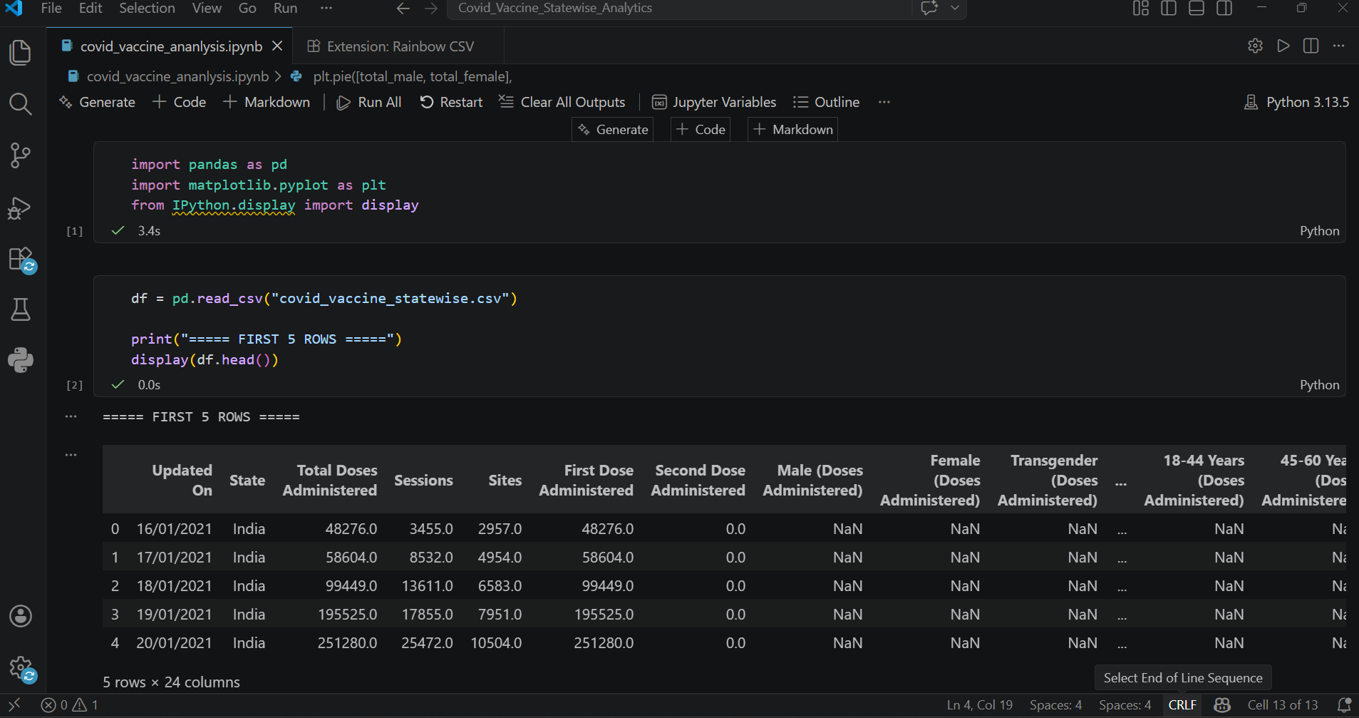

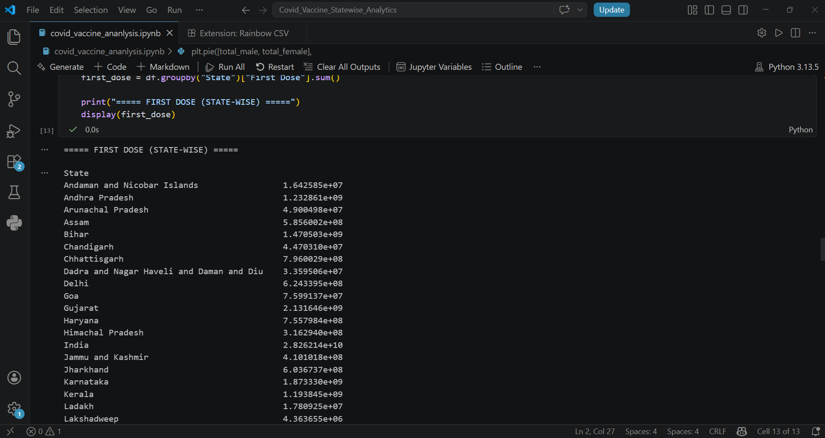

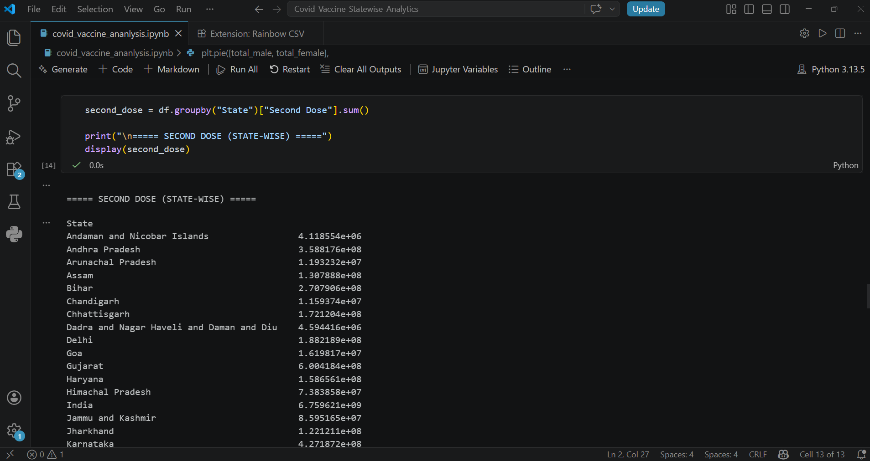

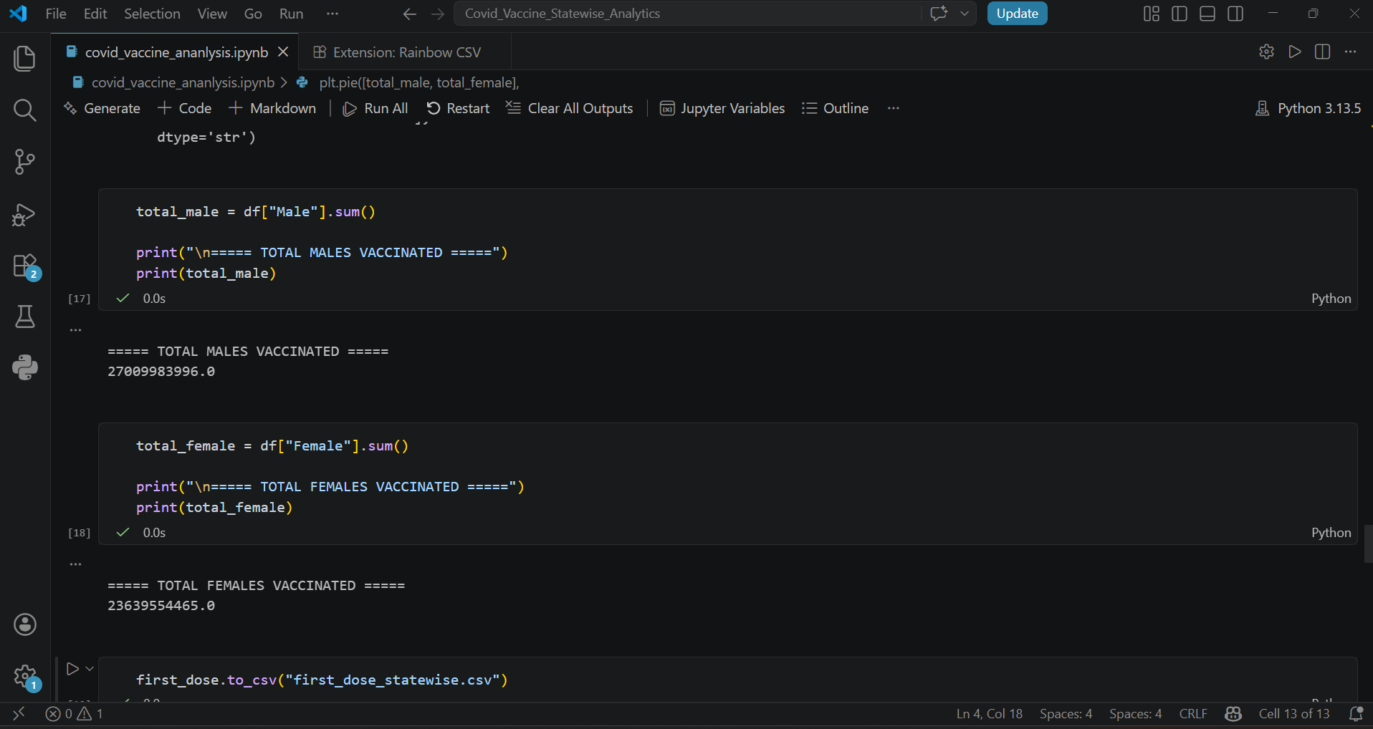

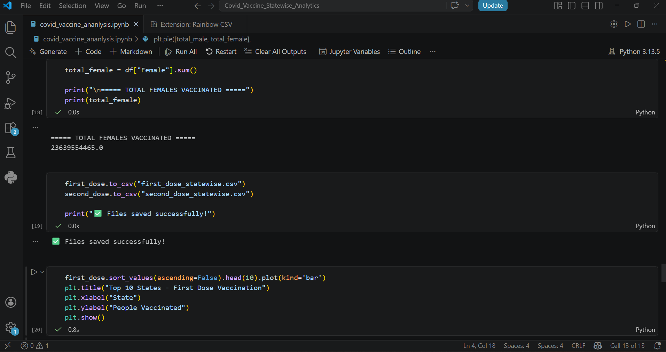

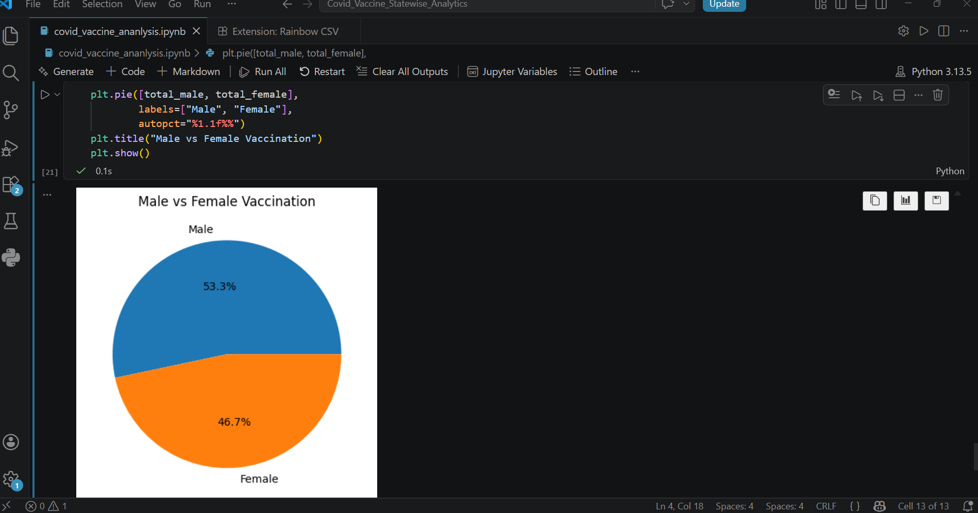

Chapter 6

Testing

Testing Techniques Used

• Functional Testing: Validation of each step in the notebook such as data loading, cleaning, aggregation, and visualization

• Data Validation Testing: Checking dataset integrity, file existence, and correctness of column names before processing

• Result Verification: Ensuring correctness of state-wise vaccination totals and gender-wise calculations

• Error Handling Testing: Handling scenarios such as missing columns, incorrect file paths, and null values in the dataset

• Visualization Testing: Verifying that graphs such as bar charts and pie charts are generated correctly and display accurate information

Sample Test Cases

TC ID | Test Case Description | Input | Expected Output | Status
TC01 | Load dataset | covid_vaccine_statewise.csv file | Dataset loaded successfully without errors | Pass
TC02 | Check column names | Dataset columns | Required columns (State, First Dose, Second Dose, Male, Female) are present | Pass
TC03 | Handle missing values | Dataset with null values | Missing values replaced or handled correctly | Pass
TC04 | First dose calculation | State-wise data | Correct total of first dose per state | Pass
TC05 | Second dose calculation | State-wise data | Correct total of second dose per state | Pass
TC06 | Male vaccination count | Male column | Correct total male vaccinated | Pass
TC07 | Female vaccination count | Female column | Correct total female vaccinated | Pass
TC08 | Data grouping | State column | Proper grouping of data by state | Pass
TC09 | Visualization (Bar chart) | First dose data | Bar chart displayed correctly | Pass
TC10 | Visualization (Pie chart) | Male & Female data | Pie chart displayed correctly | Pass
TC11 | Invalid file path | Wrong CSV file path | Error message displayed | Pass
TC12 | Missing column | Dataset without required column | Error handled gracefully | Pass

Chapter 7

Conclusion

The COVID-19 Vaccination Data Analysis project successfully demonstrates the application of data analysis techniques using Python. The system efficiently processes a real-world dataset to extract meaningful insights related to vaccination progress across different states in India.

Through this project, state-wise analysis of first dose and second dose vaccinations was performed, along with gender-wise analysis of vaccinated individuals. The use of data preprocessing techniques ensured accurate and reliable results. Visualization methods such as bar charts and pie charts enhanced the understanding of data patterns and trends.

The implementation using Python libraries like Pandas and Matplotlib proved to be effective for handling large datasets and performing computations efficiently. The project highlights the importance of data analysis in real-world scenarios, especially in the healthcare domain for monitoring and decision-making.

Overall, the system is simple, efficient, and scalable. It can be further enhanced by integrating advanced analytics, real-time data updates, and interactive dashboards. This project provides a strong foundation for applying data science techniques to solve practical problems.

