S.M. SHETTY COLLEGE OF SCIENCE, COMMERCE AND MANAGEMENT STUDIES
Department of B.Sc. Information Technology

RESEARCH PROJECT REPORT
ON
MIND CARE SYSTEM
Submitted in partial fulfilment of the academic requirements
Bachelor of Science in Information Technology
Submitted By
Roshni Singh
Roll No.: 57 | Class: TYIT / A
Under the Guidance of
Prof. Vinay Shahapurkar
University of Mumbai
Academic Year 2025–2026

CERTIFICATE
This is to certify that Mrs. Roshni Singh, Roll No. 57, of TYIT / A, Department of B.Sc. Information Technology, S.M. Shetty College of Science, Commerce and Management Studies, has successfully completed the Research Project entitled “Mind Care System” during the academic year 2025–2026, under the guidance of Prof. Vinay Shahapurkar.
The project report is submitted as part of the academic requirements of the Bachelor of Science in Information Technology under the University of Mumbai.

[Guide Signature]
[Head of Department Signature]
[Principal Signature]

Date: ____________________
Place: Mumbai

DECLARATION BY STUDENT
I, Roshni Singh, Roll No. 57, student of TYIT / A, B.Sc. Information Technology, S.M. Shetty College of Science, Commerce and Management Studies, hereby declare that the project report entitled “Mind Care System” is my academic work carried out during the academic year 2025–2026 under the guidance of Prof. Vinay Shahapurkar.
The report has been prepared for academic purposes and documents the analysis, design, development, testing, and observations associated with the project. Sources and technical documentation used during the project are acknowledged in the references section.

[Student Signature]
Roshni Singh | Roll No. 57
Date: ____________________

ACKNOWLEDGEMENT
I express my sincere gratitude to my project guide, Prof. Vinay Shahapurkar, for his guidance, suggestions, reviews, and encouragement throughout the project.
I thank the Department of B.Sc. Information Technology and S.M. Shetty College of Science, Commerce and Management Studies for providing the academic environment and resources required to complete this work.
I am also thankful to my teachers, classmates, friends, and family members for their support and feedback during the development and documentation of the project.
Finally, I acknowledge the developers and maintainers of the open-source technologies, frameworks, libraries, and documentation resources used in developing and testing the system.

ABSTRACT
Student mental wellness is an important aspect of academic life, as students may experience academic pressure, stress, emotional difficulties, sleep-related issues, and challenges in maintaining healthy daily habits. However, students may not always have a structured and accessible platform to record their well-being, monitor changes over time, and access appropriate wellness resources.
The Mind Care System is a web-based student mental wellness application developed to provide a structured and user-friendly platform for monitoring and supporting students’ everyday well-being. The system allows students to register and log in, maintain their personal profile, record daily mood and stress levels, maintain a private journal, track sleep and wellness habits, and set personal wellness goals. Students can view their mood and stress history through dashboards and charts, receive personalized wellness tips, and access meditation and breathing exercises. The system also provides a mental-health resource library, notifications and reminders, and emergency/help resources.
The administrative module allows authorized administrators to manage wellness tips, mental-health resources, meditation content, and other wellness-related information available to students. The system uses Angular for the frontend, Node.js and Express.js for the backend, and MongoDB with Mongoose for data storage. JWT is used for authentication and authorization, while bcrypt is used for secure password hashing. The application follows a client-server architecture with RESTful APIs for communication between the frontend and backend.
The project follows a research and development process covering problem identification, requirement analysis, study of existing approaches, research gap identification, system design, implementation, testing, findings, and documentation. The system is designed as a non-clinical wellness platform and does not provide medical diagnosis or treatment. It aims to help students develop awareness of their daily well-being, maintain healthy habits, and access appropriate wellness and support resources.
Keywords: Student Mental Wellness, Mood Tracking, Stress Assessment, Personal Journal, Sleep Tracking, Wellness Tracking, Meditation, Mental Health Resources, Angular, Node.js, MongoDB, JWT.

TABLE OF CONTENTS
Sr. No. | Section / Chapter | Page
1 | Cover Page | _____
2 | Certificate | _____
3 | Declaration by Student | _____
4 | Acknowledgement | _____
5 | Abstract | _____
6 | Table of Contents | _____
7 | Introduction | _____
8 | Problem Statement | _____
9 | Objectives of the Study | _____
10 | Scope and Limitations | _____
11 | Review of Literature / Existing Systems | _____
12 | Research Gap | _____
13 | Proposed System / Proposed Solution | _____
14 | Research / Development Methodology | _____
15 | Tools and Technologies Used | _____
16 | System Design / Flow Diagram | _____
17 | Implementation / Module Description | _____
18 | Testing and Results | _____
19 | Findings / Observations | _____
20 | Conclusion | _____
21 | Future Scope | _____
22 | References / Bibliography | _____
23 | Appendices | _____
Page numbers should be updated after the final screenshots, diagrams, tables, and appendices are inserted.

CHAPTER 1
INTRODUCTION

1.1 Background
Student well-being is an important part of academic life. Students may experience academic pressure, stress, emotional difficulties, sleep-related problems, and challenges in maintaining healthy daily habits. These factors can affect concentration, motivation, productivity, and overall quality of student life. Regularly monitoring everyday mood, stress, sleep, and wellness habits can help students become more aware of their well-being and identify changes over time.

1.2 Need for a Digital Wellness System
A structured digital platform can provide students with a convenient way to record and monitor everyday wellness information. Maintaining centralized records of mood, stress levels, journal entries, sleep patterns, habits, and personal goals can help students understand their own wellness trends. Providing personalized wellness tips, meditation and breathing exercises, mental-health resources, and reminders through the same platform can make wellness activities more accessible and organized.

1.3 Project Overview
The Mind Care System is a web-based student mental wellness application that provides user registration and authentication, personal profile management, daily mood tracking, stress assessment, private journaling, mood and stress history, dashboard-based visualization, sleep tracking, habit and wellness tracking, and personal wellness goals. The system also provides personalized wellness tips, meditation and breathing exercises, notifications and reminders, a mental-health resource library, and emergency/help resources. An administrative module allows authorized administrators to manage wellness content and resources.

1.4 Motivation
The project applies full-stack web development, database management, authentication, data visualization, validation, and RESTful API concepts to a practical student wellness problem. It demonstrates how multiple information-technology concepts can be integrated into a single platform that supports students in monitoring their everyday well-being and accessing useful wellness resources. The system is designed as a non-clinical wellness platform and is not intended to provide medical diagnosis or treatment.

CHAPTER 2
PROBLEM STATEMENT
Students may experience academic pressure, stress, emotional difficulties, sleep-related problems, and challenges in maintaining healthy daily habits. However, information related to everyday well-being is often not recorded or monitored in a structured manner. When students rely on separate applications, informal methods, or do not track their wellness regularly, it can be difficult to identify patterns in mood, stress, sleep, and daily habits over time.
The problem addressed by this project is the need for a unified web-based student wellness platform that allows students to securely record and monitor their daily mood, stress levels, journal entries, sleep, habits, and wellness goals. The system should provide meaningful visualizations, personalized wellness tips, meditation and breathing exercises, mental-health resources, notifications and reminders, and emergency/help resources in one accessible platform. An administrative module is also required to manage wellness-related content and resources while maintaining appropriate user privacy and access controls.

CHAPTER 3
OBJECTIVES OF THE STUDY
The main objective is to develop a web-based student wellness platform for structured monitoring and management of students’ everyday mental well-being.
- Provide a user-friendly platform for students to record and monitor their daily wellness.
- Allow students to securely record daily mood and stress levels.
- Provide a structured personal journal for recording thoughts and feelings.
- Track and store sleep patterns and wellness habits.
- Maintain a centralized MongoDB database for securely storing user and wellness-related data.
- Implement secure authentication and role-based access control.
- Provide students with mood, stress, sleep, and habit history through dashboards and charts.
- Allow students to set and monitor personal wellness goals.
- Provide personalized wellness tips based on recorded wellness information.
- Provide meditation and breathing exercises to support relaxation and healthy routines.
- Implement notifications and reminders for wellness activities and goals.
- Provide a mental-health resource library containing useful wellness and support information.
- Provide emergency and help resources for students who may require additional support.
- Provide administrators with tools to manage wellness tips, resources, and other wellness content.
- Maintain privacy and appropriate access controls for personal journal and wellness information.
- Test authentication, mood tracking, stress assessment, journaling, sleep tracking, habit tracking, dashboard visualization, notifications, and administrative workflows.

CHAPTER 4
SCOPE AND LIMITATIONS

4.1 Scope
- User registration, login, and secure authentication.
- Student profile management and protected user dashboard.
- Daily mood tracking and stress assessment.
- Personal journal for recording private thoughts and feelings.
- Mood, stress, sleep, and wellness history tracking.
- Dashboard-based visualization of wellness data using charts.
- Sleep tracking with duration and historical records.
- Habit and wellness activity tracking with progress monitoring.
- Personal wellness goal creation and progress tracking.
- Personalized wellness tips based on recorded wellness information.
- Meditation and breathing exercises.
- Notifications and reminders for wellness activities and goals.
- Mental-health resource library with categorized wellness and support content.
- Emergency and help resources for students requiring additional support.
- Administrative authentication and protected admin dashboard.
- Administrative management of wellness tips, resources, meditation content, and other wellness information.
- MongoDB-based persistence for user and wellness-related data.

4.2 Limitations
- The system depends on internet connectivity when accessed as a web application.
- The accuracy of personalized wellness suggestions depends on the quality and completeness of information entered by the student.
- Mood and stress assessments are based on user-provided responses and should not be considered medical or clinical diagnoses.
- The system does not replace professional mental-health assessment, counselling, or medical treatment.
- Emergency/help information depends on the availability and accuracy of resources maintained by the system administrator.
- Notifications and reminders may depend on browser, device, email, and network availability.
- The current system does not independently verify the accuracy of user-entered wellness information.
- Advanced clinical assessment, diagnosis, treatment recommendations, and professional therapy are outside the implemented scope.
- Production-scale deployment would require additional security auditing, monitoring, backup, privacy controls, and scalability measures.

CHAPTER 5
REVIEW OF LITERATURE / EXISTING SYSTEMS
Traditional wellness tracking: Students may use notebooks, personal notes, or informal methods to record feelings, sleep, habits, and goals. Such methods generally do not provide centralized visualization, reminders, or integrated resources.
Digital wellness applications: Digital applications can provide structured interfaces for mood tracking, journaling, habit monitoring, meditation, and wellness resources.
Mood and stress tracking: Structured records allow users to review changes in their daily experiences over time as non-clinical wellness indicators.
Journaling and self-reflection: Digital journaling provides a private space for thoughts and feelings, making privacy and ownership controls important.
Habit and goal tracking: Combining habits, sleep, mood, and goals can provide a broader view of everyday wellness.
Proposed system: The Mind Care System integrates these functions with dashboards, reminders, resources, and administrative content management.

CHAPTER 6
RESEARCH GAP
The project identifies a gap between isolated wellness activities and an integrated student-focused wellness platform. Separate tools for journaling, mood tracking, meditation, habits, sleep, or reminders can make personal wellness information fragmented.
The proposed system integrates daily mood and stress tracking, private journaling, sleep and habit monitoring, wellness goals, dashboards, personalized tips, meditation, reminders, mental-health resources, and administrative content management in one application.

CHAPTER 7
PROPOSED SYSTEM / PROPOSED SOLUTION
The proposed system is a full-stack web application connecting an Angular frontend to a Node.js and Express.js backend with MongoDB persistence. The architecture separates presentation, server-side API logic, authentication, authorization, and data storage.
Student workflow: Register/login, manage profile, record mood and stress, journal, track sleep/habits/goals, review dashboards, use wellness content, access resources, and manage reminders.
Admin workflow: Authorized administrators access a protected dashboard and manage wellness tips, resources, meditation content, and related information.
Main features: authentication, profile, mood, stress, journal, history, dashboard, tips, meditation, sleep, habits, goals, notifications, resources, help/emergency information, and admin content management.

CHAPTER 8
RESEARCH / DEVELOPMENT METHODOLOGY

Problem Identification
Identify the need for structured student wellness tracking and support.

Requirement Analysis
Identify student and administrator requirements.

Design and Development
Divide the system into frontend, backend, database, authentication, tracking, dashboard, content, and notification components.

Testing and Documentation
Test registration, login, tracking, dashboard, protected routes, role access, reminders, content management, and privacy controls.

CHAPTER 9
TOOLS AND TECHNOLOGIES USED
Technology / Tool | Purpose
Angular | Frontend application and component development.
HTML / CSS / TypeScript | Interface structure, styling, and application logic.
Node.js | Server-side runtime.
Express.js | Backend API and routing.
MongoDB | Database storage.
Mongoose | MongoDB object modelling.
JWT | Authentication and authorization.
bcrypt / bcryptjs | Password hashing.
REST APIs | Frontend/backend communication.
Chart library | Dashboard visualization.
Nodemailer / Gmail SMTP | Email notifications where configured.
Git / GitHub | Version control.
VS Code | Development environment.
Database: user accounts, mood, stress, journals, sleep, habits, goals, tips, resources, meditation content, and notification preferences.
Security: password hashing, JWT protection, role-based access, and ownership checks for private records.

CHAPTER 10
SYSTEM DESIGN / FLOW DIAGRAM
The Angular frontend sends HTTP requests to the Express.js backend. The backend validates requests, applies authentication and authorization, processes business logic, and communicates with MongoDB. Responses are returned to the frontend for display and visualization.

Figure 10.1: High-Level System Architecture Diagram
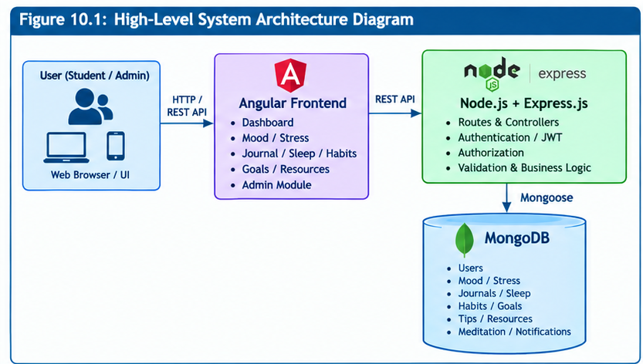

Figure 10.2: Student Workflow Diagram
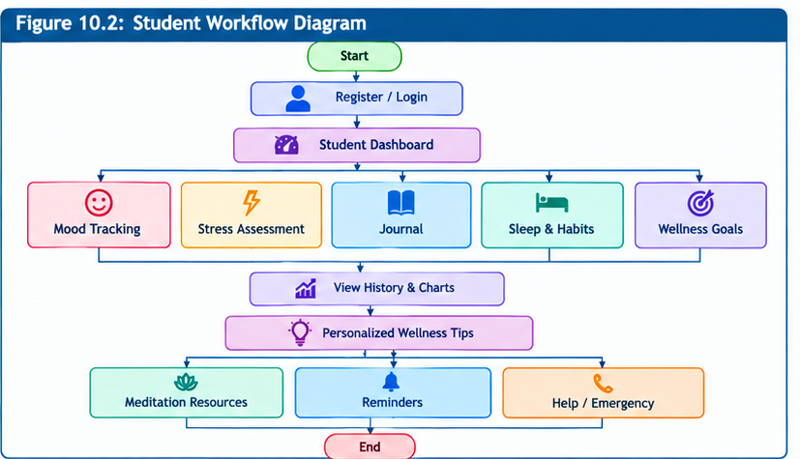
Figure 10.3: Admin Workflow Diagram
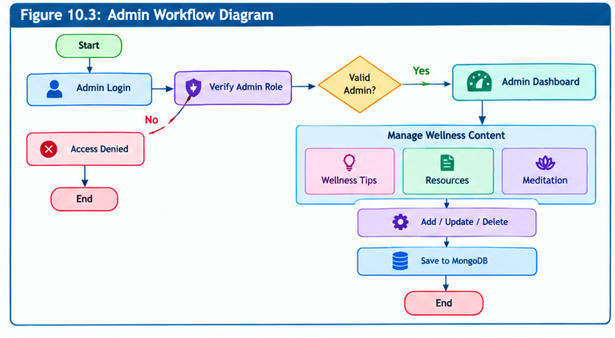

Figure 10.4: MongoDB Collections and Document Structure Diagram
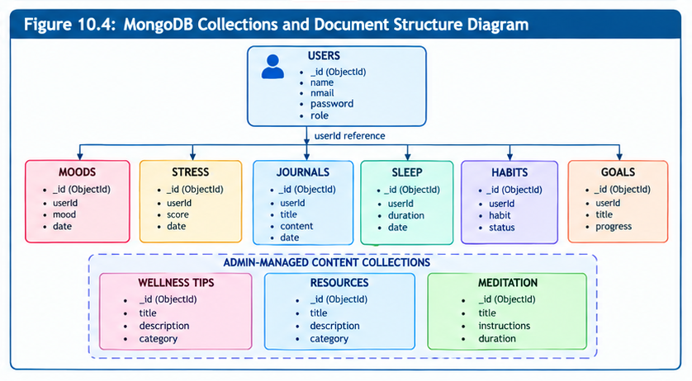
API modules include authentication, mood, stress, journal, sleep, habits, goals, resources, and administrative content management with appropriate public, authenticated, owner, and admin access.

CHAPTER 11
IMPLEMENTATION / MODULE DESCRIPTION
- Home / Dashboard — summary of recent wellness information, charts, goals, and wellness content.
- Registration — account creation with validation.
- Login — authentication for students and administrators.
- Profile — view and update personal profile information.
- Mood Tracking — daily mood records and history.
- Stress Assessment — structured non-clinical assessment and history.
- Personal Journal — private create, view, update, and delete functions.
- Sleep Tracking — sleep records, duration, and history.
- Habit and Wellness Tracking — habits, completion, and progress.
- Wellness Goals — goals, progress, and status.
- Tips and Meditation — wellness tips and breathing/meditation exercises.
- Notifications and Reminders — preferences and reminders for wellness activities.
- Resource Library — categorized wellness and support resources.
- Help / Emergency — professional and emergency support information maintained by administrators.
- Admin Dashboard — protected management of wellness content.
- Access Control — role and ownership checks enforced by the backend.

CHAPTER 12
TESTING AND RESULTS
Testing should cover valid and invalid registration/login, profile updates, mood entries, stress assessments, journal ownership, sleep records, habit completion, goal creation, dashboard charts, wellness tips, meditation exercises, reminders, resource access, admin authorization, and unauthorized access.
Test Area | Expected Result | Observed Result
Registration / Login | Valid users can authenticate; invalid input is rejected. | To be completed after final integrated testing
Mood / Stress | Records are stored and retrieved for the correct student. | To be completed after final integrated testing
Journal Ownership | Students can access only their own journal records. | To be completed after final integrated testing
Sleep / Habits / Goals | Records and progress are persisted correctly. | To be completed after final integrated testing
Dashboard | Relevant wellness data is retrieved and visualized. | To be completed after final integrated testing
Admin Authorization | Only authorized administrators can manage content. | To be completed after final integrated testing
Notifications / Reminders | Configured reminders operate as intended. | To be completed after final integrated testing
Testing types: Functional testing; input validation testing; authentication testing; role-based authorization testing; database operation testing; privacy and ownership testing; dashboard and visualization testing; notification/reminder testing; navigation and usability testing.
The provisional results above should be replaced with actual observed results after the final integrated build is tested and screenshots are captured.

CHAPTER 13
FINDINGS / OBSERVATIONS
- Structured wellness records provide a consistent way to review daily well-being information.
- Historical mood and stress records can help students observe changes over time.
- Dashboard visualizations provide a quick summary of recorded wellness information.
- Private journaling provides a dedicated space for self-reflection with ownership-based access.
- Sleep and habit tracking supports monitoring of everyday routines.
- Wellness goals provide a structured way to monitor personal progress.
- Personalized wellness content connects recorded information with relevant self-care resources.
- Role-based authorization separates administrative content management from student functions.
- Backend validation and ownership checks are important for protecting user data.
- The project integrates frontend, backend, database, authentication, visualization, and wellness-resource technologies.

CHAPTER 14
CONCLUSION
The Mind Care System demonstrates the application of full-stack web technologies to the organization and monitoring of student everyday wellness information. It provides a structured platform through which students can record mood, stress, journal entries, sleep, habits, and wellness goals while accessing dashboards, wellness tips, meditation exercises, resources, reminders, and help information.
The administrative module supports management of wellness content while role-based authorization and ownership controls help protect personal information. The project demonstrates practical application of frontend development, REST APIs, database persistence, authentication, authorization, validation, data visualization, and content management. The system is intended as a non-clinical wellness support platform and does not replace professional mental-health care.

CHAPTER 15
FUTURE SCOPE
- Dedicated Android/iOS application.
- Push notifications and improved reminder scheduling.
- Calendar-based wellness tracking.
- Optional wearable-device integration for sleep and activity data.
- Advanced analytics and personalized wellness insights.
- Multilingual accessibility.
- Accessibility improvements.
- Integration with institution-approved counselling or student-support services where appropriate.
- Enhanced privacy, audit logging, backup, and production security controls.
- Scalable cloud deployment and monitoring.
- Optional AI-assisted wellness content and journaling support with privacy and non-clinical safeguards.

CHAPTER 16
REFERENCES / BIBLIOGRAPHY
Angular. (n.d.). Angular documentation. https://angular.dev/
Node.js. (n.d.). Node.js documentation. https://nodejs.org/docs/
Express.js. (n.d.). Express documentation. https://expressjs.com/
MongoDB. (n.d.). MongoDB documentation. https://www.mongodb.com/docs/
Mongoose. (n.d.). Mongoose documentation. https://mongoosejs.com/docs/
JSON Web Tokens. (n.d.). Introduction to JSON Web Tokens. https://jwt.io/introduction
GitHub. (n.d.). GitHub documentation. https://docs.github.com/
Visual Studio Code. (n.d.). Documentation. https://code.visualstudio.com/docs/

CHAPTER 17
APPENDICES

Appendix A – Application Screenshots
Insert high-quality screenshots of the implemented application with proper figure numbers and captions. The following sequence may be used:
- Figure A.1: Home / Dashboard
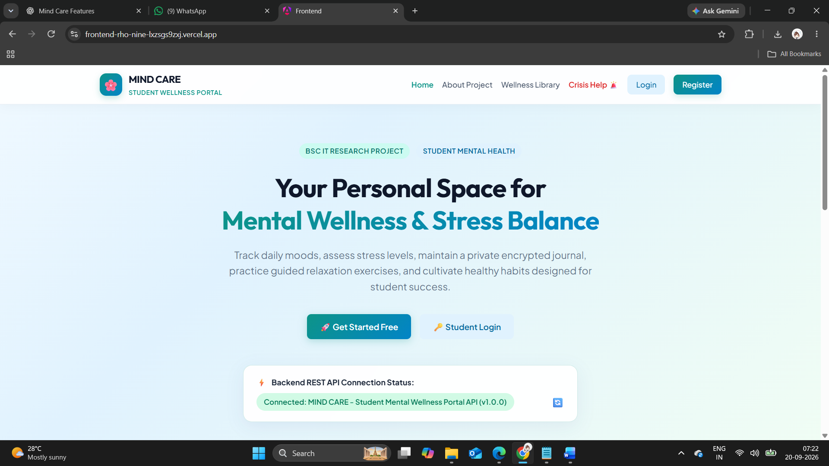

- Figure A.2: Registration Page
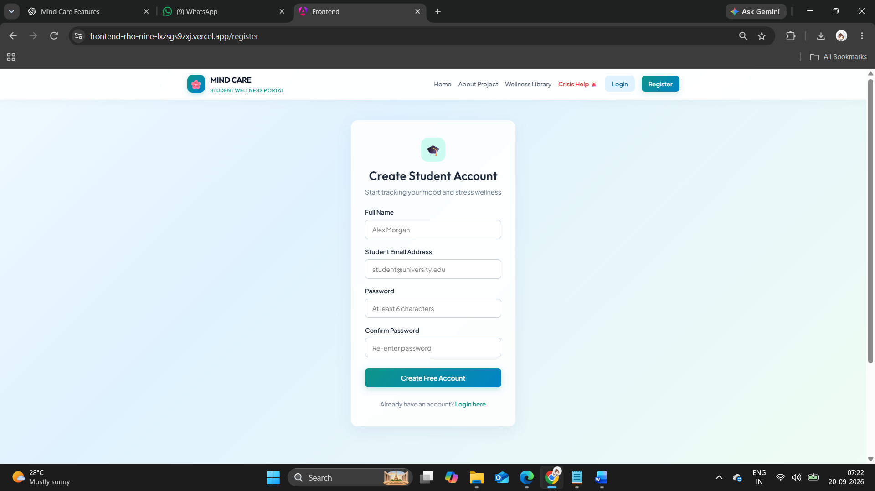
- Figure A.3: Login Page
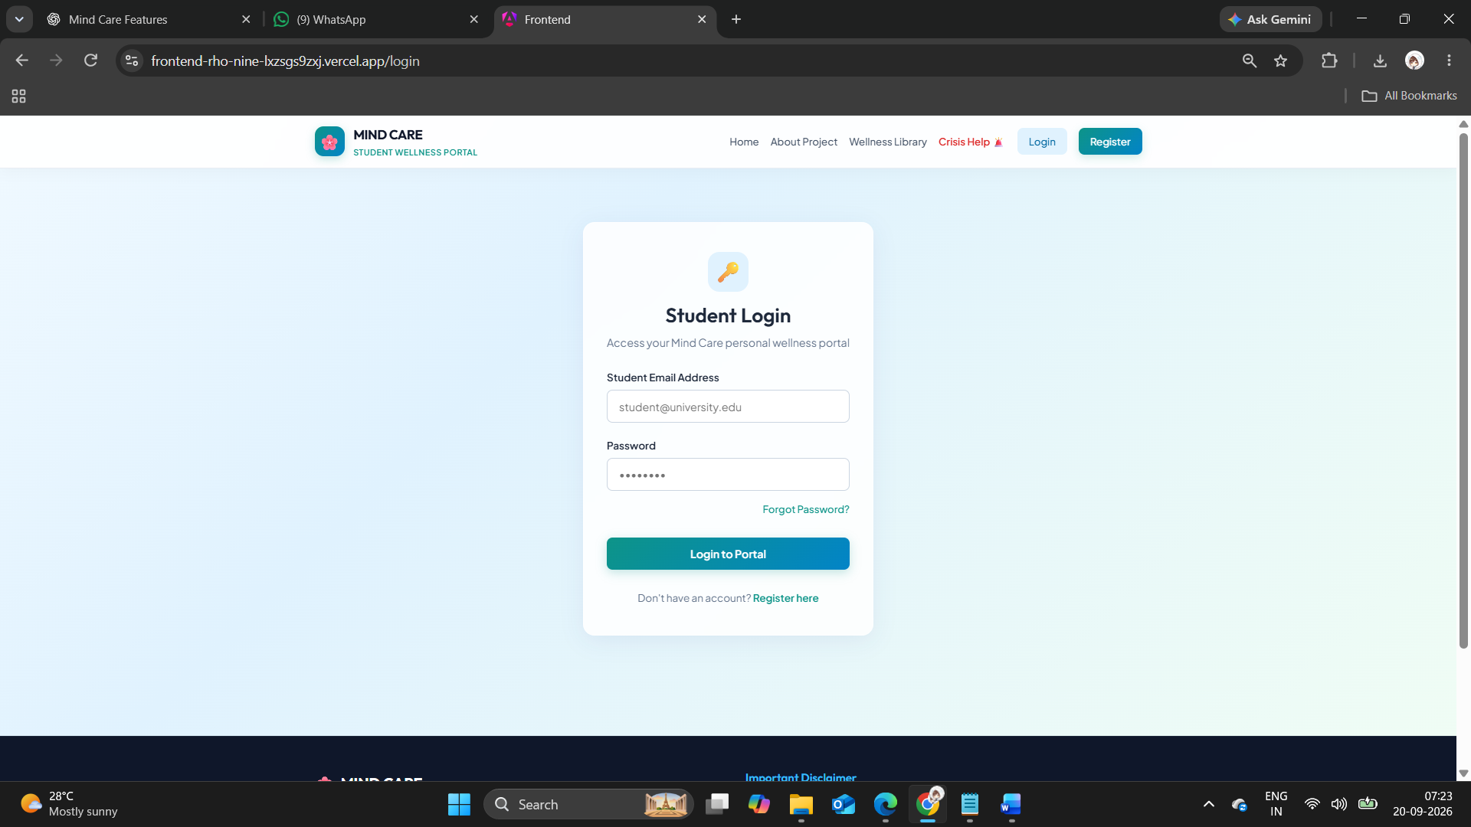

- Figure A.4: Student Profile
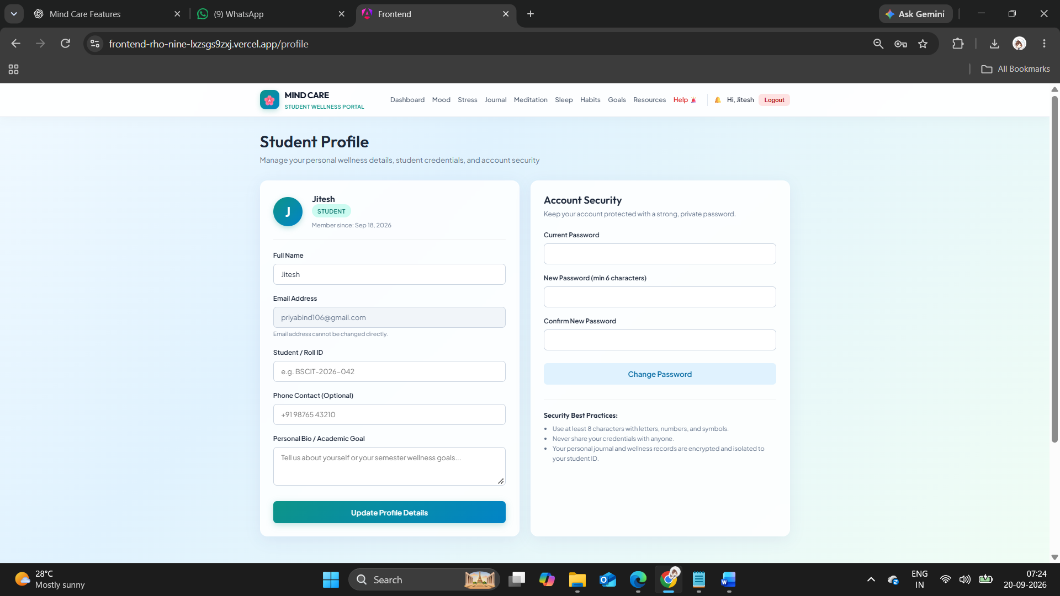

- Figure A.5: Mood Tracking
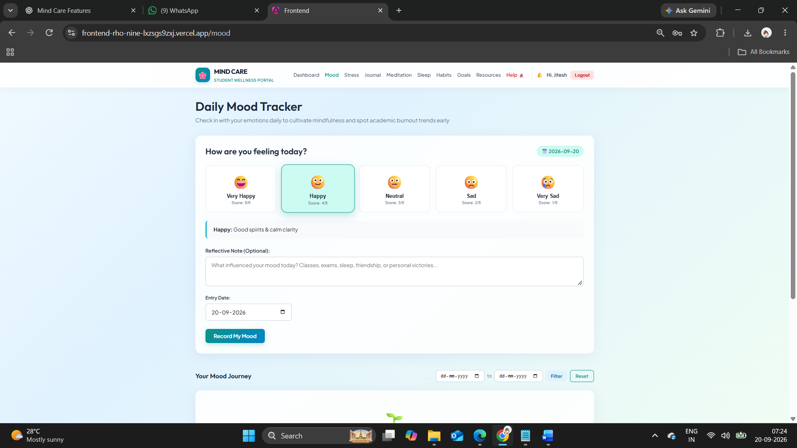

- Figure A.6: Stress Assessment
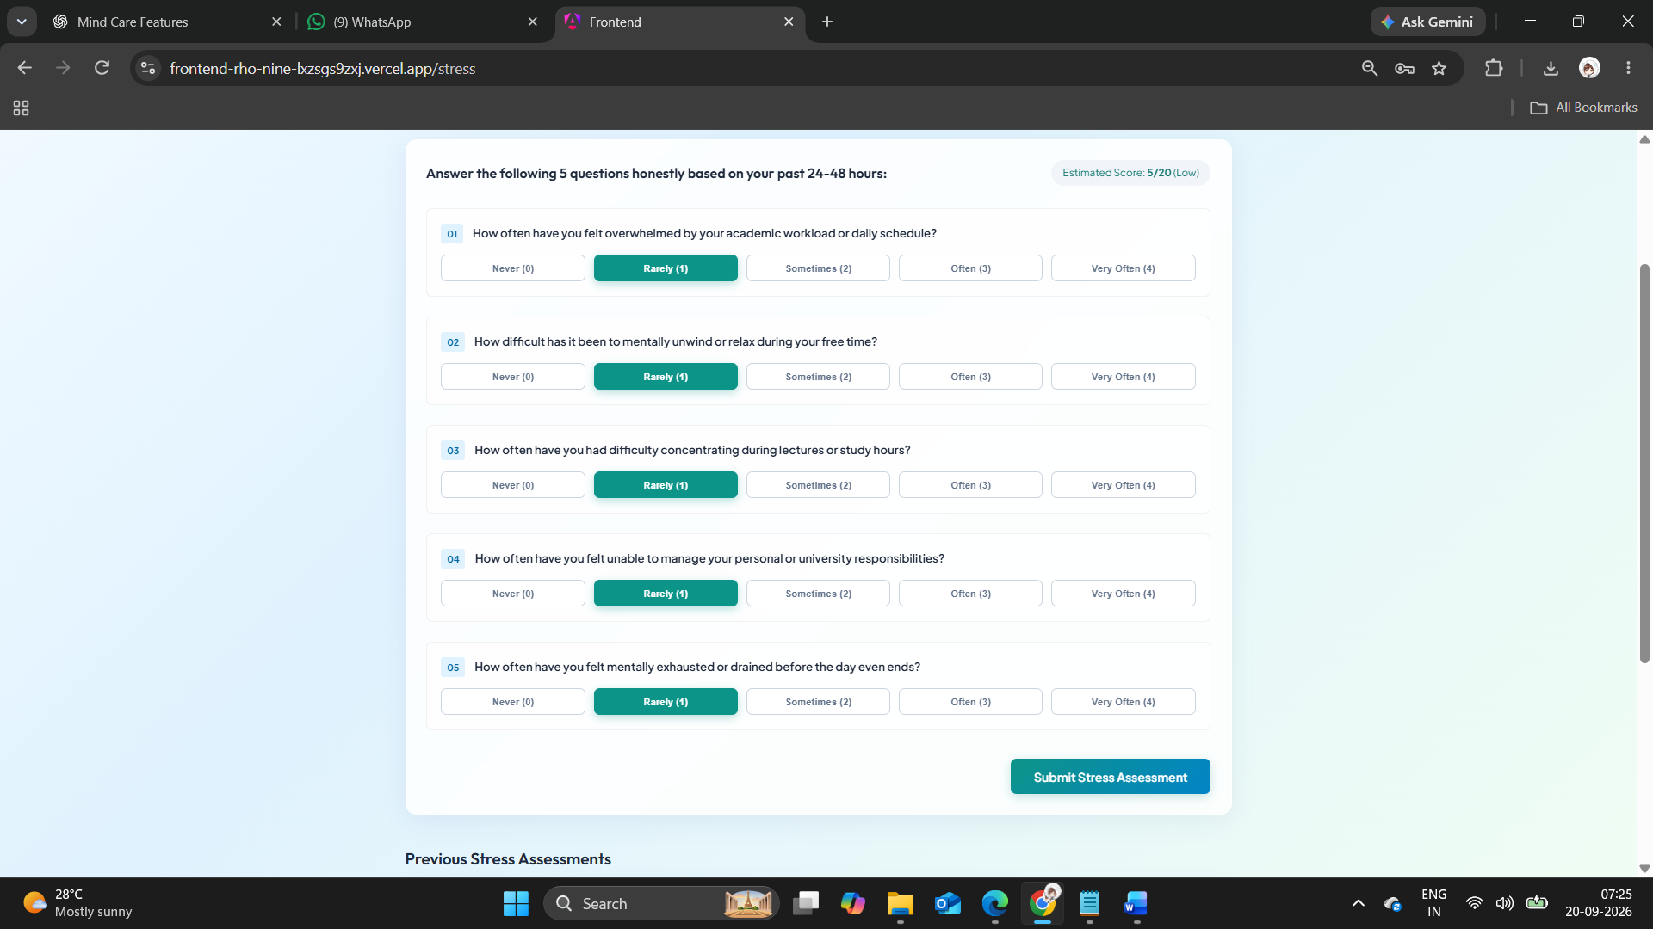

- Figure A.7: Personal Journal
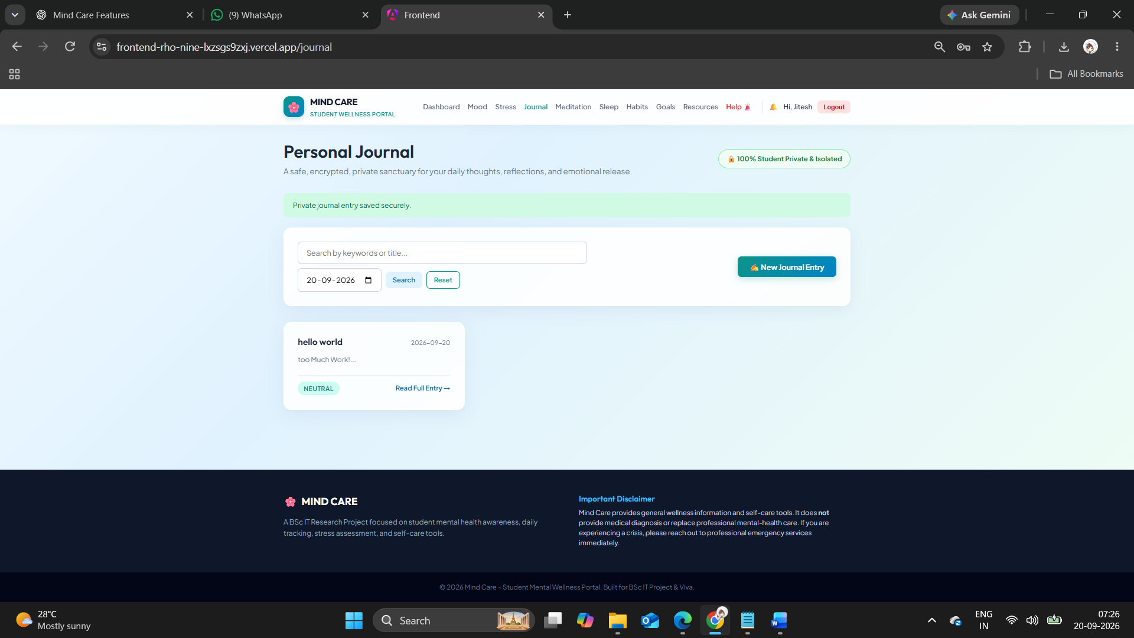

- Figure A.8: Sleep Tracking
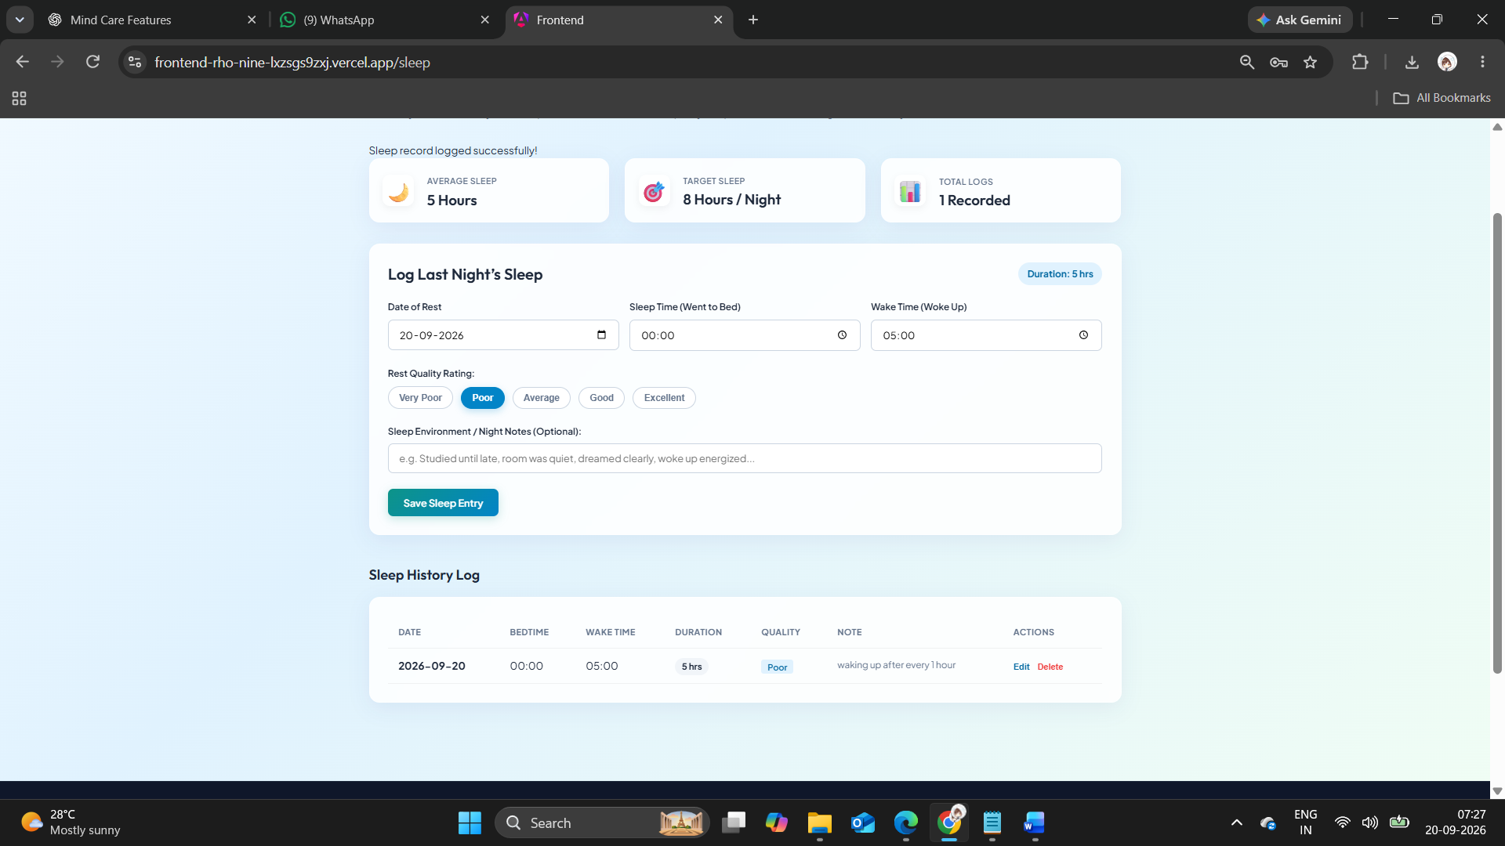

- Figure A.9: Habit and Wellness Tracking
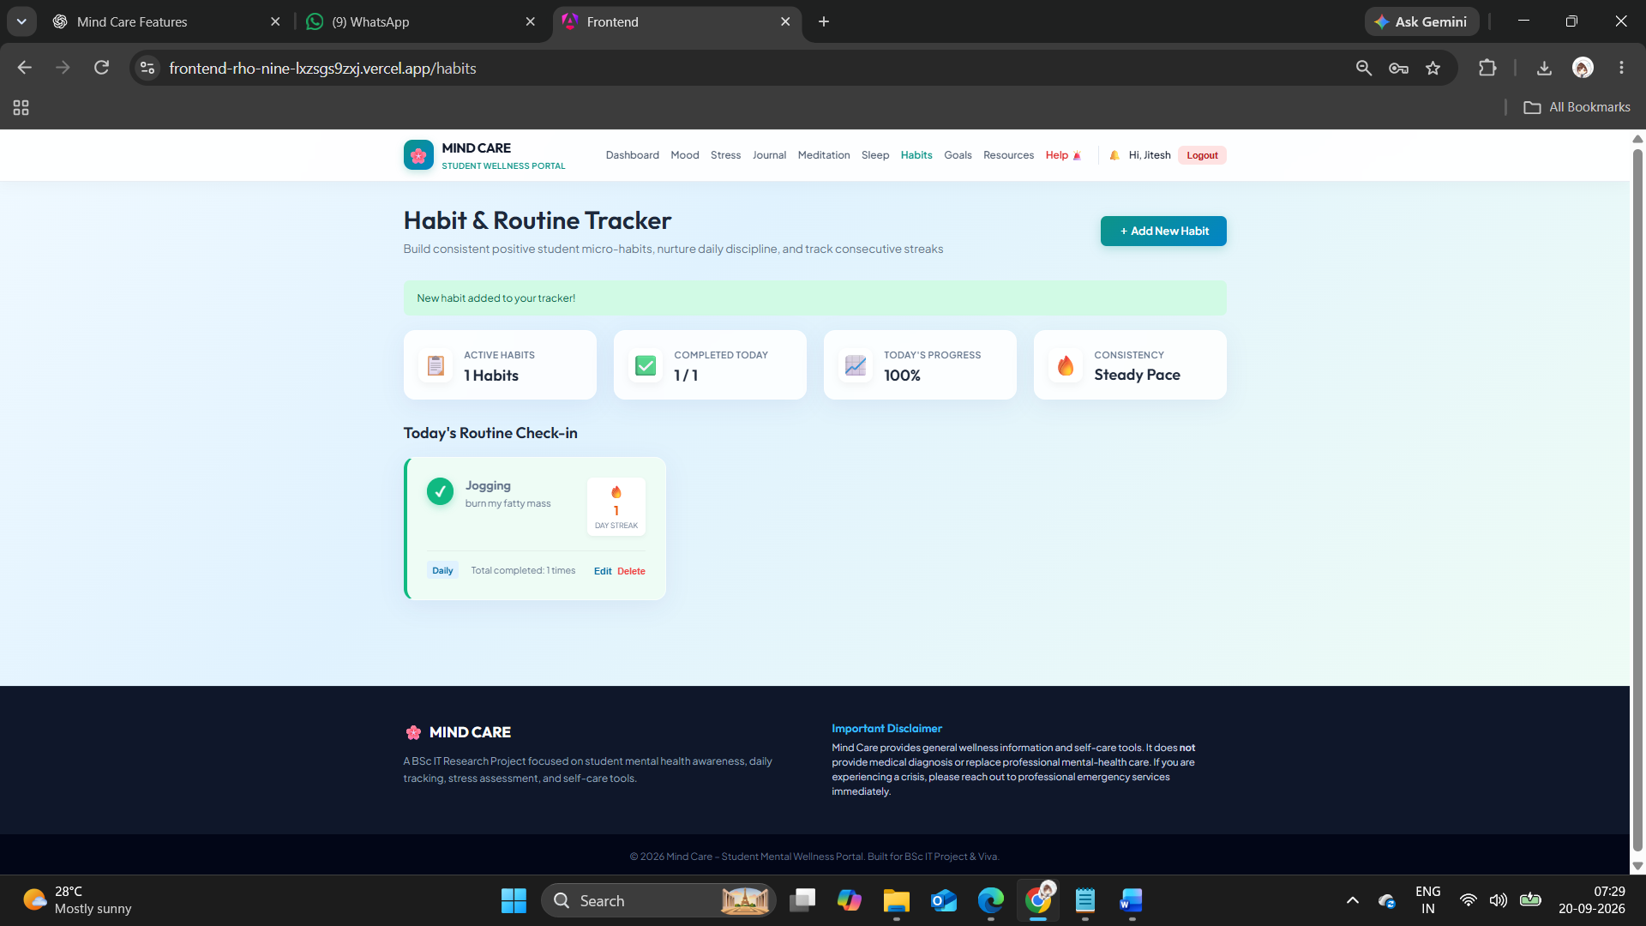

- Figure A.10: Wellness Goals
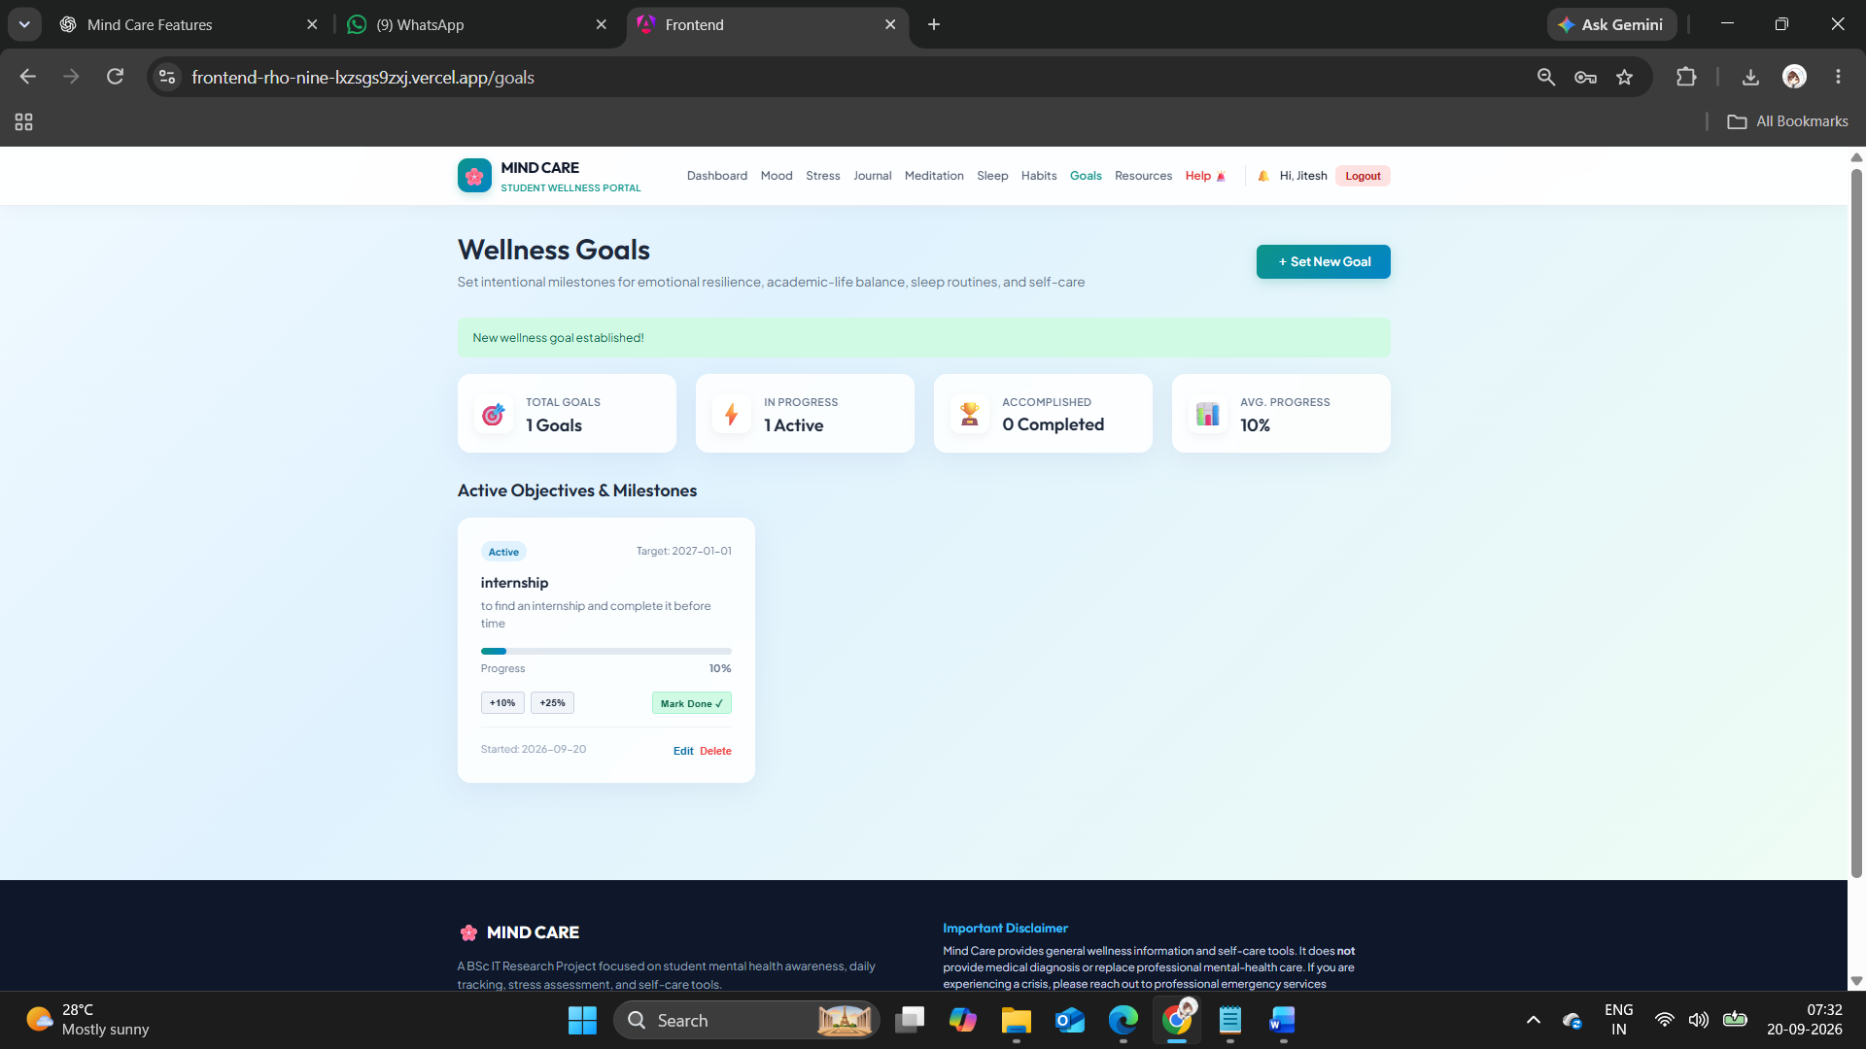
- Figure A.11: Wellness Tips

- Figure A.12: Meditation / Breathing Exercise
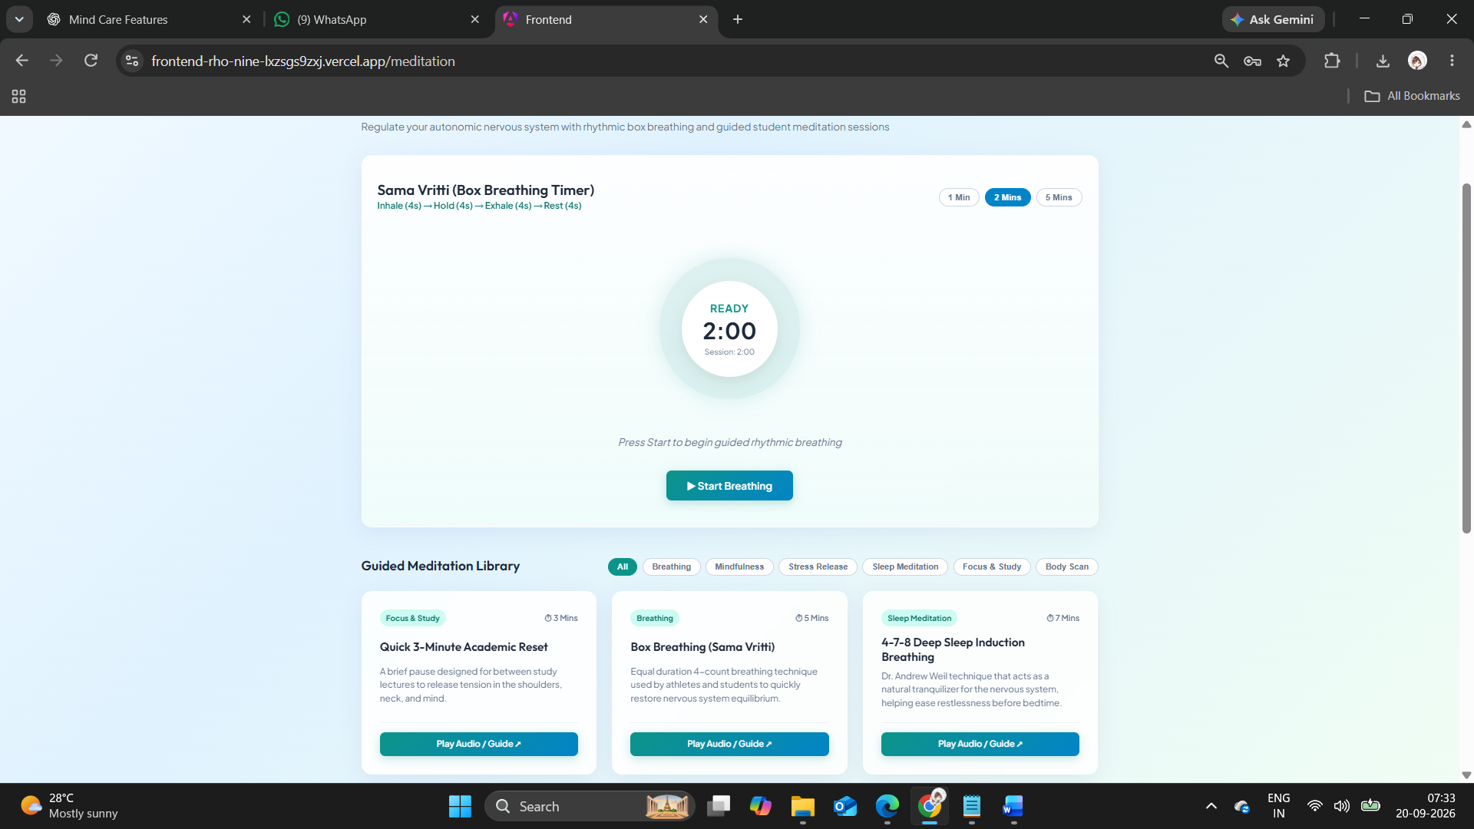

- Figure A.14: Mental-Health Resource Library
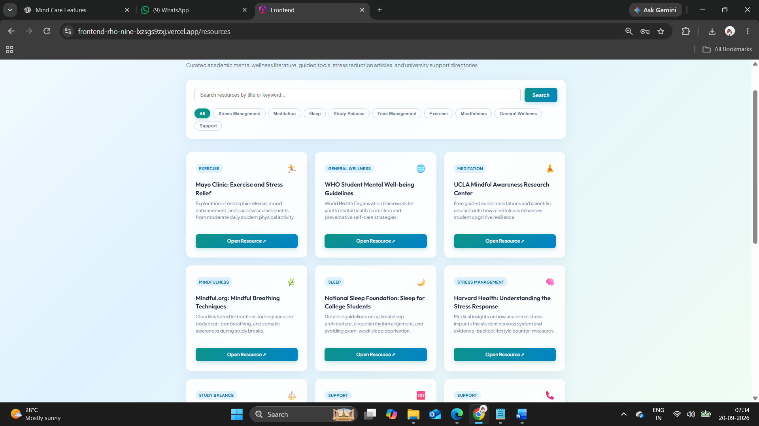

- Figure A.15: Help / Emergency Resources
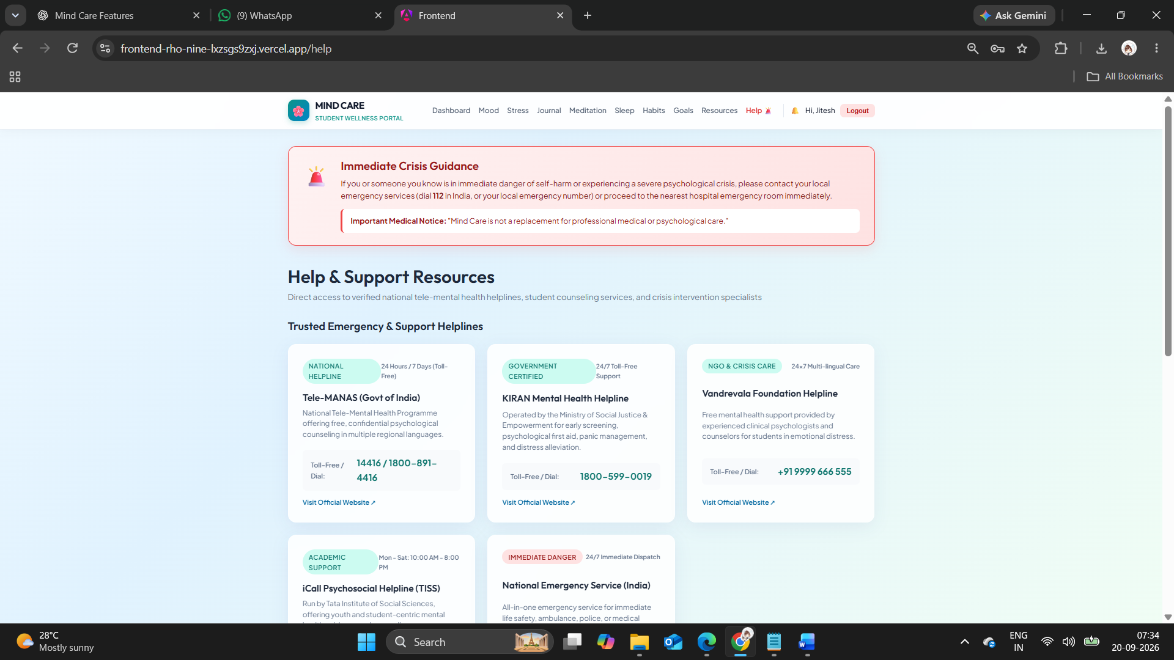

- Figure A.16: Admin Dashboard
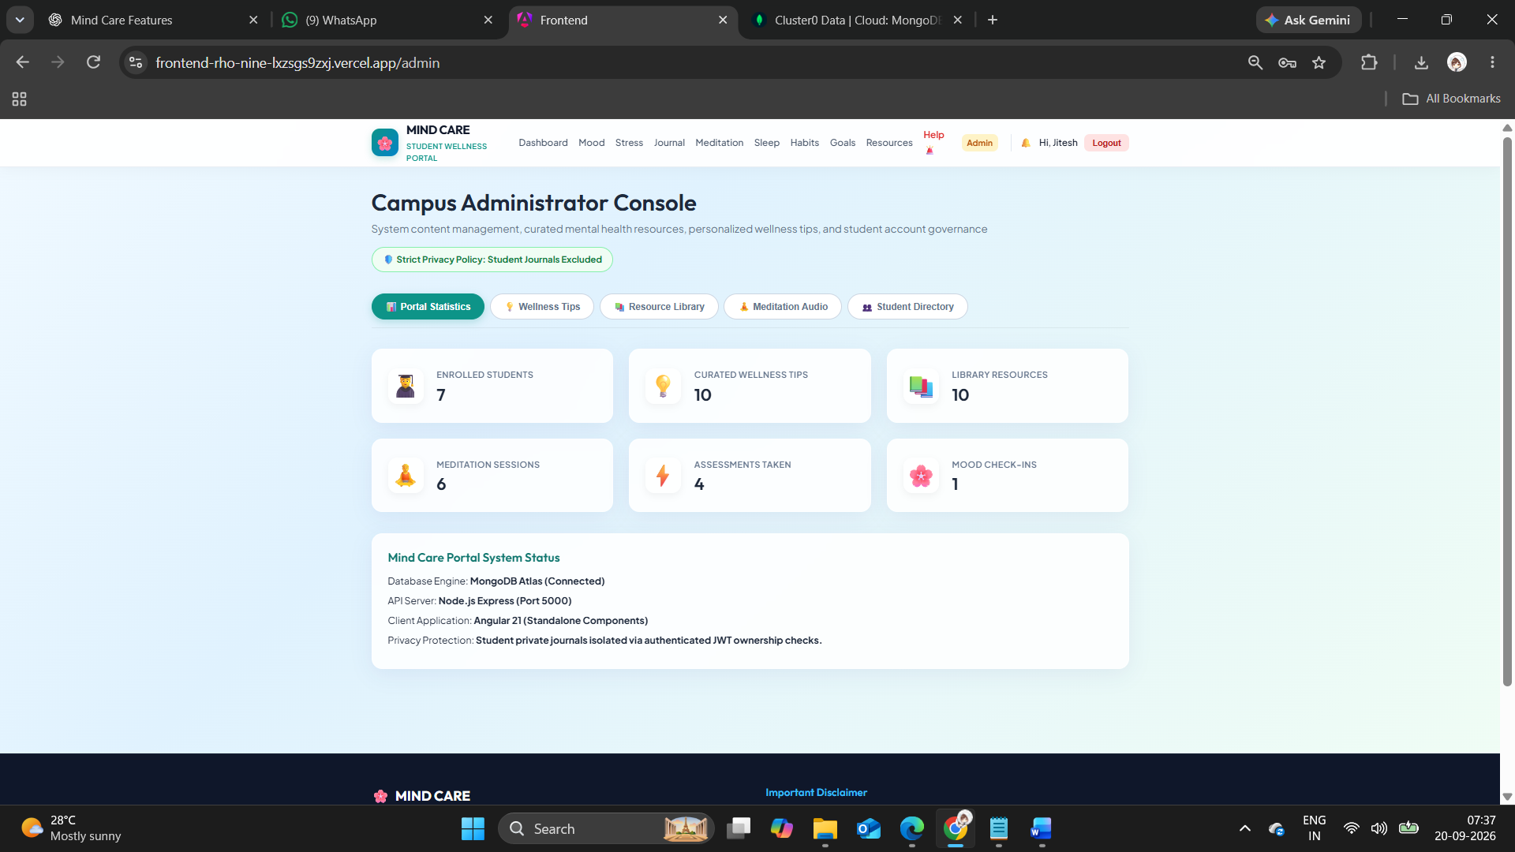

- Figure A.17: Admin Content Management
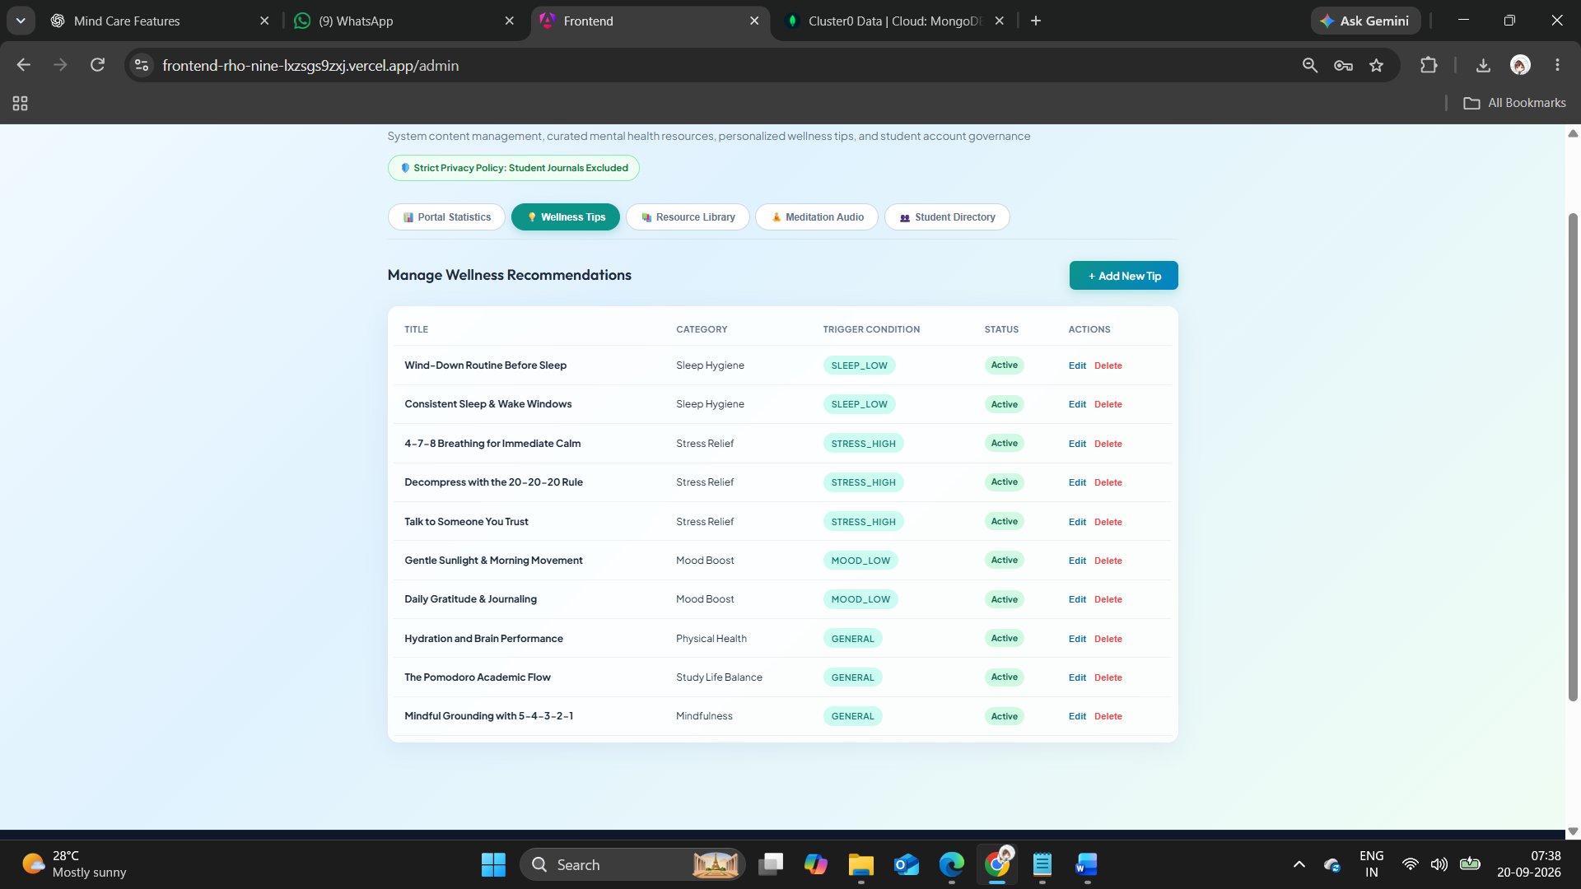

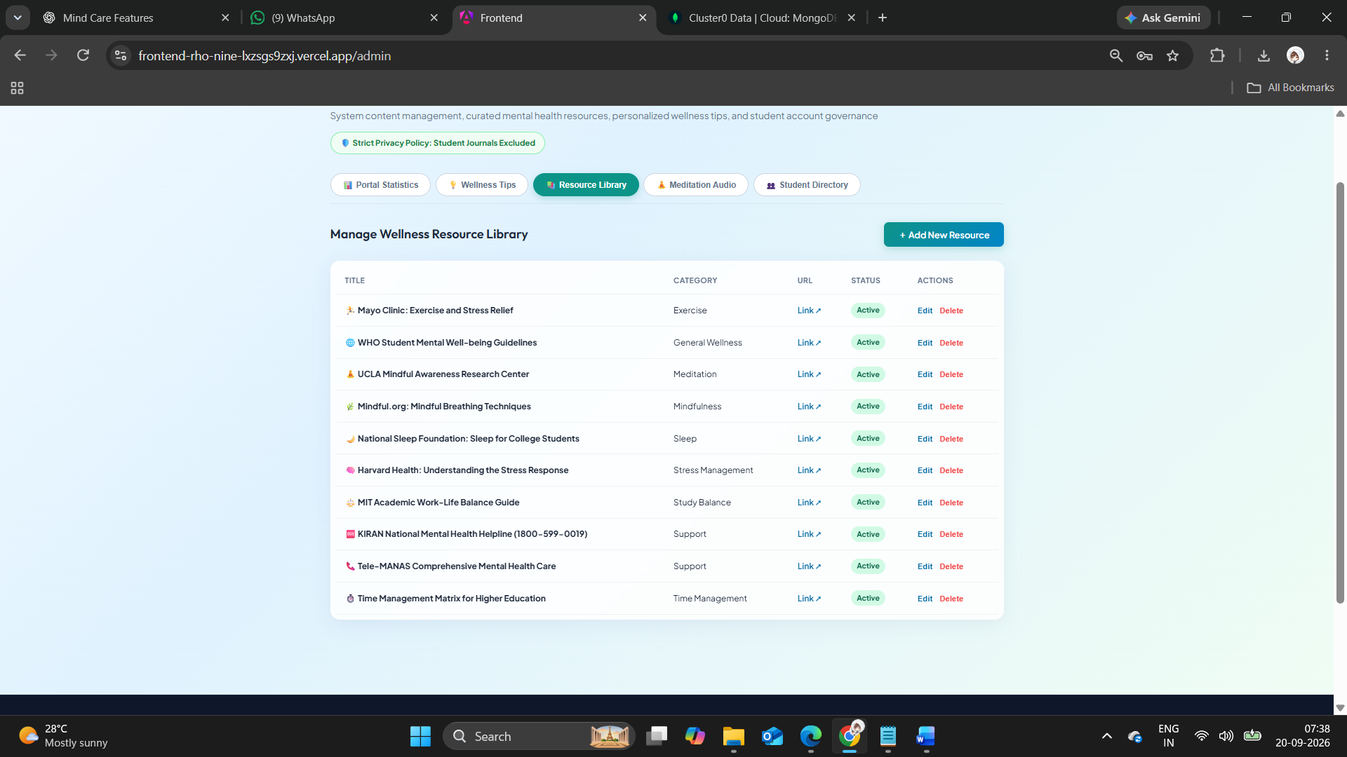

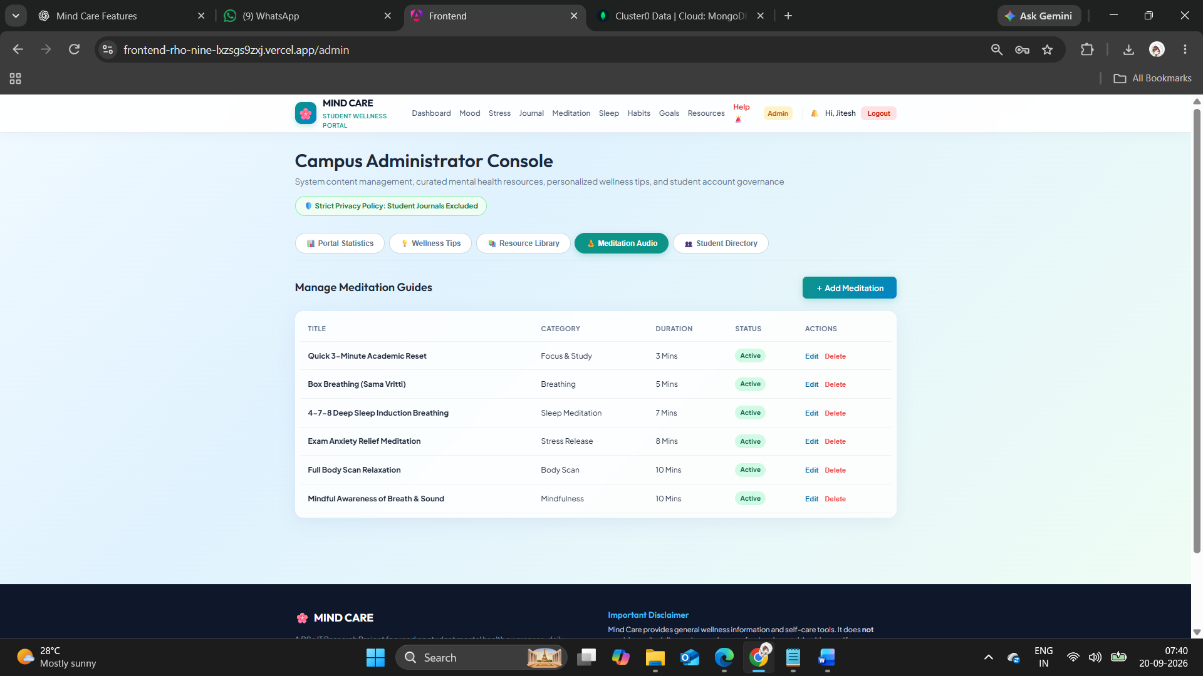

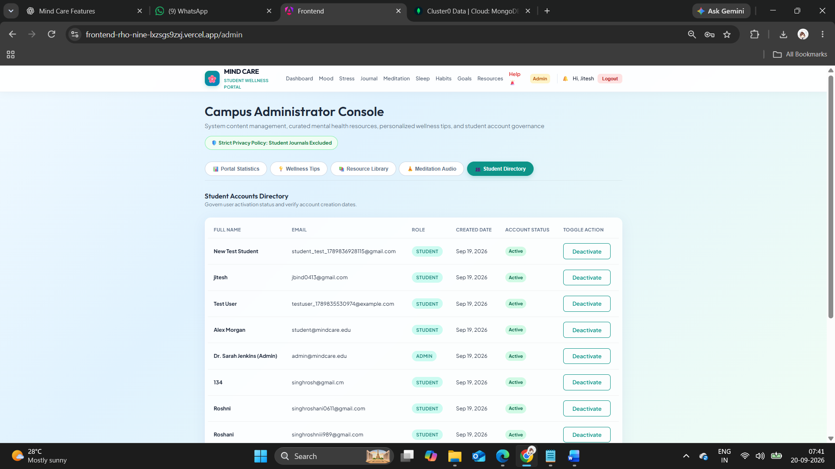

Appendix B – MongoDB Database Design
The Mind Care System uses MongoDB as a document-oriented database. Data is organized into collections such as Users, Mood Entries, Stress Assessments, Journals, Sleep Entries, Habits, Goals, Wellness Tips, Wellness Resources, and Meditation Resources. User-specific collections contain a userId reference to associate records with the corresponding student. These associations are managed at the application level rather than through traditional relational foreign keys.
Figure B.1: MongoDB Collections and Document Structure Diagram

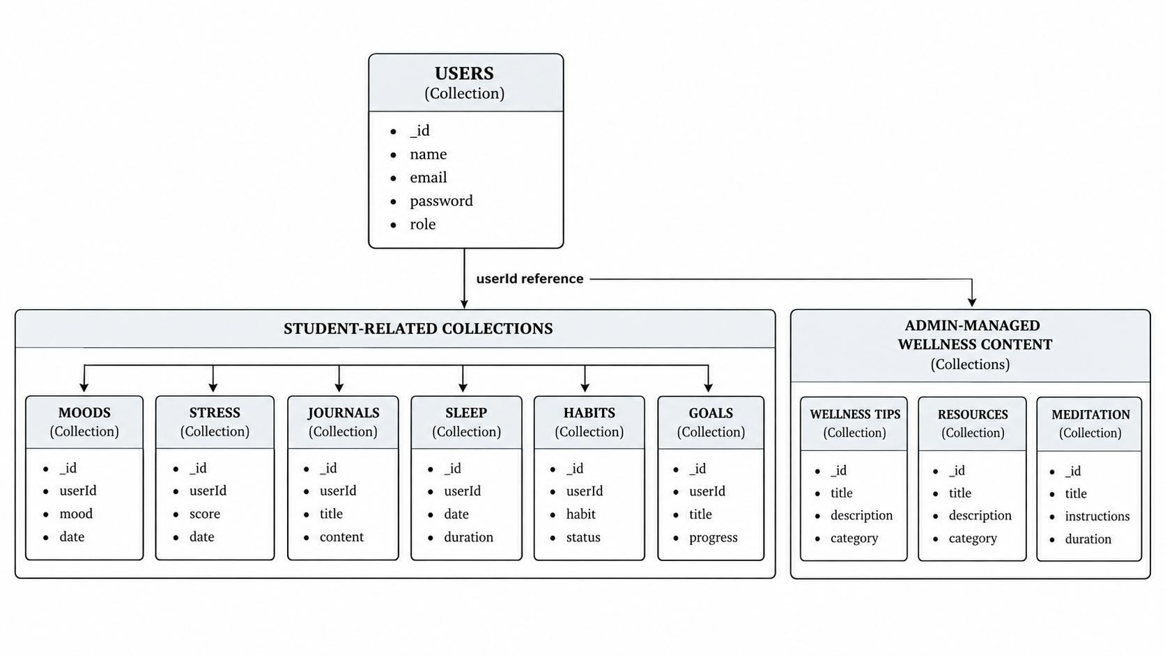

Appendix C – Sample Code
This appendix presents selected code excerpts from the Mind Care System to demonstrate the implementation of important backend functionalities. Only representative sections should be included; the complete source code should remain in the project repository.

C.1 Authentication Middleware
The authentication middleware verifies the JWT token supplied by the user and identifies the authenticated student before allowing access to protected API routes.
Purpose:
- Verify user authentication.
- Decode the JWT token.
- Attach the authenticated user's information to the request.
- Prevent unauthorized access to protected resources.
Example excerpt:
const authMiddleware = (req, res, next) => {
const token = req.headers.authorization?.split(" ")[1];
if (!token) {
return res.status(401).json({ message: "Unauthorized" });
}
try {
const decoded = jwt.verify(token, process.env.JWT_SECRET);
req.user = decoded;
next();
} catch (error) {
return res.status(401).json({ message: "Invalid token" });
}
};

C.2 Mood and Stress APIs
These APIs handle the submission and retrieval of daily mood and stress assessment data. The actual project code should be inserted below.
// Representative structure
router.post("/mood", authMiddleware, createMood);
router.get("/mood/history", authMiddleware, getMoodHistory);
router.post("/stress", authMiddleware, createStressAssessment);
router.get("/stress/history", authMiddleware, getStressHistory);

C.3 Journal Ownership Check
The journal module verifies that the requested journal entry belongs to the currently authenticated student before allowing it to be viewed, edited, or deleted.
const journal = await Journal.findOne({
_id: req.params.id,
userId: req.user.id
});
if (!journal) {
return res.status(404).json({
message: "Journal entry not found"
});
}

C.4 Dashboard Data Retrieval
The dashboard retrieves relevant wellness data for the authenticated student and provides it to the frontend for visualization. The retrieved information may include mood history, stress assessment history, sleep records, habit progress, and wellness goals.
const userId = req.user.id;
const [moods, stress, sleep, habits, goals] =
await Promise.all([
Mood.find({ userId }).sort({ date: -1 }),
StressAssessment.find({ userId }).sort({ date: -1 }),
SleepEntry.find({ userId }).sort({ date: -1 }),
Habit.find({ userId }),
Goal.find({ userId })
]);
res.json({ moods, stress, sleep, habits, goals });

C.5 Administrative Content Management
The administrative module allows authorized administrators to add, update, and remove wellness content. The final appendix should replace the representative excerpt below with the exact project implementation.
if (req.user.role !== "admin") {
return res.status(403).json({
message: "Admin access required"
});
}
const resource = await Resource.create({
title: req.body.title,
description: req.body.description,
category: req.body.category
});
res.status(201).json(resource);

C.6 Note on Source Code
The code presented in this appendix contains selected excerpts for academic documentation. The complete implementation includes additional models, controllers, routes, services, validation, error handling, authentication, and frontend integration. Before final submission, the representative excerpts should be checked against the final project source code so that the appendix accurately reflects the implemented system.

Appendix D – Guide Meeting Record
Date | Discussion / Work | Completed | Guide Remarks / Signature
________ | Topic selection and problem discussion | ________ | ________
________ | Requirement analysis | ________ | ________
________ | System design and methodology | ________ | ________
________ | Development review | ________ | ________
________ | Testing and findings review | ________ | ________
________ | Final documentation and demonstration | ________ | ________

Appendix E – Final Submission Checklist
- Guide approval
- Research report
- Source code
- Database design
- Application screenshots
- Testing results
- References / bibliography
- PPT presentation
- Final demonstration

