Single-molecule imaging data processing and particle tracking
Nayem Haque
Written: May 23, 2024
Completed: June 26, 2024
Last modified: December 29, 2025

Note: During imaging, save each file within a folder named “Raw_files” with the prefix ‘FOV_’ for a given condition. Otherwise, this analysis will not work.

The following Applications and Scripts within those applications are needed, as well as necessary toolboxes and packages:
- Python (Use PyCharm CE IDE)
  - Scripts
    - Gen_folders.py
    - Rename_companion.py
  - Packages (In PyCharm, add the following packages).
    - requests
- Fiji-2 (ImageJ)
  - ImageJ_processing.ijm
- MATLAB_R2024a
  - Scripts
    - STRAP.m
    - STRAP_multichannel.m
  - Toolboxes
    - Deep learning toolbox
    - Image acquisition toolbox
    - Image processing toolbox
    - Statistics and machine learning toolbox
    - Parallel computing toolbox

Rename companion file and generate folders – (<1 minute)
- If you collected multichannel imaging data, proceed with 1a before moving on to step 2. If you only collected imaging data for a single channel, start with step 2.
  - Open PyCharm CE and run Rename_companion.py.
  - A pop-up window should open. Select the “Raw_files” folder containing your imaging data and companion files.
  - The script should be quick. It will add the prefix “companion_file_” to the …companion.ome file. This is necessary as it will separate the dual-channel TIFF files when you open them in ImageJ.
- Open PyCharm CE and run Gen_folders.py.
  - If this doesn’t run, you likely need to install the necessary packages like requests. In the terminal within PyCharm CE, type in pip install requests and run.
- For the demo data, enter the following in PyCharm’s command line:
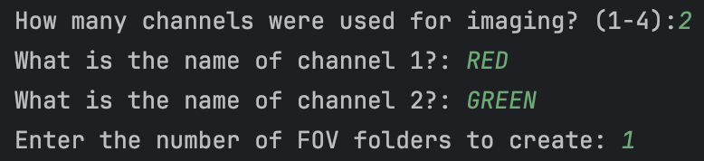
  - The names of channels 1 and 2 should correspond to the factor you are imaging in each channel. Set channel 1 as the channel with the highest signal-to-noise ratio, as it will be used to set the nuclear mask.
- Select the parent directory you want the program to create the folders. This should be in the directory which contains the “Raw_files” folder. In this case, it would be the “Demo” folder:
- It should take <5 seconds, and you should have the following directories:
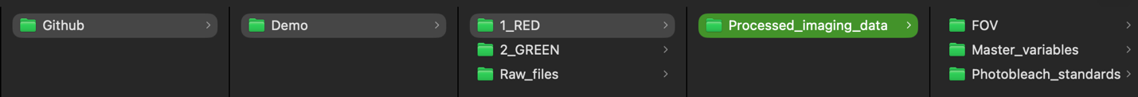

Preprocessing imaging data (<1.5 minute per each FOV)
- Open Fiji-2/ImageJ.
- Drag your TIFF file(s) into Fiji to open your file.
  - View stack with Hyperstack and set color mode to Default. Leave all other boxes in the pop-up window unchecked.
- Go to Image > Adjust > Brightness/Contrast… and click Auto.
- Scrub through the opened TIFF file and identify nuclei that move minimally throughout collection and appear in all channels, if you have multiple FOV’s open.
- Go to Plugins > Macros > Run and select the ImageJ_processing.ijm macro.
- Enter the number of ROI’s (or cells) to select. For instance, if you see 3 cells in your .tif file, set this to 3 and press OK.
- Select the channel where the signal-to-noise ratio is the highest and box in the nucleus from edge to edge and press OK to set ROI #1. Below is an example of how the nucleus should be boxed.
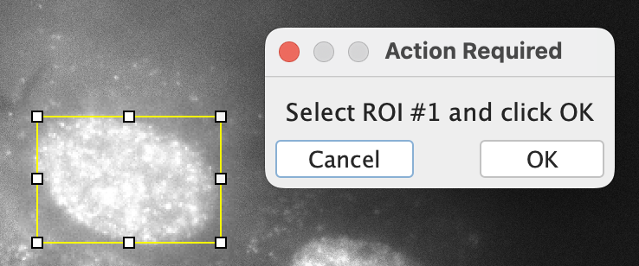
- When you press OK, it will ask you to select ROI #2. Simply drag the yellow box to maintain the same sizing (adjust it according to the nuclear boundary for the second ROI) and box the second nucleus. Keep doing this until you cover all ROIs/Cells in your FOV).
- Save the files by selecting the Processed_imaging_data folder. Repeat these steps for all FOV’s captured.

Single-particle tracking
- In MATLAB_R2024A, run STRAP.m.
- Answer all prompts in the command window and hit enter.
- Select the parent folder containing the “Raw_files” folder and click open. In this case, it would be the “Demo” folder:

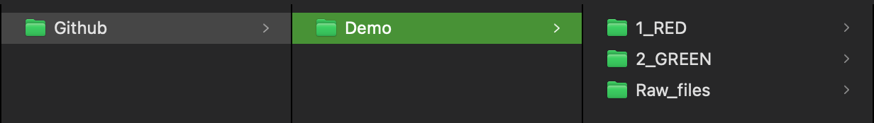
  - Explanation of each step of processing:
    - Script will begin determining photo bleach rates. It will look within the folders, calculate photo bleach rates, and link it to the associated crop50 file.
    - It will then proceed with ImageStack, which localizes spots on a frame-by-frame basis. This is typically the longest part of processing the data.
      - Following this process, multiple files will appear within each FOV_N folder, containing the rpt.mat files which will be used for the next step. A variable called ‘ImageBins.mat’ will also be created in the Master_variables folder. This is referenced within the code to pull the paths for each rpt.mat file for generating trajectories.
    - After ImageStack, it will generate trajectories for all rpt.mat files and produce an ‘rpt_tracked.mat’ file within that folder.
    - The ‘rpt_tracked.mat’ files are used to create a table using the evalSPT module, this will produce a ‘Tables_FOV_N_ROI_X.txt’ file within each folder. (N and X are any positive integer that correspond to your crop50 and photo bleach standard files).
    - IMPORTANT: Using the Tables_FOV_N_ROI_X.txt file, the script starts generating the sptana file. For each file that you are processing, a figure will appear plotting the location of localizations. The script will use a density-based scan to guess where it thinks the nucleus is, outlined in green. A prompt will appear, asking how accurate this detection is. If it is accurate, select Yes, otherwise select No. If you select no, click around the nucleus of the cell until you click back to the first point, and it will store the data. Enclosed nucleus can be found as a jpeg in Processed_imaging_data/Detected_nucleus folder.
    - The script will also generate two sptana’s, Unfiltered_sptana and Filtered_sptana. Filtered_sptana removes molecules existing in the first and last two frames of the data, since we cannot accurately measure their residence time (when they started and when they end). A ‘Tables’ variable in the workspace will tell you what percentage of the data was filtered.
- Proceed with whatever analysis you have planned after, typically using the Filtered_sptana.mat file.

