Contents
Fundamentals of Cybersecurity 2
CIA Triad (Confidentiality, Integrity, Availability) 2
Authentication & Authorization 2
Encryption Basics 2
Network & Application Security 3
Firewalls & Intrusion Detection Systems (IDS) 3
Web Application Vulnerabilities (SQL Injection, XSS) 3
Patch Management 3
Types of Cyber Threats …………………………………………………………………………………………. 4
Malware (Viruses, Worms, Ransomware) 4
Phishing & Social Engineering 4
Denial of Service (DoS/DDoS) 4

Cybersecurity

Fundamentals of Cybersecurity

CIA Triad (Confidentiality, Integrity, Availability)
The CIA Triad forms the backbone of cybersecurity principles. Confidentiality ensures data privacy, integrity maintains accuracy, and availability guarantees access when needed. Together, they define the core goals of secure systems.

Authentication & Authorization
Authentication verifies user identity, while authorization decides what resources they can access. Strong mechanisms like multi-factor authentication enhance security. These processes prevent unauthorized access and misuse of data.

Encryption Basics
Encryption converts data into unreadable code to protect it from attackers. Symmetric and asymmetric methods are widely used in securing communication. It ensures sensitive information remains safe during transmission.

Network & Application Security

Firewalls & Intrusion Detection Systems (IDS)
Firewalls act as barriers between trusted and untrusted networks. IDS monitors traffic for suspicious activity and alerts administrators. Together, they form the first line of defense against cyber threats.

Web Application Vulnerabilities (SQL Injection, XSS)
Applications often face attacks like SQL injection and cross-site scripting (XSS). These exploit coding flaws to steal or manipulate data. Secure coding practices and regular testing help prevent them.

Patch Management
Software vulnerabilities are often exploited by attackers. Patch management ensures timely updates to fix these weaknesses. It is a critical step in maintaining system security and reliability.
Types of Cyber Threats

Malware (Viruses, Worms, Ransomware)
Malware is malicious software designed to disrupt, damage, or steal data. Viruses attach to files, worms spread independently, and ransomware locks data for payment. Defenses include antivirus tools and regular updates.

Phishing & Social Engineering
Phishing tricks users into revealing sensitive information through fake emails or websites. Social engineering manipulates human psychology to bypass security. Awareness and training are key to preventing these attacks.

Denial of Service (DoS/DDoS)
DoS attacks flood systems with traffic, making them unavailable to users. DDoS amplifies this by using multiple compromised devices. Mitigation involves firewalls, traffic filtering, and robust network infrastructure.

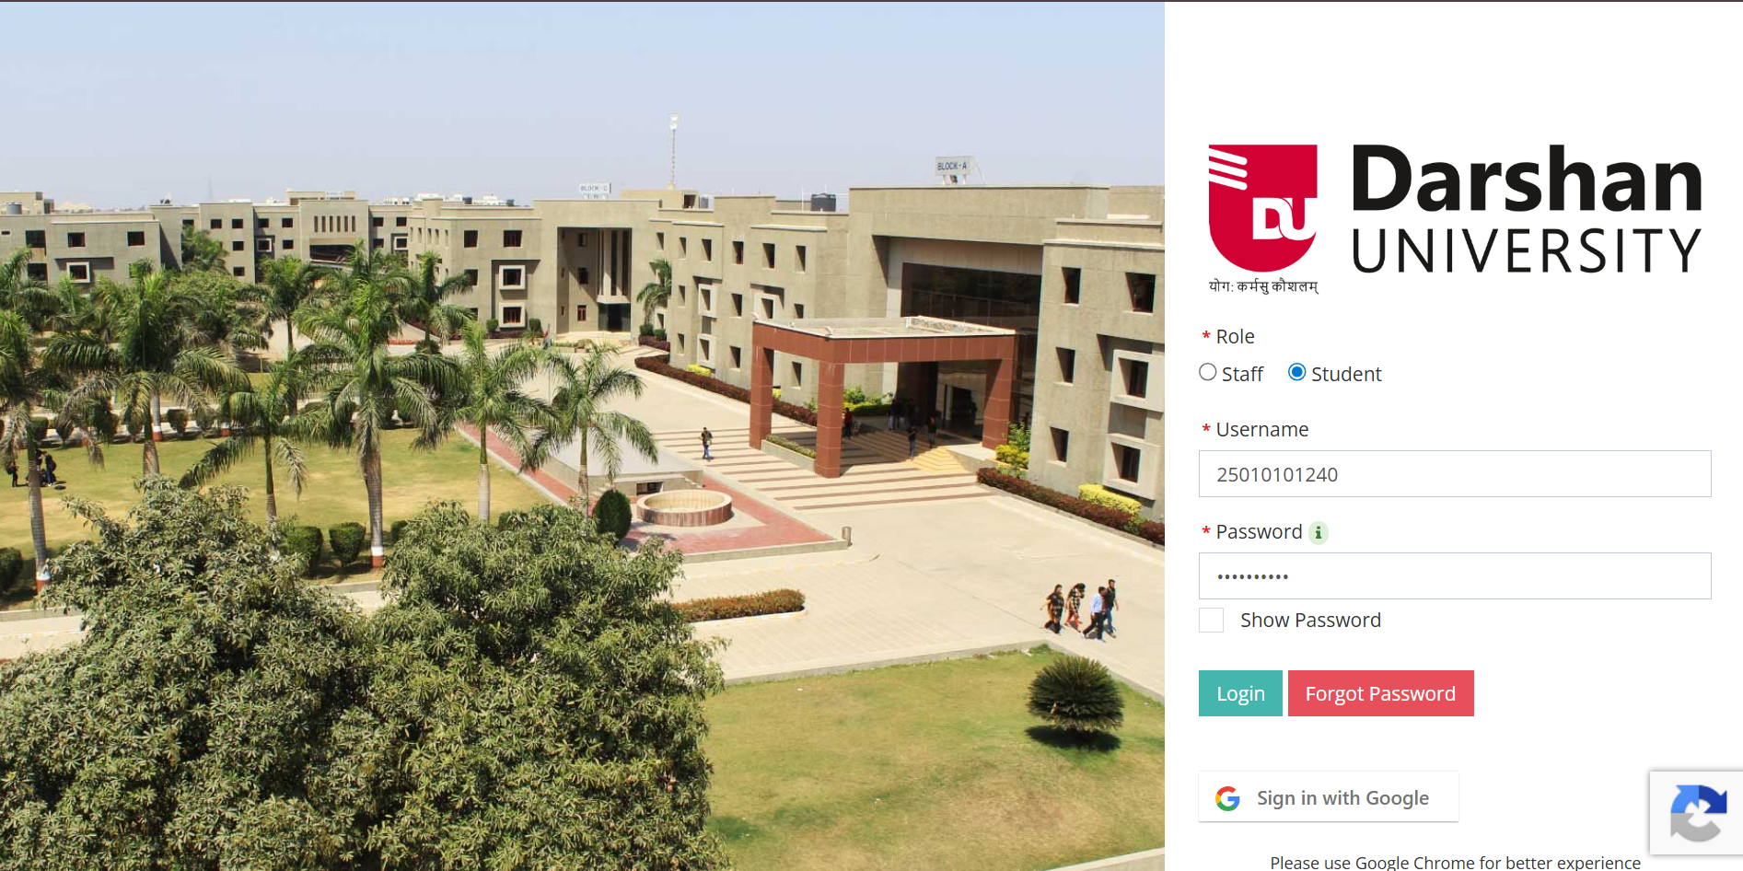
Image of Darshan University’s Home Page for UMS

Video provides a powerful way to help you prove your point. When you click Online Video, you can paste in the embed code for the video you want to add. You can also type a keyword to search online for the video that best fits your document.

- To make your document look professionally produced, Word provides header, footer, cover page, and text box designs that complement each other. For example, you can add a matching cover page, header, and sidebar. Click Insert and then choose the elements you want from the different galleries.

- Themes and styles also help keep your document coordinated. When you click Design and choose a new Theme, the pictures, charts, and SmartArt graphics change to match your new theme. When you apply styles, your headings change to match the new theme.

- Save time in Word with new buttons that show up where you need them. To change the way a picture fits in your document, click it and a button for layout options appears next to it. When you work on a table, click where you want to add a row or a column, and then click the plus sign.
- Reading is easier, too, in the new Reading view. You can collapse parts of the document and focus on the text you want. If you need to stop reading before you reach the end, Word remembers where you left off - even on another device.

Name : Shreena Solia
Roll No. : 370
Class : 3B- Batch 04

N

