Multi-Stock Price Prediction and Analysis Using Machine Learning and Time-Series Forecasting

PROJECT OVERVIEW:
This project focuses on predicting stock price movements for Nifty 50 companies using advanced time-series forecasting and machine learning techniques. Financial markets are dynamic and influenced by complex patterns, making accurate forecasting challenging. The objective of this project is to develop a robust prediction framework that analyzes historical market data and generates both short-term and long-term stock price forecasts.
The system integrates multiple modeling approaches to capture different aspects of market behavior. Long Short-Term Memory (LSTM) networks are used for short-term price prediction due to their ability to learn temporal dependencies in sequential data. Facebook Prophet is applied for long-term forecasting, as it effectively models trend and seasonality over extended periods. In addition, Random Forest is used for feature engineering to enhance predictive input variables, while ARIMA is implemented specifically for Reliance stock to compare traditional statistical forecasting with machine learning approaches.
A comparative analysis of model performance is conducted to evaluate forecasting accuracy and reliability. However, final forecasting outputs are generated using LSTM for short-term prediction and Prophet for long-term trend forecasting, as these models demonstrated strong performance in capturing time-dependent patterns.
The entire modeling pipeline is developed in PyCharm, and a user-friendly Streamlit web interface is built to enable interactive prediction and visualization. The application is deployed to provide accessible and real-time forecasting capabilities for users.
This project demonstrates a comprehensive data science workflow — from data preprocessing and feature engineering to model comparison, forecasting, and deployment — providing an end-to-end solution for stock market prediction.

USE CASE:
Financial markets are highly dynamic, and investors must make decisions under uncertainty and rapidly changing market conditions. Accurately predicting stock price movements is essential for identifying profitable investment opportunities, managing risk, and optimizing portfolio performance. However, traditional analysis methods rely heavily on manual interpretation of historical trends and often fail to capture complex nonlinear patterns in market behavior.
With the increasing availability of financial data, there is a growing need for automated and intelligent forecasting systems that can analyze historical stock performance and generate reliable predictions. Investors, traders, and financial analysts require tools that provide both short-term and long-term market insights to support strategic decision-making.
This project addresses this need by developing a multi-stock prediction and analysis system capable of forecasting price movements for Nifty 50 companies. The system leverages advanced time-series forecasting models to identify patterns, trends, and seasonal behavior in stock price data. By combining deep learning and statistical forecasting techniques, the solution provides both short-term predictive insights and long-term trend analysis.
The deployed web-based interface allows users to interact with the forecasting system in real time, making predictions accessible and easy to interpret. This supports data-driven investment planning, market monitoring, and trend analysis for multiple stocks simultaneously.

PROJECT OBJECTIVE:
The primary objective of this project is to develop an end-to-end multi-stock prediction and analysis system that leverages machine learning and time-series forecasting techniques to generate accurate and meaningful stock price forecasts.
The specific objectives of the project include:
Data Analysis and Understanding
- Collect and analyze historical stock price data for Nifty 50 companies
- Identify trends, seasonality, and volatility in market behavior
- Understand time-dependent patterns in stock price movements
Feature Engineering and Data Preparation
- Perform data preprocessing to ensure data quality and consistency
- Generate relevant features to improve predictive performance
- Utilize machine learning techniques such as Random Forest for feature enhancement
Model Development and Forecasting
- Develop short-term forecasting models using Long Short-Term Memory (LSTM) networks
- Implement long-term trend forecasting using Prophet
- Apply ARIMA modeling for statistical time-series analysis (specifically for Reliance stock)
- Compare multiple predictive models to evaluate performance and reliability
Model Evaluation and Performance Analysis
- Assess model accuracy using appropriate evaluation metrics
- Compare prediction performance across different modeling approaches
- Identify the most effective models for short-term and long-term forecasting
System Development and Deployment
- Build an interactive Streamlit-based web interface for prediction and visualization
- Deploy the application on Hugging Face Spaces for public accessibility
- Provide a user-friendly platform for real-time stock prediction and analysis
Decision Support and Insight Generation
- Generate interpretable forecasts and trend visualizations
- Support data-driven investment and market analysis decisions

DATA DESCRIPTION:
The dataset used in this project consists of historical stock market data for companies listed in the Nifty 50 index. The data was collected programmatically using the yfinance Python library, which provides access to financial market data directly from Yahoo Finance.
Data Time Range
The dataset covers a historical period from 2010 to 2025, providing long-term market observations suitable for both short-term and long-term forecasting analysis.
Data Structure
The dataset is time-series based, where each record corresponds to a specific trading day. The data is organized chronologically to preserve temporal dependencies required for forecasting models.
Features Included
The following features were retrieved for each stock:
- Date — trading date
- Open — opening price of the stock
- High — highest price during the trading session
- Low — lowest price during the trading session
- Close — closing price of the stock
- Adj Close — adjusted closing price (accounts for dividends and splits)
- Volume — number of shares traded
Target Variable
The primary target variable for prediction is the closing price of the stock, as it reflects the final market valuation for each trading period.
Data Characteristics
- Multivariate financial time-series data
- Daily frequency
- Includes trend, volatility, and market fluctuations
- Large historical coverage for reliable model training
Data Usage in the Project
- Multiple Nifty 50 stocks used for general forecasting
- Reliance stock used specifically for ARIMA-based statistical modeling and comparison
- Dataset used for training, testing, and forecasting across different prediction models
The long historical range and structured financial indicators make this dataset suitable for time-series forecasting, trend analysis, and machine learning-based stock prediction.

DATA PREPROCESSING:
The raw stock market dataset was processed through a structured preprocessing pipeline to ensure data consistency, correct formatting, and suitability for time-series modeling. The preprocessing workflow was implemented as a modular Python script and applied uniformly across all Nifty 50 stocks.
Structured Data Loading
The dataset was loaded from the raw data directory using a centralized data loading function. The preprocessing pipeline follows a defined project directory structure to ensure reproducibility and maintainability of the data workflow.
Column Selection and Cleaning
Only the relevant financial indicators were retained to maintain a standardized OHLCV structure. The dataset was restricted to the following fields:
- Date
- Open
- High
- Low
- Close
- Volume
- Stock identifier
Any unnecessary index columns generated during data export were removed.
Data Type Standardization
To ensure consistency and model compatibility:
- The date column was converted to datetime format
- Numerical features (Open, High, Low, Close, Volume) were explicitly converted to numeric types
- Invalid or non-numeric values were coerced and handled appropriately
This guarantees that all financial indicators are in the correct format for analysis and modeling.
Time-Series Ordering
The dataset was sorted by stock and trading date to preserve chronological order. Maintaining strict temporal sequencing is essential for time-series forecasting models such as LSTM, Prophet, and ARIMA.
Data Validation and Integrity Checks
Several validation checks were performed to ensure dataset quality:
- Total number of records
- Number of unique stocks
- Missing value count
- Duplicate record detection
These checks confirm dataset integrity before modeling.
Processed Data Storage
After cleaning and validation, the processed dataset was saved to a dedicated processed data directory. This ensures separation between raw and cleaned data and supports reproducible model training.

PROJECT WORKFLOW:
The Multi-Stock Prediction and Analysis system follows a structured end-to-end data science pipeline that integrates data collection, preprocessing, feature engineering, model training, forecasting, and deployment. The architecture is designed to support scalable multi-stock analysis, model comparison, and real-time prediction through an interactive web interface.
The workflow begins with historical stock data acquisition using the yfinance Python library. Raw data is stored and processed through a modular preprocessing pipeline that performs cleaning, type conversion, validation, and chronological ordering.
After preprocessing, the system performs feature preparation and modeling. Multiple forecasting models are trained for different predictive purposes. LSTM is used for short-term prediction, Prophet for long-term trend forecasting, Random Forest for feature analysis, and ARIMA for statistical time-series modeling on Reliance stock. Model performance is evaluated and compared to determine the most effective forecasting approaches.
The final prediction models (LSTM and Prophet) are integrated into a Streamlit web application that allows users to interactively select stocks and generate forecasts. The application is deployed on Hugging Face Spaces, enabling public access to the prediction system.
This architecture ensures a clear separation between data processing, modeling, and deployment, making the system scalable, maintainable, and reproducible.

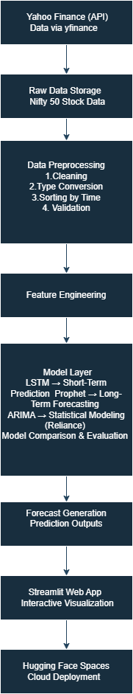
End-to-End System Architecture for Multi-Stock Prediction and Forecasting Platform
MODELING APPROACH:
LSTM Model for Short-Term Stock Price Prediction:
To capture short-term temporal dependencies in stock price movements, a Long Short-Term Memory (LSTM) neural network was implemented. LSTM is a specialized recurrent neural network (RNN) architecture designed to learn sequential patterns and retain long-term contextual information, making it highly suitable for financial time-series forecasting.
The model predicts future stock prices based on a fixed window of historical closing prices, enabling short-term trend forecasting for multiple Nifty 50 stocks.
Input Representation
The model uses closing price time-series data for each stock independently.
Data Preparation Steps
- Historical closing prices extracted per stock
- Values normalized using MinMax scaling
- Sequential sliding windows created
A rolling window of previous observations is used to predict the next value.
Lookback Window
- 60 previous trading days
- Used as input to predict next day price
This transforms the time series into supervised learning format.
Sequence Generation
Training data is constructed using a sliding window mechanism.
For each time step:
Input → previous 60 scaled price values
Output → next price value
This preserves temporal structure and enables the network to learn price momentum and short-term patterns.
Model Architecture
A stacked LSTM architecture is used to capture hierarchical temporal features.

Architecture Design
Layer 1 — LSTM (64 units)
- Returns full sequence
- Learns short-term and intermediate dependencies
Layer 2 — Dropout (0.2)
- Prevents overfitting
- Randomly deactivates neurons
Layer 3 — LSTM (64 units)
- Extracts deeper temporal representation
Layer 4 — Dropout (0.2)
Layer 5 — Dense (1 neuron)
- Outputs predicted price

Training Strategy
Each stock is trained independently to capture its unique price dynamics.
Training workflow:
- Filter dataset by stock
- Normalize closing prices
- Generate sequences
- Train LSTM model
- Save trained model
- Save scaler for inverse transformation
A minimum data length threshold ensures sufficient training history.
Prophet Model for Long-Term Stock Forecasting:
To model long-term stock price trends across Nifty 50 companies, the Prophet forecasting framework was implemented. Prophet is a decomposable time-series model that represents data as a combination of trend, seasonality, and changepoints. It is particularly effective for long-term forecasting where macro-level patterns and structural shifts are more important than short-term volatility.
Unlike LSTM, which captures sequential dependencies, Prophet models price movement as a structured time-series decomposition problem, making it well-suited for long-horizon trend prediction.
Input Representation
The model uses historical closing prices for each stock independently.
Data Preparation Steps
- Extract stock-specific historical data
- Sort chronologically
- Select Date and Close columns
- Rename columns to Prophet format:
  - Date → ds
  - Close → y
Prophet requires a strict two-column structure for training.
Data Requirements
To ensure stable forecasting:
- Minimum 300 historical data points required
- Stocks with insufficient history are skipped
This ensures that long-term trend estimation is statistically meaningful.
Model Configuration
The Prophet model was configured specifically for financial long-term forecasting.
Configuration Details
- Daily seasonality → Disabled
- Weekly seasonality → Disabled
- Yearly seasonality → Enabled
- Changepoint prior scale → 0.05
- Seasonality mode → Multiplicative
Training Strategy
Each stock is trained independently to capture its unique long-term trend characteristics.
Training workflow:
- Filter dataset by stock
- Verify minimum data length
- Convert to Prophet format
- Train Prophet model
- Save trained model
This modular approach ensures scalability across multiple stocks.
Feature Engineering Using Technical Indicators:
To enhance predictive performance and capture deeper market behavior, a feature engineering pipeline was implemented prior to model training. Rather than relying solely on raw closing prices, multiple technical indicators were computed to incorporate trend, momentum, and volatility information into the modeling process.
Financial time-series forecasting benefits significantly from derived indicators that summarize price behavior over rolling windows. These engineered features provide contextual information that improves model learning and interpretability.

Base Input Structure
The feature engineering process operates on the cleaned OHLCV dataset for each stock independently.
Each stock is:
- Sorted chronologically
- Processed individually
- Recombined into a final multi-stock dataset
This ensures that rolling calculations do not mix data across different stocks.

Trend Indicators
Simple Moving Averages (SMA)
Two moving averages were computed:
- SMA_20 → 20-day moving average
- SMA_50 → 50-day moving average
These indicators smooth short-term price noise and help capture medium- and long-term trends.
Mathematically:
SMAₙ = Average of closing prices over previous n days
These features allow models to detect crossover behavior and directional momentum.

Momentum Indicators
Daily Returns
Percentage change in closing price:
Returns = (Closeₜ − Closeₜ₋₁) / Closeₜ₋₁
Returns provide normalized price movement, which is more informative than raw price differences.

Relative Strength Index (RSI-14)
RSI measures the strength of recent price gains relative to losses.
Computed using:
- 14-day rolling average gain
- 14-day rolling average loss
- RS = Avg Gain / Avg Loss
- RSI = 100 − (100 / (1 + RS))
RSI helps identify:
- Overbought conditions (>70)
- Oversold conditions (<30)
This adds behavioral market insight into the dataset.

Volatility Indicators
Rolling Volatility (20-day)
Volatility_20 is computed as the rolling standard deviation of daily returns over 20 days.
Volatility captures market risk and instability.
Higher volatility often signals uncertainty or market stress, which can influence prediction behavior.

Multi-Stock Processing Pipeline
The feature pipeline:
- Iterates through each stock
- Computes technical indicators
- Concatenates results
- Removes rows with insufficient rolling history (dropna)
- Saves processed dataset
This modular design ensures scalability and consistency across all Nifty 50 stocks.
Random Forest Model for Feature-Based Prediction:
To incorporate engineered technical indicators into a supervised machine learning framework, a Random Forest Regressor was implemented. Unlike LSTM and Prophet, which focus on sequential modeling, Random Forest operates on structured tabular features and is used to evaluate predictive power of technical indicators for next-day stock price estimation.
Random Forest is an ensemble learning method that constructs multiple decision trees and aggregates their predictions to improve accuracy and reduce overfitting. It is particularly effective in handling nonlinear relationships between features and target variables.

Input Representation
The model operates on the engineered technical dataset generated in the feature engineering pipeline.
Selected Features
The following technical indicators were used as input predictors:
- SMA_20
- SMA_50
- RSI_14
- Volatility_20
- Returns
These features capture trend, momentum, and risk behavior.

Target Variable
The model predicts:
Next-day closing price
This was created using a one-step forward shift:
Target = Close(t + 1)
This transforms the time-series into a supervised learning regression problem.

Data Preparation Strategy
For each stock:
- Data sorted chronologically
- Target column created using shift(-1)
- Rows with missing values removed
- Minimum 200 rows required for training
- Time-based split applied (no shuffling)
Chronological splitting ensures no future information leakage.

Training Strategy
For each stock:
- 80% of historical data used for training
- Remaining 20% reserved for evaluation (if needed)
- No data shuffling to preserve temporal structure
Each stock was trained independently to capture stock-specific feature behavior.
ARIMA Model for Statistical Time-Series Forecasting (Reliance Stock):
To incorporate a traditional statistical forecasting baseline into the multi-model comparison framework, an ARIMA (AutoRegressive Integrated Moving Average) model was implemented specifically for Reliance stock. ARIMA is a classical time-series model widely used for univariate forecasting where the objective is to model linear temporal dependencies.
Unlike LSTM (deep learning) and Prophet (decomposable forecasting), ARIMA focuses on modeling autocorrelation structures within stationary time-series data. It provides a statistical benchmark to evaluate how modern machine learning methods compare against traditional econometric techniques.

Input Representation
The ARIMA model operates on the univariate closing price series of Reliance stock.
Data Preparation Steps
- Filter dataset for RELIANCE.NS
- Sort chronologically
- Set Date as index
- Convert frequency to business days
- Forward-fill missing trading values
- Remove remaining null values
Business-day frequency enforcement ensures temporal continuity in the series.

Stationarity Check (ADF Test)
ARIMA requires the time series to be stationary.
Stationarity was tested using the Augmented Dickey-Fuller (ADF) test.
Decision rule:
- p-value < 0.05 → Series is stationary
- p-value ≥ 0.05 → Series is non-stationary
If non-stationary, differencing was applied iteratively until stationarity was achieved.

Differencing Strategy
The series was differenced automatically until it satisfied stationarity conditions.
The number of differencing steps applied determines the parameter:
d = order of integration
This ensures compliance with ARIMA assumptions.

Model Order Selection
The ARIMA model was configured using a baseline order:
ARIMA(p, d, q) = (5, d, 0)
Where:
- p = 5 → autoregressive terms
- d = number of differences applied
- q = 0 → no moving average component
This provides a simple but effective baseline configuration for comparison purposes.

Training Strategy
The stationary series was split using time-based splitting:
- 80% → Training data
- 20% → Testing data
No shuffling was applied to preserve chronological order.
The ARIMA model was fitted on training data only.

MODEL EVALUATION:
To evaluate the effectiveness of different forecasting approaches, a comparative study was conducted across four models: LSTM, Random Forest, ARIMA, and Prophet. Each model was trained using historical stock price data and assessed based on its ability to predict future closing prices. Quantitative evaluation was performed using Root Mean Squared Error (RMSE) and Mean Absolute Error (MAE), which measure the deviation between predicted and actual values. These metrics were selected because they provide a clear indication of predictive accuracy and error magnitude in financial forecasting.
The results demonstrate a clear performance hierarchy among the models. The LSTM model achieved the lowest prediction error, with an RMSE of approximately 39.84 and an MAE of 32.58. In contrast, the Random Forest model produced an RMSE of 176.03 and an MAE of 123.17, while the ARIMA model recorded the highest error values, with an RMSE of 219.87 and an MAE of 169.87. Prophet was primarily used for long-term trend forecasting and was not directly evaluated using short-term next-day prediction metrics, as its modeling objective differs fundamentally from the other approaches.
The superior performance of the LSTM model can be attributed to its ability to capture nonlinear temporal dependencies in sequential data. Stock market prices exhibit memory effects, volatility clustering, and complex nonlinear behavior. The LSTM architecture, with its gated memory cells and sequential learning capability, effectively models these patterns by retaining information from previous time steps. The use of a 60-day lookback window allowed the network to learn short-term momentum and trend transitions, which significantly reduced prediction error. Furthermore, proper normalization of data using MinMax scaling contributed to stable convergence during training, enhancing generalization performance.
In comparison, the Random Forest model demonstrated moderate predictive capability but significantly higher error than LSTM. Although Random Forest can model nonlinear relationships, it treats each observation independently and lacks sequential memory. While engineered technical indicators such as moving averages, RSI, volatility, and returns provide useful contextual information, they compress historical information into summary statistics. This reduction in sequential detail limits the model’s ability to capture dynamic market transitions. As a result, the model performs reasonably well but cannot match the performance of deep sequential learning methods.
The ARIMA model exhibited the highest error among all approaches. ARIMA is based on linear autoregressive assumptions and requires stationarity in the time series. Although differencing was applied to achieve stationarity, financial markets often violate ARIMA’s core assumptions due to heteroskedasticity, structural breaks, regime shifts, and nonlinear volatility patterns. Diagnostic statistics from the model indicated significant deviations from normality and constant variance, confirming that the underlying stock price process does not align well with ARIMA’s theoretical framework. Consequently, ARIMA serves as a statistical baseline rather than a competitive predictive model in this context.
Prophet, on the other hand, was optimized for long-term forecasting rather than next-day prediction. Unlike LSTM, Prophet decomposes the time series into trend and seasonal components and produces smoother projections over extended horizons. While this approach may not capture short-term volatility precisely, it provides stable and interpretable long-range trend estimates. Therefore, Prophet was not directly compared using short-horizon RMSE values but instead evaluated based on its macro-level trend forecasting capability.
Overall, the comparative analysis confirms that model performance aligns with theoretical expectations. Deep learning approaches such as LSTM outperform classical statistical models when forecasting nonlinear financial time series. Feature-based ensemble models like Random Forest offer moderate accuracy but lack temporal memory. Traditional models such as ARIMA struggle due to their linear assumptions and sensitivity to volatility. Prophet complements LSTM by offering stable long-term forecasting despite reduced short-term precision.
Based on both quantitative results and behavioral analysis, the final system design integrates LSTM for short-term prediction and Prophet for long-term trend forecasting. This hybrid approach leverages the strengths of both sequential deep learning and structured time-series decomposition, providing a balanced and robust multi-horizon stock prediction framework.
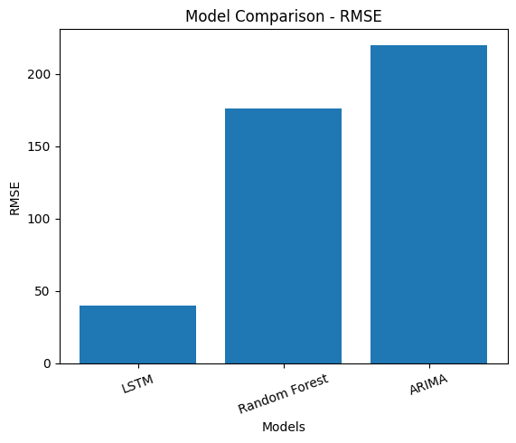
The RMSE comparison plot demonstrates a substantial difference in predictive accuracy across models. LSTM exhibits the lowest RMSE (~39.84), significantly outperforming Random Forest (~176.03) and ARIMA (~219.87). Since RMSE penalizes larger errors more heavily, this indicates that LSTM not only reduces average error but also avoids large deviation spikes more effectively.
The large gap between LSTM and ARIMA confirms that linear statistical modeling struggles with the nonlinear dynamics of stock prices. Random Forest performs moderately but remains far behind LSTM due to the absence of sequential memory modeling.
In practical financial terms, an RMSE of approximately 40 on a large-cap stock priced in the ₹1500–₹3000 range corresponds to roughly 1–3% deviation, which is considered strong short-term predictive performance.

Visual Model Comparison and Behavioral Analysis:
LSTM – Strong Sequential Tracking
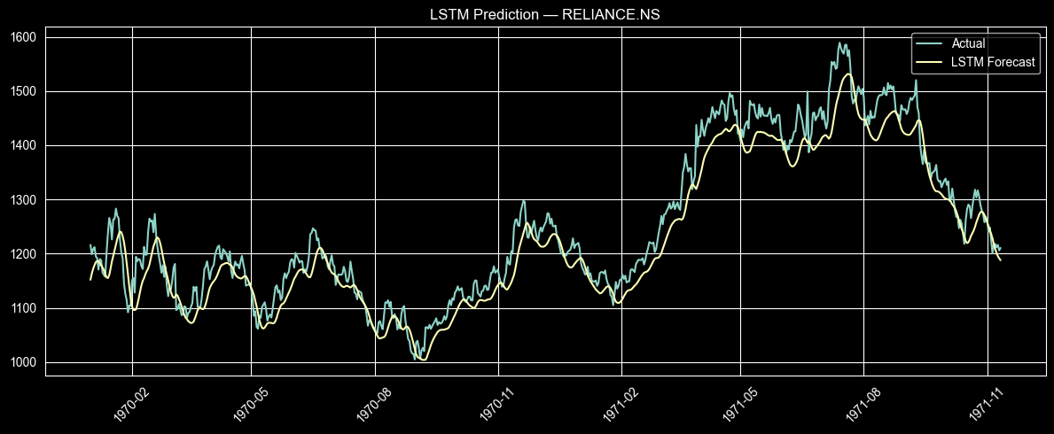
The LSTM prediction closely follows the actual price movement throughout most of the time horizon. The model adapts to upward trends, volatility clusters, and minor corrections more effectively than other models.
Key visual observations:
- Minimal lag during trend transitions
- Better response to volatility spikes
- Smooth yet adaptive behavior
- Reduced prediction bias
The LSTM curve mirrors market structure, particularly during momentum-driven price increases. This confirms that the 60-day lookback window effectively captures short-term memory dependencies.

Prophet – Long-Term Structural Forecasting
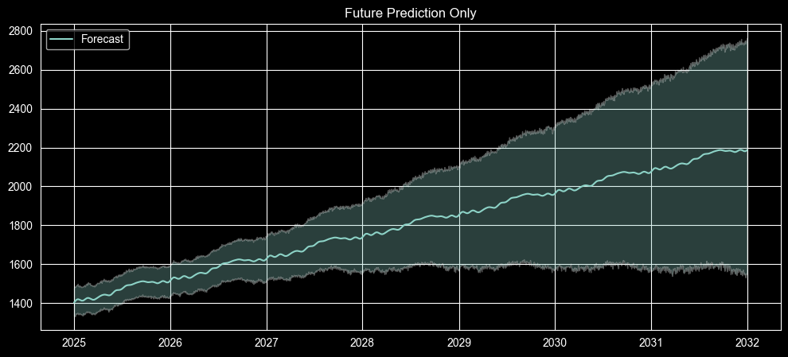

The Prophet forecast visualization demonstrates smooth long-term trend projection with confidence intervals. Unlike LSTM, Prophet does not attempt to track daily fluctuations. Instead, it estimates a structured upward trajectory over multiple years.
Key observations:
- Strong macro trend capture
- Smooth seasonal decomposition
- Widening uncertainty bands over time
- No short-term volatility tracking
This is expected behavior, as Prophet models trend and yearly seasonality rather than daily price dynamics.

Random Forest – Moderate Signal Capture but Poor Volatility Tracking
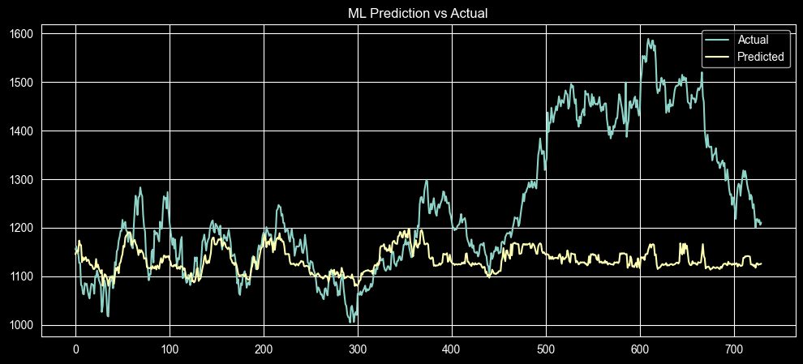
The Random Forest prediction shows some directional alignment with the actual price in earlier periods. However, as volatility increases and stronger upward trends emerge, the model predictions become relatively flat and fail to track sharp movements.
This happens because:
- Random Forest does not retain temporal memory
- It treats each time step independently
- Technical indicators compress historical information
- Trees cannot extrapolate beyond observed patterns
Visually, we observe lagging behavior and smoothing effects. The model captures general price level but fails during strong upward momentum and volatility spikes.
This explains its moderate but significantly higher error compared to LSTM.

ARIMA – Underfitting and Flat Forecast Behavior
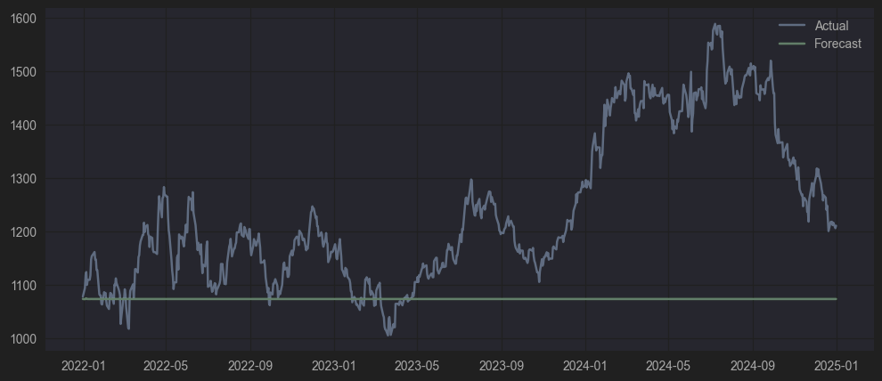
The ARIMA forecast plot shows a nearly flat prediction line that fails to adapt to real price fluctuations. While the actual stock price exhibits significant volatility and structural trend changes, the ARIMA forecast remains relatively constant.
This behavior occurs because:
- ARIMA assumes linear autoregressive structure
- The selected (5, d, 0) order captures limited dependency
- The model struggles with nonlinear volatility
- Financial time-series violate constant variance assumptions
The flat forecast indicates underfitting. The model captures average behavior but fails to respond dynamically to market movement.
The visual evidence strongly validates the quantitative results. LSTM provides the most reliable short-term tracking capability due to its sequential learning mechanism. Random Forest performs moderately but lacks temporal depth. ARIMA struggles with nonlinear volatility and structural breaks. Prophet complements the system by providing stable long-term forecasts rather than precise daily predictions.
The hybrid use of LSTM for short-term forecasting and Prophet for long-term projection creates a balanced multi-horizon forecasting architecture that leverages the strengths of both deep learning and structured time-series decomposition.

DEPLOYMENT:
After successful model development and evaluation, the forecasting system was deployed through a web-based interactive interface using Streamlit. The objective of deployment was to transform the trained machine learning models into an accessible and user-friendly prediction platform.
The deployment architecture separates model training from inference. All trained models (LSTM, Prophet, Random Forest, and ARIMA) were serialized and stored as reusable artifacts. During deployment, only the required trained models are loaded dynamically, ensuring efficient runtime performance without retraining overhead.
The Streamlit application serves as the user interface layer of the system. It allows users to:
- Select a stock from the Nifty 50 list
- Choose prediction type (short-term or long-term)
- Generate forecasts dynamically
- Visualize prediction results
- Analyze historical vs predicted behavior
For short-term forecasting, the system loads the corresponding LSTM model and its associated scaler. The latest available stock data is processed into the required sequence format, and next-day predictions are generated in real time.
For long-term forecasting, the Prophet model is loaded and used to generate extended future projections. The results are displayed with clear visualization, including forecast curves and confidence intervals.
The application was deployed on Hugging Face Spaces, which provides cloud-based hosting for machine learning applications. Hugging Face was selected because:
- It supports Python and Streamlit integration
- It allows public deployment with minimal infrastructure setup
- It simplifies version control and environment management
- It enables easy sharing of the application link
Deployment on Hugging Face transforms the project from a research prototype into a functional forecasting platform accessible via web browser. This enhances usability, demonstration capability, and portfolio value.
The deployment pipeline ensures:
- Clear separation between training and inference
- Scalable multi-stock prediction
- Reproducible environment
- Efficient model loading
- Real-time forecast generation
By integrating modeling and deployment, the project demonstrates a complete end-to-end machine learning lifecycle, from raw data collection to production-level forecasting application.

CONCLUSION:
This project presented a comprehensive end-to-end stock price forecasting system built using multiple modeling approaches, including ARIMA, Random Forest, LSTM, and Prophet. The objective was to evaluate different forecasting methodologies and identify the most effective model for short-term and long-term stock prediction within the Nifty 50 market.
The comparative analysis demonstrated that deep learning approaches significantly outperform classical statistical models in capturing financial time-series behavior. Among all evaluated models, LSTM achieved the lowest prediction error, indicating its strong capability in modeling nonlinear temporal dependencies, volatility clustering, and short-term momentum patterns. The architecture’s ability to retain memory across time steps enables it to adapt dynamically to rapid price fluctuations, making it highly suitable for short-term forecasting tasks.
Random Forest, while capable of modeling nonlinear relationships, showed moderate performance due to its lack of sequential memory. Although technical indicators such as moving averages, RSI, volatility, and returns provide valuable contextual information, they compress historical dynamics into summary statistics, limiting the model’s responsiveness to structural market shifts.
ARIMA, a classical linear time-series model, exhibited the highest error among all approaches. Its reliance on stationarity and linear autoregressive assumptions makes it less suitable for financial markets characterized by heteroskedasticity, regime changes, and heavy-tailed distributions. Nevertheless, ARIMA served as an important statistical baseline for comparison.
Prophet was deployed for long-term forecasting rather than short-term prediction. Its trend and seasonality decomposition framework provides stable and interpretable macro-level forecasts over extended horizons. While it does not capture daily volatility precisely, it effectively models structural trends and long-term directional movement. Therefore, Prophet complements the LSTM model by addressing multi-horizon forecasting requirements.
The final system integrates LSTM for short-term next-day forecasting and Prophet for long-term trend projection. This hybrid modeling strategy leverages the strengths of deep sequential learning and structured time-series decomposition, resulting in a robust and balanced forecasting framework.
Beyond model development, the project successfully implemented a production-ready deployment pipeline using Streamlit and Hugging Face Spaces. The application allows users to select stocks, generate forecasts dynamically, and visualize results interactively. This demonstrates a complete machine learning lifecycle, from data preprocessing and feature engineering to model training, evaluation, and cloud deployment.
In summary, the study confirms that:
- Financial time-series are highly nonlinear and memory-dependent.
- Deep learning models such as LSTM are more effective than linear statistical models for short-term stock forecasting.
- Ensemble tree models provide moderate predictive capability but lack temporal depth.
- Hybrid modeling approaches can enhance forecasting robustness across different time horizons.
- End-to-end deployment transforms analytical models into practical decision-support systems.
This project not only highlights the comparative strengths and limitations of different forecasting methodologies but also showcases practical implementation skills in data engineering, machine learning, deep learning, time-series analysis, and production deployment. It provides a scalable foundation for further research in advanced financial forecasting systems.

LIMITATIONS:
While the multi-stock forecasting system demonstrates strong predictive capability, particularly with the LSTM model, several limitations must be acknowledged to provide a balanced and transparent evaluation of the project.
One of the primary limitations is the reliance solely on historical price data. All models in this system — including LSTM, Random Forest, ARIMA, and Prophet — are trained using past stock prices and derived technical indicators. However, financial markets are influenced by numerous external factors such as macroeconomic events, corporate announcements, geopolitical developments, interest rate changes, and investor sentiment. Since these external drivers are not incorporated into the modeling framework, the system cannot account for sudden market shocks or event-driven volatility.
Another limitation arises from the inherent unpredictability of financial markets. Stock prices often exhibit regime shifts, structural breaks, and nonlinear volatility patterns that are difficult to model accurately. Although LSTM captures nonlinear dependencies effectively, extreme black swan events or abrupt policy changes remain challenging for any purely data-driven model.
The ARIMA model is limited by its linear assumptions and stationarity requirements. Despite applying differencing techniques to achieve stationarity, financial time-series often exhibit heteroskedasticity and heavy-tailed distributions, violating ARIMA’s core assumptions. As a result, ARIMA serves primarily as a benchmark rather than a robust forecasting solution.
The Random Forest model, while useful for feature-based prediction, does not retain temporal memory. It treats each observation independently, which restricts its ability to model dynamic time-dependent relationships. This reduces its responsiveness during strong trending or highly volatile periods.
The LSTM model, although highly effective for short-term forecasting, also has certain constraints. Deep learning models require sufficient historical data and careful hyperparameter tuning. They are computationally more intensive compared to classical statistical models. Additionally, multi-step forecasting with LSTM can lead to error accumulation over longer horizons, limiting its reliability for extended future projections.
Prophet, on the other hand, focuses on structured trend and seasonality modeling. While it produces stable long-term forecasts, it smooths short-term volatility and may underrepresent daily price fluctuations. Its assumption of relatively smooth trend changes may not fully reflect sudden structural breaks in the market.
Another practical limitation involves model generalization across all Nifty 50 stocks. Each stock has unique volatility characteristics and sector-specific behavior. While the system trains models individually per stock, performance may vary depending on liquidity, historical data length, and volatility patterns.
Furthermore, evaluation was primarily conducted using RMSE and MAE. While these metrics measure prediction accuracy, they do not directly assess profitability or trading strategy effectiveness. A model with low prediction error does not necessarily guarantee optimal investment returns.
Finally, although the system is deployed via Streamlit on Hugging Face Spaces, it operates as a forecasting tool rather than a fully automated trading engine. It does not include real-time data streaming, live execution capability, risk management modules, or portfolio optimization features.
In summary, while the proposed forecasting framework demonstrates strong technical performance and practical deployment capability, it remains a predictive analytical system rather than a comprehensive financial decision-making or trading automation platform. Addressing these limitations would require integration of additional data sources, advanced modeling techniques, and real-time financial infrastructure.

