Comparative A/B Testing Analysis of Facebook Ads and Google Ads– Project Report
OVERVIEW:
Digital marketing campaigns are often run across multiple advertising platforms. However, businesses must determine which platform generates better engagement and conversions.
This project performs an A/B testing analysis comparing Facebook Ads and Google Ads campaigns to evaluate their effectiveness in driving conversions. Using statistical analysis and exploratory data analysis, the study identifies which platform performs better and provides insights for optimizing marketing strategy.

BUSINESS PROBLEM:
Companies invest heavily in digital advertising platforms such as Facebook and Google Ads. Without proper analysis, businesses may allocate marketing budgets inefficiently.
The key challenge is determining:
- Which platform produces higher conversions
- Which platform delivers better engagement
- Where marketing budget should be allocated for maximum return

OBJECTIVE:
The main objectives of this analysis are:
- Compare performance between Facebook Ads and Google Ads
- Analyze engagement metrics such as clicks, CTR, and conversions
- Determine which platform drives higher conversion rates
- Use statistical hypothesis testing to validate performance differences
- Provide data-driven marketing recommendations

DATASET DESCRIPTION:
The dataset contains digital advertising campaign performance data from Facebook Ads and Google Ads (AdWords).

Column | Description
date_of_campaign | Date when the campaign was run
facebook_ad_clicks | Number of clicks received from Facebook Ads
facebook_ad_conversions | Conversions from Facebook Ads
facebook_ctr | Click-through rate for Facebook Ads
facebook_conversion_rate | Conversion rate for Facebook
adword_ad_clicks | Number of clicks from Google Ads
adword_ad_conversions | Conversions from Google Ads
adword_ctr | Click-through rate for Google Ads
adword_conversion_rate | Conversion rate for Google Ads

The dataset enables comparison of engagement and conversion performance across both platforms.
TOOLS & TECHNOLOGIES:
Programming & Analysis: Python, Pandas, Scipy, Matplotlib, Seaborn
Dashboard: Power BI
Development Environment: Jupyter Notebook, PyCharm

DATA PREPROCESSING:
Before performing analysis, the dataset was cleaned and prepared.
Steps performed:
- Loaded dataset using Pandas
- Checked dataset structure using .info()
- Converted date_of_campaign column to datetime format
- Verified column types and missing values
- Generated descriptive statistics using .describe()
These steps ensured the dataset was suitable for analysis.

EXPLORATORY DATA ANALYIS (EDA):
Exploratory Data Analysis was conducted to understand campaign performance.
Distribution Analysis:
The following distributions were analyzed:
- Facebook Ad Clicks
- Facebook Ad Conversions
- Google Ad Clicks
- Google Ad Conversions
These visualizations helped understand the spread and variation in campaign engagement.
Conversion Rate Distribution:
Conversion rate distributions for both platforms were analyzed to compare marketing efficiency.
The analysis revealed:
- Google Ads tends to show slightly higher conversion consistency.
- Facebook Ads demonstrate variability depending on campaign conditions.

Total Conversion Share:
A pie chart visualization was used to compare total conversions generated by both platforms.
This provides a quick view of which platform contributes more conversions overall.
CTR vs Conversions Trend:
A trend analysis was conducted comparing Click Through Rate (CTR) and conversions.
Key observation:
Higher CTR generally correlates with higher conversions across both platforms.
HYPOTHESIS TESTING AND RESULTS:
To statistically compare performance between platforms, a two-sample T-test was conducted.
Hypotheses
Null Hypothesis (H₀):
There is no significant difference between Facebook and Google Ads conversions.
Alternative Hypothesis (H₁):
There is a significant difference between Facebook and Google Ads conversions.
Statistical Test
The test compares the average conversions between platforms.
If the p-value < 0.05, the null hypothesis is rejected.
Results
The analysis calculated:
- Mean conversions for Facebook Ads
- Mean conversions for Google Ads
- T-statistic and p-value
Based on the p-value comparison with the significance level (α = 0.05), the hypothesis test determines whether the performance difference is statistically significant.
DASHBOARD DEVELOPMENT:
An interactive dashboard was created in Power BI to visualize the analysis.

Dashboard Features
The dashboard includes:
- Campaign performance overview
- Click and conversion comparison
- CTR and conversion rate analysis
- Platform performance comparison
- Conversion share visualization
The dashboard allows stakeholders to explore marketing performance easily.
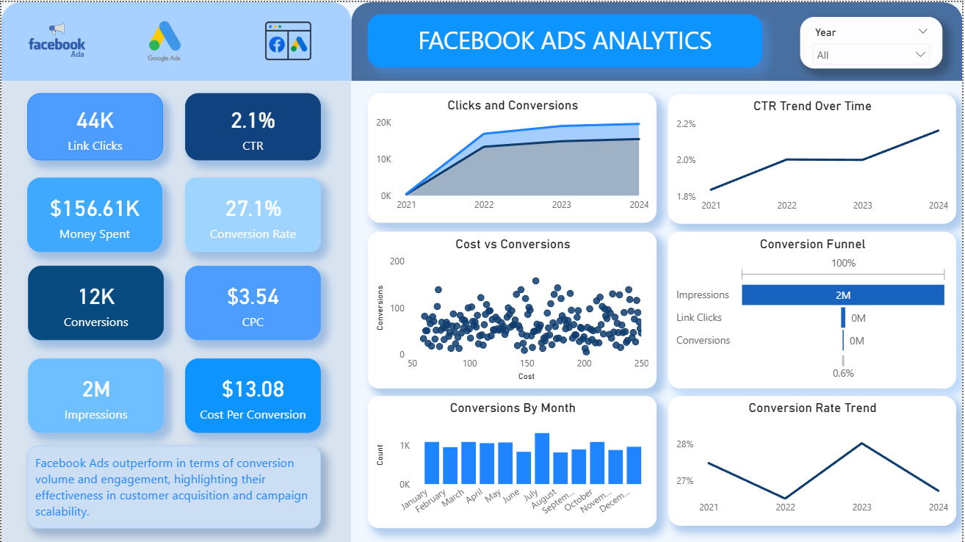
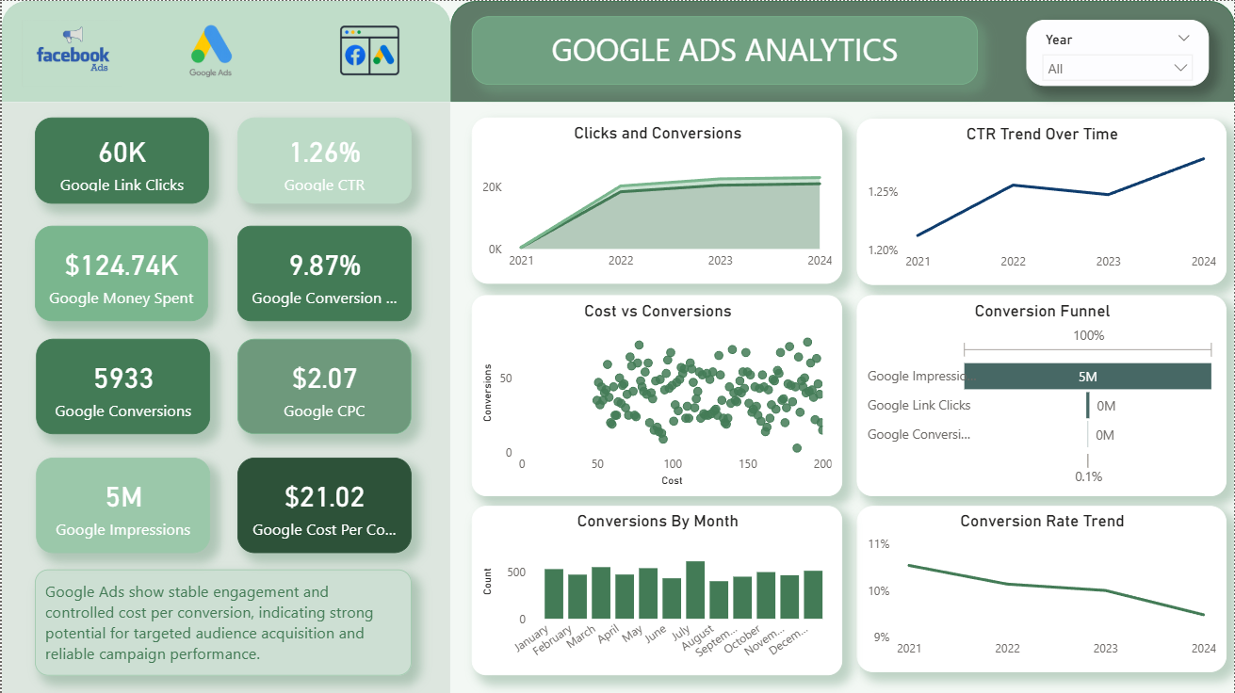

KEY INSIGHTS:
Several insights were discovered from the analysis:
- Google Ads demonstrates higher conversion efficiency compared to Facebook Ads.
- Facebook Ads generate strong engagement but do not always translate into conversions.
- CTR has a direct influence on conversions for both platforms.
- Conversion distribution shows different performance patterns across campaigns.
BUSINESS RECOMMENDATIONS:
Based on the findings, the following recommendations are suggested:
- Increase investment in Google Ads for conversion-driven campaigns.
- Use Facebook Ads primarily for awareness and engagement campaigns.
- Conduct further A/B testing with different ad creatives and audience targeting.
- Monitor CTR and conversion rate metrics to optimize ad performance.
CONCLUSION:
This A/B testing analysis compared Facebook Ads and Google Ads performance using statistical analysis and visualization.
The results indicate that Google Ads generally provide better conversion performance, while Facebook Ads contribute significantly to reach and engagement.
Businesses can use these insights to optimize advertising budgets and improve marketing ROI.

