Telecom Customer Churn Analysis – Project Report

OVERVIEW:
Customer churn is a major challenge for telecom companies because losing customers directly impacts revenue. This project analyzes customer behavior to identify patterns and factors that lead to churn. By understanding these patterns, companies can implement strategies to improve customer retention.
The project combines Python-based exploratory data analysis, SQL querying, and Power BI dashboard visualization to generate meaningful business insights.

BUSINESS PROBLEM:
Telecom companies experience revenue loss when customers discontinue their services. Identifying customers who are likely to churn and understanding the reasons behind their decision is essential for improving retention strategies.
Analyze telecom customer data to determine the main factors influencing churn and provide actionable insights.

OBJECTIVE:
- Measure the overall churn rate of customers.
- Identify customer characteristics related to churn.
- Analyze service usage patterns affecting churn.
- Generate business insights using SQL queries.
- Create an interactive dashboard for visual decision-making.

DATASET DESCRIPTION:
The dataset contains 3333 telecom customers with 11 features.
Column | Description
State | Customer state
Account Length | Duration of the customer account
Area Code | Geographic code
International Plan | Whether the customer has an international plan
Voice Mail Plan | Whether the customer has voicemail
Number Vmail Messages | Number of voicemail messages
Total Day Minutes | Day call usage
Total Eve Minutes | Evening call usage
Total Night Minutes | Night call usage
Customer Service Calls | Number of customer service calls
Churn | Whether the customer left the service (1 = Yes, 0 = No)

TOOLS & TECHNOLOGIES:
Programming & Analysis: Python, Pandas, Numpy
Data Visualization: Matplotlib, Seaborn
Database & Querying: SQL(SQLite)
Dashboard: Power BI
Development Environment: Jupyter Notebook, PyCharm

DATA PREPROCESSING:
The dataset was inspected and cleaned before analysis.
Steps Performed
- Data loading using Pandas
- Data inspection (info(), describe())
- Checked for missing values
- Checked for duplicate records
Findings
- There were 3333 records and 11 fields.
- No missing and duplicate entries were found.

EXPLORATORY DATA ANALYIS (EDA):
Exploratory analysis was conducted to understand customer behavior patterns.
Key Visualizations
- Churn distribution
- Monthly charge vs data usage
- Roaming minutes vs churn
- Customer service calls vs churn
- Data plan vs churn
- Contract renewal vs churn
These visualizations help identify patterns that contribute to customer churn.

SQL ANALYSIS:
- SQL was used to perform structured queries on the telecom dataset.
- Queries were written to calculate total customers, churned customers, and churn rate.
- SQL aggregation functions such as COUNT(), AVG(), and GROUP BY were used to summarize data.
- Customer behavior was analyzed by grouping records based on churn status.
- Queries were used to analyze average monthly charges for churned and non-churned customers.
- SQL analysis also examined the relationship between customer service calls and churn.
- These queries helped identify patterns that contribute to customer churn.
- The SQL analysis complemented the exploratory data analysis performed in Python.

DASHBOARD DEVELOPMENT:
- An interactive dashboard was developed using Power BI.
- The dashboard displays important KPIs such as:
    - Total Customers
    - Churned Customers
    - Churn Rate
    - Average Monthly Charges
- A donut chart was used to visualize the overall churn distribution.
- A bar chart was used to analyze roaming minutes by churn status.
- A scatter plot was used to study the relationship between monthly charges and data usage.
- A chart was created to analyze the number of customer service calls made by customers.
- Data plan usage and contract renewal patterns were also visualized.
- Filters were added to allow users to interact with the dashboard dynamically.
- The dashboard helps stakeholders quickly understand churn trends and customer behavior.
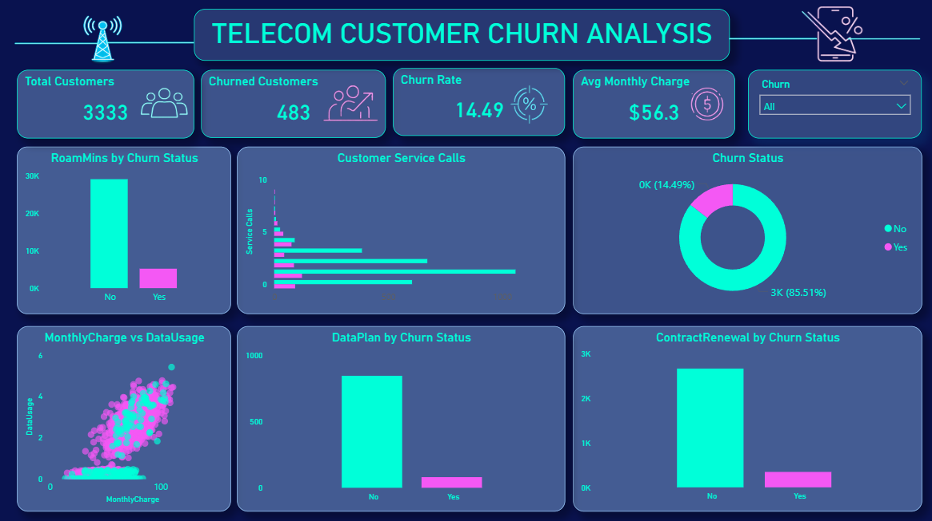

KEY INSIGHTS:
- The dataset contains 3333 customers, out of which 483 customers have churned.
- The overall churn rate is approximately 14.49%.
- Customers with higher monthly charges tend to churn more frequently.
- Customers who make more customer service calls are more likely to leave the service.
- Customers without contract renewal show higher churn rates.
- Roaming minutes are higher among customers who churn.
- Customers who actively use services such as data plans tend to remain with the company.
- Customer behavior and service usage patterns play a significant role in predicting churn.

BUSINESS RECOMMENDATIONS:
- Improve customer support quality and response time to reduce dissatisfaction.
- Identify customers with frequent service complaints and address their issues proactively.
- Introduce loyalty programs and retention offers for long-term customers.
- Provide flexible pricing plans for customers with high monthly charges.
- Encourage contract renewal through discounts or incentives.
- Monitor customers with high service usage and billing complaints to prevent churn.
- Use data-driven strategies to identify and retain customers at risk of leaving.
CONCLUSION:
- This project analyzed telecom customer data to understand patterns leading to customer churn.
- The analysis combined Python for exploratory analysis, SQL for data querying, and Power BI for visualization.
- Several key factors influencing churn were identified, including customer service calls, monthly charges, and contract renewal.
- The insights generated from this analysis can help telecom companies improve customer retention strategies.
- By using data analytics and visualization, businesses can make better decisions to reduce customer churn and increase revenue.

