E-Commerce Sales Analysis – Project Report
OVERVIEW:
E-commerce platforms generate large volumes of transactional data from customers, products, sellers, and logistics operations. Analyzing this data helps businesses understand sales performance, customer behavior, and operational efficiency.
This project analyzes the Olist marketplace dataset to identify key patterns in sales, product performance, customer satisfaction, and delivery logistics.
The project combines Python-based exploratory data analysis, SQL querying, and Power BI dashboard visualization to generate meaningful insights that support data-driven decision making.

BUSINESS PROBLEM:
Online marketplaces must manage multiple sellers, products, and logistics partners while maintaining customer satisfaction. Poor delivery performance, inefficient product management, or weak customer engagement can negatively affect sales and reviews.
The challenge is to analyze e-commerce transaction data to identify factors influencing sales performance, logistics efficiency, and customer satisfaction.

OBJECTIVE:
- Analyze overall sales performance of the marketplace.
- Identify top-performing product categories and sellers.
- Understand customer purchasing behavior and geographic distribution.
- Evaluate logistics performance including delivery time and freight costs.
- Analyze customer reviews and identify factors affecting customer satisfaction.
- Build an interactive Power BI dashboard for business insights.

DATASET DESCRIPTION:
The dataset contains multiple tables representing marketplace transactions.
Column | Description
order_id | Unique order identifier
customer_id | Unique customer identifier
product_id | Unique product identifier
seller_id | Unique seller identifier
order_status | Status of the order
order_purchase_timestamp | Time when the order was placed
order_delivered_customer_date | Actual delivery date
order_estimated_delivery_date | Estimated delivery date
price | Product price
freight_value | Shipping cost
review_score | Customer review rating

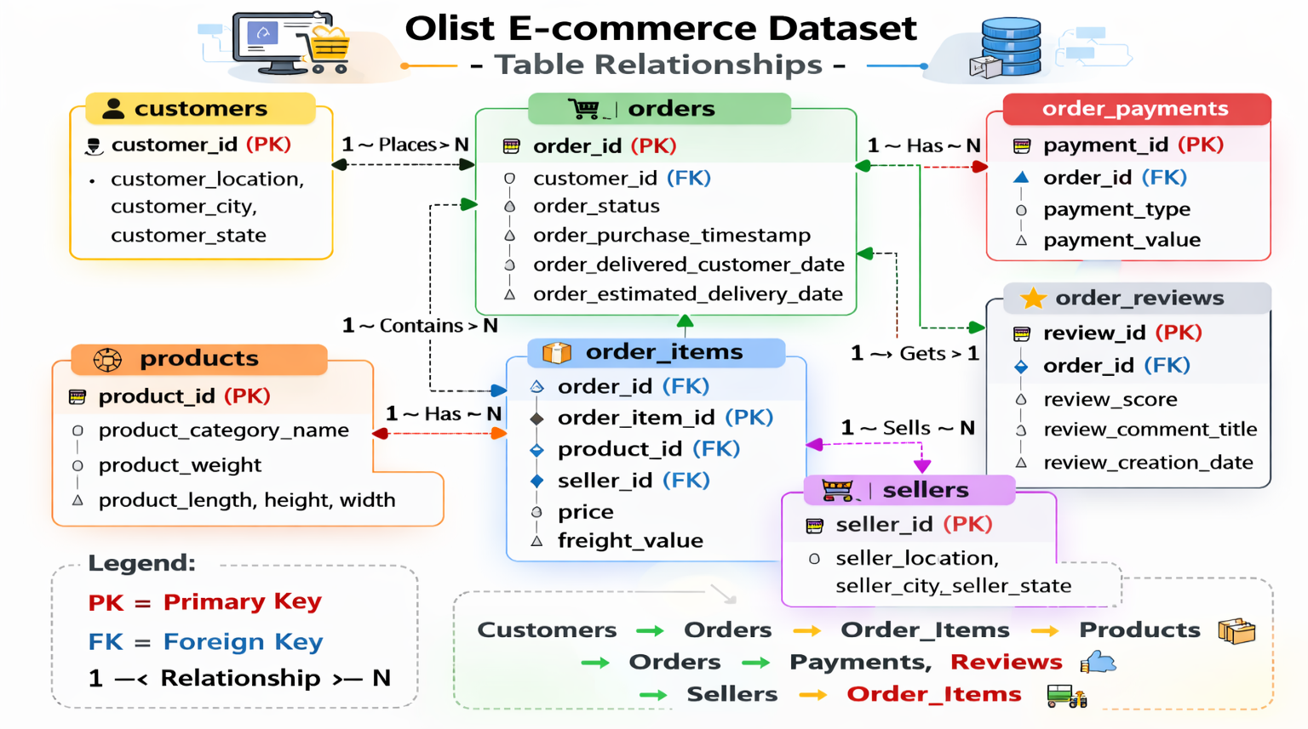

TOOLS & TECHNOLOGIES:
Programming & Analysis: Python, Pandas, Numpy
Database & Querying: SQL(SQLite)
Dashboard: Power BI
Development Environment: Jupyter Notebook, PyCharm

DATA PREPROCESSING:
The dataset was cleaned and prepared before performing analysis.
Steps Performed
• Data loading using Pandas
• Data inspection using info() and describe()
• Handling missing values
• Checking for duplicate records
• Merging multiple tables for analysis
Findings
• The dataset contains multiple related tables for orders, products, customers, and sellers.
• Missing values were identified in delivery-related fields.
• Data was merged to create a unified dataset for analysis.

EXPLORATORY DATA ANALYIS (EDA):
Exploratory analysis was conducted to understand customer behavior patterns.
Key Visualizations
• Sales distribution across product categories
• Monthly order trends
• Customer distribution by state
• Freight cost vs product weight
• Delivery time analysis
• Review score distribution
These visualizations helped identify patterns in sales performance and customer satisfaction.

SQL ANALYSIS:
• SQL queries were used to analyze transaction data.
• Queries calculated total orders, revenue, and average order value.
• Aggregation functions such as COUNT(), SUM(), and AVG() were used to summarize data.
• Product categories were analyzed to identify top-performing products.
• Customer distribution was analyzed based on geographic regions.
• Delivery performance was examined using estimated and actual delivery dates.
• SQL queries were used to identify sellers generating the highest revenue.
• These queries helped uncover key operational and sales insights.
DASHBOARD DEVELOPMENT:
An interactive dashboard was developed using Power BI to visualize marketplace performance.
Key Dashboard Metrics
• Total Orders
• Total Revenue
• Average Order Value (AOV)
• Freight Cost
Visualizations Included
• Sales trend over time
• Top product categories by revenue
• Customer geographic distribution
• Delivery time analysis
• Freight cost analysis
• Customer review distribution
Interactive filters allow users to explore the data by product category, state, city, and date.
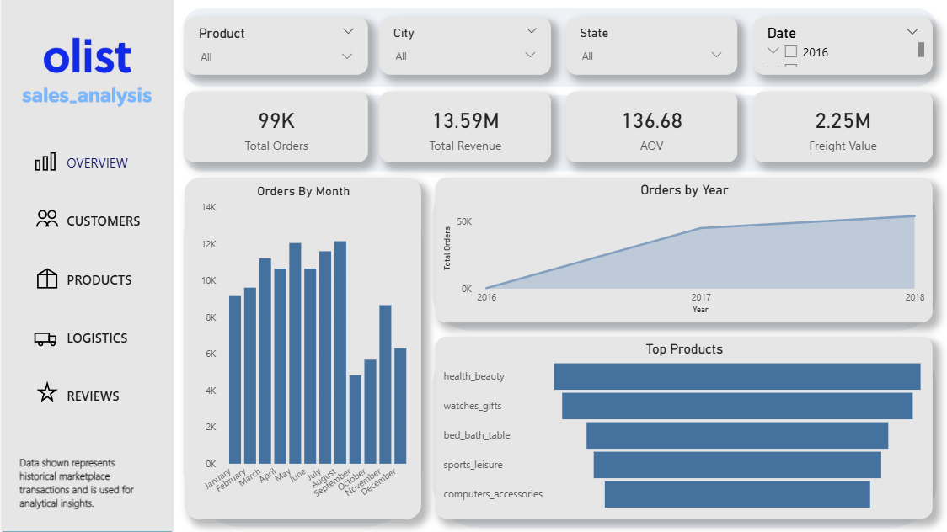

KEY INSIGHTS:
• The marketplace processed approximately 99K orders, generating around 13.5M in total revenue.
• Average Order Value is approximately 136, indicating moderate spending per purchase.
• Product categories such as Health & Beauty and Watches & Gifts generate the highest sales.
• Customers are highly concentrated in major urban regions such as São Paulo.
• Delivery delays negatively impact customer review scores.
• Freight costs increase with heavier product weights.
• Customer reviews average around 4 stars, indicating generally positive customer experiences.
• Efficient logistics operations play a critical role in maintaining customer satisfaction.
BUSINESS RECOMMENDATIONS:
• Improve delivery logistics in regions experiencing longer delivery times.
• Focus marketing strategies on high-performing product categories
• Optimize freight cost strategies for heavy products.
• Encourage repeat purchases through customer loyalty programs.
• Monitor seller performance and product quality to maintain high review ratings.
• Use data-driven insights to optimize inventory and product assortment.
• Continuously monitor customer feedback to improve service quality.
CONCLUSION:
- This project analyzed the Olist e-commerce dataset to understand marketplace performance, customer behavior, and operational efficiency.
- The analysis combined Python for exploratory analysis, SQL for querying transactional data, and Power BI for visualization and dashboard development.
- Key insights were identified regarding sales trends, product performance, logistics efficiency, and customer satisfaction. These insights can help businesses optimize operations, improve customer experience, and increase revenue.
- Data-driven decision making enables e-commerce platforms to continuously improve their services and maintain competitive advantage.

