DIKULT205 – Web Design 2

Spring 2017

Assignment 2

Website One: https://dikult205.k.uib.no/u4z17/assignment1/against/

Website Two: https://dikult205.k.uib.no/u4z17/assignment1/for/

Student Number: 115

_ _ _ _ Words

My source
I found my source on the guardian. It is an article written by journalist Jessica Glenza the 12th of January 2017. The article is a report on a meta-study of over 10000 reports on the therapeutic use of cannabis. It was written in New York and all the statistics and numbers are based on surveys done in the US and I have also done this in my websites.
The report explains in simple short terms the dangers and benefits of cannabis the meta-study found and other views by various experts on the subject.
Link to the article:
https://www.theguardian.com/society/2017/jan/12/marijuana-study-benefits-chemotherapy-pain-multiple-sclerosis
Illustration 1: The source for this assignment

I First identified all the information I could use in the websites that I would create and sorted them in the categories: site One(Extra Chance), site Two(PALM) and both. I have then used these arguments on one or both sites with various viewpoints and tried to make them appear natural so that it is the theme of the website that flips the argument in the intended direction.
Arguments | Category
Recognized for chemotherapy, cronic pain and MS. | One
Likely to increase risk of schizophrenia, anxiety disorders and depression | Two
Driving under the influence of cannabis increases car accident | Two
Recreational marijuana is legal in eight states and medical is legal in 28 states | Both
An estimated 22.2 million people using cannabis | Both
It is Illicit on a federal level | Both
There is not enough research | Both
Most cannabis medicinal benefits are inconclusive | Both

My Pages
In the process of designing and developing these pages I have tried to keep the numbers and facts as close linked as possible, but for some of the numbers I have had to guess.

Page One, Extra Chance.
Single page website
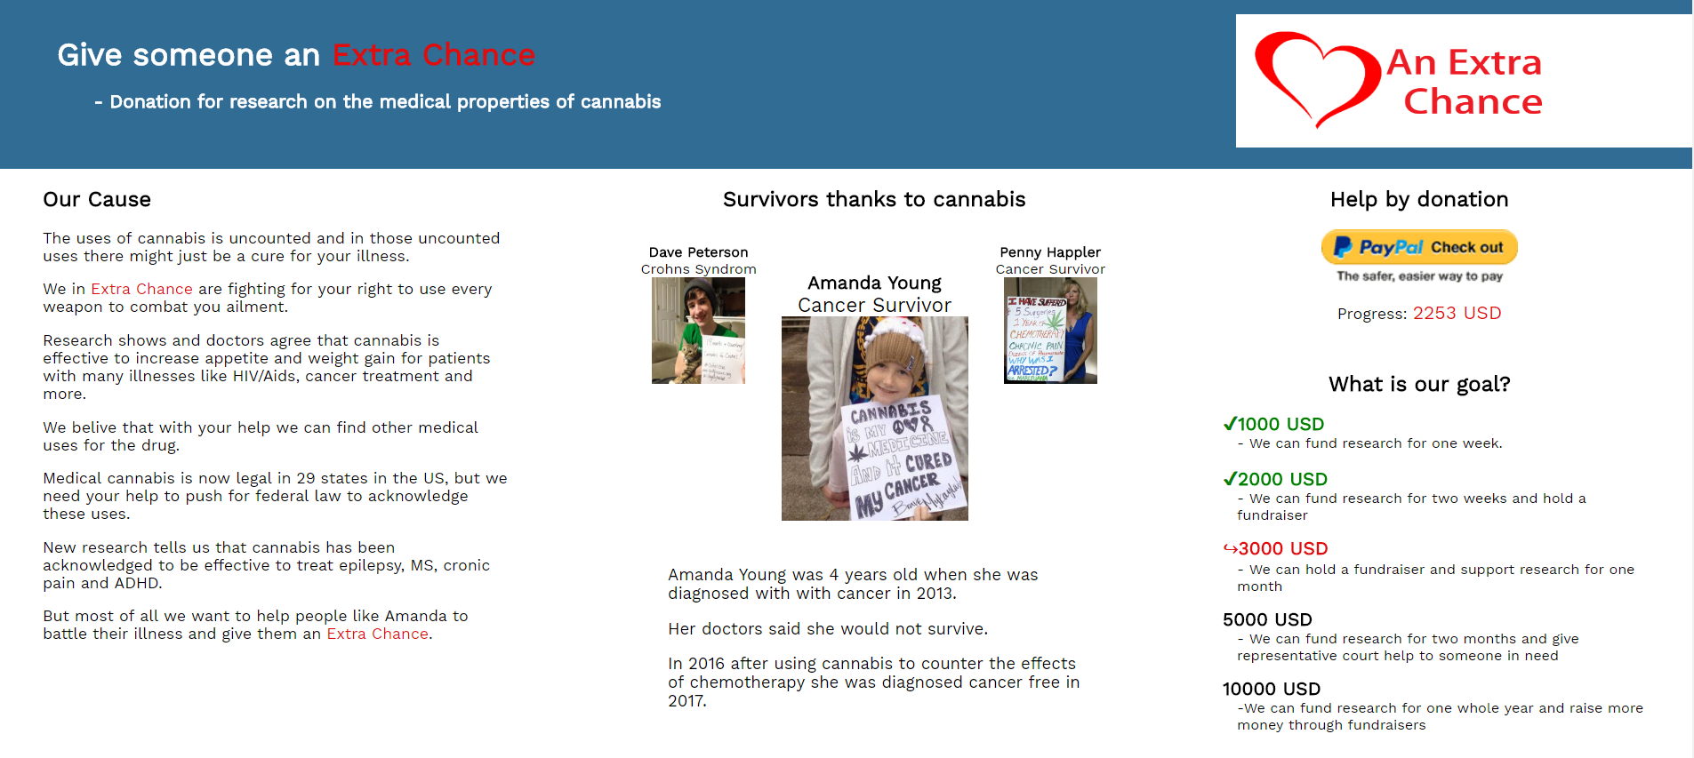
Illustration 2: Extra Chance Website image

This world: Donation for collecting money for research on the medical properties of cannabis.

Page Two, PALM (Parents Against Legalizing Marijuana).

This worlds angle: A signature campaign to keep the current laws on cannabis.
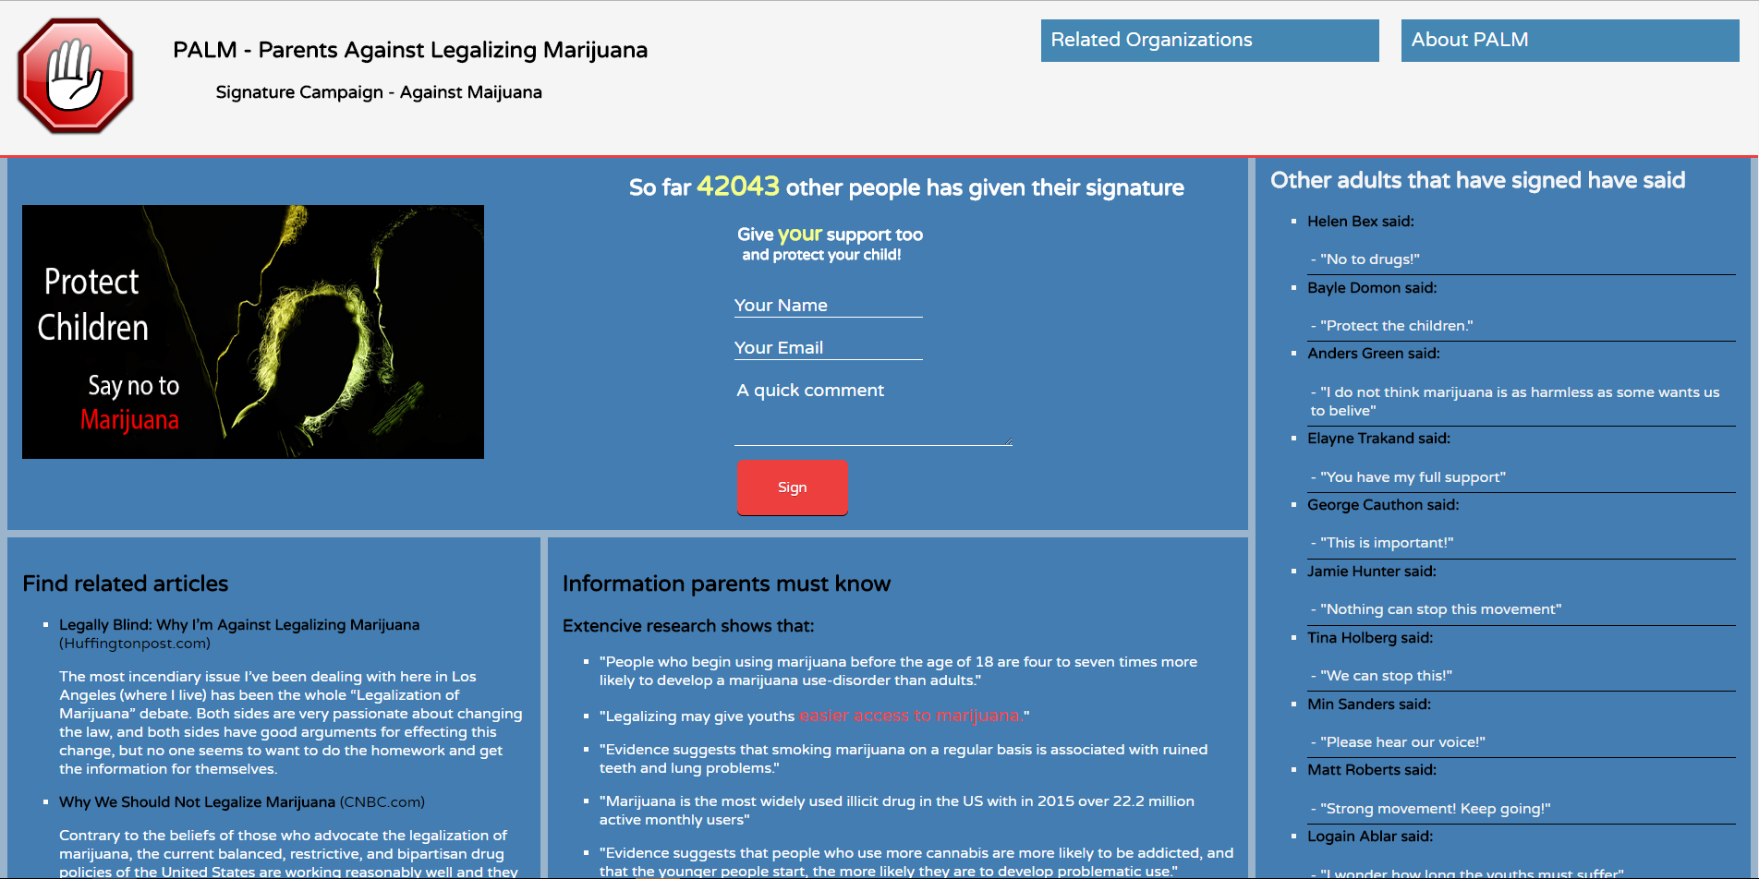
Illustration 3: PALM Website image

Page One – Extra Chance – Fund-raiser site

Persona
When i created this website i made a persona for the person behind the message to show that message through the website. I imagined a person who is well educated, middle to upper class, around 40 years old and lives in a medium sized city. I have named the person Sally. Sally has a family and has had close family struck with illness in the past 5-10 years where in addition to traditional treatment was treated with cannabis to counter some side-effects from the treatment. This is what sparked the idea to start a fund-raiser for research on medical cannabis and these emotions is what i wanted to show and transfer through the website. By trying to express a personalized persona through the website I can impend the persona in the website, thereby increase the trustworthiness in the website by increasing the emotional factor.

Target audience
Sally wants to reach people in the middle to upper wealth class and shares the point of view she has. That openness towards treatments might save lives in some cases. She wants to give them an easy chance to help other people.

Creation, Design and Rhetoric
During the creation and design process I tried to think about what emotions my Sally would want to express through this site, and for a donation site she wants to capture the users with empathy and curiosity. This will be the primary goal and would be an emotion that the target audience should respond well to. Curiosity is added since in addition to taking donations Sally also wants to inspire users to find out more about the subject and get activated into her way of thinking. Giving extra motivation to donate or help the cause in the future.
Further Sally want to display openness, professionalism since she is asking for people to donate money to the Extra Chance organization. I have tried to capitalize on these items in both the text, layout and modes.

Layout
I chose a simple layout of 2-3-3 as in the table below
Header |  | Logo
Item 1  Cause of the Organization | Item Two  Images | Item Three  Donation and  Goals
About Organization | Related Organizations | Contact Info

I have made a few very conscious decisions when deciding the layout of the page. For example I have put the logo on the right hand side instead of left. This is to bring the logo closer to the donation area of the site. This helps the user connect the donation with Extra Chance and will, if the brand and logo implies confidence, increase the chance of a user donating money. The footer is also separated into three section so that each of the elements on top stands on a solid foundation. Each rhetorically connected to the item on top. Item one is a combination of pathos and logos by using the arguments presented to put the spotlight on the people whom may benefit from using medicinal cannabis and therefore create empathy. On the bottom of item one is a short message which by using professional words like “non profit” and the wording “strives to fund research” increases ethos. This is because people see the goodwill and virtue that is presented in the organization.
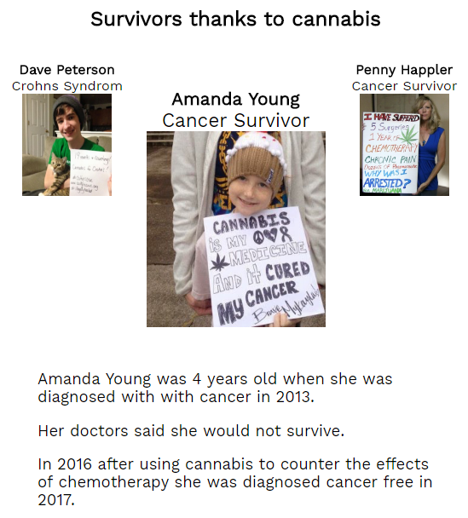
Illustration 4: Screenshot of Item Two on Extra Chance Website
For the rest of the columns I will talk more in-depth of the decisions I have made there.

Item Two
This is the center-point of the web-page and this is what i want to draw the eyes towards. The picture of the girl in the middle and the two additional people holding signs is the draw of the web-page. In addition to the text under describing the girls condition and her story it creates a sense of personality and it gives the user someone to empathize with that would not exist without the picture and the story as can be seen in illustration 4.
More than this it binds together the story that this website is trying to tell with real people and shows that if the goals is reached it will make a difference for real people giving further encouragement for the user to give donations.
The symmetrical balance also gives the user a natural flow to either side and will make the user read on and explore the page further because humans are inherently curious. Using modality and presenting pictures with signs in them gives another story of a young girl, or boy, or adult woman and their battle with an illness. This gives an image to the user that what they have is something that can affect anyone and will give an identification to more people. Which is something that I was inspired to do because of the personas background.

Item Three
The last, but the most important item on the web-page is the donation area. This stands out with the contrasting yellow PayPal button that provides payment-services for many big companies, it is well known and has a very good reputation. I have chosen this for both those reasons. The users must not discard this area and must to a certain degree be drawn to it. It also tells the users that the payment will be secure and go to the organization that the user thinks. There is also a counter to give the users a sense of the progress of the donation. The overview under furthers this by telling the user what the organization is working towards and what has been accomplished as can be seen in illustration 5.
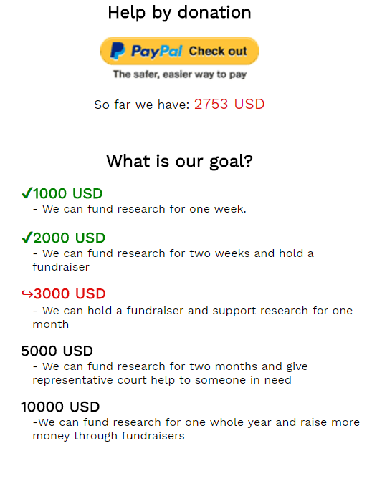
Illustration 5: Donation section of Extra Chance web-site

Details
There are many design choices that I would like to explain, but here are the most important. I have used the color of the organizations logo wherever the organizations name is mentioned and this shows that the organization is proud of the name and

Page Two – PALM – Signature Campaign

Persona
For this page I created Paul. He is a concerned parent that has watched a lot of documentaries and heard many stories about youths whom have wasted their life in drugs. This was his motivation to found PALM(Parents Against Legalizing Marijuana) because of the many states in the US that has legalized medicinal or recreational. He is also afraid that any of his children will start doing drugs.

Target Audience
Paul would through his organization firstly like to gather signatures to take the matter to congress and show that there are voices that would like to keep cannabis out of the hands of children and youths. Secondly he wants to raise the awareness of the dangers of cannabis to other parents. His target audience

