Report INFO134

Project Two

Kristian Os

Report
This is a post-report from the creation of the second assignment and the design choices I have made during the design and testing process. I will show how the website works, the migration process from static design to a fully functional dynamic layout with imported data and to how my search functions work. I am still working alone on this project and have written all the code myself.
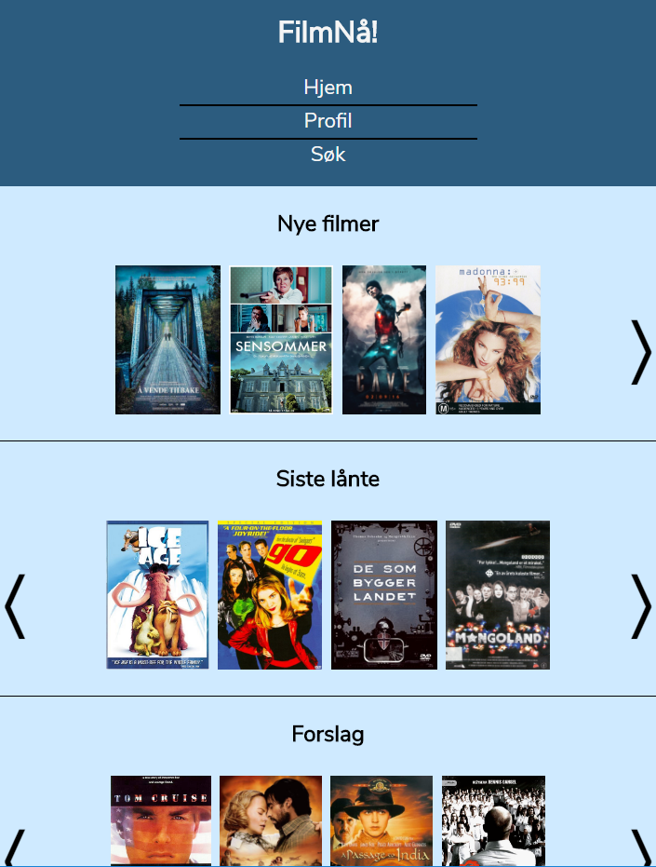
Illustration 1: Index page populated with movies from JSON file

The website
The websites layout is very much the same as when everything was static, but some things are changed, but everything that is changed is because of the new requirements assignment two set for what information should be displayed. Other than that the only thing that has changed is the layout for each result error on the search_results.html. This is in a way also because of the new requirements.

The index
The only real different here is that now there is a scrolling property that the user can apply to the lists displayed on the index page. Here if the user clicks the arrows the movie-lists goes to the next movies in the respectable list. In addition to this I have added a nice hover effect that gives the title when one hovers over the image it fades out and shows the title of the movie.
The section about new movies are displaying the movies with the newest dates in the JSON file. This is the only way I could find to get the “newest”. The last borrowed is a list of movies that are randomly picked from the JSON file and lastly the recommended movies are the best rated movies in the JSON file. The method is described in the code.
When submitting a rating in the ratingsection the site now grabs a new movie so the users can rate movies directly. The rating function does not work since I can not insert ratings into the JSON file from JS without Ajax or similar frameworks.

Search function
The search layout is basically the same and the only difference is that the now the search results are responsive to the width of the screen. This is done by setting width and flex-wrap so they manage themselves after the CSS rules.
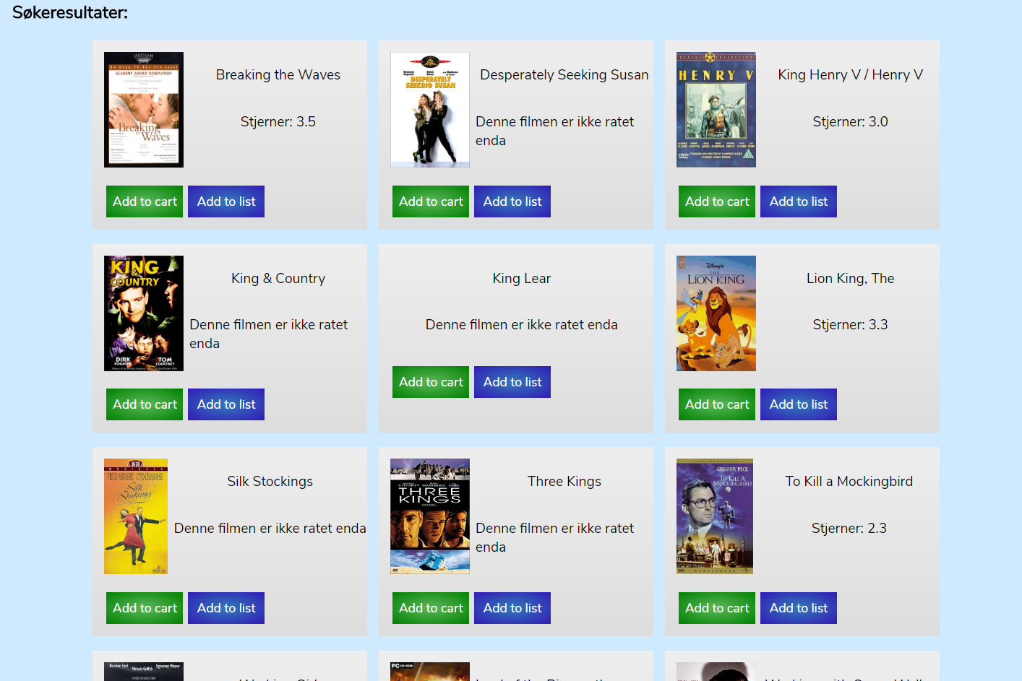
The search function is rather simply created. I have taken all the movies into an array. Then I apply the search terms on them and if the search term does not apply then I take the item out of the list. Then when all search terms are applied the remaining movies in the array are the ones that the user wants. More interestingly the only place one can access the advanced search function is when the user has done a title search. This is because the search function that is available on all the other sites should be easy and convenient to use.
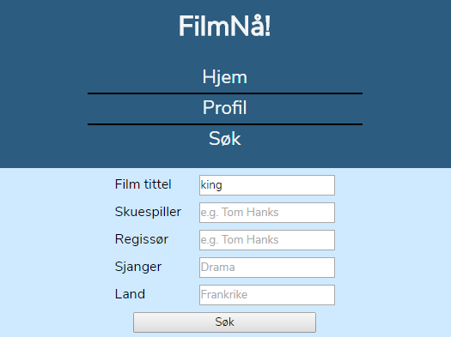
As can be seen here the only search term that is applied to the filtering is Film Title and this is remembered so that the user can fine tune their search each time. Timing the method it is pretty quick, but I am uncertain about what could happen if the movie database got 10 times as big or even 100 times.

Movies-detail-page
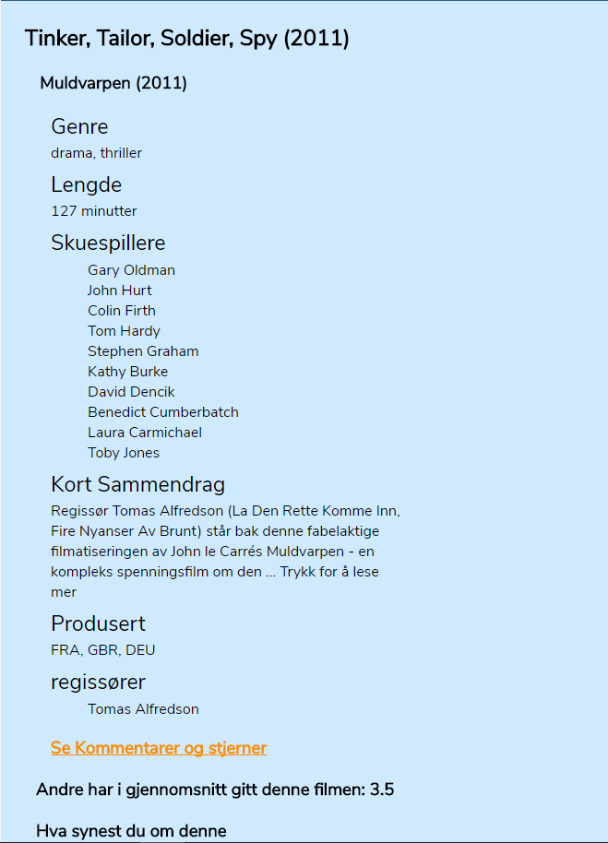
This is basically the same except that I have added some elements to compensate for the requirements that is put down in this assignment and some minor changes to the functionality. The biggest change is that now it is possible to extend the page and see the ratings and comments from the other users. This is done by clicking “se Kommentarer og stjerner” and then close it by clicking its counterpart. Other than that when clicking on the actors name one is searching in the appropriate filter for movies with this actor playing in it. This is done with the directors also.

Conclusion
It was a fun exercise and I can’t wait to get started on the mongodb database to make it more dynamic. Lets go. I have commented what I think is necessary and I think this has been solved pretty nicely.

