Report INFO134

Project one

Kristian Os

Report
This is a post-report from the creation of the first assignment and the design choices I have made during the design and testing process
I will go through the website one page at a time and explain the choices I made, what is now and what has been discarded.
The website has been tested on newer browsers including Firefox, Google Chrome and Internet Explorer. All these browsers are of course up to date.
For the two required movies I have chosen Intouchables and Valkyrie. There are four pages in total for now, all static and running on pure HTML and CSS. All elements are made by me and everything is static for now.
I will regard the header and the navigational element by itself since this is the same on every page.

Header
The first and foremost is the header which should be the first thing the user sees upon entering the page and should be the starting point for the user to navigate to the subsequent elements. Therefore I have given this element a high contrasting color to its background both for readability and an assurance that this is where the user should start and work downwards.

Navigational Element
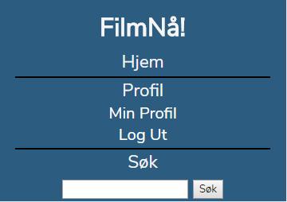
Illustration 1: Header and navigational element (Fully expanded)
Just below this element is the navigation menu. There was a choice to be made here about structuring this as a navigation bar, navigation stack or just have the links in a section on the side.
For consistency I chose to have a navigation stack since this is the optimal choice for a mobile version and the user does then not have to learn a new system. It consists of 3 main elements; “Hjem”, “Profil” and “Søk”. “Hjem” leads the user back to the index page and is present on every page, as a reload button if the user is on the index page, or a navigation button should the user need to go back to the index page. The next two elements “Profil” and “Søk” will expand when the user clicks the respective area. Profile yields two hidden elements, “Min Profil” and “Log Ut” and “Søk” does the same. This is for “available when needed” principle. The color choice for the navigational element and header is a heavy blue color and this is also to give weight to this area so the user knows where the site starts and gives the contrast to the child elements of the two.

Index
Index is the first page that the user sees when using the page and should be easy to read/navigate.
In full-screen mode, this page looks very empty but when populated with movies will make a lot more sense and I might then give each element more breathing space than I am doing now. There are 5 sections and the three first “Nye filmer”, “Sist sette” and “Forslag” works the same way, but will be populated with different content based on the users preferences and/or some randomness. When overflowing as they will on mobile devices very easily they will expand with a scroll property in the x-dimension.I have not given the title on this page because as so often most users will judge a film by the cover and especially on mobile devices space is sparse and must be savored.
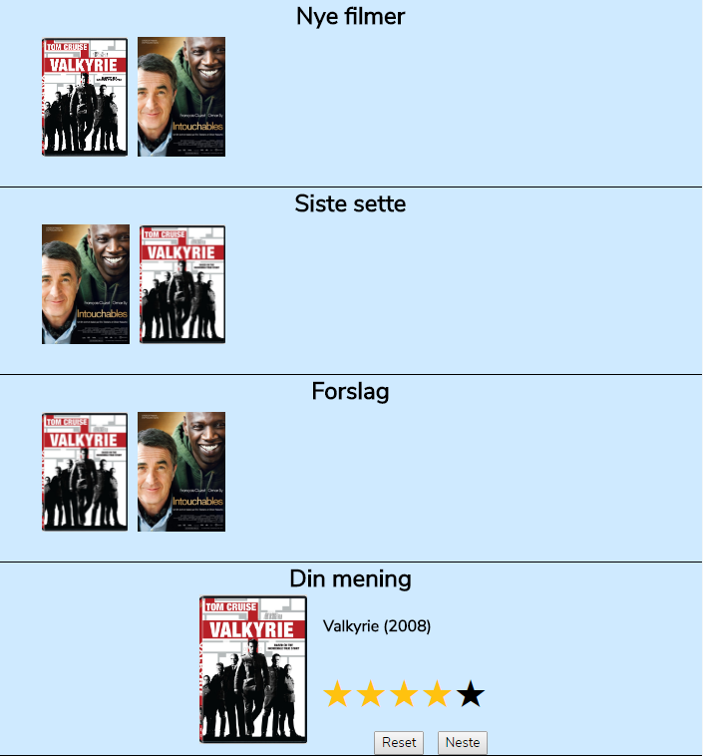
Illustration 2: Index page section 1-4
The forth section, “Din mening” is the rating section. This just gives the user an image, the title and a five star rating system for easy rating and sorting. This is so that later one may promote the highest rated movies easily based on numbers from [0-5]. When the user is happy with the given rating, the user can then press “Neste” and another movie should come up based on previously seen movies. This is a form so that the information can be processed in a script of some sort later when implemented.
The last section, “Rutiner”, on the index page is the section explaining the routines a person must use when loaning a movie. This is easily read, step by step. I have pushed this all the way to the bottom because this does not need to be read all the time and should not be in the users way.

Movie pages
When a user clicks a movie anywhere on the site he is presented with general information about the selected movie. It is indented and marked up so that information headers and sub-information is easily distinguished so reading is clear. At the very top of the document, just below the header and the navigation is two buttons where a user can add movies to loan cart and to a wish list. These stand out and is placed at the top so the user can click them immediately if the user wants the movie. All the information in this section is structured so that a user can easily navigate to the parts of interest and is not overflowed with information to not confuse the user.
Further down is a rating section where the user is presented with how others have rated the movie and also the chance to rate the specific movie itself. There is also a section for diverse media like screen-shots and trailers. There is a hidden section, it is shown with a right-arrow on the left side of the text and upon hovering the text turns an orange color.

Search page
The search page is laid out in a similar layout as the other pages, again for familiarity and the and each search item looks like the example in Illustration 2. The picture is relative small and only important meta-data is included that can be searched and sorted in a “database” for the future. Each movie has a picture, title and a rating based on how many stars it has gotten. This list will expand forever now, but can easily be limited to “x” number of items or multiple pages layout.
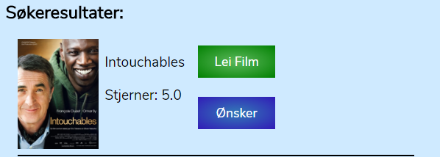
Illustration 3: Example of a search item.

Profile page
The profile page is laid out with two section. One for movies that is loaned already and one for a list of movies that you wish to loan. They are also flex-wrapped so it handles many movies. On the other pages the images scale on hover, but this page does not because a user should recognize the movie based on the cover. The headers are easy to spot and goes into two rows instead of two columns on a small screen.
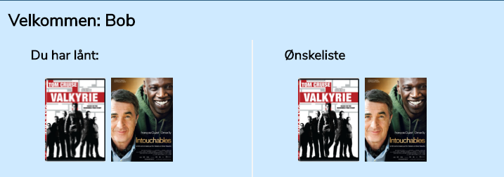
Illustration 4: Example of a profile screen-shot

Development cycle
Starting this project I began with a design that was more modular and placed differently. I also began design for a big screen and when I then started working on a mobile design for responsiveness it did not work the way I wanted and looked bad. I scrapped everything and began anew. This time I began development for mobile first and had at the end under 60 lines of CSS to make the whole site responsive and it all went very smoothly. The most difficult parts of this site is definitely the rating system and a feature that is not implemented yet since I need JavaScript to solve it.
The ratings system will be a 0-5 stars system and this is the numbers that will be averaged to make up the total rating. In the HTML it is ordered the wrong way, but this is to make the CSS tilde selector to reach the correct siblings.
Commenting was also hard since it is difficult to decide what to me might be obvious, but in the graders eyes should have been commented. However I have tried to take the CSS selectors that is difficult to understand and comment what they do and what they affect.
The HTML is commented on what each of the section where many are ended and it is unclear what ends where. This is of course for me or future developers that need to understand the markup.

