INF115 – Assignment Two

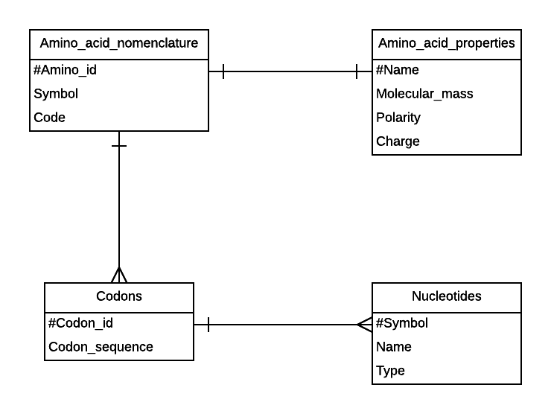
- One Nomenclature can have one set of properties, one Nomenclature can have many Codons and one Codon can have many Nucleotides.

  - Entities:
-Genes
-Exons
-Isoforms
-Chromosome

  - ER-Diagram:
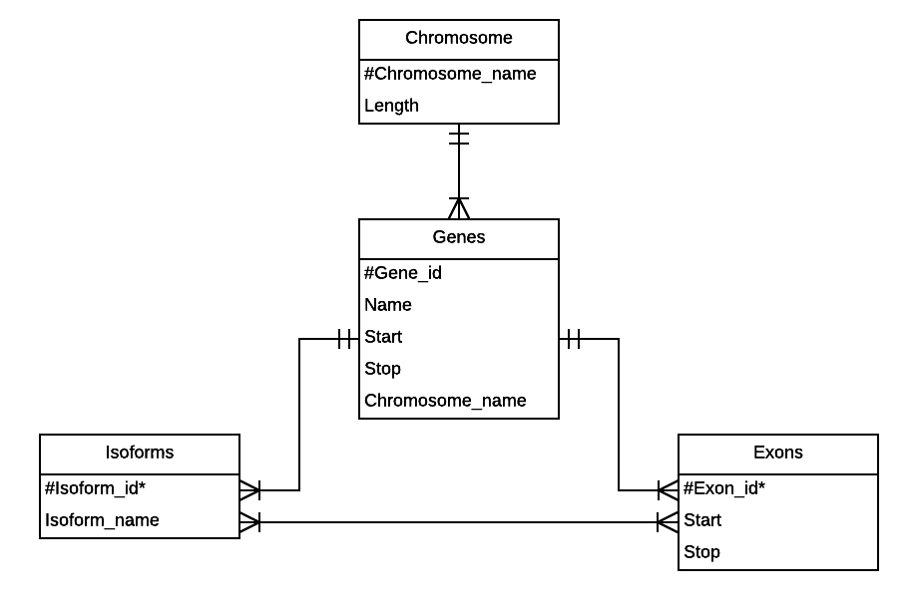
  - DB in Third Normal Form:
Chromosome(#Chromosome_name, Length)
Genes(#Gene_id, Name, Start, Stop, Chromosome_name*)
Exons(#Exon_id, Start, Stop, Gene_id*)
Isofom(#Isoform_id, Isoform_name, Gene_id*)
Isoform_exons(#Isoform_id*, #Exon_id*)

  - Entities:
-Chromosomes
-Genes
-Synonyms
-References

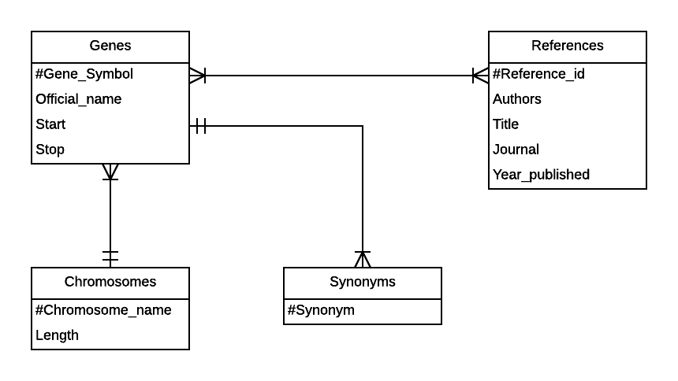
  - ER-Diagram:
  - First Normal Form: Breakes second normal form since Chromosome_Name is not dependent on Gene_symbol.
Synonyms(#Synonym, Gene_symbol*)

Genes(#Gene_symbol, Chromosome_name, Chromosome_length, Official_name, Start_coordinate, Stop_coordinate, Reference_id*, Year_published)

References(#Reference_id, Authors, Title, Journal)
  - Chromosome(#Chromosome_name, Chromosome_length)

Synonyms(#Synonym, #Gene_symbol*)

Gene(#Gene_symbol, Chromosome_name*, Official_name, Start_coordinate, Stop_coordinate)

GeneReference(#Gene_symbol*, #Reference_id*)

Reference(#Reference_id, Authors, Title, Journal, Year_published)

- Four

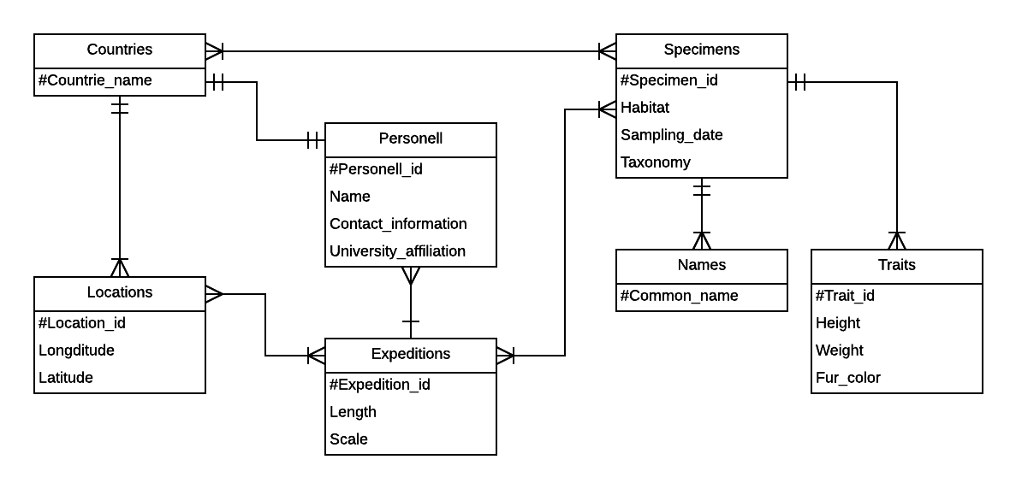
  - Two

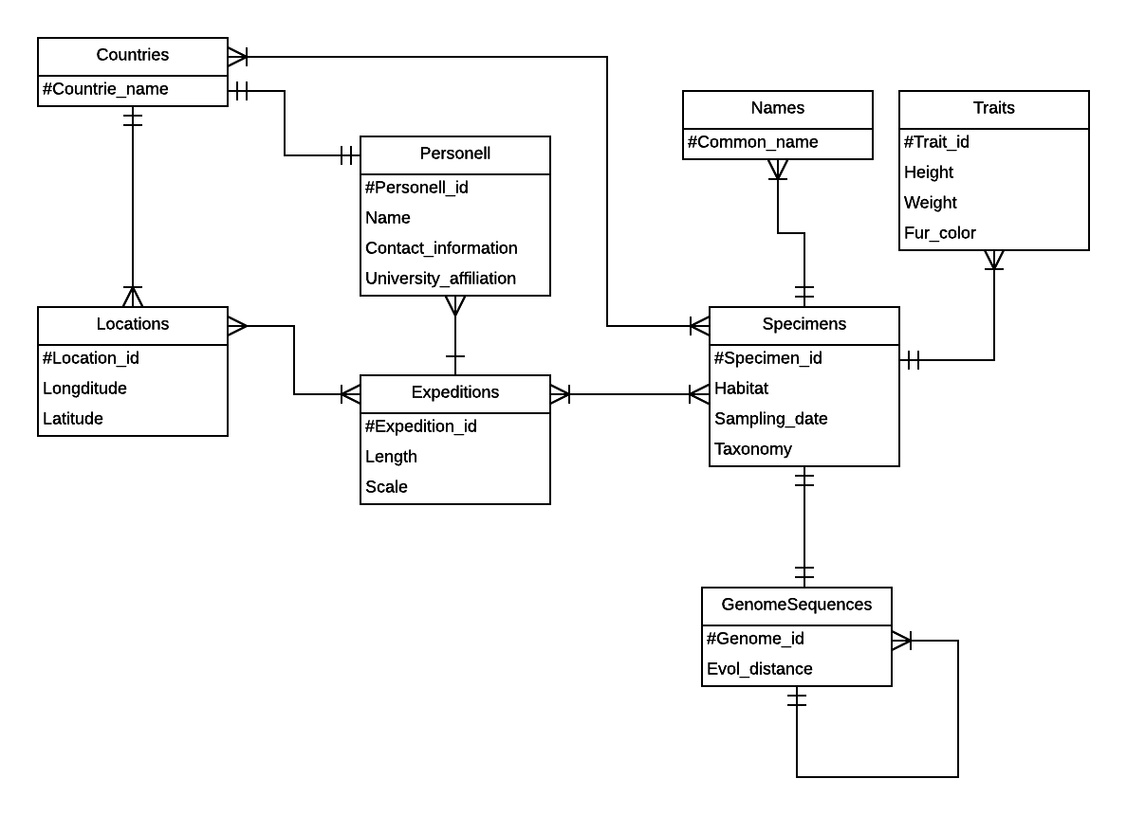

- Task Five
  - Errors
    - Dependency error in Patient: Where postcode is dependent on Region, not PatientID
    - Patient can only be in one location at one time so PatientToLocation is not needed.
    - The highest normalization level these tables upholds are 2NF

