Course: Dikult 105
Candidate Number: 137

Group project report

Assignment: 3

https://dikult105.k.uib.no/groups/dikult105_15/

Word Count:
05/12/2016

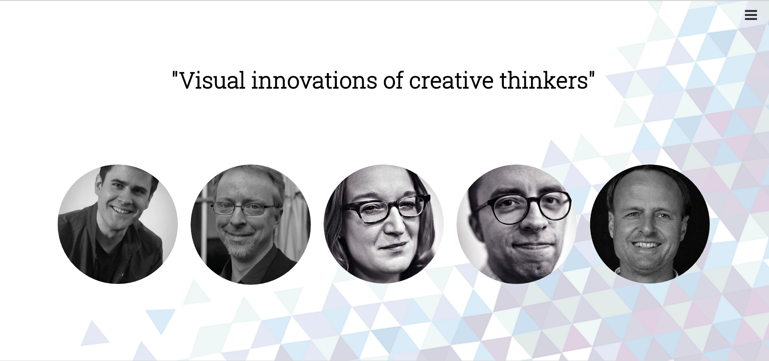
Illustration 1: Image of the front page (Desktop Version)
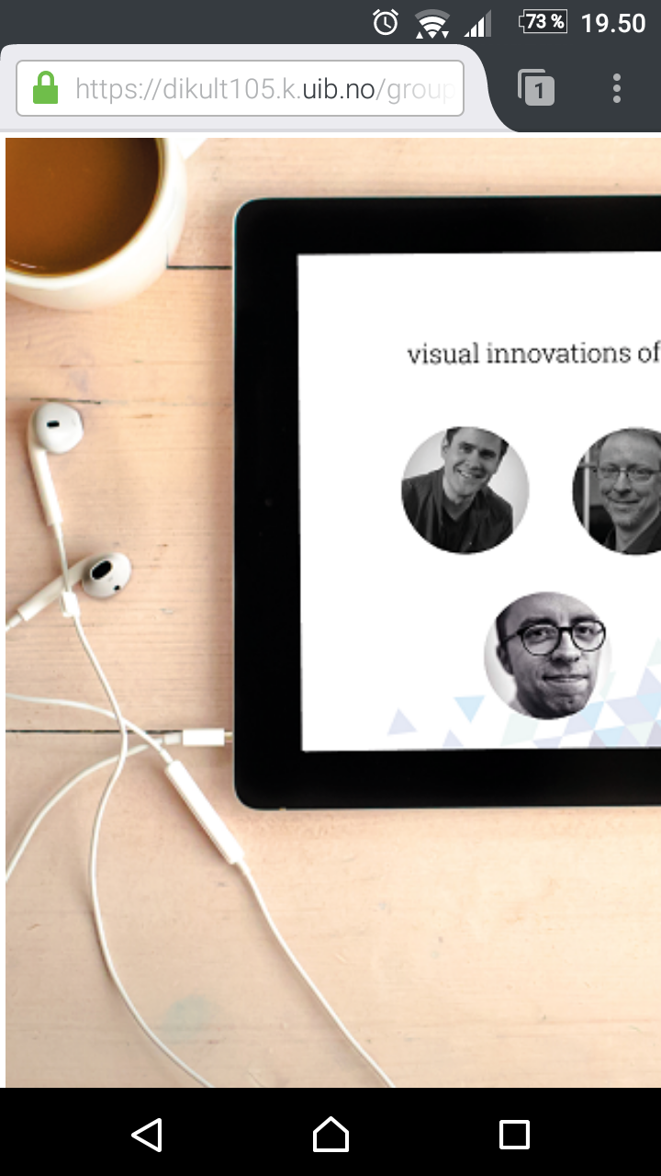
Illustration 2: Image of the front page (Mobile Version)

Table of Contents
Report 4
Topic 4
Architecture 4
Target group 4
Personal contribution 4
User testing 4
Browser testing 4
Project life cycle 4
Retrospect and regrets 4

Report

Introduction
This report is about how me and my group created the website we wanted to create. I will discuss the structure, content, my contributions and general development of the website.

Topic
For topic there was quite a discussion. We were not certain about what we wanted to do and while all had good ideas we could not decide on one topic that was doable and had all of us interested. However when we came up with the idea of creating a website featuring important web designers/innovators we all wanted to know/learn more about. Given this common goal we decided on this topic. We were pretty confident that no such service existed and it took little research to realise that there were no competition. This gave us the opening of designing the web site however we wanted and populate it with the content we found interesting without a thought of crashing with other sites, because there were none.

Architecture

Target group

Personal contribution

User testing

Browser testing

Project life cycle

Retrospect and regrets

