# Assignment #14

## Getting Familiar With the Tool's Trac Wiki

In this exercise, you will explore the functions of a tool's wiki area. Along the way you will become familiar with the wiki syntax and learn where to find the latest changes to the wiki project area.

We'll use an example tool, named bootcamp, to practice using editing wiki pages. Get started by navigating to the bootcamp's tool status page:

[**https://nanohub.org/tools/bootcamp/status**](https://nanohub.org/tools/bootcamp/status)

On the left side of the web page, is a section named Developer Tools. Click the link labeled “Wiki” to get to the tool's wiki pages.

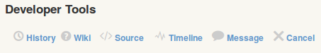

The link takes developers to a set of web pages with basic information about the tool.

[**https://nanohub.org/tools/bootcamp/wiki**](https://nanohub.org/tools/bootcamp/wiki)

These web pages can be created and modified by using a simple “wiki” syntax. You don't need to be a master at HTML to create wiki pages. A little bit of wiki syntax can cover many of your web page editing needs.

You need to be logged in to edit the wiki pages. Click the “Login” link in the upper right corner of the web page.

When prompted for your username and password, use your HUB credentials. 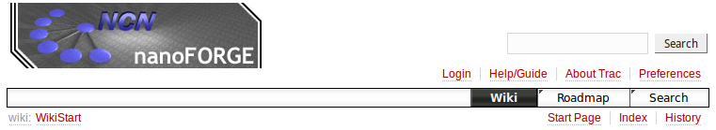

***NOTE:*** If you used a third-party service, like Google or Facebook, to login to the HUB, you will need to first setup a local HUB password in the go to your HUB Account settings to retrieve your username and setup a local HUB password. Navigate your web browser to:

<https://nanohub.org/members/myaccount>

Click the “Account” link on the left side of the web page and create a password that will be used to connect with the HUB through ssh, sftp, and tool wiki services.

You were assigned a group number at the beginning of the assignment. Locate your group's wiki page and click the “Edit this page” button at the bottom of the page.

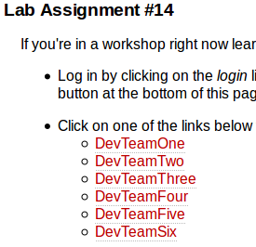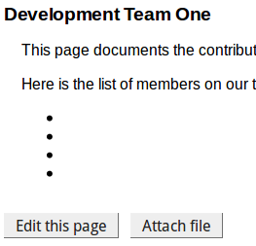

Add your name to the list of members on the team. Use the “WikiFormatting” link in the lower right corner of the editing window to find a cheat sheet for common formatting markups. Try making your name a Level 2 header or adding a bold or italic font style.

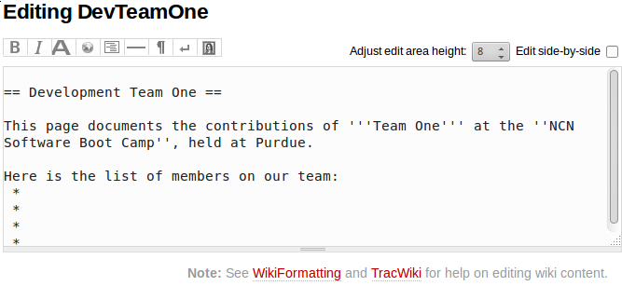

After you have added your name to the list of team members, add a comment to the Change Information section of the web page describing the changes you are making to the wiki page. It can be something as simple as “adding my name to the member list”. Then press the “Submit changes” button to save and publish the wiki page.