# Assignment #10

## Add a loader to Spirograph

In Assignment #6, we built a nice looking version of Spirograph. But it was missing one thing: built-in examples for the user to try out. In this assignment, we’ll add a loader with a series of predefined parameter sets.

1. Start with your solution from Assignment #6, and add the “loader” control to the top:

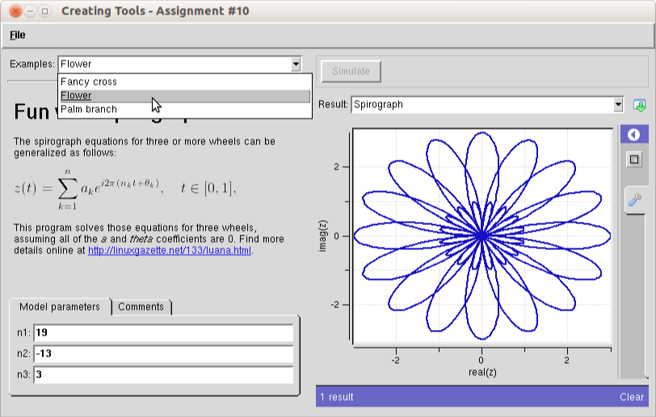

***REMEMBER:*** The loader is not available in the builder, so in order to add it, you’ll have to edit the XML code directly using your favorite editor.

1. Create a folder called “examples” and create three files within it to load the following parameter sets:

* Fancy cross n1=13, n2=-7, n3=-3
* Flower n1=19, n2=-13, n3=3
* Palm branch n1=7, n2=-5, n3=2

1. Try out the program. Does the drop-down menu appear at the top with the correct labels for each of the test cases? Do the parameter values load correctly and produce the right plot?
2. *Extra Credit:* Add a couple of your own examples to the loader.

### Lessons Learned:

* The loader cares only about the <current> values defined for each input.
* If you forget to add the <about> section to each example file, the loader uses a default name in the drop-down list.