# Assignment #11

## Experiment with drawings

You can use the Rappture drawing object to create expressive and intuitive tools. In this assignment, we’ll create a simple drawing and connect it to a couple of controls.

1. Use the Rappture Builder to create a tool with a Boolean value and a string:



Save the tool.xml file. That’s as far as we can go with the builder. We’ll have to add the drawing by hand.

1. Edit the tool.xml file and add the specification for a <drawing> element. Add components to the drawing to make a smiley face:

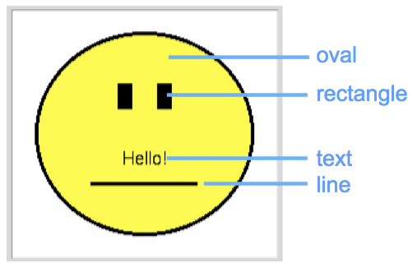 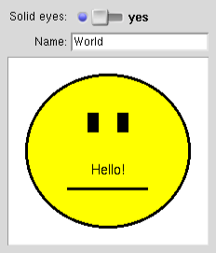

1. Now, connect the hard-coded text (“Hello!”) on the drawing to the string input, so that the text shown on the face comes from the value of the string input. Connecting a text element with a control string automatically creates a hotspot on the drawing. Click on the hotspot to bring up the string control.
2. Connect the Boolean control to the fill color for the eyes on the face. When the control is on, set the fill color to black, and when the control is off, set the fill color to yellow or the empty string. Your final drawing should look like this:

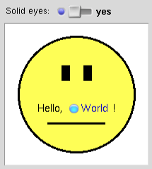 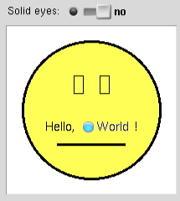

### Lessons Learned:

* A drawing can be added to an existing tool—after other controls have been defined in the builder.
* The drawing can subsume controls into hotspots.
* The drawing can react to values of various controls.