# Assignment #12

## Advanced Visualizations

Many programs produce complex data sets, which Rappture can help you visualize. For example, let’s use MATLAB to create a program that plots Bessel functions. The core of this program is the following bit of code:

nu = linspace(0,numax,npts);  
x = linspace(0,xmax,npts);  
[xx,yy] = meshgrid(x,nu);  
z = besselj(xx,yy);

In this code, the variable npts is the number of grid points. Variables nu and x define a rectangular mesh, and z is the field defined on that mesh of points.

1. Use the Rappture Builder to create an interface with three controls: An integer value numax representing the maximum value for nu, a number xmax representing the maximum value for x, an integer value npts controlling the number of grid points. Set the language in the Tool section to “Octave.”
2. Save the tool.xml file from the builder, then edit it by hand to add a mesh and a field definition in the output section. Define as much as you can about the mesh and the field—labels, descriptions, etc. Of course, you can’t specify the max values of the x- and y-axes of the mesh, since they are set later by xmax and numax. But define everything else that you possibly can.

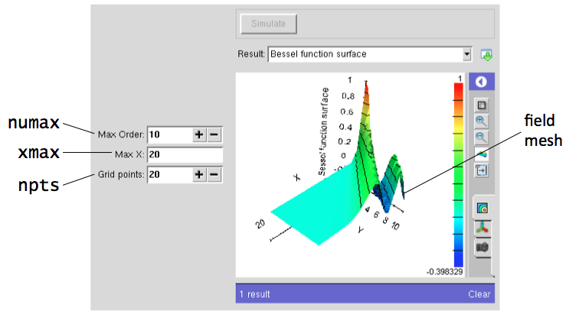

1. Edit the skeleton program and insert the three lines of code from the top of this assignment. Below that, add some code to insert the resulting values of the z matrix into the field.component.values element in the output section. Now that we know the values for xmax and numax, we need to store them in the output as well, setting the maximum values for the xaxis and yaxis of the mesh.
2. Test out your new program. Does it generate a surface that looks like the Bessel function? Find the button along the right-hand side that toggles between a contour plot and a mountain plot. In “mountain plot” mode, click and drag on the plot to rotate the view. Click on the side panel to open up other options on the right-hand side.
3. Change the value of xmax or numax and generate another result.

### Lessons Learned:

* Anything that you put in the output section of the tool.xml file is automatically carried through as output. Your program can override those values or add new values by calling “put” to put strings in the output section.
* Field and mesh objects are not yet available in the builder. They must be coded by hand in the tool.xml file.
* Each field must contain the name of its associated mesh object.