# Assignment #19

## Building Jupyter Notebooks with Python

In this assignment, we’ll write our Spirograph program using a Jupyter Notebook.

Launch the Jupyter Notebook application from your HUB Dashboard. From the index page, click the “My Files” link on the upper right side of the page to get to your notebook files:

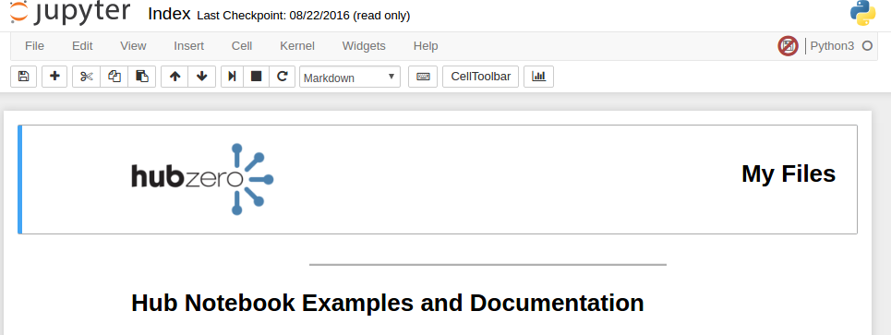

This brings you to the Notebook file browser. To launch a new Notebook, find and click the “New” dropdown menu located on the right side of the page. Choose “Python2” from the dropdown list:

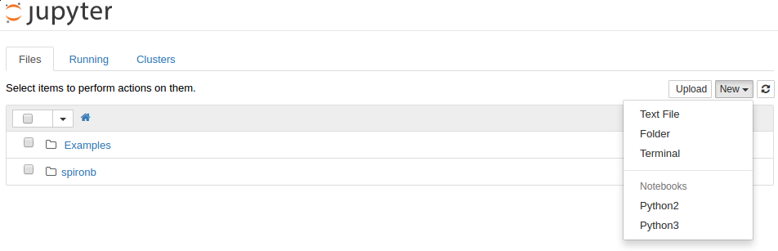

Once the new Notebook has finished loading, change the name of the notebook by clicking on the text “Untitled” in the header and rename the document “Spirograph”.

We are now ready to type in our Spirograph program. We'll use the first Code cell to load libraries. Type the following into the first Code cell:

from numpy import linspace, exp, pi, real, imag

import matplotlib.pyplot as plt

You can run the code cell by pressing the Shift and Enter keys at the same time. Run the code cell.

In the second Code cell, we'll create a function that accepts our three number values (n1, n2, and n3) and displays a plot of the Spirograph. Type the following into the second Code cell:

def plot_spiro(n1, n2, n3):

t = linspace(0,1,1000)

z = exp(1j*2*pi*n1*t) + exp(1j*2*pi*n2*t) + exp(1j*2*pi*n3*t)  
 plt.plot(real(z),imag(z))

plt.show()

Run the second Code cell.

In the third Code cell, we will make a call to our function to calculate and show the Spirograph plot. Type the following into the third Code cell:

plot_spiro(13,-7,-3)

After running the third Code cell, an XY plot should be displayed showing the spirograph. Users can continue to make repeated calls to the plot_spiro() function, with different n1, n2, and n3 values to generate new spirographs.

Jupyter Notebooks also includes widgets that can easily be attached to your program to make it more interactive. In the next Code cell, import the “interact” method from the ipywidgets library, and attach it to your plot_spiro() function like this:

from ipywidgets import interact

interact(plot_spiro, n1=(-20,20), n2=(-20,20), n3=(-20,20))

Running the Code cell should produce an XY plot like we saw earlier, but it is now controlled by three sliders, one to represent the value of n1, n2, and n3. Play with the sliders to figure out the n1, n2, and n3 values that generate your favorite Spirograph.

Last, create a Markdown cell, and use the Markdown wiki language to write a description of your application and the n1, n2, and n3 values your found interesting.

### Lessons Learned:

* Jupyter Notebooks allow users to build programs on the fly.
* Use the interact() function from the ipywidgets library to add sliders and make your program more interactive.