# Assignment #5

## Building Tools with Rappture and MATLAB/Octave

In this assignment, we’ll take the Spirograph code from Assignment #4 and build a tool that anyone can use to generate Spirographs.

First, use the Rappture Builder to define the interface for the new tool. The tool will take three numbers (*n1*, *n2*, *n3*) as inputs, and produce a plot of *real(z)* versus *imag(z)* as the output. Define the language for the tool as “Octave” (the GNU free version of MATLAB).

Once you’ve generated the tool.xml file and the skeleton program, edit the program to insert the Spirograph code:

t = linspace(0, 1, 1000);  
z = exp(i*2*pi*n1*t) + exp(i*2*pi*n2*t) + exp(i*2*pi*n3*t);  
plot(real(z),imag(z));

Your finished program should look something like this:

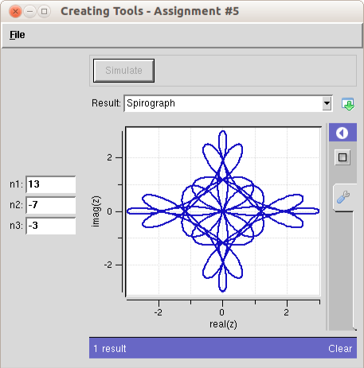

Test out your program with different values for *n1*, *n2*, *n3.* What is your favorite combination?

### Lessons Learned:

* Having a Rappture interface is better than hard-coding values in scripts.