# Assignment #6

## Spice up your Spirograph Tool

Explore some of the more exotic controls available in Rappture. Start with the Spirograph tool that you created in Assignment #5, and add the following options:

* Add a note with information about Spirographs at the very top
* Add a “Model parameters” tab and a “Comments” tab. Move the inputs *n1*, *n2*, *n3* into the “Model parameters” tab, and add a Boolean value and a string into the “Comments” tab.
* When comments are enabled (Boolean control is on), the string should also be enabled, and the tool should produce an output string with comments from the string area.

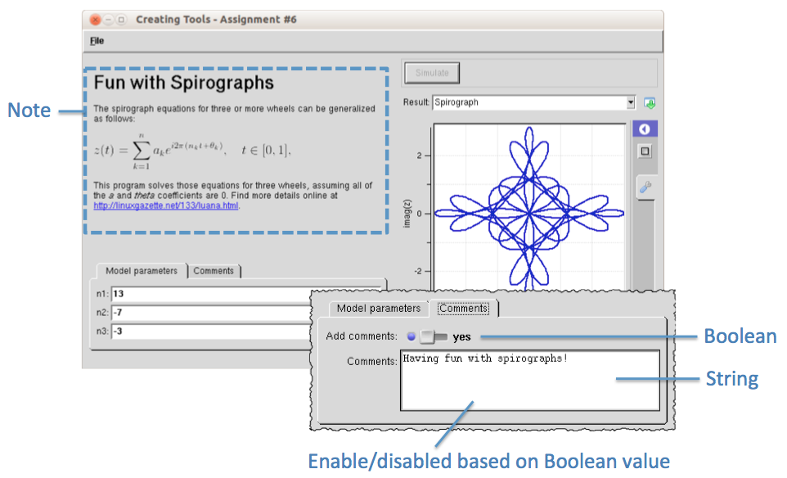

### Lessons Learned:

* You can add features to a Rappture tool later, but you need to generate a new skeleton program and transfer your core code from the old program to the new one.
* You can use values of inputs (such as the Boolean value) to control the behavior of your program (such as whether or not to output comments).
* Notes are a good way to add documentation within your program. Links within the notes can lead to even more documentation or video tutorials.