# Assignment #8b

## Create a Rappture interface for your C program

In Assignment #8a, we finally got the letters program to work. Now, let’s create a Rappture interface for the program so that other people can run it more easily.

1. Use the Rappture Builder to define the interface for the tool. It should look something like this:

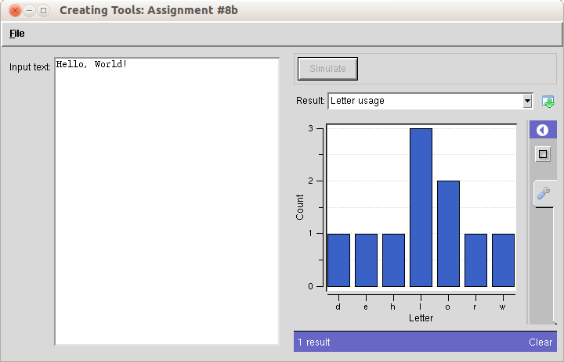

1. Generate a Makefile and a skeleton program in C.
2. Edit the skeleton program and insert the core of your program from letters.c, and then connect the inputs and the outputs of your program to the Rappture controls.

***NOTE:*** The original program used getchar() to read letters that you typed in standard input. Instead, the Rappture program stores all characters in an array variable with the variable name that you specified for the string input. For example, if you named the string text, then the first character is text[0], then text[1], text[2], and so forth. You might use a loop variable, such as i, to scan through the string text[i].

1. Compile and test your program. Try “Hello, world!” and a few other strings. Does it count the letters correctly?
2. *Extra Credit:* Add a number output to report the number of words in the input string.