# Assignment #9b

## Create a Rappture interface for your Fortran program

In Assignment #9a, we finally got the letters program to work. Now, let’s create a Rappture interface for the program so that other people can run it more easily.

1. Use the Rappture Builder to define the interface for the tool. It should look something like this:

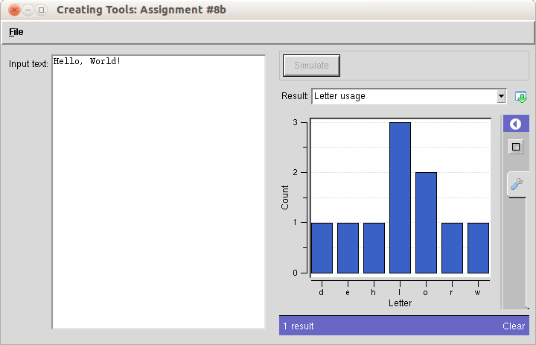

1. Generate a Makefile and a skeleton program in Fortran.
2. Edit the skeleton program and insert the core of your program from letters.f, and then connect the inputs and the outputs of your program to the Rappture controls.
3. Compile and test your program. Try “Hello, world!” and a few other strings. Does it count the letters correctly?
4. *Extra Credit:* Add a number output to report the number of words in the input string.

### Lessons Learned:

* The interface for this tool is identical to the interface for Assignment #8b. You can start with the same tool.xml file, but you have to change the programming language defined in the Tool section.