## An Important Idea

Communicating important ideas can be effective when *text* and *diagrams* are combined.



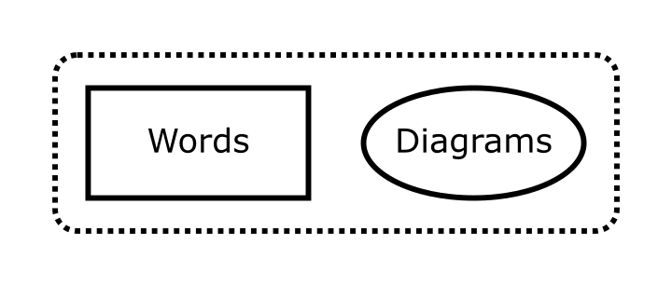

This may increase both understanding and retention.

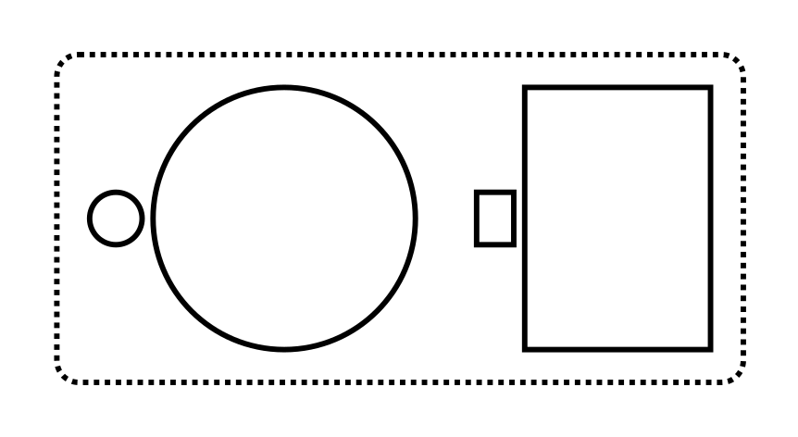

Maybe try this in **your** next document!

def fn():  
 pass

def ident(x):  
 return x

Fin.