Exercise: Digital transformation

Introduction
As you progressed on your learning journey in networking and cloud computing, you learned about various network technologies. You also learned that many of these technologies are available as cloud services these days, enabling businesses to expand faster. This is because they don’t need to build and purchase their own data centers, not to mention the maintenance and security responsibilities that come with it.
You are now required to create a digital transformation expansion plan for Sam’s Scoops using the knowledge you have gained on networks and cloud computing throughout this course. Let’s take a moment and think back to where your interactions with Sam’s Scoops started.
During this course, you joined Sam in exploring network architectures, devices, and security considerations for her business. In week one, you helped them set up their first network, connecting two computers and a printer via a switch, as depicted in the physical topology diagram below.
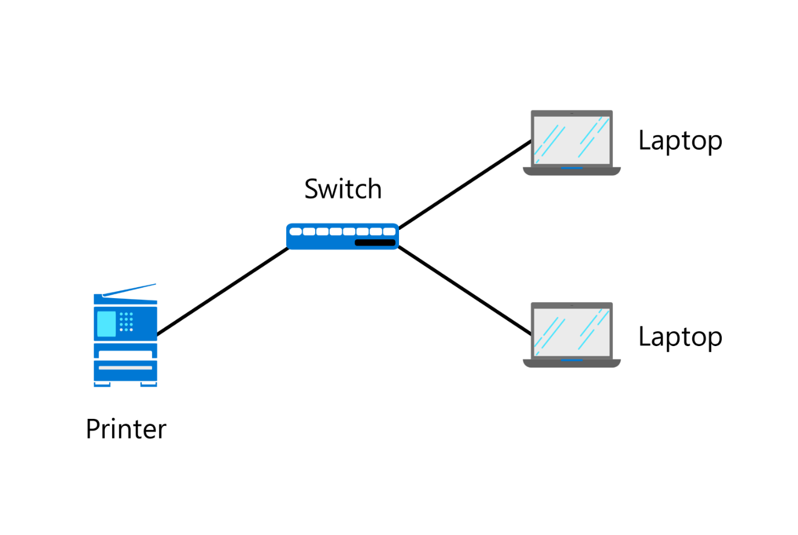
And in the second week, you helped them expand this network by adding a Wi-Fi router and two tablets. The physical topology diagram below demonstrates how these tablets can wirelessly connect to the rest of the network.
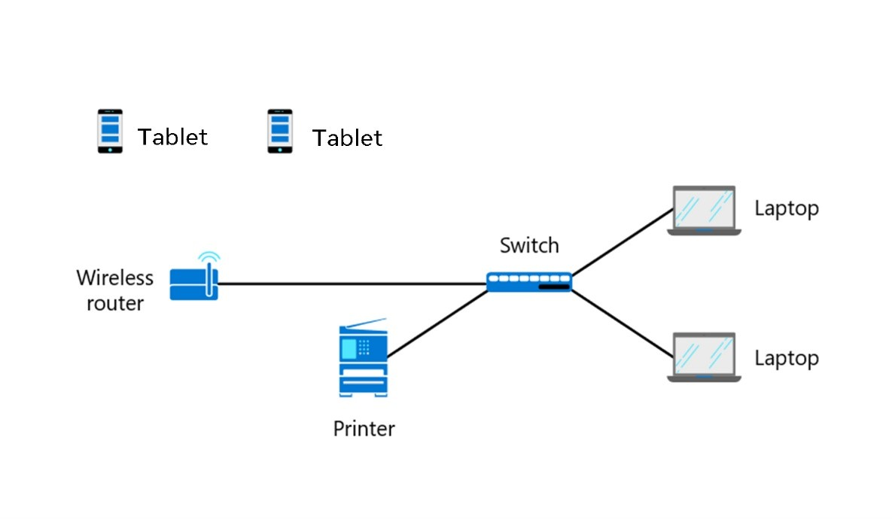
You then gained some practical experience with setting up a virtual network in week three. This exercise challenged you to plan a more extensive network with more components than Sam’s Scoop’s network, which allowed three in-house departments and a remote team to connect securely to a network.
Later, in week four, you completed an exercise exploring how cloud transformation can help Sam’s Scoops overcome its IT infrastructure limitations and expand its reach by selling ice cream online.
Throughout the course, you considered various network technologies that might help Sam’s Scoops improve and extend its network. You discovered the threats and opportunities of connecting the network with the internet. And you examined the options of on-premise and public cloud providers. Recall that for Sam’s Scoops, a combination network solution including some local on-premise resources as well as the public cloud will likely serve them best. Sam learned that SaaS has lots to offer a fast-growing business and realized that adopting these services is far easier than trying to build their own.
All of these considerations and scenarios prepared you to complete this final course project.

Case study
So far, Sam’s Scoops' local area network has a WI-FI router with two connected company tablets that can connect to the network. Although you did not do this in an exercise, their network is now also connected to the internet. This enables staff to do online training. However, many aspects of the business are still manual, which makes it challenging to keep up with demand.
Sam needs to modernize the business and asks you to create an expansion plan to digitize different aspects of the business by taking advantage of cloud technology.
Take note: While digitizing the business, the security of the network and minimizing the risk of a cybersecurity attack should be your primary focus.
The business functions that need to be digitized using SaaS are:
- Electronic point of sale – At the moment, taking cash and using notepads or tablets to write orders down is a slow process. Accepting card payments and digitizing the ordering process is a must.
- Accounting – Sam still uses spreadsheets on the computer and needs to automate the whole process.
- Supplier communication – They would like to meet with the shop suppliers through an interface that supports video and chat capabilities.
- Website - Sam needs to promote the business through a website and maybe with e-commerce functionalities in the future.
Sam is also open to any other recommendations and ideas that you might have that could help the business.
After making your recommendations, you will complete a network diagram. Your new updated network diagram for Sam’s Scoops should show how all existing and new suggested additions interconnect. Remember that this is still a small business with only a few employees, so any solutions should be easy to set up and use.

Instructions

Step 1: Search and find SaaS solutions that will help digitize the business
Based on what you learned in the reading SaaS in action, consider the business functions that Sam has identified and search the internet for solutions that could help digitize the processes involved in those functions. List your suggestions in the table below. The first business function has been completed as an example.
Business function | Solution name and link | Additional equipment needed? | List 3 features | How is the solution  accessed?
Electronic point of sale | Square: https://squareup.com/gb/en/point-of-sale | Wi-Fi card reader | Card payments  Payment protection  Checkout | Website and app

Step 2: Explore and advise Sam on an Azure solution(s)
Think about how Microsoft Azure’s cloud technology can help this small ice cream business. Revisiting the first lesson in week 4 will help you perform this task. Suggest which Azure service(s)can help the business and explain why by listing its key benefits.

Step 3: Suggest a security device(s)
With the suggestion of digitizing more of Sam’s business processes, more business and customer data will flow across the network. What additional device or devices would you add to their network to protect it and why?

Step 4: Produce a network diagram to present to Sam
Since you created a network diagram for Sam’s Scoops in week 2, they have also acquired an internet connection, as indicated in the diagram below. Use this diagram as your starting point.
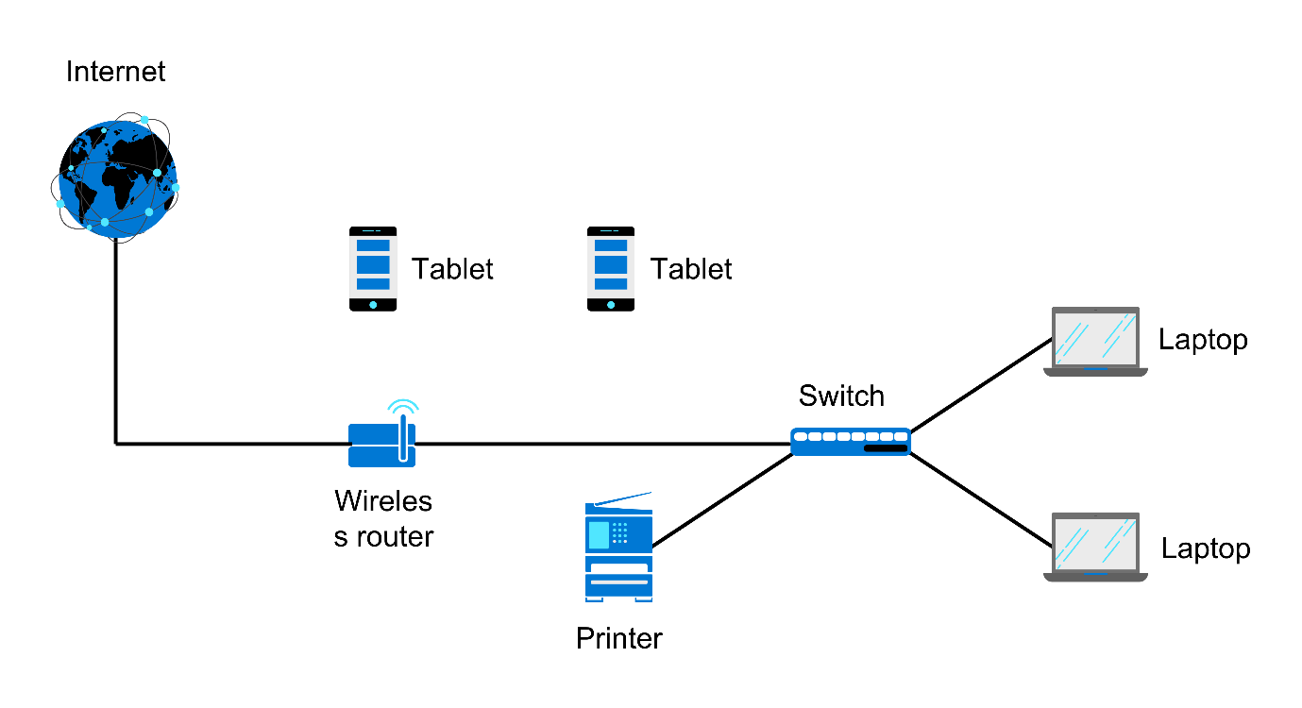
Now it’s time to add all your suggestions to the network diagram, extending it to incorporate the additional cloud services and any extra devices you have suggested in steps 1 to 3. Refer back to previous exercises – particularly the Virtual network simulation exercise for a reminder of how to build a more extensive network.
Tip: A cloud icon such at the one below is a great way to represent any cloud services in your diagram.


Conclusion
Completing this final course project allows you to apply concepts you’ve learned over the weeks of taking this course. By suggesting solutions that would help a small business digitize its processes, you will demonstrate your understanding of how cloud technology can help a small business expand. And by adding these solutions to the physical network diagram, you will demonstrate your knowledge of digital transformation.

Exemplar: Digital transformation

Introduction
In the Digital transformation exercise, you were tasked with demonstrating your knowledge of previous topics by producing a digital transformation plan for Sam’s Scoops’ network. Review this exemplar that outlines a possible solution to this exercise.

Step 1: Search and find SaaS solutions that will help digitize the business
Your first step was to search for and suggest SaaS solutions that will help digitize the business. The following solutions could modernize the business functions that Sam identified.
Business need | Solution name and link | Additional equipment needed? | List 3 Features | How is the solution accessed?
Electronic point of sale | Square: https://squareup.com/gb/en/point-of-sale | Wi-Fi card reader | Card payments  Payment protection  Checkout | Website and app
Accounting | Xero: https://www.xero.com/uk/ | None | Pay bills  Payroll  Send invoices | Website and app
Supplier communication | Microsoft Teams: https://www.microsoft.com/en-gb/microsoft-teams/free | USB camera | Video calls  Instant messaging  Voice calls | Web browser and app
Website | Wix: https://www.wix.com/ | None | e-commerce  Online store  Templates | Web browser

Step 2: Explore and advise Sam on an Azure solution(s)
Next, you had to suggest an Azure service or services that can help the business and explain why by listing the key benefits it offers. The following Azure services could benefit them:
- Azure Bot can be used to collect customer feedback of their online purchases. This service will help the business determine their performance and identify how services or products can be improved.
- Azure Analytics can be used to gain insights into customer behaviors and monitor business performance. By using this service Sam could analyze purchase history and direct offers to certain customers who like a particular flavor of ice cream.
- Azure app service could be used to build a Sam’s Scoops app, ready for customers to order directly from their phones.
- Azure security services could be used to monitor their network for threats, but also to store passwords used by the business, in a secure way.

Step 3: Suggest security device(s)
In Step 3 you had to identify a device that will protect customer data on the business’ network and motivate why you chose it.
Because of the increase in business and customer data on the network, a dedicated firewall to protect Sam’s Scoops’ network is a necessity. Choosing a next-generation firewall will mean that Sam’s business will benefit from better security features. These features would help prevent many attacks from entering the network as the firewall can examine packets for threats. VPN connectivity could also be something Sam might need in addition to a firewall to provide remote access to the network from any location.

Step 4: Produce a network diagram to present to Sam
In this step, you had to produce a network diagram to present to Sam. You were tasked with adding the cloud services as well as any additional devices that you suggested as part of your digital transformation plan for Sam’s Scoops. The diagram below is a possible solution.
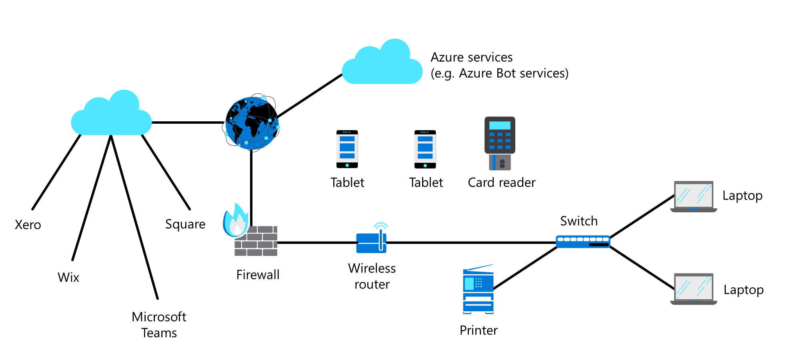

Conclusion
By creating a digital transformation plan for Sam’s Scoops you have practiced what you learned during this course. You specifically demonstrated that you understand how cloud technology can help a small business expand. And by adding your suggested solutions to a network diagram, you indicated that you understand network infrastructure.

