1. Introduction DBMS , SQL, Database

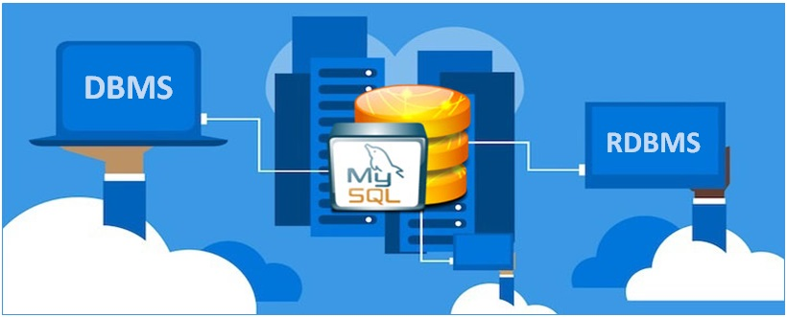

DBMS:

DBMS stands for Database Management System, as we mentioned above. SQL stands for Structured Query Language. If you have lots of data that you need to store, you don't just want to keep it anywhere – then there would be no sense of what that huge amount of data means or can tell you. That's why we use a DBMS.

A DBMS is software that manages the database. Some of the commonly used DBMS (software) are MS ACCESS, MySQL, Oracle, and others.

SQL:
SQL is a database language. SQL is used widely and almost all Relational Database Management Systems can recognize it.
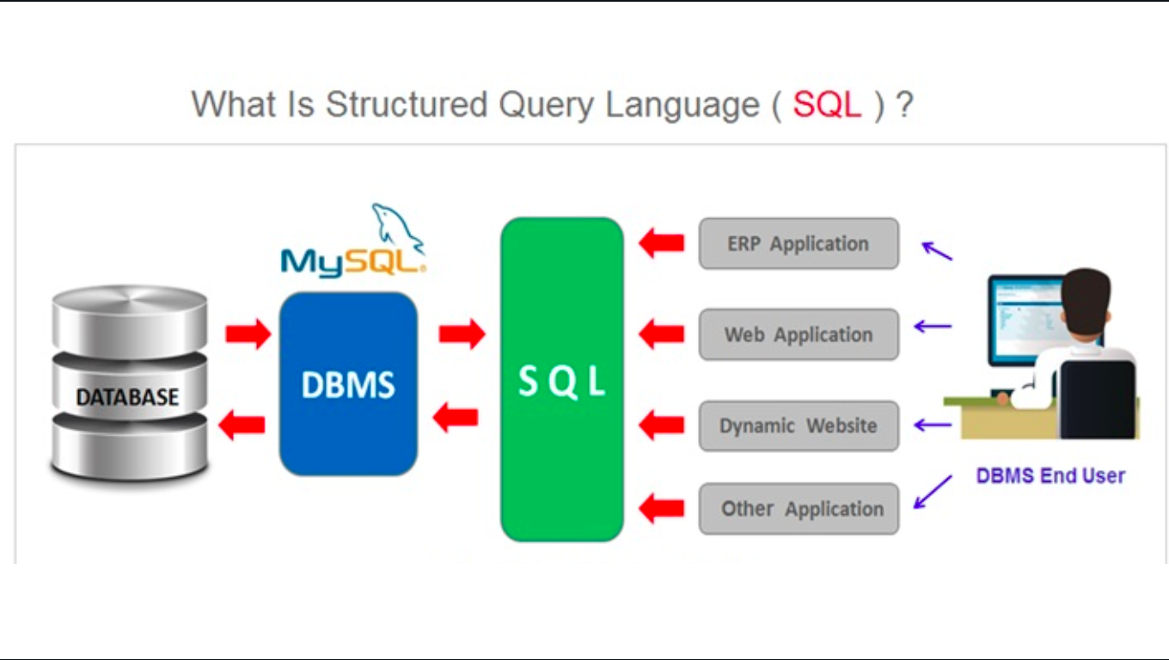
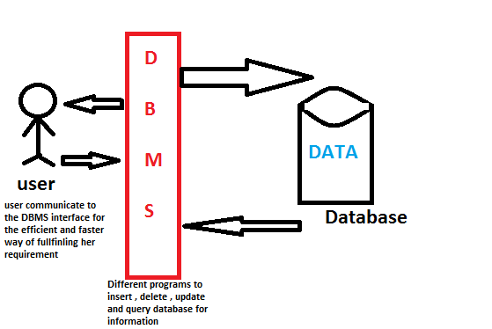

1. Introduction to MySql

MySQL is a very popular open-source relational database management system (RDBMS).
What is MySQL?
- MySQL is a relational database management system
- MySQL is open-source
- MySQL is free
- MySQL is ideal for both small and large applications
- MySQL is very fast, reliable, scalable, and easy to use
- MySQL is cross-platform
Who Uses MySQL?
- Huge websites like Facebook, Twitter, Airbnb, Booking.com, Uber, GitHub, YouTube, etc.
- Content Management Systems like WordPress, Drupal, Joomla!, Contao, etc.
- A very large number of web developers around the world

Types Of SQL ?

- DDL - Data Definition Language
- DQL - Data Query Language
- DML - Data Manipulation Language
- DCL - Data Control Language
- TCL - Transaction Control Language
