Student Name: Pratik Deshpande Student NetID:PRD190001

**University of Texas at Dallas**

**Department of Computer Science**

**CS 6364.001 – Artificial Intelligence**

**Fall 2020**

**Instructor: Dr. Sanda Harabagiu**

**Instructions:** Do not communicate with anyone in any shape or form. This is an independent exam. Do not delete any problem formulation, just attach your answer in the space provided. If the problem is deleted and you send only the answer, you shall receive ZERO points.

Copy and paste the Mid-Term Exam into a Word document, enter your answers (either by typing in Word, or by inserting a VERY CLEAR picture of your hand-written solution) and transform the file of the exam into a PDF format. If we cannot clearly read the picture, you will get ZERO for that answer! Make sure that you insert EACH answer immediately after EACH question. Failure to do so will result in ZERO points for the entire exam! Submit the PDF file with the name **MidTerM_Exam_netID.pdf**, where netID is your unique netid provided by UTD. If you submit your exam in any other format your will receive ZERO points. The Midterm shall be submitted in eLearning before the deadline. No late submissions shall be graded! Any cheating attempt will determine the ENTIRE grade of the mid-term to become ZERO.

___________________________________________________

**Problem 1 (50 points)**

*Proteins have an amino acid “alphabet” of 11 elements:* AM1, AM2, ..., AM11*. Amino acids are chemically linked together to form protein chains. Between amino acids there are chemical links of different strengths. Suppose you examine under microscope a sample of a protein that belongs to an alien species, having only 11 amino acids. You want to generate an optimal path between* AM1 *and* AM2 *using the A* search algorithm. You are given the strengths of the chemical links in the sample as a graph representation:*

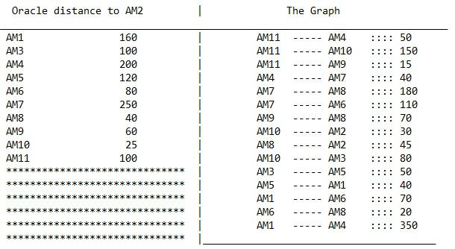

*An oracle also gives you the heuristic distance values to* AM2 *from each other amino acid in the sample. This heuristic is consistent. Specify if you will use TREE-SEARCH or GRAPH-*

*SEARCH. Motivate your decision.* **(5 points)**

*Provide the path of amino acids from* AM1 *to* AM2 *as well as the cost of obtaining it. it. Describe at each step of the search (1) what amino acids you have on the search frontier; (2) the current list of explored amino acids; (3) the current path from AM1 to the current amino acid and the cost of that path. Show the successors of each current node, show how you compute all the evaluation functions and which node you select for the next step.* **(45 points)**

Solution:

The use of A* graph-search would be optimal here as the heuristic, “Oracle-distance” that is provided is consistent.

**A* Graph Search:**

# Spare Page

**Problem 2 (50 points)**

(a) (**15 points**) Given the following game tree, find the possible values of variables *a* and *b* such that the minimax values in node N1 are (7, −1, −4). Also compute the minimax values at nodes: N2, N3, N4, N5, N6, N7, N8, N9 and N10.

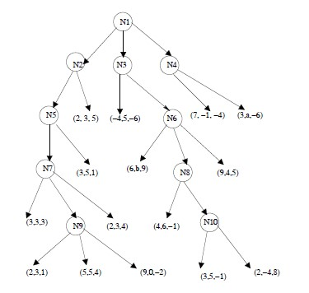*Player 1 Player 2*

*Player 3*

*Player 1 Player 2*

*Player 3*

Solution:

# Spare Page

(b) (**15 points**) An agent stating in state *S* should reach the goal state *G*. If the possible states the agent can reach are *A, B, C* or *G*, as depicted bellow:

**B**

**C**

**G**

***1***

***4***

***3***

***2***

***4***

***5***

***2***

## S *2* A

And as shown in the figure: cost(S→A) = 2; cost(S→B) = 4; cost(S→C) = 3; cost(A→B) = 1; cost(A→C) = 2; cost(B→C) = 4; cost(B→G) = 2; cost(C→G) = 5; you are asked to:

1. draw the search tree that allows the agent to travel from *S* to *G*, knowing that the agent *cannot ever visit S again*, and cannot visit any state more than once. Show in the search tree all the ways in which the agent can get from the state *S* to the goal state *G*; (**5 points**) How many ways of getting to the goal state *G* from *S* are there? (**2 points**) *HINT:* Any solution path starts in *S* and ends in *G* but does not have to visit all other nodes! However, it cannot visit more than one any node!

1. What is the least costly and the costliest way for the agent to get from state *S* to state *G*? Show the least costly path (**2 points**) and specify how much it costs (**2 points**). Show the costliest path (**2 points**) and specify how much it costs (**2 points**) and show how you have computed the costs.

Solution:

# Spare Page

(c) (**20 points**) Given the game tree below, compute the value of alpha and beta at following nodes, if the order is the same as in depth-first search:

1. alpha and beta at node N3 before and after visiting the terminal node with utility 5. Also show the values of alpha and beta in N3 after visiting N6 (Hint: Show also the values of alpha and beta at all nodes visited before you reached N3.); **(3 points)**
2. alpha and beta at node N6; **(2 points)**
3. alpha and beta at node N1 after visiting N7, if the node N7 has a child node with an utility value *x* (after you visited all nodes illustrated in the Figure) **(5 points)**
4. should the game tree be pruned? If yes, how? **(10 points)**

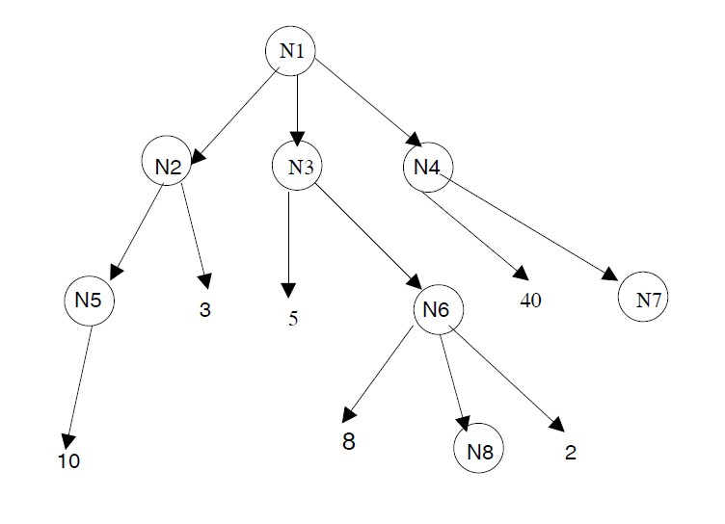

*MAX*

*MIN*

*MAX*

*MIN*

# Spare Page