For Naïve Bayes POS Tagging:  
Run the file NaiveBayes-POS.py like this:

“python3 NaiveBayes-POS.py ‘inputSentence’ ”

This fille will generate a txt file called result.txt that will contain the calculations for this

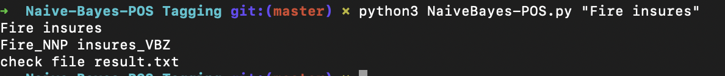

For Viterbi:

This requires pandas as the emission, transitions tables use dataframes

Run the file “python3 Viterbi- POS.py ‘Janet will back the bill’”