1 INTRODUCTION

Distributed robotics is an interdisciplinary and rapidly growing area, combining research in computer science, communication and control systems, and electrical and mechanical engineering. Distributed robotic systems can autonomously solve complex problems while operating in highly unstructured real-world environments. They are expected to play a major role in addressing future societal needs, for example, by improving environmental impact assessment, food supply, transportation, manufacturing, security, and emergency and rescue services.

1.1 Background

The field of distributed robotics has its origins in the late 1980s, when several researchers began investigating issues in multiple mobile robot systems. The problem of efficient multi-robot coordination has risen to the forefront of robotics research in recent years. Interest in this problem is motivated by the wide range of application domains demanding multi-robot solutions. In general, multi-robot coordination strategies assume either a centralized approach, where a single robot/agent plans for the group, or a distributed approach, where each robot is responsible for its own planning. The key advantage of centralized approaches is that they can produce globally optimal plans.

Robot football has been taken as a benchmark for collectively intelligent systems and is an active part of research. The AI and control system of a Robot Football team is highly stratified, each layer having specific functionalities to come together to work as a whole system. The strata are broadly threefold – Skills, Tactics and Plays. Skills are the lower level functionalities such as velocity tracking or actuator enabling; Tactics are sequence of skills such as intercepting the ball or retaining possession while Plays are overall strategies assigning tactics to one or more players.

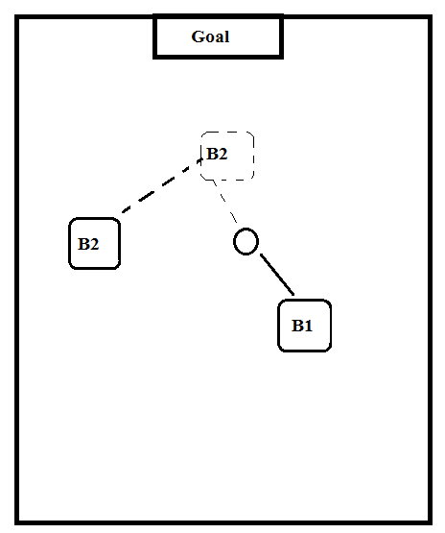
Figure 1 1-vs-1 tactics in robot football

1.2 Motivation

Nearly all of the work in cooperative mobile robotics began after the induction of the new robotics paradigm of behaviour-based control. This has a strong influence in much of cooperative mobile robotics research. The main inspiration comes particularly from the researches of social characteristics of insects and animals. The most common application of this knowledge is in the use of simple local control rules of various biological societies – particularly ants, bees, and birds – to the development of similar behaviours in cooperative robot systems. To some extent, the motivation also comes from higher animals, such as wolf packs.

The motivation for this project arises from even higher animal behaviours, that is human teams. We would like to study and apply the common social interactive strategies present in sport and model a robotics system which can do the same. Football is one of those sports utilizing high level of coordination and social interaction. Thus, the paper will attempt to utilize this behaviour and conjure up an interesting and applicable robotic system.

1.3 Objectives

The main objective of the project will be to construct a squad of robots which will be able to cooperatively solve dynamic problems of football like cooperatively getting the ball into the net and strikers versus defender problem.

The overall objectives of the project can be enumerated as:

- To meet the course requirements
- Implement Robotic kinematic systems
- Implement communication system between multiple participating agents.
- Solve well known football tactics by mutual cooperation
- Track the robots, terrain and the obstacles using centralized image processing systems
- Detect and avoid obstacles
- Implement collective intelligence algorithms.

1.4 Problem Statement

Robots have been a major part of different solutions to well-known problems. Innumerable intelligent approaches have been applied to solve a vast majority of problems in the world. What has been recently realized through the inspiration of various biological flocks is that a larger number of robots can solve more distributed problems more efficiently.

Football, being such a cooperative sector, is a curious sector to be solved and optimized using robotics. Therefore, the project will intend to apply and use various algorithms to implement the real-life football tactics in the robotics domain.

The paper primarily focuses on 2 vital football tactics – cooperatively moving the ball to the goal (1-to-1 passing) and an aggressive defence behaviour in a 1 vs 1 scenario. The action space for all these scenarios are chosen according to the logic presented in standard learning scenarios. The work also addresses pressing challenges such as large state space discretization through effective tile coding methods, discussing the possible applications of the tactics in real game situations as well as analysing the nature of trajectory taken in the state space with varying policies of the opponent.

The problem with tactics designed by hand-coded rules is that it makes a very strong assumption about the opponent leaving very little flexibility. Thus, the paper focuses on environment based learning systems.

This abstract problem solution is hoped to be used in arbitrary problems requiring coordinated behaviour.

1.5 Scope of the Project

Multi-bot systems is an emerging field of robotics and has huge applications. The project is scalable to various applications. It can be used for most of the works done by a single robot but is able to solve the problem faster. Since the project uses a centralized system, it will be able to control an arbitrary number of cheap robots. Learning systems enable us to be able to design rules that are very difficult to implement when hard-coded.

The major scopes of coordinative learning systems are:

- Coordinated exploration systems
- Post-disaster rescue systems
- Military applications
- Nano-robotics for medical applications
- Warehouse assistance system

2. METHODOLOGY

2.1 System Operation Overview

The system consists of multiple bare-boned mobile robots equipped with just the minimal sensors required for their local actions. The minimal system include basic hardware manipulation module(motor driver), communication module and the pose feedback module.
The system requires huge computation power. So the system is centralized and a powerful central computer is proposed to be used for the computationally heavy tasks. The tasks include to inspect, collect and the correct the global pose of the whole environment(the robots, the ball and the objective locations). It will also require to be able to run the learning algorithms used for the solution of the task.

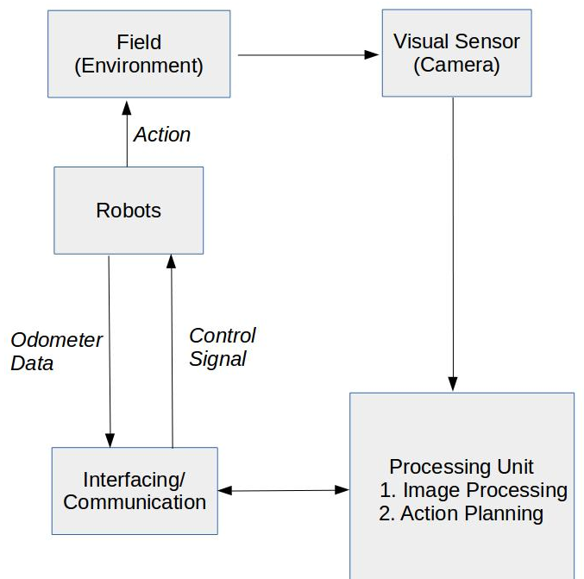
Figure 2 Overall System Block Diagram
2.2 System Operation Details/Algorithms

2.2.1 Rotary Encoder
A rotary encoder, also called a shaft encoder, is an electro-mechanical device that converts the angular position or motion of a shaft or axle to an analog or digital code.
The rotary encoder is a sensor attached to a rotating object (such as a wheel or motor) to measure rotation. By measuring rotation, the robot can do things such as determine displacement, velocity, acceleration, or the angle of a rotating sensor. A typical encoder uses optical sensor(s), a moving mechanical component, and a special reflector to provide a series of electrical pulses to the micro-controller. These pulses are to be used as part of a PID feedback control system to determine translation distance, rotational velocity, and/or angle of the moving robot or robot part.
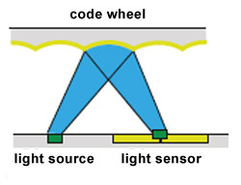

Figure 3 Working of rotary encoder

The rotary encoder is used in each wheels in junction to a software PID feedback loop to control the speed and direction of the robot. This enables us to navigate fairly accurately using only the hardware in the robot. Some amount of drift error accumulates in the positioning system which is periodically corrected using vision-based or IMU-based systems.
The optical encoder's disc is made of glass or plastic with transparent and opaque areas. A light source and photo detector array reads the optical pattern that results from the disc's position at any one time.This code can be read by a controlling device, such as a microprocessor or microcontroller to determine the angle of the shaft. The absolute analog type produces a unique dual analog code that can be translated into an absolute angle of the shaft.

2.2.2 Visual Recognition
A camera mounted on a central governing computer is used as a visual recognition system in this project. We use a visual recognition system for tracking the ball on the game field.

For this implementation, the task can be subdivided as :

>> Hue-based Blob detection: In computer vision, blob detection methods are aimed at detecting regions in a digital image that differ in properties, such as brightness or colour, compared to surrounding regions. Informally, a blob is a region of an image in which some properties are constant or approximately constant; all the points in a blob can be considered in some sense to be similar to each other.
The hue range of the ball is first found out in the calibration. The ball can then further be tracked in the unique hue environment.

>> Ball Tracking: The blob of the ball is detected in every frame of the and correlated in each of the following frames so that the ball can be accurately tracked and its positions transferred to the central system. There sometimes exist some error due to improper selection of hue range. This causes the system to consider the whole surrounding as a ball and output improper radius and centre of the ball.

>> Robot Position Detection: Similar as the detection and tracking of ball, the position of robots can also be determined and tracked. By covering robots with different colours and top view shape, the robots can be tracked. To track orientation of robots we can use patch comparison and matching technique. In patch comparison technique, each robots top is patched with different colours so, we can find the orientation of robots.

>> Velocity Calculation: If we know the size of the object, we can extract the ratio of pixels/mm. If the frame rate is known, we can convert frames to seconds. Now,
pixels/mm = Object size in pixels / object size in mm
mm/frame = (pixels/frame) / (pixels/mm)
mm / second = mm/frame * frames/second
Rejected Algorithms:
Various of the algorithms were observed and their pros and cons were weighed. The following are the image recognition algorithms rejected solely due to the inability to compute them in real time.
1. SIFT:
Scale-invariant feature transform (or SIFT) is an algorithm in computer vision to detect and describe local features in images.
For any object in an image, interesting points on the object can be extracted to provide a "feature description" of the object. This description, extracted from a training image, can then be used to identify the object when attempting to locate the object in a test image containing many other objects. To perform reliable recognition, it is important that the features extracted from the training image be detectable even under changes in image scale, noise and illumination. Such points usually lie on high-contrast regions of the image, such as object edges.
Another important characteristic of these features is that the relative positions between them in the original scene shouldn't change from one image to another. For example, if only the four corners of a door were used as features, they would work regardless of the door's position; but if points in the frame were also used, the recognition would fail if the door is opened or closed. Similarly, features located in articulated or flexible objects would typically not work if any change in their internal geometry happens between two images in the set being processed. However, in practice SIFT detects and uses a much larger number of features from the images, which reduces the contribution of the errors caused by these local variations in the average error of all feature matching errors.

2. SURF
Speeded Up Robust Features (SURF) is a local feature detector and descriptor that can be used for tasks such as object recognition or registration or classification or 3D reconstruction. It is partly inspired by the scale-invariant feature transform (SIFT) descriptor. The standard version of SURF is several times faster than SIFT and claimed by its authors to be more robust against different image transformations than SIFT.

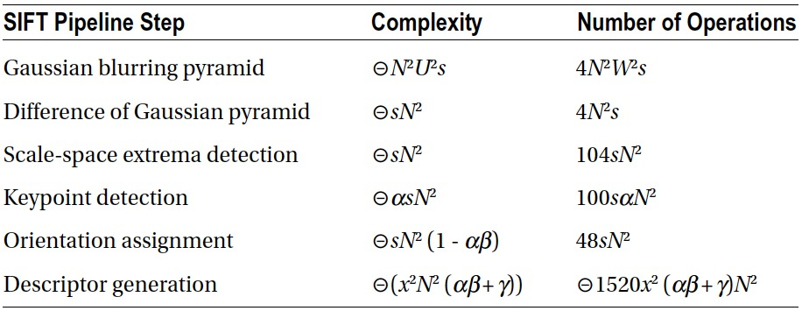
SURF is a detector and a descriptor for points of interest in images where the image is transformed into coordinates, using the multi-resolution pyramid technique, to make a copy of the original image with Pyramidal Gaussian or Laplacian Pyramid shape to obtain an image with the same size but with reduced bandwidth. Thus a special blurring effect on the original image, called Scale-Space, is achieved. This technique ensures that the points of interest are scale invariant.
Table: Comapirson of SIFT and SURF complexit

2.2.3 Robot Drive mechanism

The differential drive is a two-wheeled drive system with independent actuators for each wheel. The name refers to the fact that the motion vector of the robot is sum of the independent wheel motions, something that is also true of the mechanical differential (however, this drive system does not use a mechanical differential). The drive wheels are usually placed on each side of the robot and toward the front
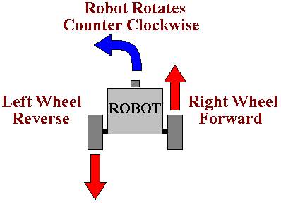

Figure 4 A typical counter clockwise rotation in differential drive robots

Two wheel differential drive mechanism is used for the robot movement. Varying the speed of left and right wheels, we can achieve the desired motion in the robot.
If both the wheels are driven in the same direction and speed, the robot will go in a straight line. If both wheels are turned with equal speed in opposite directions, as is clear from the diagram shown, the robot will rotate about the central point of the axis. Otherwise, depending on the speed of rotation and its direction, the center of rotation may fall anywhere on the line defined by the two contact points of the tires. While the robot is traveling in a straight line, the center of rotation is an infinite distance from the robot. Since the direction of the robot is dependent on the rate and direction of rotation of the two driven wheels, these quantities should be sensed and controlled precisely.

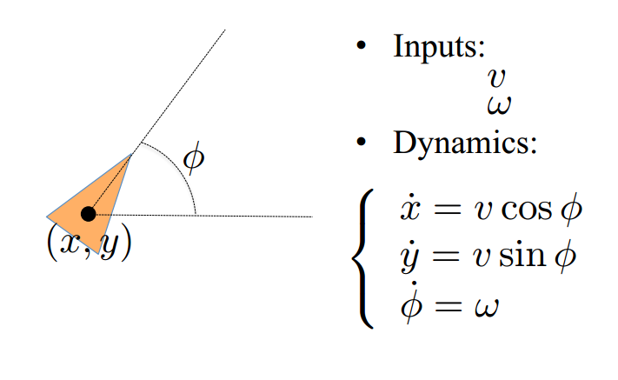
Figure 5 Unicycle model for the differential drive

To achieve desired velocity 'v' and angular speed 'w' we can specify the rotation speed of the left and right wheels as
v_right = (2*v + w*L)/(2*R)
v_right = (2*v – w*L)/(2*R)
where
R: radius of the wheels.
L: distance between two wheels.

2.2.4 Mathematical model

The system of two robots is modelled as Markov Decision Processes where we have:

- a set of states
- a set of actions
- a transition function
- reward function
- start state

To find the next step of the robots we search through the states available along with the transition functions for various actions taken in that state, and reward functions for each action. The we decide upon the next action.

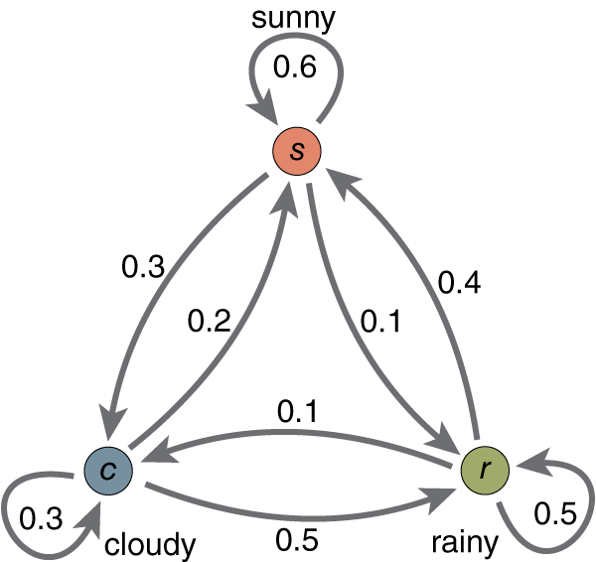

figure: Markov Model representation of weather

2.2.5 Communication Channel (Bluetooth)

Bluetooth is a wireless technology standard for exchanging data over short distances (using short-wavelength UHF radio waves in the ISM band from 2.4 to 2.485 GHz) from fixed and mobile devices, and building personal area networks (PANs).
Bluetooth operates at frequencies between 2402 and 2480 MHz, or 2400 and 2483.5 MHz including guard bands 2 MHz wide at the bottom end and 3.5 MHz wide at the top.This is in the globally unlicensed (but not unregulated) Industrial, Scientific and Medical (ISM) 2.4 GHz short-range radio frequency band. Bluetooth uses a radio technology called frequency-hopping spread spectrum. Bluetooth divides transmitted data into packets, and transmits each packet on one of 79 designated Bluetooth channels. Each channel has a bandwidth of 1 MHz. It usually performs 800 hops per second, with Adaptive Frequency-Hopping (AFH) enabled.Bluetooth low energy uses 2 MHz spacing, which accommodates 40 channels.

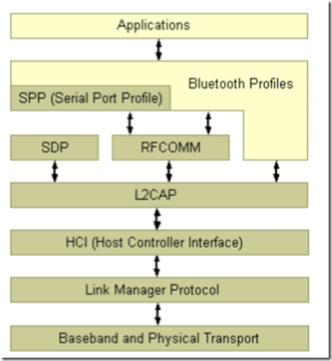

figure: Bluetooth Protocol Stack

Bluetooth is a packet-based protocol with a master-slave structure. One master may communicate with up to seven slaves in a piconet. All devices share the master's clock. Packet exchange is based on the basic clock, defined by the master, which ticks at 312.5 µs intervals. Two clock ticks make up a slot of 625 µs, and two slots make up a slot pair of 1250 µs. In the simple case of single-slot packets the master transmits in even slots and receives in odd slots. The slave, conversely, receives in even slots and transmits in odd slots. Packets may be 1, 3 or 5 slots long, but in all cases the master's transmission begins in even slots and the slave's in odd slots.

Communication and connection
A master Bluetooth device can communicate with a maximum of seven devices in a piconet (an ad-hoc computer network using Bluetooth technology), though not all devices reach this maximum. The devices can switch roles, by agreement, and the slave can become the master (for example, a headset initiating a connection to a phone necessarily begins as master—as initiator of the connection—but may subsequently operate as slave).
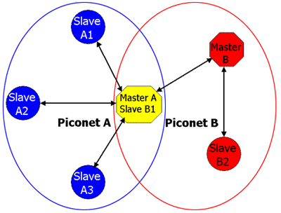

Figure: Bluetooth piconets

The Bluetooth Core Specification provides for the connection of two or more piconets to form a scatternet, in which certain devices simultaneously play the master role in one piconet and the slave role in another.
At any given time, data can be transferred between the master and one other device (except for the little-used broadcast mode.) The master chooses which slave device to address; typically, it switches rapidly from one device to another in a round-robin fashion. Since it is the master that chooses which slave to address, whereas a slave is (in theory) supposed to listen in each receive slot, being a master is a lighter burden than being a slave. Being a master of seven slaves is possible; being a slave of more than one master is difficult.
RFCOMM:
The RFCOMM protocol emulates the serial cable line settings and status of an RS-232 serial port and is used for providing serial data transfer. RFCOMM connects to the lower layers of the Bluetooth protocol stack through the L2CAP layer. RFCOMM is intended to cover applications that make use of the serial ports of the devices in which they reside. In the simple configuration, the communication segment is a Bluetooth link from one device to another (direct connect), see the figure to the left. Where the communication segment is another network, Bluetooth wireless technology is used for the path between the device and a network connection device like a modem. RFCOMM is only concerned with the connection between the devices in the direct connect case, or between the device and a modem in the network case.
RFCOMM can support other configurations, such as modules that communicate via Bluetooth wireless technology on one side and provide a wired interface on the other side, as shown in the figure below. These devices are not really modems but offer a similar service. They are therefore not explicitly discussed here.

System Implementation of Communication Channel

The system implements communication with the help of bluetooth. A central computer is equipped with a bluetooth dongle through which it communicates with the robots. Each robots are equipped with an HC-06 arduino module. The bluetooth module acts as a serial channel through which the Arduino can communicate as through the serial channel.
For controlling the robot, the central computer sends certains strings which is then interpreted by the arduino and the required function is performed.
The communication protocol of our system implementation is:

- “00#”: Echo Back Dummy Data (For Debugging Purposes)
- “10#”: Move forward
- “11#”: Move backward
- “12#”: Move Left
- “13#”: Move right
Other various commands can be maintained. Some of the commands to be implemented into the system are:
- Echo Position
- Receive Position Information
- Receive Ball Information

2.2.6 Reinforcement Learning

Reinforcement Learning is a type of Machine Learning, and thereby also a branch of Artificial Intelligence. It allows machines and software agents to automatically determine the ideal behaviour within a specific context, in order to maximize its performance. Simple reward feedback is required for the agent to learn its behaviour; this is known as the reinforcement signal.
There are many different algorithms that tackle this issue. As a matter of fact, Reinforcement Learning is defined by a specific type of problem, and all its solutions are classed as Reinforcement Learning algorithms. In the problem, an agent is supposed decide the best action to select based on his current state. When this step is repeated, the problem is known as a Markov Decision Process.
The main difference between the classical techniques and reinforcement learning algorithms is that the latter do not need knowledge about the MDP and they target large MDPs where exact methods become infeasible.
The basic reinforcement learning model consists of:
- a set of environment states S;
- a set of actions A;
- rules of transitioning between states;
- rules that determine the scalar immediate reward of a transition; and
- rules that describe what the agent observes.
The rules are often stochastic. The observation typically involves the scalar immediate reward associated with the last transition. In many works, the agent is also assumed to observe the current environmental state, in which case we talk about full observability, whereas in the opposing case we talk about partial observability. Sometimes the set of actions available to the agent is restricted
A reinforcement learning agent interacts with its environment in discrete time steps. At each time t, the agent receives an observation O, which typically includes the reward . It R then chooses an action A from the set of actions available, which is subsequently sent to the environment. The environment moves to a new state S1 and the reward R associated with the transition S to S1 is determined. The goal of a reinforcement learning agent is to collect as much reward as possible. The agent can choose any action as a function of the history and it can even randomize its action selection.
When the agent's performance is compared to that of an agent which acts optimally from the beginning, the difference in performance gives rise to the notion of regret. Note that in order to act near optimally, the agent must reason about the long term consequences of its actions: In order to maximize my future income I had better go to school now, although the immediate monetary reward associated with this might be negative.

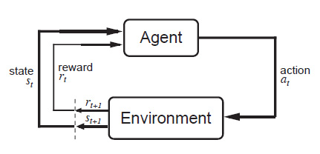
Figure: Reinforcement Learning Model
The methods that can be used to solve reinforcement learning model Problems are:
- Brute Force Method
- Monte-Carlo Method
- Value Function Approach
- Direct Policy Search

3. PROGRESS

The aim for until the mid-term was basic study and research and familiarization with the environment and tools that we'll be utilizing for the rest of the project. Thus, we familiarized ourselves with the Python programming language for solving all the complex tasks, familiarized ourselves with the basic industry standard simulation software and some of the Python libraries for image and video processing.

Apart from this, the actual progress on project tasks has been through the assembly of the robot system in hardware and some basic visual recognition tasks in software. Also the basic program for controlling the motors have been written. In addition the program for moving robot with desired velocity and orientation is also ready.

The communication channel for the robots have been established through Bluetooth and a basic software layer has been maintained. As per the present conditions, the robot can be controlled using a central PC wirelessly.

The current major difficulty is maintaining a closed loop sytem because of unavaibility of fabricated motor encoders and high inaccuracy of custom-made motor encoders.

4.2 Task Schedule and Details

1. Study and Research task has been completed.
2. Image Processing task is 70% complete.
3. Simulation System is 40% complete.
4. Hardware Development is 60% complete.
5. Prototype Development task is 40% complete.

REFERENCES

1. M. Betke, L.Gurvits, “Mobile Robot Localization Using Visual Landmarks,” IEEE
Transaction on Robotics and Automation, Vol.13, No.2, pp. 251-263, 1997.
2. R. Sim, G. Dudek, “Mobile robot localization from learned landmarks,” In Proceedings
of the International Conference on Intelligent Robots and Systems, Vol.2, pp. 1060-1065,
1998.
3. S. Thrun, “Finding landmarks for mobile robot navigation,” In Proceedings of the
International Conference on Robotics and Automation, Vol. 2, pp. 958-963, 1998.
4. P. Tangamchit, J. Dolan, P. Khosla "Crucial Factors Affecting Cooperative Multirobot Learning".
5. S. Choudhury "Application of Reinforcement Learning in Robot Soccer", 2011
6. M. Riedmiller, T. Gabel, R. Hafner "Reinforcement learning for robot soccer", 2009
7. L. Parker "Current research in multirobot systems", 2003
8. R. Brunelli, Template Matching Techniques in Computer Vision: Theory and Practice, Wiley, ISBN 978-0-470-51706-2, 2009 ([1] TM book)
9. Aksoy, M. S., O. Torkul, and I. H. Cedimoglu. "An industrial visual inspection system that uses inductive learning." Journal of Intelligent Manufacturing 15.4 (August 2004): 569(6). Expanded Academic ASAP. Thomson Gale.
10. E. H. Adelson, C. H. Anderson, J. R. Bergen, P. J. Burt and J. M. Ogden, Pyramid methods in image processing http://web.mit.edu/persci/people/adelson/pub_pdfs/RCA84.pdf

APPENDIX A: Extraction of Ball Region
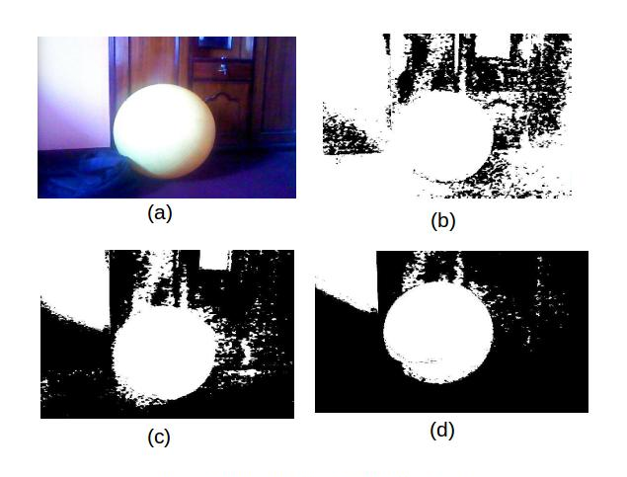

Figure 7a Extraction of Ball Region

APPENDIX B: Ball Tracking
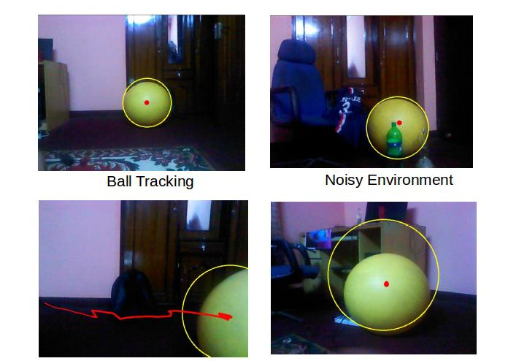

Ball Motion Tracking Improper Tracking due to Hue Interference
Figure 7b Ball Tracking
APPENDIX C: Robots Chassis (Frame)
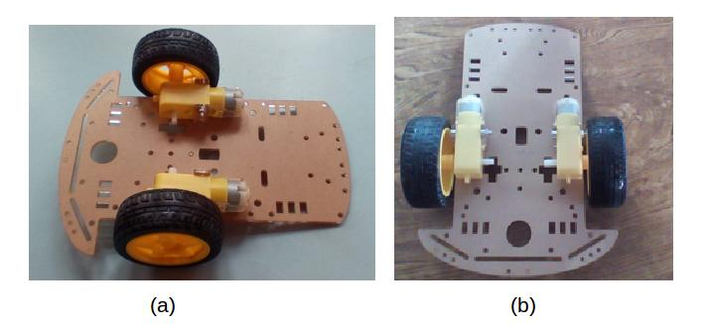
Figure 7c Robots Chassis (Frame)

