1 INTRODUCTION

Distributed robotics is an interdisciplinary and rapidly growing area, combining research in computer science, communication and control systems, and electrical and mechanical engineering. Distributed robotic systems can autonomously solve complex problems while operating in highly unstructured real-world environments. They are expected to play a major role in addressing future societal needs, for example, by improving environmental impact assessment, food supply, transportation, manufacturing, security, and emergency and rescue services.

1.1 Background
The field of distributed robotics has its origins in the late 1980s, when several researchers began investigating issues in multiple mobile robot systems. The problem of efficient multi-robot coordination has risen to the forefront of robotics research in recent years. Interest in this problem is motivated by the wide range of application domains demanding multi-robot solutions. In general, multi-robot coordination strategies assume either a centralized approach, where a single robot/agent plans for the group, or a distributed approach, where each robot is responsible for its own planning. The key advantage of centralized approaches is that they can produce globally optimal plans.

Robot football has been taken as a benchmark for collectively intelligent systems and is an active part of research. The AI and control system of a Robot Football team is highly stratified, each layer having specific functionalities to come together to work as a whole system. The strata are broadly threefold – Skills, Tactics and Plays. Skills are the lower level functionalities such as velocity tracking or actuator enabling; Tactics are sequence of skills such as intercepting the ball or retaining possession while Plays are overall strategies assigning tactics to one or more players.

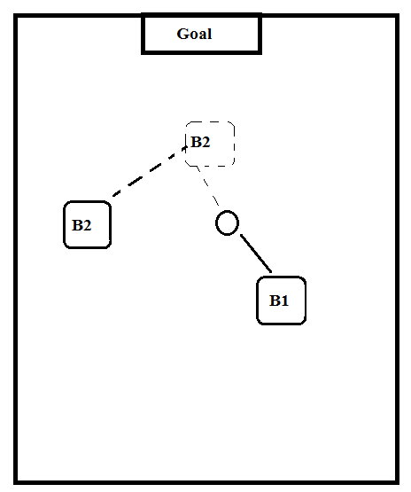
Figure 1 1-vs-1 tactics in robot football

1.2 Motivation
Nearly all of the work in cooperative mobile robotics began after the induction of the new robotics paradigm of behaviour-based control. This has a strong influence in much of cooperative mobile robotics research. The main inspiration comes particularly from the researches of social characteristics of insects and animals. The most common application of this knowledge is in the use of simple local control rules of various biological societies – particularly ants, bees, and birds – to the development of similar behaviours in cooperative robot systems. To some extent, the motivation also comes from higher animals, such as wolf packs.

The motivation for this project arises from even higher animal behaviours, that is human teams. We would like to study and apply the common social interactive strategies present in sport and model a robotics system which can do the same. Football is one of those sports utilizing high level of coordination and social interaction. Thus, the paper will attempt to utilize this behaviour and conjure up an interesting and applicable robotic system.

1.3 Objectives
The main objective of the project will be to construct a squad of robots which will be able to cooperatively solve dynamic problems of football like cooperatively getting the ball into the net and strikers versus defender problem.

The overall objectives of the project can be enumerated as:

- To meet the course requirements
- Implement Robotic kinematic systems
- Implement communication system between multiple participating agents.
- Solve well known football tactics by mutual cooperation
- Track the robots, terrain and the obstacles using centralized image processing systems
- Detect and avoid obstacles
- Implement collective intelligence algorithms.

1.4 Problem Statement
Robots have been a major part of different solutions to well-known problems. Innumerable intelligent approaches have been applied to solve a vast majority of problems in the world. What has been recently realized through the inspiration of various biological flocks is that a larger number of robots can solve more distributed problems more efficiently.

Football, being such a cooperative sector, is a curious sector to be solved and optimized using robotics. Therefore, the project will intend to apply and use various algorithms to implement the real-life football tactics in the robotics domain.

The paper primarily focuses on 2 vital football tactics – cooperatively moving the ball to the goal (1-to-1 passing) and an aggressive defence behaviour in a 1 vs 1 scenario. The action space for all these scenarios are chosen according to the logic presented in standard learning scenarios. The work also addresses pressing challenges such as large state space discretization through effective tile coding methods, discussing the possible applications of the tactics in real game situations as well as analysing the nature of trajectory taken in the state space with varying policies of the opponent.

The problem with tactics designed by hand-coded rules is that it makes a very strong assumption about the opponent leaving very little flexibility. Thus, the paper focuses on environment based learning systems.

This abstract problem solution is hoped to be used in arbitrary problems requiring coordinated behaviour.

1.5 Scope of the Project
Multi-bot systems is an emerging field of robotics and has huge applications. The project is scalable to various applications. It can be used for most of the works done by a single robot but is able to solve the problem faster. Since the project uses a centralized system, it will be able to control an arbitrary number of cheap robots. Learning systems enable us to be able to design rules that are very difficult to implement when hard-coded.

The major scopes of coordinative learning systems are:

- Coordinated exploration systems
- Post-disaster rescue systems
- Military applications
- Nano-robotics for medical applications
- Warehouse assistance system

2. METHODOLOGY

2.1 System Operation Overview

The system consists of multiple bare-boned mobile robots equipped with just the minimal sensors required for their local actions. The minimal system include basic hardware manipulation module(motor driver), communication module and the pose feedback module.
The system requires huge computation power. So the system is centralized and a powerful central computer is proposed to be used for the computationally heavy tasks. The tasks include to inspect, collect and the correct the global pose of the whole environment(the robots, the ball and the objective locations). It will also require to be able to run the learning algorithms used for the solution of the task.

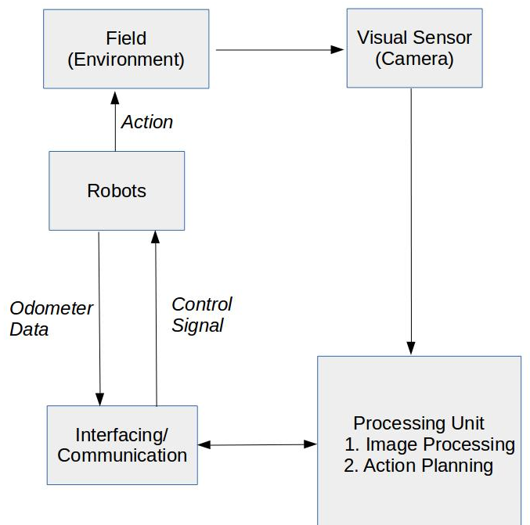
Figure 2 Overall System Block Diagram
2.2 Sensor Fusion:

2.2.1 Rotary Encoder
The rotary encoder is a sensor attached to a rotating object (such as a wheel or motor) to measure rotation. By measuring rotation, the robot can do things such as determine displacement, velocity, acceleration, or the angle of a rotating sensor. A typical encoder uses optical sensor(s), a moving mechanical component, and a special reflector to provide a series of electrical pulses to the micro-controller. These pulses are to be used as part of a PID feedback control system to determine translation distance, rotational velocity, and/or angle of the moving robot or robot part.
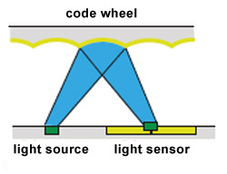

Figure 3 Working of rotary encoder

The rotary encoder is used in each wheels in junction to a software PID feedback loop to control the speed and direction of the robot. This enables us to navigate fairly accurately using only the hardware in the robot. Some amount of drift error accumulates in the positioning system which is periodically corrected using vision-based or IMU-based systems.

2.2.2 Visual Recognition
A camera mounted on a central governing computer is used as a visual recognition system in this project. We use a visual recognition system for tracking the ball on the game field.

For this implementation, the task can be subdivided as :

>> Hue-based Blob detection: In computer vision, blob detection methods are aimed at detecting regions in a digital image that differ in properties, such as brightness or colour, compared to surrounding regions. Informally, a blob is a region of an image in which some properties are constant or approximately constant; all the points in a blob can be considered in some sense to be similar to each other.
The hue range of the ball is first found out in the calibration. The ball can then further be tracked in the unique hue environment.

>> Ball Tracking: The blob of the ball is detected in every frame of the and correlated in each of the following frames so that the ball can be accurately tracked and its positions transferred to the central system. There sometimes exist some error due to improper selection of hue range. This causes the system to consider the whole surrounding as a ball and output improper radius and centre of the ball.

>> Robot Position Detection: Similar as the detection and tracking of ball, the position of robots can also be determined and tracked. By covering robots with different colours and top view shape, the robots can be tracked. To track orientation of robots we can use patch comparison and matching technique. In patch comparison technique, each robots top is patched with different colours so, we can find the orientation of robots.

>> Velocity Calculation: If we know the size of the object, we can extract the ratio of pixels/mm. If the frame rate is known, we can convert frames to seconds. Now,
pixels/mm = Object size in pixels / object size in mm
mm/frame = (pixels/frame) / (pixels/mm)
mm / second = mm/frame * frames/second
2.2.3 Robot Drive mechanism
Two wheel differential drive mechanism is used for the robot movement. Varying the speed of left and right wheels, we can achieve the desired motion in the robot.

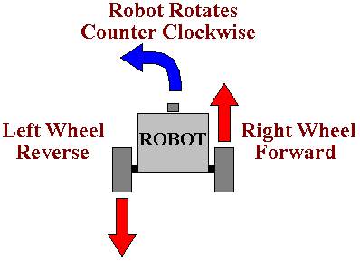

Figure 4 A typical counter clockwise rotation in differential drive robots

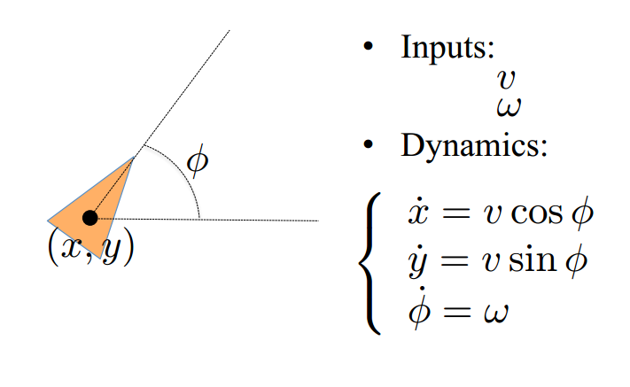
Figure 5 Unicycle model for the differential drive

To achieve desired velocity 'v' and angular speed 'w' we can specify the rotation speed of the left and right wheels as
v_right = (2*v + w*L)/(2*R)
v_right = (2*v – w*L)/(2*R)
where
R: radius of the wheels.
L: distance between two wheels.

2.2.4 Mathematical model

The system of two robots is modelled as Markov Decision Processes where we have:

- a set of states
- a set of actions
- a transition function
- reward function
- start state

To find the next step of the robots we search through the states available along with the transition functions for various actions taken in that state, and reward functions for each action. The we decide upon the next action.

3. PROGRESS

The aim for until the mid-term was basic study and research and familiarization with the environment and tools that we'll be utilizing for the rest of the project. Thus, we familiarized ourselves with the Python programming language for solving all the complex tasks, familiarized ourselves with the basic industry standard simulation software and some of the Python libraries for image and video processing.

Apart from this, the actual progress on project tasks has been through the assembly of the robot system in hardware and some basic visual recognition tasks in software. Also the basic program for controlling the motors have been written. In addition the program for moving robot with desired velocity and orientation is also ready.

4. TIME SCHEDULE

4.1 Gantt Chart

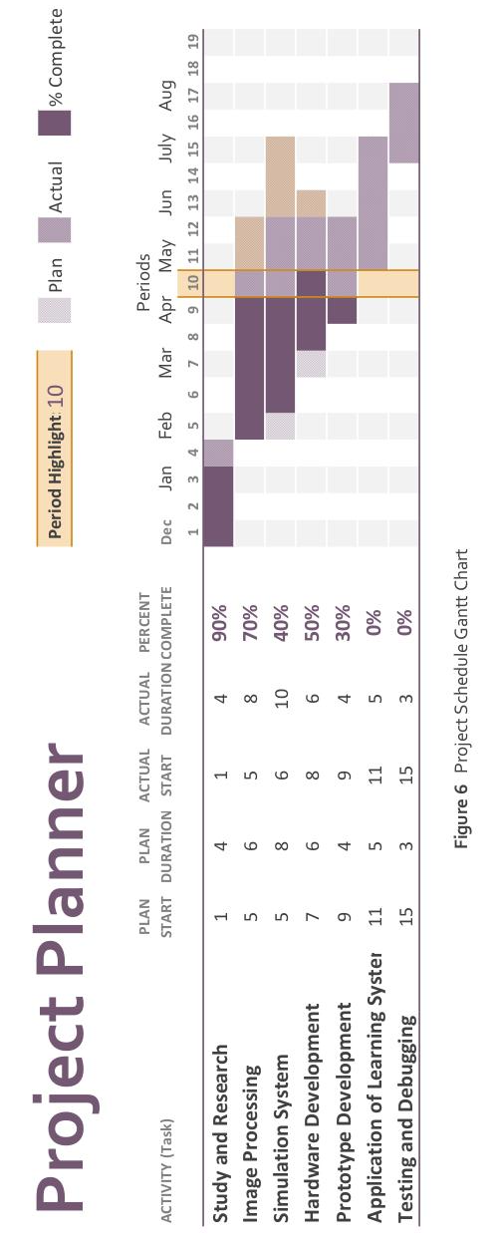

4.2 Task Schedule and Details

1. Study and Research task has been completed.
2. Image Processing task is 70% complete.
3. Simulation System is 40% complete.
4. Hardware Development is 50% complete.
5. Prototype Development task is 10% complete.

The project is slightly under scheduled and is expected to catch up with the schedule at the end of April.

REFERENCES

1. M. Betke, L.Gurvits, “Mobile Robot Localization Using Visual Landmarks,” IEEE
Transaction on Robotics and Automation, Vol.13, No.2, pp. 251-263, 1997.
2. R. Sim, G. Dudek, “Mobile robot localization from learned landmarks,” In Proceedings
of the International Conference on Intelligent Robots and Systems, Vol.2, pp. 1060-1065,
1998.
3. S. Thrun, “Finding landmarks for mobile robot navigation,” In Proceedings of the
International Conference on Robotics and Automation, Vol. 2, pp. 958-963, 1998.
4. P. Tangamchit, J. Dolan, P. Khosla "Crucial Factors Affecting Cooperative Multirobot Learning".
5. S. Choudhury "Application of Reinforcement Learning in Robot Soccer", 2011
6. M. Riedmiller, T. Gabel, R. Hafner "Reinforcement learning for robot soccer", 2009
7. L. Parker "Current research in multirobot systems", 2003
8. R. Brunelli, Template Matching Techniques in Computer Vision: Theory and Practice, Wiley, ISBN 978-0-470-51706-2, 2009 ([1] TM book)
9. Aksoy, M. S., O. Torkul, and I. H. Cedimoglu. "An industrial visual inspection system that uses inductive learning." Journal of Intelligent Manufacturing 15.4 (August 2004): 569(6). Expanded Academic ASAP. Thomson Gale.
10. E. H. Adelson, C. H. Anderson, J. R. Bergen, P. J. Burt and J. M. Ogden, Pyramid methods in image processing http://web.mit.edu/persci/people/adelson/pub_pdfs/RCA84.pdf

APPENDIX A: Extraction of Ball Region
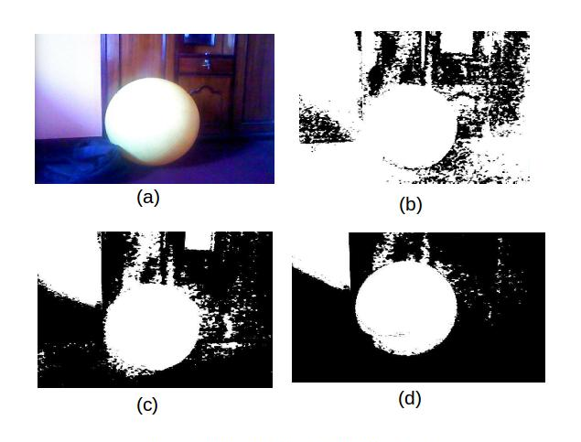

Figure 7a Extraction of Ball Region

APPENDIX B: Ball Tracking
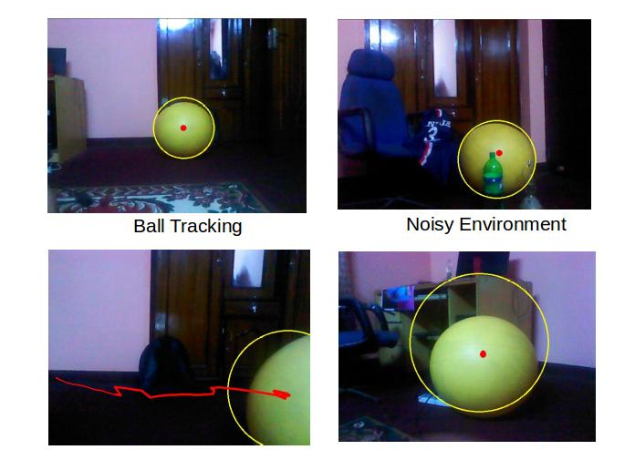

Ball Motion Tracking Improper Tracking due to Hue Interference
Figure 7b Extraction of Ball Region
APPENDIX C: Robots Chassis (Frame)
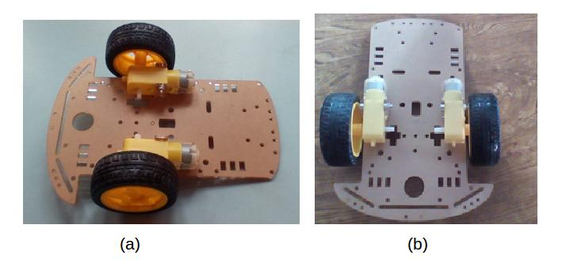
Figure 7c Robots Chassis (Frame)

