HexCommerce
Business Requirements Document
Online marketplace: storefront, seller centre and back office - target-state requirements, independent of any user interface

Item | Detail
Document version | 3.0
Date | 22 October 2026
Status | Draft for review and approval
Prepared by | Warren J
Standards | ISO/IEC/IEEE 29148:2018; IIBA BABOK Guide v3; BPMN 2.0.2
Classification | Internal

Contents
Contents 2
1 Document control 6
1.1 Document information 6
1.2 Revision history 6
1.3 Approvals 6
1.4 Conventions used in this document 7
1.5 Distribution 8
1.6 References 9
2 Executive summary 9
3 Business objectives and scope 10
3.1 Business context 10
3.2 Business objectives 11
3.3 In scope 11
3.4 Out of scope 12
4 Stakeholders and user roles 12
4.1 Stakeholders 12
4.2 User roles 13
4.3 Role and capability matrix 13
5 Solution overview 14
5.1 Solution summary 14
5.2 System context 14
5.3 Capability map 15
5.4 Status lifecycles 15
5.5 Basis of this document 21
6 Business processes 21
6.0 Notation 22
6.1 P01 Discover products (browse, search and filter) 24
6.2 P02 Manage the basket, saved-for-later list and wish list 26
6.3 P03 Check out, pay and place an order 28
6.4 P04 Track an order, get an invoice and request a return 30
6.5 P05 Raise and follow a customer-service issue 32
6.6 P06 Write a product review and vote on reviews 34
6.7 P07 Maintain delivery addresses and payment cards 35
6.8 P08 Apply to become a seller and decide the application 37
6.9 P09 Create and publish a product listing 39
6.10 P10 Run a seller deal (time-limited discount) 41
6.11 P11 Fulfil a seller order 43
6.12 P12 Register, sign in and recover access 45
6.13 P13 Maintain seller business details 47
6.14 P14 Return a decided seller application to Pending 49
6.15 P15 Reopen a resolved customer-service issue 50
6.16 P16 Choose the delivery address for the next order 52
6.17 P17 Maintain a seller deal (start early, edit, end or remove) 54
6.18 P18 Delete or edit a review you wrote 56
6.19 P19 Move a wish-list or saved-for-later item to the basket 57
6.20 P20 Sign out (end the session) 59
6.21 P21 Maintain a product listing (edit, publish, unpublish, remove) 60
6.22 P22 Handle customer-service issues (support agent) 62
6.23 P23 Progress an order through fulfilment 63
6.24 P24 Cancel an order or order line and refund 65
6.25 P25 Process a return and refund 66
6.26 P26 Manage back-office access 68
6.27 P27 Set up or change a seller payout account 69
6.28 P28 Calculate and settle seller payouts 70
6.29 P29 Maintain promotions and store deals 72
6.30 P30 Maintain the store catalogue 73
6.31 P31 Report and moderate reviews 75
7 Functional requirements 76
7.1 Catalogue browsing and search (CAT) 76
7.2 Merchandising and promotions (MKT) 77
7.3 Product and listing detail (PDP) 78
7.4 Ratings and reviews (REV) 79
7.5 Basket, saved-for-later and wish list (CRT) 80
7.6 Checkout and order placement (CHK) 81
7.7 Payment and refunds (PAY) 82
7.8 Orders, fulfilment, cancellations and returns (ORD) 83
7.9 Customer service (CS) 84
7.10 Account, addresses, payment cards and access (ACC) 85
7.11 Notifications (NTF) 86
7.12 Seller onboarding (SAP) 86
7.13 Back-office administration and seller application review (ADM) 87
7.14 Seller account overview and business profile (SDB) 88
7.15 Seller listings (SLS) 89
7.16 Seller deals (SDL) 90
7.17 Seller order fulfilment (SOR) 91
7.18 Seller payouts (SPY) 91
7.19 Store catalogue management (CTL) 92
7.20 Store configuration (CFG) 92
7.21 Data retention, privacy and initial data (DAT) 93
7.22 Deferred capabilities (Won't have in this release) (DEF) 93
8 Business rules and validations 94
8.1 Pricing, delivery, tax and refunds 94
8.2 Basket and stock 95
8.3 Catalogue 95
8.4 Orders, fulfilment, cancellations and returns 96
8.5 Customer service 96
8.6 Reviews 97
8.7 Account book and access 97
8.8 Seller onboarding 98
8.9 Seller listings 99
8.10 Seller deals 99
8.11 Store deals 100
8.12 Seller orders, earnings and payouts 100
8.13 System date and time 101
8.14 Validation outcomes 101
9 Data requirements 103
9.1 Key entities and attributes 103
9.2 Relationships 104
9.3 Entity-relationship model 105
9.4 Reference data and code lists 106
9.5 Field-level data dictionary 107
9.6 Data quality, retention and privacy 109
10 Non-functional requirements 109
10.1 Security and privacy 110
10.2 Performance and capacity 110
10.3 Reliability and data retention 111
10.4 Accessibility 111
10.5 Usability and device support 111
10.6 Localisation 111
11 Integrations and external dependencies 112
11.1 External system interfaces 112
11.2 Internal integration points 112
12 Assumptions, constraints, dependencies, open questions and risks 113
12.1 Assumptions 113
12.2 Constraints 113
12.3 Dependencies 113
12.4 Open questions 114
12.5 Risk register 116
13 Requirements traceability matrix 117
13.1 Functional requirements 117
13.2 Business rules 125
13.3 Non-functional requirements 127
13.4 Coverage by business objective 128
13.5 Coverage by process 129
14 Glossary 130
Appendix B Requirement attribute register 131
Appendix C Changes from version 2.5 144
C.1 Summary 144
C.2 Process changes 145
C.3 Withdrawn requirements 146
C.4 New requirements 149
Appendix D Resolution of verification findings 150

1 Document control

1.1 Document information
Attribute | Value
Title | HexCommerce Business Requirements Document
Version | 3.0
Date | 22 October 2026
Author | Warren J
Owner | Product Owner, HexCommerce (to be confirmed - see approvals)
Status | Draft for review and approval
Purpose | The target-state business requirements for HexCommerce, written so that the user interface, and the solution behind it, can be designed from this document alone. It describes what the business needs, not any existing screen.
Basis | The business rules of the demonstration application analysed in v2.5 [6], [9], corrected and completed by the verification of v2.5 [10].
Companion files | HexCommerce_Process_Diagrams.drawio - the 31 process diagrams, one page each [7]. HexCommerce_Complete_Process_Flow.drawio - every process on one page, with the hand-overs between them [8]. Both are in the docs folder of the repository.
Standards | ISO/IEC/IEEE 29148:2018; IIBA BABOK Guide v3; BPMN 2.0.2
Classification | Internal

1.2 Revision history
Version | Date | Author | Description of change
1.0 | 28 Sep 2026 |  | Initial BRD of an earlier version of the application (since removed from the repository).
1.1 | 28 Sep 2026 |  | Added business case, delivery plan and proposed production modules (since removed from the repository).
2.0 | 4 October 2026 | Warren J | Complete re-baseline against the application then current. Described current-state behaviour only.
2.1 - 2.4 | 4 October 2026 | Warren J | Gap fixes, attribute register, traceability by business module, wording in business terms.
2.5 | 4 October 2026 | Warren J | Added processes P17 to P20 and open questions Q-28 and Q-29.
3.0 | 22 October 2026 | Warren J | Re-baselined as the target state, independent of any user interface, from which the user interface is to be designed. 131 new, 230 reworded and 98 unchanged requirements; 54 withdrawn with reasons (Appendix C). Eleven new processes (P21 to P31) for listing maintenance, support, fulfilment, cancellation, returns, back-office access, payouts, merchandising, catalogue and review moderation; P16, P17, P18 and P20 renamed. Diagrams regenerated from one model in both companion files; Appendix B (draw.io XML) removed. Findings of the verification report resolved (Appendix D).

1.3 Approvals
This document is approved when every role below has signed. Names are to be completed by the Product Owner.
Role | Name | Signature | Date
Business Sponsor
Product Owner
Marketplace Operations Lead
Finance Representative
Customer Service Lead
Security / Data Protection Lead
Engineering Lead
UX Design Lead
QA Lead

1.4 Conventions used in this document
Requirements follow ISO/IEC/IEEE 29148:2018 characteristics (necessary, unambiguous, singular, feasible, verifiable) and are written with "shall". Each carries a unique identifier and a MoSCoW priority. Identifiers carried over from v2.5 keep their number; new requirements continue the numbering of their module; withdrawn identifiers are never reused (Appendix C).

Design independence
This document states what the system must do, the information it holds and exchanges with each user, and the rules it applies. It does not prescribe screens, pages, layout, navigation, controls, interaction sequences, visual style, wording or technology. Those are decided by the user-experience and solution design that follows this document.
Where a requirement says that the system "provides" information to a user, "tells" a user something, or "allows" a user to do something, the medium, timing within the interaction and presentation are for that design to decide. Validation outcomes (section 8.14) state the information a user must be given, not its wording.
Quantities that are business rules (for example the 10-unit basket limit, six images per listing or a 160-character summary) are requirements. Quantities that would only shape a presentation (how many items fit on a page, how long a promotion is shown) are not, except where they are stated as configurable defaults.

Identifiers
Prefix | Meaning
BO-nn | Business objective
Pnn | Business process (section 6)
FR-<module>-nnn | Functional requirement (section 7). Modules: CAT catalogue, MKT merchandising, PDP product detail, REV reviews, CRT basket, CHK checkout, PAY payment, ORD orders and fulfilment, CS customer service, ACC account and access, NTF notifications, SAP seller onboarding, ADM back office and administration, SDB seller account, SLS seller listings, SDL seller deals, SOR seller orders, SPY seller payouts, CTL store catalogue, CFG configuration, DAT data retention and privacy, DEF deferred
BR-<area>-nnn | Business rule or validation (section 8)
NFR-<area>-nnn | Non-functional requirement (section 10)
A-, C-, D-, Q-, R-nn | Assumption, constraint, dependency, open question, risk (section 12)

Priority, verification and status
Priority | Definition
Must (M) | Essential to the business outcome; the solution is not acceptable without it.
Should (S) | Important and expected, but a workaround exists in the short term.
Could (C) | Desirable; adds convenience and can be dropped under pressure.
Won't (W) | Agreed as out of this release; recorded so its absence is a conscious decision.

Verification method | Meaning
T - Test | Execute the function with defined inputs and compare the result with the expected outcome.
D - Demonstration | Show the capability working, without detailed measurement.
I - Inspection | Examine content, configuration or documentation to confirm compliance.
A - Analysis | Confirm a calculation or model by reasoning or calculation, then test sample values.

Status | Meaning
Proposed | Stated by this document and awaiting approval of the baseline.
To be confirmed | Proposed in answer to an open question (section 12.4); the named owner must confirm it before design relies on it.
Deferred | Agreed as out of this release (Won't have).

Every requirement carries the attributes recommended by ISO/IEC/IEEE 29148: identifier, statement, priority, rationale, verification method, business objective, process, business module, owner and status. Statement, priority and verification appear in sections 7, 8 and 10; objective, process and module in the traceability matrix (section 13); rationale, owner and status in the attribute register (Appendix B). A requirement that depends on an open question names it in grey after its statement.

1.5 Distribution
Recipient (role) | Purpose | Action
Business Sponsor | Confirm objectives, scope and deferred capabilities | Approve
Product Owner | Own the document and resolve open questions | Approve
Marketplace operations lead | Confirm seller onboarding, listing, deal, fulfilment and returns rules | Approve
Finance representative | Confirm pricing, tax, payment, refund, fee and payout rules (Q-01, Q-03, Q-33, Q-34) | Approve
Customer service lead | Confirm issue handling, service level, returns and moderation (Q-16, Q-37, Q-39) | Approve
Security / data protection lead | Confirm access control, authentication, audit and data protection (Q-05, Q-22, Q-38) | Approve
Merchandising lead | Confirm promotions, featured selections and store deals (Q-35) | Review
UX design lead | Design the user interface from this document | Approve
Engineering lead | Confirm feasibility; plan integrations and non-functional targets (Q-24) | Approve
QA lead | Plan verification from the traceability matrix | Approve

1.6 References
Ref | Document
[1] | ISO/IEC/IEEE 29148:2018, Systems and software engineering - Life cycle processes - Requirements engineering.
[2] | International Institute of Business Analysis, A Guide to the Business Analysis Body of Knowledge (BABOK Guide) v3, 2015.
[3] | Object Management Group, Business Process Model and Notation (BPMN) Version 2.0.2, 2014.
[4] | W3C, Web Content Accessibility Guidelines (WCAG) 2.2, 2023 (NFR-ACC-009).
[5] | PCI Security Standards Council, PCI DSS v4.0 (NFR-SEC-010).
[6] | HexCommerce demonstration application analysed for v2.5: repository codefinity/hex-commerce-source-ui, commit 2ae3753.
[7] | HexCommerce_Process_Diagrams.drawio - companion file holding the 31 process diagrams of section 6.
[8] | HexCommerce_Complete_Process_Flow.drawio - companion file holding every process on one page, with hand-overs.
[9] | HexCommerce Business Requirements Document v2.5 (current-state analysis), superseded by this version.
[10] | HexCommerce BRD and Diagram Verification Report (docs/BRD_and_Diagram_Verification_Report.md), 22 October 2026.
[11] | UK General Data Protection Regulation and Data Protection Act 2018 (NFR-SEC-011).
[12] | Superseded: HexCommerce BRD v1.0 and v1.1 (repository history, commits 29878fa and 9c3d370).

2 Executive summary
HexCommerce is an online marketplace. Shoppers browse eight departments, search and filter the catalogue, collect items in a basket or wish list, pay at checkout, and follow their orders through delivery, cancellation and returns. Independent businesses apply to sell; once an administrator approves them they list products, run time-limited deals, fulfil their orders and are paid, less referral fees. Their products are sold alongside the store's own catalogue. A back office supports customer service, fulfilment, merchandising, catalogue management, seller payouts and access control.
Version 2.5 of this document recorded what a demonstration application did, including its screens and its shortcuts (no sign-in check, no payment, data kept in the browser, a fixed date). Version 3.0 is the target state: it keeps the business rules the demonstration established, removes every description of screens, navigation, wording and technology, and adds the capabilities a real marketplace needs and that the demonstration lacked. The user interface is to be designed from this document.

Key figures
Measure | Count
Business processes (BPMN swimlanes) | 31 (11 new in v3.0)
Functional requirements | 317 (Must 193, Should 98, Could 21, Won't 5)
Business rules and validations | 111
Non-functional requirements | 31
Requirements to be confirmed against an open question | 61
Requirements withdrawn from v2.5 | 54
User roles | 12, plus three external systems
Open questions | 41 (10 open, the rest with a proposed answer or closed)
Risks recorded | 17

Principal changes from version 2.5
- Independent of any user interface: references to pages, menus, headers, buttons, carousels, page sizes, keyboard keys, browser storage and the demonstration's sample data are removed or restated as capabilities (Appendix C).
- Complete commerce: real registration, sign-in and sign-out (P12, P20); payment authorisation and capture through a payment service provider (P03, FR-PAY); order fulfilment with tracking (P23); cancellation (P24) and returns with refunds (P25).
- Back office in the system: support agents (P22), back-office access and audit (P26), seller payouts (P27, P28), merchandising and store deals (P29), store catalogue (P30) and review moderation (P31).
- Multi-seller marketplace: every approved seller has their own account, listings and payouts (FR-SAP-016); approval effects apply to every applicant (FR-ADM-008, FR-ADM-009).
- Gaps found by the verification [10] are closed: listing maintenance (P21), the buy-immediately path, expired cards at checkout, deal units above stock, the delivery promise, purchase terms for every item, store-deal rules and reapplication history.
- Many new requirements answer open questions with a proposal; they carry the status "To be confirmed" and the question they depend on (section 12.4).
Recommendation: approve sections 6 to 10 as the target-state baseline, have each owner confirm the requirements marked "To be confirmed" and answer the open questions in section 12.4 (starting with those that block design), and use the traceability matrix in section 13 to plan design, delivery and verification.

3 Business objectives and scope

3.1 Business context
Assumption: HexCommerce is to operate as a multi-department online marketplace in the United Kingdom, selling the store's own catalogue alongside the listings of approved independent sellers, under a configurable brand.
This document is the input to the next stage: user-experience design, solution design and delivery planning. It deliberately does not describe how any existing application presents these capabilities.

3.2 Business objectives
The success measures below are proposed (Assumption A-08) and should be agreed by the Business Sponsor.
ID | Objective | Capabilities that serve it | Proposed success measure
BO-01 | Help shoppers find relevant products quickly | Keyword search with suggestions, departments, filters, sort orders, related products | Share of searches returning at least one result; search-to-product-view rate
BO-02 | Convert intent into paid orders through a simple, transparent checkout | Checkout starting from saved choices, clear totals, stock checks, payment authorisation | Basket-to-order conversion; checkout abandonment rate; payment success rate
BO-03 | Increase basket value | Free-delivery threshold, store deals, seller deals, promotions, savings | Average order value; share of orders above the free-delivery threshold
BO-04 | Provide self-service and responsive post-purchase support | Tracking, invoices, cancellation, returns, issue threads with a 24-hour reply, notifications | Issues answered within 24 hours; repeat-contact rate; returns completed within target
BO-05 | Grow the assortment through vetted third-party sellers | Seller application, administrator decision, multi-seller accounts | Applications decided within an agreed time; number of active seller listings
BO-06 | Give sellers self-service tools to list, promote, fulfil and get paid | Listings, deals, seller orders, account overview, payout statements | Time to first listing; dispatch time; payout disputes
BO-07 | Build trust in the marketplace | Verified-purchase reviews, moderation, honest stock and deal information, purchase terms | Review volume and share verified; complaint rate
BO-08 | Re-brand and re-parameterise without development work | Configurable brand, currency, locale, delivery, tax and returns settings | Time to launch a new brand configuration
BO-10 | Protect customers, sellers and the business | Authentication, role-based back-office access, audit, PCI DSS scope reduction, data-protection rights | Security incidents; audit findings; data-protection requests met on time
BO-11 | Run marketplace operations efficiently | Fulfilment, support console, payouts, merchandising and catalogue tools in one system | Cost per order; time to resolve issues; payout run effort

BO-09 (demonstrate the experience with sample data) is withdrawn: it described the purpose of the demonstration application, not of the business.

3.3 In scope
- Catalogue browsing, keyword search, filtering, sorting and result handling across eight departments, including marketplace listings.
- Promotions, featured selections, merchandising badges, store deals and seller deals, and their maintenance.
- Product and listing detail, ratings and reviews, including editing, deletion, reporting and moderation.
- Basket, saved-for-later list and wish list, for guests and signed-in shoppers.
- Checkout, payment authorisation and capture, order creation and the hand-over of marketplace items to sellers.
- Order history, fulfilment progress and tracking, invoices, cancellation, returns and refunds.
- Customer-service issues, the support-agent queue and help information.
- Customer accounts: registration, sign-in, sign-out, password reset, account book, data-protection rights.
- Notifications by email to shoppers, sellers and applicants.
- Seller recruitment, applications, administrator decisions, seller accounts, business details and payout accounts.
- Seller listings, seller deals, seller order fulfilment and seller payouts.
- Back-office access control and audit; store catalogue maintenance; store configuration.

3.4 Out of scope
- Design of the user interface - screens, layout, navigation, controls, visual style and wording - which follows this document.
- Product variants with their own price and stock (FR-DEF-008, Q-11); content in more than one language (FR-DEF-011).
- Notifications by SMS or mobile push (FR-DEF-012); live chat with support (FR-DEF-014).
- Fulfilment of seller stock by the marketplace (FR-DEF-013); warehouse management beyond confirming dispatch.
- Marketing communications, loyalty schemes, gift cards and vouchers; affiliate and advertising programmes.
- Corporate content (careers, press, sustainability).
- Reporting and analytics beyond the figures named in this document.

4 Stakeholders and user roles

4.1 Stakeholders
Stakeholder | Interest | Involvement
Business Sponsor / marketplace owner | Revenue growth, marketplace reputation, cost of operation | Approves objectives, scope and priorities
Product Owner | Coherent customer, seller and staff experience; backlog | Owns this document and the open questions
Shoppers (customers) | Find, buy and receive products easily; resolve problems | Primary users
Marketplace sellers | Reach shoppers, promote products, fulfil orders, get paid | Users of the seller tools
Marketplace administrator | Admit only legitimate, compliant sellers | Decides seller applications
Customer-service team | Resolve issues within the 24-hour promise; moderate reviews | Support agents in the system (P22, P31)
Fulfilment team | Dispatch the store's own items; receive returns | Confirms dispatch and returns (P23, P25)
Finance | Correct tax, delivery charges, payments, refunds, referral fees and payouts | Owns pricing, payment and payout rules; verifies payout accounts
Merchandising and marketing | Promotions, featured selections, store deals, badges | Maintains merchandising (P29)
Catalogue team | Accurate store catalogue | Maintains products and departments (P30)
Store operator / IT operations | Configuration, branding, back-office access | Maintains configuration and staff access (P26)
Data protection and security | Privacy of personal and card data; access control; audit | Owns NFR-SEC and the security open questions
UX design | A usable, accessible experience for every role | Designs the user interface from this document
Engineering and QA | Buildable, testable requirements | Implement and verify via the traceability matrix
Payment service provider, email service, carriers (external) | Reliable integration | External systems (section 11)

4.2 User roles
Role | Who | Can
R1 Visitor (guest) | Anyone not signed in | Browse, search, view, build a basket, register, sign in, reset a password
R2 Shopper | Registered customer, signed in | Everything a guest can do, plus checkout, orders, wish list, account book, reviews, votes, reports, customer service, applying to sell
R3 Prospective seller | Shopper whose own application is Pending or Rejected, or who has none | Apply to sell; follow their application
R4 Approved seller | Shopper whose own application is Approved | Seller tools: account overview, listings, deals, seller orders, returns of their items, business details, payout account and statements
R5 Marketplace administrator | Staff user with the administrator role | Decide and re-queue seller applications
R6 Support agent | Staff user with the support-agent role | Work customer-service issues; start returns and cancellations for shoppers; moderate reviews
R7 Fulfilment team member | Staff user with the fulfilment role | Confirm dispatch of store items; receive and inspect returned store items
R8 Merchandiser | Staff user with the merchandiser role | Maintain promotions, featured selections, badges and store deals
R9 Catalogue manager | Staff user with the catalogue-manager role | Maintain store products, prices, stock and departments
R10 Finance user | Staff user with the finance role | Maintain the fee schedule; verify payout accounts; approve payout runs
R11 Store operator | Staff user with the store-operator role | Maintain store configuration
R12 Back-office administrator | Staff user with the back-office-administrator role | Create staff users, assign and revoke roles; search and export audit records

Roles R2 to R4 are states of one customer account. Staff roles R5 to R12 can be combined on one staff user. External systems (payment service provider, email service, carriers) are not roles but appear as lanes where they take part in a process.

4.3 Role and capability matrix
Capability | R1 | R2 | R4 | R5 | R6 | R7 | R8 | R9 | R10 | R11 | R12
Browse, search, view products and deals; build a basket | Y | Y | Y | - | - | - | - | - | - | - | -
Checkout, orders, cancellation, returns | - | Y | Y | - | (1) | - | - | - | - | - | -
Wish list, account book, reviews, votes, reports, issues | - | Y | Y | - | - | - | - | - | - | - | -
Apply to sell; follow own application | - | Y | Y | - | - | - | - | - | - | - | -
Seller tools (listings, deals, seller orders, payouts) | - | - | Y | - | - | - | - | - | - | - | -
Decide and re-queue seller applications | - | - | - | Y | - | - | - | - | - | - | -
Work issues; moderate reviews | - | - | - | - | Y | - | - | - | - | - | -
Confirm dispatch of store items; receive returns | - | - | (2) | - | - | Y | - | - | - | - | -
Promotions, featured selections, badges, store deals | - | - | - | - | - | - | Y | - | - | - | -
Store products, prices, stock, departments | - | - | - | - | - | - | - | Y | - | - | -
Fee schedule, payout accounts, payout runs | - | - | - | - | - | - | - | - | Y | - | -
Store configuration | - | - | - | - | - | - | - | - | - | Y | -
Staff users, roles, audit records | - | - | - | - | - | - | - | - | - | - | Y

Y = permitted; - = not permitted. (1) On the shopper's behalf, from an issue (FR-CS-021). (2) For the seller's own items only. R3 has the same capabilities as R2.

5 Solution overview

5.1 Solution summary
HexCommerce is one marketplace with three faces: the storefront for visitors and shoppers, the seller tools for approved sellers, and the back office for staff. All three share one set of business data held centrally (FR-DAT-008).
The store's own catalogue (eight departments with sub-departments) is maintained by the catalogue team; approved sellers add their own listings, which are sold alongside it. Payments are authorised and captured through a payment service provider; email notifications go through an email service; carriers report delivery progress.

5.2 System context
The diagram shows who uses HexCommerce, its three faces, the central business data and the external systems it exchanges data with (section 11).
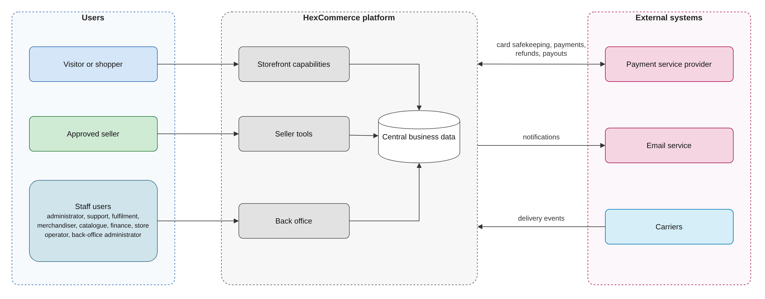
Figure 1: System context.

5.3 Capability map
Area | Capabilities | Main users
Discovery | Departments and sub-departments; keyword search with suggestions; filters; sort orders; results including marketplace listings; related products | Visitor, shopper
Merchandising | Promotions; featured selections; badges; store deals; seller deals | Shopper, merchandiser, seller
Product | Product and listing details; stock and delivery information; purchase terms; reviews, votes, reports, moderation | Shopper, support agent
Purchase | Basket with stock control; saved-for-later; wish list; checkout; payment authorisation; order confirmation | Visitor, shopper, payment service provider
After sale | Order history; fulfilment progress and tracking; invoices; cancellation; returns and refunds; customer-service issues; help information | Shopper, support agent, fulfilment team, carrier
Account and access | Registration; sign-in; sign-out; password reset; account book; data-protection rights; staff access and audit | Visitor, shopper, back-office administrator
Seller onboarding | Seller information; application; administrator decision; seller account; business details | Prospective seller, administrator
Seller operations | Account overview; listings; deals; seller orders; returns; payout account and statements | Approved seller
Finance | Payments and refunds; referral-fee schedule; payout runs | Finance, payment service provider
Configuration | Brand, currency, locale, delivery fee and threshold, cut-off, tax, returns window | Store operator

5.4 Status lifecycles
The business objects below each move through a defined set of states. Transition rules are in section 8.
Object | States | Who or what changes the state
Order and order line | Processing -> Shipped -> Out for delivery -> Delivered; Processing -> Cancelled | Created Processing at checkout; each line moves as it is dispatched (fulfilment team or seller) and as the carrier reports; the order status is derived from its lines (BR-ORD-008); a line is cancelled only while Processing.
Seller order | New -> Dispatched -> Delivered; New -> Cancelled | Created New at checkout; the seller confirms dispatch, marks delivered (or the carrier reports it), or cancels a New order; a shopper cancellation also cancels it.
Return request | Requested -> Awaiting items -> Received -> Accepted -> Completed; Received -> Rejected | Created by the shopper or an agent; the dispatching party records receipt and decides; the system completes it with a refund or replacement.
Customer-service issue | Open, In review, Awaiting your reply, Resolved | Created Open; support agents set any status when replying; a shopper reply moves Awaiting your reply or Resolved to In review.
Seller application | Pending -> Approved | Rejected; decided -> Pending | Applicant submits; administrator decides or re-queues.
Seller listing | Draft, Active, Out of stock, Unpublished | Seller saves, publishes or unpublishes; a sale that empties stock sets Out of stock; removal deletes it.
Seller deal | Scheduled -> Live -> Ended | Derived from its dates; the seller can start early or end it; it also ends when its end date passes.
Store deal | Scheduled -> Running -> Ended | Derived from its start and end; ends early when sold out or ended by a merchandiser.
Payout account | Awaiting verification -> Verified | Rejected | Seller provides details; finance verifies or rejects.
Catalogue product | Unpublished -> Published -> Unpublished | Retired | Catalogue manager publishes, unpublishes or retires.

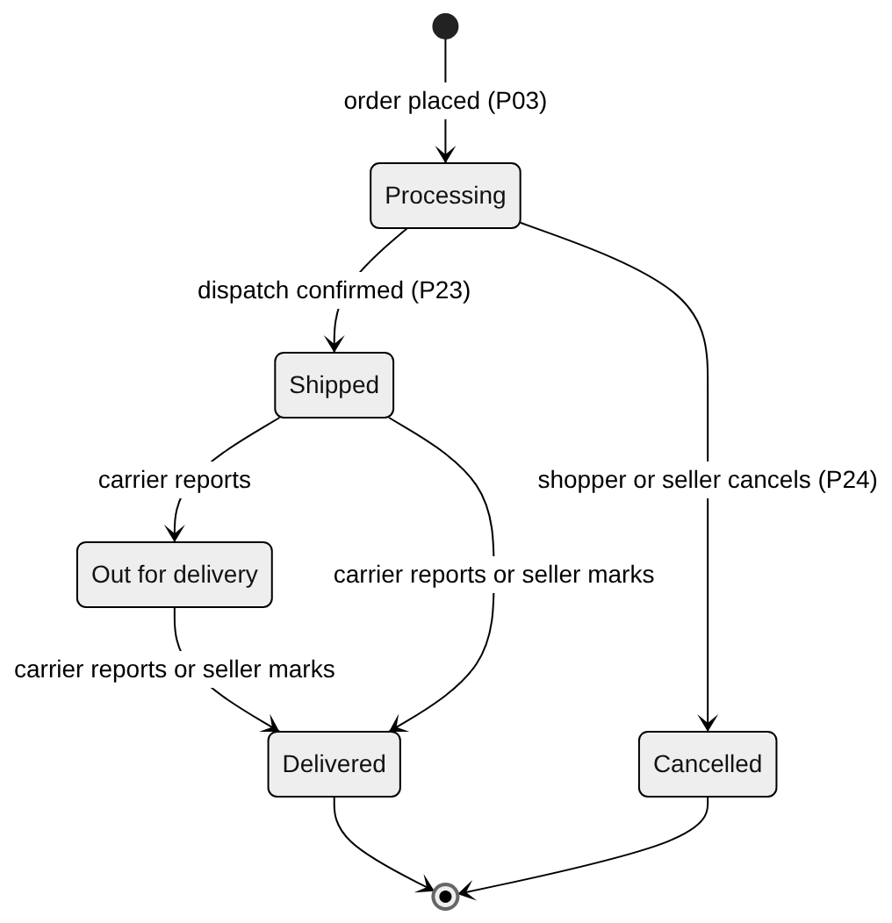
Figure 2: Order line and order lifecycle (state diagram). The order status is the least advanced status of its lines that are not cancelled.
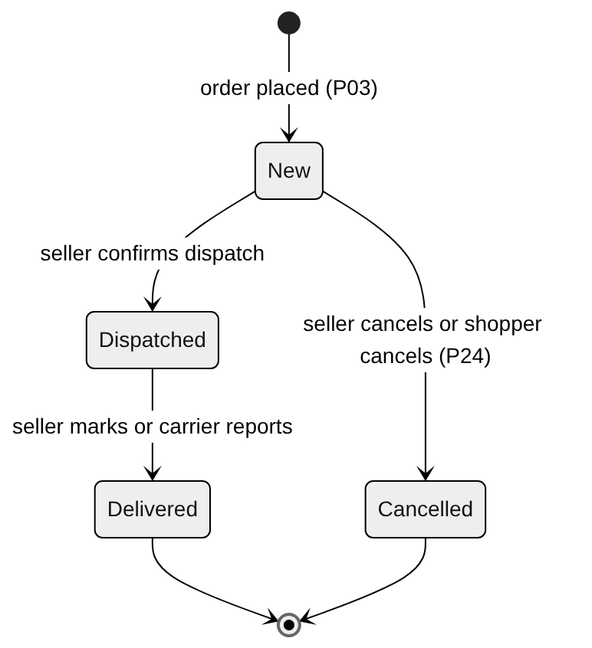
Figure 3: Seller order lifecycle (state diagram).
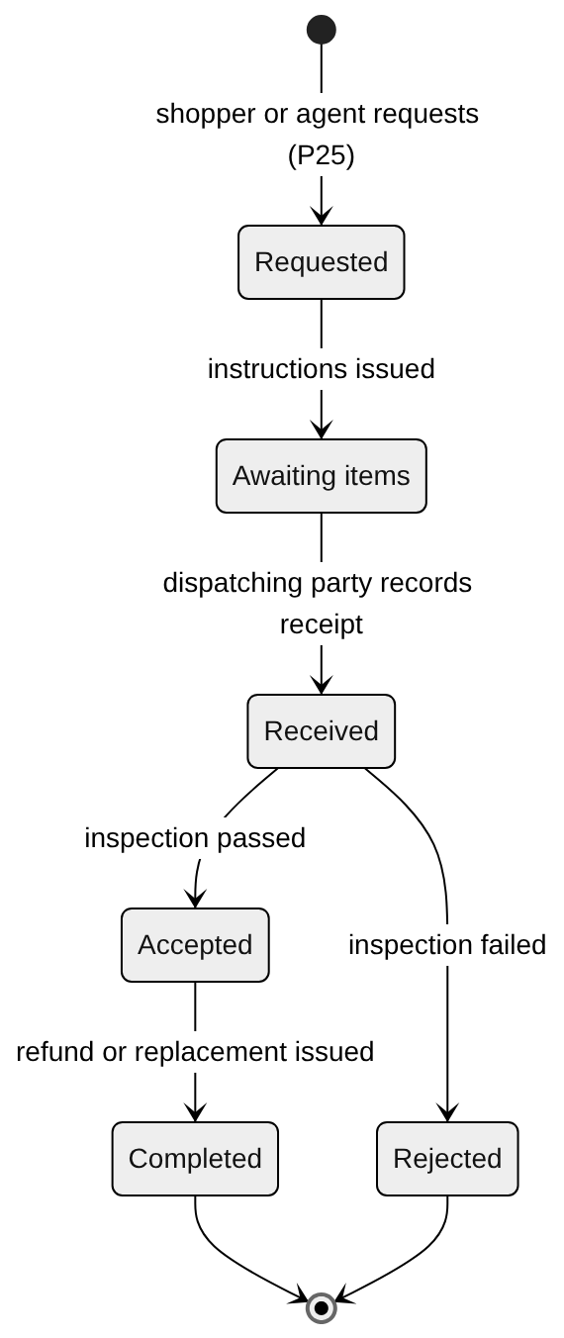
Figure 4: Return request lifecycle (state diagram).
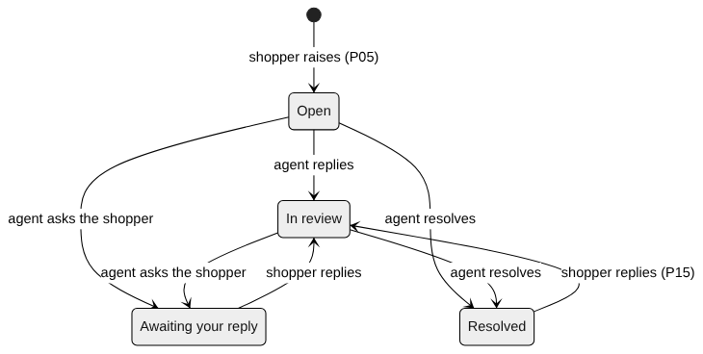
Figure 5: Customer-service issue lifecycle (state diagram).
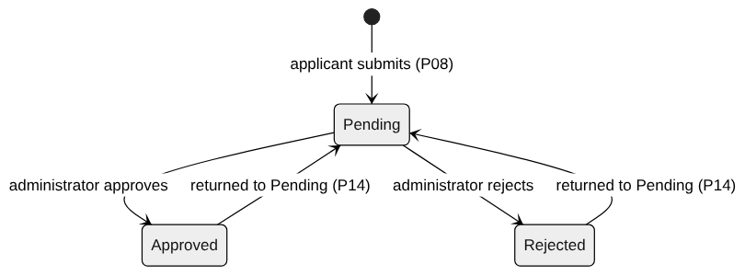
Figure 6: Seller application lifecycle (state diagram).
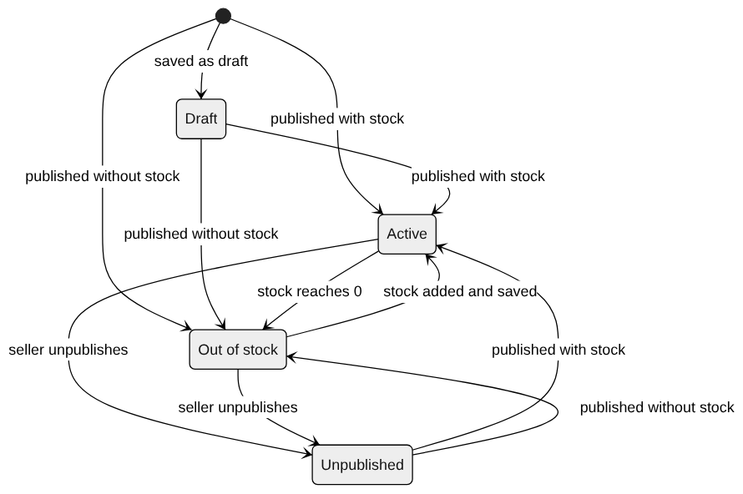
Figure 7: Seller listing lifecycle (state diagram). A listing in any status can be removed (P21).
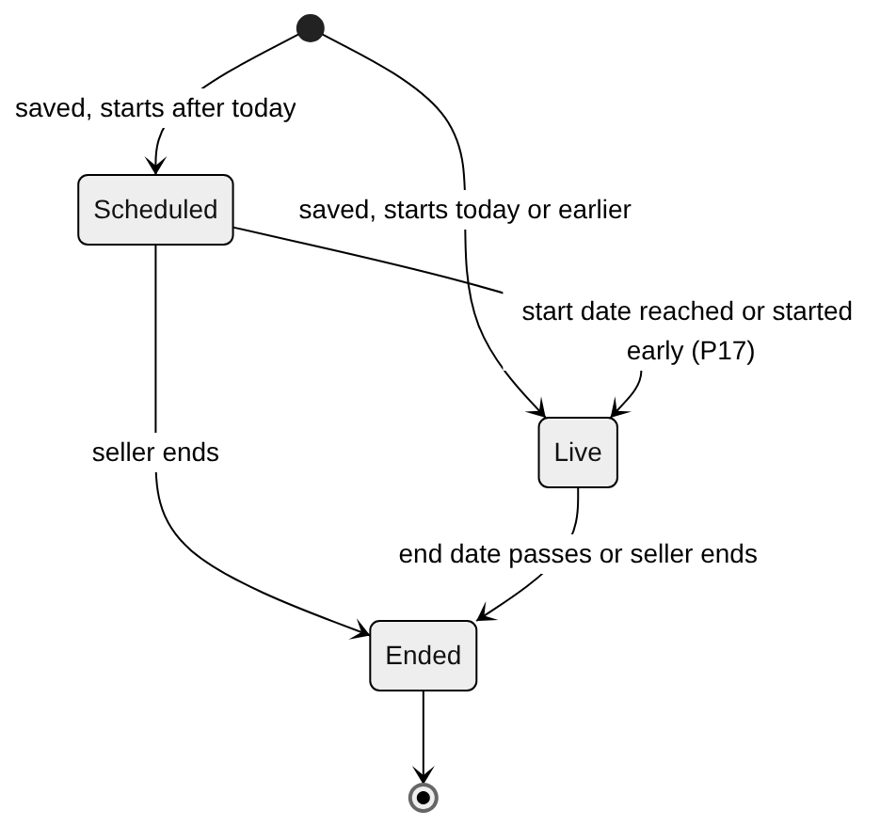
Figure 8: Seller deal lifecycle (state diagram).
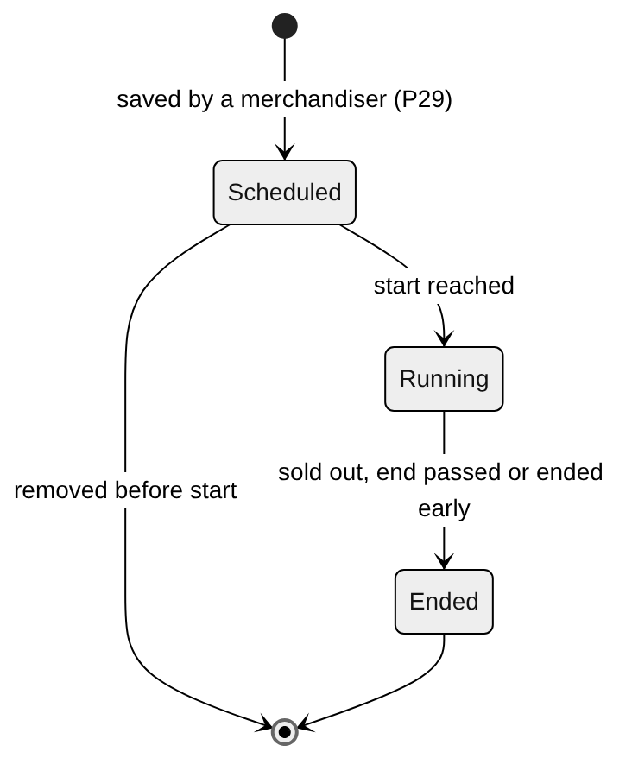
Figure 9: Store deal lifecycle (state diagram).
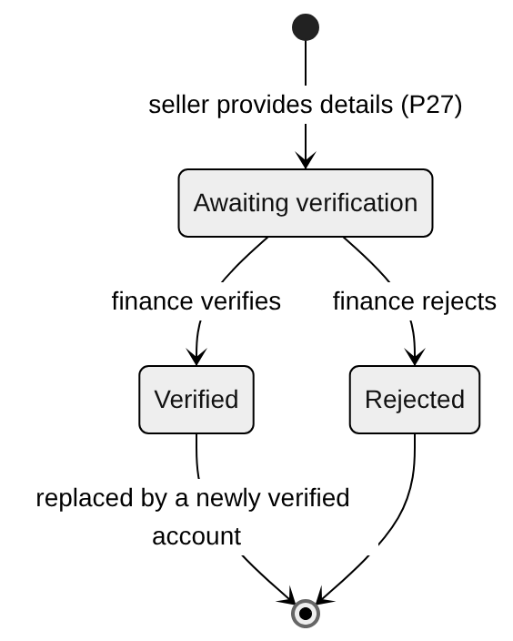
Figure 10: Payout account lifecycle (state diagram).

5.5 Basis of this document
Version 2.5 analysed every screen, rule, calculation and message of a demonstration application [6]. A verification of v2.5 against that application [10] confirmed that the business rules were complete for what the application did, found gaps in the processes and rules, identified use cases for actors the application never served, and found that the document described the application's user interface and implementation.
Version 3.0 restates the requirements for the target system. Rules carried over keep their identifiers. Every withdrawn requirement is listed with its reason in Appendix C, and Appendix D shows how each verification finding is resolved.

6 Business processes
31 end-to-end workflows are modelled. Each is a BPMN 2.0 collaboration with one swimlane per role, system or external party, showing start and end events, exclusive decision gateways and exception paths. Every diagram is in the companion file HexCommerce_Process_Diagrams.drawio (one page per process). HexCommerce_Complete_Process_Flow.drawio shows every process on one page, grouped in tiers, with the hand-overs between them.

6.0 Notation
Symbol | BPMN element | Meaning in these diagrams
Thin green circle | Start event | What triggers the process
Thick black circle | End event | A normal outcome, or a hand-over to another process (named in the label)
Thick red circle with lightning mark | Error end event | An exception outcome, where the process stops without its goal
Rounded rectangle | Task | Work done by the role or system named on the lane
Diamond | Exclusive gateway | A decision; each outgoing flow is labelled with its condition
Arrow | Sequence flow | Order of work; arrows may loop back for rework
Vertical band | Lane | The role, system or external party responsible for the elements inside it

ID | Process | Lanes | Status
P01 | Discover products (browse, search and filter) | Shopper; HexCommerce platform (system) | Revised
P02 | Manage the basket, saved-for-later list and wish list | Shopper; HexCommerce platform (system) | Revised
P03 | Check out, pay and place an order | Shopper; HexCommerce platform (system); Payment service provider (external); Approved seller | Revised
P04 | Track an order, get an invoice and request a return | Shopper; HexCommerce platform (system) | Revised
P05 | Raise and follow a customer-service issue | Shopper; HexCommerce platform (system); Support agent | Revised
P06 | Write a product review and vote on reviews | Shopper; HexCommerce platform (system) | Revised
P07 | Maintain delivery addresses and payment cards | Shopper; HexCommerce platform (system); Payment service provider (external) | Revised
P08 | Apply to become a seller and decide the application | Prospective seller (applicant); HexCommerce platform (system); Marketplace administrator | Revised
P09 | Create and publish a product listing | Approved seller; HexCommerce platform (system) | Revised
P10 | Run a seller deal (time-limited discount) | Approved seller; HexCommerce platform (system); Shopper | Revised
P11 | Fulfil a seller order | Shopper; HexCommerce platform (system); Approved seller | Revised
P12 | Register, sign in and recover access | Visitor or shopper; HexCommerce platform (system) | Revised
P13 | Maintain seller business details | Approved seller; HexCommerce platform (system) | Revised
P14 | Return a decided seller application to Pending | Marketplace administrator; HexCommerce platform (system); Approved seller | Revised
P15 | Reopen a resolved customer-service issue | Shopper; HexCommerce platform (system); Support agent | Revised
P16 | Choose the delivery address for the next order | Shopper; HexCommerce platform (system) | Renamed
P17 | Maintain a seller deal (start early, edit, end or remove) | Approved seller; HexCommerce platform (system) | Revised
P18 | Delete or edit a review you wrote | Shopper; HexCommerce platform (system) | Renamed
P19 | Move a wish-list or saved-for-later item to the basket | Shopper; HexCommerce platform (system) | Revised
P20 | Sign out (end the session) | Shopper; HexCommerce platform (system) | Revised
P21 | Maintain a product listing (edit, publish, unpublish, remove) | Approved seller; HexCommerce platform (system) | New
P22 | Handle customer-service issues (support agent) | Support agent; HexCommerce platform (system); Shopper | New
P23 | Progress an order through fulfilment | Approved seller; Fulfilment team; HexCommerce platform (system); Carrier (external); Shopper | New
P24 | Cancel an order or order line and refund | Shopper; Approved seller; HexCommerce platform (system); Payment service provider (external) | New
P25 | Process a return and refund | Shopper; HexCommerce platform (system); Dispatching party (fulfilment team or seller); Payment service provider (external) | New
P26 | Manage back-office access | Back-office administrator; HexCommerce platform (system); Staff user | New
P27 | Set up or change a seller payout account | Approved seller; HexCommerce platform (system); Finance | New
P28 | Calculate and settle seller payouts | Approved seller; HexCommerce platform (system); Finance; Payment service provider (external) | New
P29 | Maintain promotions and store deals | Merchandiser; HexCommerce platform (system); Shopper | New
P30 | Maintain the store catalogue | Catalogue manager; HexCommerce platform (system) | New
P31 | Report and moderate reviews | Shopper; HexCommerce platform (system); Support agent | New

6.1 P01 Discover products (browse, search and filter)
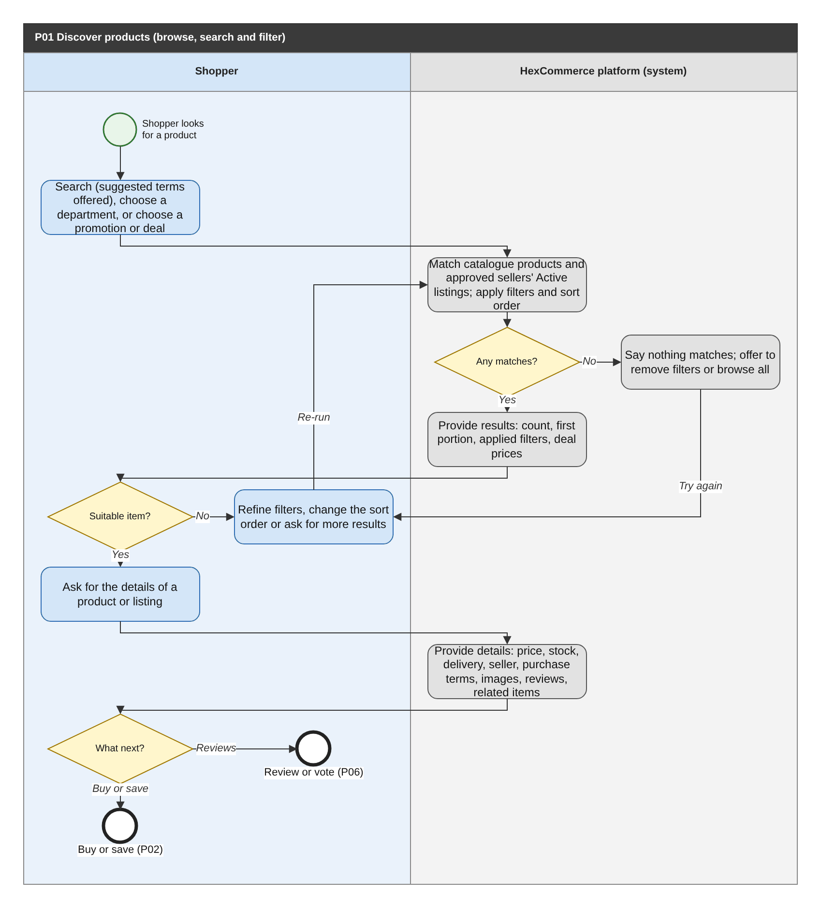
Figure 11: P01 Discover products (browse, search and filter) (BPMN swimlane). draw.io: page P01 of HexCommerce_Process_Diagrams.drawio.
Attribute | Description
Purpose | Help a shopper move from a need to a specific product or marketplace listing, using search, departments, promotions and deals, filters, sorting and related items.
Trigger | The shopper searches, chooses a department, or chooses a promotion or deal.
Actors / lanes | Shopper; HexCommerce platform (system).
Preconditions | None. The catalogue is available to every visitor, signed in or not (FR-ACC-022).
Postconditions | The shopper has the details of a chosen product or listing.
Change from v2.5 | Reworded; adds promotions and deals as entry points and the related and brand products loop (verification findings G-01, G-02).

Main flow
1. The shopper enters search terms (the system suggests terms after two characters), chooses a department, or chooses a promotion or a store or seller deal.
2. The system matches catalogue products and the Active listings of every approved seller against the search terms or department, then applies any filters and the sort order.
3. If there are matches, the system provides the number of results, the first portion of them, the filters that apply and the current deal prices.
4. If no suitable item is found, the shopper refines the filters, changes the sort order or asks for the next results, and the system matches again.
5. The shopper asks for the details of a product or listing; the system provides its price, stock status, delivery estimate, seller, purchase terms, images, reviews and related products.
6. The shopper buys or saves the item (P02), or reviews or votes (P06).

Exception and alternative paths
- No matches: the system says so and offers to remove the filters, or to browse the whole catalogue when no filters are applied; the shopper tries again.
- Related or same-brand products: the shopper asks for the details of one of them, returning to step 5.
- Unknown product, listing or department: the system says it does not exist and suggests the deals and the departments (FR-PDP-015).
- A listing that is a draft, removed, or belongs to a seller who is not approved is not available (FR-PDP-014).
- The shopper may stop at any point without choosing a product (not modelled).

Related requirements
BR-CAT-001, BR-CAT-002, BR-CAT-003, BR-CAT-004, BR-CAT-005, BR-PRC-001, BR-PRC-008, BR-SLS-008, BR-STD-005, BR-STK-001, FR-ACC-012, FR-ACC-022, FR-CAT-001, FR-CAT-002, FR-CAT-003, FR-CAT-004, FR-CAT-005, FR-CAT-006, FR-CAT-007, FR-CAT-008, FR-CAT-010, FR-CAT-011, FR-CAT-012, FR-CAT-013, FR-CAT-014, FR-CAT-015, FR-CAT-016, FR-CAT-017, FR-CAT-018, FR-CAT-019, FR-CAT-020, FR-CAT-021, FR-CAT-022, FR-CAT-023, FR-CAT-025, FR-CAT-026, FR-CAT-027, FR-CAT-028, FR-CAT-029, FR-CAT-030, FR-CAT-031, FR-CAT-032, FR-CAT-033, FR-CAT-034, FR-CAT-035, FR-DEF-008, FR-MKT-001, FR-MKT-005, FR-MKT-006, FR-MKT-007, FR-MKT-010, FR-MKT-011, FR-MKT-012, FR-MKT-014, FR-MKT-017, FR-PDP-001, FR-PDP-002, FR-PDP-003, FR-PDP-004, FR-PDP-005, FR-PDP-006, FR-PDP-007, FR-PDP-011, FR-PDP-012, FR-PDP-015, FR-PDP-016, FR-PDP-017, FR-PDP-018, FR-SLS-020, NFR-ACC-005, NFR-PRF-006, NFR-PRF-007

6.2 P02 Manage the basket, saved-for-later list and wish list
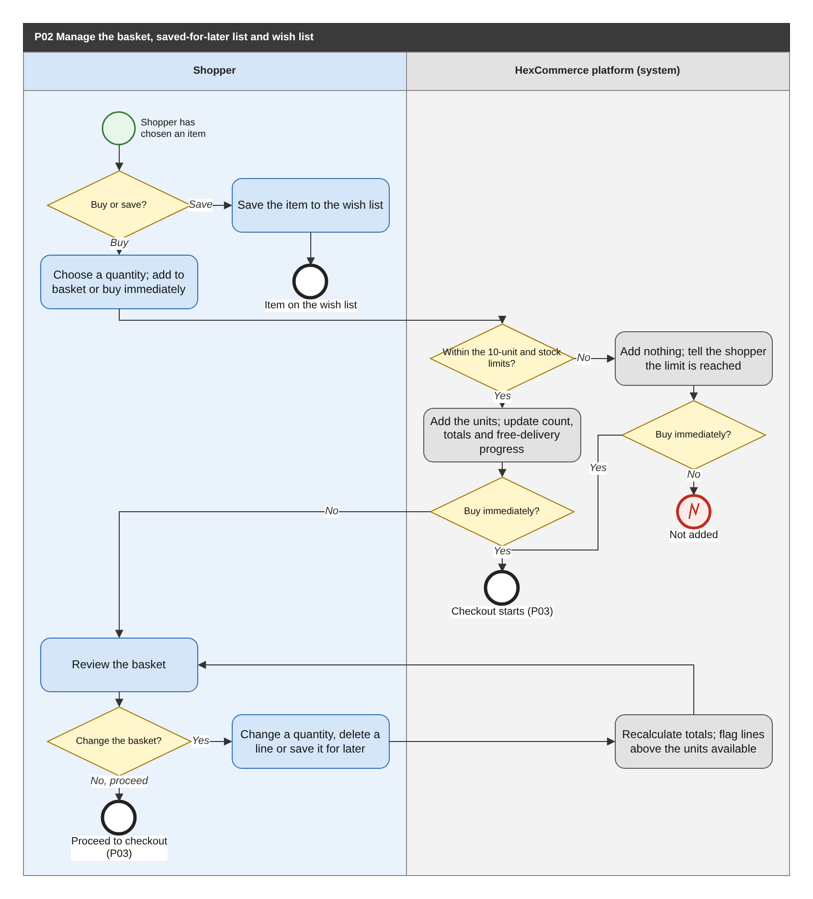
Figure 12: P02 Manage the basket, saved-for-later list and wish list (BPMN swimlane). draw.io: page P02 of HexCommerce_Process_Diagrams.drawio.
Attribute | Description
Purpose | Let the shopper collect items to buy now (basket) or later (saved-for-later list, wish list) while keeping quantities within the limits.
Trigger | The shopper chooses to add an item to the basket, to buy it immediately, or to save it.
Actors / lanes | Shopper; HexCommerce platform (system).
Preconditions | The product or listing is on sale. Saving to the wish list requires the shopper to be signed in; a guest basket is kept for the visit (FR-CRT-018).
Postconditions | The basket, saved-for-later list and wish list reflect the shopper's choices and are retained in their account.
Change from v2.5 | Reworded; adds the buy-immediately path (G-06). The stock check that blocks an order now sits only in P03 (G-07).

Main flow
1. The shopper decides whether to buy or save the item.
2. To buy, the shopper chooses a quantity and either adds it to the basket or chooses to buy immediately.
3. The system checks the 10-unit limit and the units available, adds the units and updates the item count, totals and free-delivery progress.
4. If the shopper chose to buy immediately, checkout starts for the whole basket (P03).
5. Otherwise the shopper reviews the basket and may change quantities, delete lines or save lines for later; the system recalculates and flags any line above the units available.
6. The shopper proceeds to checkout (P03), where an order cannot be placed while any line exceeds the units available (BR-CRT-005).

Exception and alternative paths
- Limit reached when adding: nothing is added and the shopper is told; the process ends.
- Limit reached when buying immediately: nothing is added, the shopper is told, and checkout still starts with the existing basket (FR-PDP-009).
- Save: the item is added to the wish list and the process ends.
- A saved or wish-list item is later moved to the basket, or removed, in P19.

Related requirements
BR-CRT-001, BR-CRT-002, BR-CRT-003, BR-CRT-004, BR-CRT-005, BR-CRT-007, BR-PRC-001, BR-PRC-002, BR-PRC-005, BR-PRC-006, BR-STK-001, FR-ACC-022, FR-CAT-035, FR-CFG-003, FR-CFG-007, FR-CRT-001, FR-CRT-002, FR-CRT-003, FR-CRT-004, FR-CRT-005, FR-CRT-006, FR-CRT-008, FR-CRT-009, FR-CRT-010, FR-CRT-011, FR-CRT-012, FR-CRT-013, FR-CRT-016, FR-CRT-017, FR-CRT-018, FR-PDP-006, FR-PDP-007, FR-PDP-008, FR-PDP-009, FR-PDP-010, FR-PDP-016

6.3 P03 Check out, pay and place an order
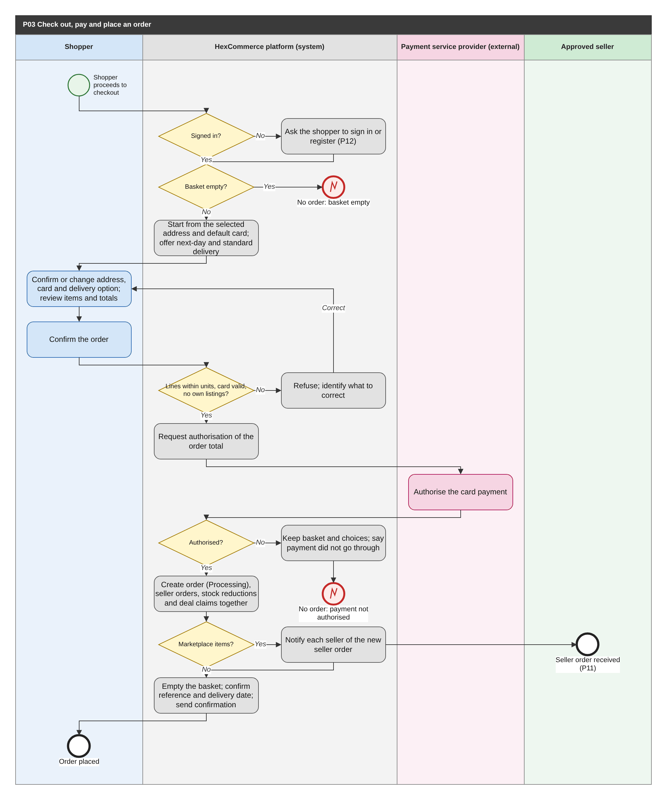
Figure 13: P03 Check out, pay and place an order (BPMN swimlane). draw.io: page P03 of HexCommerce_Process_Diagrams.drawio.
Attribute | Description
Purpose | Convert the basket into a paid order, capture delivery and payment choices, and pass marketplace items to their sellers.
Trigger | The shopper proceeds to checkout, or chooses to buy an item immediately (P02).
Actors / lanes | Shopper; HexCommerce platform (system); Payment service provider (external); Approved seller.
Preconditions | The basket holds at least one item. The shopper has, or adds during checkout, at least one delivery address and one card that is not expired.
Postconditions | The payment is authorised; the order appears first in the shopper's order history; each marketplace item is a New seller order for its seller; the shopper has a confirmation.
Change from v2.5 | Payment authorisation, the sign-in requirement, the expired-card check (G-16), self-purchase prevention (Q-21) and all-or-nothing order creation (Q-09) are new.

Main flow
1. The system checks that the shopper is signed in (FR-CHK-021) and that the basket is not empty.
2. The system starts from the selected delivery address and default card, and offers next-day and standard delivery with their expected dates and charge.
3. The shopper confirms or changes the address, card and delivery option (adding an address or card if needed, FR-CHK-016), reviews the items and totals, and confirms the order.
4. The system checks that no line exceeds the units available, that the card is not expired and that the shopper is not buying their own listings.
5. The system asks the payment service provider to authorise the order total; the provider authorises it.
6. The system creates the order (Processing, with a reference and a snapshot of prices, address, card and totals) together with a New seller order for each marketplace item, the stock reductions and the deal claims (FR-CHK-022).
7. The system notifies each seller of their new seller order (P11), empties the basket, confirms the reference and expected delivery date, and sends the order confirmation (FR-NTF-001).

Exception and alternative paths
- Not signed in: the shopper signs in or registers (P12) and continues; their guest basket is merged (FR-CRT-018).
- Empty basket: the shopper is told and no order is created.
- A line exceeds the units available, the card has expired, or a line is the shopper's own listing: the order is refused and the shopper is told what to correct.
- Authorisation declined or unavailable: no order is created; the basket and choices are kept and the shopper is told to try again or choose another card, without the issuer's reason (FR-PAY-003). Trying again restarts at step 3.

Related requirements
BR-ACC-010, BR-CRT-005, BR-ORD-001, BR-ORD-002, BR-ORD-003, BR-ORD-004, BR-PRC-002, BR-PRC-003, BR-PRC-004, BR-PRC-006, BR-PRC-007, BR-SDL-009, BR-SLS-005, BR-STD-004, BR-SYS-001, FR-ACC-007, FR-CFG-003, FR-CFG-004, FR-CFG-007, FR-CFG-008, FR-CHK-001, FR-CHK-002, FR-CHK-003, FR-CHK-004, FR-CHK-005, FR-CHK-006, FR-CHK-007, FR-CHK-008, FR-CHK-009, FR-CHK-010, FR-CHK-011, FR-CHK-012, FR-CHK-013, FR-CHK-014, FR-CHK-015, FR-CHK-016, FR-CHK-017, FR-CHK-018, FR-CHK-019, FR-CHK-020, FR-CHK-021, FR-CHK-022, FR-CHK-023, FR-CRT-009, FR-MKT-017, FR-NTF-001, FR-PAY-002, FR-PAY-003, FR-PAY-006, FR-PDP-009, NFR-PRF-008, NFR-SEC-001, NFR-SEC-010

6.4 P04 Track an order, get an invoice and request a return
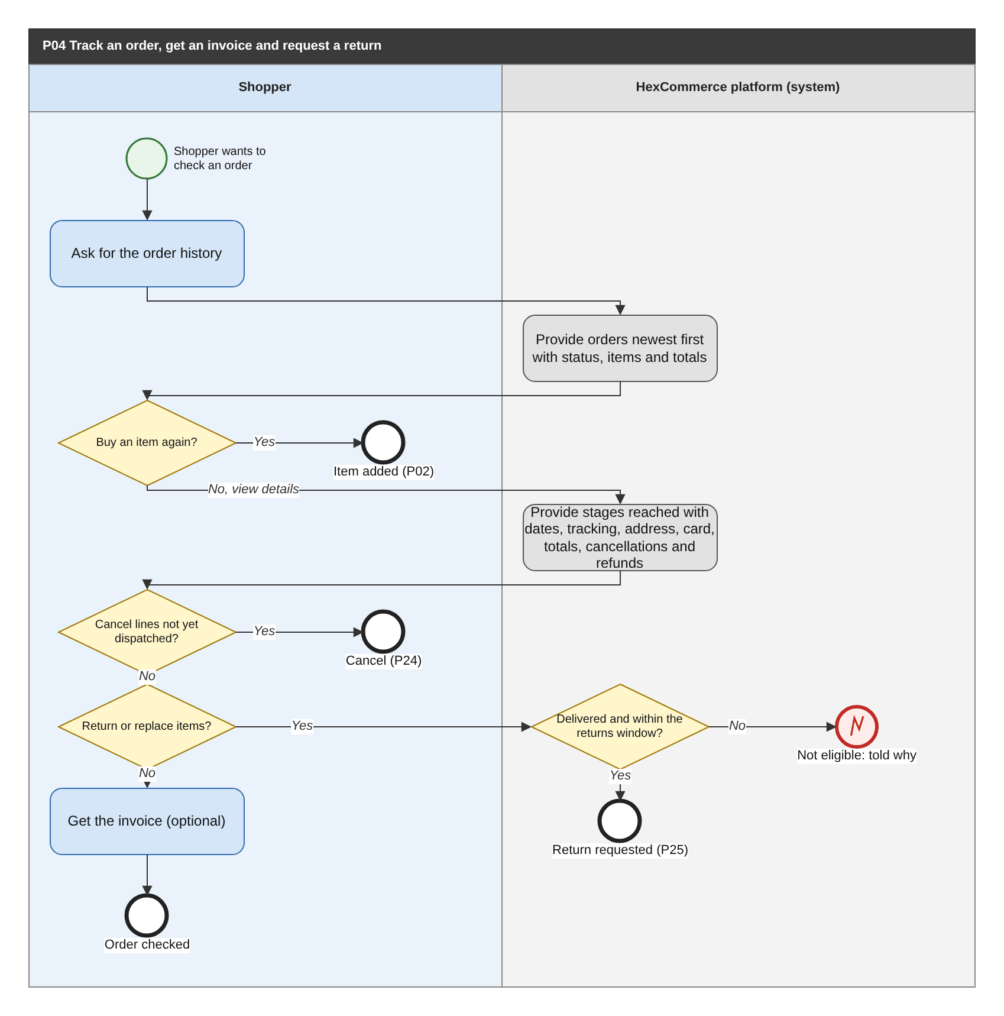
Figure 14: P04 Track an order, get an invoice and request a return (BPMN swimlane). draw.io: page P04 of HexCommerce_Process_Diagrams.drawio.
Attribute | Description
Purpose | Give the shopper visibility of their orders, each line's progress, invoices, and the routes to cancellation and returns.
Trigger | The shopper asks for their order history.
Actors / lanes | Shopper; HexCommerce platform (system).
Preconditions | The shopper is signed in and has at least one order.
Postconditions | The shopper has the information they needed, an item added to the basket, a cancellation started (P24), or a return requested (P25).
Change from v2.5 | Return requests now start a return (P25) instead of a customer-service issue; cancellation (P24) and tracking references are new.

Main flow
1. The shopper asks for their order history; the system provides orders newest first with status, items and totals.
2. The shopper either buys an item again (adding it to the basket, P02) or asks for the order details.
3. The system provides the progress stages reached with their dates, each dispatched line's carrier and tracking reference, the delivery address, card, totals, and any cancellation and refund.
4. The shopper may cancel lines that have not been dispatched (P24).
5. For Delivered lines within the returns window, the shopper may request a return or replacement (P25).
6. The shopper may get the invoice as a document to print or keep.

Exception and alternative paths
- Lines not Delivered, or outside the returns window: no return can be requested; the shopper is told why (BR-ORD-006).
- Unknown order reference, or an order of another customer: the shopper is told and directed to their order history.
- Item no longer sold: shown by its captured title, without purchase actions.

Related requirements
BR-ORD-003, BR-ORD-005, BR-ORD-006, FR-CRT-001, FR-ORD-001, FR-ORD-002, FR-ORD-003, FR-ORD-004, FR-ORD-005, FR-ORD-006, FR-ORD-007, FR-ORD-008, FR-ORD-009, FR-ORD-010, FR-ORD-017

6.5 P05 Raise and follow a customer-service issue
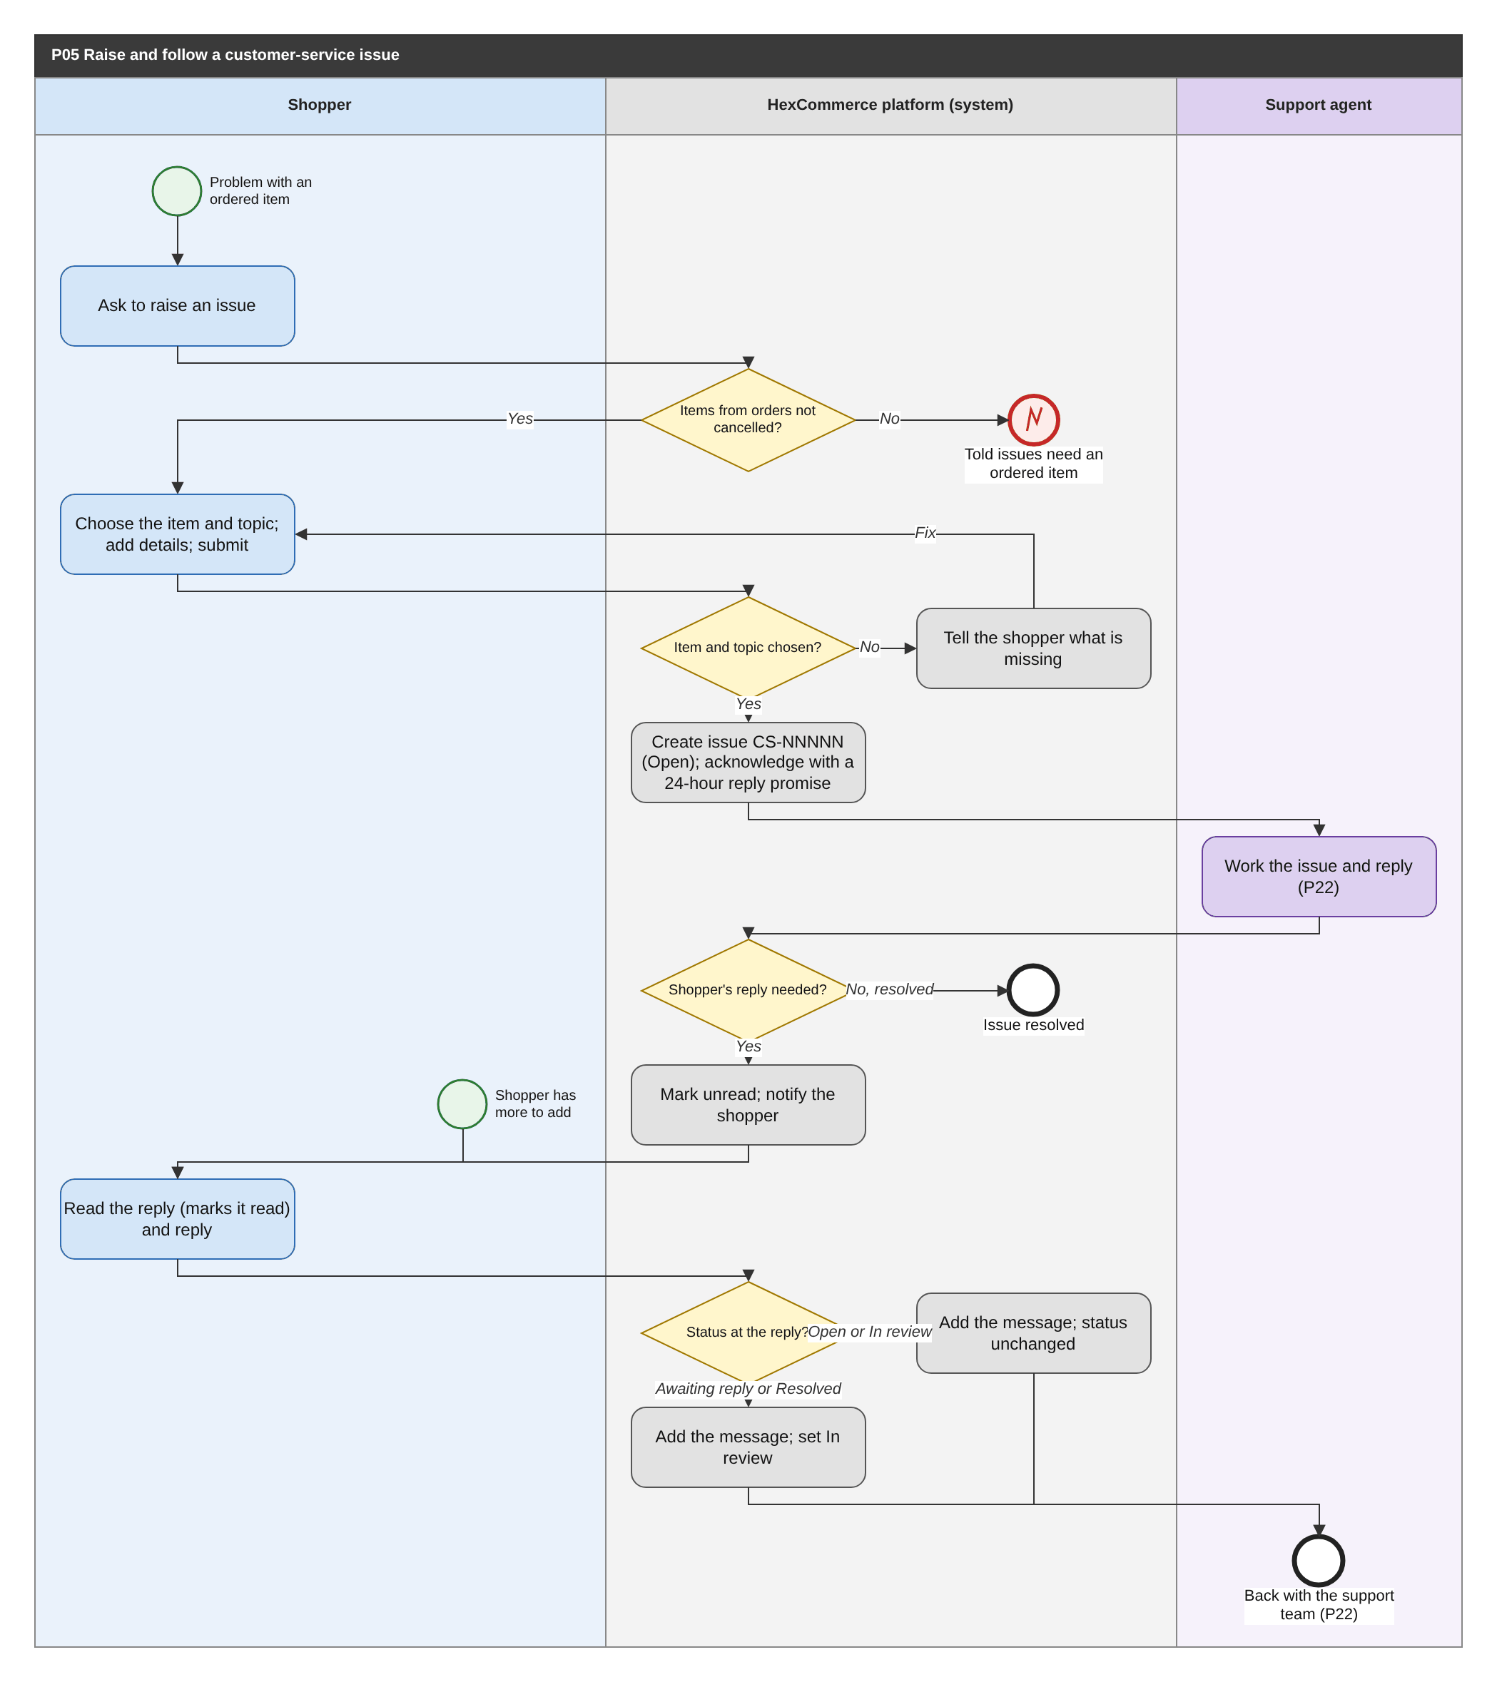
Figure 15: P05 Raise and follow a customer-service issue (BPMN swimlane). draw.io: page P05 of HexCommerce_Process_Diagrams.drawio.
Attribute | Description
Purpose | Let a shopper report a problem with an ordered item and follow the conversation with the support team to resolution.
Trigger | The shopper asks to raise an issue, or is directed to customer service from an order.
Actors / lanes | Shopper; HexCommerce platform (system); Support agent.
Preconditions | The shopper is signed in and has at least one item in an order that was not cancelled.
Postconditions | The issue and its full thread are recorded with their current status.
Change from v2.5 | The support team is now in the system (P22); the shopper can add a message at any status (G-10).

Main flow
1. The system offers the items from the shopper's orders that were not cancelled.
2. The shopper chooses the item and one of the nine topics, optionally adds details, and submits.
3. The system checks that an item and a topic are chosen, creates issue CS-NNNNN with status Open, and adds an automated acknowledgement promising a reply within 24 hours.
4. A support agent works the issue and replies (P22). When the shopper's reply is needed, the issue is set to Awaiting your reply, marked unread and the shopper is notified; otherwise it may be resolved.
5. The shopper reads the reply (marking it read) and replies; the system adds the message and sets the status to In review, returning the issue to the team.

Exception and alternative paths
- No eligible items: the shopper is told issues can be raised only about ordered items.
- Item or topic missing: the system says what is missing and keeps the entries.
- The shopper adds a message while the issue is Open or In review: the message is added and the status is unchanged (BR-CS-001).
- Reply to a Resolved issue: see P15.
- Returns are requested through P25, not through an issue; an agent can start one from an issue (FR-CS-021).

Related requirements
BR-CS-001, BR-CS-002, BR-CS-003, BR-CS-004, BR-ORD-007, FR-CS-001, FR-CS-002, FR-CS-003, FR-CS-004, FR-CS-005, FR-CS-006, FR-CS-007, FR-CS-008, FR-CS-009, FR-CS-010, FR-CS-012, FR-CS-013, FR-CS-014

6.6 P06 Write a product review and vote on reviews
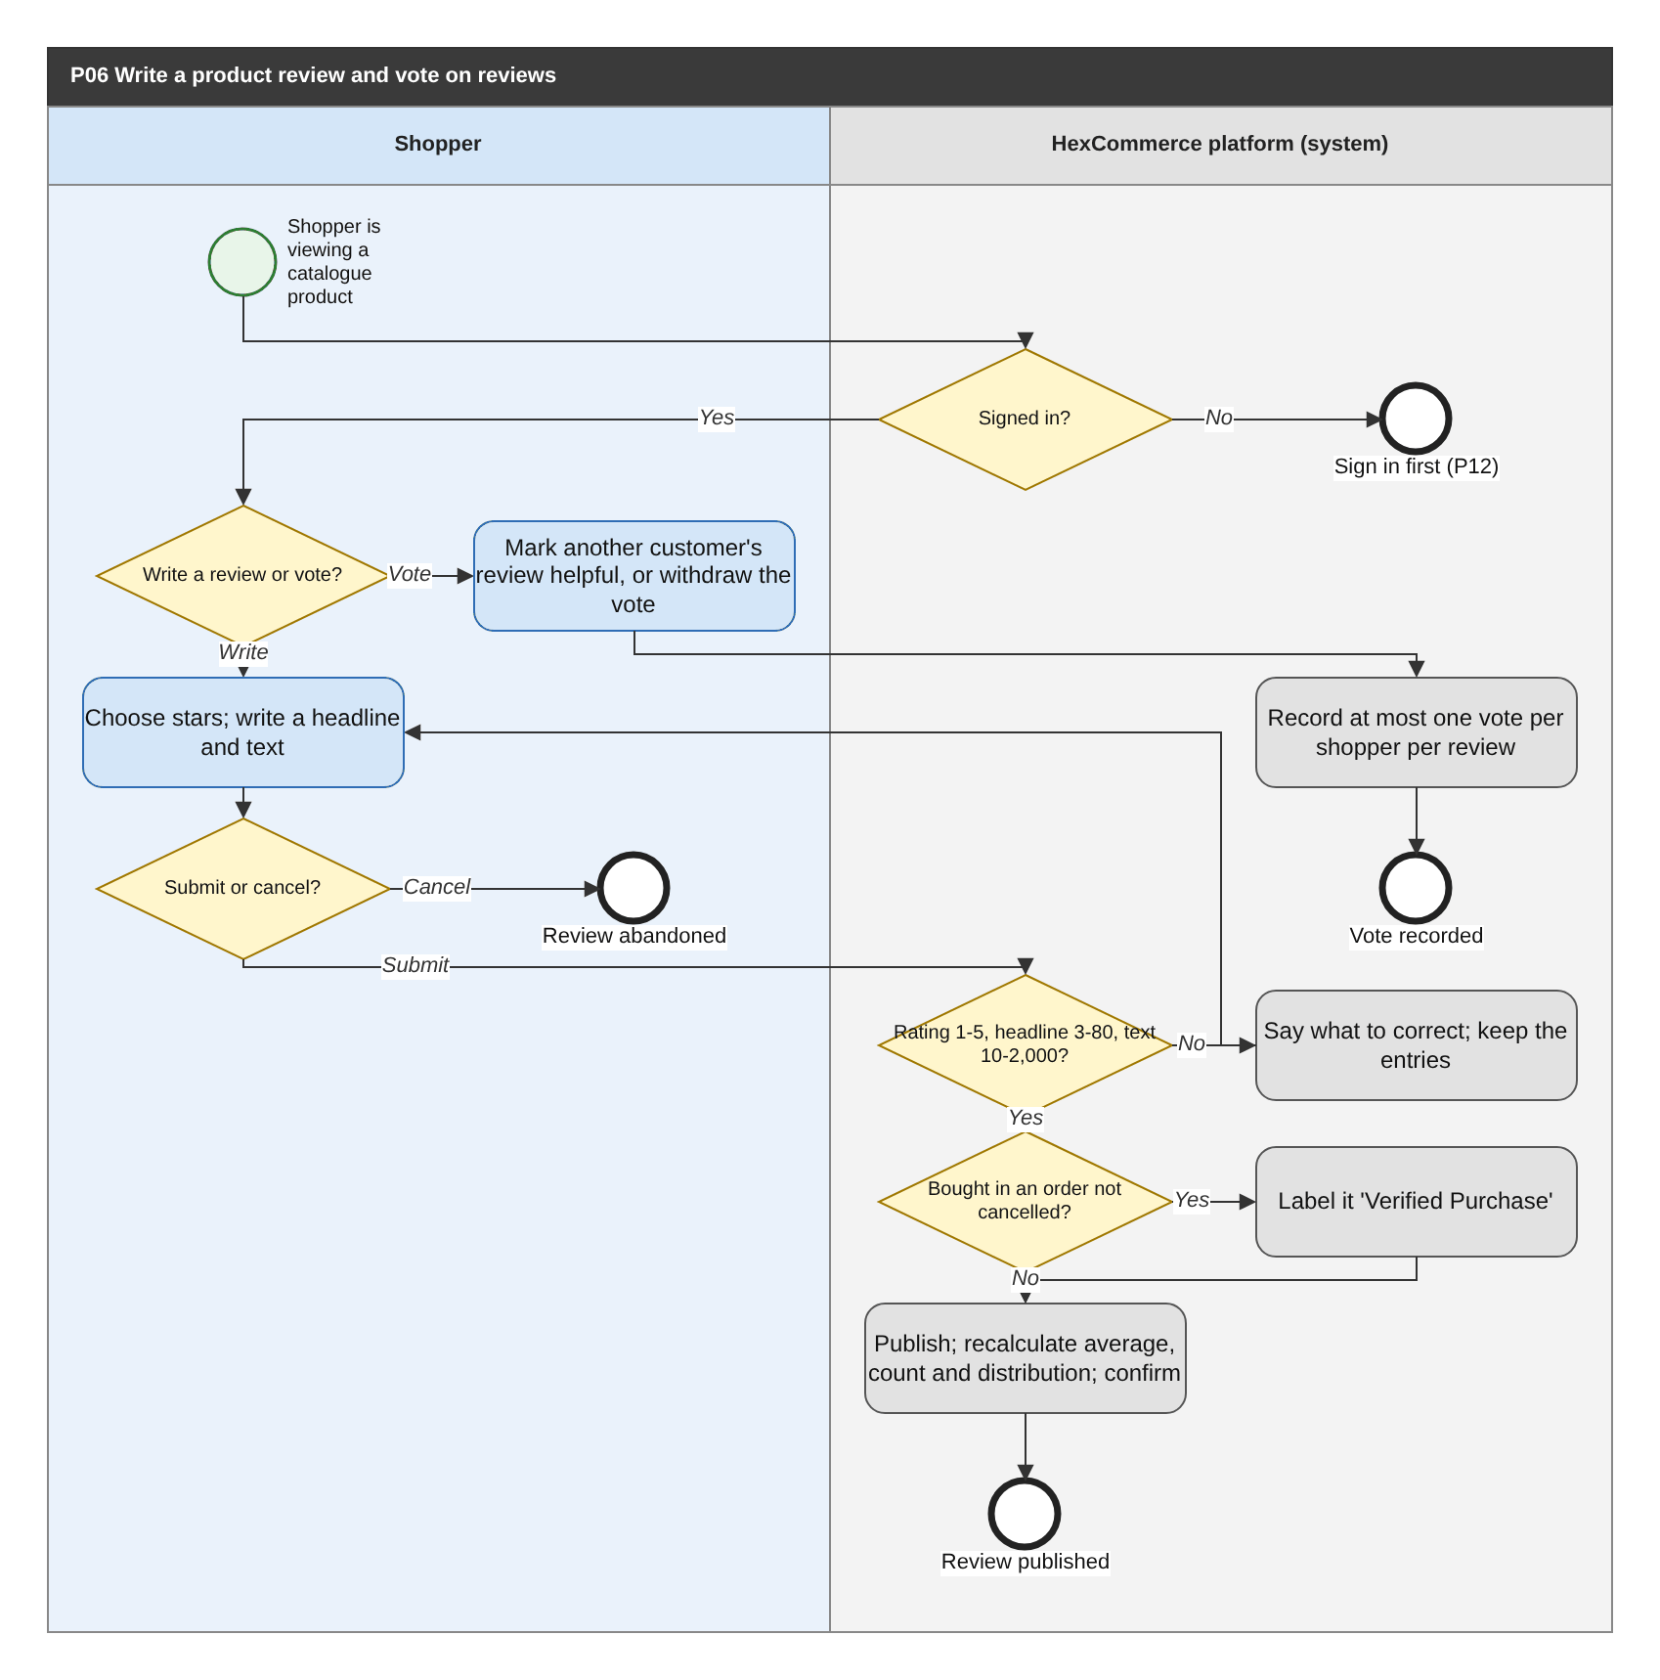
Figure 16: P06 Write a product review and vote on reviews (BPMN swimlane). draw.io: page P06 of HexCommerce_Process_Diagrams.drawio.
Attribute | Description
Purpose | Capture customer opinion on products and let shoppers signal which reviews are useful.
Trigger | The shopper chooses to write a review of, or to vote on a review of, a catalogue product.
Actors / lanes | Shopper; HexCommerce platform (system).
Preconditions | The shopper is viewing a catalogue product and is signed in.
Postconditions | The review is published, or the vote is recorded, and the product's rating figures include it.
Change from v2.5 | Adds the sign-in check and the cancel path (G-12); the rating distribution is now counted, not estimated (Q-23).

Main flow
1. The shopper chooses to write a review or to vote on an existing review.
2. To write, the shopper chooses a star rating, writes a headline and review text, and submits (or cancels).
3. The system checks the review rules; if the shopper bought the product in an order that was not cancelled, the review is labelled Verified Purchase.
4. The system publishes the review, gives it precedence for that shopper, recalculates the average, count and distribution, and confirms publication.

Exception and alternative paths
- Rule broken: the shopper is told what to correct and the entries are kept.
- Cancel: nothing is saved.
- Vote: the shopper marks another customer's review helpful or withdraws the vote; one vote per review, never on their own review.
- Own review: the shopper can delete or edit it (P18). Inappropriate review: the shopper can report it (P31).
- A shopper may write more than one review of the same product (FR-REV-009).

Related requirements
BR-ORD-007, BR-REV-001, BR-REV-002, BR-REV-003, BR-REV-004, BR-REV-005, BR-REV-006, FR-REV-001, FR-REV-002, FR-REV-004, FR-REV-005, FR-REV-006, FR-REV-007, FR-REV-009, FR-REV-010, FR-REV-011

6.7 P07 Maintain delivery addresses and payment cards
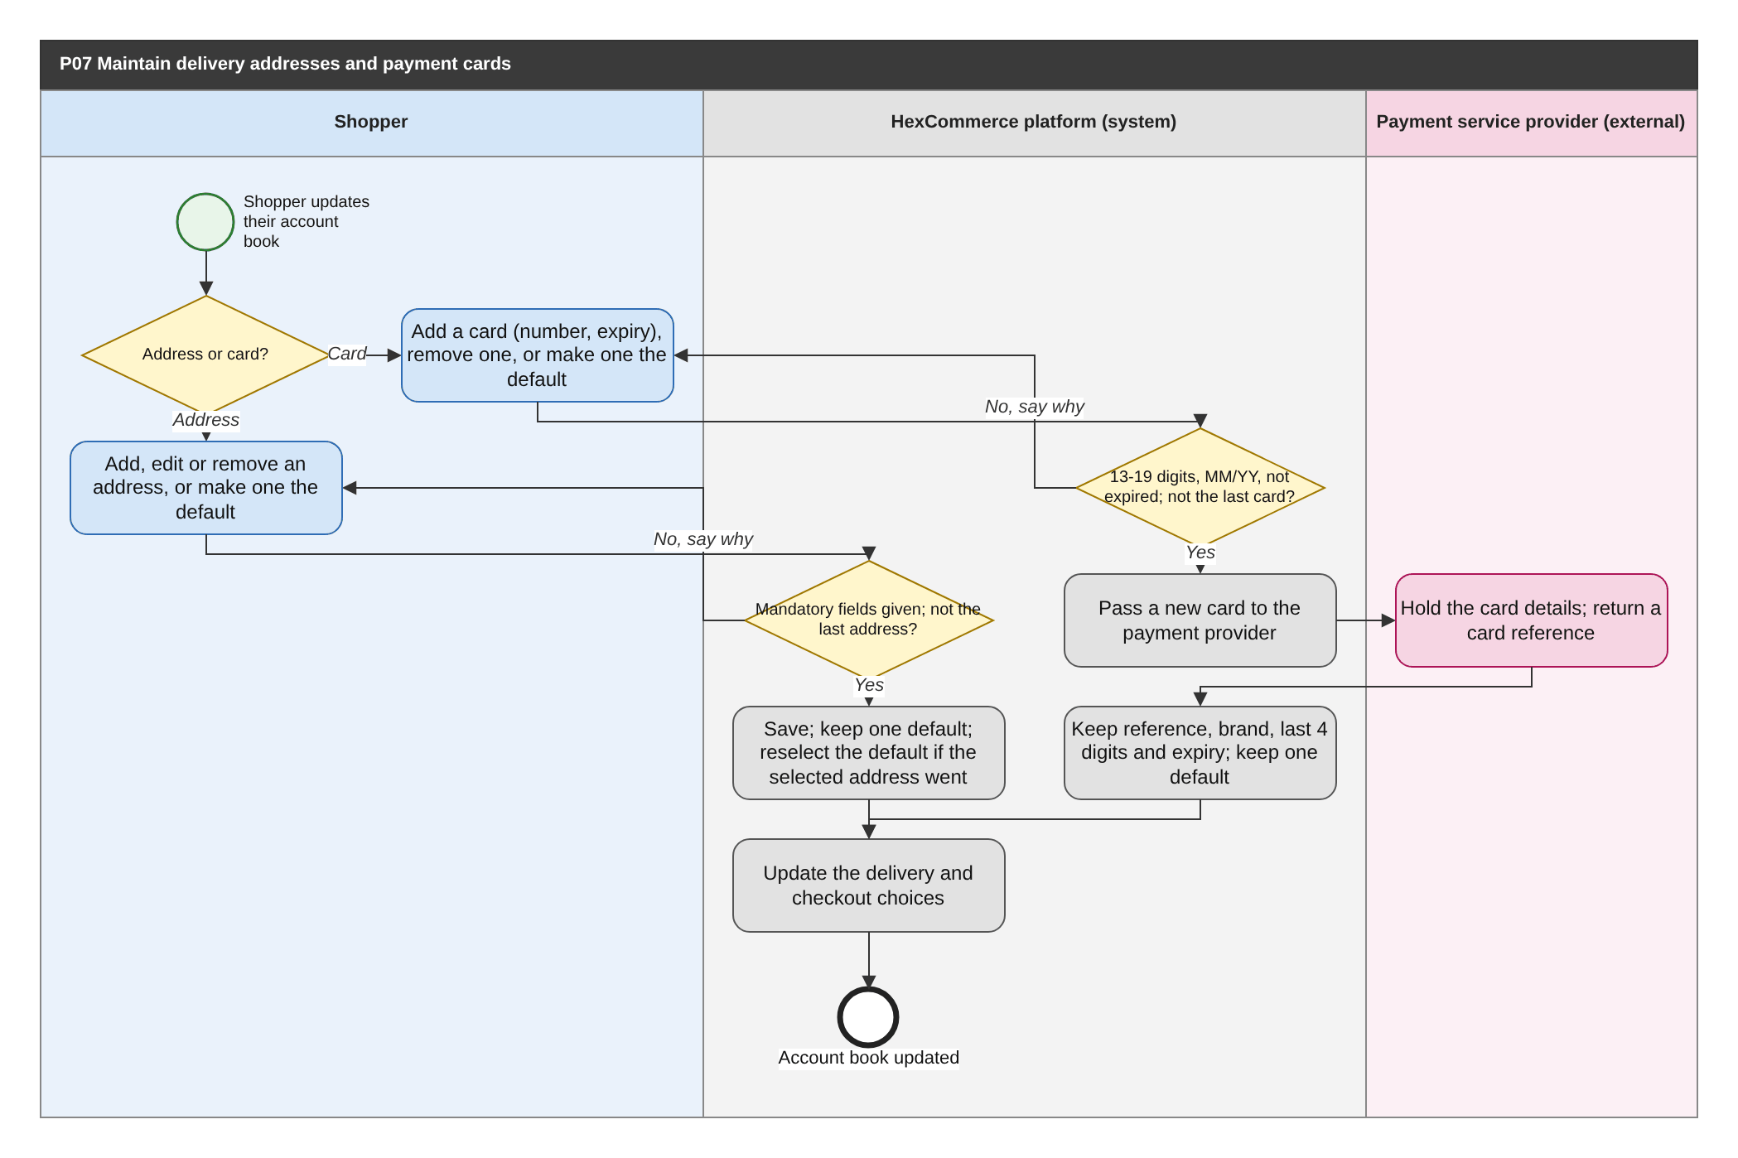
Figure 17: P07 Maintain delivery addresses and payment cards (BPMN swimlane). draw.io: page P07 of HexCommerce_Process_Diagrams.drawio.
Attribute | Description
Purpose | Keep the shopper's delivery addresses and payment cards accurate for checkout.
Trigger | The shopper chooses to maintain their addresses or cards, including during checkout.
Actors / lanes | Shopper; HexCommerce platform (system); Payment service provider (external).
Preconditions | The shopper is signed in.
Postconditions | The account book is updated and used by delivery estimates and checkout.
Change from v2.5 | Cards are now held by the payment service provider (FR-PAY-001).

Main flow
1. The shopper chooses to maintain an address or a card.
2. For an address, the shopper adds, edits or removes one, or makes one the default; the system checks the mandatory fields, saves the change and keeps exactly one default, never removing the last address.
3. For a card, the shopper adds a card (number and expiry), removes one or makes one the default; the system checks the number and expiry, passes a new card to the payment service provider and keeps only the provider's reference, the brand, the last four digits and the expiry, keeping exactly one default.
4. The system updates the delivery and checkout choices.

Exception and alternative paths
- Missing address fields, or an invalid or expired card: the shopper is told why and the entries are kept.
- Removing the last address or card: refused (BR-ACC-001).
- Removing the selected delivery address: the default address becomes the selected one (BR-ACC-003).
- An expired card cannot be made the default (BR-ACC-010).

Related requirements
BR-ACC-001, BR-ACC-002, BR-ACC-003, BR-ACC-004, BR-ACC-005, BR-ACC-006, BR-ACC-007, BR-ACC-008, BR-ACC-010, BR-SYS-001, FR-ACC-001, FR-ACC-002, FR-ACC-003, FR-ACC-004, FR-ACC-005, FR-ACC-006, FR-ACC-007, FR-ACC-008, FR-ACC-009, FR-ACC-010, FR-ACC-011, FR-CHK-016, FR-PAY-001, NFR-SEC-001, NFR-SEC-010

6.8 P08 Apply to become a seller and decide the application
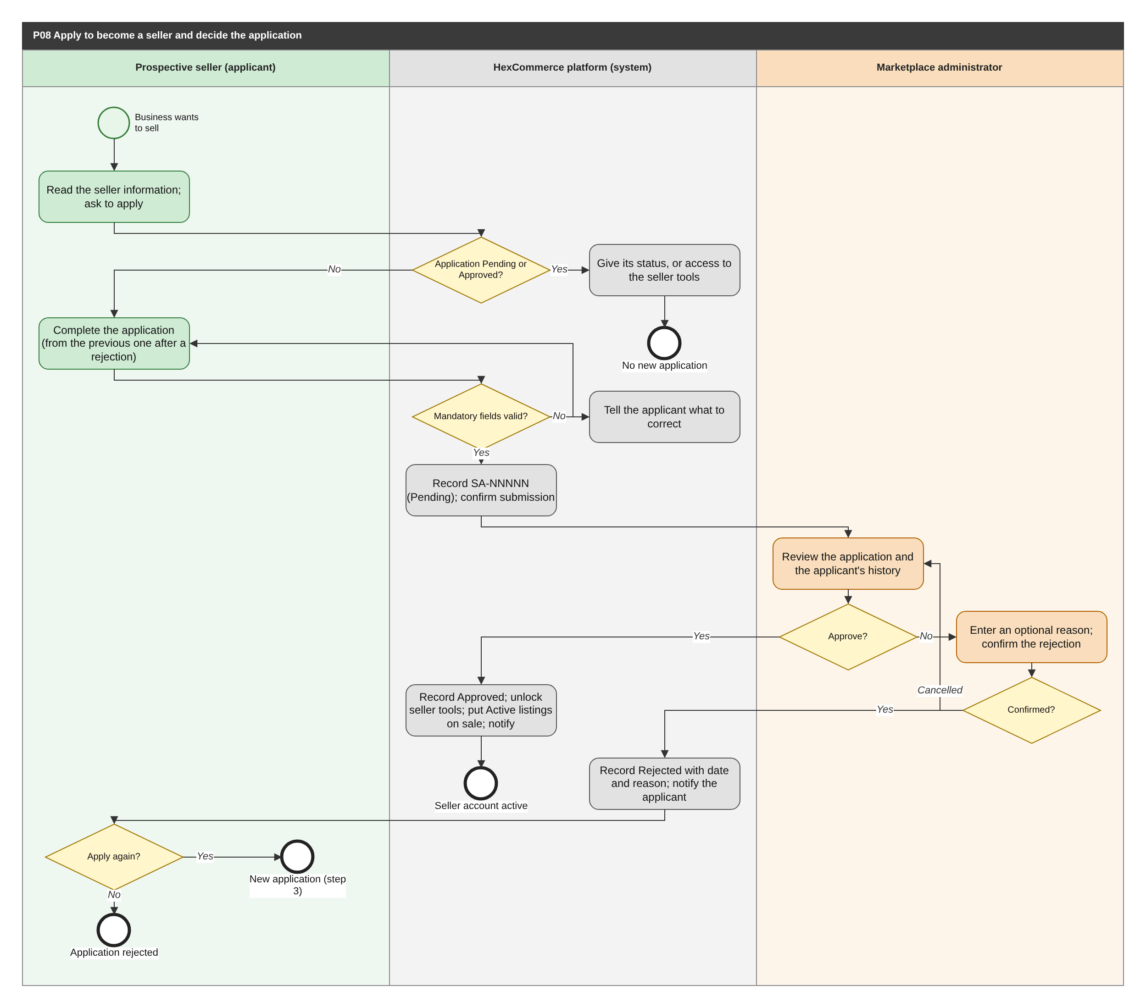
Figure 18: P08 Apply to become a seller and decide the application (BPMN swimlane). draw.io: page P08 of HexCommerce_Process_Diagrams.drawio.
Attribute | Description
Purpose | Recruit third-party sellers through a controlled application and decision.
Trigger | A signed-in shopper asks to apply to sell.
Actors / lanes | Prospective seller (applicant); HexCommerce platform (system); Marketplace administrator.
Preconditions | The shopper is signed in and has no application that is Pending or Approved.
Postconditions | The application is Approved (seller tools unlocked) or Rejected (seller tools locked; a new application is possible).
Change from v2.5 | Approval now acts on the applicant's own account for every applicant (G-22); the cancelled rejection path is drawn (G-04); reapplication creates a new application (G-21).

Main flow
1. The prospective seller reads the information for sellers and asks to apply.
2. If they already have a Pending or Approved application, the system gives its status (or access to the seller tools) instead.
3. Otherwise they complete the application; after a rejection it starts from their previous application.
4. The system validates the mandatory fields, records application SA-NNNNN as Pending and confirms submission.
5. An administrator reviews the application, with the applicant's earlier applications, and approves or rejects it.
6. On approval, the system records the decision, date and administrator, unlocks the applicant's seller tools, puts their Active listings on sale and notifies them.
7. On rejection, the administrator enters an optional reason and confirms; the system records the decision and notifies the applicant, who may apply again (a new application with its own reference, FR-SAP-015).

Exception and alternative paths
- Validation failure: the applicant is told what to correct and the entries are kept.
- The administrator cancels the rejection: the application stays Pending (G-04).
- An administrator cannot decide an application in which they are the applicant or contact (FR-ADM-015).
- A decided application can be returned to Pending (P14).

Related requirements
BR-ACC-009, BR-ADM-001, BR-SAP-001, BR-SAP-002, BR-SAP-003, BR-SAP-004, BR-SAP-005, BR-SAP-006, BR-SAP-007, BR-SAP-009, BR-SAP-010, BR-SAP-011, FR-ADM-001, FR-ADM-002, FR-ADM-003, FR-ADM-004, FR-ADM-005, FR-ADM-006, FR-ADM-008, FR-ADM-009, FR-ADM-013, FR-ADM-015, FR-NTF-007, FR-SAP-001, FR-SAP-002, FR-SAP-003, FR-SAP-004, FR-SAP-005, FR-SAP-006, FR-SAP-007, FR-SAP-008, FR-SAP-009, FR-SAP-010, FR-SAP-011, FR-SAP-012, FR-SAP-013, FR-SAP-014, FR-SAP-015, FR-SAP-016

6.9 P09 Create and publish a product listing
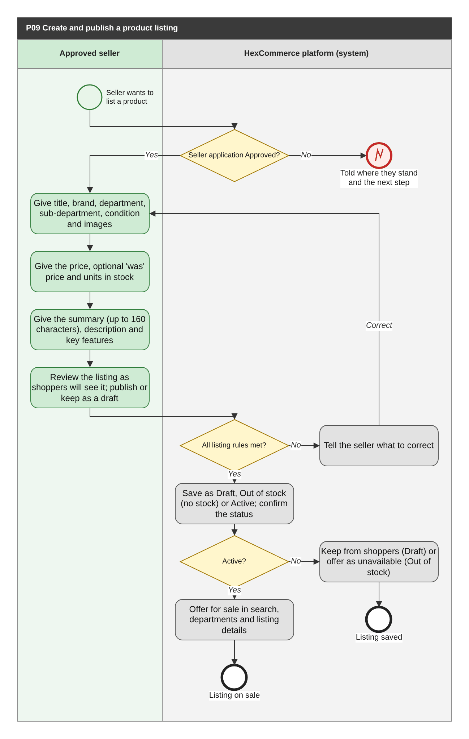
Figure 19: P09 Create and publish a product listing (BPMN swimlane). draw.io: page P09 of HexCommerce_Process_Diagrams.drawio.
Attribute | Description
Purpose | Allow an approved seller to put a new product on sale.
Trigger | The seller chooses to add a product.
Actors / lanes | Approved seller; HexCommerce platform (system).
Preconditions | The seller's own application is Approved.
Postconditions | The listing is saved with the correct status and, if Active, is on sale.
Change from v2.5 | Listing maintenance moved to its own process, P21 (G-03); the device-storage check is withdrawn.

Main flow
1. The system confirms that the seller account is approved.
2. The seller gives the product details (with images), the pricing and stock, and the description.
3. The seller reviews the listing as shoppers will see it and chooses to publish it or keep it as a draft.
4. The system checks every listing rule (BR-SLS-001, BR-SLS-006); failures are reported and the seller corrects them.
5. The system saves the listing as Draft (kept as a draft), Out of stock (no units in stock) or Active, and confirms the status.
6. Active listings go on sale in search, department results and their own details; Drafts are never offered and Out-of-stock listings are offered as unavailable.

Exception and alternative paths
- Seller account not approved: the seller is told where they stand and the next step.
- Publishing with no units in stock: the seller is told beforehand that it will be Out of stock (FR-SLS-022).
- Images refused or unreadable: the seller is told how many and why (FR-SLS-019).
- The change cannot be saved: the seller is told and the entries are kept (NFR-REL-003).
- Maintaining an existing listing is P21.

Related requirements
BR-SAP-004, BR-SLS-001, BR-SLS-002, BR-SLS-003, BR-SLS-004, BR-SLS-006, BR-SLS-010, FR-PDP-014, FR-SAP-010, FR-SAP-011, FR-SAP-016, FR-SDB-001, FR-SLS-003, FR-SLS-004, FR-SLS-005, FR-SLS-006, FR-SLS-007, FR-SLS-008, FR-SLS-009, FR-SLS-010, FR-SLS-011, FR-SLS-012, FR-SLS-018, FR-SLS-019, FR-SLS-020, FR-SLS-022, NFR-PRF-004

6.10 P10 Run a seller deal (time-limited discount)
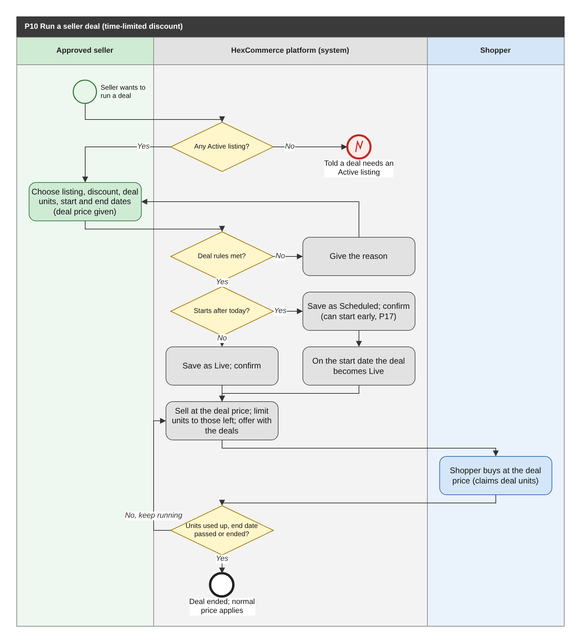
Figure 20: P10 Run a seller deal (time-limited discount) (BPMN swimlane). draw.io: page P10 of HexCommerce_Process_Diagrams.drawio.
Attribute | Description
Purpose | Let sellers drive sales with time-limited percentage discounts, controlled by business rules.
Trigger | The seller chooses to create a deal.
Actors / lanes | Approved seller; HexCommerce platform (system); Shopper.
Preconditions | The seller account is approved and has at least one Active listing.
Postconditions | The deal is recorded with a status that follows its dates and claims.
Change from v2.5 | Starting a Scheduled deal early moved to P17, where its refusal branch is drawn (G-13); the device-storage check is withdrawn.

Main flow
1. The system confirms that the seller has an Active listing.
2. The seller chooses the listing, discount percentage, deal units and start and end dates; the system gives the resulting deal price.
3. The system checks the deal rules (BR-SDL-001 to BR-SDL-005) and saves the deal as Live (starting today or earlier) or Scheduled, confirming which.
4. A Scheduled deal becomes Live on its start date, or earlier if the seller starts it early (P17).
5. While Live, with the listing Active and deal units left, the listing sells at the deal price, the units on offer are limited to those left (BR-SDL-014), and the deal is offered with the store deals.
6. Shoppers buying at the deal price claim deal units; when the units are used up, the end date passes or the seller ends the deal, it ends and the normal price applies.

Exception and alternative paths
- No Active listing: the seller is told a deal needs one and is directed to add a product.
- Rule broken (discount outside 5-70%, units outside 1 to stock, invalid dates, overlap): the reason is given.
- Starting early, editing, ending or removing a deal is P17.

Related requirements
BR-CRT-002, BR-SDL-001, BR-SDL-002, BR-SDL-004, BR-SDL-005, BR-SDL-006, BR-SDL-007, BR-SDL-008, BR-SDL-009, BR-SDL-010, BR-SDL-012, BR-SDL-013, BR-SDL-014, BR-SYS-001, FR-CHK-012, FR-MKT-012, FR-PDP-012, FR-PDP-013, FR-SDL-001, FR-SDL-002, FR-SDL-003, FR-SDL-004, FR-SDL-005, FR-SDL-006, FR-SDL-008, FR-SDL-011, FR-SDL-012, FR-SDL-013

6.11 P11 Fulfil a seller order
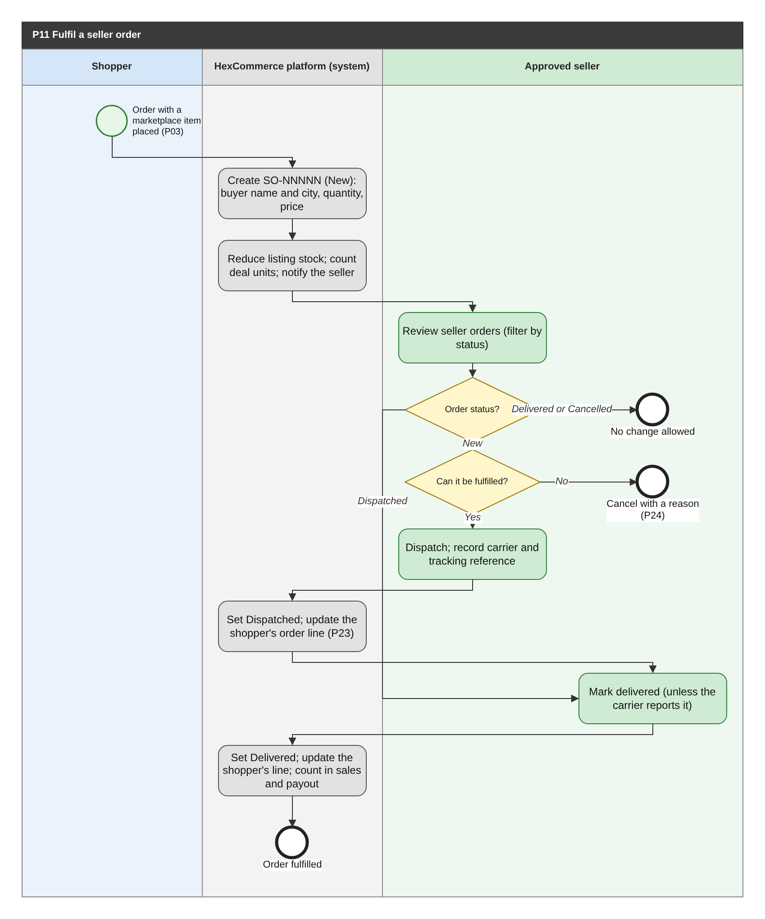
Figure 21: P11 Fulfil a seller order (BPMN swimlane). draw.io: page P11 of HexCommerce_Process_Diagrams.drawio.
Attribute | Description
Purpose | Ensure that orders for marketplace items are dispatched and delivered by the seller, and reflected in the shopper's order and the seller's earnings.
Trigger | A shopper places an order containing a marketplace item (P03).
Actors / lanes | Shopper; HexCommerce platform (system); Approved seller.
Preconditions | The seller account is approved and the listing was Active when bought.
Postconditions | The seller order is Delivered (or Cancelled, P24); the shopper's order line has the same progress; the sale counts in the seller's figures and payouts.
Change from v2.5 | Seller dispatch now updates the shopper's order (resolves Q-07); cancellation by the seller is new (Q-19).

Main flow
1. The system creates seller order SO-NNNNN with status New, recording the buyer's name and city, the quantity and the unit price.
2. The system reduces the listing stock (setting Out of stock at zero), counts any deal units claimed and notifies the seller.
3. The seller reviews their seller orders, filtering by status.
4. For a New order, the seller dispatches the item and records the carrier and tracking reference; the status becomes Dispatched and the shopper's order line becomes Shipped (P23).
5. When the item is delivered, the seller marks it delivered or the carrier reports it; the status becomes Delivered, the shopper's line is updated, and the order counts in units sold, revenue and estimated payout.

Exception and alternative paths
- The seller cannot fulfil a New order: they cancel it with a reason (P24).
- Delivered or Cancelled orders cannot be changed by the seller.
- Returns of the seller's items are received and decided by the seller (P25).

Related requirements
BR-SLS-005, BR-SOR-001, BR-SOR-002, BR-SOR-003, BR-SOR-004, BR-SOR-005, BR-SOR-006, FR-CHK-010, FR-CHK-011, FR-CHK-022, FR-DEF-013, FR-NTF-008, FR-NTF-010, FR-ORD-014, FR-SAP-016, FR-SDB-001, FR-SDB-002, FR-SDB-003, FR-SOR-001, FR-SOR-002, FR-SOR-003, FR-SOR-004, FR-SOR-005, FR-SOR-006, NFR-SEC-003

6.12 P12 Register, sign in and recover access
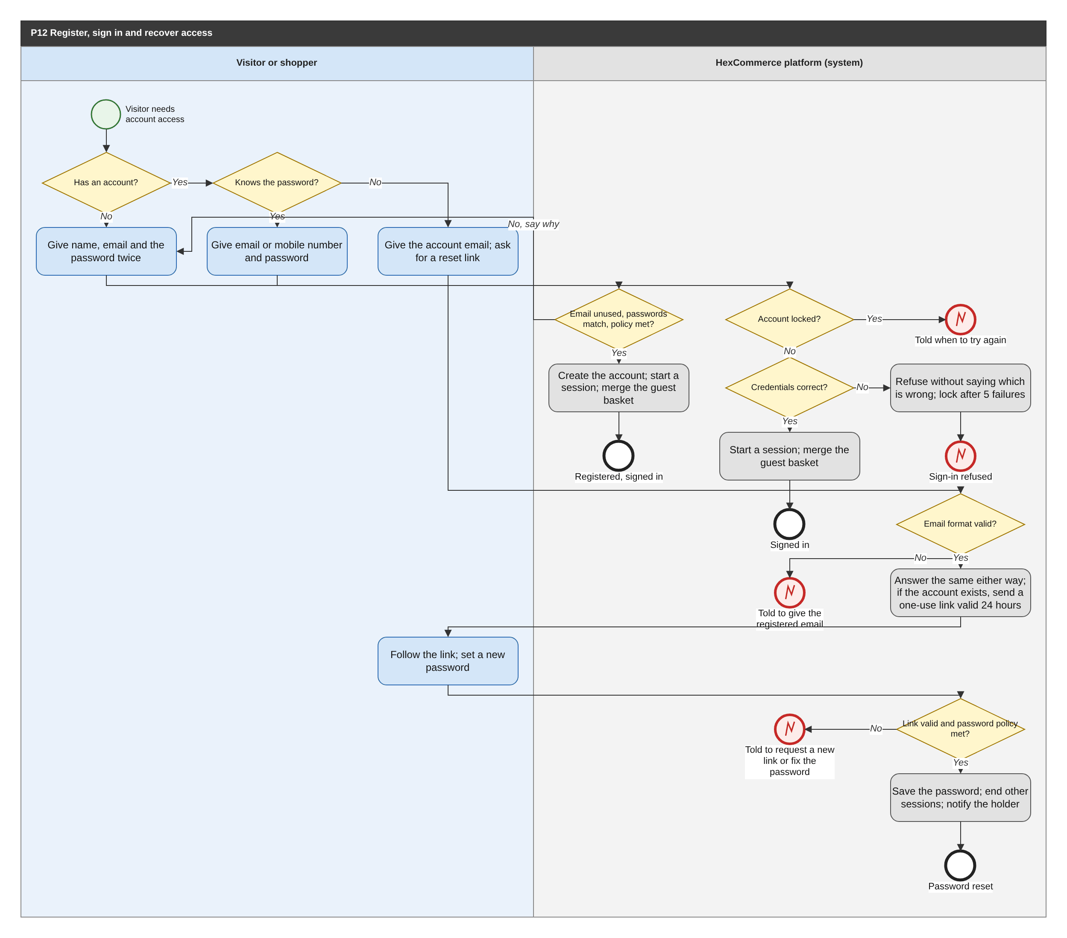
Figure 22: P12 Register, sign in and recover access (BPMN swimlane). draw.io: page P12 of HexCommerce_Process_Diagrams.drawio.
Attribute | Description
Purpose | Give customers their own secure account: registration, sign-in, and recovery of a forgotten password.
Trigger | A visitor chooses to register, to sign in, or to reset a forgotten password, or is asked to sign in (for example at checkout).
Actors / lanes | Visitor or shopper; HexCommerce platform (system).
Preconditions | None.
Postconditions | The visitor has a new account and is signed in, is signed in to their existing account, or has reset their password.
Change from v2.5 | Replaces the simulated journeys with real authentication (supersedes FR-DEF-001); adds registration checks, lock-out and completing a reset.

Main flow
1. The visitor chooses to register (no account yet), sign in (knows the password) or reset the password (forgotten).
2. To register, the visitor gives their name, email address and a password entered twice; the system checks that the email address is not already registered, the passwords match and the password policy is met (BR-ACC-011), creates the account and signs the shopper in.
3. To sign in, the visitor gives their email address or mobile number and password; if the account is not locked and the credentials are correct, the system starts a session.
4. On registration or sign-in, the system merges the guest basket into the shopper's saved basket (FR-CRT-018).
5. To reset the password, the visitor gives the account email; the system checks its format and answers the same way whether or not an account exists; if it exists, it sends a one-use link valid for 24 hours.
6. The visitor follows the link and sets a new password; the system checks the link and the policy, saves the password, ends every other session of the account and notifies the holder.

Exception and alternative paths
- Email already registered: the visitor is told and invited to sign in or reset the password.
- Incorrect credentials: refused without saying which is wrong; after 5 consecutive failures sign-in is locked for 15 minutes and the holder is told (BR-ACC-012).
- Invalid email format for a reset: the visitor is told to give the email address they registered with.
- Expired or used reset link, or a password that breaks the policy: the visitor is told and can request a new link.
- Inactivity: the session ends after the inactivity period (BR-ACC-013); see P20.

Related requirements
BR-ACC-009, BR-ACC-011, BR-ACC-012, BR-ACC-013, FR-ACC-013, FR-ACC-014, FR-ACC-015, FR-ACC-018, FR-ACC-019, FR-ACC-020, FR-ACC-021, FR-ACC-022, FR-ACC-023, FR-CHK-021, FR-CRT-016, FR-CRT-018, FR-DAT-010, FR-DAT-011, FR-NTF-006, NFR-SEC-004, NFR-SEC-007

6.13 P13 Maintain seller business details
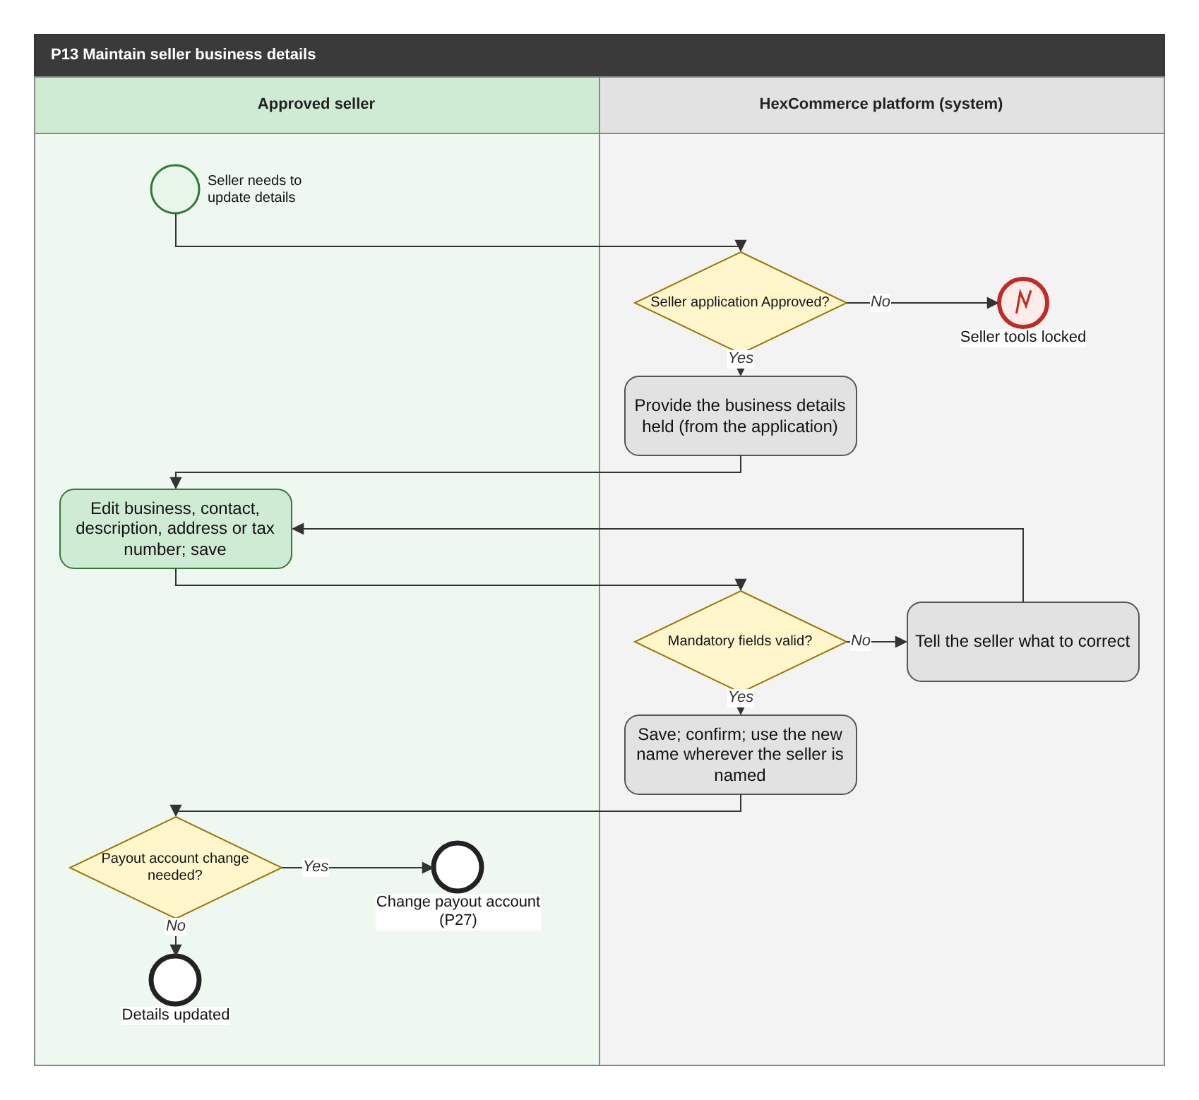
Figure 23: P13 Maintain seller business details (BPMN swimlane). draw.io: page P13 of HexCommerce_Process_Diagrams.drawio.
Attribute | Description
Purpose | Keep the business details the marketplace holds for a seller accurate, and reflect them wherever the seller is named.
Trigger | The seller chooses to view or change their business details.
Actors / lanes | Approved seller; HexCommerce platform (system).
Preconditions | The seller's own application is Approved.
Postconditions | The seller record holds the new details, and everywhere the seller is named uses them.
Change from v2.5 | The payout-account change, previously made outside the system, is now P27.

Main flow
1. The system confirms that the seller account is approved and provides the business details held, taken from the application.
2. The seller edits the business, contact, description, registered address or tax details and saves.
3. The system checks the mandatory fields (BR-SAP-008), saves the details and confirms the save.
4. The system uses any new business name wherever the seller is named, including on their listings and in the application queue.
5. If the payout account must change, the seller does so through P27.

Exception and alternative paths
- Seller account not approved: the seller tools are locked and the seller is told where they stand.
- Validation failure: the seller is told what to correct and the entries are kept.
- Years trading cannot be changed; the payout account is given only in masked form.

Related requirements
BR-ACC-009, BR-SAP-008, FR-SAP-010, FR-SAP-011, FR-SDB-005, FR-SDB-006, FR-SDB-007, FR-SDB-008

6.14 P14 Return a decided seller application to Pending
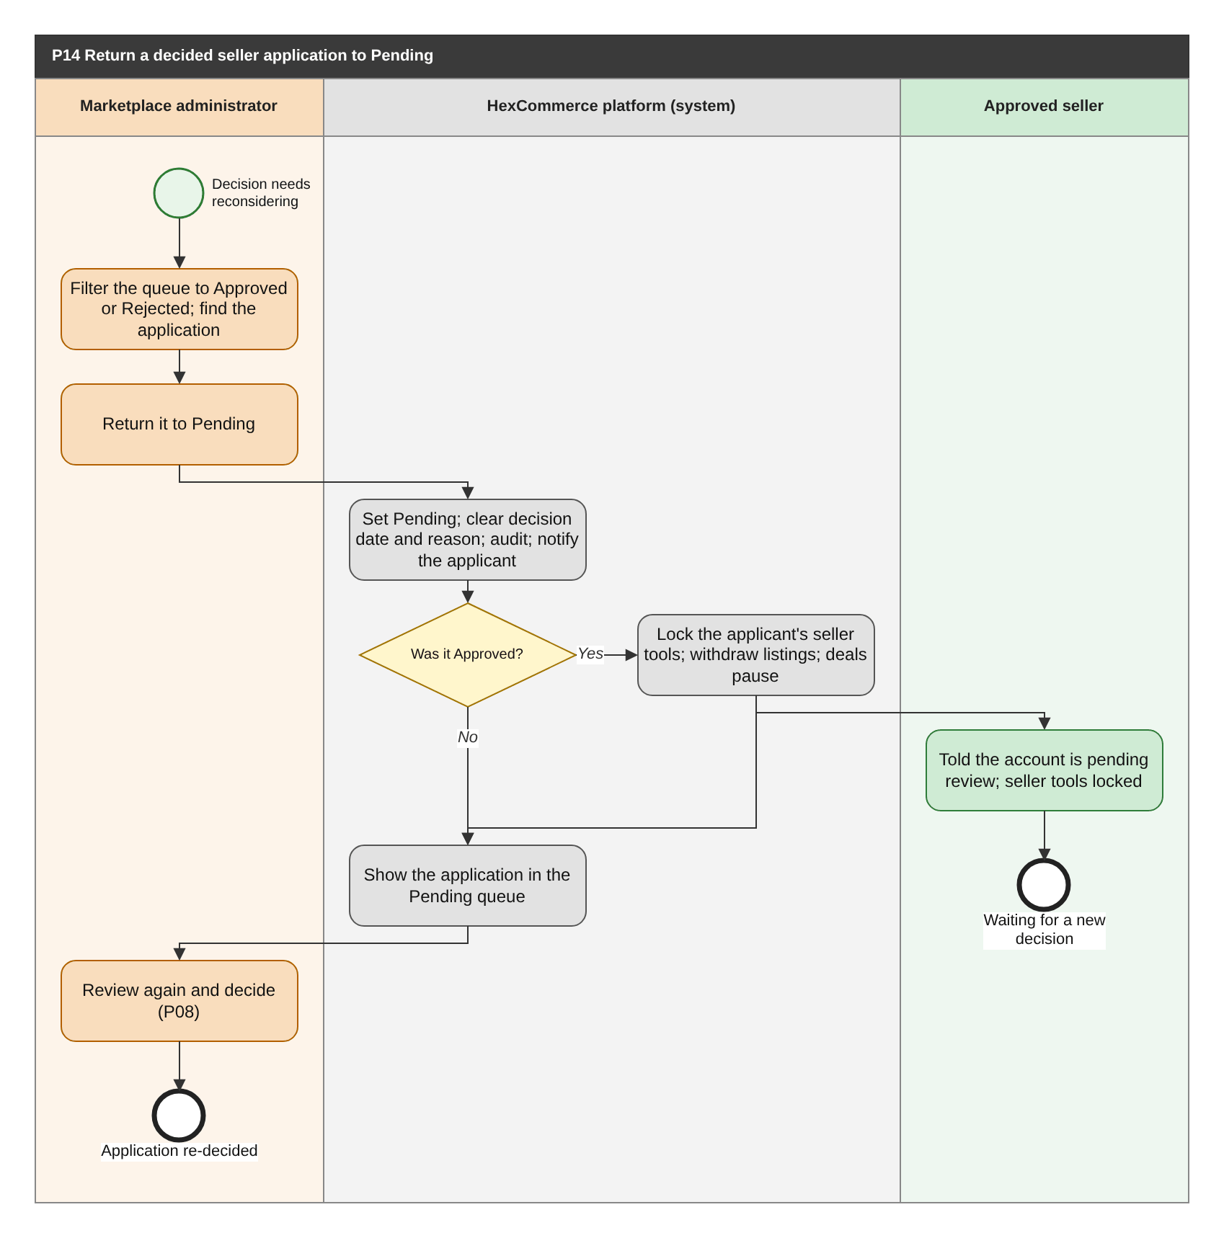
Figure 24: P14 Return a decided seller application to Pending (BPMN swimlane). draw.io: page P14 of HexCommerce_Process_Diagrams.drawio.
Attribute | Description
Purpose | Allow an administrator to reopen a seller-application decision, with an immediate effect on the applicant's access.
Trigger | An administrator decides that a past approval or rejection needs to be reconsidered.
Actors / lanes | Marketplace administrator; HexCommerce platform (system); Approved seller.
Preconditions | The application is Approved or Rejected; the administrator is signed in with the administrator role.
Postconditions | The application is Pending and awaits a new decision; the applicant's access follows the new status.
Change from v2.5 | Applies to every applicant, not only 'the shopper's own' account (G-22); notification and audit are new.

Main flow
1. The administrator filters the queue to Approved or Rejected applications and returns the application to Pending.
2. The system sets the status to Pending, clears the decision date and reason, records the change in the audit record and notifies the applicant.
3. If the application was Approved, the system immediately locks the applicant's seller tools and withdraws their listings from sale; the applicant is told the account is pending review.
4. The application appears in the Pending queue and the administrator decides it again (P08).

Exception and alternative paths
- Live deals on the withdrawn listings stop reaching shoppers while the account is locked (BR-SDL-008).

Related requirements
BR-SAP-003, BR-SAP-004, BR-SDL-008, FR-ADM-002, FR-ADM-007, FR-ADM-009, FR-ADM-013, FR-NTF-007, FR-PDP-014

6.15 P15 Reopen a resolved customer-service issue
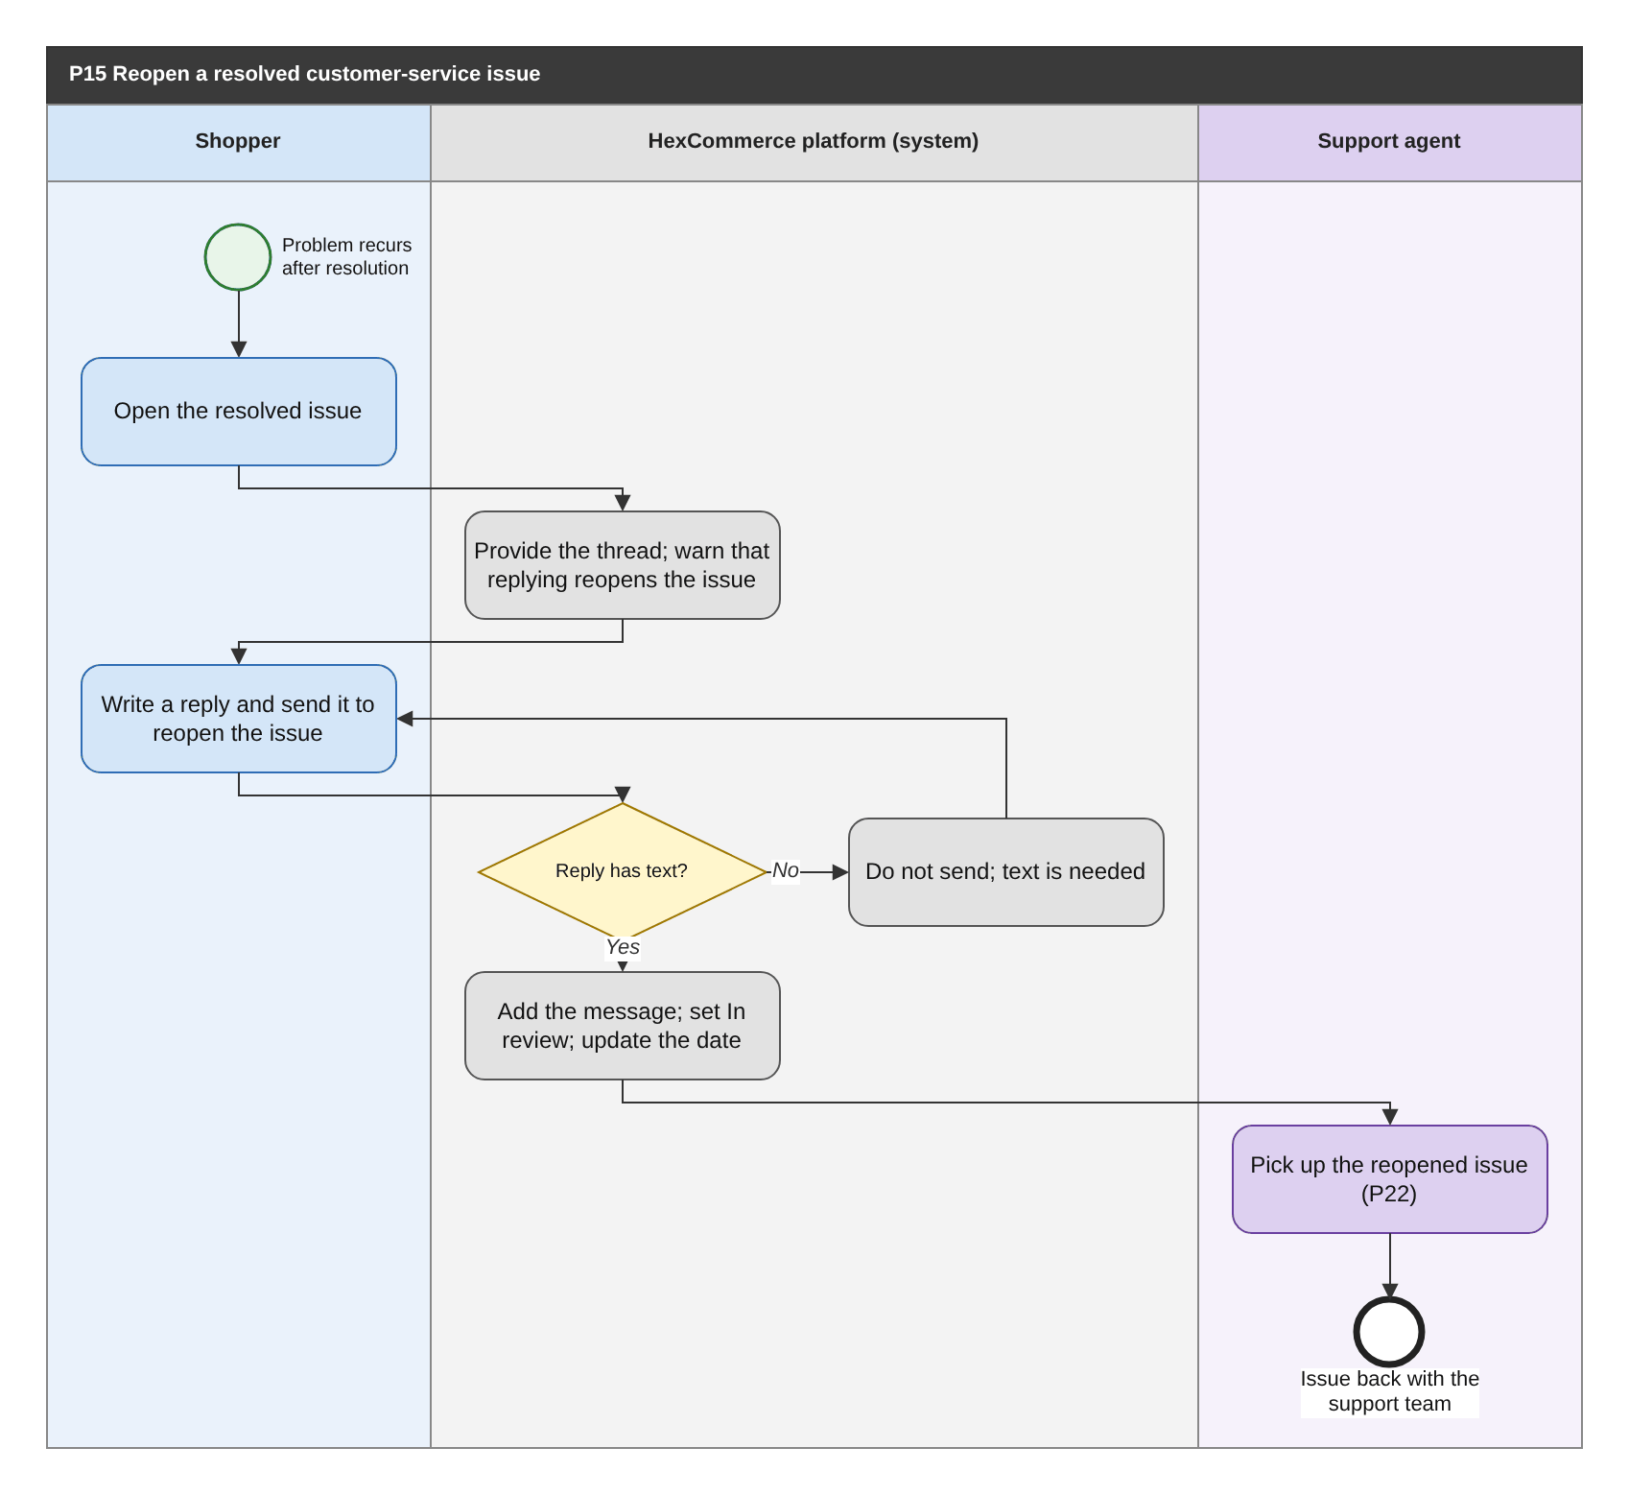
Figure 25: P15 Reopen a resolved customer-service issue (BPMN swimlane). draw.io: page P15 of HexCommerce_Process_Diagrams.drawio.
Attribute | Description
Purpose | Let a shopper reopen an issue that was resolved but has recurred, returning it to the support team.
Trigger | The shopper opens a Resolved issue.
Actors / lanes | Shopper; HexCommerce platform (system); Support agent.
Preconditions | The shopper is signed in; the issue has the status Resolved.
Postconditions | The issue is In review with the shopper's new message at the end of the thread, back with the support team.
Change from v2.5 | The support team is now in the system (P22).

Main flow
1. The shopper opens the resolved issue.
2. The system provides the thread and warns that replying will reopen the issue.
3. The shopper writes a reply and sends it.
4. The system checks that the reply has text, adds it to the thread, sets the status to In review and updates the issue date.
5. A support agent picks up the reopened issue (P22).

Exception and alternative paths
- Empty reply: nothing is sent until text is entered.

Related requirements
BR-CS-001, FR-CS-009, FR-CS-010, FR-CS-011

6.16 P16 Choose the delivery address for the next order
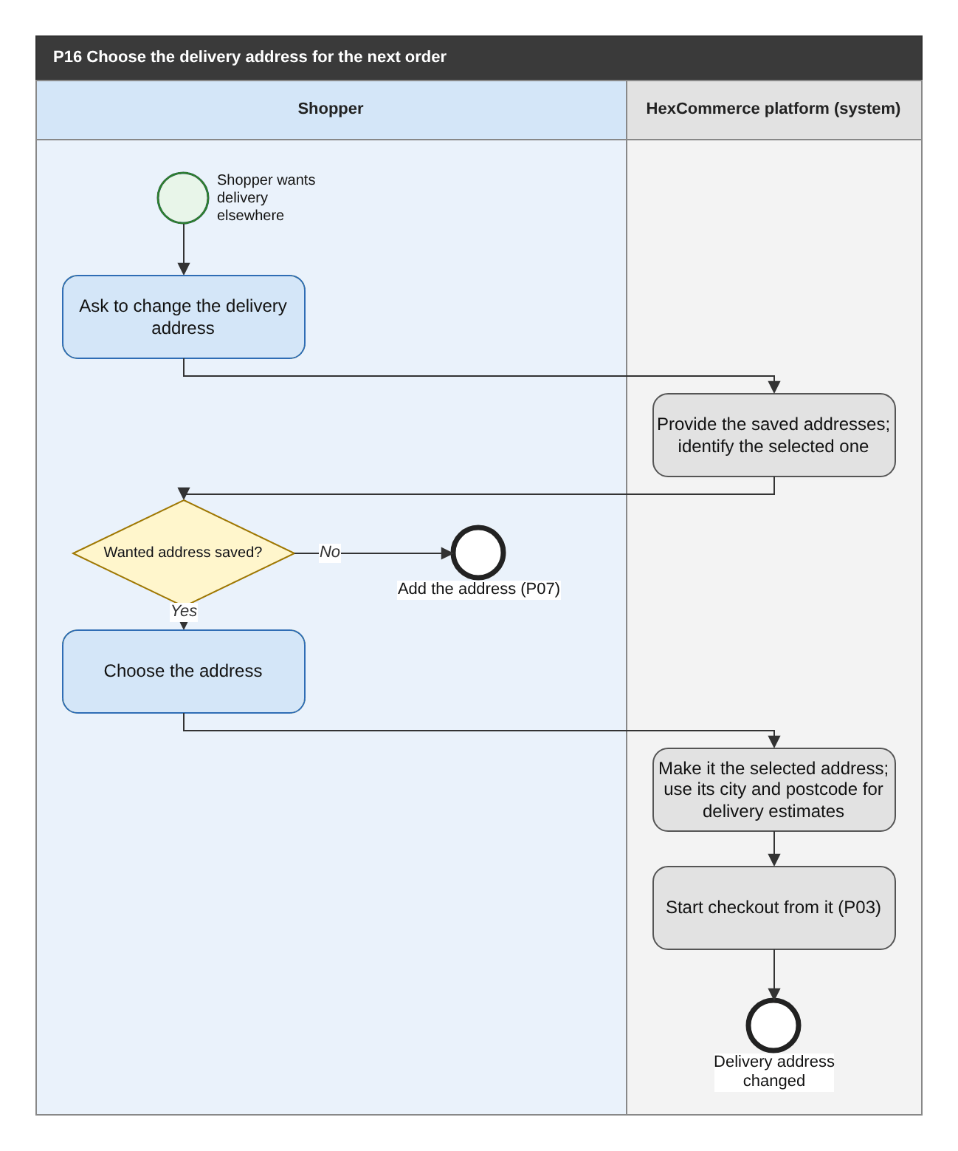
Figure 26: P16 Choose the delivery address for the next order (BPMN swimlane). draw.io: page P16 of HexCommerce_Process_Diagrams.drawio.
Attribute | Description
Purpose | Let the shopper choose where their next order will be delivered, at any time while shopping.
Trigger | The shopper asks to change the delivery address.
Actors / lanes | Shopper; HexCommerce platform (system).
Preconditions | The shopper is signed in and has at least one saved delivery address (BR-ACC-001).
Postconditions | The chosen address is the selected delivery address used for delivery estimates and at checkout.
Change from v2.5 | Renamed from 'Change the delivery address from the header'; describes the capability, not where it is offered.

Main flow
1. The shopper asks to change the delivery address.
2. The system provides the saved addresses and identifies the one currently selected.
3. If the wanted address is saved, the shopper chooses it.
4. The system makes it the selected delivery address and uses its city and postcode wherever delivery estimates are given.
5. Checkout starts from the selected address (P03).

Exception and alternative paths
- Address not saved: the shopper adds it (P07).
- The selected address is removed or no longer exists: the default address is selected instead (BR-ACC-003).

Related requirements
BR-ACC-003, FR-ACC-007, FR-CHK-002

6.17 P17 Maintain a seller deal (start early, edit, end or remove)
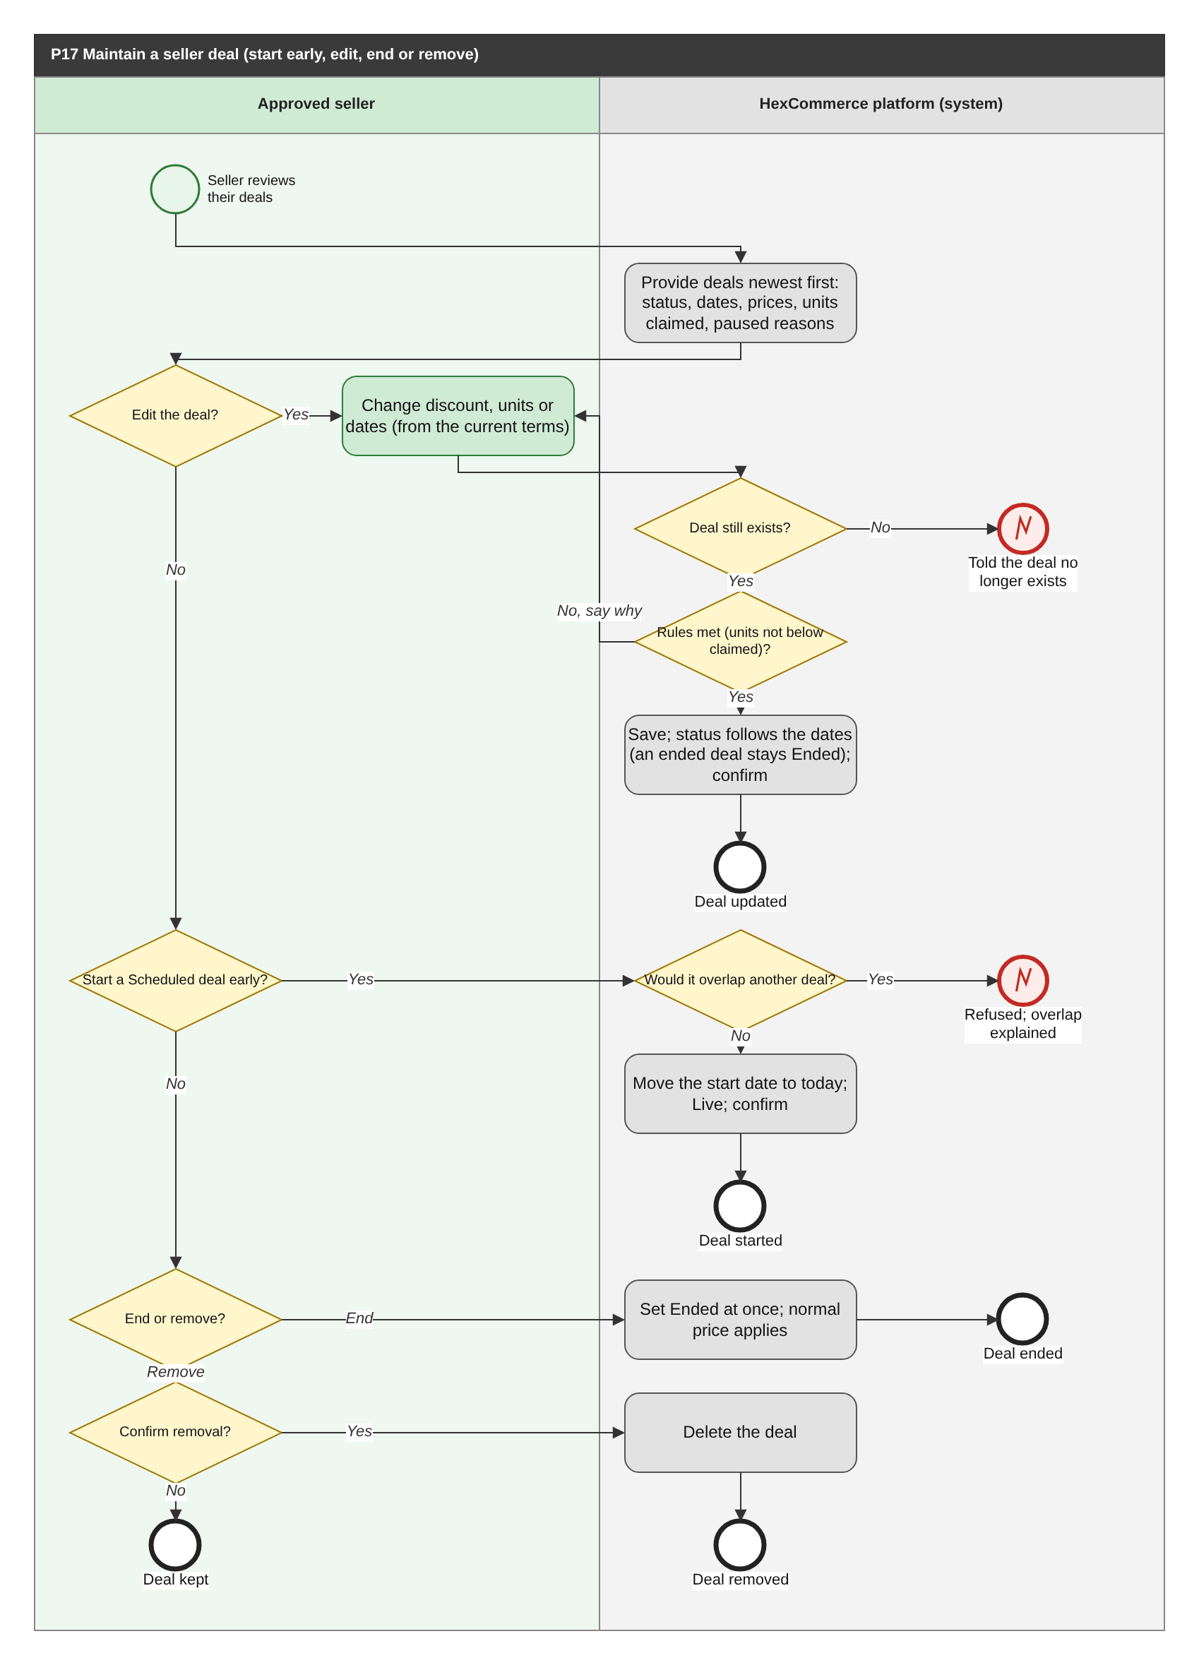
Figure 27: P17 Maintain a seller deal (start early, edit, end or remove) (BPMN swimlane). draw.io: page P17 of HexCommerce_Process_Diagrams.drawio.
Attribute | Description
Purpose | Let an approved seller keep a deal correct after it is created: start it early, change its terms, stop it, or delete it.
Trigger | The seller reviews their deals.
Actors / lanes | Approved seller; HexCommerce platform (system).
Preconditions | The seller's own application is Approved and the seller has at least one deal (P10).
Postconditions | The deal has started, holds its new terms, is Ended, or no longer exists. Shoppers get the price that follows from its status (BR-SDL-008).
Change from v2.5 | Starting a Scheduled deal early moved here from P10, with its refusal branch; the not-found end is drawn (G-13).

Main flow
1. The system provides the deals, newest first, with status, reference, dates, deal price against normal price and units claimed, a status filter, and the reason any Live deal is not reaching shoppers.
2. To edit, the seller changes the discount, deal units or dates, starting from the current terms (the deal's own listing is still offered when no longer Active). The system checks the deal rules, including that deal units are not below those already claimed, saves the deal and confirms; its status follows its new dates, except that a deal the seller ended stays Ended.
3. To start a Scheduled deal early, the seller asks to start it; unless that would overlap another deal on the listing, the system moves its start date to today and it becomes Live (BR-SDL-010).
4. To end a Live or Scheduled deal, the seller ends it; the system sets it to Ended at once, the normal price applies and the deal is no longer offered.
5. To remove a deal, the seller confirms the removal and the system deletes the deal.

Exception and alternative paths
- Starting early would overlap another deal: refused, with the dates of the other deal.
- Rule broken when editing: the reason is given and the entries are kept.
- The deal no longer exists (for example, its listing was removed, BR-SLS-007): the seller is told.
- The seller does not confirm a removal: the deal is unchanged.
- An ended deal cannot be restarted or ended again, but can still be edited or removed.
- A deal's units on offer never exceed the listing's stock (BR-SDL-014); the seller is told when the deal units exceed the stock (FR-SDL-014).

Related requirements
BR-SDL-001, BR-SDL-002, BR-SDL-003, BR-SDL-004, BR-SDL-005, BR-SDL-007, BR-SDL-008, BR-SDL-011, BR-SDL-014, BR-SLS-007, FR-SDL-001, FR-SDL-002, FR-SDL-005, FR-SDL-007, FR-SDL-009, FR-SDL-010, FR-SDL-011, FR-SDL-014, FR-SDL-015, NFR-USE-003

6.18 P18 Delete or edit a review you wrote
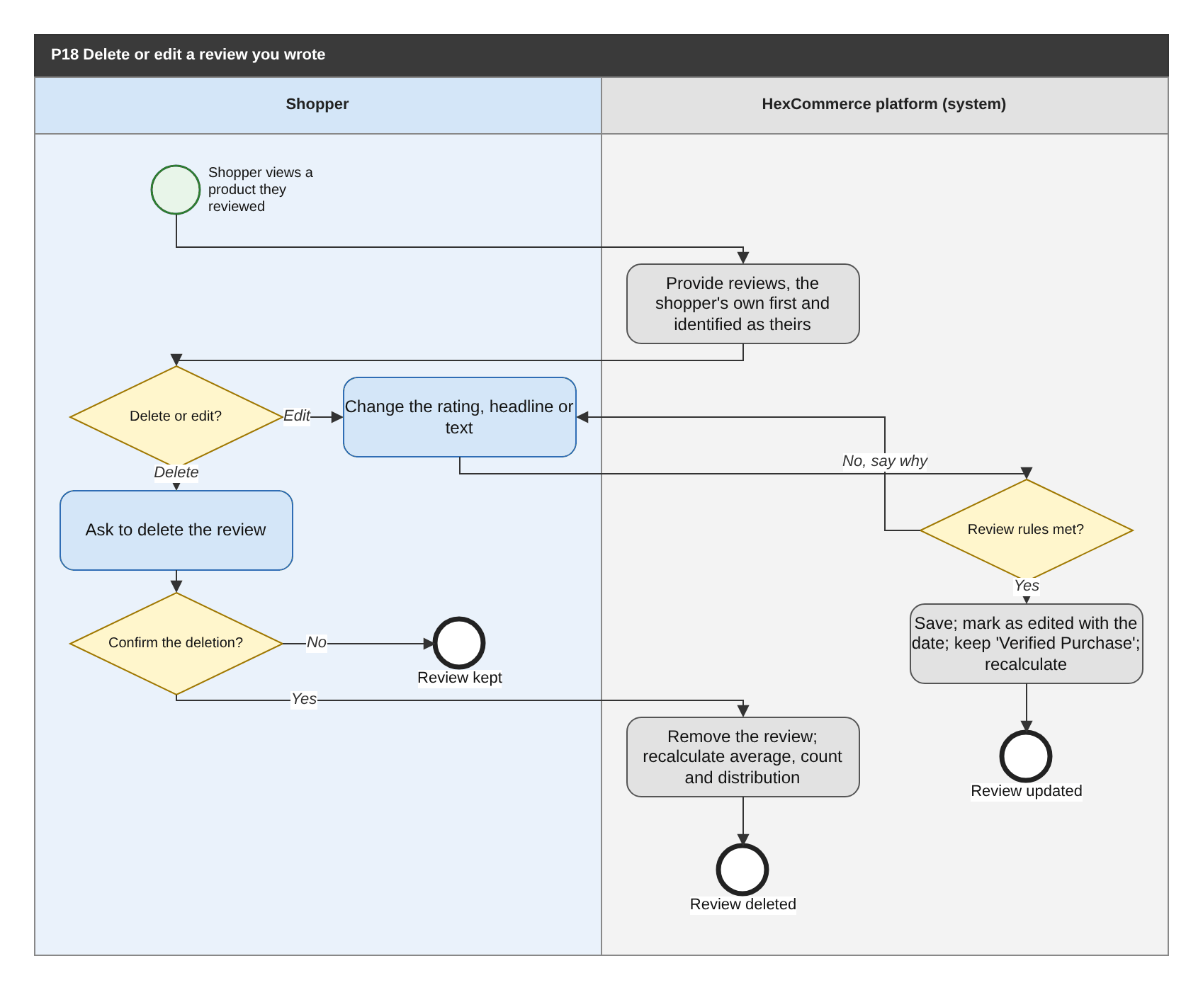
Figure 28: P18 Delete or edit a review you wrote (BPMN swimlane). draw.io: page P18 of HexCommerce_Process_Diagrams.drawio.
Attribute | Description
Purpose | Let a shopper withdraw or correct a review they wrote, so that the product's rating reflects only reviews they stand by.
Trigger | The shopper views a catalogue product they have reviewed.
Actors / lanes | Shopper; HexCommerce platform (system).
Preconditions | The shopper is signed in and has written at least one review of the product (P06).
Postconditions | The review is deleted, or updated and marked as edited, and the product's average rating, rating count and distribution reflect the change.
Change from v2.5 | Renamed from 'Delete a review you wrote'; adds the deletion confirmation and editing (Q-29, to be confirmed).

Main flow
1. The system provides the product's reviews, giving the shopper's own precedence and identifying them as theirs (FR-REV-007).
2. For a review they wrote, the shopper can delete it or edit it; for other reviews they can vote instead (P06).
3. To delete, the shopper confirms the deletion; the system removes the review and recalculates the average rating, rating count and distribution.
4. To edit, the shopper changes the rating, headline or text; the system checks the review rules, saves the review, marks it as edited with the date, keeps its 'Verified Purchase' label and recalculates the rating figures.

Exception and alternative paths
- Review written by another customer: it cannot be deleted or edited; the shopper can mark it helpful (P06) or report it (P31).
- The shopper does not confirm the deletion: the review is kept.
- A deleted review cannot be restored.
- Catalogue ratings loaded with the catalogue cannot be deleted by shoppers.

Related requirements
BR-REV-004, BR-REV-005, BR-REV-006, FR-REV-007, FR-REV-008, FR-REV-012, FR-REV-015, NFR-USE-003

6.19 P19 Move a wish-list or saved-for-later item to the basket
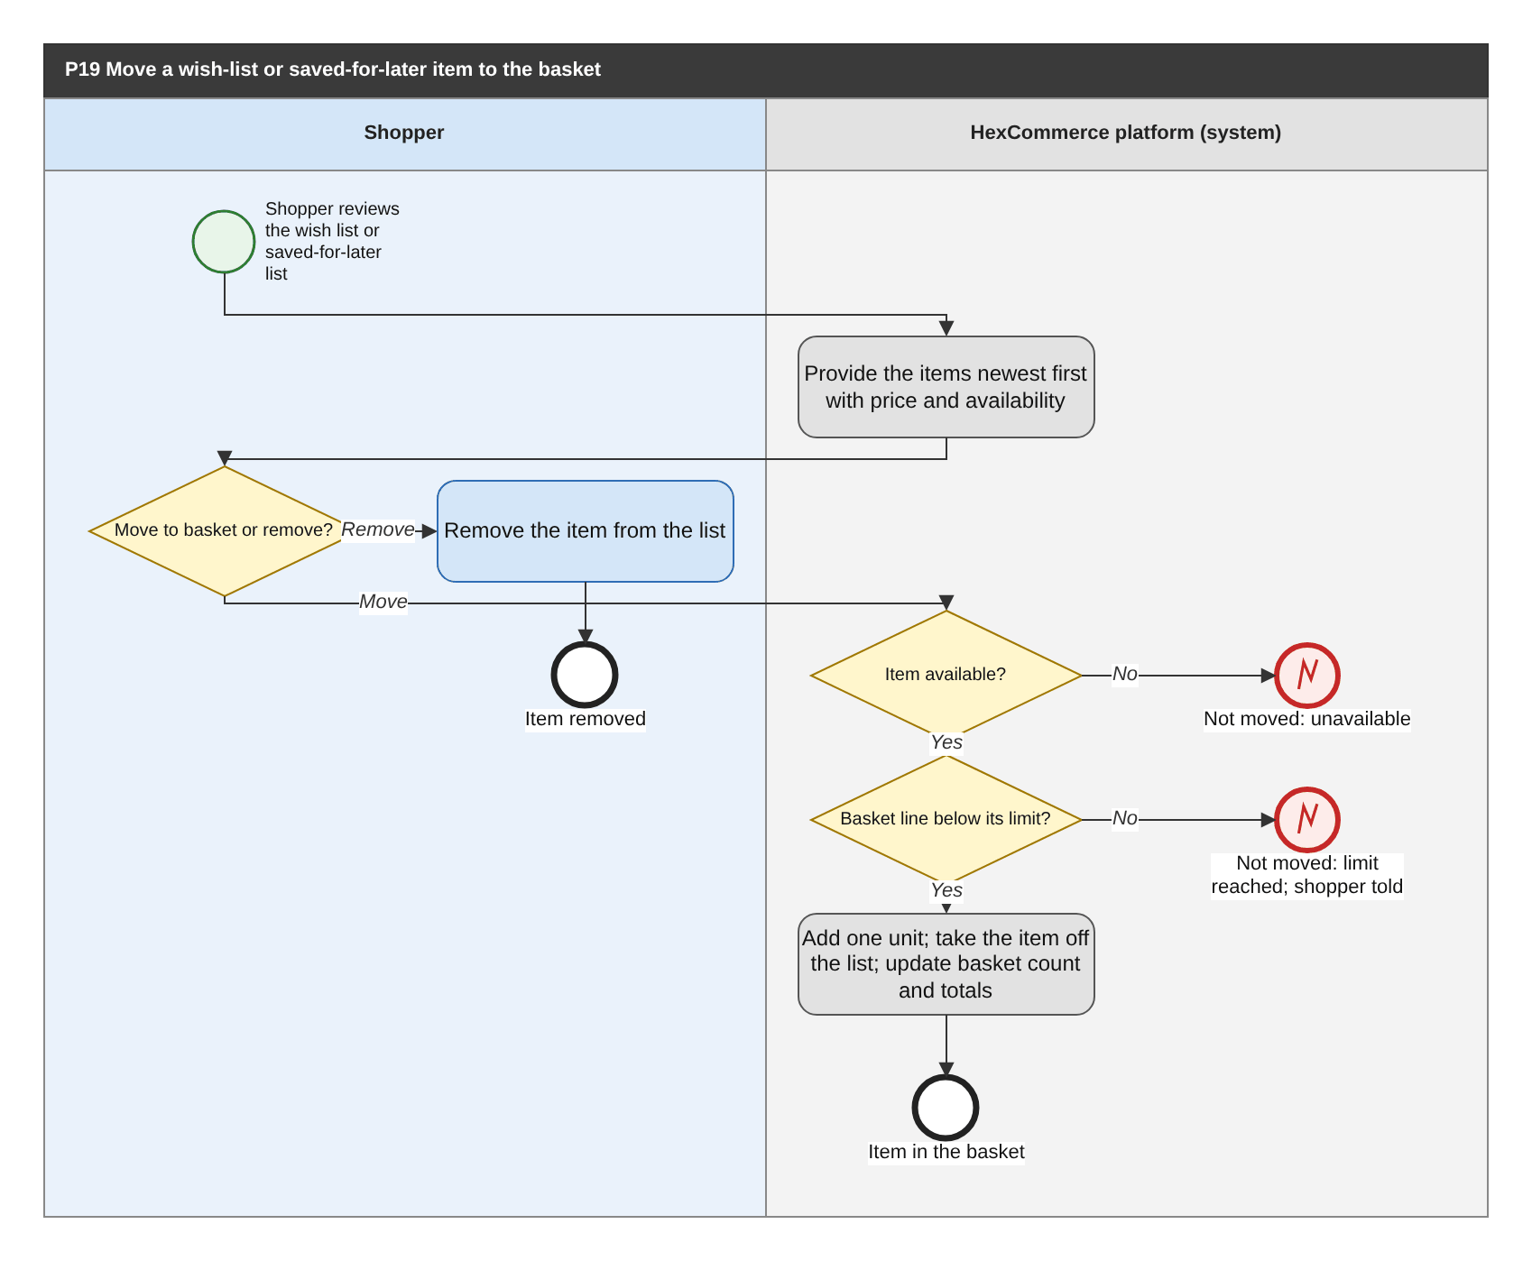
Figure 29: P19 Move a wish-list or saved-for-later item to the basket (BPMN swimlane). draw.io: page P19 of HexCommerce_Process_Diagrams.drawio.
Attribute | Description
Purpose | Let the shopper turn an item they saved earlier into a purchase, or clear items they no longer want.
Trigger | The shopper reviews their wish list or their saved-for-later list.
Actors / lanes | Shopper; HexCommerce platform (system).
Preconditions | The shopper is signed in and has at least one item on the wish list or the saved-for-later list (P02).
Postconditions | The item is in the basket and off the list, or it has been removed from the list; the basket count and totals are current.
Change from v2.5 | Draws the 'limit reached' branch (G-08), with the behaviour proposed in answer to Q-28.

Main flow
1. The system provides each item, most recently saved first, with price and availability; the wish list also gives the rating or seller and any discount.
2. The shopper chooses to move an item to the basket, or to remove it from the list.
3. To move, the system checks that the item is available and that its basket line is below its limit, adds one unit, takes the item off the list and updates the basket count and totals.

Exception and alternative paths
- Item unavailable: it cannot be moved and stays on the list (FR-CRT-007).
- Basket line already at its limit: nothing is added, the item stays on the list and the shopper is told (FR-CRT-019, to be confirmed under Q-28).
- An item can also be removed from the wish list wherever it is presented (P02).

Related requirements
BR-CRT-001, BR-CRT-002, BR-CRT-003, BR-CRT-006, BR-CRT-007, FR-CRT-001, FR-CRT-006, FR-CRT-007, FR-CRT-014, FR-CRT-015, FR-CRT-016, FR-CRT-019

6.20 P20 Sign out (end the session)
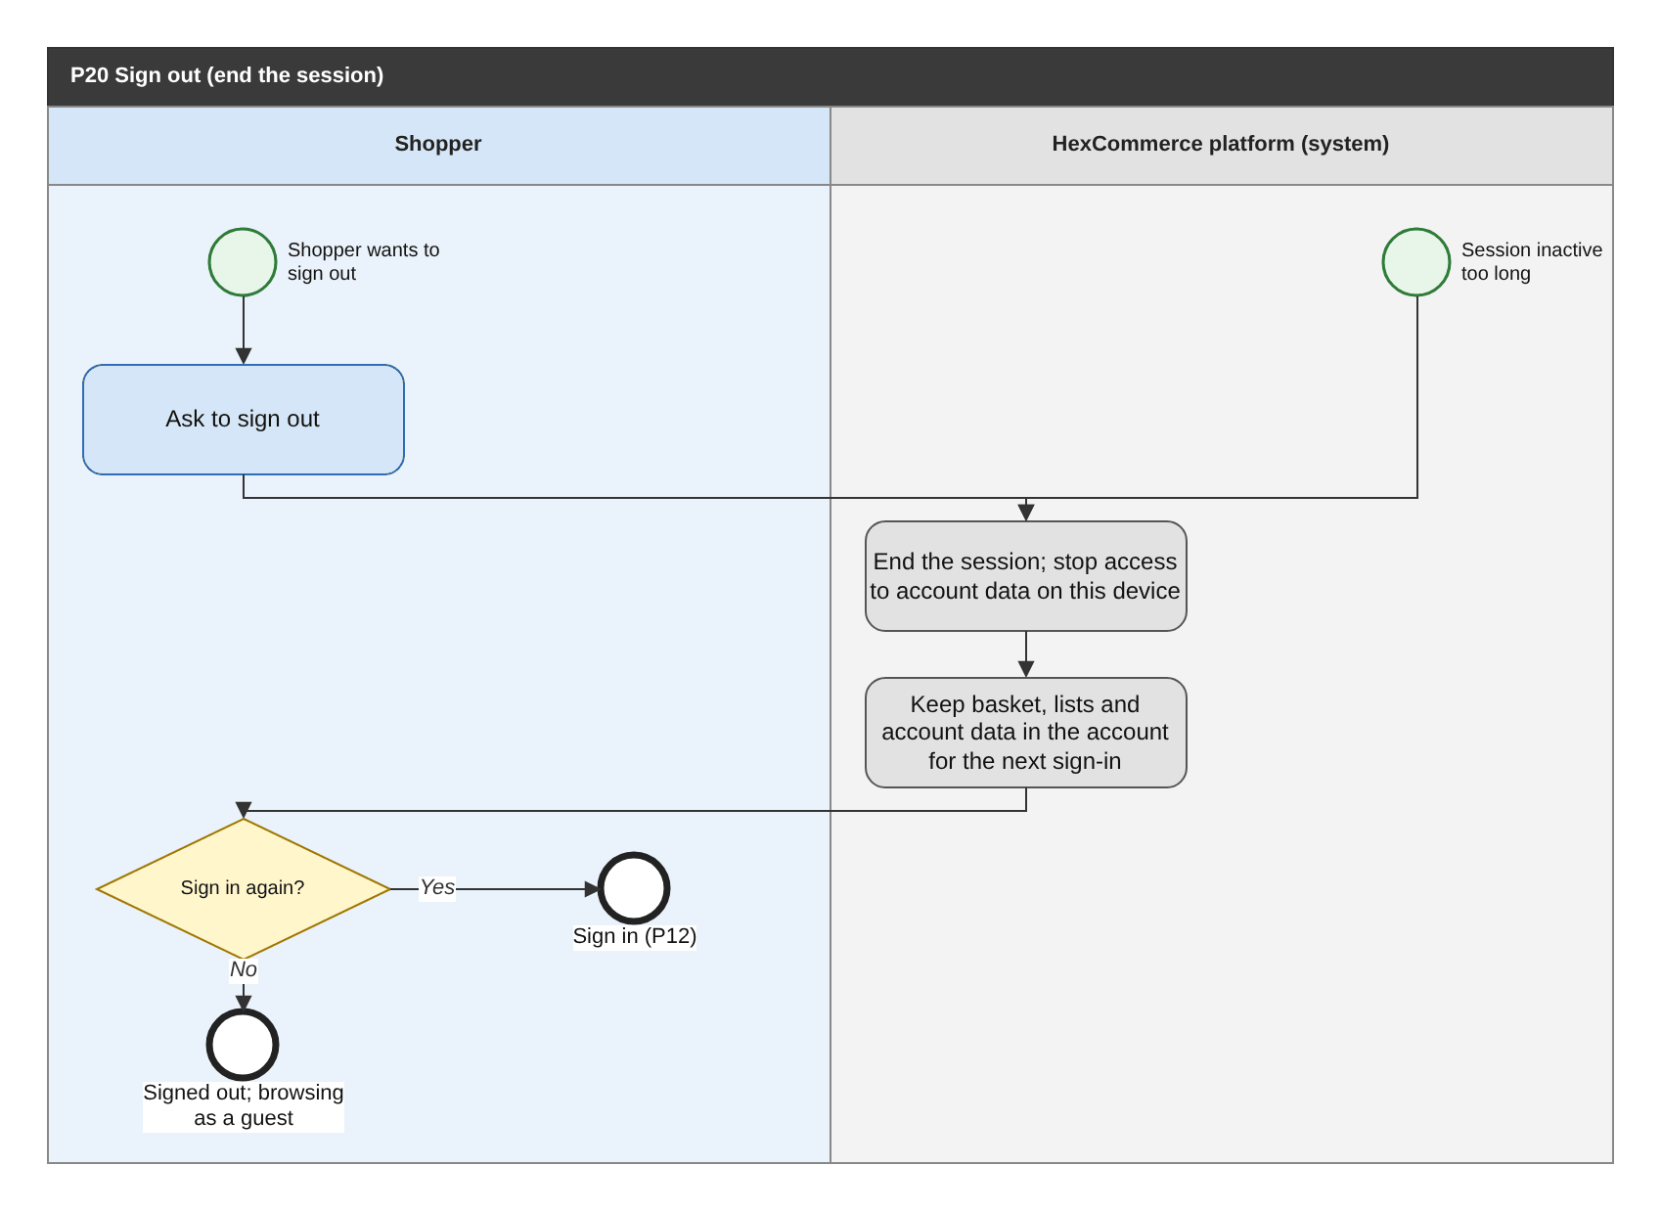
Figure 30: P20 Sign out (end the session) (BPMN swimlane). draw.io: page P20 of HexCommerce_Process_Diagrams.drawio.
Attribute | Description
Purpose | Let a signed-in user end their session so that their account cannot be used from the same device afterwards.
Trigger | The user asks to sign out, or their session has been inactive for longer than the inactivity period (BR-ACC-013).
Actors / lanes | Shopper; HexCommerce platform (system).
Preconditions | The user is signed in.
Postconditions | The session has ended; account data is no longer available on that device until the user signs in again; their saved data is kept in their account.
Change from v2.5 | Now a real sign-out that ends the session (supersedes the demonstration behaviour and closes Q-20).

Main flow
1. The shopper asks to sign out (or the session times out).
2. The system ends the session and stops access to the account's data from that device.
3. The basket, lists, account book, orders, reviews, issues and seller data stay in the account for the next sign-in.
4. The shopper either signs in again (P12) or continues as a guest.

Exception and alternative paths
- Staff users: the same process applies, with the shorter staff inactivity period.

Related requirements
BR-ACC-013, FR-ACC-016, FR-ACC-021

6.21 P21 Maintain a product listing (edit, publish, unpublish, remove)
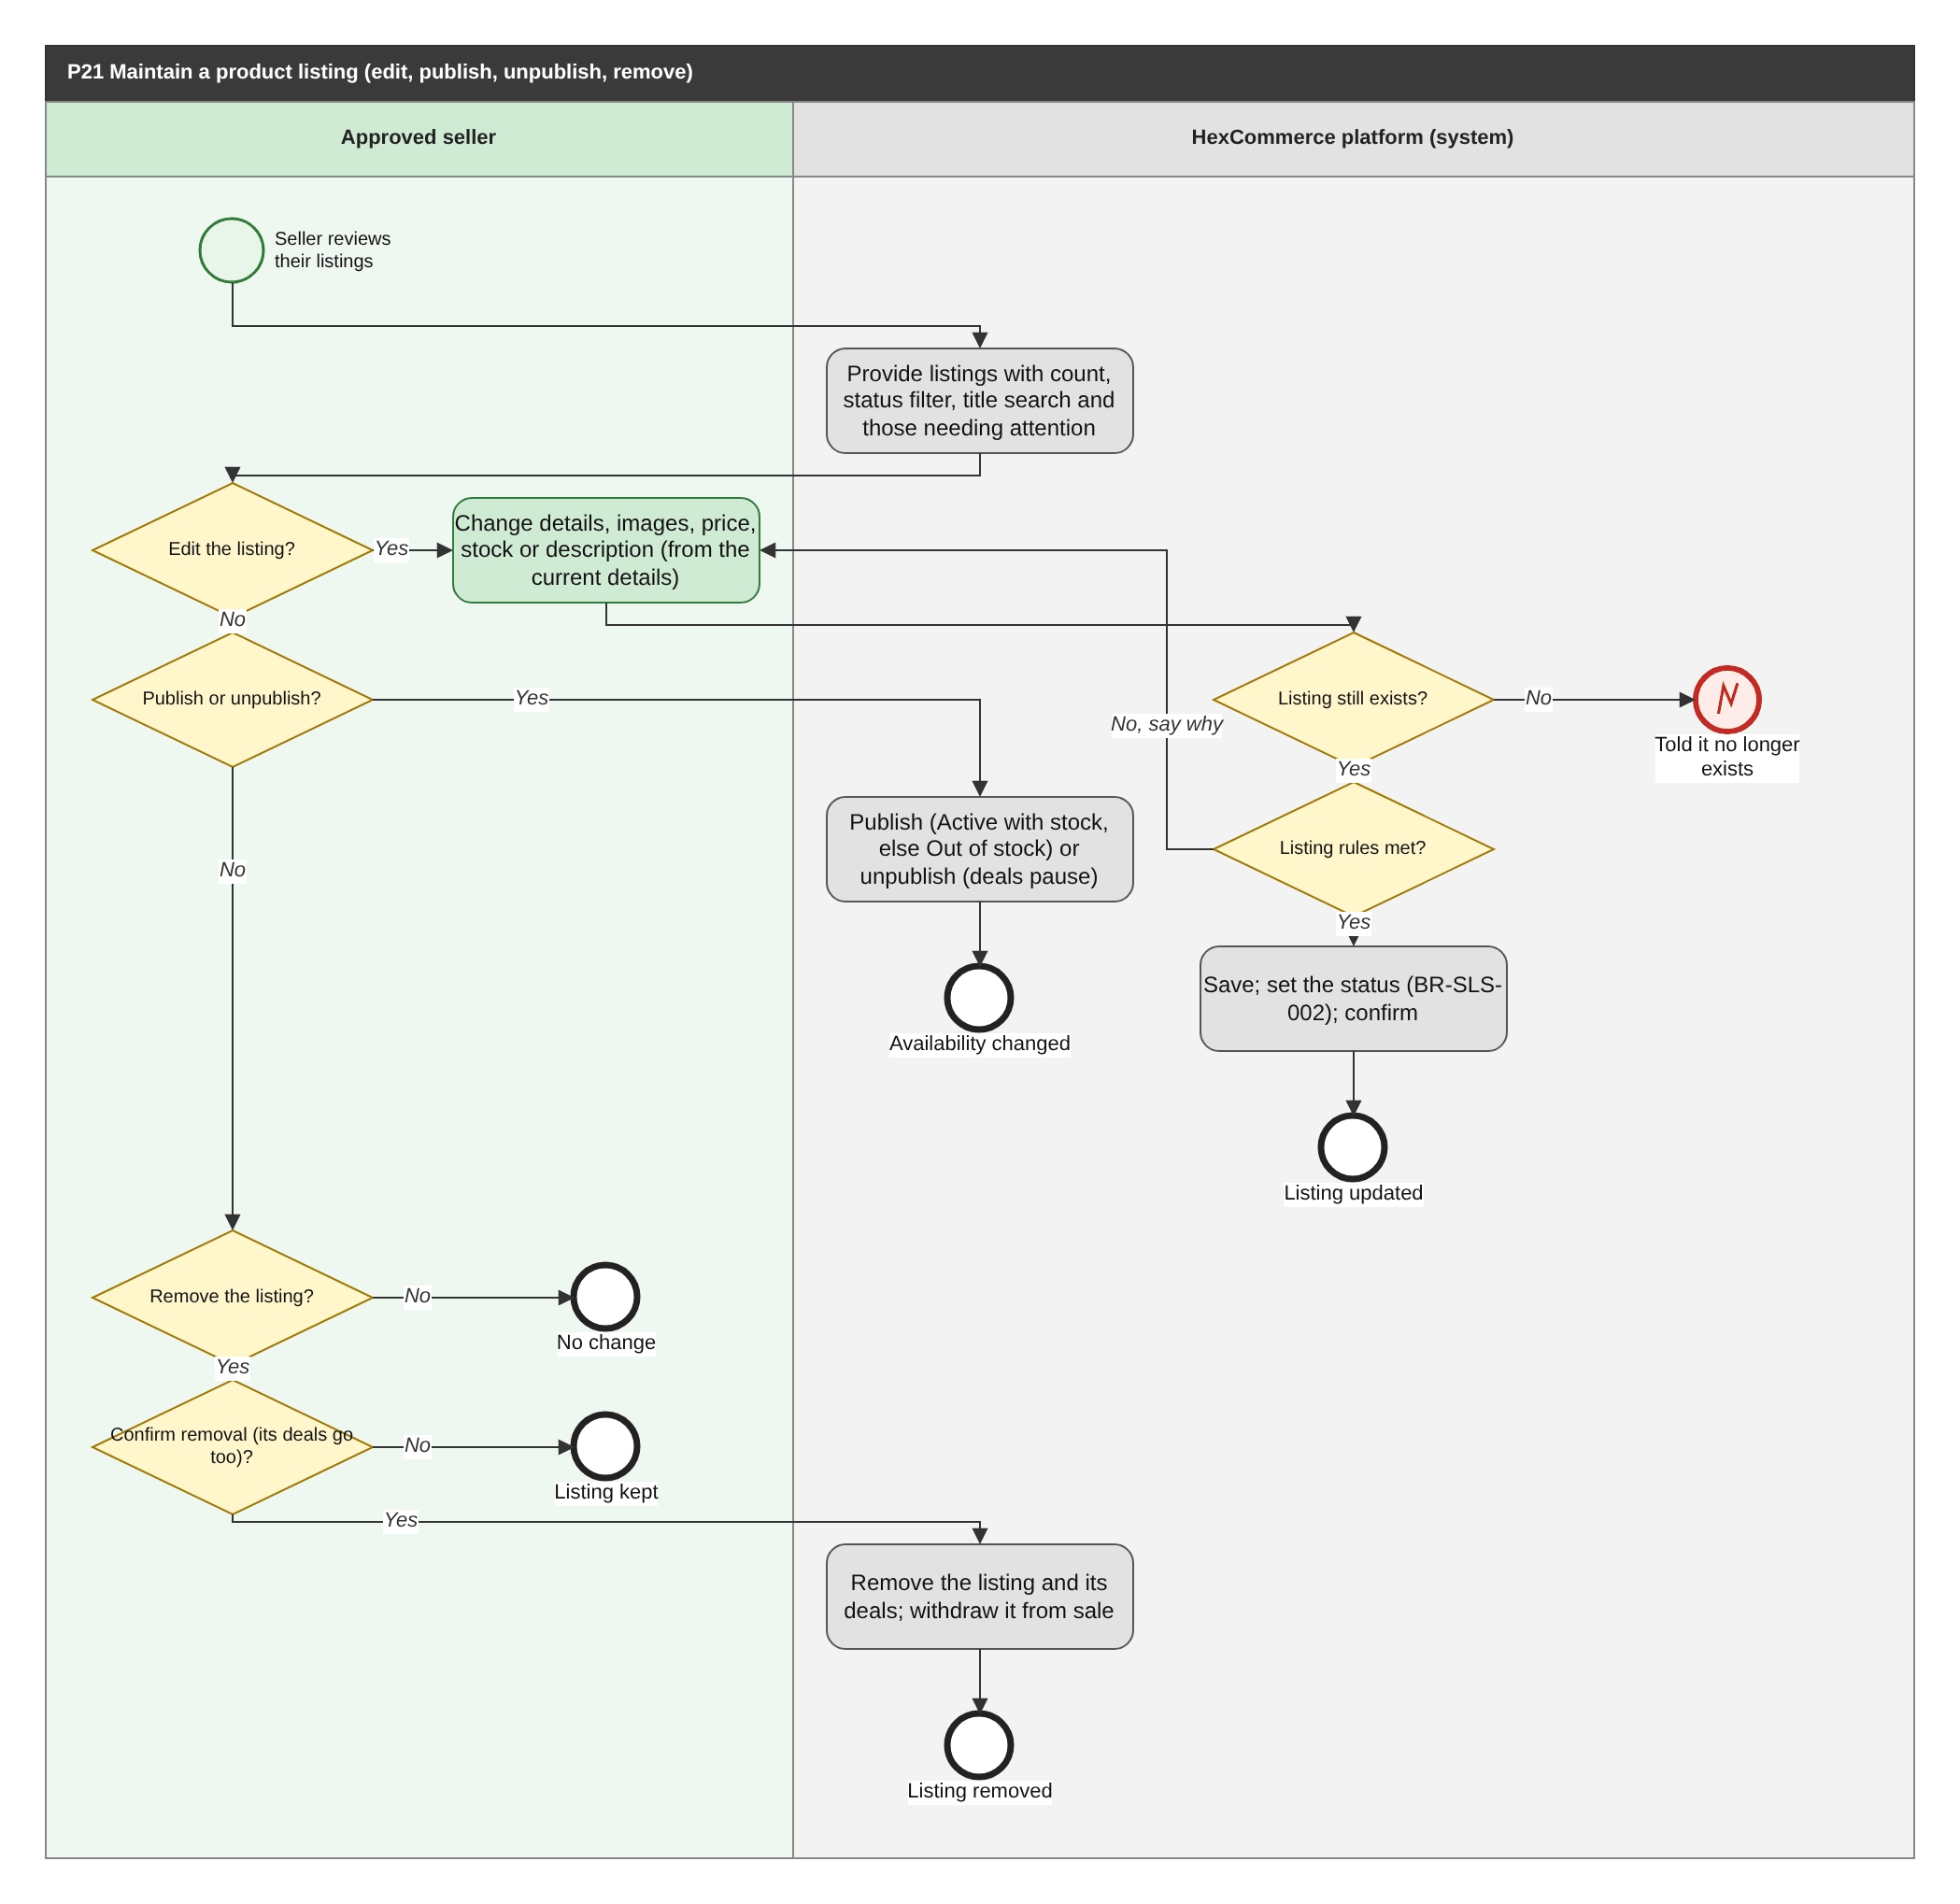
Figure 31: P21 Maintain a product listing (edit, publish, unpublish, remove) (BPMN swimlane). draw.io: page P21 of HexCommerce_Process_Diagrams.drawio.
Attribute | Description
Purpose | Allow an approved seller to keep their listings current: change them, take them on and off sale, and remove them.
Trigger | The seller reviews their listings, or follows up a listing that needs attention.
Actors / lanes | Approved seller; HexCommerce platform (system).
Preconditions | The seller's own application is Approved and the seller has at least one listing (P09).
Postconditions | The listing holds its new details and the correct status, or no longer exists; shoppers are offered only Active listings.
Change from v2.5 | New process (G-03): listing maintenance was a single step of P09 in v2.5.

Main flow
1. The system provides the seller's listings with their count, a status filter, a title search, and the listings that need attention (drafts and out-of-stock listings).
2. To edit, the seller changes any details, images, price, stock or description, starting from the current details; the system checks the listing rules (BR-SLS-001, BR-SLS-006), saves the listing with its resulting status (BR-SLS-002) and confirms it.
3. To publish a Draft or Unpublished listing, the seller publishes it; it becomes Active when it has stock and Out of stock otherwise (the seller is told beforehand, FR-SLS-022). To unpublish an Active or Out-of-stock listing, the seller unpublishes it; it is withdrawn from sale and its deals pause.
4. To remove a listing, the seller confirms the removal, having been told that its deals will be removed too; the system removes the listing and its deals and withdraws it from sale.

Exception and alternative paths
- The listing no longer exists: the seller is told.
- Rule broken when editing: the seller is told what to correct and the entries are kept.
- The seller does not confirm a removal: the listing is unchanged.
- Stock reduced below a live deal's remaining units: the deal offers only the stock (BR-SDL-014) and the seller is told (FR-SDL-014).
- The change cannot be saved: the seller is told and the entries are kept (NFR-REL-003).

Related requirements
BR-SAP-004, BR-SDL-014, BR-SLS-001, BR-SLS-002, BR-SLS-003, BR-SLS-006, BR-SLS-007, FR-NTF-010, FR-PDP-014, FR-SAP-010, FR-SAP-011, FR-SDB-004, FR-SDL-014, FR-SLS-001, FR-SLS-002, FR-SLS-008, FR-SLS-011, FR-SLS-012, FR-SLS-013, FR-SLS-014, FR-SLS-015, FR-SLS-016, FR-SLS-017, FR-SLS-018, FR-SLS-019, FR-SLS-020, FR-SLS-022, NFR-USE-003

6.22 P22 Handle customer-service issues (support agent)
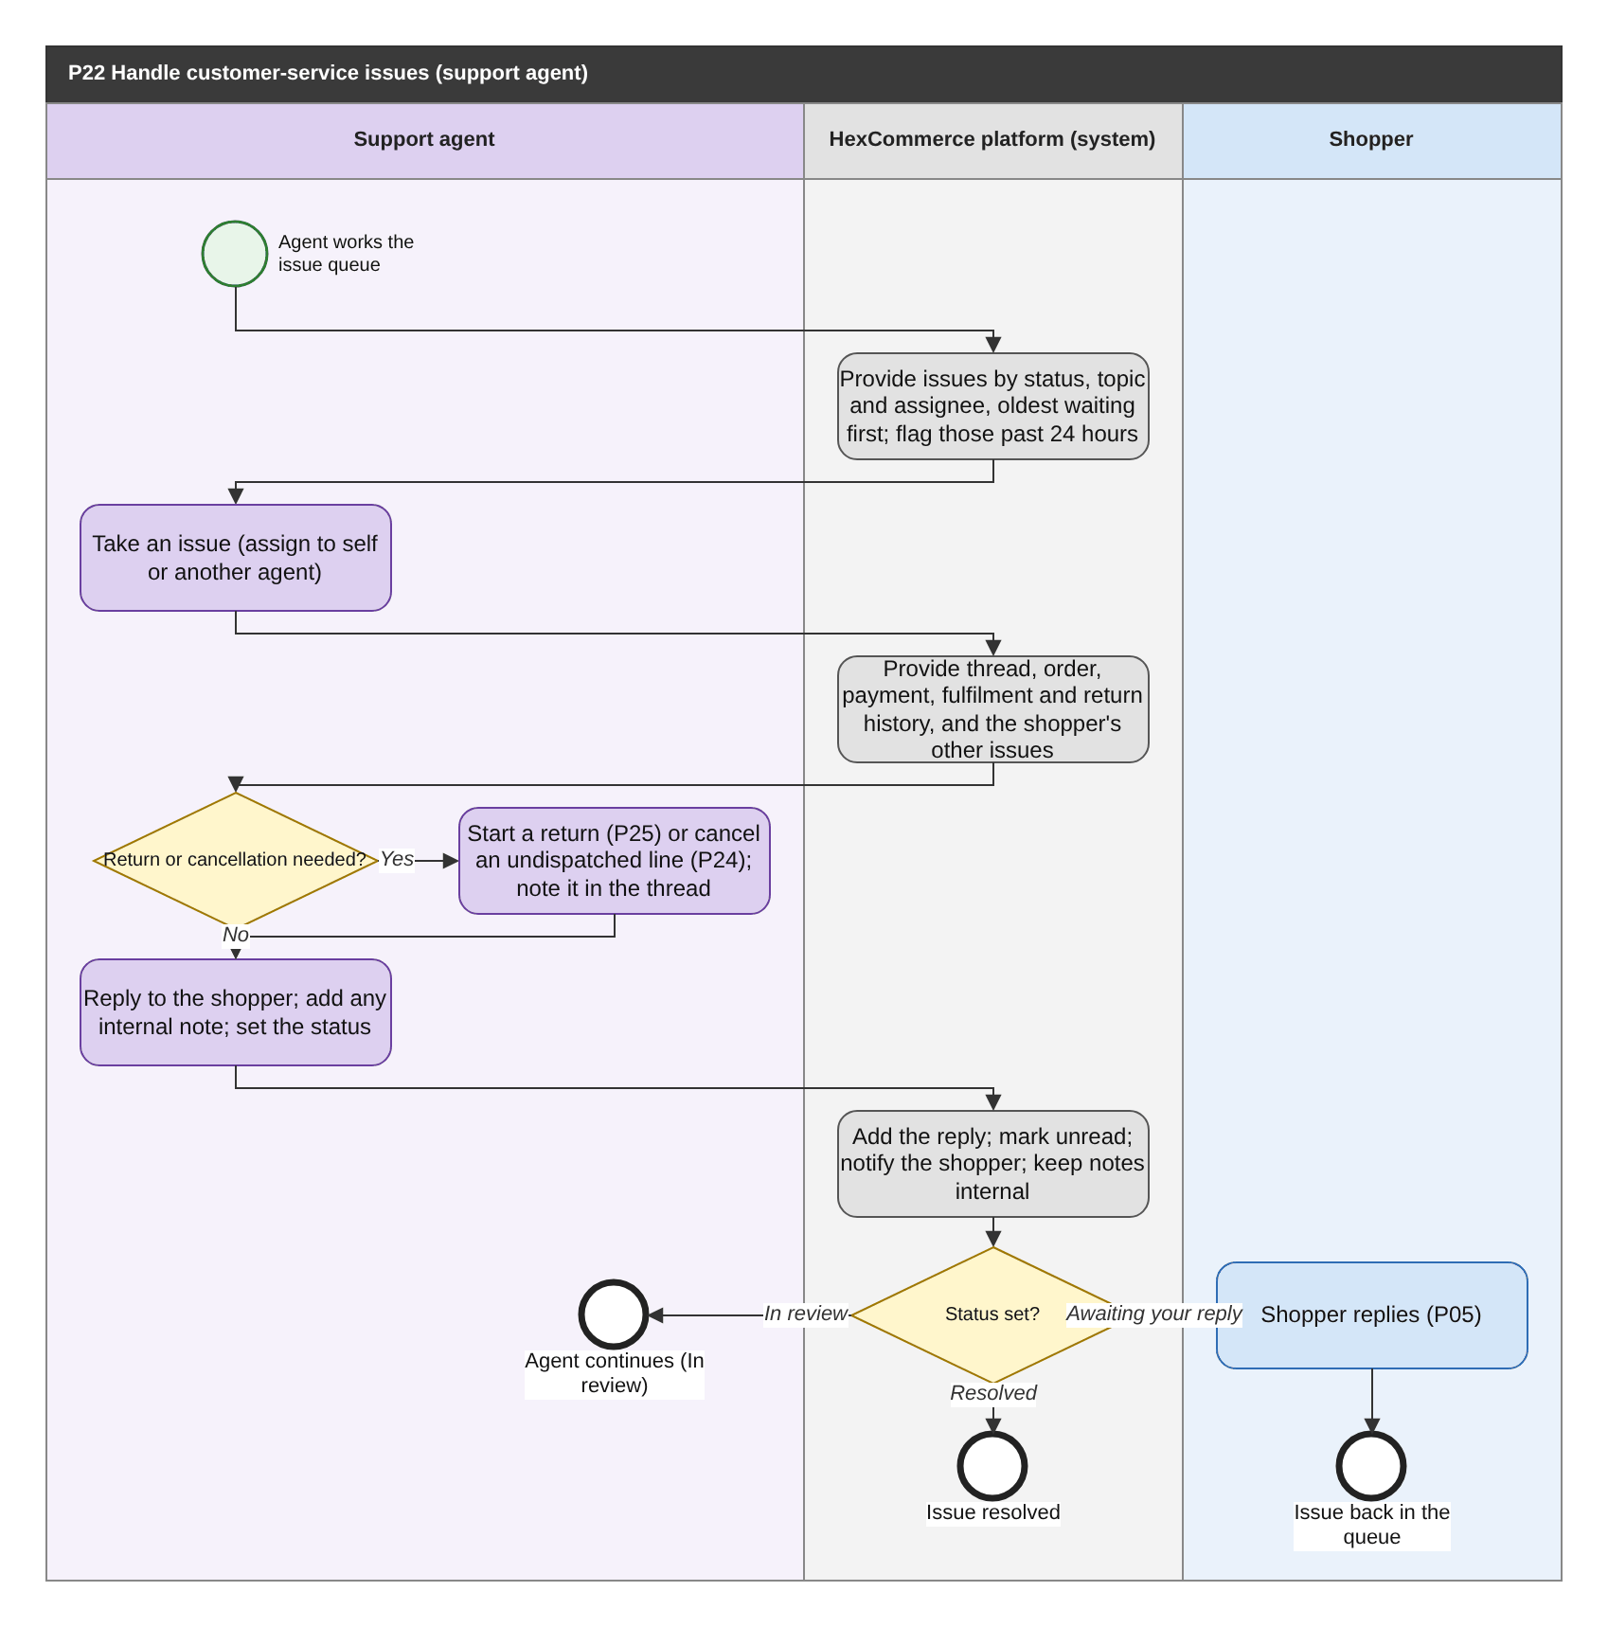
Figure 32: P22 Handle customer-service issues (support agent) (BPMN swimlane). draw.io: page P22 of HexCommerce_Process_Diagrams.drawio.
Attribute | Description
Purpose | Let support agents answer, progress and resolve customer issues in the system, within the 24-hour service level.
Trigger | A support agent works the issue queue, or an issue is flagged as past the 24-hour service level.
Actors / lanes | Support agent; HexCommerce platform (system); Shopper.
Preconditions | The agent is signed in with the support-agent role (FR-ADM-010).
Postconditions | The shopper has a reply; the issue is In review, Awaiting your reply or Resolved; any return or cancellation is started.
Change from v2.5 | New process (U-01): support replies were made outside the system and the support team was an off-system lane.

Main flow
1. The system provides the issue queue, filterable by status, topic and assigned agent, oldest waiting first, flagging issues whose last shopper message has waited more than 24 hours (BR-CS-003).
2. The agent takes an issue, assigning it to themselves or another agent.
3. The system provides the thread, the related order and item, the order's payment, fulfilment and return history, and the shopper's other issues.
4. Where needed, the agent starts a return (P25) or cancels an undispatched line (P24) for the shopper, noting it in the thread.
5. The agent replies, optionally adds an internal note, and sets the status: In review (still working), Awaiting your reply (the shopper must answer) or Resolved.
6. The system adds the reply, marks the issue unread for the shopper, notifies them (FR-NTF-005) and never provides internal notes to the shopper (BR-CS-005).

Exception and alternative paths
- The shopper replies (P05) or reopens a resolved issue (P15): the issue returns to the queue as In review.
- An abusive or inappropriate review raised by a shopper is handled through P31.

Related requirements
BR-CS-001, BR-CS-003, BR-CS-005, FR-ADM-013, FR-CS-015, FR-CS-016, FR-CS-017, FR-CS-018, FR-CS-019, FR-CS-020, FR-CS-021, FR-DEF-014, FR-NTF-005

6.23 P23 Progress an order through fulfilment
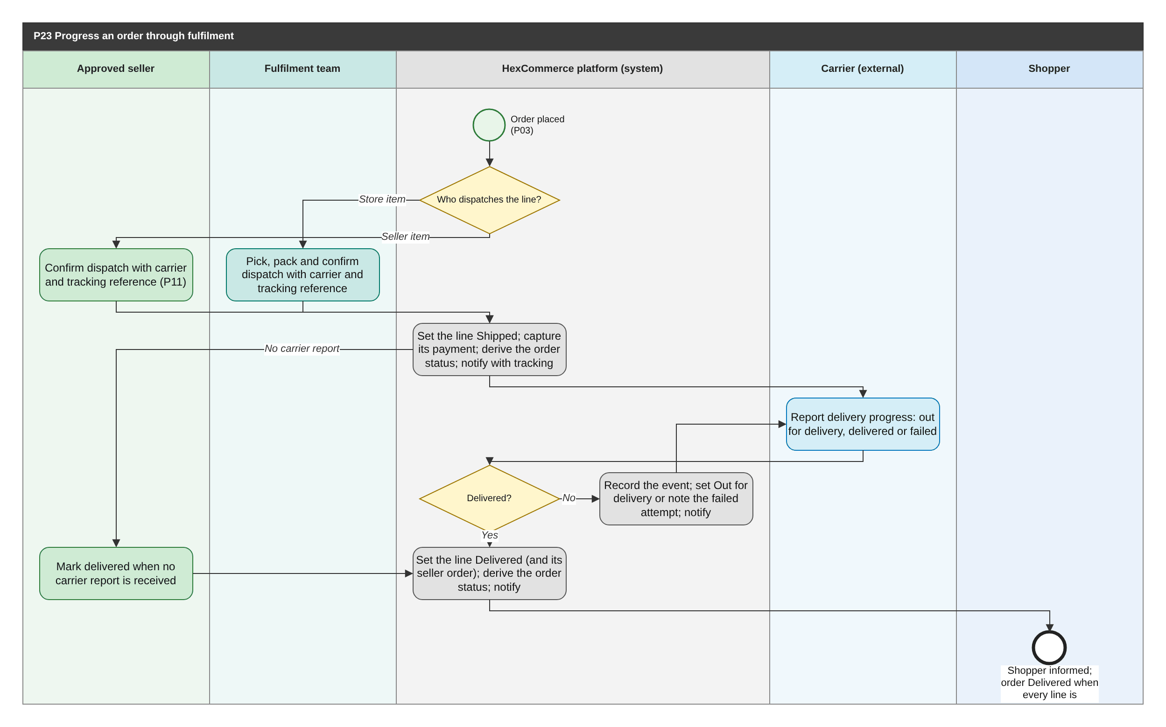
Figure 33: P23 Progress an order through fulfilment (BPMN swimlane). draw.io: page P23 of HexCommerce_Process_Diagrams.drawio.
Attribute | Description
Purpose | Move each order line from Processing to Delivered as it is dispatched and delivered, keeping the shopper informed and taking payment for what is sent.
Trigger | An order is placed (P03).
Actors / lanes | Approved seller; Fulfilment team; HexCommerce platform (system); Carrier (external); Shopper.
Preconditions | The order exists with its lines in Processing. Store items are dispatched by the fulfilment team; marketplace items by their seller.
Postconditions | Every line that was not cancelled is Delivered; the order status follows its lines (BR-ORD-008); payment has been captured for every dispatched line.
Change from v2.5 | New process (U-02): orders never progressed beyond Processing and seller dispatch did not reach the shopper (Q-07).

Main flow
1. For each line, the system determines who dispatches it: the fulfilment team for store items, the seller for marketplace items.
2. The dispatching party dispatches the line and records the carrier and tracking reference (FR-ORD-015, FR-SOR-003).
3. The system sets the line to Shipped, captures payment for it (FR-PAY-004), derives the order status from its lines, and notifies the shopper with the tracking reference (FR-NTF-002).
4. The carrier reports delivery progress; the system records each event, sets the line Out for delivery, or notes a failed attempt, and notifies the shopper.
5. When the carrier reports delivery (or the seller marks it delivered), the system sets the line, and any seller order, to Delivered, derives the order status and notifies the shopper.

Exception and alternative paths
- A line is cancelled before dispatch: P24.
- Failed delivery attempts are recorded and the shopper notified; what happens after repeated failures is open question Q-40.
- An order whose lines are dispatched at different times shows the least advanced status of its lines (BR-ORD-008).

Related requirements
BR-ORD-005, BR-ORD-008, FR-NTF-002, FR-ORD-005, FR-ORD-013, FR-ORD-014, FR-ORD-015, FR-ORD-016, FR-ORD-017, FR-PAY-004, FR-PAY-006, FR-SOR-003, FR-SOR-004

6.24 P24 Cancel an order or order line and refund
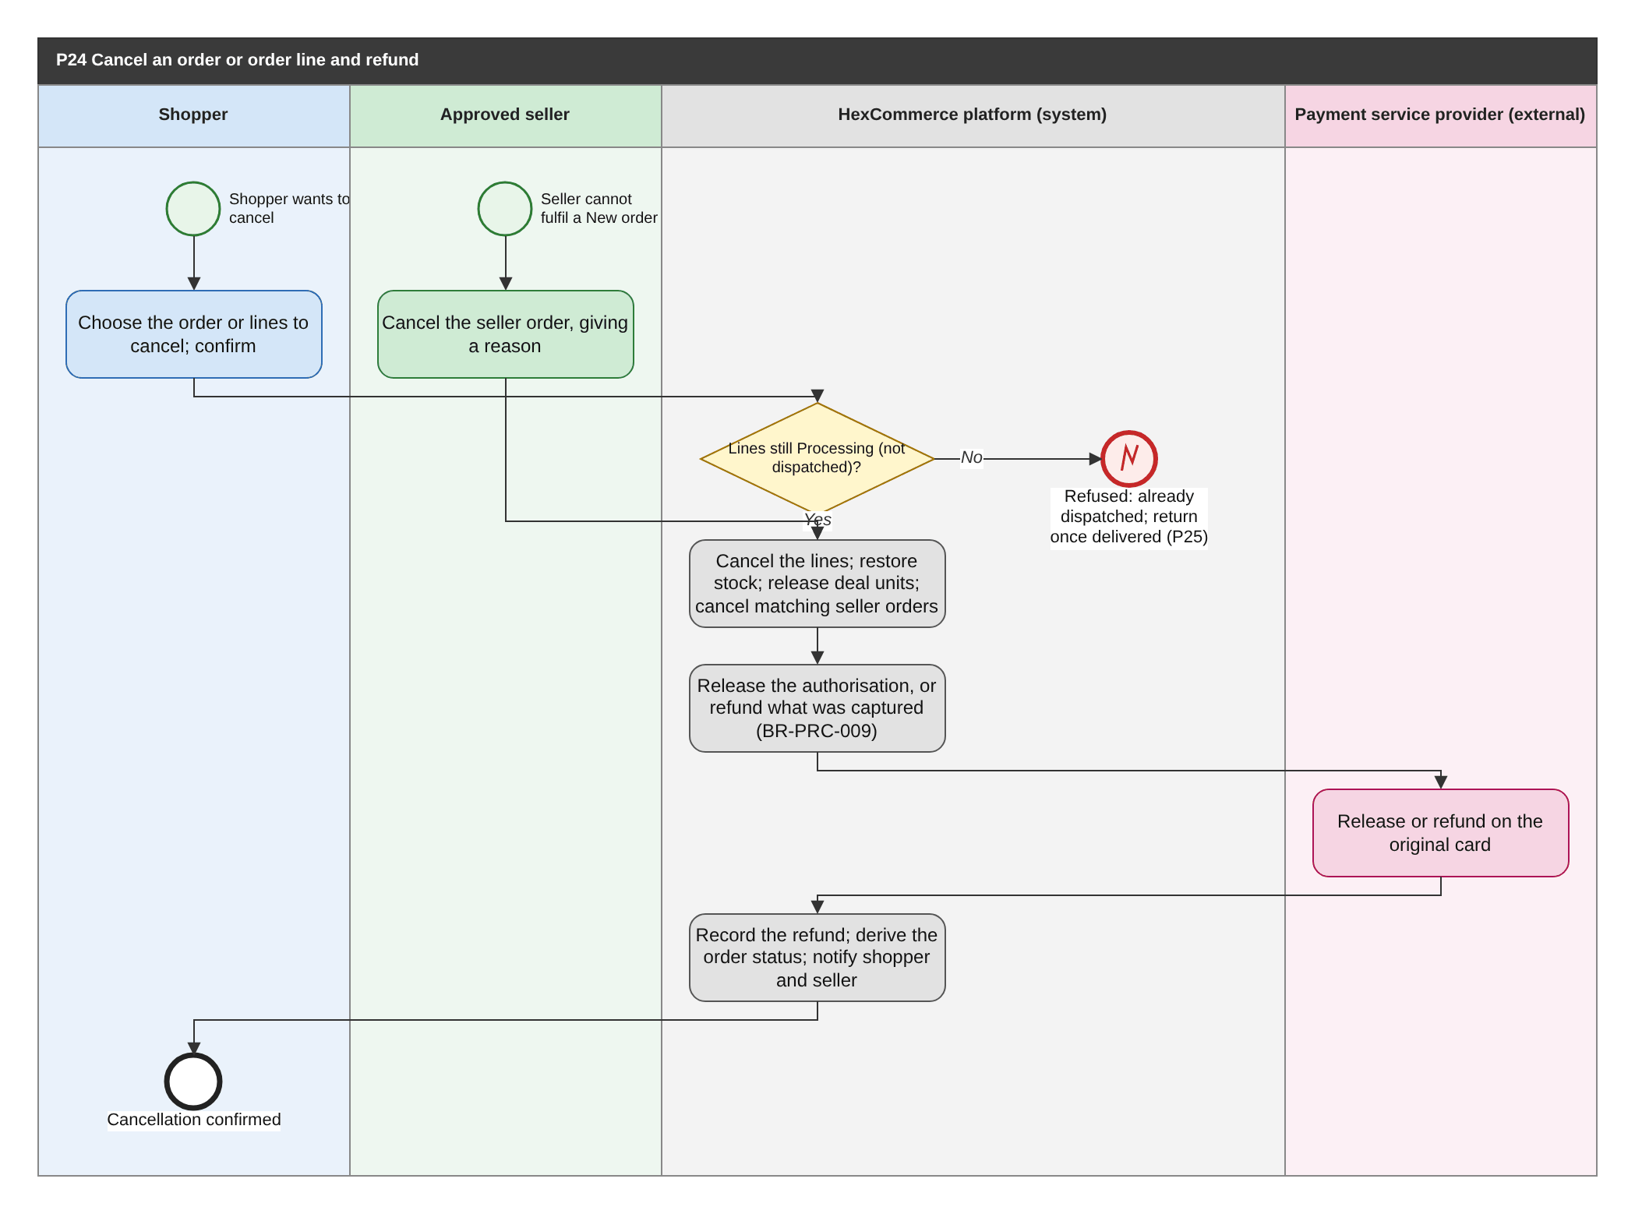
Figure 34: P24 Cancel an order or order line and refund (BPMN swimlane). draw.io: page P24 of HexCommerce_Process_Diagrams.drawio.
Attribute | Description
Purpose | Let a shopper cancel what has not been dispatched, and a seller cancel what they cannot fulfil, with stock, deals, seller orders and payment put right.
Trigger | The shopper asks to cancel an order or some of its lines, or a seller cancels a New seller order, or a support agent cancels on the shopper's behalf (P22).
Actors / lanes | Shopper; Approved seller; HexCommerce platform (system); Payment service provider (external).
Preconditions | The lines to cancel are Processing (not dispatched). For a seller, the seller order is New.
Postconditions | The lines are Cancelled; stock and deal units are restored; matching seller orders are Cancelled; the payment is released or refunded; the shopper (and seller) are notified.
Change from v2.5 | New process (U-03): orders could not be cancelled (FR-DEF-007, Q-08, Q-19).

Main flow
1. The shopper chooses the order or the lines to cancel and confirms (NFR-USE-003); or the seller cancels a New seller order, giving a reason (FR-SOR-006).
2. The system checks that every chosen line is still Processing (BR-ORD-009).
3. The system cancels the lines, adds their quantity back to stock, releases any deal units they claimed (BR-ORD-011) and cancels the matching seller orders.
4. The system releases the authorisation for lines not yet captured, or refunds the amount captured (BR-PRC-009), through the payment service provider.
5. The system records the refund, derives the order status, and notifies the shopper and the seller (FR-NTF-003).

Exception and alternative paths
- A line has already been dispatched: cancellation is refused and the shopper is told a return can be requested once it is delivered (P25).
- Every line of the order is cancelled: the order becomes Cancelled and the delivery fee is refunded (BR-PRC-009).

Related requirements
BR-ORD-008, BR-ORD-009, BR-ORD-011, BR-PRC-009, BR-SOR-001, FR-CS-021, FR-NTF-003, FR-ORD-006, FR-ORD-018, FR-ORD-019, FR-PAY-004, FR-PAY-005, FR-PAY-006, FR-SOR-006, NFR-USE-003

6.25 P25 Process a return and refund
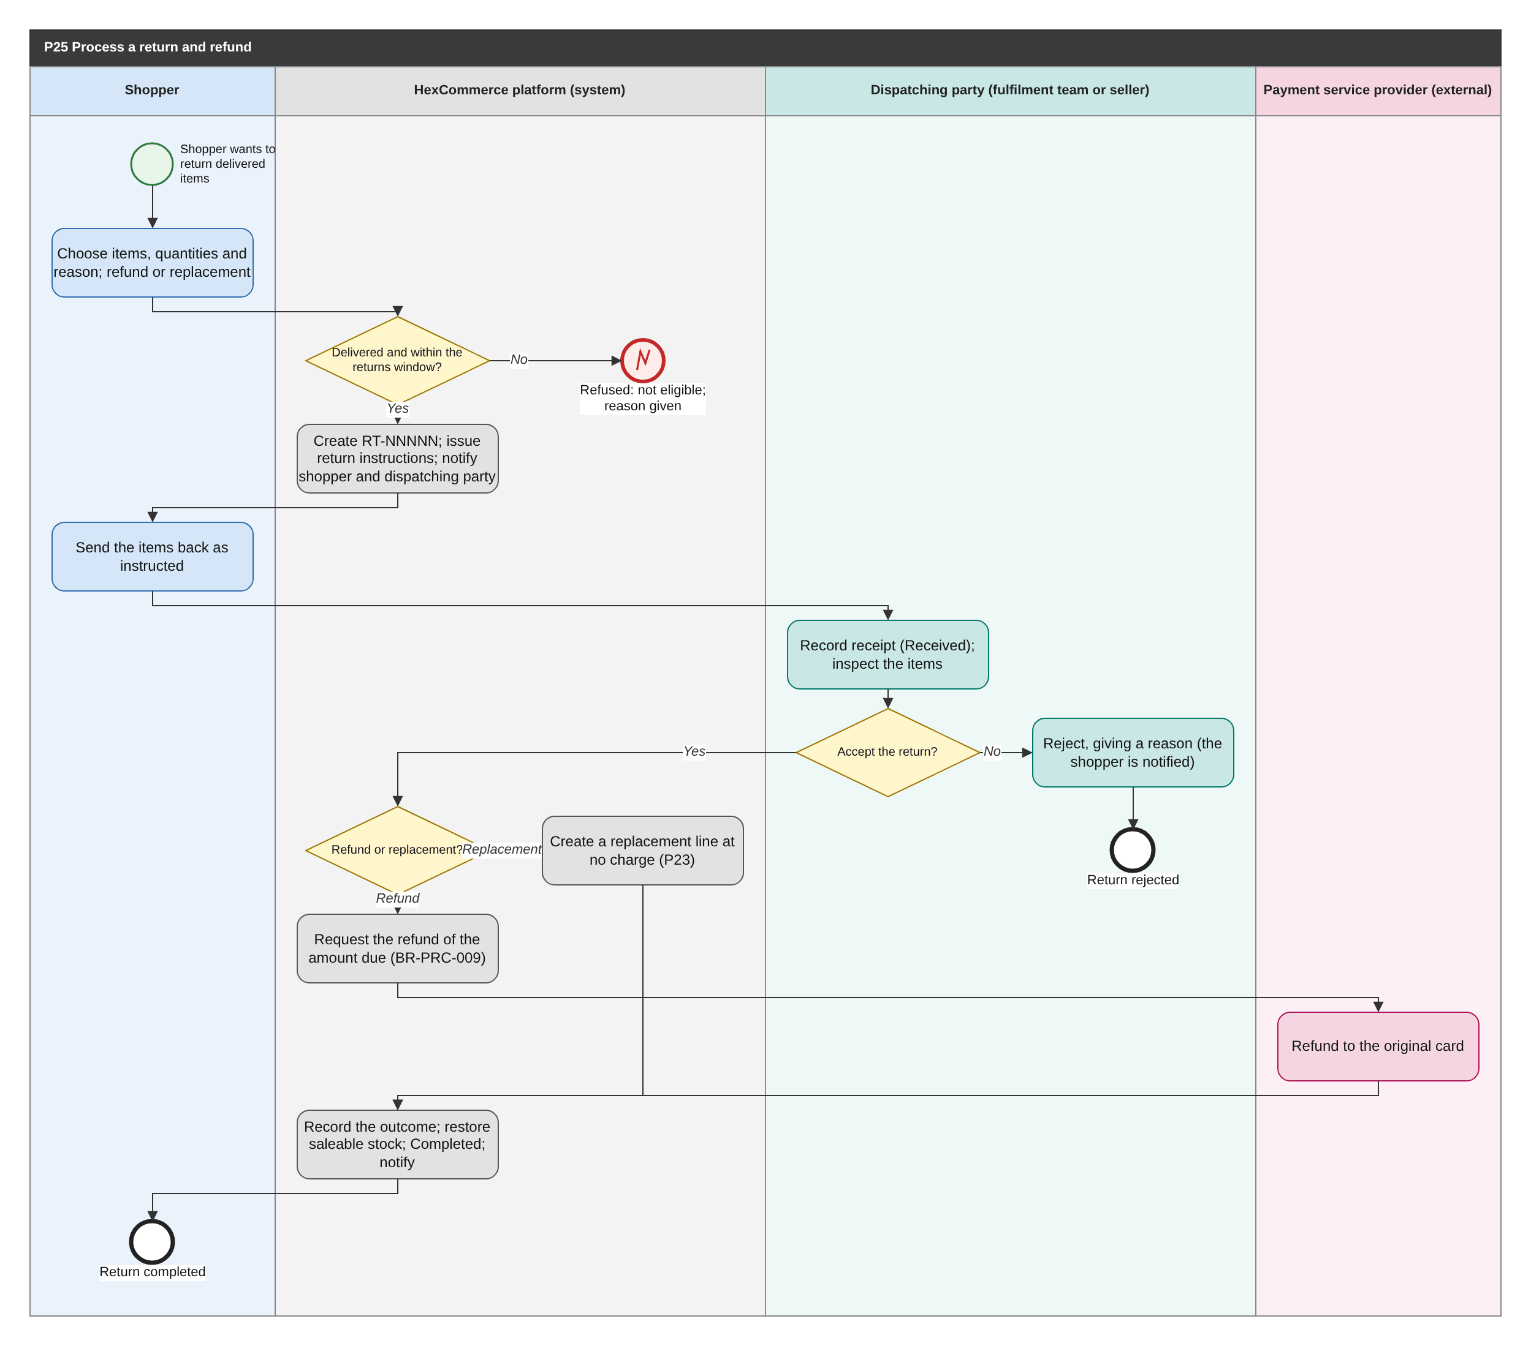
Figure 35: P25 Process a return and refund (BPMN swimlane). draw.io: page P25 of HexCommerce_Process_Diagrams.drawio.
Attribute | Description
Purpose | Take back delivered items within the returns policy and refund or replace them.
Trigger | The shopper asks to return delivered items (P04), or a support agent starts a return for them (P22).
Actors / lanes | Shopper; HexCommerce platform (system); Dispatching party (fulfilment team or seller); Payment service provider (external).
Preconditions | The shopper is signed in; the items are Delivered and within the returns window (BR-ORD-006).
Postconditions | The return is Completed with a refund or replacement, or Rejected with a reason; the shopper and the dispatching party are informed.
Change from v2.5 | New process (U-04): v2.5 only let the shopper open an issue with the topic 'Request a return'.

Main flow
1. The shopper chooses the items and quantities, a return reason, and whether they want a refund or a replacement.
2. The system checks that each item is Delivered and within the returns window, creates return RT-NNNNN, issues the return instructions (Awaiting items) and notifies the shopper and the party that dispatched the items.
3. The shopper sends the items back as instructed.
4. The dispatching party (the fulfilment team for store items, the seller for marketplace items) records receipt (Received) and inspects the items.
5. If the return is accepted, the system refunds the amount due to the original card (BR-PRC-009) or creates a replacement line at no charge, restores saleable stock, sets the return Completed and notifies the shopper (FR-NTF-004).

Exception and alternative paths
- Not eligible (not Delivered, or outside the returns window): refused with the reason.
- The inspection fails: the dispatching party rejects the return with a reason; the shopper is notified.
- Accepted returns of marketplace items reduce the seller's revenue and payout (BR-SOR-002, BR-SPY-002).
- Who receives returns of marketplace items is open question Q-39.

Related requirements
BR-CS-004, BR-ORD-006, BR-ORD-010, BR-ORD-012, BR-PRC-009, BR-SYS-001, FR-CFG-009, FR-CS-021, FR-NTF-004, FR-NTF-008, FR-ORD-009, FR-ORD-020, FR-ORD-021, FR-ORD-022, FR-ORD-023, FR-PAY-005, FR-PAY-006, FR-SOR-007

6.26 P26 Manage back-office access
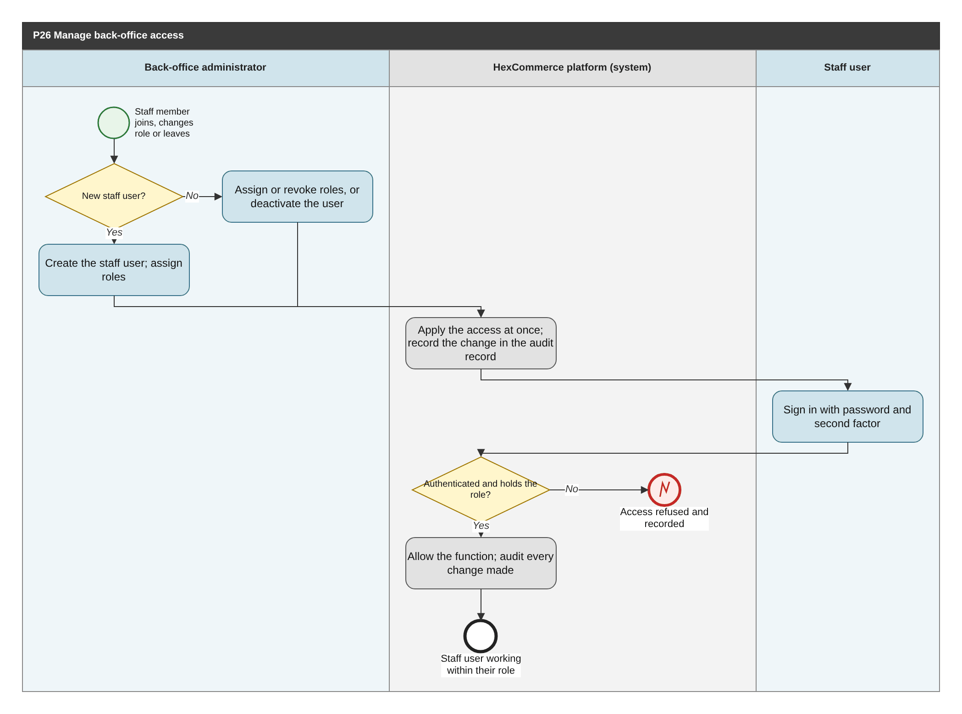
Figure 36: P26 Manage back-office access (BPMN swimlane). draw.io: page P26 of HexCommerce_Process_Diagrams.drawio.
Attribute | Description
Purpose | Make every back-office capability available only to the staff who need it, and make their actions traceable.
Trigger | A staff member joins, changes job or leaves, or a staff user signs in.
Actors / lanes | Back-office administrator; HexCommerce platform (system); Staff user.
Preconditions | The back-office administrator is signed in with that role.
Postconditions | Each staff user holds exactly the roles they need; every back-office action is recorded in the audit record.
Change from v2.5 | New process (U-08): the seller-application queue was open to anyone (Q-05, R-02).

Main flow
1. The back-office administrator creates a staff user and assigns their roles, or assigns or revokes roles, or deactivates a staff user.
2. The system applies the access change at once and records it in the audit record (FR-ADM-013).
3. A staff user signs in with their password and a second factor (FR-ADM-012).
4. The system allows a back-office function only to a signed-in staff user who holds its role (FR-ADM-010), and records every change they make.

Exception and alternative paths
- Wrong credentials, missing second factor, or a role not held: access is refused and the attempt recorded.
- Staff sessions end after 15 minutes of inactivity (BR-ACC-013).
- Back-office administrators can search and export the audit records (FR-ADM-014).

Related requirements
BR-ACC-013, FR-ADM-010, FR-ADM-011, FR-ADM-012, FR-ADM-013, FR-ADM-014, FR-CFG-010, NFR-SEC-006, NFR-SEC-012

6.27 P27 Set up or change a seller payout account
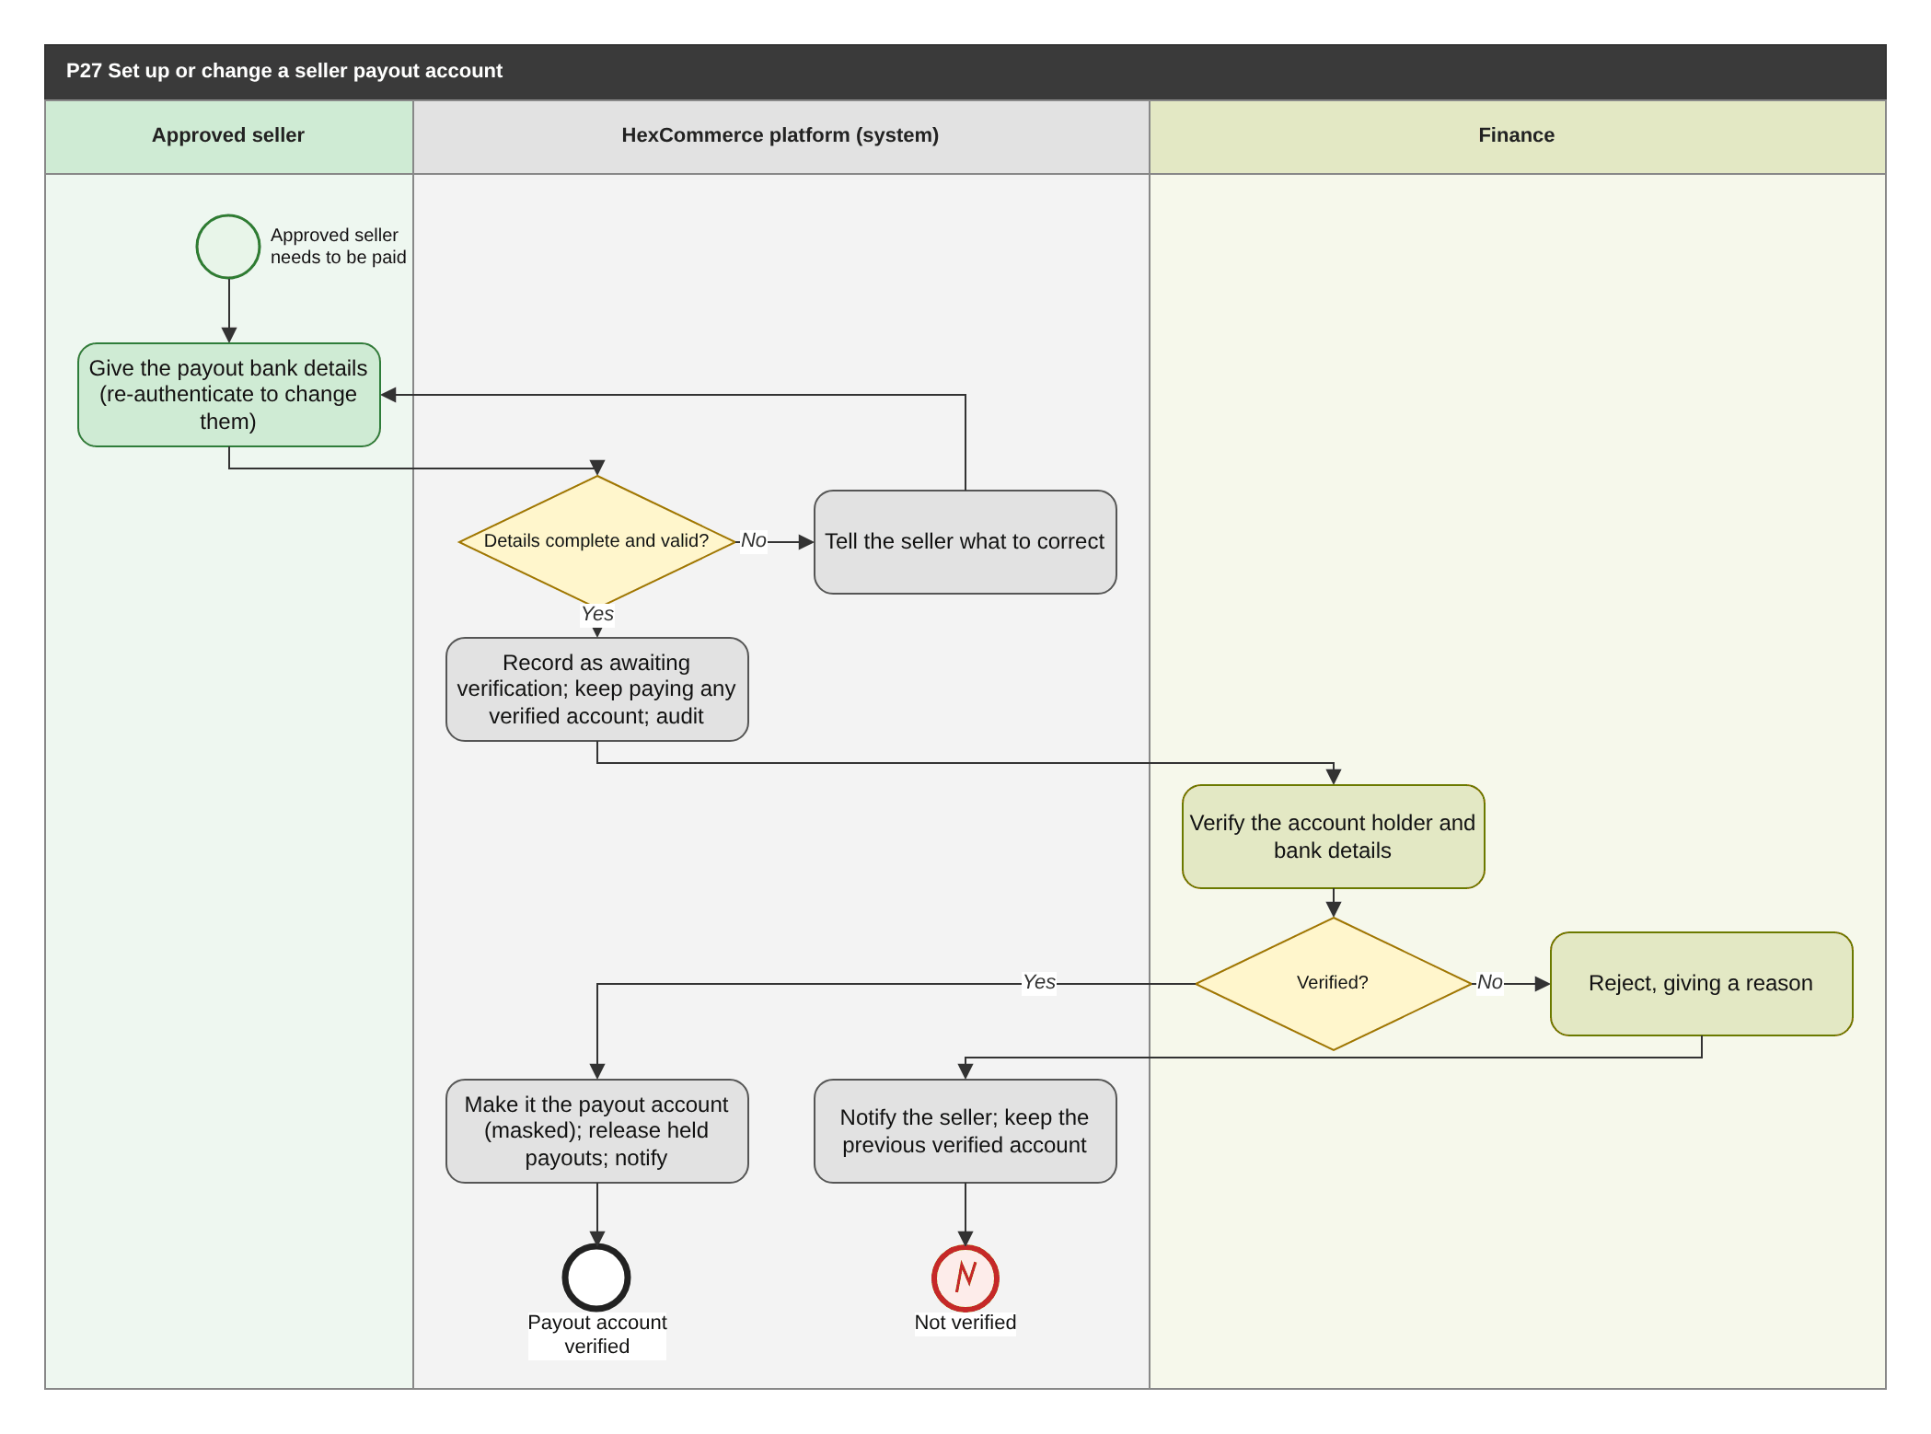
Figure 37: P27 Set up or change a seller payout account (BPMN swimlane). draw.io: page P27 of HexCommerce_Process_Diagrams.drawio.
Attribute | Description
Purpose | Give each seller a verified account to be paid into, and protect payouts against fraudulent changes.
Trigger | A newly approved seller provides payout details, or a seller asks to change them (P13).
Actors / lanes | Approved seller; HexCommerce platform (system); Finance.
Preconditions | The seller's own application is Approved.
Postconditions | The seller has a verified payout account, or the change is rejected and the previous verified account remains.
Change from v2.5 | New process (U-09): the payout account was "set up separately" and changed "through the seller team", outside the system.

Main flow
1. The seller gives the payout bank details (account holder name, sort code and account number, or IBAN); to change existing details they must re-authenticate.
2. The system checks that the details are complete and valid, records them as awaiting verification, keeps paying any account already verified, and records the change in the audit record.
3. Finance verifies the account holder and bank details.
4. If verified, the system makes it the payout account (provided to the seller only in masked form), releases any payouts held, and notifies the seller.

Exception and alternative paths
- Incomplete or invalid details: the seller is told what to correct.
- Verification fails: finance rejects with a reason; the seller is notified and the previous verified account remains.
- No verified account exists: payouts are held (BR-SPY-003).

Related requirements
BR-SAP-005, BR-SPY-003, FR-SDB-008, FR-SPY-001, FR-SPY-002, FR-SPY-003

6.28 P28 Calculate and settle seller payouts
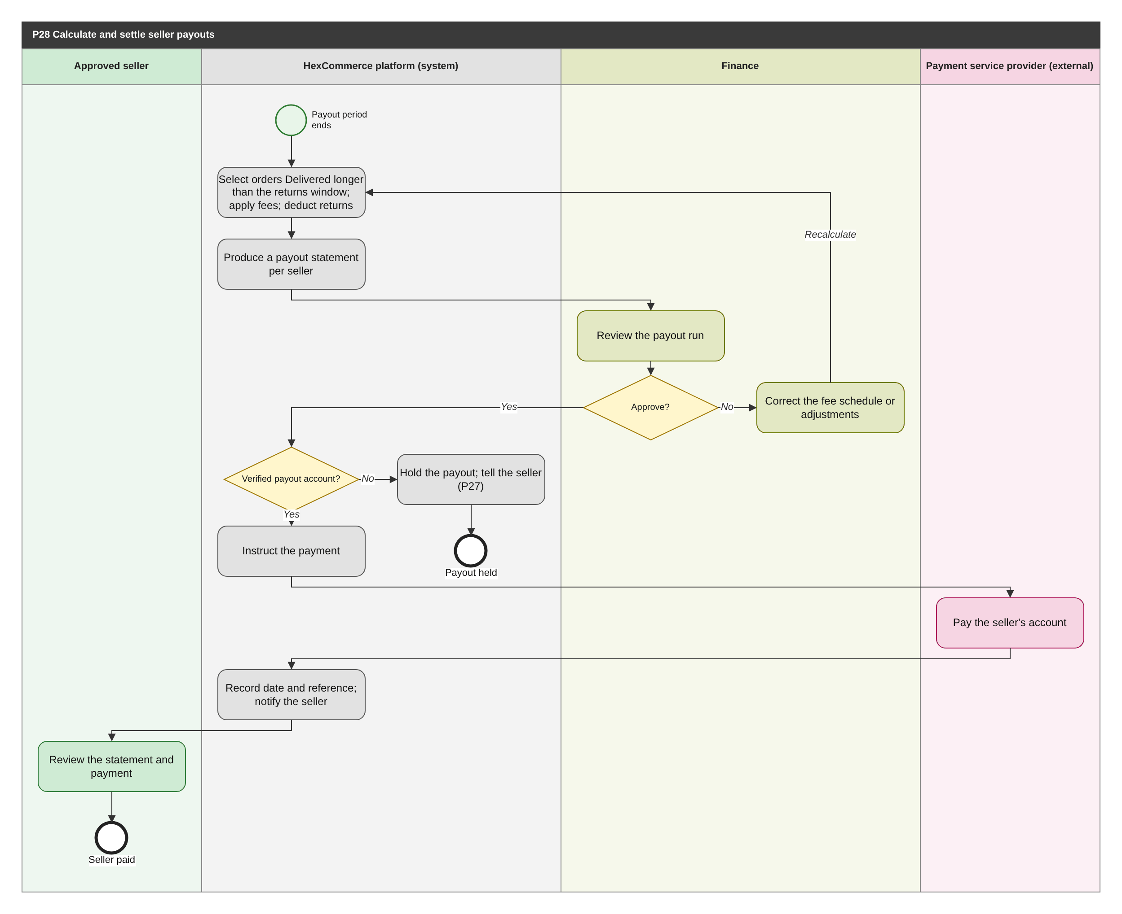
Figure 38: P28 Calculate and settle seller payouts (BPMN swimlane). draw.io: page P28 of HexCommerce_Process_Diagrams.drawio.
Attribute | Description
Purpose | Pay each seller what they are owed for delivered sales, net of referral fees and returns, under finance control.
Trigger | A payout period ends (the period length is open question Q-34).
Actors / lanes | Approved seller; HexCommerce platform (system); Finance; Payment service provider (external).
Preconditions | Finance has set the referral-fee schedule (FR-SPY-004).
Postconditions | Each seller with a verified account has been paid and has a statement; payouts to sellers without one are held.
Change from v2.5 | New process (U-09): payouts were an estimate on the dashboard only (FR-DEF-010, Q-01).

Main flow
1. The system selects each seller's orders that have been Delivered for longer than the returns window (BR-SPY-002), applies the referral fee for each order's department (BR-SPY-001), and deducts returns accepted since the last payout.
2. The system produces a payout statement for each seller (FR-SPY-005).
3. Finance reviews and approves the payout run.
4. For each seller with a verified payout account, the system instructs the payment; the payment service provider pays it; the system records the date and reference and notifies the seller (FR-NTF-009).
5. The seller reviews the statement and payment (FR-SPY-007).

Exception and alternative paths
- Finance does not approve: the fee schedule or adjustments are corrected and the run is recalculated.
- No verified payout account: the payout is held and the seller is told to complete P27.

Related requirements
BR-SOR-002, BR-SOR-004, BR-SPY-001, BR-SPY-002, BR-SPY-003, FR-ADM-013, FR-NTF-009, FR-SPY-004, FR-SPY-005, FR-SPY-006, FR-SPY-007

6.29 P29 Maintain promotions and store deals
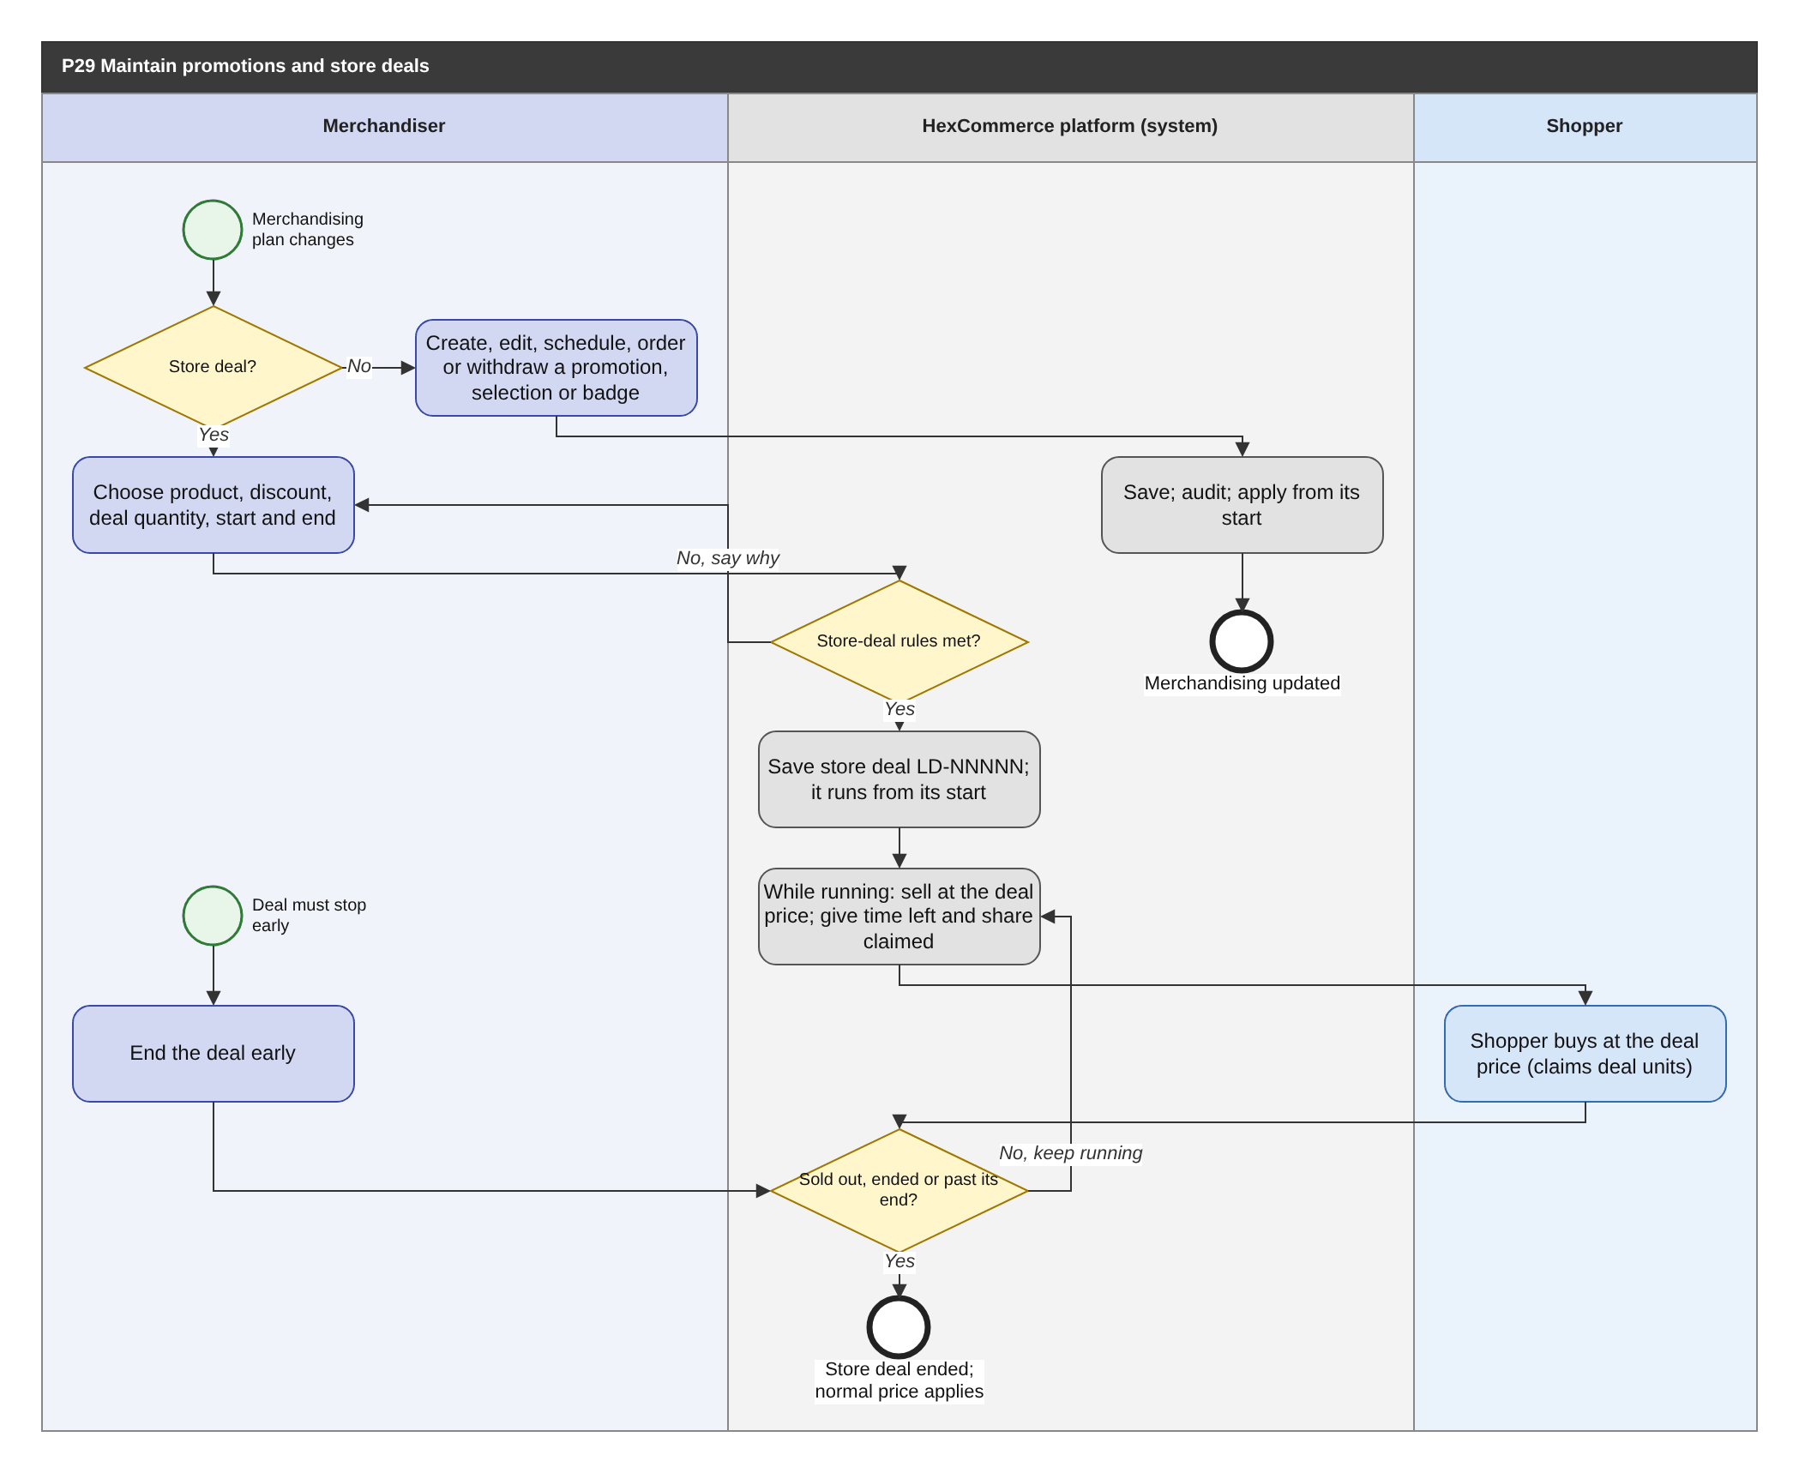
Figure 39: P29 Maintain promotions and store deals (BPMN swimlane). draw.io: page P29 of HexCommerce_Process_Diagrams.drawio.
Attribute | Description
Purpose | Let the merchandising team run promotions, featured selections, badges and store deals without development work, with store deals governed by rules.
Trigger | The merchandising plan changes.
Actors / lanes | Merchandiser; HexCommerce platform (system); Shopper.
Preconditions | The merchandiser is signed in with the merchandiser role.
Postconditions | Promotions, selections and badges are current; each store deal runs from its start and ends when sold out, ended or past its end.
Change from v2.5 | New process (U-10, G-19): promotions, featured selections and lightning deals were fixed content with static countdowns.

Main flow
1. For a promotion, featured selection or badge, the merchandiser creates, edits, schedules, orders or withdraws it; the system saves it, records it in the audit record and applies it from its start.
2. For a store deal, the merchandiser chooses the catalogue product, discount, deal quantity and start and end date and time.
3. The system checks the store-deal rules (BR-STD-001 to BR-STD-003) and saves the store deal LD-NNNNN.
4. While the deal is running, the product sells at the deal price (BR-STD-004) and the system gives the time remaining and the share of the deal quantity claimed (BR-STD-005).
5. Shoppers buying at the deal price claim deal units; when the quantity is used up, the end passes, or the merchandiser ends it early, the deal ends and the normal price applies.

Exception and alternative paths
- Rule broken: the merchandiser is told why.
- A store deal that has not started can be edited or removed; a running one can be edited or ended (FR-MKT-018).

Related requirements
BR-CRT-002, BR-STD-001, BR-STD-002, BR-STD-003, BR-STD-004, BR-STD-005, BR-STD-006, BR-SYS-001, FR-ADM-013, FR-CHK-012, FR-MKT-001, FR-MKT-014, FR-MKT-015, FR-MKT-016, FR-MKT-017, FR-MKT-018, FR-MKT-019, FR-MKT-020

6.30 P30 Maintain the store catalogue
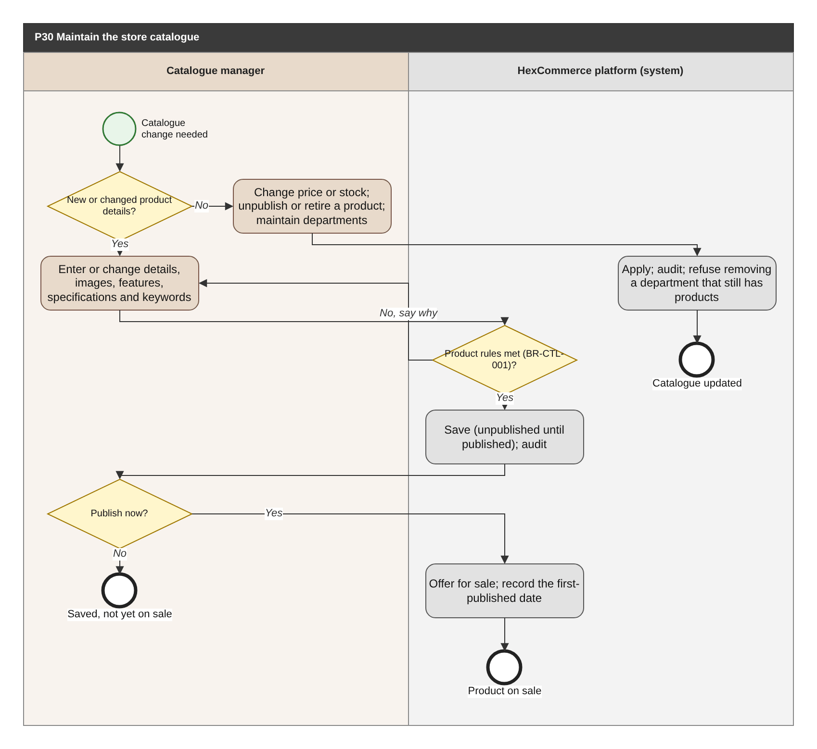
Figure 40: P30 Maintain the store catalogue (BPMN swimlane). draw.io: page P30 of HexCommerce_Process_Diagrams.drawio.
Attribute | Description
Purpose | Keep the store's own products, prices, stock and department structure current.
Trigger | A product is added or changes, or the department structure changes.
Actors / lanes | Catalogue manager; HexCommerce platform (system).
Preconditions | The catalogue manager is signed in with the catalogue-manager role.
Postconditions | The catalogue holds the change; only complete, published products are offered to shoppers.
Change from v2.5 | New process (U-11): the store catalogue was fixed sample data with no maintenance process.

Main flow
1. For a new or changed product, the catalogue manager enters or changes its details, images, features, specifications, colour and size options and search keywords.
2. The system checks the product rules (BR-CTL-001) and saves the product, unpublished until it is published, recording the change in the audit record.
3. The catalogue manager publishes the product; the system offers it for sale and records the first-published date (for newest arrivals, BR-CAT-004).
4. For price, list price or stock changes, unpublishing or retiring a product, or department changes, the system applies the change and records it in the audit record.

Exception and alternative paths
- Rule broken: the catalogue manager is told why.
- Removing a department or sub-department that still contains products or listings is refused (FR-CTL-005).
- A retired product remains in order history (FR-CTL-003).

Related requirements
BR-CAT-004, BR-CTL-001, FR-ADM-013, FR-CTL-001, FR-CTL-002, FR-CTL-003, FR-CTL-004, FR-CTL-005, FR-CTL-006, FR-DAT-012, NFR-PRF-004

6.31 P31 Report and moderate reviews
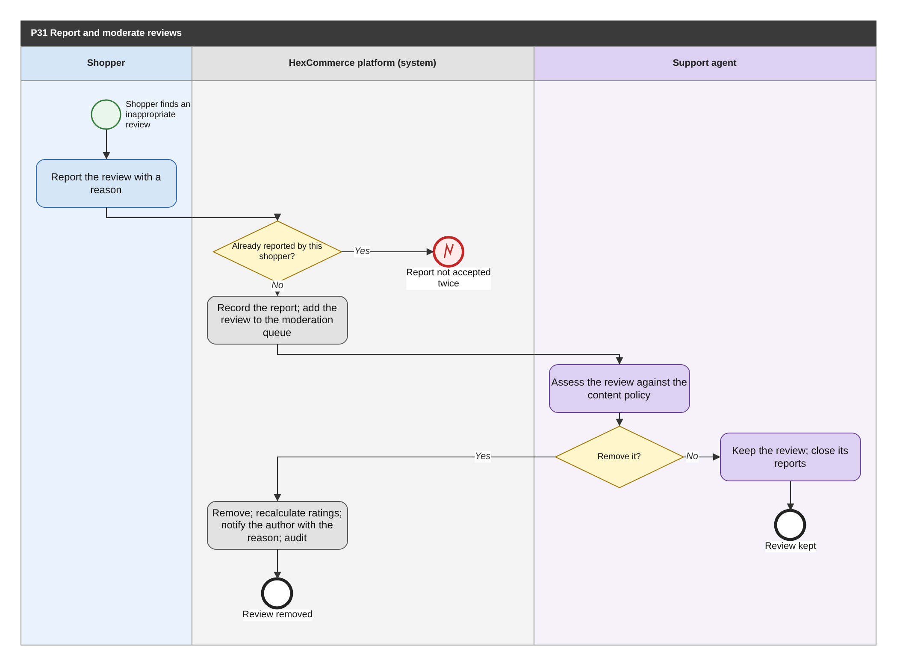
Figure 41: P31 Report and moderate reviews (BPMN swimlane). draw.io: page P31 of HexCommerce_Process_Diagrams.drawio.
Attribute | Description
Purpose | Remove abusive, misleading or unlawful reviews, through an accountable decision explained to the author.
Trigger | A signed-in shopper reports a review.
Actors / lanes | Shopper; HexCommerce platform (system); Support agent.
Preconditions | The review is published.
Postconditions | The review is kept and its reports closed, or removed and excluded from the product's ratings, with the author told why.
Change from v2.5 | New process (U-12): there was no way to report or remove an inappropriate review.

Main flow
1. The shopper reports the review with one of the report reasons (section 9.4).
2. The system accepts one report per shopper per review (BR-REV-007), records it and adds the review to the moderation queue.
3. A support agent assesses the review against the content policy.
4. To remove it, the system removes the review, recalculates the product's ratings (FR-REV-015), notifies the author with the reason and records the decision in the audit record.

Exception and alternative paths
- The agent keeps the review: its reports are closed.
- Who moderates, and the content policy, are open question Q-37.

Related requirements
BR-REV-004, BR-REV-006, BR-REV-007, FR-ADM-013, FR-REV-013, FR-REV-014, FR-REV-015

7 Functional requirements
Requirements are grouped by business module. "Verif." is the verification method (section 1.4). Business objectives are in the traceability matrix (section 13); rationale, owner and status are in Appendix B.

7.1 Catalogue browsing and search (CAT)
How shoppers find products and marketplace listings: departments, keyword search, filters, sorting and result sets.
ID | Requirement | Priority | Verif. | Process
FR-CAT-001 | The system shall organise the catalogue into eight departments: Electronics; Home & Kitchen; Fashion; Books; Sports & Outdoors; Beauty & Personal Care; Toys & Games; and Grocery. | Must | T | P01
FR-CAT-002 | The system shall allow each department to contain sub-departments, and shall allow the products of a department to be narrowed to one of its sub-departments. | Must | T | P01
FR-CAT-003 | The system shall allow the shopper to browse every product and marketplace listing that belongs to a chosen department. | Must | D | P01
FR-CAT-004 | The system shall allow a shopper to search the store using free-text keywords. | Must | T | P01
FR-CAT-005 | The system shall match search keywords against each product's title, brand, search keywords, summary and department. | Must | T | P01
FR-CAT-006 | The system shall include a product in search results only when every word of the search term appears somewhere in the product's searchable text. | Must | T | P01
FR-CAT-007 | The system shall rank search results by relevance, weighting a title match highest, followed by brand, search keywords, department or sub-department, and summary, and shall break ties by higher average customer rating. | Should | T | P01
FR-CAT-008 | The system shall suggest up to eight search terms, drawn from product titles, brands and search keywords, once the shopper has entered at least two characters of a search. | Should | D | P01
FR-CAT-010 | The system shall return the whole catalogue when a search is made without a search term. | Should | T | P01
FR-CAT-011 | The system shall restrict search results to a single department when the shopper limits the search to that department. | Could | T | P01
FR-CAT-012 | The system shall allow results to be filtered by sub-department. | Must | T | P01
FR-CAT-013 | The system shall allow results to be filtered by one or more brands, offering each brand present in the current results together with the number of matching products. | Must | T | P01
FR-CAT-014 | The system shall count brand options before the brand filter is applied, so that selecting one brand does not remove the other brand options. | Should | T | P01
FR-CAT-015 | The system shall allow results to be filtered by one of six price bands, expressed in the store currency: under 25; 25 to 50; 50 to 100; 100 to 200; 200 to 500; and 500 and above. To be confirmed - Q-04, Q-15 | Must | T | P01
FR-CAT-016 | The system shall allow results to be filtered by a minimum average customer rating of 4, 3, 2 or 1 stars and up. | Should | T | P01
FR-CAT-017 | The system shall allow results to be restricted to items that are currently in stock. | Should | T | P01
FR-CAT-018 | The system shall allow results to be restricted to items on sale (BR-CAT-002). | Should | T | P01
FR-CAT-019 | The system shall offer six sort orders: featured; price, low to high; price, high to low; average customer rating; number of reviews; and newest arrivals. | Must | T | P01
FR-CAT-020 | The system shall order featured results with merchandising-badged products first, followed by the remaining products in descending popularity score (BR-CAT-001). | Should | T | P01
FR-CAT-021 | The system shall keep search results in relevance order unless the shopper explicitly chooses a sort order other than featured. | Should | T | P01
FR-CAT-022 | The system shall tell the shopper how many results match and which of them are being provided, and shall provide large result sets in successive portions of a configurable size (default 12). | Must | T | P01
FR-CAT-023 | The system shall restart from the first portion of results whenever a filter or the sort order changes. | Should | T | P01
FR-CAT-025 | The system shall tell the shopper which filters are applied, shall allow any one of them to be removed, and shall allow all of them to be removed at once while keeping the search term, department scope and sort order. | Should | T | P01
FR-CAT-026 | The system shall allow any filtered, sorted and partitioned set of results to be revisited or shared by reference, reproducing the same results. | Should | T | P01
FR-CAT-027 | The system shall include in search and department results the active listings of every approved marketplace seller that match the search term and filters, identifying each as a marketplace item. | Must | T | P01
FR-CAT-028 | The system shall treat a search or department as having results when only marketplace listings match it. | Should | T | P01
FR-CAT-029 | The system shall tell the shopper when nothing matches, and shall offer to remove the filters when filters are applied, or to browse the whole catalogue when none are. | Must | T | P01
FR-CAT-030 | The system shall provide for each result its main image, title, and average rating with rating count, or an indication that it has no reviews yet. | Must | D | P01
FR-CAT-031 | The system shall provide for each result its price and, when it is discounted, its list price and discount percentage (BR-PRC-001). | Must | T | P01
FR-CAT-032 | The system shall provide for each result its merchandising badge, if any, and whether it is out of stock. | Should | D | P01
FR-CAT-033 | The system shall provide an estimated delivery date for each in-stock result. | Should | D | P01
FR-CAT-034 | The system shall provide the name of the selling seller for each marketplace item in results. | Must | D | P01
FR-CAT-035 | The system shall allow the shopper to add any result to the basket, or save it to the wish list, without first opening its full details. | Must | T | P01, P02

7.2 Merchandising and promotions (MKT)
Promotions, featured selections, store deals and seller deals presented to shoppers, and their maintenance by the merchandising team.
ID | Requirement | Priority | Verif. | Process
FR-MKT-001 | The system shall present the current promotions, each with a headline, a description and a destination (a department, a product, a search or the deals). | Should | D | P01, P29
FR-MKT-005 | The system shall feature up to six current store deals among the featured merchandising, each with its discount percentage, time remaining, title and deal price. | Should | D | P01
FR-MKT-006 | The system shall provide a 'Best sellers' selection of up to 12 products ranked by popularity score (BR-CAT-001). | Should | T | P01
FR-MKT-007 | The system shall provide a 'Biggest savings' selection of up to 12 discounted products ranked by percentage discount. | Should | T | P01
FR-MKT-010 | The system shall provide a list of every current store deal with its discount percentage, time remaining, customer rating, deal price, normal price and the percentage of the deal quantity claimed. | Must | D | P01
FR-MKT-011 | The system shall provide, with the store deals, up to 10 of the most deeply discounted products that are not on a store deal. | Could | T | P01
FR-MKT-012 | The system shall provide, with the store deals, every running seller deal with its discount percentage, deal price, normal price, end date and percentage claimed, and shall allow the item to be added to the basket from there. | Must | D | P01, P10
FR-MKT-014 | The system shall associate merchandising badges ('Best Seller', 'Deal of the Day', 'Hex Choice') with catalogue products and provide the badge wherever the product is presented. | Could | D | P01, P29
FR-MKT-015 | The system shall allow a merchandiser to create, edit, schedule (start and end date and time), order and withdraw promotions. | Should | T | P29
FR-MKT-016 | The system shall allow a merchandiser to create a store deal on a catalogue product by setting the discount percentage, the deal quantity and the start and end date and time, subject to the store-deal rules (BR-STD-001 to BR-STD-006). To be confirmed - Q-35 | Must | T | P29
FR-MKT-017 | The system shall, while a store deal is running, sell the product at the deal price, count units bought at that price against the deal quantity, and return the product to its normal price when the deal ends. | Must | T | P29, P01, P03
FR-MKT-018 | The system shall allow a merchandiser to edit a scheduled or running store deal, end it early, or remove a store deal that has not started. | Should | T | P29
FR-MKT-019 | The system shall allow a merchandiser to define featured selections (title, the products chosen or the rule that chooses them, and the maximum number shown) and to change which selections are featured. | Should | T | P29
FR-MKT-020 | The system shall allow a merchandiser to assign a merchandising badge to a catalogue product, or remove it. | Could | T | P29

7.3 Product and listing detail (PDP)
The information and purchase capabilities provided for an individual catalogue product or marketplace listing.
ID | Requirement | Priority | Verif. | Process
FR-PDP-001 | The system shall provide for every catalogue product its title, brand, average rating, rating count, merchandising badge, price, list price and saving percentage, together with a statement of whether the price includes tax. To be confirmed - Q-03 | Must | D | P01
FR-PDP-002 | The system shall provide for every catalogue product a list of key features, a full description and technical specifications that include the brand and the item model number. | Must | D | P01
FR-PDP-003 | The system shall provide every image of a product or listing, with one of them designated as the main image. | Should | D | P01
FR-PDP-004 | The system shall record and provide the colour and size options available for a product. To be confirmed - Q-11 | Could | D | P01
FR-PDP-005 | The system shall allow the shopper to see every product of a product's brand. | Could | T | P01
FR-PDP-006 | The system shall provide the stock status of each product and listing according to the stock-status rule (BR-STK-001). | Must | T | P01, P02
FR-PDP-007 | The system shall provide the estimated next-day delivery date and whether the item qualifies for free delivery or attracts the standard delivery fee (BR-PRC-008). | Should | D | P01, P02
FR-PDP-008 | The system shall allow the shopper to choose a quantity from 1 up to the lower of 10 and the units available before adding to the basket. | Must | T | P02
FR-PDP-009 | The system shall provide an immediate-purchase action that adds the chosen quantity to the basket, within BR-CRT-001 and BR-CRT-002, and starts checkout for the whole basket. When no unit can be added because the basket line is already at its limit, checkout shall still start and the shopper shall be told that no further units were added. | Must | T | P02, P03
FR-PDP-010 | The system shall tell the shopper how many units of the item are already in the basket and when the maximum orderable quantity has been reached. | Should | D | P02
FR-PDP-011 | The system shall provide up to 10 related products, taken first from the same sub-department and then from the same department (BR-CAT-005). | Should | T | P01
FR-PDP-012 | The system shall provide for every marketplace listing on sale its brand, the selling seller's name and, when not New, its condition. | Must | D | P01, P10
FR-PDP-013 | The system shall provide, for a listing with a running seller deal, the deal discount percentage, the deal end date and the deal units remaining out of the total. | Must | T | P10
FR-PDP-014 | The system shall treat a listing that is a draft, has been removed, or belongs to a seller whose account is not approved as not available to shoppers, and shall say so when it is requested directly. | Must | T | P09, P21, P14
FR-PDP-015 | The system shall tell the shopper when a requested product, department or other item does not exist, and shall suggest ways to continue shopping (the deals and the departments). | Must | T | P01
FR-PDP-016 | The system shall provide for a marketplace listing its price, key features and the seller's images, with the same purchase capabilities as a catalogue product. | Must | D | P01, P02
FR-PDP-017 | The system shall state, for a marketplace listing, that the item is sold and dispatched by an independent seller, together with its condition and item reference. | Should | D | P01
FR-PDP-018 | The system shall state for every product and listing who sells it, who dispatches it, the returns terms (BR-CS-004) and that payment is processed securely. | Should | I | P01

7.4 Ratings and reviews (REV)
Customer reviews of catalogue products: writing, voting, deleting, editing and moderating them.
ID | Requirement | Priority | Verif. | Process
FR-REV-001 | The system shall provide for each catalogue product the average rating out of 5, the total number of ratings, and the distribution of ratings across 5, 4, 3, 2 and 1 stars (BR-REV-006). To be confirmed - Q-23 | Should | T | P06
FR-REV-002 | The system shall provide each published review with its author, star rating, headline, review text, review date, verified-purchase indicator and helpful-vote count. | Must | D | P06
FR-REV-004 | The system shall allow a signed-in shopper to write a review consisting of a 1-to-5 star rating, a headline and review text. | Must | T | P06
FR-REV-005 | The system shall reject a review that breaks a review validation rule (BR-REV-001 to BR-REV-003), telling the shopper what to correct without discarding what they entered. | Must | T | P06
FR-REV-006 | The system shall label a new review 'Verified Purchase' when the shopper has bought the product in an order that was not cancelled. | Must | T | P06
FR-REV-007 | The system shall identify the shopper's own reviews to them, give them precedence over other reviews when reviews are provided to that shopper, and include them in the product's average rating, rating count and distribution. | Should | T | P06, P18
FR-REV-008 | The system shall allow a shopper to delete a review they wrote, after confirming the deletion. To be confirmed - Q-29 | Should | T | P18
FR-REV-009 | The system shall allow a shopper to write more than one review for the same product. | Could | T | P06
FR-REV-010 | The system shall allow a shopper to mark another customer's review as helpful and to withdraw that vote (BR-REV-005). | Should | T | P06
FR-REV-011 | The system shall confirm to the shopper that their review has been published. | Could | T | P06
FR-REV-012 | The system shall allow a shopper to edit a review they wrote, keeping its verified-purchase status and recording that it was edited and when. To be confirmed - Q-29 | Could | T | P18
FR-REV-013 | The system shall allow any signed-in shopper to report a review as inappropriate, giving one of the report reasons (section 9.4). | Should | T | P31
FR-REV-014 | The system shall give support agents a queue of reported reviews and allow an agent to keep a reported review or remove it with a reason, telling the author when their review is removed. To be confirmed - Q-37 | Should | T | P31
FR-REV-015 | The system shall exclude a removed review from the product's reviews, average rating, rating count and distribution. | Should | T | P31, P18

7.5 Basket, saved-for-later and wish list (CRT)
Collecting items before purchase: the basket, the saved-for-later list and the wish list.
ID | Requirement | Priority | Verif. | Process
FR-CRT-001 | The system shall allow a shopper to add a product or listing to the basket wherever it is presented to them, including results, product details, deals, the wish list, the saved-for-later list and order history. | Must | T | P02, P04, P19
FR-CRT-002 | The system shall provide for each basket line the item's image and title, the seller name (or brand), stock status, estimated arrival date, chosen quantity and line price. | Must | D | P02
FR-CRT-003 | The system shall allow the shopper to change the quantity of a basket line, where choosing 0 removes the line. | Must | T | P02
FR-CRT-004 | The system shall allow the shopper to delete a basket line. | Must | T | P02
FR-CRT-005 | The system shall allow the shopper to move a basket line to a 'Saved for later' list. | Should | T | P02
FR-CRT-006 | The system shall keep the saved-for-later list with the basket, provide the price and availability of each item on it, and allow each item to be moved to the basket or deleted. | Should | T | P02, P19
FR-CRT-007 | The system shall prevent an unavailable item from being moved from the saved-for-later list or the wish list into the basket. | Should | T | P19
FR-CRT-008 | The system shall flag each basket line whose quantity exceeds the units now available, and shall warn the shopper that such lines must be changed before an order can be placed (BR-CRT-004, BR-CRT-005). | Must | T | P02
FR-CRT-009 | The system shall provide a basket summary of item count, subtotal, savings, delivery charge (or free delivery), estimated tax and order total. | Must | T | P02, P03
FR-CRT-010 | The system shall tell the shopper how much more they need to spend to qualify for free delivery. | Should | T | P02
FR-CRT-011 | The system shall make the number of items in the basket available to the shopper at all times. | Must | D | P02
FR-CRT-012 | The system shall tell the shopper when the basket is empty and point them to the current deals and to any saved-for-later items. | Could | D | P02
FR-CRT-013 | The system shall allow the shopper to save a product or listing to the wish list, or remove it, wherever it is presented, and shall indicate whether it is already saved. | Must | T | P02
FR-CRT-014 | The system shall provide the wish list with each saved item's rating or seller, price, discount and availability, and allow each item to be moved to the basket or removed. | Must | T | P19
FR-CRT-015 | The system shall remove an item from the wish list when it is moved to the basket. | Should | T | P19
FR-CRT-016 | The system shall retain a signed-in shopper's basket, saved-for-later list and wish list between visits and across devices. | Must | T | P02, P19, P12
FR-CRT-017 | The system shall confirm each add-to-basket action as added, or as not added because the limit has been reached (BR-CRT-003). | Should | T | P02
FR-CRT-018 | The system shall keep a guest's basket for the visit and, when the guest signs in, merge it into the shopper's saved basket, applying the quantity limits (BR-CRT-001, BR-CRT-002). To be confirmed - Q-32 | Should | T | P02, P12
FR-CRT-019 | The system shall, when an item is moved from the wish list or the saved-for-later list to a basket line that is already at its limit, add nothing, leave the item on its list and tell the shopper the limit has been reached. To be confirmed - Q-28 | Should | T | P19

7.6 Checkout and order placement (CHK)
Turning the basket into an order, including payment authorisation and the hand-off of marketplace items to their sellers.
ID | Requirement | Priority | Verif. | Process
FR-CHK-001 | The system shall collect, before an order is placed, the delivery address, the payment card and the delivery option, and shall let the shopper review the items and totals. | Must | T | P03
FR-CHK-002 | The system shall start checkout from the shopper's selected delivery address (P16), allow any saved address to be chosen instead, and make the chosen address the selected delivery address. | Must | T | P03, P16
FR-CHK-003 | The system shall start checkout from the shopper's default card and allow any other saved card that is not expired to be chosen instead. | Must | T | P03
FR-CHK-004 | The system shall use the selected delivery address as the billing address. | Could | I | P03
FR-CHK-005 | The system shall offer two delivery options, next-day and standard, each with its expected delivery date (BR-ORD-002) and delivery charge. | Must | T | P03
FR-CHK-006 | The system shall provide the items being ordered with their quantity and, for marketplace items, the seller name. | Must | D | P03
FR-CHK-007 | The system shall provide the order totals (BR-PRC-002 to BR-PRC-004) and shall place the order only on an explicit confirmation from the shopper. | Must | T | P03
FR-CHK-008 | The system shall not place an order while any basket line exceeds the units available; it shall identify each affected item and allow the shopper to correct the basket. | Must | T | P03
FR-CHK-009 | The system shall, on order placement, create an order with a unique reference (BR-ORD-004), the status Processing and the order date. | Must | T | P03
FR-CHK-010 | The system shall, on order placement, create a seller order with status New for each marketplace item, recording buyer name, buyer city, quantity and unit price. | Must | T | P03, P11
FR-CHK-011 | The system shall, on order placement, reduce the stock of each marketplace listing and catalogue product by the quantity sold. | Must | T | P03, P11
FR-CHK-012 | The system shall, on order placement, count units bought at a deal price against that deal's claimed units (BR-SDL-009, BR-STD-004). | Must | T | P03, P10, P29
FR-CHK-013 | The system shall empty the basket once an order has been placed. | Must | T | P03
FR-CHK-014 | The system shall confirm a placed order to the shopper with the order reference and expected delivery date, and shall send an order confirmation (FR-NTF-001). | Must | T | P03
FR-CHK-015 | The system shall not start checkout with an empty basket, and shall tell the shopper so. | Should | T | P03
FR-CHK-016 | The system shall allow the shopper to add or change a delivery address or payment card during checkout without losing the checkout in progress. | Could | T | P03, P07
FR-CHK-017 | The system shall tell the shopper, when choosing a delivery option, how much more must be spent to qualify for free delivery whenever a delivery charge applies. | Could | T | P03
FR-CHK-018 | The system shall record on each new order the expected delivery date for the chosen delivery option. | Must | T | P03
FR-CHK-019 | The system shall record on each new order the title and unit price of every item as they were at placement. | Must | T | P03
FR-CHK-020 | The system shall record on each new order the delivery address, the card brand and last four digits, and the subtotal, delivery fee, tax and total as they were at placement. | Must | T | P03
FR-CHK-021 | The system shall require the shopper to be signed in before an order can be placed. To be confirmed - Q-32 | Must | T | P03, P12
FR-CHK-022 | The system shall create the order, its seller orders, the stock reductions and the deal claims together, so that either all of them are recorded or none is. | Must | T | P03, P11
FR-CHK-023 | The system shall prevent a seller from buying their own listings. To be confirmed - Q-21 | Should | T | P03

7.7 Payment and refunds (PAY)
Card payment for orders through a payment service provider, and refunds for cancellations and returns.
ID | Requirement | Priority | Verif. | Process
FR-PAY-001 | The system shall pass each new card's details to the payment service provider for safekeeping and shall retain only the provider's card reference, the card brand, the last four digits and the expiry (BR-ACC-008). | Must | T | P07
FR-PAY-002 | The system shall obtain authorisation for the order total on the chosen card from the payment service provider before the order is created, and shall create the order only when the authorisation succeeds. | Must | T | P03
FR-PAY-003 | The system shall, when authorisation is declined or cannot be obtained, not create the order, keep the basket and the checkout choices, and tell the shopper to try again or choose another card, without giving the reason held by the card issuer. | Must | T | P03
FR-PAY-004 | The system shall capture payment for each order line when it is dispatched, and shall release the authorised amount for any line cancelled before dispatch. To be confirmed - Q-33 | Must | T | P23, P24
FR-PAY-005 | The system shall refund to the original card, through the payment service provider, the amount due for cancelled lines that were already captured and for accepted returns (BR-PRC-009). | Must | T | P24, P25
FR-PAY-006 | The system shall record against the order every authorisation, capture, release and refund, with its amount, date, outcome and provider reference. | Must | T | P03, P23, P24, P25

7.8 Orders, fulfilment, cancellations and returns (ORD)
The shopper's order history, the progress of each order through fulfilment, invoices, and cancelling or returning items.
ID | Requirement | Priority | Verif. | Process
FR-ORD-001 | The system shall provide all of the shopper's orders, newest first, with the total number of orders. | Must | D | P04
FR-ORD-002 | The system shall provide for each order its reference, order date, total, recipient, status, delivered or expected delivery date, and each item with its quantity, unit price and status. | Must | D | P04
FR-ORD-003 | The system shall allow the shopper to buy again, or view, any ordered item that is still sold, and shall indicate when such an item is unavailable. | Should | T | P04
FR-ORD-004 | The system shall identify an ordered item that is no longer sold by the title captured at ordering (or as 'Item no longer listed'), without purchase actions. | Should | T | P04
FR-ORD-005 | The system shall provide for each order its date, reference and progress through the stages Processing, Shipped, Out for delivery and Delivered, identifying the stages reached and when each was reached. | Must | D | P04, P23
FR-ORD-006 | The system shall state, for a cancelled order or line, that it was cancelled, when, and the amount refunded or released. | Must | T | P04, P24
FR-ORD-007 | The system shall provide for each order the delivery address, the card brand and last four digits, and the subtotal, delivery charge, tax and total. | Must | D | P04
FR-ORD-008 | The system shall provide an invoice for each order as a document the shopper can print or keep. | Should | T | P04
FR-ORD-009 | The system shall allow the shopper to request a return or replacement of items in an order only when those items are Delivered and within the returns window (BR-ORD-006), starting a return request (P25). | Must | T | P04, P25
FR-ORD-010 | The system shall tell the shopper when a requested order reference does not exist or belongs to another customer, and shall direct them to their order history. | Must | T | P04
FR-ORD-013 | The system shall track the fulfilment status of each order line and derive the order status from the status of its lines (BR-ORD-008). To be confirmed - Q-07 | Must | T | P23
FR-ORD-014 | The system shall update the shopper's order line when the seller confirms dispatch or delivery of the matching seller order. To be confirmed - Q-07 | Must | T | P23, P11
FR-ORD-015 | The system shall allow the fulfilment team to confirm dispatch of the store's own items, recording the carrier and tracking reference. | Must | T | P23
FR-ORD-016 | The system shall record delivery-progress events (out for delivery, delivered, delivery failed) received from the carrier against the order line and update its status. | Should | T | P23
FR-ORD-017 | The system shall provide the carrier and tracking reference of each dispatched line to the shopper. | Should | D | P04, P23
FR-ORD-018 | The system shall allow the shopper to cancel an order, or individual lines of it, that have not been dispatched (BR-ORD-009). To be confirmed - Q-08 | Must | T | P24
FR-ORD-019 | The system shall, on cancellation of a line, restore its stock, release any deal units it claimed (BR-ORD-011), cancel the matching seller order and release or refund its payment (FR-PAY-004, FR-PAY-005). | Must | T | P24
FR-ORD-020 | The system shall allow the shopper to request a return of one or more delivered items, choosing for each the quantity, a return reason (section 9.4) and whether they want a refund or a replacement. | Must | T | P25
FR-ORD-021 | The system shall give each return request a reference (BR-ORD-010), tell the shopper how and where to send the items, and track the request through the return statuses (BR-ORD-012). | Must | T | P25
FR-ORD-022 | The system shall allow the party that dispatched the item (the fulfilment team or the seller) to record receipt and inspection of returned items and to accept or reject the return, giving a reason for a rejection. To be confirmed - Q-39 | Must | T | P25
FR-ORD-023 | The system shall, when a return is accepted, refund the amount due (BR-PRC-009) or create a replacement order line at no charge, as the shopper chose, and restore saleable stock. | Must | T | P25

7.9 Customer service (CS)
Raising and following issues about ordered items, the support team handling them, and help information.
ID | Requirement | Priority | Verif. | Process
FR-CS-001 | The system shall allow the shopper to raise an issue against any item in any of their orders that was not cancelled. | Must | T | P05
FR-CS-002 | The system shall require the shopper to classify each issue as one of the nine support topics listed in section 9.4. | Must | T | P05
FR-CS-003 | The system shall allow the shopper to add optional free-text details to a new issue. | Must | T | P05
FR-CS-004 | The system shall refuse to raise an issue until an item and a topic are chosen, telling the shopper which is missing. | Must | T | P05
FR-CS-005 | The system shall, when an issue is raised, assign it a reference (BR-CS-002), set its status to Open, record the shopper's message (the details, or the topic when no details are given), and add an automated acknowledgement quoting the reference and a reply within 24 hours. | Must | T | P05
FR-CS-006 | The system shall provide the shopper's issues, newest first, with reference, item, last-updated date and status, and with the total and open counts. | Must | D | P05
FR-CS-007 | The system shall mark an issue that has a support reply the shopper has not yet read as unread, and shall mark it read when the shopper opens it. | Should | T | P05
FR-CS-008 | The system shall provide the full message thread of an issue, with the author and date and time of each message, and a reference to the related order. | Must | D | P05
FR-CS-009 | The system shall allow the shopper to add a non-empty reply to any issue. | Must | T | P05, P15
FR-CS-010 | The system shall change an issue's status to In review when the shopper replies while it is Awaiting your reply or Resolved, and leave it unchanged when the shopper replies while it is Open or In review (BR-CS-001). | Must | T | P05, P15
FR-CS-011 | The system shall tell the shopper, before they reply to a resolved issue, that replying will reopen it. | Should | T | P15
FR-CS-012 | The system shall describe issue statuses to the shopper in customer terms, presenting 'Awaiting your reply' as needing the shopper's reply. | Should | I | P05
FR-CS-013 | The system shall tell a shopper who has no order items eligible for an issue that issues can be raised only about ordered items. | Should | T | P05
FR-CS-014 | The system shall provide help information on delivery options and charges, returns and replacements (BR-CS-004), and how to contact the support team. | Should | I | P05
FR-CS-015 | The system shall give support agents a queue of issues that can be filtered by status, topic and assigned agent, ordered by the time since the shopper last wrote, oldest first. | Must | T | P22
FR-CS-016 | The system shall allow a support agent to assign an issue to themselves or to another agent. | Should | T | P22
FR-CS-017 | The system shall provide the agent with the issue thread, the related order and item, the order's payment, fulfilment and return history, and the shopper's other issues. | Must | D | P22
FR-CS-018 | The system shall allow a support agent to reply to the shopper and, with the reply, set the issue to In review, Awaiting your reply or Resolved; a reply shall mark the issue unread for the shopper and notify them (FR-NTF-005). | Must | T | P22
FR-CS-019 | The system shall allow a support agent to add internal notes to an issue that are never provided to the shopper. | Should | T | P22
FR-CS-020 | The system shall flag to support agents every issue whose last shopper message has waited longer than the 24-hour service level (BR-CS-003). | Should | T | P22
FR-CS-021 | The system shall allow a support agent to start a return request (P25) or cancel an undispatched line (P24) on the shopper's behalf from an issue, recording it in the issue thread. | Should | T | P22, P24, P25

7.10 Account, addresses, payment cards and access (ACC)
The shopper's account, account book and the registration, sign-in, password and sign-out journeys.
ID | Requirement | Priority | Verif. | Process
FR-ACC-001 | The system shall provide an account overview with the shopper's name, email address, member-since date and most recent orders, and access to their orders, wish list, addresses, payment cards, customer-service issues and seller account. | Should | D | P07
FR-ACC-002 | The system shall provide the saved delivery addresses with label, recipient, address lines, city, postcode, country and an indication of the default address. | Must | D | P07
FR-ACC-003 | The system shall allow the shopper to add a delivery address and optionally make it the default. | Must | T | P07
FR-ACC-004 | The system shall allow the shopper to edit a saved delivery address. | Must | T | P07
FR-ACC-005 | The system shall allow the shopper to remove any saved delivery address except the last remaining one. | Must | T | P07
FR-ACC-006 | The system shall allow the shopper to make any saved delivery address the default. | Must | T | P07
FR-ACC-007 | The system shall maintain a selected delivery address for the shopper, provide its city and postcode wherever delivery estimates are given, and allow it to be changed to any saved address at any time. | Should | T | P16, P07, P03
FR-ACC-008 | The system shall provide the saved payment cards with brand, last four digits, expiry date, whether the card has expired, and an indication of the default card. | Must | D | P07
FR-ACC-009 | The system shall allow the shopper to add a payment card by giving its number and expiry date, and optionally make it the default (FR-PAY-001). | Must | T | P07
FR-ACC-010 | The system shall allow the shopper to remove any saved card except the last remaining one. | Must | T | P07
FR-ACC-011 | The system shall allow the shopper to make any saved card that is not expired the default. | Must | T | P07
FR-ACC-012 | The system shall record the products a signed-in shopper views and provide their most recently viewed products. To be confirmed - Q-18 | Could | T | P01
FR-ACC-013 | The system shall authenticate a registered shopper by email address or mobile number and password, and start a signed-in session. | Must | T | P12
FR-ACC-014 | The system shall allow a visitor to register by giving their name, email address and a password entered twice, applying the password policy (BR-ACC-011), and shall sign the new shopper in. To be confirmed - Q-22 | Must | T | P12
FR-ACC-015 | The system shall allow a visitor to request a password reset by email address, validating its format (BR-ACC-009), and shall respond in the same way whether or not an account exists for it (NFR-SEC-004). | Should | T | P12
FR-ACC-016 | The system shall allow a signed-in user to sign out, ending their session (P20). | Must | T | P20
FR-ACC-018 | The system shall refuse a registration whose email address is already registered, and shall suggest signing in or resetting the password. | Must | T | P12
FR-ACC-019 | The system shall refuse a sign-in with incorrect credentials without saying which credential was wrong, and shall lock sign-in for the account temporarily after repeated failures (BR-ACC-012). To be confirmed - Q-38 | Must | T | P12
FR-ACC-020 | The system shall send a password-reset link that is valid for 24 hours and for one use only, allow the visitor to set a new password that meets the password policy, and end every other session of the account when the password changes. | Must | T | P12
FR-ACC-021 | The system shall end a signed-in session after a period of inactivity (BR-ACC-013). To be confirmed - Q-38 | Must | T | P12, P20
FR-ACC-022 | The system shall allow a guest to browse, search, view products and listings and build a basket, and shall require sign-in for checkout, orders, the wish list, the account book, reviews, helpful votes, customer service and selling. To be confirmed - Q-32 | Must | T | P12, P01, P02
FR-ACC-023 | The system shall allow a signed-in shopper to change their name, mobile number and password, and to change their email address after confirming the new address. | Should | T | P12

7.11 Notifications (NTF)
Messages the system sends to shoppers, sellers and applicants when something they need to know happens.
ID | Requirement | Priority | Verif. | Process
FR-NTF-001 | The system shall send the shopper an order confirmation with the order reference, items, totals, delivery address and expected delivery date. | Must | T | P03
FR-NTF-002 | The system shall notify the shopper when an order line is dispatched (with the carrier and tracking reference), is out for delivery, is delivered or fails delivery. | Should | T | P23
FR-NTF-003 | The system shall notify the shopper when an order or line is cancelled, by them or by a seller, and of the amount refunded or released. | Must | T | P24
FR-NTF-004 | The system shall notify the shopper when a return request is created, when the returned items are received, and of the outcome (refund amount, replacement or rejection with its reason). | Must | T | P25
FR-NTF-005 | The system shall notify the shopper when a support agent replies to their issue or needs their reply. | Should | T | P22
FR-NTF-006 | The system shall send password-reset links (FR-ACC-020) and notify the account holder whenever their password or email address is changed. | Must | T | P12
FR-NTF-007 | The system shall notify an applicant when their seller application is approved, rejected (with the reason, if given) or returned to Pending. | Should | T | P08, P14
FR-NTF-008 | The system shall notify a seller of each new seller order and of each return request for their items. | Should | T | P11, P25
FR-NTF-009 | The system shall notify a seller when a payout statement is issued and when a payout is paid. | Should | T | P28
FR-NTF-010 | The system shall notify a seller when one of their Active listings goes out of stock. | Could | T | P11, P21
FR-NTF-011 | The system shall not include full card numbers, passwords or buyer contact details other than name and city in any notification. | Must | I | All

7.12 Seller onboarding (SAP)
Recruiting sellers, capturing seller applications and controlling access to selling.
ID | Requirement | Priority | Verif. | Process
FR-SAP-001 | The system shall provide information for prospective sellers on the benefits of selling, how to get started and the fee structure (BR-SPY-001). | Should | I | P08
FR-SAP-002 | The system shall tell a shopper who has applied to sell the business name, status and next step of their own application. | Should | D | P08
FR-SAP-003 | The system shall capture on the seller application the legal business name, business type, primary contact, business email, business phone, years trading and an optional website. | Must | T | P08
FR-SAP-004 | The system shall default the contact name and email address of a new application from the shopper's account, and the country to United Kingdom. | Could | T | P08
FR-SAP-005 | The system shall refuse an application that breaks a seller-application rule (BR-SAP-001, BR-SAP-010, BR-SAP-011) and shall tell the applicant what to correct. | Must | T | P08
FR-SAP-006 | The system shall, on submission, record the application with a unique reference (BR-SAP-009), status Pending and the submission time, link it to the applicant, and confirm that it will be reviewed. | Must | T | P08
FR-SAP-007 | The system shall provide the status of a pending application, and shall not accept a new application, while the applicant has one Pending (BR-SAP-007). | Must | T | P08
FR-SAP-008 | The system shall tell an approved applicant the approval and decision dates and give them access to the seller tools. | Must | D | P08
FR-SAP-009 | The system shall tell a rejected applicant the rejection reason (or a standard explanation when none was given) and allow them to apply again, starting from the details of their previous application. | Must | T | P08
FR-SAP-010 | The system shall restrict the seller tools (account overview, listings, deals, seller orders, business details and payouts) to shoppers whose own seller application is Approved. | Must | T | P08, P09, P13, P21
FR-SAP-011 | The system shall tell a shopper without an approved application who tries to use the seller tools where they stand (no application, pending since a date, or rejected with reason) and what their next step is. | Must | T | P08, P09, P13, P21
FR-SAP-012 | The system shall capture on the seller application a description of what the business plans to sell. | Must | T | P08
FR-SAP-013 | The system shall capture on the seller application the registered address: line 1, optional line 2, city, state or county, postcode and country. | Must | T | P08
FR-SAP-014 | The system shall capture on the seller application the tax registration number, stating that payout details are provided separately after approval (P27). | Must | T | P08
FR-SAP-015 | The system shall record an application made after a rejection as a new application with its own reference, and keep the earlier application and its decision in the applicant's history. | Should | T | P08
FR-SAP-016 | The system shall support any number of approved sellers, each with their own seller account, listings, deals, seller orders and payouts, visible only to that seller and to authorised back-office staff. | Must | T | P08, P09, P11

7.13 Back-office administration and seller application review (ADM)
The marketplace administrator's review of seller applications, and access control and audit for every back-office role.
ID | Requirement | Priority | Verif. | Process
FR-ADM-001 | The system shall provide authorised administrators with a queue of all seller applications, newest submission first, with the total count and the count awaiting a decision. | Must | T | P08
FR-ADM-002 | The system shall allow the queue to be filtered to All, Pending, Approved or Rejected applications, showing Pending by default. | Should | T | P08, P14
FR-ADM-003 | The system shall provide for every application its reference, business name, contact, email, phone, business type, years trading, tax number, submission date, website, registered address, description and the applicant's earlier applications. | Must | D | P08
FR-ADM-004 | The system shall allow the administrator to approve a pending application. | Must | T | P08
FR-ADM-005 | The system shall allow the administrator to reject a pending application, with an optional reason that is given to the applicant, after a confirmation step that can be cancelled. | Must | T | P08
FR-ADM-006 | The system shall record the date, time and administrator of each approval or rejection. | Must | T | P08
FR-ADM-007 | The system shall allow the administrator to move a decided application back to Pending, clearing its decision date and reason. | Should | T | P14
FR-ADM-008 | The system shall, when an application is approved, immediately give the applicant access to the seller tools and put the applicant's Active listings on sale. | Must | T | P08
FR-ADM-009 | The system shall, when an application is rejected or returned to Pending, immediately lock the applicant's seller tools and withdraw the applicant's listings from sale. | Must | T | P08, P14
FR-ADM-010 | The system shall make every back-office capability (seller applications, support, review moderation, fulfilment, merchandising, catalogue, payouts, configuration and back-office access) available only to signed-in staff users who hold the role for it (section 4.2). | Must | T | P26
FR-ADM-011 | The system shall allow a back-office administrator to create staff users, assign and revoke roles, and deactivate staff users. | Must | T | P26
FR-ADM-012 | The system shall require staff users to sign in with multi-factor authentication. To be confirmed - Q-05 | Must | T | P26
FR-ADM-013 | The system shall keep an audit record of every back-office action that changes data (who, what, when, and the values before and after), including application decisions, refunds, moderation decisions, payout approvals, role changes and configuration changes. | Must | T | P26, P08, P14, P22, P28, P29, P30, P31
FR-ADM-014 | The system shall allow back-office administrators to search and export the audit records. | Should | T | P26
FR-ADM-015 | The system shall prevent a staff user from deciding a seller application in which they are the applicant or the primary contact. | Could | T | P08

7.14 Seller account overview and business profile (SDB)
The seller's overview of their business and the business details held on file.
ID | Requirement | Priority | Verif. | Process
FR-SDB-001 | The system shall provide the seller with an overview of their account: business name, verification status, seller-since date and masked payout account. | Must | D | P09, P11
FR-SDB-002 | The system shall provide the seller with the number of active listings, number of live deals, units sold, revenue and estimated payout (BR-SOR-002 to BR-SOR-004). | Must | T | P11
FR-SDB-003 | The system shall provide the seller's most recent seller orders (by default three) with listing, reference, buyer, date and status. | Should | D | P11
FR-SDB-004 | The system shall identify the listings that need the seller's attention (drafts and out-of-stock listings) with guidance for each. | Should | D | P21
FR-SDB-005 | The system shall allow the seller to view and edit every application field except years trading as their business details. | Must | T | P13
FR-SDB-006 | The system shall refuse business-detail changes that break a business-details rule (BR-SAP-008), telling the seller what to correct, and shall confirm a successful save. | Must | T | P13
FR-SDB-007 | The system shall apply a changed business name immediately wherever the seller is named, including the seller name on their listings and in the application queue. | Should | T | P13
FR-SDB-008 | The system shall provide the payout account to the seller only in masked form, and shall allow it to be changed only through the payout-account process (P27). | Should | T | P13, P27

7.15 Seller listings (SLS)
Creating, publishing and maintaining the products an approved seller offers.
ID | Requirement | Priority | Verif. | Process
FR-SLS-001 | The system shall provide the seller with their listings and their count, and allow them to be filtered by status (All, Active, Draft, Out of stock, Unpublished) and searched by title. | Must | T | P21
FR-SLS-002 | The system shall provide for each listing its cover image, title, status, reference, department, condition, last-updated date, price, any "was" price, and stock level. | Must | D | P21
FR-SLS-003 | The system shall capture a listing's product details, pricing and stock, and description, and shall let the seller review the complete listing before it is saved. | Must | T | P09
FR-SLS-004 | The system shall capture for a listing its title, brand, department, optional sub-department, condition and up to six images. | Must | T | P09
FR-SLS-005 | The system shall offer only the sub-departments of the chosen department, and shall clear the sub-department when the department changes. | Should | T | P09
FR-SLS-006 | The system shall capture for a listing the selling price, an optional "was" price and the units in stock. | Must | T | P09
FR-SLS-007 | The system shall capture for a listing a short summary of up to 160 characters, a full description, and optional key features. | Must | T | P09
FR-SLS-008 | The system shall validate listing information as it is captured and re-check all of it before the listing is saved, telling the seller what must be corrected (BR-SLS-001). | Must | T | P09, P21
FR-SLS-009 | The system shall summarise the listing for review (title, brand, department, condition, price, stock, images, summary) before it is saved. | Should | D | P09
FR-SLS-010 | The system shall let the seller see the listing as shoppers will see it before saving it. | Should | D | P09
FR-SLS-011 | The system shall allow the seller, when saving a listing, either to publish it or to keep it as a draft. | Must | T | P09, P21
FR-SLS-012 | The system shall confirm a saved listing to the seller together with its resulting status. | Should | T | P09, P21
FR-SLS-013 | The system shall allow the seller to edit an existing listing, starting from its current details. | Must | T | P21
FR-SLS-014 | The system shall tell the seller when a listing they ask to edit no longer exists. | Should | T | P21
FR-SLS-015 | The system shall allow the seller to unpublish an Active or Out-of-stock listing. | Must | T | P21
FR-SLS-016 | The system shall allow the seller to publish a Draft or Unpublished listing, making it Active when it has stock and Out of stock otherwise. | Must | T | P21
FR-SLS-017 | The system shall allow the seller to remove a listing after confirming the removal, telling them that its deals will also be removed (BR-SLS-007). | Must | T | P21
FR-SLS-018 | The system shall allow the seller to add images to a listing, remove any image, and choose which image is the cover (BR-SLS-006). | Should | T | P09, P21
FR-SLS-019 | The system shall tell the seller how many of the images they supplied were added, how many were refused for breaking the image rules (BR-SLS-006), and how many could not be read. | Should | T | P09, P21
FR-SLS-020 | The system shall put every approved seller's Active listings on sale: they shall be found by search and department browsing, have their own detail, and be purchasable. | Must | T | P09, P21, P01
FR-SLS-022 | The system shall tell the seller, before a listing with no units in stock is published, that it will be published as Out of stock. | Could | T | P09, P21

7.16 Seller deals (SDL)
Time-limited percentage discounts that sellers run on their own listings.
ID | Requirement | Priority | Verif. | Process
FR-SDL-001 | The system shall provide the seller's deals, newest first, with the number of deals, the number running for shoppers and a status filter (All, Scheduled, Live, Ended). | Must | D | P10, P17
FR-SDL-002 | The system shall provide for each deal the listing title, status, reference, start and end dates, deal price against normal price, and units claimed out of deal units. | Must | D | P10, P17
FR-SDL-003 | The system shall allow the seller to create a deal by choosing one of their Active listings, a discount percentage, a number of deal units, a start date (default today) and an end date (default seven days later). | Must | T | P10
FR-SDL-004 | The system shall tell the seller the resulting deal price (BR-SDL-006) for the discount entered. | Should | T | P10
FR-SDL-005 | The system shall refuse a deal that breaks a seller-deal rule (BR-SDL-001 to BR-SDL-005), giving the reason. | Must | T | P10, P17
FR-SDL-006 | The system shall save a new deal as Live when its start date is today or earlier and as Scheduled otherwise, and shall confirm which. | Must | T | P10
FR-SDL-007 | The system shall allow the seller to edit an existing deal, including one whose listing is no longer Active. | Must | T | P17
FR-SDL-008 | The system shall allow the seller to start a Scheduled deal immediately unless that would overlap another deal on the same listing, in which case it shall refuse and give the reason (BR-SDL-010). | Must | T | P10
FR-SDL-009 | The system shall allow the seller to end a Live or Scheduled deal. | Must | T | P17
FR-SDL-010 | The system shall allow the seller to remove a deal after confirming the removal. | Must | T | P17
FR-SDL-011 | The system shall tell the seller why a Live deal is not reaching shoppers (listing removed, listing not Active, all deal units claimed, or another deal already running). | Should | T | P10, P17
FR-SDL-012 | The system shall tell a seller who has no Active listing that a deal needs one, and direct them to add a product. | Should | T | P10
FR-SDL-013 | The system shall, while a deal is running, sell the listing at the deal price, provide its normal price as the 'was' price, identify it as a deal with its percentage, and limit the units on offer to the deal units remaining (BR-SDL-014). | Must | T | P10
FR-SDL-014 | The system shall tell the seller when a deal's remaining units exceed the listing's units in stock. | Could | T | P17, P21
FR-SDL-015 | The system shall tell the seller when a deal they ask to edit no longer exists. | Could | T | P17

7.17 Seller order fulfilment (SOR)
How sellers see and progress, cancel and take back orders placed for their listings.
ID | Requirement | Priority | Verif. | Process
FR-SOR-001 | The system shall provide the seller's orders, newest first, with the total, the number awaiting dispatch and a status filter (All, New, Dispatched, Delivered, Cancelled). | Must | D | P11
FR-SOR-002 | The system shall provide for each seller order the listing title (or that the listing was removed), order reference, buyer name, buyer city, order date, status, quantity, unit price and line total. | Must | D | P11
FR-SOR-003 | The system shall allow the seller to confirm dispatch of a New order, recording the carrier and tracking reference, changing its status to Dispatched. | Must | T | P11, P23
FR-SOR-004 | The system shall allow the seller to mark a Dispatched order as Delivered, and shall also mark it Delivered when the carrier reports delivery. | Must | T | P11, P23
FR-SOR-005 | The system shall not allow the seller to change the status of a Delivered or Cancelled seller order. | Must | T | P11
FR-SOR-006 | The system shall allow the seller to cancel a New seller order they cannot fulfil, giving a reason; the shopper's order line shall then be cancelled and its payment released or refunded (P24). To be confirmed - Q-19 | Must | T | P24, P11
FR-SOR-007 | The system shall provide the seller with return requests for their items and allow them to record receipt and inspection and accept or reject each return (FR-ORD-022). To be confirmed - Q-39 | Must | T | P25

7.18 Seller payouts (SPY)
Payout accounts, referral fees, payout statements and settlement for sellers.
ID | Requirement | Priority | Verif. | Process
FR-SPY-001 | The system shall allow an approved seller to provide a payout bank account (account holder name, sort code and account number, or IBAN) and shall hold payouts until finance has verified it. | Must | T | P27
FR-SPY-002 | The system shall allow the seller to request a change of payout account, requiring them to re-authenticate, and shall continue to pay the verified account until finance verifies the new one. | Must | T | P27
FR-SPY-003 | The system shall allow finance to verify or reject a payout account, giving a reason for a rejection, and shall notify the seller of the outcome. | Must | T | P27
FR-SPY-004 | The system shall allow finance to maintain the referral-fee schedule by department (BR-SPY-001). To be confirmed - Q-01 | Must | T | P28
FR-SPY-005 | The system shall produce a payout statement for each seller for each payout period, listing the eligible seller orders (BR-SPY-002), revenue, referral fees, refunds and adjustments, and the net payout. To be confirmed - Q-34 | Must | T | P28
FR-SPY-006 | The system shall allow finance to approve a payout run, pay the approved payouts to the verified payout accounts, and record each payment with its date and reference. | Must | T | P28
FR-SPY-007 | The system shall provide the seller with their payout statements and payment history. | Should | D | P28

7.19 Store catalogue management (CTL)
The catalogue team's maintenance of the store's own products, departments and stock.
ID | Requirement | Priority | Verif. | Process
FR-CTL-001 | The system shall allow a catalogue manager to create and edit a catalogue product with every attribute in section 9.1, including images, features, specifications, colour and size options and search keywords. | Must | T | P30
FR-CTL-002 | The system shall validate a catalogue product before it is published (BR-CTL-001) and allow it to be kept unpublished until it is ready. | Must | T | P30
FR-CTL-003 | The system shall allow a catalogue manager to publish, unpublish and retire a catalogue product; a retired product shall remain in order history. | Must | T | P30
FR-CTL-004 | The system shall allow a catalogue manager to change the price, list price and units in stock of a catalogue product. | Must | T | P30
FR-CTL-005 | The system shall allow a catalogue manager to maintain departments and sub-departments, preventing removal of one that still contains products or listings. | Should | T | P30
FR-CTL-006 | The system shall record the date each product was first published, for the newest-arrivals order (BR-CAT-004). | Should | T | P30

7.20 Store configuration (CFG)
Settings that let the operator re-brand and re-parameterise the store without development work.
ID | Requirement | Priority | Verif. | Process
FR-CFG-001 | The system shall allow the store name and tagline to be configured without development work. | Should | I, T | All
FR-CFG-002 | The system shall allow the currency (ISO 4217 code) and locale to be configured, and shall format all prices, numbers and dates accordingly. | Should | I, T | All
FR-CFG-003 | The system shall allow the free-delivery threshold to be configured, defaulting to 35.00. | Must | I, T | P02, P03
FR-CFG-004 | The system shall allow the sales-tax rate to be configured, defaulting to 8.75%. To be confirmed - Q-03 | Must | I, T | P03
FR-CFG-005 | The system shall allow the store's brand identity (logo and brand colours) to be configured without development work. | Could | I, D | All
FR-CFG-006 | The system shall fall back to the default value of any configuration setting that is missing or invalid. | Should | T | All
FR-CFG-007 | The system shall allow the delivery fee to be configured, defaulting to 5.99. To be confirmed - Q-02 | Should | I, T | P02, P03
FR-CFG-008 | The system shall allow the next-day delivery cut-off time to be configured, defaulting to 23:00 in the store time zone. To be confirmed - Q-31 | Should | I, T | P03
FR-CFG-009 | The system shall allow the returns window to be configured, defaulting to 30 days from delivery. To be confirmed - Q-16 | Should | I, T | P25
FR-CFG-010 | The system shall restrict configuration changes to the store operator role and record each change in the audit record (FR-ADM-013). | Must | T | P26

7.21 Data retention, privacy and initial data (DAT)
How personal data is retained, exported and erased, and how the store is first loaded with data.
ID | Requirement | Priority | Verif. | Process
FR-DAT-008 | The system shall hold every customer's, seller's and staff user's data centrally, so that it is the same on every device they use. | Must | T | All
FR-DAT-009 | The system shall retain each class of data for the period set in the retention schedule and then delete or anonymise it. To be confirmed - Q-08 | Must | I | All
FR-DAT-010 | The system shall allow a shopper to close their account, erasing or anonymising their personal data except where it must be retained (for example, order and tax records). | Must | T | P12
FR-DAT-011 | The system shall allow a shopper to obtain a copy of the personal data held about them. | Should | T | P12
FR-DAT-012 | The system shall allow the initial catalogue (departments, sub-departments, products and existing reviews) to be loaded in bulk before launch. | Must | T | P30

7.22 Deferred capabilities (Won't have in this release) (DEF)
Capabilities agreed as outside this release, recorded so that their absence is a conscious decision.
ID | Requirement | Priority | Verif. | Process
FR-DEF-008 | The system shall price and stock colour and size variants individually. Q-11 | Won't | n/a | P01
FR-DEF-011 | The system shall provide content in more than one language. | Won't | n/a | All
FR-DEF-012 | The system shall send notifications by SMS or mobile push in addition to email. | Won't | n/a | All
FR-DEF-013 | The system shall offer sellers fulfilment by the marketplace (storage, picking, packing and dispatch of seller stock). | Won't | n/a | P11
FR-DEF-014 | The system shall allow a support agent to chat with a shopper in real time. | Won't | n/a | P22

8 Business rules and validations
Business rules are constraints and calculations that apply wherever the related function is used. Each is stated as a verifiable "shall" requirement.

8.1 Pricing, delivery, tax and refunds
ID | Rule | Priority | Verif. | Process
BR-PRC-001 | The system shall calculate a discount percentage as ((list price - selling price) / list price) x 100, rounded to the nearest whole number, and shall treat an item as discounted only when its list price is greater than its selling price. | Must | T | P01, P02
BR-PRC-002 | The system shall charge the configured delivery fee (default 5.99) when the basket subtotal is below the free-delivery threshold (default 35.00), and no delivery fee when the subtotal is at or above the threshold or the basket is empty. To be confirmed - Q-02 | Must | T | P02, P03
BR-PRC-003 | The system shall calculate tax as the basket subtotal multiplied by the tax rate (default 8.75%), rounded to the cent, and shall not charge tax on the delivery fee. To be confirmed - Q-03 | Must | T | P03
BR-PRC-004 | The system shall calculate the order total as subtotal plus delivery fee plus tax, rounded to the cent. | Must | T | P03
BR-PRC-005 | The system shall calculate basket savings as the sum, over discounted basket lines, of (list price - selling price) x quantity. | Should | T | P02
BR-PRC-006 | The system shall round line totals and the subtotal to whole cents so that the line amounts add up to the total. | Should | T | P02, P03
BR-PRC-007 | The system shall charge the same delivery fee for next-day and standard delivery. To be confirmed - Q-02 | Should | T | P03
BR-PRC-008 | The system shall describe free delivery for an individual item as applying when the item's own price is at or above the free-delivery threshold, and shall otherwise state the delivery fee and the threshold. To be confirmed - Q-10 | Could | T | P01
BR-PRC-009 | The system shall refund for a cancelled or returned line the unit price paid x quantity plus the tax charged on it, and shall refund the delivery fee only when every line of the order is cancelled before dispatch or returned because it was faulty or wrong. To be confirmed - Q-08 | Must | T | P24, P25

8.2 Basket and stock
ID | Rule | Priority | Verif. | Process
BR-CRT-001 | The system shall limit the basket to 10 units of any one product or listing. | Must | T | P02, P19
BR-CRT-002 | The system shall further limit the units of an item in the basket to its units available: its units in stock, or, while a seller deal or store deal is running on it, the lower of its units in stock and the deal units remaining. | Must | T | P02, P10, P19, P29
BR-CRT-003 | The system shall add nothing to a basket line that is already at its limit and shall tell the shopper that the limit has been reached. | Must | T | P02, P19
BR-CRT-004 | The system shall keep unchanged, and flag, a basket line whose quantity exceeds the units now available, rather than reducing it automatically. | Must | T | P02
BR-CRT-005 | The system shall not place an order while any basket line exceeds the units available. | Must | T | P02, P03
BR-CRT-006 | The system shall move an item from the wish list or the saved-for-later list to the basket by adding exactly one unit, only when the item is available and its basket line is below its limit; otherwise the item stays on its list. To be confirmed - Q-28 | Should | T | P19
BR-CRT-007 | The system shall hold each product at most once on the saved-for-later list and on the wish list, the most recently saved item first. | Should | T | P02, P19
BR-STK-001 | The system shall classify stock as unavailable at 0 units, low (giving the number of units left) at 1 to 10 units, and in stock above 10 units. | Must | T | P01, P02

8.3 Catalogue
ID | Rule | Priority | Verif. | Process
BR-CAT-001 | The system shall calculate a popularity score as average rating x log10(number of ratings + 10) and use it to rank best sellers and the non-badged part of the featured order. | Should | A, T | P01
BR-CAT-002 | The system shall treat an item as 'on sale' when its list price is greater than its selling price. | Must | T | P01
BR-CAT-003 | The system shall include both boundary values in a price-band filter (minimum <= price <= maximum). To be confirmed - Q-15 | Should | T | P01
BR-CAT-004 | The system shall order newest arrivals by the date each product or listing was first published, most recent first. | Could | T | P01, P30
BR-CAT-005 | The system shall exclude the product being viewed from its related products. | Should | T | P01
BR-CTL-001 | The system shall require a catalogue product to have a title, brand, department, price greater than 0, units in stock of 0 or more, a summary of at most 160 characters, a full description and at least one image before it is published, and any list price to be greater than the price. | Must | T | P30

8.4 Orders, fulfilment, cancellations and returns
ID | Rule | Priority | Verif. | Process
BR-ORD-001 | The system shall give a newly placed order the status Processing. | Must | T | P03
BR-ORD-002 | The system shall set the expected delivery date to the order date plus 1 day for next-day delivery when the order is placed before the next-day cut-off time (FR-CFG-008), plus 2 days when it is placed after it, and plus 4 days for standard delivery. To be confirmed - Q-31 | Must | T | P03
BR-ORD-003 | The system shall keep the item titles, unit prices, delivery address, masked card and totals of an order as they were when it was placed, unaffected by later catalogue or account changes. | Must | T | P03, P04
BR-ORD-004 | The system shall give each order a reference in the form 204-NNNNNNN-NNNNNNN. | Should | T | P03
BR-ORD-005 | The system shall use only the order and order-line statuses Processing, Shipped, Out for delivery, Delivered and Cancelled. | Must | T | P04, P23
BR-ORD-006 | The system shall allow a return or replacement to be requested for an order line only when it is Delivered and no more than the returns window (default 30 days, FR-CFG-009) has passed since its delivery. To be confirmed - Q-16 | Must | T | P04, P25
BR-ORD-007 | The system shall exclude items in cancelled orders and cancelled lines from customer-service issues and from purchases that qualify a review as verified. | Must | T | P05, P06
BR-ORD-008 | The system shall derive the order status from its lines that are not cancelled, as the least advanced of their statuses in the order Processing, Shipped, Out for delivery, Delivered; an order whose lines are all cancelled is Cancelled. To be confirmed - Q-07 | Must | T | P23, P24
BR-ORD-009 | The system shall allow an order line to be cancelled by the shopper only while it is Processing (not yet dispatched). | Must | T | P24
BR-ORD-010 | The system shall give each return request a reference in the form RT-NNNNN. | Should | T | P25
BR-ORD-011 | The system shall, when a line is cancelled, add its quantity back to the stock of the product or listing and subtract it from the claimed units of any deal it was bought under. | Must | T | P24
BR-ORD-012 | The system shall use only the return statuses Requested, Awaiting items, Received, Accepted, Rejected and Completed, moving a return from Requested to Awaiting items when the return instructions are issued, to Received when receipt is recorded, to Accepted or Rejected after inspection, and from Accepted to Completed when the refund or replacement is issued. | Must | T | P25

8.5 Customer service
ID | Rule | Priority | Verif. | Process
BR-CS-001 | The system shall use only the issue statuses Open, In review, Awaiting your reply and Resolved; a shopper reply shall move an issue that is Awaiting your reply or Resolved to In review and leave an Open or In review issue unchanged; a support agent may set any status when replying. | Must | T | P05, P15, P22
BR-CS-002 | The system shall give each issue a reference in the form CS-NNNNN. | Should | T | P05
BR-CS-003 | The system shall commit to a support reply within 24 hours of the shopper's last message. | Should | T | P05, P22
BR-CS-004 | The system shall apply the returns policy that most items may be returned within 30 days of delivery for a refund or replacement, with refunds made to the original card within 3 to 5 working days of the return being accepted. To be confirmed - Q-16 | Should | I | P05, P25
BR-CS-005 | The system shall never provide internal notes on an issue to the shopper. | Must | T | P22

8.6 Reviews
ID | Rule | Priority | Verif. | Process
BR-REV-001 | The system shall require a review star rating from 1 to 5. | Must | T | P06
BR-REV-002 | The system shall require a review headline of 3 to 80 characters after trimming. | Must | T | P06
BR-REV-003 | The system shall require review text of 10 to 2,000 characters after trimming. | Must | T | P06
BR-REV-004 | The system shall calculate a product's average rating over every published rating of it, including the shopper's own. | Should | T | P06, P18, P31
BR-REV-005 | The system shall accept at most one helpful vote per shopper per review, shall allow the vote to be withdrawn, and shall not allow a shopper to vote on their own review. | Should | T | P06, P18
BR-REV-006 | The system shall calculate the rating distribution as the share of published ratings at each star level, from the actual ratings. To be confirmed - Q-23 | Should | T | P06, P18, P31
BR-REV-007 | The system shall accept only the report reasons listed in section 9.4 and shall accept at most one report per shopper per review. | Should | T | P31

8.7 Account book and access
ID | Rule | Priority | Verif. | Process
BR-ACC-001 | The system shall always keep at least one delivery address and at least one payment card for a shopper who has saved any, and shall not allow the last of either to be removed. | Must | T | P07
BR-ACC-002 | The system shall keep exactly one default address and exactly one default card, promoting the first remaining entry when the default is removed. | Must | T | P07
BR-ACC-003 | The system shall make the default address the selected delivery address whenever the selected address is removed or no longer exists. | Must | T | P07, P16
BR-ACC-004 | The system shall require recipient name, address line 1, city, postcode and country for an address, treat line 2 and state or county as optional, and store a blank label as 'Home'. | Must | T | P07
BR-ACC-005 | The system shall require a card number of 13 to 19 digits, ignoring spaces and hyphens. | Must | T | P07
BR-ACC-006 | The system shall require a card expiry in the form MM/YY with a month from 01 to 12 that is not earlier than the current month. | Must | T | P07
BR-ACC-007 | The system shall derive the card brand from the leading digits: 4 as Visa; 51-55 or 22-27 as Mastercard; 34 or 37 as Amex; otherwise 'Card'. | Should | T | P07
BR-ACC-008 | The system shall retain only the payment provider's card reference, the card brand, the last four digits and the expiry, and shall never store the full card number. | Must | T | P07
BR-ACC-009 | The system shall accept an email address only in the form text@text.text with no spaces. | Must | T | P08, P12, P13
BR-ACC-010 | The system shall not accept an expired card for payment or as the default card, and shall treat a card as expired from the first day of the month after its expiry month. To be confirmed - Q-30 | Must | T | P03, P07
BR-ACC-011 | The system shall require a password of at least 8 characters that is not among commonly used or previously breached passwords, and that differs from the email address. To be confirmed - Q-22 | Must | T | P12
BR-ACC-012 | The system shall lock sign-in to an account for 15 minutes after 5 consecutive failed attempts, and shall tell the account holder by email. To be confirmed - Q-38 | Must | T | P12
BR-ACC-013 | The system shall end a shopper session after 30 minutes of inactivity, and a staff session after 15 minutes. To be confirmed - Q-38 | Must | T | P12, P20, P26

8.8 Seller onboarding
ID | Rule | Priority | Verif. | Process
BR-ADM-001 | The system shall treat a rejection reason as optional and, when none is given, shall give the applicant a standard explanation inviting them to apply again. | Should | T | P08
BR-SAP-001 | The system shall require on a seller application the legal business name, primary contact, a valid business email (BR-ACC-009), business phone and years trading as a whole number of 0 or more, and shall treat the website as optional. | Must | T | P08
BR-SAP-002 | The system shall accept only the business types Sole trader, Partnership, Limited company and Non-profit. | Must | T | P08
BR-SAP-003 | The system shall use only the application statuses Pending, Approved and Rejected, shall allow a Pending application to be approved or rejected, and shall allow a decided application to be returned to Pending. | Must | T | P08, P14
BR-SAP-004 | The system shall allow only a shopper whose own application is Approved to use the seller tools or sell, and shall withdraw that access as soon as the status changes. | Must | T | P08, P09, P14, P21
BR-SAP-005 | The system shall describe an approved seller as Verified, and shall treat the seller's payout account as not set up until one has been provided and verified (P27). | Should | T | P08, P27
BR-SAP-006 | The system shall take the seller-since date from the date the application was approved. | Could | T | P08
BR-SAP-007 | The system shall not accept a new application from a shopper whose application is Pending or Approved. | Must | T | P08
BR-SAP-008 | The system shall apply BR-SAP-001, BR-SAP-010 and BR-SAP-011 to business-detail edits, except that years trading shall not be editable. | Must | T | P13
BR-SAP-009 | The system shall give each application a reference in the form SA-NNNNN. | Should | T | P08
BR-SAP-010 | The system shall require on a seller application the registered address line 1, city, state or county, postcode and country, and shall treat address line 2 as optional. | Must | T | P08
BR-SAP-011 | The system shall require on a seller application a description of what will be sold and a tax registration number. | Must | T | P08

8.9 Seller listings
ID | Rule | Priority | Verif. | Process
BR-SLS-001 | The system shall require a listing title, a brand, a selling price greater than 0, whole units in stock of 0 or more, a summary of at most 160 characters and a full description, and shall require any 'was' price to be greater than the selling price. | Must | T | P09, P21
BR-SLS-002 | The system shall set a saved listing to Draft when it is saved as a draft; otherwise to Out of stock when its stock is 0; otherwise to Active, including when a previously Unpublished listing is published again. | Must | T | P09, P21
BR-SLS-003 | The system shall use only the listing statuses Active, Draft, Out of stock and Unpublished, shall sell only Active listings, shall treat Out-of-stock and Unpublished listings as unavailable, and shall never offer Drafts to shoppers. | Must | T | P09, P21
BR-SLS-004 | The system shall accept only the listing conditions New, Renewed, Used - like new and Used - good, and shall identify any condition other than New to shoppers. | Must | T | P09
BR-SLS-005 | The system shall reduce listing stock by the quantity sold when an order is placed, never below 0, and shall change an Active listing that reaches 0 to Out of stock. | Must | T | P03, P11
BR-SLS-006 | The system shall accept up to six images per listing, each a JPEG, PNG or WebP image file of at most 8 MB, and shall treat the first image as the cover; a listing may have no images. | Should | T | P09, P21
BR-SLS-007 | The system shall remove every deal on a listing when the listing is removed. | Must | T | P21, P17
BR-SLS-008 | The system shall give a new marketplace listing no customer rating and no search keywords. To be confirmed - Q-12 | Could | T | P01
BR-SLS-010 | The system shall give each listing a reference in the form SL-NNNNN. | Should | T | P09

8.10 Seller deals
ID | Rule | Priority | Verif. | Process
BR-SDL-001 | The system shall require a deal discount from 5% to 70% inclusive, rounded to a whole percentage. | Must | T | P10, P17
BR-SDL-002 | The system shall require at least 1 deal unit and no more than the listing's units in stock. | Must | T | P10, P17
BR-SDL-003 | The system shall not allow the deal units of an existing deal to be set below the units already claimed. | Must | T | P17
BR-SDL-004 | The system shall require a deal start date and end date, with the end date after the start date and not before today. | Must | T | P10, P17
BR-SDL-005 | The system shall not allow two deals that have not ended on the same listing to have overlapping dates. | Must | T | P10, P17
BR-SDL-006 | The system shall calculate the deal price as normal listing price x (1 - discount / 100), rounded to the cent. | Must | T | P10
BR-SDL-007 | The system shall derive deal status from its dates whenever it is used: Ended if the seller ended it or its end date has passed; Scheduled if its start date is after today; otherwise Live. | Must | T | P10, P17
BR-SDL-008 | The system shall apply a deal to shoppers only while it is Live, its listing is Active and it has deal units remaining, and shall otherwise treat it as paused and tell the seller the reason. | Must | T | P10, P17, P14
BR-SDL-009 | The system shall add units bought at the deal price to the deal's claimed units, up to the deal units, and shall charge the normal price once all deal units are claimed. | Must | T | P10, P03
BR-SDL-010 | The system shall move a Scheduled deal's start date to today when the seller starts it early, and shall refuse to do so if that would overlap another deal on the listing. | Must | T | P10
BR-SDL-011 | The system shall keep a deal that the seller ended as Ended, including after later edits. | Should | T | P17
BR-SDL-012 | The system shall allow a new deal only on an Active listing. | Must | T | P10
BR-SDL-013 | The system shall give each deal a reference in the form SD-NNNNN. | Should | T | P10
BR-SDL-014 | The system shall never offer more units at the deal price than the listing has in stock: the units on offer are the lower of the listing's units in stock and the deal units remaining. | Must | T | P10, P17, P21

8.11 Store deals
ID | Rule | Priority | Verif. | Process
BR-STD-001 | The system shall require a store deal discount from 5% to 70% inclusive, rounded to a whole percentage. To be confirmed - Q-35 | Must | T | P29
BR-STD-002 | The system shall require a store deal quantity of at least 1 and no more than the product's units in stock. | Must | T | P29
BR-STD-003 | The system shall require a store deal start and end date and time, with the end after the start and not in the past, and shall not allow two store deals on the same product to overlap. | Must | T | P29
BR-STD-004 | The system shall calculate the store deal price as the product price x (1 - discount / 100), rounded to the cent, and shall add units bought at that price to the deal's claimed units. | Must | T | P29, P03
BR-STD-005 | The system shall treat a store deal as running only between its start and end and while it has deal units remaining, and shall derive its time remaining and percentage claimed from its end time and claimed units. | Must | T | P29, P01
BR-STD-006 | The system shall give each store deal a reference in the form LD-NNNNN. | Should | T | P29

8.12 Seller orders, earnings and payouts
ID | Rule | Priority | Verif. | Process
BR-SOR-001 | The system shall use only the seller order statuses New, Dispatched, Delivered and Cancelled, and shall allow a seller to move an order only from New to Dispatched, from Dispatched to Delivered, and from New to Cancelled. | Must | T | P11, P24
BR-SOR-002 | The system shall calculate seller revenue as the sum of unit price x quantity over seller orders that are not Cancelled, less the value of accepted returns. | Must | T | P11, P28
BR-SOR-003 | The system shall calculate units sold as the sum of quantity over seller orders that are not Cancelled, less the quantity of accepted returns. | Must | T | P11
BR-SOR-004 | The system shall calculate estimated payout as revenue less the referral fees calculated from the fee schedule (BR-SPY-001). To be confirmed - Q-01 | Must | T | P11, P28
BR-SOR-005 | The system shall give a seller only the buyer's name and city, and no other contact details. | Must | T | P11
BR-SOR-006 | The system shall give each seller order a reference in the form SO-NNNNN, dated with the order date. | Should | T | P11
BR-SPY-001 | The system shall charge a referral fee on each delivered seller order at the rate set for its department in the fee schedule, defaulting to 12% for a department without a rate. To be confirmed - Q-01 | Must | T | P28
BR-SPY-002 | The system shall include a seller order in a payout once it has been Delivered for longer than the returns window, and shall deduct from the payout the value of returns accepted since the previous payout. To be confirmed - Q-34 | Must | T | P28
BR-SPY-003 | The system shall pay out only to a verified payout account, and shall hold a seller's payouts while no verified account exists. | Must | T | P27, P28

8.13 System date and time
ID | Rule | Priority | Verif. | Process
BR-SYS-001 | The system shall apply all date-dependent rules (deal status, delivery dates, card expiry, order dates, returns window, session expiry) using the current date and time in the store time zone. | Must | T | P03, P07, P10, P25, P29

8.14 Validation outcomes
The information a user must be given when a rule is broken. Each outcome names what must be corrected; the wording is decided in content design (section 1.4). Checks run in the order listed for each context.
Context | Condition | Information the user must be given
Seller application / business details | Business name blank | The legal business name is required.
Seller application / business details | Primary contact blank | A primary contact is required.
Seller application / business details | Email not in the form text@text.text | A valid business email address is required.
Seller application / business details | Phone blank | A business phone number is required.
Seller application | Years trading blank or negative | The number of years trading is required (0 for a new business).
Seller application / business details | Description blank | A description of what the business sells is required.
Seller application / business details | Line 1, city, state, postcode or country blank | The registered address is incomplete.
Seller application / business details | Tax number blank | The tax registration number is required.
Listing | Title blank | The product title is required.
Listing | Brand blank | The brand or maker is required.
Listing | Price blank, not a number or <= 0 | A selling price greater than zero is required.
Listing | "Was" price not greater than price | The "was" price must be higher than the selling price.
Listing | Stock blank or negative | The units in stock (0 or more) are required.
Listing | Summary blank or over 160 characters | A summary of up to 160 characters is required.
Listing | Description blank | A full description is required.
Listing images | Six images already held | No more images can be added until one is removed.
Listing images | File over 8 MB, not a JPEG, PNG or WebP image, or over the limit | How many files were refused and why.
Listing images | File cannot be read | How many files could not be read, and which formats are accepted.
Any save | The change could not be saved | The change was not saved; the entries are kept so the user can try again.
Deal | No listing chosen | The listing the deal applies to is required.
Deal | Discount blank | A discount percentage is required.
Deal / store deal | Discount outside 5-70% | The discount must be between 5% and 70%.
Deal | Units blank or < 1 | At least one deal unit is required.
Deal / store deal | Units above stock | Only N units are in stock.
Deal (edit) | Units below units claimed | N units have already been claimed, so the deal needs at least N.
Deal / store deal | Start or end missing | Both a start and an end are required.
Deal / store deal | End not after start | The end must be after the start.
Deal / store deal | End already passed | The end has already passed; the earliest possible end.
Deal / store deal | Overlaps another deal on the same item | The dates of the existing deal, and that it must end first or the dates must not overlap.
Deal (start early) | Starting now would overlap another deal | The deal cannot start now, and the dates of the deal it would overlap.
Address | Recipient name blank | The name of the person receiving deliveries is required.
Address | Line 1, city, postcode or country blank | The street address, city, postcode and country are required.
Card | Not 13-19 digits | A card number of 13 to 19 digits is required.
Card | Expiry not MM/YY or month invalid | The expiry is required as month and year (MM/YY).
Card | Expiry before the current month | The card has expired.
Checkout | Chosen card has expired | The card has expired; another card must be chosen or added.
Checkout | Payment authorisation declined or unavailable | The payment did not go through; the shopper can try again or choose another card. No issuer reason is given.
Checkout | Line above available units | For each affected item: unavailable, or only N available against M in the basket.
Checkout | Seller buying their own listing | Sellers cannot buy their own listings; the line must be removed.
Basket line | Item now unavailable | The item is unavailable and can be removed or saved for later.
Basket line | Quantity above available units | Only N are available; the quantity must be lowered before ordering.
Basket / lists | Line already at its limit | The limit for this item has been reached; nothing was added.
Review | No star rating | A star rating is required.
Review | Headline under 3 or over 80 characters | A headline of 3 to 80 characters is required.
Review | Text under 10 or over 2,000 characters | Review text of 10 to 2,000 characters is required.
Customer-service issue | No item chosen | The item the issue is about is required.
Customer-service issue | No topic chosen | What went wrong (the topic) is required.
Cancellation | Line already dispatched | The item has been dispatched and can no longer be cancelled; a return can be requested once it is delivered.
Return request | Line not Delivered or outside the returns window | The item is not eligible for return, and why.
Registration | Email already registered | An account already exists for the email address; sign in or reset the password.
Registration / password change | Password breaks the password policy | Which password rule is not met.
Registration | Passwords do not match | The two passwords differ.
Sign-in | Incorrect credentials | The email or password is incorrect (without saying which).
Sign-in | Account locked after repeated failures | Sign-in is temporarily locked and when it can be tried again.
Password help | Email format invalid | The email address used to register is required.
Password reset | Link expired or already used | The link is no longer valid; a new one can be requested.
Payout account | Account details incomplete or invalid | Which bank details are missing or invalid.

9 Data requirements
The business entities below are described at business level. Attribute lists are indicative and are not a physical design.

9.1 Key entities and attributes
Entity | Business meaning | Key attributes
Customer account | A registered shopper | Name, email, mobile number, password (hashed), member-since date, status (active, locked, closed)
Staff user | A member of staff with back-office access | Name, email, roles, second factor, status (active, deactivated)
Delivery address | A saved place to deliver to | Label, recipient name, line 1, line 2, city, state/county, postcode, country, default flag
Payment card | A saved card, held by the payment service provider | Provider card reference, brand, last four digits, expiry (MM/YY), default flag
Department / sub-department | Groupings of products and listings | Name, short description; sub-departments of a department
Catalogue product | An item in the store's own catalogue | Title, brand, department, sub-department, price, list price, stock, badge, summary, description, features, specifications, colours, sizes, search keywords, images, status, first-published date
Review | A customer opinion of a product | Author, rating (1-5), headline, text, date, verified-purchase flag, helpful count, status (published, removed), edited date, removal reason
Helpful vote | A shopper's endorsement of a review | Review, shopper (one per pair)
Review report | A report that a review is inappropriate | Review, reporting shopper, reason, date, outcome
Basket line | An item the shopper intends to buy | Product or listing, quantity
Saved-for-later item / wish-list item | An item kept for later | Product or listing, date saved
Order | A confirmed purchase | Reference, order date, expected delivery date, status (derived), recipient, delivery address (snapshot), card brand and last four (snapshot), subtotal, delivery, tax, total
Order line | One item within an order | Product or listing, quantity, unit price and title (snapshot), status, dispatching party, carrier, tracking reference, dispatch and delivery dates
Payment transaction | A movement of money for an order | Order, type (authorisation, capture, release, refund), amount, date, outcome, provider reference
Return request | A request to return delivered items | Reference, order, lines and quantities, reason, refund or replacement, status, dates, rejection reason, refund amount
Store deal | A store-run time-limited discount | Reference, product, percentage off, deal quantity, units claimed, start, end, status
Promotion / featured selection | Merchandising content | Headline or title, description, destination or products (or rule), start, end, order
Support issue | A problem raised about an ordered item | Reference, order, product, topic, status, assigned agent, created, updated, read flag
Support message | One message in an issue thread | From (customer, agent, system), author, text, sent date and time, internal flag
Seller application | A request to sell on the marketplace | Reference, business name, business type, contact, email, phone, website, description, years trading, registered address, tax number, status, submitted, decided, decided by, note
Seller profile | The business record of an approved seller | Business details from the application, seller-since date, verification status
Payout account | A seller's bank account for payouts | Account holder, sort code and account number or IBAN (masked when provided), status, verified by and when
Seller listing | A product offered by a seller | Reference, title, brand, department, sub-department, condition, price, "was" price, stock, status, summary, description, features, images, created, updated, first published
Seller deal | A seller-run time-limited discount | Reference, listing, percentage off, deal units, units claimed, status, start date, end date, created, updated
Seller order | A sale of a seller listing | Reference, listing, buyer name, buyer city, quantity, unit price, order date, status, carrier, tracking reference, cancellation reason
Referral-fee schedule | The fee charged on seller sales | Department, rate, effective from
Payout statement | A seller's payout for a period | Seller, period, orders, revenue, fees, returns and adjustments, net payout, status, paid date, payment reference
Notification | A message sent to a user | Recipient, type, related record, sent date and time
Audit record | A record of a back-office change | Staff user, action, record changed, values before and after, date and time
Store configuration | Operator settings | Store name, tagline, logo, brand colours, currency, locale, time zone, free-delivery threshold, delivery fee, next-day cut-off, tax rate, returns window

9.2 Relationships
Entity | Relationship | Related entity | Cardinality
Customer account | saves | Delivery address; Payment card | 1 to 0..many
Customer account | places | Order | 1 to 0..many
Order | contains | Order line | 1 to 1..many
Order | records | Payment transaction | 1 to 1..many
Order line | refers to | Catalogue product or Seller listing | many to 1
Order line | becomes | Seller order (marketplace lines) | 1 to 0..1
Return request | covers | Order line | many to many
Department | contains | Sub-department | 1 to 0..many
Department / Sub-department | classifies | Catalogue product and Seller listing | 1 to 0..many
Catalogue product | receives | Review | 1 to 0..many
Review | receives | Helpful vote; Review report | 1 to 0..many
Customer account | holds | Basket line; Saved item; Wish-list item | 1 to 0..many
Customer account | raises | Support issue | 1 to 0..many
Support issue | concerns | Order line | many to 1
Support issue | contains | Support message | 1 to 1..many
Customer account | owns | Seller application | 1 to 0..many (at most one Pending or Approved)
Seller application | becomes when approved | Seller profile | 1 to 0..1
Seller profile | has | Payout account; Payout statement | 1 to 0..many
Seller profile | offers | Seller listing | 1 to 0..many
Seller listing | is discounted by | Seller deal | 1 to 0..many (one running at a time)
Catalogue product | is discounted by | Store deal | 1 to 0..many (one running at a time)
Staff user | makes | Audit record | 1 to 0..many

9.3 Entity-relationship model
The model is drawn in two views for legibility.
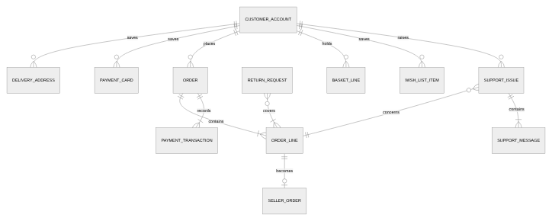
Figure 42: Entity-relationship model - customer, order, payment and service data.
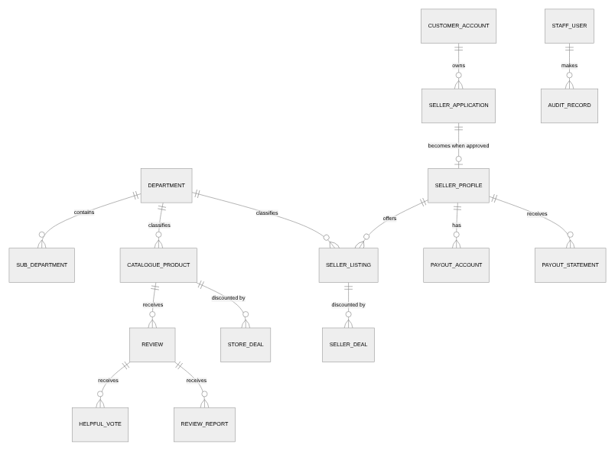
Figure 43: Entity-relationship model - catalogue, marketplace, merchandising and back-office data.

9.4 Reference data and code lists
Code list | Values
Departments | Electronics; Home & Kitchen; Fashion; Books; Sports & Outdoors; Beauty & Personal Care; Toys & Games; Grocery
Sub-departments | Audio, Computers, Cameras, Wearables; Cookware, Small appliances, Decor, Bedding; Men's, Women's, Footwear, Accessories; Fiction, Non-fiction, Children's; Fitness, Camping, Cycling; Skincare, Haircare, Fragrance; Building sets, Board games, Outdoor play; Coffee & tea, Snacks, Pantry
Merchandising badges | Best Seller; Deal of the Day; Hex Choice; for seller listings, "<N>% off deal" or the listing condition
Listing conditions | New; Renewed; Used - like new; Used - good
Business types | Sole trader; Partnership; Limited company; Non-profit
Support topics | Item arrived damaged or defective; Item never arrived; Wrong item delivered; Parts or accessories missing; Item not as described; Request a return; Refund not received; Billing or payment query; Something else
Return reasons (to be confirmed) | Damaged or defective; Wrong item sent; Not as described; Parts missing; No longer needed; Arrived too late
Review report reasons (to be confirmed) | Offensive or abusive; Spam or advertising; Not about the product; Contains personal information; Something else
Card brands | Visa; Mastercard; Amex; Card (other)
Delivery options | Next-day (order date + 1, or + 2 after the cut-off); Standard (order date + 4)
Sort orders | Featured; Price, low to high; Price, high to low; Average customer rating; Number of reviews; Newest arrivals
Price bands | Under 25; 25 to 50; 50 to 100; 100 to 200; 200 to 500; 500 and above (store currency)
Order and line statuses | Processing; Shipped; Out for delivery; Delivered; Cancelled
Return statuses | Requested; Awaiting items; Received; Accepted; Rejected; Completed
Staff roles | Marketplace administrator; Support agent; Fulfilment team; Merchandiser; Catalogue manager; Finance; Store operator; Back-office administrator
Reference formats | Order 204-NNNNNNN-NNNNNNN; Issue CS-NNNNN; Application SA-NNNNN; Listing SL-NNNNN; Deal SD-NNNNN; Store deal LD-NNNNN; Seller order SO-NNNNN; Return RT-NNNNN

9.5 Field-level data dictionary
Every field users enter, with whether it is mandatory, its format or rule, and its default. Validation outcomes are in section 8.14.
Context | Field | Req. | Format / rule | Default
Registration | Name | Yes | Free text | Blank
Registration | Email address | Yes | Email format (BR-ACC-009); not already registered | Blank
Registration | Password; password again | Yes | Password policy (BR-ACC-011); both the same | Blank
Sign-in | Email or mobile number; password | Yes | Must match a registered account | Blank
Password reset request | Email address | Yes | Email format (BR-ACC-009) | Blank
Password reset | New password; again | Yes | Password policy (BR-ACC-011) | Blank
Seller application / business details | Legal business name | Yes | Free text | Blank
Seller application / business details | Business type | Yes | One of the business types (BR-SAP-002) | Sole trader
Seller application / business details | Primary contact | Yes | Free text | Account holder's name
Seller application / business details | Business email | Yes | Email format (BR-ACC-009) | Account holder's email
Seller application / business details | Business phone number | Yes | Free text | Blank
Seller application | Years trading | Yes | Whole number, 0 or more; not editable after approval | Blank
Seller application / business details | Website or online store | No | Web address | Blank
Seller application / business details | What the business sells | Yes | Free text | Blank
Seller application / business details | Address line 1, city, state or county, postcode | Yes | Free text | Blank
Seller application / business details | Address line 2 | No | Free text | Blank
Seller application / business details | Country | Yes | Free text | United Kingdom
Seller application / business details | Tax registration number | Yes | Free text | Blank
Administrator decision | Rejection reason | No | Free text, given to the applicant | Blank
Payout account | Account holder name | Yes | Free text | Business name
Payout account | Sort code and account number, or IBAN | Yes | Valid bank details | Blank
Listing | Product title | Yes | Free text | Blank
Listing | Brand or maker | Yes | Free text | Blank
Listing | Department | Yes | One of eight departments | None
Listing | Sub-department | No | Sub-departments of the chosen department | None
Listing | Condition | Yes | New; Renewed; Used - like new; Used - good | New
Listing | Images | No | Up to 6 JPEG, PNG or WebP files, each at most 8 MB; first is the cover | None
Listing | Selling price | Yes | Number greater than 0 | Blank
Listing | "Was" price | No | Number greater than the selling price | Blank
Listing | Units in stock | Yes | Whole number, 0 or more | Blank
Listing | Short summary | Yes | Free text, at most 160 characters | Blank
Listing | Full description | Yes | Free text | Blank
Listing | Key features | No | List of free-text lines; blank lines ignored | None
Seller deal | Listing | Yes | One of the seller's Active listings | First Active listing
Seller deal / store deal | Discount | Yes | Whole percentage from 5 to 70 | Blank
Seller deal | Units in this deal | Yes | Whole number from 1 to units in stock; not below units claimed | Blank
Seller deal | Starts on; ends on | Yes | Dates; end after start and not before today | Today; today + 7 days
Store deal | Product; deal quantity; start; end | Yes | A catalogue product; 1 to units in stock; date and time, end after start | None
Delivery address | Label | No | Free text; blank is stored as "Home" | Blank
Delivery address | Full name | Yes | Free text | Account holder's name
Delivery address | Address line 1, city, postcode, country | Yes | Free text | Country: United Kingdom
Delivery address | Address line 2, county or region | No | Free text | Blank
Delivery address / payment card | Use as default | No | Yes / no | No (yes when editing the default)
Payment card | Card number | Yes | 13 to 19 digits, spaces and hyphens ignored; passed to the payment service provider, never stored | Blank
Payment card | Expiry | Yes | MM/YY, month 01-12, not before the current month | Blank
Review | Overall rating | Yes | 1 to 5 stars | None
Review | Headline | Yes | 3 to 80 characters | Blank
Review | Review text | Yes | 10 to 2,000 characters | Blank
Review report | Reason | Yes | One of the report reasons | None
Customer-service issue | Item | Yes | One item from an order that was not cancelled | None
Customer-service issue | Topic | Yes | One of nine support topics | None
Customer-service issue | Details | No | Free text | Blank
Customer-service reply | Reply | Yes | Non-empty free text | Blank
Agent reply | Status; internal note | Status yes | Open, In review, Awaiting your reply or Resolved; free-text note | In review
Cancellation | Lines to cancel | Yes | Lines still Processing | All undispatched lines
Seller cancellation | Reason | Yes | Free text, given to the shopper | Blank
Return request | Items and quantities; reason; refund or replacement | Yes | Delivered lines within the returns window; one of the return reasons | None; refund
Return decision | Accept or reject; rejection reason | Yes; reason when rejecting | Free text | None
Dispatch | Carrier; tracking reference | Yes | Free text | Blank
Adding to the basket | Quantity | Yes | 1 to the lower of 10 and the units available | 1
Basket | Quantity | Yes | 0 (delete) to the lower of 10 and the units available | Current quantity
Checkout | Delivery address | Yes | One saved address | Selected delivery address
Checkout | Payment card | Yes | One saved card that is not expired | Default card
Checkout | Delivery option | Yes | Next-day or standard | Next-day
Staff user | Name; email; roles | Yes | Roles from the staff roles list | None

9.6 Data quality, retention and privacy
- Orders keep a snapshot of title, price, address, card and totals at the time of purchase (BR-ORD-003).
- Card data is held by the payment service provider; the marketplace keeps only the provider reference, brand, last four digits and expiry (BR-ACC-008). Buyer data given to sellers is limited to name and city (BR-SOR-005).
- Personal data is retained according to the retention schedule (FR-DAT-009, Q-08) and can be exported or erased on request (FR-DAT-010, FR-DAT-011).
- Every back-office change is recorded in a tamper-evident audit record (FR-ADM-013, NFR-SEC-012).

10 Non-functional requirements
Quality requirements of the target system. Values marked "To be confirmed" are proposals for their owners to confirm (Q-24).

10.1 Security and privacy
ID | Requirement | Priority | Verif. | Process
NFR-SEC-001 | The system shall never store or provide a full card number; card details shall be held by the payment service provider and only the brand, last four digits and expiry shall be kept. | Must | I, T | P07, P03
NFR-SEC-003 | The system shall disclose to a seller only the buyer's name and city. | Must | I, T | P11
NFR-SEC-004 | The response to a password-reset request shall not reveal whether an account exists for the email address given. | Should | T | P12
NFR-SEC-006 | The system shall restrict administrative functions to authorised staff users holding the relevant role. | Must | T | P26
NFR-SEC-007 | Passwords shall be stored only as salted one-way hashes using an algorithm designed for passwords. | Must | I | P12
NFR-SEC-008 | All data exchanged with users and external systems shall be encrypted in transit (TLS 1.2 or later). | Must | I, T | All
NFR-SEC-009 | Personal data shall be encrypted at rest. | Must | I | All
NFR-SEC-010 | The card-payment process shall meet PCI DSS v4.0, with card data captured and held by the payment service provider so that the marketplace qualifies for the reduced self-assessment. | Must | I | P03, P07
NFR-SEC-011 | The system shall comply with UK GDPR and the Data Protection Act 2018 for all personal data it processes. | Must | I | All
NFR-SEC-012 | Audit records (FR-ADM-013) shall be tamper-evident and retained for at least 7 years. To be confirmed - Q-08 | Must | I | P26

10.2 Performance and capacity
ID | Requirement | Priority | Verif. | Process
NFR-PRF-004 | Listing and product images shall be optimised for delivery (reduced in size and compressed) without the seller or catalogue manager having to prepare them. | Should | T | P09, P30
NFR-PRF-006 | 95% of browse, search and product-detail requests shall be answered within 2 seconds at the expected peak load. To be confirmed - Q-24 | Should | T | P01
NFR-PRF-007 | Search-term suggestions shall be returned within 300 milliseconds for 95% of requests. To be confirmed - Q-24 | Should | T | P01
NFR-PRF-008 | 95% of order placements, including payment authorisation, shall complete within 5 seconds. To be confirmed - Q-24 | Should | T | P03
NFR-PRF-009 | The system shall support the expected peak of concurrent shoppers, sellers and staff users agreed by the Business Sponsor, with headroom of at least 50%. To be confirmed - Q-24 | Should | T | All

10.3 Reliability and data retention
ID | Requirement | Priority | Verif. | Process
NFR-REL-001 | The system shall durably retain each user's basket, wish list, saved-for-later list, account book, orders, reviews, helpful votes, support issues, seller applications and seller data, and make them available on any device the user signs in from. | Must | T | All
NFR-REL-003 | The system shall confirm a change to the user only after it has been saved, and shall report a change that could not be saved without discarding what the user entered. | Must | T | All
NFR-REL-006 | The system shall be available 99.5% of each calendar month, excluding announced maintenance. To be confirmed - Q-24 | Should | A | All
NFR-REL-007 | The system shall be recoverable after a failure with no more than 15 minutes of committed data lost and within 4 hours. To be confirmed - Q-24 | Should | T | All

10.4 Accessibility
ID | Requirement | Priority | Verif. | Process
NFR-ACC-002 | Every function shall be operable by keyboard alone and by assistive technologies. | Must | T | All
NFR-ACC-004 | Information conveyed by position, colour, shape or graphics (for example progress, ratings and status) shall also be available as text. | Should | I, T | All
NFR-ACC-005 | Content that moves or changes automatically shall be possible to pause and shall not move for users who have asked for reduced motion. | Should | T | P01
NFR-ACC-006 | Every image shall have a text alternative, using the product title or the image role. | Must | I | All
NFR-ACC-007 | Every validation outcome (section 8.14) shall be given as text that identifies what must be corrected. | Should | I | All
NFR-ACC-009 | The system shall conform to WCAG 2.2 level AA [4] and shall be audited against it before launch. To be confirmed - Q-25 | Must | I, T | All

10.5 Usability and device support
ID | Requirement | Priority | Verif. | Process
NFR-USE-001 | Every function shall be usable on mobile phones, tablets and desktop computers. | Must | D | All
NFR-USE-003 | Irreversible actions - removing a listing or a deal, deleting a review, cancelling an order or line, and closing an account - shall require the user to confirm them. | Must | T | P17, P18, P21, P24

10.6 Localisation
ID | Requirement | Priority | Verif. | Process
NFR-LOC-001 | Prices, numbers and dates shall be formatted according to the configured locale and currency. | Should | T | All
NFR-LOC-002 | Dates shall be calculated and recorded in UTC and presented in the store time zone, so that the same date applies everywhere. | Should | T | All
NFR-LOC-003 | All currency amounts given to users shall use the configured currency. | Must | I, T | All
NFR-LOC-004 | User-facing text shall be in English (UK spelling) in this release. | Could | I | All

11 Integrations and external dependencies

11.1 External system interfaces
External system | Business data exchanged | Requirements | Processes
Payment service provider | Card safekeeping (references), authorisation, capture, release, refund, seller payouts | FR-PAY-001 to FR-PAY-006, FR-SPY-006 | P03, P07, P23, P24, P25, P28
Email service | Notifications to shoppers, sellers, applicants and staff | FR-NTF-001 to FR-NTF-011 | P03, P08, P11, P12, P22 to P25, P28
Carriers | Delivery-progress events (out for delivery, delivered, failed) against tracking references | FR-ORD-016 | P23
Tax engine (if needed) | Tax calculation if rates vary by region or product (Q-03) | BR-PRC-003 | P03

11.2 Internal integration points
From | To | Business data exchanged | Requirements
Checkout | Orders; seller orders; listings and products; deals; payments | Order, seller orders, stock reductions and deal claims created together; payment authorised first | FR-CHK-009 to FR-CHK-012, FR-CHK-022, FR-PAY-002
Seller orders and fulfilment | Shopper orders | Dispatch and delivery update the shopper's order line | FR-ORD-014, FR-SOR-003, FR-SOR-004
Cancellation and returns | Stock, deals, seller orders, payments | Stock and deal units restored; seller orders cancelled; refunds issued | FR-ORD-019, FR-ORD-023, FR-PAY-005
Seller-application decision | Seller tools and storefront | Approval unlocks seller tools and puts Active listings on sale; withdrawal locks them | FR-ADM-008, FR-ADM-009, BR-SAP-004
Seller listings and deals; store deals | Search, departments, deals, basket | Active listings sold as products, priced with any running deal | FR-SLS-020, FR-SDL-013, FR-MKT-017
Order history | Reviews; customer service; returns | Purchases decide Verified Purchase; eligible items for issues and returns | FR-REV-006, FR-CS-001, FR-ORD-009
Account book | Delivery estimates and checkout | Selected delivery address and default card | FR-ACC-007, FR-CHK-002, FR-CHK-003
Business details | Every place the seller is named | Business name | FR-SDB-007
Seller orders and returns | Payouts | Delivered orders past the returns window, less returns | BR-SPY-002, FR-SPY-005
Every back-office function | Audit records | Who changed what, when, before and after | FR-ADM-013

12 Assumptions, constraints, dependencies, open questions and risks

12.1 Assumptions
ID | Assumption
A-01 | The business rules observed in the demonstration application and recorded in v2.5 carry into the target system unless this document changes them.
A-02 | The marketplace serves many customers and many sellers; each has their own account.
A-03 | Back-office staff are employees or contractors who are given staff user accounts with specific roles.
A-04 | The store operates in one currency, one language (English, UK) and one time zone, set by configuration.
A-05 | Sample content used by the demonstration application (products, reviews, accounts, orders) is not part of the target system; the initial catalogue is loaded before launch (FR-DAT-012).
A-06 | A payment service provider, an email service and one or more carriers will be contracted and offer the interfaces in section 11.1.
A-07 | The store's own items are dispatched by a fulfilment team from stock the business holds; sellers dispatch their own items.
A-08 | The proposed success measures in section 3.2 and the proposed values in requirements marked "To be confirmed" are suggestions until their owners confirm them.
A-09 | Seller recruitment content that mentions fulfilment services, analytics and category-based fees describes intentions, not capabilities of this release (FR-DEF-013).
A-10 | The user interface will be designed after this document is approved, by a design team using it as their input.

12.2 Constraints
ID | Constraint
C-01 | Card payments must comply with PCI DSS v4.0; card details are captured and held by the payment service provider, not the marketplace (NFR-SEC-010).
C-02 | Personal data processing must comply with UK GDPR and the Data Protection Act 2018 (NFR-SEC-011).
C-03 | Single language (English, UK) and single currency in this release (FR-DEF-011, A-04).
C-04 | Notifications are sent by email only in this release (FR-DEF-012).
C-05 | Only the settings listed in section 7 (CFG) can be changed without development work.

12.3 Dependencies
ID | Dependency
D-01 | Contract with, and integration of, a payment service provider for card safekeeping, payments, refunds and seller payouts.
D-02 | An email service for notifications.
D-03 | Carrier integration for delivery-progress events (FR-ORD-016).
D-04 | A decision on the tax model (Q-03) before checkout totals can be finalised.
D-05 | Checkout depends on the account book (address and card) and on stock of products and listings.
D-06 | Verified reviews, customer-service eligibility and returns depend on the order history.
D-07 | Selling depends on an Approved seller application; payouts depend on a verified payout account.
D-08 | User-interface design depends on approval of this document and on answers to the open questions marked as blocking design.

12.4 Open questions
Questions carried from v2.5 keep their number. "Proposed answer" means v3.0 states requirements on that basis and they are marked "To be confirmed" until the owner confirms them.
ID | Question | Proposed answer in v3.0 | Owner | Status
Q-01 | Seller payouts were estimated with a flat 12% referral fee, while seller information states 8% to 15% by category. Which is correct? | A fee schedule by department maintained by finance, with 12% as the default rate (BR-SPY-001, FR-SPY-004). | Finance / Marketplace ops | Proposed answer
Q-02 | Next-day and standard delivery cost the same. Should next-day carry a premium? | Keep one fee for both, now configurable (BR-PRC-007, FR-CFG-007). | Product Owner | Proposed answer
Q-03 | Are prices tax-inclusive or tax-exclusive, and does tax apply to delivery? | Open. FR-PDP-001 requires the statement of whether the price includes tax; BR-PRC-003 adds tax on top until decided. | Finance | Open - blocks design of price information
Q-04 | What are the target market and currency? | All amounts and price bands are expressed in the configured currency (FR-CAT-015, NFR-LOC-003); the market is assumed to be the UK (A-04). | Product Owner | Proposed answer
Q-05 | Who are the administrators and how are they authenticated and audited? | Staff users with roles, multi-factor sign-in and an audit record (FR-ADM-010 to FR-ADM-014, P26). | Security / Marketplace ops | Proposed answer
Q-06 | How will agents reply to, request information on and resolve issues? | A support-agent queue in the system (P22, FR-CS-015 to FR-CS-021). | Customer service lead | Proposed answer
Q-07 | How should seller fulfilment and shopper order statuses be synchronised? | Line-level fulfilment status, updated by dispatch and carrier events; order status derived from the lines (P23, FR-ORD-013 to FR-ORD-016, BR-ORD-008). | Product Owner | Proposed answer
Q-08 | What cancellation, refund and data-retention policies apply? | Cancellation before dispatch (P24), returns within the window (P25), refund amounts per BR-PRC-009. The retention schedule itself is still needed (FR-DAT-009). | Product Owner / Legal | Partly answered
Q-09 | Should checkout be blocked when the seller order cannot be recorded? | The order and its seller orders are created together or not at all (FR-CHK-022). | Engineering | Closed
Q-10 | Item-level free-delivery statements use the item price, but the charge uses the basket subtotal. Should this change? | Open; BR-PRC-008 is retained. | Product Owner | Open
Q-11 | Are colour and size variants with their own price and stock required? | Deferred (FR-DEF-008); options are recorded and provided (FR-PDP-004). | Product Owner | Open
Q-12 | New marketplace listings have no rating, so any rating filter hides them. Acceptable? | Open; BR-SLS-008 is retained. | Product Owner | Open
Q-13 | Should shoppers be able to review marketplace listings? | Open; reviews apply to catalogue products only. | Product Owner | Open
Q-14 | Confirm the multi-seller model. | Every approved seller has their own account and listings (FR-SAP-016). | Business Sponsor | Proposed answer
Q-15 | Price bands share boundaries. Should one boundary be exclusive? | Open; BR-CAT-003 is retained. | Product Owner | Open
Q-16 | Should the 30-day returns window be enforced? | Yes, with a configurable window (BR-ORD-006, FR-CFG-009). | Customer service lead | Proposed answer
Q-17 | Should sub-department names be searchable? | Open. | Product Owner | Open
Q-18 | Should recently viewed products track actual browsing? | Yes, for signed-in shoppers (FR-ACC-012). | Product Owner | Proposed answer
Q-19 | Who can cancel seller orders and when? | The seller, for New seller orders, with a reason (FR-SOR-006); the shopper, before dispatch (BR-ORD-009). | Marketplace ops | Proposed answer
Q-20 | Is a sign-out that keeps the user signed in acceptable? | No: sign-out ends the session (P20). | Product Owner | Closed
Q-21 | Should a seller be prevented from buying their own listings? | Yes (FR-CHK-023). | Marketplace ops | Proposed answer
Q-22 | What password policy applies? | At least 8 characters, not commonly used or breached, not the email address (BR-ACC-011). | Security | Proposed answer
Q-23 | Should real per-star rating counts be held and shown? | Yes (BR-REV-006). | Product Owner / Legal | Proposed answer
Q-24 | What performance, capacity and availability targets apply? | NFR-PRF-006 to NFR-PRF-009 and NFR-REL-006, NFR-REL-007 propose values; the expected peak load is still needed. | Engineering lead / Product Owner | Proposed answer
Q-25 | What accessibility conformance level applies? | WCAG 2.2 AA, audited before launch (NFR-ACC-009). | Product Owner / Legal | Proposed answer
Q-26 | Are corporate pages (careers, press, sustainability, affiliates, advertising) required? | Out of scope (section 3.4); presentation of store information is a design matter. | Marketing | Closed
Q-27 | Who produces the future-state requirements? | This document is the future state. Transition requirements are now Q-41. | Business Sponsor | Closed
Q-28 | Should moving an item from a list to a basket line at its limit be refused and the item kept? | Yes (FR-CRT-019, BR-CRT-006). | Product Owner | Proposed answer
Q-29 | Should deleting a review ask for confirmation, and can shoppers edit a review? | Yes to both (FR-REV-008, FR-REV-012). | Product Owner | Proposed answer
Q-30 | Can a card that has expired since it was saved be used at checkout? | No (BR-ACC-010). | Finance | Proposed answer
Q-31 | What delivery promise applies: the next-day cut-off time, and the standard delivery window? | Configurable next-day cut-off (default 23:00), next-day + 2 days after it, standard + 4 days (BR-ORD-002, FR-CFG-008). Do weekends and holidays count? | Product Owner / Marketplace ops | Proposed answer
Q-32 | What can guests do, and is guest checkout wanted? | Guests browse and build a basket; checkout and the other capabilities require sign-in (FR-ACC-022, FR-CHK-021). | Product Owner | Proposed answer - blocks design of checkout
Q-33 | When is payment captured? | Per order line on dispatch; authorisations for cancelled lines are released (FR-PAY-004). | Finance | Proposed answer
Q-34 | How often are sellers paid, and how long is a sale held before it is paid? | Per payout period (weekly proposed), for orders Delivered longer than the returns window (BR-SPY-002). | Finance | Proposed answer
Q-35 | What discount limits apply to store deals? | The same as seller deals, 5% to 70% (BR-STD-001). | Merchandising lead | Proposed answer
Q-36 | Can shoppers choose which notifications they receive, and are marketing emails in scope? | Service notifications are always sent; marketing emails are out of scope (section 3.4). | Product Owner / Legal | Open
Q-37 | Who moderates reviews, and against what content policy? | Support agents (FR-REV-014); the content policy is to be written by the customer service lead and legal. | Customer service lead | Proposed answer
Q-38 | What lock-out and session-timeout values apply? | 5 failed attempts lock sign-in for 15 minutes; sessions end after 30 minutes (shoppers) and 15 minutes (staff) of inactivity (BR-ACC-012, BR-ACC-013). | Security | Proposed answer
Q-39 | Who receives and decides returns of marketplace items? | The seller (FR-ORD-022, FR-SOR-007); the alternative is the marketplace on the seller's behalf. | Marketplace ops | Proposed answer
Q-40 | What happens after repeated failed delivery attempts? | Open (P23). | Marketplace ops | Open
Q-41 | What transition requirements apply (launch cut-over, data migration, training), and who prepares the business case? | Open; initial catalogue loading is FR-DAT-012. | Business Sponsor | Open

12.5 Risk register
Likelihood and impact are rated High, Medium or Low for the launch of the target system.
ID | Risk | Likelihood | Impact | Mitigation | Owner | Status
R-01 | A seller's sale is not recorded although the shopper's order is placed. | Low | High | Order, seller orders, stock and deals created together (FR-CHK-022). | Engineering lead | Mitigated by requirement
R-02 | Anyone can decide seller applications. | High | High | Role-based staff access with multi-factor sign-in and audit (FR-ADM-010 to FR-ADM-014). | Security / data protection | Mitigated by requirement
R-03 | Users lose baskets, orders and seller work. | High | Medium | Central data storage (FR-DAT-008, NFR-REL-001). | Engineering lead | Mitigated by requirement
R-04 | Tax presentation is inconsistent, risking complaints or regulatory challenge. | Medium | High | Decide the tax model (Q-03) and align price information and checkout. | Finance | Open
R-05 | Sellers dispute payouts because fees differ from those stated. | Medium | Medium | Fee schedule by department maintained by finance (BR-SPY-001); payout statements (FR-SPY-005). | Finance | Mitigated by requirement
R-06 | Orders never progress, driving 'where is my order' contacts. | High | Medium | Fulfilment progress, tracking and notifications (P23). | Product Owner | Mitigated by requirement
R-07 | Amounts shown in the wrong currency. | Medium | Low | Every amount in the configured currency (NFR-LOC-003). | Product Owner | Mitigated by requirement
R-08 | Date rules break if a fixed date is used. | Medium | High | The current date and time in the store time zone (BR-SYS-001). | Engineering lead | Mitigated by requirement
R-09 | An estimated rating breakdown is judged misleading. | Medium | Medium | Actual per-star counts (BR-REV-006). | Product Owner | Mitigated by requirement
R-10 | No accessibility target exposes the business to claims. | Medium | High | WCAG 2.2 AA with an audit before launch (NFR-ACC-009). | Product Owner | Mitigated by requirement
R-11 | Sellers inflate sales or deal claims by buying their own listings. | Low | Medium | Self-purchase prevented (FR-CHK-023). | Marketplace operations lead | Mitigated by requirement
R-12 | Returns accepted regardless of the returns policy increase costs. | Medium | Low | Returns window enforced (BR-ORD-006). | Customer service lead | Mitigated by requirement
R-13 | An outage of the payment service provider stops all orders. | Low | High | Contract service levels; clear failure handling (FR-PAY-003); monitoring. | Engineering lead | Open
R-14 | Card fraud and chargebacks. | Medium | High | Provider fraud screening and strong customer authentication; refund records (FR-PAY-006). | Finance | Open
R-15 | A personal-data breach. | Low | High | NFR-SEC-007 to NFR-SEC-012; data minimisation for sellers (BR-SOR-005). | Security / data protection | Open
R-16 | Sellers dispatch late or not at all, harming trust. | Medium | Medium | Seller cancellation with refund (FR-SOR-006); dispatch-time measure (BO-06); seller performance review (future). | Marketplace operations lead | Open
R-17 | The scope added in v3.0 (payments, fulfilment, back office) delays launch. | Medium | High | Prioritise by MoSCoW; plan releases from the traceability matrix. | Product Owner | Open

13 Requirements traceability matrix
Each requirement is traced backward to the business objective it serves (section 3.2) and forward to the process(es) it supports, its verification method and the module in which it is specified. "Change" compares it with v2.5. "All" means the requirement applies across processes.

13.1 Functional requirements
Requirement | Pri. | Objective | Process(es) | Verif. | Module | Change
FR-ACC-001 | S | BO-02 | P07 | D | ACC - Account, addresses, payment cards and access | Reworded
FR-ACC-002 | M | BO-02 | P07 | D | ACC - Account, addresses, payment cards and access | Reworded
FR-ACC-003 | M | BO-02 | P07 | T | ACC - Account, addresses, payment cards and access | Unchanged
FR-ACC-004 | M | BO-02 | P07 | T | ACC - Account, addresses, payment cards and access | Unchanged
FR-ACC-005 | M | BO-02 | P07 | T | ACC - Account, addresses, payment cards and access | Unchanged
FR-ACC-006 | M | BO-02 | P07 | T | ACC - Account, addresses, payment cards and access | Unchanged
FR-ACC-007 | S | BO-02 | P16, P07, P03 | T | ACC - Account, addresses, payment cards and access | Reworded
FR-ACC-008 | M | BO-02, BO-07 | P07 | D | ACC - Account, addresses, payment cards and access | Reworded
FR-ACC-009 | M | BO-02, BO-07 | P07 | T | ACC - Account, addresses, payment cards and access | Reworded
FR-ACC-010 | M | BO-02 | P07 | T | ACC - Account, addresses, payment cards and access | Unchanged
FR-ACC-011 | M | BO-02 | P07 | T | ACC - Account, addresses, payment cards and access | Reworded
FR-ACC-012 | C | BO-01 | P01 | T | ACC - Account, addresses, payment cards and access | Reworded
FR-ACC-013 | M | BO-10 | P12 | T | ACC - Account, addresses, payment cards and access | Reworded
FR-ACC-014 | M | BO-10 | P12 | T | ACC - Account, addresses, payment cards and access | Reworded
FR-ACC-015 | S | BO-07 | P12 | T | ACC - Account, addresses, payment cards and access | Reworded
FR-ACC-016 | M | BO-10 | P20 | T | ACC - Account, addresses, payment cards and access | Reworded
FR-ACC-018 | M | BO-10 | P12 | T | ACC - Account, addresses, payment cards and access | New
FR-ACC-019 | M | BO-10 | P12 | T | ACC - Account, addresses, payment cards and access | New
FR-ACC-020 | M | BO-10 | P12 | T | ACC - Account, addresses, payment cards and access | New
FR-ACC-021 | M | BO-10 | P12, P20 | T | ACC - Account, addresses, payment cards and access | New
FR-ACC-022 | M | BO-10 | P12, P01, P02 | T | ACC - Account, addresses, payment cards and access | New
FR-ACC-023 | S | BO-10 | P12 | T | ACC - Account, addresses, payment cards and access | New
FR-ADM-001 | M | BO-05 | P08 | T | ADM - Back-office administration and seller application review | Reworded
FR-ADM-002 | S | BO-05 | P08, P14 | T | ADM - Back-office administration and seller application review | Unchanged
FR-ADM-003 | M | BO-05 | P08 | D | ADM - Back-office administration and seller application review | Reworded
FR-ADM-004 | M | BO-05 | P08 | T | ADM - Back-office administration and seller application review | Unchanged
FR-ADM-005 | M | BO-05 | P08 | T | ADM - Back-office administration and seller application review | Reworded
FR-ADM-006 | M | BO-05 | P08 | T | ADM - Back-office administration and seller application review | Reworded
FR-ADM-007 | S | BO-05 | P14 | T | ADM - Back-office administration and seller application review | Unchanged
FR-ADM-008 | M | BO-05 | P08 | T | ADM - Back-office administration and seller application review | Reworded
FR-ADM-009 | M | BO-05 | P08, P14 | T | ADM - Back-office administration and seller application review | Reworded
FR-ADM-010 | M | BO-10 | P26 | T | ADM - Back-office administration and seller application review | New
FR-ADM-011 | M | BO-10 | P26 | T | ADM - Back-office administration and seller application review | New
FR-ADM-012 | M | BO-10 | P26 | T | ADM - Back-office administration and seller application review | New
FR-ADM-013 | M | BO-10 | P26, P08, P14, P22, P28, P29, P30, P31 | T | ADM - Back-office administration and seller application review | New
FR-ADM-014 | S | BO-10 | P26 | T | ADM - Back-office administration and seller application review | New
FR-ADM-015 | C | BO-10 | P08 | T | ADM - Back-office administration and seller application review | New
FR-CAT-001 | M | BO-01 | P01 | T | CAT - Catalogue browsing and search | Unchanged
FR-CAT-002 | M | BO-01 | P01 | T | CAT - Catalogue browsing and search | Reworded
FR-CAT-003 | M | BO-01 | P01 | D | CAT - Catalogue browsing and search | Reworded
FR-CAT-004 | M | BO-01 | P01 | T | CAT - Catalogue browsing and search | Unchanged
FR-CAT-005 | M | BO-01 | P01 | T | CAT - Catalogue browsing and search | Unchanged
FR-CAT-006 | M | BO-01 | P01 | T | CAT - Catalogue browsing and search | Unchanged
FR-CAT-007 | S | BO-01 | P01 | T | CAT - Catalogue browsing and search | Unchanged
FR-CAT-008 | S | BO-01 | P01 | D | CAT - Catalogue browsing and search | Reworded
FR-CAT-010 | S | BO-01 | P01 | T | CAT - Catalogue browsing and search | Reworded
FR-CAT-011 | C | BO-01 | P01 | T | CAT - Catalogue browsing and search | Reworded
FR-CAT-012 | M | BO-01 | P01 | T | CAT - Catalogue browsing and search | Unchanged
FR-CAT-013 | M | BO-01 | P01 | T | CAT - Catalogue browsing and search | Reworded
FR-CAT-014 | S | BO-01 | P01 | T | CAT - Catalogue browsing and search | Unchanged
FR-CAT-015 | M | BO-01 | P01 | T | CAT - Catalogue browsing and search | Reworded
FR-CAT-016 | S | BO-01 | P01 | T | CAT - Catalogue browsing and search | Unchanged
FR-CAT-017 | S | BO-01 | P01 | T | CAT - Catalogue browsing and search | Unchanged
FR-CAT-018 | S | BO-01, BO-03 | P01 | T | CAT - Catalogue browsing and search | Reworded
FR-CAT-019 | M | BO-01 | P01 | T | CAT - Catalogue browsing and search | Reworded
FR-CAT-020 | S | BO-01 | P01 | T | CAT - Catalogue browsing and search | Reworded
FR-CAT-021 | S | BO-01 | P01 | T | CAT - Catalogue browsing and search | Reworded
FR-CAT-022 | M | BO-01 | P01 | T | CAT - Catalogue browsing and search | Reworded
FR-CAT-023 | S | BO-01 | P01 | T | CAT - Catalogue browsing and search | Reworded
FR-CAT-025 | S | BO-01 | P01 | T | CAT - Catalogue browsing and search | Reworded
FR-CAT-026 | S | BO-01 | P01 | T | CAT - Catalogue browsing and search | Reworded
FR-CAT-027 | M | BO-01, BO-05 | P01 | T | CAT - Catalogue browsing and search | Reworded
FR-CAT-028 | S | BO-01, BO-05 | P01 | T | CAT - Catalogue browsing and search | Reworded
FR-CAT-029 | M | BO-01 | P01 | T | CAT - Catalogue browsing and search | Reworded
FR-CAT-030 | M | BO-01 | P01 | D | CAT - Catalogue browsing and search | Reworded
FR-CAT-031 | M | BO-01 | P01 | T | CAT - Catalogue browsing and search | Reworded
FR-CAT-032 | S | BO-01 | P01 | D | CAT - Catalogue browsing and search | Reworded
FR-CAT-033 | S | BO-01 | P01 | D | CAT - Catalogue browsing and search | Reworded
FR-CAT-034 | M | BO-07 | P01 | D | CAT - Catalogue browsing and search | Reworded
FR-CAT-035 | M | BO-01 | P01, P02 | T | CAT - Catalogue browsing and search | Reworded
FR-CFG-001 | S | BO-08 | All | I, T | CFG - Store configuration | Unchanged
FR-CFG-002 | S | BO-08 | All | I, T | CFG - Store configuration | Unchanged
FR-CFG-003 | M | BO-08 | P02, P03 | I, T | CFG - Store configuration | Unchanged
FR-CFG-004 | M | BO-08 | P03 | I, T | CFG - Store configuration | Unchanged
FR-CFG-005 | C | BO-08 | All | I, D | CFG - Store configuration | Reworded
FR-CFG-006 | S | BO-08 | All | T | CFG - Store configuration | Unchanged
FR-CFG-007 | S | BO-08 | P02, P03 | I, T | CFG - Store configuration | New
FR-CFG-008 | S | BO-08 | P03 | I, T | CFG - Store configuration | New
FR-CFG-009 | S | BO-08 | P25 | I, T | CFG - Store configuration | New
FR-CFG-010 | M | BO-10 | P26 | T | CFG - Store configuration | New
FR-CHK-001 | M | BO-02 | P03 | T | CHK - Checkout and order placement | Reworded
FR-CHK-002 | M | BO-02 | P03, P16 | T | CHK - Checkout and order placement | Reworded
FR-CHK-003 | M | BO-02 | P03 | T | CHK - Checkout and order placement | Reworded
FR-CHK-004 | C | BO-02 | P03 | I | CHK - Checkout and order placement | Reworded
FR-CHK-005 | M | BO-02 | P03 | T | CHK - Checkout and order placement | Reworded
FR-CHK-006 | M | BO-02 | P03 | D | CHK - Checkout and order placement | Reworded
FR-CHK-007 | M | BO-02 | P03 | T | CHK - Checkout and order placement | Reworded
FR-CHK-008 | M | BO-02 | P03 | T | CHK - Checkout and order placement | Reworded
FR-CHK-009 | M | BO-02 | P03 | T | CHK - Checkout and order placement | Reworded
FR-CHK-010 | M | BO-06 | P03, P11 | T | CHK - Checkout and order placement | Unchanged
FR-CHK-011 | M | BO-06 | P03, P11 | T | CHK - Checkout and order placement | Reworded
FR-CHK-012 | M | BO-03, BO-06 | P03, P10, P29 | T | CHK - Checkout and order placement | Reworded
FR-CHK-013 | M | BO-02 | P03 | T | CHK - Checkout and order placement | Unchanged
FR-CHK-014 | M | BO-02 | P03 | T | CHK - Checkout and order placement | Reworded
FR-CHK-015 | S | BO-02 | P03 | T | CHK - Checkout and order placement | Reworded
FR-CHK-016 | C | BO-02 | P03, P07 | T | CHK - Checkout and order placement | Reworded
FR-CHK-017 | C | BO-03 | P03 | T | CHK - Checkout and order placement | Reworded
FR-CHK-018 | M | BO-02 | P03 | T | CHK - Checkout and order placement | Unchanged
FR-CHK-019 | M | BO-02 | P03 | T | CHK - Checkout and order placement | Unchanged
FR-CHK-020 | M | BO-02 | P03 | T | CHK - Checkout and order placement | Unchanged
FR-CHK-021 | M | BO-10 | P03, P12 | T | CHK - Checkout and order placement | New
FR-CHK-022 | M | BO-06 | P03, P11 | T | CHK - Checkout and order placement | New
FR-CHK-023 | S | BO-07 | P03 | T | CHK - Checkout and order placement | New
FR-CRT-001 | M | BO-02 | P02, P04, P19 | T | CRT - Basket, saved-for-later and wish list | Reworded
FR-CRT-002 | M | BO-02 | P02 | D | CRT - Basket, saved-for-later and wish list | Reworded
FR-CRT-003 | M | BO-02 | P02 | T | CRT - Basket, saved-for-later and wish list | Unchanged
FR-CRT-004 | M | BO-02 | P02 | T | CRT - Basket, saved-for-later and wish list | Unchanged
FR-CRT-005 | S | BO-02 | P02 | T | CRT - Basket, saved-for-later and wish list | Unchanged
FR-CRT-006 | S | BO-02 | P02, P19 | T | CRT - Basket, saved-for-later and wish list | Reworded
FR-CRT-007 | S | BO-02 | P19 | T | CRT - Basket, saved-for-later and wish list | Unchanged
FR-CRT-008 | M | BO-02 | P02 | T | CRT - Basket, saved-for-later and wish list | Reworded
FR-CRT-009 | M | BO-02 | P02, P03 | T | CRT - Basket, saved-for-later and wish list | Reworded
FR-CRT-010 | S | BO-03 | P02 | T | CRT - Basket, saved-for-later and wish list | Reworded
FR-CRT-011 | M | BO-02 | P02 | D | CRT - Basket, saved-for-later and wish list | Reworded
FR-CRT-012 | C | BO-02 | P02 | D | CRT - Basket, saved-for-later and wish list | Reworded
FR-CRT-013 | M | BO-02, BO-03 | P02 | T | CRT - Basket, saved-for-later and wish list | Reworded
FR-CRT-014 | M | BO-02 | P19 | T | CRT - Basket, saved-for-later and wish list | Reworded
FR-CRT-015 | S | BO-02 | P19 | T | CRT - Basket, saved-for-later and wish list | Unchanged
FR-CRT-016 | M | BO-02 | P02, P19, P12 | T | CRT - Basket, saved-for-later and wish list | Reworded
FR-CRT-017 | S | BO-02 | P02 | T | CRT - Basket, saved-for-later and wish list | Reworded
FR-CRT-018 | S | BO-02 | P02, P12 | T | CRT - Basket, saved-for-later and wish list | New
FR-CRT-019 | S | BO-02 | P19 | T | CRT - Basket, saved-for-later and wish list | New
FR-CS-001 | M | BO-04 | P05 | T | CS - Customer service | Unchanged
FR-CS-002 | M | BO-04 | P05 | T | CS - Customer service | Unchanged
FR-CS-003 | M | BO-04 | P05 | T | CS - Customer service | Unchanged
FR-CS-004 | M | BO-04 | P05 | T | CS - Customer service | Reworded
FR-CS-005 | M | BO-04 | P05 | T | CS - Customer service | Reworded
FR-CS-006 | M | BO-04 | P05 | D | CS - Customer service | Reworded
FR-CS-007 | S | BO-04 | P05 | T | CS - Customer service | Reworded
FR-CS-008 | M | BO-04 | P05 | D | CS - Customer service | Reworded
FR-CS-009 | M | BO-04 | P05, P15 | T | CS - Customer service | Unchanged
FR-CS-010 | M | BO-04 | P05, P15 | T | CS - Customer service | Reworded
FR-CS-011 | S | BO-04 | P15 | T | CS - Customer service | Reworded
FR-CS-012 | S | BO-04 | P05 | I | CS - Customer service | Reworded
FR-CS-013 | S | BO-04 | P05 | T | CS - Customer service | Reworded
FR-CS-014 | S | BO-04 | P05 | I | CS - Customer service | Reworded
FR-CS-015 | M | BO-04 | P22 | T | CS - Customer service | New
FR-CS-016 | S | BO-11 | P22 | T | CS - Customer service | New
FR-CS-017 | M | BO-04 | P22 | D | CS - Customer service | New
FR-CS-018 | M | BO-04 | P22 | T | CS - Customer service | New
FR-CS-019 | S | BO-11 | P22 | T | CS - Customer service | New
FR-CS-020 | S | BO-04 | P22 | T | CS - Customer service | New
FR-CS-021 | S | BO-04 | P22, P24, P25 | T | CS - Customer service | New
FR-CTL-001 | M | BO-01 | P30 | T | CTL - Store catalogue management | New
FR-CTL-002 | M | BO-01 | P30 | T | CTL - Store catalogue management | New
FR-CTL-003 | M | BO-01 | P30 | T | CTL - Store catalogue management | New
FR-CTL-004 | M | BO-03 | P30 | T | CTL - Store catalogue management | New
FR-CTL-005 | S | BO-01 | P30 | T | CTL - Store catalogue management | New
FR-CTL-006 | S | BO-01 | P30 | T | CTL - Store catalogue management | New
FR-DAT-008 | M | BO-10 | All | T | DAT - Data retention, privacy and initial data | New
FR-DAT-009 | M | BO-10 | All | I | DAT - Data retention, privacy and initial data | New
FR-DAT-010 | M | BO-10 | P12 | T | DAT - Data retention, privacy and initial data | New
FR-DAT-011 | S | BO-10 | P12 | T | DAT - Data retention, privacy and initial data | New
FR-DAT-012 | M | BO-01 | P30 | T | DAT - Data retention, privacy and initial data | New
FR-DEF-008 | W | BO-01 | P01 | n/a | DEF - Deferred capabilities (Won't have in this release) | Unchanged
FR-DEF-011 | W | BO-08 | All | n/a | DEF - Deferred capabilities (Won't have in this release) | New
FR-DEF-012 | W | BO-04 | All | n/a | DEF - Deferred capabilities (Won't have in this release) | New
FR-DEF-013 | W | BO-06 | P11 | n/a | DEF - Deferred capabilities (Won't have in this release) | New
FR-DEF-014 | W | BO-04 | P22 | n/a | DEF - Deferred capabilities (Won't have in this release) | New
FR-MKT-001 | S | BO-03 | P01, P29 | D | MKT - Merchandising and promotions | Reworded
FR-MKT-005 | S | BO-03 | P01 | D | MKT - Merchandising and promotions | Reworded
FR-MKT-006 | S | BO-03 | P01 | T | MKT - Merchandising and promotions | Reworded
FR-MKT-007 | S | BO-03 | P01 | T | MKT - Merchandising and promotions | Reworded
FR-MKT-010 | M | BO-03 | P01 | D | MKT - Merchandising and promotions | Reworded
FR-MKT-011 | C | BO-03 | P01 | T | MKT - Merchandising and promotions | Reworded
FR-MKT-012 | M | BO-03, BO-06 | P01, P10 | D | MKT - Merchandising and promotions | Reworded
FR-MKT-014 | C | BO-03 | P01, P29 | D | MKT - Merchandising and promotions | Reworded
FR-MKT-015 | S | BO-03 | P29 | T | MKT - Merchandising and promotions | New
FR-MKT-016 | M | BO-03 | P29 | T | MKT - Merchandising and promotions | New
FR-MKT-017 | M | BO-03 | P29, P01, P03 | T | MKT - Merchandising and promotions | New
FR-MKT-018 | S | BO-03 | P29 | T | MKT - Merchandising and promotions | New
FR-MKT-019 | S | BO-03 | P29 | T | MKT - Merchandising and promotions | New
FR-MKT-020 | C | BO-03 | P29 | T | MKT - Merchandising and promotions | New
FR-NTF-001 | M | BO-04 | P03 | T | NTF - Notifications | New
FR-NTF-002 | S | BO-04 | P23 | T | NTF - Notifications | New
FR-NTF-003 | M | BO-04 | P24 | T | NTF - Notifications | New
FR-NTF-004 | M | BO-04 | P25 | T | NTF - Notifications | New
FR-NTF-005 | S | BO-04 | P22 | T | NTF - Notifications | New
FR-NTF-006 | M | BO-10 | P12 | T | NTF - Notifications | New
FR-NTF-007 | S | BO-05 | P08, P14 | T | NTF - Notifications | New
FR-NTF-008 | S | BO-06 | P11, P25 | T | NTF - Notifications | New
FR-NTF-009 | S | BO-06 | P28 | T | NTF - Notifications | New
FR-NTF-010 | C | BO-06 | P11, P21 | T | NTF - Notifications | New
FR-NTF-011 | M | BO-10 | All | I | NTF - Notifications | New
FR-ORD-001 | M | BO-04 | P04 | D | ORD - Orders, fulfilment, cancellations and returns | Reworded
FR-ORD-002 | M | BO-04 | P04 | D | ORD - Orders, fulfilment, cancellations and returns | Reworded
FR-ORD-003 | S | BO-03 | P04 | T | ORD - Orders, fulfilment, cancellations and returns | Reworded
FR-ORD-004 | S | BO-04 | P04 | T | ORD - Orders, fulfilment, cancellations and returns | Reworded
FR-ORD-005 | M | BO-04 | P04, P23 | D | ORD - Orders, fulfilment, cancellations and returns | Reworded
FR-ORD-006 | M | BO-04 | P04, P24 | T | ORD - Orders, fulfilment, cancellations and returns | Reworded
FR-ORD-007 | M | BO-04 | P04 | D | ORD - Orders, fulfilment, cancellations and returns | Reworded
FR-ORD-008 | S | BO-04 | P04 | T | ORD - Orders, fulfilment, cancellations and returns | Reworded
FR-ORD-009 | M | BO-04 | P04, P25 | T | ORD - Orders, fulfilment, cancellations and returns | Reworded
FR-ORD-010 | M | BO-04 | P04 | T | ORD - Orders, fulfilment, cancellations and returns | Reworded
FR-ORD-013 | M | BO-04 | P23 | T | ORD - Orders, fulfilment, cancellations and returns | New
FR-ORD-014 | M | BO-04 | P23, P11 | T | ORD - Orders, fulfilment, cancellations and returns | New
FR-ORD-015 | M | BO-11 | P23 | T | ORD - Orders, fulfilment, cancellations and returns | New
FR-ORD-016 | S | BO-04 | P23 | T | ORD - Orders, fulfilment, cancellations and returns | New
FR-ORD-017 | S | BO-04 | P04, P23 | D | ORD - Orders, fulfilment, cancellations and returns | New
FR-ORD-018 | M | BO-04 | P24 | T | ORD - Orders, fulfilment, cancellations and returns | New
FR-ORD-019 | M | BO-04 | P24 | T | ORD - Orders, fulfilment, cancellations and returns | New
FR-ORD-020 | M | BO-04 | P25 | T | ORD - Orders, fulfilment, cancellations and returns | New
FR-ORD-021 | M | BO-04 | P25 | T | ORD - Orders, fulfilment, cancellations and returns | New
FR-ORD-022 | M | BO-11 | P25 | T | ORD - Orders, fulfilment, cancellations and returns | New
FR-ORD-023 | M | BO-04 | P25 | T | ORD - Orders, fulfilment, cancellations and returns | New
FR-PAY-001 | M | BO-10 | P07 | T | PAY - Payment and refunds | New
FR-PAY-002 | M | BO-02 | P03 | T | PAY - Payment and refunds | New
FR-PAY-003 | M | BO-02 | P03 | T | PAY - Payment and refunds | New
FR-PAY-004 | M | BO-10 | P23, P24 | T | PAY - Payment and refunds | New
FR-PAY-005 | M | BO-04 | P24, P25 | T | PAY - Payment and refunds | New
FR-PAY-006 | M | BO-10 | P03, P23, P24, P25 | T | PAY - Payment and refunds | New
FR-PDP-001 | M | BO-01, BO-02 | P01 | D | PDP - Product and listing detail | Reworded
FR-PDP-002 | M | BO-01, BO-02 | P01 | D | PDP - Product and listing detail | Reworded
FR-PDP-003 | S | BO-01, BO-02 | P01 | D | PDP - Product and listing detail | Reworded
FR-PDP-004 | C | BO-01, BO-02 | P01 | D | PDP - Product and listing detail | Reworded
FR-PDP-005 | C | BO-01, BO-02 | P01 | T | PDP - Product and listing detail | Reworded
FR-PDP-006 | M | BO-07 | P01, P02 | T | PDP - Product and listing detail | Reworded
FR-PDP-007 | S | BO-01, BO-02 | P01, P02 | D | PDP - Product and listing detail | Reworded
FR-PDP-008 | M | BO-01, BO-02 | P02 | T | PDP - Product and listing detail | Reworded
FR-PDP-009 | M | BO-01, BO-02 | P02, P03 | T | PDP - Product and listing detail | Reworded
FR-PDP-010 | S | BO-01, BO-02 | P02 | D | PDP - Product and listing detail | Reworded
FR-PDP-011 | S | BO-01, BO-02 | P01 | T | PDP - Product and listing detail | Reworded
FR-PDP-012 | M | BO-01, BO-02 | P01, P10 | D | PDP - Product and listing detail | Reworded
FR-PDP-013 | M | BO-03 | P10 | T | PDP - Product and listing detail | Reworded
FR-PDP-014 | M | BO-01, BO-02 | P09, P21, P14 | T | PDP - Product and listing detail | Reworded
FR-PDP-015 | M | BO-01, BO-02 | P01 | T | PDP - Product and listing detail | Reworded
FR-PDP-016 | M | BO-01, BO-02 | P01, P02 | D | PDP - Product and listing detail | Reworded
FR-PDP-017 | S | BO-07 | P01 | D | PDP - Product and listing detail | Reworded
FR-PDP-018 | S | BO-07 | P01 | I | PDP - Product and listing detail | New
FR-REV-001 | S | BO-07 | P06 | T | REV - Ratings and reviews | Reworded
FR-REV-002 | M | BO-07 | P06 | D | REV - Ratings and reviews | Reworded
FR-REV-004 | M | BO-07 | P06 | T | REV - Ratings and reviews | Reworded
FR-REV-005 | M | BO-07 | P06 | T | REV - Ratings and reviews | Reworded
FR-REV-006 | M | BO-07 | P06 | T | REV - Ratings and reviews | Unchanged
FR-REV-007 | S | BO-07 | P06, P18 | T | REV - Ratings and reviews | Reworded
FR-REV-008 | S | BO-07 | P18 | T | REV - Ratings and reviews | Reworded
FR-REV-009 | C | BO-07 | P06 | T | REV - Ratings and reviews | Unchanged
FR-REV-010 | S | BO-07 | P06 | T | REV - Ratings and reviews | Reworded
FR-REV-011 | C | BO-07 | P06 | T | REV - Ratings and reviews | Reworded
FR-REV-012 | C | BO-07 | P18 | T | REV - Ratings and reviews | New
FR-REV-013 | S | BO-07 | P31 | T | REV - Ratings and reviews | New
FR-REV-014 | S | BO-07 | P31 | T | REV - Ratings and reviews | New
FR-REV-015 | S | BO-07 | P31, P18 | T | REV - Ratings and reviews | New
FR-SAP-001 | S | BO-05 | P08 | I | SAP - Seller onboarding | Reworded
FR-SAP-002 | S | BO-05 | P08 | D | SAP - Seller onboarding | Reworded
FR-SAP-003 | M | BO-05 | P08 | T | SAP - Seller onboarding | Unchanged
FR-SAP-004 | C | BO-05 | P08 | T | SAP - Seller onboarding | Reworded
FR-SAP-005 | M | BO-05 | P08 | T | SAP - Seller onboarding | Reworded
FR-SAP-006 | M | BO-05 | P08 | T | SAP - Seller onboarding | Reworded
FR-SAP-007 | M | BO-05 | P08 | T | SAP - Seller onboarding | Reworded
FR-SAP-008 | M | BO-05 | P08 | D | SAP - Seller onboarding | Reworded
FR-SAP-009 | M | BO-05 | P08 | T | SAP - Seller onboarding | Reworded
FR-SAP-010 | M | BO-05 | P08, P09, P13, P21 | T | SAP - Seller onboarding | Reworded
FR-SAP-011 | M | BO-05 | P08, P09, P13, P21 | T | SAP - Seller onboarding | Reworded
FR-SAP-012 | M | BO-05 | P08 | T | SAP - Seller onboarding | Unchanged
FR-SAP-013 | M | BO-05 | P08 | T | SAP - Seller onboarding | Unchanged
FR-SAP-014 | M | BO-05 | P08 | T | SAP - Seller onboarding | Reworded
FR-SAP-015 | S | BO-05 | P08 | T | SAP - Seller onboarding | New
FR-SAP-016 | M | BO-05 | P08, P09, P11 | T | SAP - Seller onboarding | New
FR-SDB-001 | M | BO-06 | P09, P11 | D | SDB - Seller account overview and business profile | Reworded
FR-SDB-002 | M | BO-06 | P11 | T | SDB - Seller account overview and business profile | Reworded
FR-SDB-003 | S | BO-06 | P11 | D | SDB - Seller account overview and business profile | Reworded
FR-SDB-004 | S | BO-06 | P21 | D | SDB - Seller account overview and business profile | Reworded
FR-SDB-005 | M | BO-05, BO-06 | P13 | T | SDB - Seller account overview and business profile | Reworded
FR-SDB-006 | M | BO-06 | P13 | T | SDB - Seller account overview and business profile | Reworded
FR-SDB-007 | S | BO-06 | P13 | T | SDB - Seller account overview and business profile | Reworded
FR-SDB-008 | S | BO-06 | P13, P27 | T | SDB - Seller account overview and business profile | Reworded
FR-SDL-001 | M | BO-03, BO-06 | P10, P17 | D | SDL - Seller deals | Reworded
FR-SDL-002 | M | BO-03, BO-06 | P10, P17 | D | SDL - Seller deals | Reworded
FR-SDL-003 | M | BO-03, BO-06 | P10 | T | SDL - Seller deals | Unchanged
FR-SDL-004 | S | BO-03, BO-06 | P10 | T | SDL - Seller deals | Reworded
FR-SDL-005 | M | BO-03, BO-06 | P10, P17 | T | SDL - Seller deals | Reworded
FR-SDL-006 | M | BO-03, BO-06 | P10 | T | SDL - Seller deals | Unchanged
FR-SDL-007 | M | BO-03, BO-06 | P17 | T | SDL - Seller deals | Unchanged
FR-SDL-008 | M | BO-03, BO-06 | P10 | T | SDL - Seller deals | Reworded
FR-SDL-009 | M | BO-03, BO-06 | P17 | T | SDL - Seller deals | Unchanged
FR-SDL-010 | M | BO-03, BO-06 | P17 | T | SDL - Seller deals | Unchanged
FR-SDL-011 | S | BO-03, BO-06 | P10, P17 | T | SDL - Seller deals | Reworded
FR-SDL-012 | S | BO-03, BO-06 | P10 | T | SDL - Seller deals | Reworded
FR-SDL-013 | M | BO-03, BO-06 | P10 | T | SDL - Seller deals | Reworded
FR-SDL-014 | C | BO-06 | P17, P21 | T | SDL - Seller deals | New
FR-SDL-015 | C | BO-06 | P17 | T | SDL - Seller deals | New
FR-SLS-001 | M | BO-06 | P21 | T | SLS - Seller listings | Reworded
FR-SLS-002 | M | BO-06 | P21 | D | SLS - Seller listings | Reworded
FR-SLS-003 | M | BO-06 | P09 | T | SLS - Seller listings | Reworded
FR-SLS-004 | M | BO-06 | P09 | T | SLS - Seller listings | Reworded
FR-SLS-005 | S | BO-06 | P09 | T | SLS - Seller listings | Unchanged
FR-SLS-006 | M | BO-06 | P09 | T | SLS - Seller listings | Reworded
FR-SLS-007 | M | BO-06 | P09 | T | SLS - Seller listings | Reworded
FR-SLS-008 | M | BO-06 | P09, P21 | T | SLS - Seller listings | Reworded
FR-SLS-009 | S | BO-06 | P09 | D | SLS - Seller listings | Unchanged
FR-SLS-010 | S | BO-06 | P09 | D | SLS - Seller listings | Reworded
FR-SLS-011 | M | BO-06 | P09, P21 | T | SLS - Seller listings | Reworded
FR-SLS-012 | S | BO-06 | P09, P21 | T | SLS - Seller listings | Reworded
FR-SLS-013 | M | BO-06 | P21 | T | SLS - Seller listings | Reworded
FR-SLS-014 | S | BO-06 | P21 | T | SLS - Seller listings | Reworded
FR-SLS-015 | M | BO-06 | P21 | T | SLS - Seller listings | Unchanged
FR-SLS-016 | M | BO-06 | P21 | T | SLS - Seller listings | Unchanged
FR-SLS-017 | M | BO-06 | P21 | T | SLS - Seller listings | Reworded
FR-SLS-018 | S | BO-06 | P09, P21 | T | SLS - Seller listings | Reworded
FR-SLS-019 | S | BO-06 | P09, P21 | T | SLS - Seller listings | Reworded
FR-SLS-020 | M | BO-06 | P09, P21, P01 | T | SLS - Seller listings | Reworded
FR-SLS-022 | C | BO-06 | P09, P21 | T | SLS - Seller listings | Reworded
FR-SOR-001 | M | BO-06 | P11 | D | SOR - Seller order fulfilment | Reworded
FR-SOR-002 | M | BO-06 | P11 | D | SOR - Seller order fulfilment | Reworded
FR-SOR-003 | M | BO-06 | P11, P23 | T | SOR - Seller order fulfilment | Reworded
FR-SOR-004 | M | BO-06 | P11, P23 | T | SOR - Seller order fulfilment | Reworded
FR-SOR-005 | M | BO-06 | P11 | T | SOR - Seller order fulfilment | Reworded
FR-SOR-006 | M | BO-06 | P24, P11 | T | SOR - Seller order fulfilment | New
FR-SOR-007 | M | BO-06 | P25 | T | SOR - Seller order fulfilment | New
FR-SPY-001 | M | BO-06 | P27 | T | SPY - Seller payouts | New
FR-SPY-002 | M | BO-10 | P27 | T | SPY - Seller payouts | New
FR-SPY-003 | M | BO-10 | P27 | T | SPY - Seller payouts | New
FR-SPY-004 | M | BO-06 | P28 | T | SPY - Seller payouts | New
FR-SPY-005 | M | BO-06 | P28 | T | SPY - Seller payouts | New
FR-SPY-006 | M | BO-11 | P28 | T | SPY - Seller payouts | New
FR-SPY-007 | S | BO-06 | P28 | D | SPY - Seller payouts | New

13.2 Business rules
Requirement | Pri. | Objective | Process(es) | Verif. | Module | Change
BR-ACC-001 | M | BO-02 | P07 | T | Account book and access | Reworded
BR-ACC-002 | M | BO-02 | P07 | T | Account book and access | Unchanged
BR-ACC-003 | M | BO-02 | P07, P16 | T | Account book and access | Reworded
BR-ACC-004 | M | BO-02 | P07 | T | Account book and access | Unchanged
BR-ACC-005 | M | BO-02 | P07 | T | Account book and access | Unchanged
BR-ACC-006 | M | BO-02 | P07 | T | Account book and access | Unchanged
BR-ACC-007 | S | BO-02 | P07 | T | Account book and access | Unchanged
BR-ACC-008 | M | BO-07 | P07 | T | Account book and access | Reworded
BR-ACC-009 | M | BO-05, BO-07 | P08, P12, P13 | T | Account book and access | Unchanged
BR-ACC-010 | M | BO-02 | P03, P07 | T | Account book and access | New
BR-ACC-011 | M | BO-10 | P12 | T | Account book and access | New
BR-ACC-012 | M | BO-10 | P12 | T | Account book and access | New
BR-ACC-013 | M | BO-10 | P12, P20, P26 | T | Account book and access | New
BR-ADM-001 | S | BO-05 | P08 | T | Seller onboarding | Reworded
BR-CAT-001 | S | BO-01 | P01 | A, T | Catalogue | Reworded
BR-CAT-002 | M | BO-01 | P01 | T | Catalogue | Unchanged
BR-CAT-003 | S | BO-01 | P01 | T | Catalogue | Unchanged
BR-CAT-004 | C | BO-01 | P01, P30 | T | Catalogue | Reworded
BR-CAT-005 | S | BO-01 | P01 | T | Catalogue | Unchanged
BR-CRT-001 | M | BO-02 | P02, P19 | T | Basket and stock | Reworded
BR-CRT-002 | M | BO-02, BO-07 | P02, P10, P19, P29 | T | Basket and stock | Reworded
BR-CRT-003 | M | BO-02 | P02, P19 | T | Basket and stock | Unchanged
BR-CRT-004 | M | BO-02 | P02 | T | Basket and stock | Unchanged
BR-CRT-005 | M | BO-02 | P02, P03 | T | Basket and stock | Reworded
BR-CRT-006 | S | BO-02 | P19 | T | Basket and stock | Reworded
BR-CRT-007 | S | BO-02 | P02, P19 | T | Basket and stock | Reworded
BR-CS-001 | M | BO-04 | P05, P15, P22 | T | Customer service | Reworded
BR-CS-002 | S | BO-04 | P05 | T | Customer service | Unchanged
BR-CS-003 | S | BO-04 | P05, P22 | T | Customer service | Reworded
BR-CS-004 | S | BO-04 | P05, P25 | I | Customer service | Reworded
BR-CS-005 | M | BO-07 | P22 | T | Customer service | New
BR-CTL-001 | M | BO-01 | P30 | T | Catalogue | New
BR-ORD-001 | M | BO-04 | P03 | T | Orders, fulfilment, cancellations and returns | Unchanged
BR-ORD-002 | M | BO-04 | P03 | T | Orders, fulfilment, cancellations and returns | Reworded
BR-ORD-003 | M | BO-04 | P03, P04 | T | Orders, fulfilment, cancellations and returns | Unchanged
BR-ORD-004 | S | BO-04 | P03 | T | Orders, fulfilment, cancellations and returns | Unchanged
BR-ORD-005 | M | BO-04 | P04, P23 | T | Orders, fulfilment, cancellations and returns | Reworded
BR-ORD-006 | M | BO-04 | P04, P25 | T | Orders, fulfilment, cancellations and returns | Reworded
BR-ORD-007 | M | BO-04 | P05, P06 | T | Orders, fulfilment, cancellations and returns | Reworded
BR-ORD-008 | M | BO-04 | P23, P24 | T | Orders, fulfilment, cancellations and returns | New
BR-ORD-009 | M | BO-04 | P24 | T | Orders, fulfilment, cancellations and returns | New
BR-ORD-010 | S | BO-04 | P25 | T | Orders, fulfilment, cancellations and returns | New
BR-ORD-011 | M | BO-03 | P24 | T | Orders, fulfilment, cancellations and returns | New
BR-ORD-012 | M | BO-04 | P25 | T | Orders, fulfilment, cancellations and returns | New
BR-PRC-001 | M | BO-02 | P01, P02 | T | Pricing, delivery, tax and refunds | Reworded
BR-PRC-002 | M | BO-03 | P02, P03 | T | Pricing, delivery, tax and refunds | Reworded
BR-PRC-003 | M | BO-02 | P03 | T | Pricing, delivery, tax and refunds | Unchanged
BR-PRC-004 | M | BO-02 | P03 | T | Pricing, delivery, tax and refunds | Unchanged
BR-PRC-005 | S | BO-03 | P02 | T | Pricing, delivery, tax and refunds | Unchanged
BR-PRC-006 | S | BO-02 | P02, P03 | T | Pricing, delivery, tax and refunds | Reworded
BR-PRC-007 | S | BO-02 | P03 | T | Pricing, delivery, tax and refunds | Unchanged
BR-PRC-008 | C | BO-03 | P01 | T | Pricing, delivery, tax and refunds | Reworded
BR-PRC-009 | M | BO-04 | P24, P25 | T | Pricing, delivery, tax and refunds | New
BR-REV-001 | M | BO-07 | P06 | T | Reviews | Reworded
BR-REV-002 | M | BO-07 | P06 | T | Reviews | Reworded
BR-REV-003 | M | BO-07 | P06 | T | Reviews | Reworded
BR-REV-004 | S | BO-07 | P06, P18, P31 | T | Reviews | Reworded
BR-REV-005 | S | BO-07 | P06, P18 | T | Reviews | Unchanged
BR-REV-006 | S | BO-07 | P06, P18, P31 | T | Reviews | Reworded
BR-REV-007 | S | BO-07 | P31 | T | Reviews | New
BR-SAP-001 | M | BO-05 | P08 | T | Seller onboarding | Unchanged
BR-SAP-002 | M | BO-05 | P08 | T | Seller onboarding | Unchanged
BR-SAP-003 | M | BO-05 | P08, P14 | T | Seller onboarding | Unchanged
BR-SAP-004 | M | BO-05 | P08, P09, P14, P21 | T | Seller onboarding | Reworded
BR-SAP-005 | S | BO-05 | P08, P27 | T | Seller onboarding | Reworded
BR-SAP-006 | C | BO-05 | P08 | T | Seller onboarding | Reworded
BR-SAP-007 | M | BO-05 | P08 | T | Seller onboarding | Reworded
BR-SAP-008 | M | BO-05 | P13 | T | Seller onboarding | Unchanged
BR-SAP-009 | S | BO-05 | P08 | T | Seller onboarding | Unchanged
BR-SAP-010 | M | BO-05 | P08 | T | Seller onboarding | Unchanged
BR-SAP-011 | M | BO-05 | P08 | T | Seller onboarding | Unchanged
BR-SDL-001 | M | BO-03, BO-06 | P10, P17 | T | Seller deals | Unchanged
BR-SDL-002 | M | BO-03, BO-06 | P10, P17 | T | Seller deals | Unchanged
BR-SDL-003 | M | BO-03, BO-06 | P17 | T | Seller deals | Unchanged
BR-SDL-004 | M | BO-03, BO-06 | P10, P17 | T | Seller deals | Unchanged
BR-SDL-005 | M | BO-03, BO-06 | P10, P17 | T | Seller deals | Unchanged
BR-SDL-006 | M | BO-03, BO-06 | P10 | T | Seller deals | Unchanged
BR-SDL-007 | M | BO-03, BO-06 | P10, P17 | T | Seller deals | Reworded
BR-SDL-008 | M | BO-03, BO-06 | P10, P17, P14 | T | Seller deals | Reworded
BR-SDL-009 | M | BO-03, BO-06 | P10, P03 | T | Seller deals | Unchanged
BR-SDL-010 | M | BO-03, BO-06 | P10 | T | Seller deals | Unchanged
BR-SDL-011 | S | BO-03, BO-06 | P17 | T | Seller deals | Unchanged
BR-SDL-012 | M | BO-03, BO-06 | P10 | T | Seller deals | Unchanged
BR-SDL-013 | S | BO-03, BO-06 | P10 | T | Seller deals | Unchanged
BR-SDL-014 | M | BO-06 | P10, P17, P21 | T | Seller deals | New
BR-SLS-001 | M | BO-06 | P09, P21 | T | Seller listings | Unchanged
BR-SLS-002 | M | BO-06 | P09, P21 | T | Seller listings | Reworded
BR-SLS-003 | M | BO-06 | P09, P21 | T | Seller listings | Reworded
BR-SLS-004 | M | BO-06 | P09 | T | Seller listings | Reworded
BR-SLS-005 | M | BO-06 | P03, P11 | T | Seller listings | Unchanged
BR-SLS-006 | S | BO-06 | P09, P21 | T | Seller listings | Reworded
BR-SLS-007 | M | BO-06 | P21, P17 | T | Seller listings | Unchanged
BR-SLS-008 | C | BO-06 | P01 | T | Seller listings | Unchanged
BR-SLS-010 | S | BO-06 | P09 | T | Seller listings | Unchanged
BR-SOR-001 | M | BO-06 | P11, P24 | T | Seller orders, earnings and payouts | Reworded
BR-SOR-002 | M | BO-06 | P11, P28 | T | Seller orders, earnings and payouts | Reworded
BR-SOR-003 | M | BO-06 | P11 | T | Seller orders, earnings and payouts | Reworded
BR-SOR-004 | M | BO-06 | P11, P28 | T | Seller orders, earnings and payouts | Reworded
BR-SOR-005 | M | BO-06 | P11 | T | Seller orders, earnings and payouts | Reworded
BR-SOR-006 | S | BO-06 | P11 | T | Seller orders, earnings and payouts | Unchanged
BR-SPY-001 | M | BO-06 | P28 | T | Seller orders, earnings and payouts | New
BR-SPY-002 | M | BO-06 | P28 | T | Seller orders, earnings and payouts | New
BR-SPY-003 | M | BO-10 | P27, P28 | T | Seller orders, earnings and payouts | New
BR-STD-001 | M | BO-03 | P29 | T | Store deals | New
BR-STD-002 | M | BO-03 | P29 | T | Store deals | New
BR-STD-003 | M | BO-03 | P29 | T | Store deals | New
BR-STD-004 | M | BO-03 | P29, P03 | T | Store deals | New
BR-STD-005 | M | BO-07 | P29, P01 | T | Store deals | New
BR-STD-006 | S | BO-03 | P29 | T | Store deals | New
BR-STK-001 | M | BO-07 | P01, P02 | T | Basket and stock | Reworded
BR-SYS-001 | M | BO-02 | P03, P07, P10, P25, P29 | T | System date and time | Reworded

13.3 Non-functional requirements
Requirement | Pri. | Objective | Process(es) | Verif. | Module | Change
NFR-ACC-002 | M | BO-01, BO-02 | All | T | Accessibility | Reworded
NFR-ACC-004 | S | BO-02 | All | I, T | Accessibility | Reworded
NFR-ACC-005 | S | BO-01 | P01 | T | Accessibility | Reworded
NFR-ACC-006 | M | BO-01 | All | I | Accessibility | Reworded
NFR-ACC-007 | S | BO-02 | All | I | Accessibility | Reworded
NFR-ACC-009 | M | BO-07 | All | I, T | Accessibility | New
NFR-LOC-001 | S | BO-08 | All | T | Localisation | Unchanged
NFR-LOC-002 | S | BO-08 | All | T | Localisation | Reworded
NFR-LOC-003 | M | BO-08 | All | I, T | Localisation | Reworded
NFR-LOC-004 | C | BO-08 | All | I | Localisation | Unchanged
NFR-PRF-004 | S | BO-01 | P09, P30 | T | Performance and capacity | Reworded
NFR-PRF-006 | S | BO-01 | P01 | T | Performance and capacity | New
NFR-PRF-007 | S | BO-01 | P01 | T | Performance and capacity | New
NFR-PRF-008 | S | BO-02 | P03 | T | Performance and capacity | New
NFR-PRF-009 | S | BO-02 | All | T | Performance and capacity | New
NFR-REL-001 | M | BO-02 | All | T | Reliability and data retention | Reworded
NFR-REL-003 | M | BO-06 | All | T | Reliability and data retention | Reworded
NFR-REL-006 | S | BO-02 | All | A | Reliability and data retention | New
NFR-REL-007 | S | BO-10 | All | T | Reliability and data retention | New
NFR-SEC-001 | M | BO-07 | P07, P03 | I, T | Security and privacy | Reworded
NFR-SEC-003 | M | BO-07 | P11 | I, T | Security and privacy | Unchanged
NFR-SEC-004 | S | BO-07 | P12 | T | Security and privacy | Reworded
NFR-SEC-006 | M | BO-07 | P26 | T | Security and privacy | Reworded
NFR-SEC-007 | M | BO-10 | P12 | I | Security and privacy | New
NFR-SEC-008 | M | BO-10 | All | I, T | Security and privacy | New
NFR-SEC-009 | M | BO-10 | All | I | Security and privacy | New
NFR-SEC-010 | M | BO-10 | P03, P07 | I | Security and privacy | New
NFR-SEC-011 | M | BO-10 | All | I | Security and privacy | New
NFR-SEC-012 | M | BO-10 | P26 | I | Security and privacy | New
NFR-USE-001 | M | BO-02 | All | D | Usability and device support | Reworded
NFR-USE-003 | M | BO-06 | P17, P18, P21, P24 | T | Usability and device support | Reworded

13.4 Coverage by business objective
Every requirement traces to at least one objective, and every objective is supported by requirements and processes.
Objective | Title | FR | BR | NFR | Processes
BO-01 | Help shoppers find relevant products quickly | 54 | 6 | 6 | P01, P02, P03, P09, P10, P14, P21, P30
BO-02 | Convert intent into paid orders through a simple, transparent checkout | 61 | 21 | 8 | P01, P02, P03, P04, P07, P09, P10, P12, P14, P16, P19, P21, P25, P29
BO-03 | Increase basket value | 35 | 22 | 0 | P01, P02, P03, P04, P10, P14, P17, P24, P29, P30
BO-04 | Provide self-service and responsive post-purchase support | 45 | 16 | 0 | P03, P04, P05, P06, P11, P15, P22, P23, P24, P25
BO-05 | Grow the assortment through vetted third-party sellers | 29 | 13 | 0 | P01, P08, P09, P11, P12, P13, P14, P21, P27
BO-06 | Give sellers self-service tools to list, promote, fulfil and get paid | 64 | 31 | 2 | P01, P03, P09, P10, P11, P13, P14, P17, P18, P21, P23, P24, P25, P27, P28, P29
BO-07 | Build trust in the marketplace | 22 | 13 | 5 | P01, P02, P03, P06, P07, P08, P10, P11, P12, P13, P18, P19, P22, P26, P29, P31
BO-08 | Re-brand and re-parameterise without development work | 10 | 0 | 4 | P02, P03, P25
BO-10 | Protect customers, sellers and the business | 28 | 4 | 7 | P01, P02, P03, P07, P08, P12, P14, P20, P22, P23, P24, P25, P26, P27, P28, P29, P30, P31
BO-11 | Run marketplace operations efficiently | 5 | 0 | 0 | P22, P23, P25, P28

13.5 Coverage by process
Process | Title | FR | BR | NFR
P01 | Discover products (browse, search and filter) | 59 | 10 | 3
P02 | Manage the basket, saved-for-later list and wish list | 25 | 11 | 0
P03 | Check out, pay and place an order | 35 | 15 | 3
P04 | Track an order, get an invoice and request a return | 12 | 3 | 0
P05 | Raise and follow a customer-service issue | 13 | 5 | 0
P06 | Write a product review and vote on reviews | 9 | 7 | 0
P07 | Maintain delivery addresses and payment cards | 13 | 10 | 2
P08 | Apply to become a seller and decide the application | 27 | 12 | 0
P09 | Create and publish a product listing | 19 | 7 | 1
P10 | Run a seller deal (time-limited discount) | 14 | 14 | 0
P11 | Fulfil a seller order | 17 | 7 | 1
P12 | Register, sign in and recover access | 15 | 4 | 2
P13 | Maintain seller business details | 6 | 2 | 0
P14 | Return a decided seller application to Pending | 6 | 3 | 0
P15 | Reopen a resolved customer-service issue | 3 | 1 | 0
P16 | Choose the delivery address for the next order | 2 | 1 | 0
P17 | Maintain a seller deal (start early, edit, end or remove) | 9 | 10 | 1
P18 | Delete or edit a review you wrote | 4 | 3 | 1
P19 | Move a wish-list or saved-for-later item to the basket | 7 | 5 | 0
P20 | Sign out (end the session) | 2 | 1 | 0
P21 | Maintain a product listing (edit, publish, unpublish, remove) | 20 | 7 | 1
P22 | Handle customer-service issues (support agent) | 10 | 3 | 0
P23 | Progress an order through fulfilment | 11 | 2 | 0
P24 | Cancel an order or order line and refund | 9 | 5 | 1
P25 | Process a return and refund | 12 | 6 | 0
P26 | Manage back-office access | 6 | 1 | 2
P27 | Set up or change a seller payout account | 4 | 2 | 0
P28 | Calculate and settle seller payouts | 6 | 5 | 0
P29 | Maintain promotions and store deals | 10 | 8 | 0
P30 | Maintain the store catalogue | 8 | 2 | 1
P31 | Report and moderate reviews | 4 | 3 | 0

14 Glossary
Term | Definition
Audit record | A tamper-evident record of who changed what in the back office, and when (FR-ADM-013).
Authorisation | The payment service provider reserving the order total on the shopper's card before the order is created.
Basket (cart) | The list of items a shopper intends to buy now.
BPMN | Business Process Model and Notation 2.0 - the standard used for the process diagrams.
Business date | The current date in the store time zone, used by every date rule (BR-SYS-001).
Capture | Taking the authorised payment for an order line, on dispatch (FR-PAY-004).
Carrier | The delivery company that delivers a dispatched line and reports its progress.
Catalogue product | An item in the store's own catalogue, as opposed to a marketplace listing.
Claimed (deal units) | Units sold at a deal price, counted against the units committed to the deal.
Dispatching party | The fulfilment team for store items, or the seller for marketplace items.
Department / sub-department | Top-level and second-level groupings of products.
Exclusive gateway | A BPMN decision point where exactly one outgoing path is taken.
Facet / filter | A criterion that narrows results, for example brand or price band.
Free-delivery threshold | Basket subtotal at or above which delivery is free (default 35.00).
Fulfilment team | Staff who dispatch the store's own items and receive returns of them.
Guest | A visitor who is not signed in.
List price ("was" price) | A reference price higher than the selling price, used to show a saving.
Marketplace listing | A product offered by an independent seller rather than the store.
MoSCoW | Prioritisation scheme: Must, Should, Could, Won't (this time).
Multi-factor authentication | Signing in with a password and a second factor, required for staff users.
Payment service provider | The external company that holds card details and processes payments, refunds and payouts.
Payout | Amount paid to a seller: revenue less referral fees and returns.
Payout statement | A seller's statement of the orders, fees and adjustments behind a payout.
Popularity score | Average rating x log10(rating count + 10); used for best-seller ranking.
Referral fee | The marketplace's commission on each seller sale, set by department in the fee schedule.
Return request | A request to return delivered items for a refund or replacement (P25).
Role | A set of back-office capabilities given to a staff user.
RTM | Requirements traceability matrix (section 13).
Saved for later | Items moved out of the basket but kept with it.
Selected delivery address | The address the shopper has chosen for their next order; delivery estimates and checkout start from it.
Seller application | A request by a business to sell, decided by an administrator.
Seller deal | A seller-run percentage discount on one listing for a date range and number of units.
Seller order | The seller's record of a sale of one of their listings.
Session | The period during which a user is signed in.
Staff user | A back-office user with one or more roles.
Store deal | A store-run percentage discount on one catalogue product for a period and quantity (formerly "lightning deal").
Swimlane | A band in a process diagram showing which role, system or external party performs the work in it.
Unpublished | A listing or product taken off sale without deleting it.
Verified Purchase | A review label given when the reviewer bought the product in an order that was not cancelled.
Wish list | A durable list of products the shopper wants to remember.

Appendix B Requirement attribute register
Rationale, business objective, owner and status for every requirement (ISO/IEC/IEEE 29148 attributes).
Requirement | Rationale | Objective | Owner | Status
BR-ACC-001 | Checkout always has an address and card to use. | BO-02 | Product Owner | Proposed
BR-ACC-002 | Unambiguous defaults for checkout. | BO-02 | Product Owner | Proposed
BR-ACC-003 | Never deliver to a removed address. | BO-02 | Product Owner | Proposed
BR-ACC-004 | Minimum information for a deliverable address. | BO-02 | Product Owner | Proposed
BR-ACC-005 | Rejects obviously invalid card numbers. | BO-02 | Product Owner | Proposed
BR-ACC-006 | Prevents adding expired cards. | BO-02 | Product Owner | Proposed
BR-ACC-007 | Shoppers recognise their cards by brand. | BO-02 | Product Owner | Proposed
BR-ACC-008 | Minimises card-data exposure. | BO-07 | Product Owner | Proposed
BR-ACC-009 | Basic check that an email can receive messages. | BO-05, BO-07 | Product Owner | Proposed
BR-ACC-010 | A saved card can expire after it is saved (verification finding G-16). | BO-02 | Finance | To be confirmed Q-30
BR-ACC-011 | Resolves Q-22: a 6-character minimum was advised but nothing was enforced. | BO-10 | Security / data protection | To be confirmed Q-22
BR-ACC-012 | Limits password guessing without permanent lock-out. | BO-10 | Security / data protection | To be confirmed Q-38
BR-ACC-013 | Limits exposure of unattended sessions; staff hold more powerful access. | BO-10 | Security / data protection | To be confirmed Q-38
BR-ADM-001 | Rejections are explained where possible. | BO-05 | Marketplace operations lead | Proposed
BR-CAT-001 | Balances rating quality with review volume. | BO-01 | Product Owner | Proposed
BR-CAT-002 | Consistent definition of a sale item. | BO-01 | Product Owner | Proposed
BR-CAT-003 | Defines filter boundaries precisely (see Q-15). | BO-01 | Product Owner | To be confirmed Q-15
BR-CAT-004 | Defines Newest Arrivals without listing dates. | BO-01 | Product Owner | Proposed
BR-CAT-005 | Avoids recommending what is already being viewed. | BO-01 | Product Owner | Proposed
BR-CRT-001 | Limits bulk buying and fair-use abuse. | BO-02 | Product Owner | Proposed
BR-CRT-002 | Prevents selling stock that does not exist. | BO-02, BO-07 | Product Owner | Proposed
BR-CRT-003 | Predictable behaviour at the limit. | BO-02 | Product Owner | Proposed
BR-CRT-004 | The shopper decides how to resolve shortages. | BO-02 | Product Owner | Proposed
BR-CRT-005 | Prevents unfulfillable orders. | BO-02 | Product Owner | Proposed
BR-CRT-006 | Simple, predictable move behaviour. | BO-02 | Product Owner | To be confirmed Q-28
BR-CRT-007 | Avoids duplicates in lists. | BO-02 | Product Owner | Proposed
BR-CS-001 | Status shows who must act next. | BO-04 | Customer service lead | Proposed
BR-CS-002 | Recognisable reference for follow-up. | BO-04 | Customer service lead | Proposed
BR-CS-003 | Sets a service expectation. | BO-04 | Customer service lead | Proposed
BR-CS-004 | Communicates the returns policy. | BO-04 | Customer service lead | To be confirmed Q-16
BR-CS-005 | Internal notes may contain candid assessments or other customers' data. | BO-07 | Customer service lead | Proposed
BR-CTL-001 | Applies the listing-quality rules sellers already meet to the store's own products. | BO-01 | Product Owner | Proposed
BR-ORD-001 | Defines the starting state of every order. | BO-04 | Product Owner | Proposed
BR-ORD-002 | Consistent delivery promises. | BO-04 | Product Owner | To be confirmed Q-31
BR-ORD-003 | Orders are records of a past transaction and must not change. | BO-04 | Product Owner | Proposed
BR-ORD-004 | Recognisable reference for support and records. | BO-04 | Product Owner | Proposed
BR-ORD-005 | Shared vocabulary for order progress. | BO-04 | Product Owner | Proposed
BR-ORD-006 | Returns apply to received goods. | BO-04 | Product Owner | To be confirmed Q-16
BR-ORD-007 | Cancelled orders represent no purchase. | BO-04 | Product Owner | Proposed
BR-ORD-008 | Orders can contain items dispatched by different parties at different times. | BO-04 | Product Owner | To be confirmed Q-07
BR-ORD-009 | Once dispatched, the route is a return (P25). | BO-04 | Product Owner | Proposed
BR-ORD-010 | Consistent with the other business references. | BO-04 | Customer service lead | Proposed
BR-ORD-011 | Keeps stock and deal limits truthful after a cancellation. | BO-03 | Marketplace operations lead | Proposed
BR-ORD-012 | A defined lifecycle makes returns trackable. | BO-04 | Customer service lead | Proposed
BR-PRC-001 | Consistent, honest saving claims. | BO-02 | Finance | Proposed
BR-PRC-002 | Free-delivery threshold encourages larger baskets. | BO-03 | Finance | To be confirmed Q-02
BR-PRC-003 | Correct tax collection. | BO-02 | Finance | To be confirmed Q-03
BR-PRC-004 | The total charged must be exact and reproducible. | BO-02 | Finance | Proposed
BR-PRC-005 | Shows value to the shopper. | BO-03 | Finance | Proposed
BR-PRC-006 | Avoids penny differences that undermine trust. | BO-02 | Finance | Proposed
BR-PRC-007 | Simple delivery pricing (to be confirmed, Q-02). | BO-02 | Finance | To be confirmed Q-02
BR-PRC-008 | Signals the delivery cost early, before the basket. | BO-03 | Finance | To be confirmed Q-10
BR-PRC-009 | Refund amounts must be predictable and consistent. | BO-04 | Finance | To be confirmed Q-08
BR-REV-001 | Every review contributes a rating. | BO-07 | Product Owner | Proposed
BR-REV-002 | Headlines must be meaningful and scannable. | BO-07 | Product Owner | Proposed
BR-REV-003 | Reviews must contain useful detail. | BO-07 | Product Owner | Proposed
BR-REV-004 | Statistics stay consistent with the shopper's own contribution. | BO-07 | Product Owner | Proposed
BR-REV-005 | Prevents vote inflation and self-promotion. | BO-07 | Product Owner | Proposed
BR-REV-006 | Shows a plausible distribution when per-star counts are not held (see Q-23). | BO-07 | Product Owner | To be confirmed Q-23
BR-REV-007 | Prevents one shopper from flooding the moderation queue. | BO-07 | Customer service lead | Proposed
BR-SAP-001 | Minimum information to identify and contact a business. | BO-05 | Marketplace operations lead | Proposed
BR-SAP-002 | Standard legal structures for review and tax. | BO-05 | Marketplace operations lead | Proposed
BR-SAP-003 | Controls the review lifecycle. | BO-05 | Marketplace operations lead | Proposed
BR-SAP-004 | Only vetted sellers can trade. | BO-05 | Marketplace operations lead | Proposed
BR-SAP-005 | Shows verification and payout readiness. | BO-05 | Marketplace operations lead | Proposed
BR-SAP-006 | Consistent seller tenure. | BO-05 | Marketplace operations lead | Proposed
BR-SAP-007 | One active application per applicant. | BO-05 | Marketplace operations lead | Proposed
BR-SAP-008 | The business record stays complete. | BO-05 | Marketplace operations lead | Proposed
BR-SAP-009 | Recognisable application reference. | BO-05 | Marketplace operations lead | Proposed
BR-SAP-010 | Needed to verify the business location. | BO-05 | Marketplace operations lead | Proposed
BR-SAP-011 | Needed to judge suitability and for tax compliance. | BO-05 | Marketplace operations lead | Proposed
BR-SDL-001 | Keeps discounts meaningful and protects margins. | BO-03, BO-06 | Marketplace operations lead | Proposed
BR-SDL-002 | Deals cannot promise stock that does not exist. | BO-03, BO-06 | Marketplace operations lead | Proposed
BR-SDL-003 | Honours units already sold at the deal price. | BO-03, BO-06 | Marketplace operations lead | Proposed
BR-SDL-004 | Valid, future-facing deal periods. | BO-03, BO-06 | Marketplace operations lead | Proposed
BR-SDL-005 | Shoppers see one price per item. | BO-03, BO-06 | Marketplace operations lead | Proposed
BR-SDL-006 | Consistent deal pricing. | BO-03, BO-06 | Marketplace operations lead | Proposed
BR-SDL-007 | Status always reflects the calendar. | BO-03, BO-06 | Marketplace operations lead | Proposed
BR-SDL-008 | Deals apply only where the item can be bought. | BO-03, BO-06 | Marketplace operations lead | Proposed
BR-SDL-009 | Enforces the committed deal quantity. | BO-03, BO-06 | Marketplace operations lead | Proposed
BR-SDL-010 | Flexible start without creating price conflicts. | BO-03, BO-06 | Marketplace operations lead | Proposed
BR-SDL-011 | A seller decision to end a deal is final. | BO-03, BO-06 | Marketplace operations lead | Proposed
BR-SDL-012 | Deals need a sellable listing. | BO-03, BO-06 | Marketplace operations lead | Proposed
BR-SDL-013 | Recognisable deal reference. | BO-03, BO-06 | Marketplace operations lead | Proposed
BR-SDL-014 | Listing stock can fall below the deal units after the deal is created (verification finding G-14). | BO-06 | Marketplace operations lead | Proposed
BR-SLS-001 | Listings must be complete and coherent. | BO-06 | Marketplace operations lead | Proposed
BR-SLS-002 | Status reflects whether the item can be sold. | BO-06 | Marketplace operations lead | Proposed
BR-SLS-003 | Only sellable items are offered to shoppers. | BO-06 | Marketplace operations lead | Proposed
BR-SLS-004 | Shoppers know what condition they are buying. | BO-06 | Marketplace operations lead | Proposed
BR-SLS-005 | Stock stays accurate after each sale. | BO-06 | Marketplace operations lead | Proposed
BR-SLS-006 | Keeps imagery useful and within storage limits. | BO-06 | Marketplace operations lead | Proposed
BR-SLS-007 | Deals cannot apply to items that no longer exist. | BO-06 | Marketplace operations lead | Proposed
BR-SLS-008 | New listings have no review history. | BO-06 | Marketplace operations lead | To be confirmed Q-12
BR-SLS-010 | Recognisable listing reference. | BO-06 | Marketplace operations lead | Proposed
BR-SOR-001 | Controlled fulfilment progression. | BO-06 | Marketplace operations lead | Proposed
BR-SOR-002 | Accurate sales reporting. | BO-06 | Marketplace operations lead | Proposed
BR-SOR-003 | Accurate sales reporting. | BO-06 | Marketplace operations lead | Proposed
BR-SOR-004 | Sellers can estimate earnings (fee to be confirmed, Q-01). | BO-06 | Finance | To be confirmed Q-01
BR-SOR-005 | Minimises personal-data sharing with sellers. | BO-06 | Marketplace operations lead | Proposed
BR-SOR-006 | Recognisable seller-order reference. | BO-06 | Marketplace operations lead | Proposed
BR-SPY-001 | Resolves Q-01: the stated fees vary from 8% to 15% by category. | BO-06 | Finance | To be confirmed Q-01
BR-SPY-002 | Avoids paying out money that a return may claw back. | BO-06 | Finance | To be confirmed Q-34
BR-SPY-003 | Prevents payment to unverified or fraudulent accounts. | BO-10 | Finance | Proposed
BR-STD-001 | Same bounds as seller deals until merchandising sets its own (Q-35). | BO-03 | Merchandising lead | To be confirmed Q-35
BR-STD-002 | A deal cannot promise more units than exist. | BO-03 | Merchandising lead | Proposed
BR-STD-003 | One price per product at any time. | BO-03 | Merchandising lead | Proposed
BR-STD-004 | Consistent with seller deals (BR-SDL-006, BR-SDL-009). | BO-03 | Merchandising lead | Proposed
BR-STD-005 | Advertised countdowns and claimed percentages must be true (assumption A-07 in v2.5). | BO-07 | Merchandising lead | Proposed
BR-STD-006 | Consistent with the other business references. | BO-03 | Merchandising lead | Proposed
BR-STK-001 | Consistent stock messages across the store. | BO-07 | Product Owner | Proposed
BR-SYS-001 | Every date-based outcome (deals, delivery dates, card expiry, returns window, sessions) must follow the real date in one time zone. | BO-02 | Engineering lead | Proposed
FR-ACC-001 | Central hub for account self-service. | BO-02 | Product Owner | Proposed
FR-ACC-002 | Shoppers manage where orders go. | BO-02 | Product Owner | Proposed
FR-ACC-003 | Supports new delivery locations and gifts. | BO-02 | Product Owner | Proposed
FR-ACC-004 | Keeps addresses current. | BO-02 | Product Owner | Proposed
FR-ACC-005 | Removes outdated addresses while keeping checkout possible. | BO-02 | Product Owner | Proposed
FR-ACC-006 | Sets the usual delivery location. | BO-02 | Product Owner | Proposed
FR-ACC-007 | Shoppers can change where they want delivery at any point while shopping. | BO-02 | Product Owner | Proposed
FR-ACC-008 | Shoppers manage how they pay. | BO-02, BO-07 | Product Owner | Proposed
FR-ACC-009 | Supports new cards without storing sensitive data. | BO-02, BO-07 | Product Owner | Proposed
FR-ACC-010 | Removes old cards while keeping checkout possible. | BO-02 | Product Owner | Proposed
FR-ACC-011 | Sets the usual payment card. | BO-02 | Product Owner | Proposed
FR-ACC-012 | Helps shoppers return to products they considered. | BO-01 | Product Owner | To be confirmed Q-18
FR-ACC-013 | Supersedes FR-DEF-001: sign-in previously checked no credentials. | BO-10 | Security / data protection | Proposed
FR-ACC-014 | Customers need their own account; supersedes the simulated registration. | BO-10 | Security / data protection | To be confirmed Q-22
FR-ACC-015 | Self-service password recovery without revealing which accounts exist. | BO-07 | Product Owner | Proposed
FR-ACC-016 | Sign-out did not end anything; a shared device must be safe to leave. | BO-10 | Security / data protection | Proposed
FR-ACC-018 | One account per email address. | BO-10 | Product Owner | Proposed
FR-ACC-019 | Protects accounts against password guessing. | BO-10 | Security / data protection | To be confirmed Q-38
FR-ACC-020 | Completes the password-reset journey; supersedes the simulated confirmation. | BO-10 | Security / data protection | Proposed
FR-ACC-021 | Limits exposure of an unattended session. | BO-10 | Security / data protection | To be confirmed Q-38
FR-ACC-022 | Defines which capabilities need an identified customer. | BO-10 | Product Owner | To be confirmed Q-32
FR-ACC-023 | Customers must be able to keep their account details current. | BO-10 | Product Owner | Proposed
FR-ADM-001 | Administrators see the whole workload. | BO-05 | Marketplace operations lead | Proposed
FR-ADM-002 | Focuses attention on applications awaiting a decision. | BO-05 | Marketplace operations lead | Proposed
FR-ADM-003 | Administrators need full details to decide. | BO-05 | Marketplace operations lead | Proposed
FR-ADM-004 | Admits suitable sellers. | BO-05 | Marketplace operations lead | Proposed
FR-ADM-005 | Declines unsuitable sellers and explains why. | BO-05 | Marketplace operations lead | Proposed
FR-ADM-006 | Provides an audit trail of decisions. | BO-05 | Marketplace operations lead | Proposed
FR-ADM-007 | Allows mistakes or new information to be acted on. | BO-05 | Marketplace operations lead | Proposed
FR-ADM-008 | Approval must take effect without delay. | BO-05 | Marketplace operations lead | Proposed
FR-ADM-009 | Revocation must take effect without delay to protect shoppers. | BO-05 | Marketplace operations lead | Proposed
FR-ADM-010 | Supersedes FR-DEF-005; resolves Q-05 and risk R-02. | BO-10 | Security / data protection | Proposed
FR-ADM-011 | Access must be granted and withdrawn by an accountable person. | BO-10 | Security / data protection | Proposed
FR-ADM-012 | Back-office accounts can approve sellers and issue refunds. | BO-10 | Security / data protection | To be confirmed Q-05
FR-ADM-013 | Decisions must be traceable to a person (Q-05). | BO-10 | Security / data protection | Proposed
FR-ADM-014 | Supports investigations and audits. | BO-10 | Security / data protection | Proposed
FR-ADM-015 | Segregation of duties. | BO-10 | Marketplace operations lead | Proposed
FR-CAT-001 | Gives shoppers a familiar top-level map of the range. | BO-01 | Product Owner | Proposed
FR-CAT-002 | Lets shoppers narrow a large department quickly. | BO-01 | Product Owner | Proposed
FR-CAT-003 | Provides a browsable entry point for each department. | BO-01 | Product Owner | Proposed
FR-CAT-004 | Search is the fastest route to a known need. | BO-01 | Product Owner | Proposed
FR-CAT-005 | Covers the words shoppers actually type, including brand and synonyms. | BO-01 | Product Owner | Proposed
FR-CAT-006 | Keeps results precise as the query grows. | BO-01 | Product Owner | Proposed
FR-CAT-007 | Puts the most likely match first, reducing scrolling. | BO-01 | Product Owner | Proposed
FR-CAT-008 | Reduces typing and misspellings; guides shoppers to terms that return results. | BO-01 | Product Owner | Proposed
FR-CAT-010 | An empty search still leads somewhere useful instead of a dead end. | BO-01 | Product Owner | Proposed
FR-CAT-011 | Allows a search to stay within the department the shopper is browsing. | BO-01 | Product Owner | Proposed
FR-CAT-012 | Narrows results to the type of product wanted. | BO-01 | Product Owner | Proposed
FR-CAT-013 | Brand is a primary buying criterion for many shoppers. | BO-01 | Product Owner | Proposed
FR-CAT-014 | Lets shoppers compare and multi-select brands without losing options. | BO-01 | Product Owner | Proposed
FR-CAT-015 | Lets shoppers stay within budget. | BO-01 | Product Owner | To be confirmed Q-04, Q-15
FR-CAT-016 | Lets shoppers favour well-reviewed products. | BO-01 | Product Owner | Proposed
FR-CAT-017 | Avoids frustration with items that cannot be bought now. | BO-01 | Product Owner | Proposed
FR-CAT-018 | Serves deal-seeking shoppers and supports promotions. | BO-01, BO-03 | Product Owner | Proposed
FR-CAT-019 | Shoppers order results by what matters most to them. | BO-01 | Product Owner | Proposed
FR-CAT-020 | Promotes merchandised and proven products by default. | BO-01 | Product Owner | Proposed
FR-CAT-021 | Relevance is the best default order for a search. | BO-01 | Product Owner | Proposed
FR-CAT-022 | Shoppers need to know how many matches exist and to work through them in manageable portions. | BO-01 | Product Owner | Proposed
FR-CAT-023 | Prevents shoppers being left beyond the end of a narrowed set of results. | BO-01 | Product Owner | Proposed
FR-CAT-025 | Shows what is applied and allows quick undo without losing the search. | BO-01 | Product Owner | Proposed
FR-CAT-026 | Shoppers can share a set of results or come back to it later. | BO-01 | Product Owner | Proposed
FR-CAT-027 | Exposes marketplace supply to shoppers alongside the catalogue. | BO-01, BO-05 | Product Owner | Proposed
FR-CAT-028 | Turns a would-be empty result into a sale opportunity. | BO-01, BO-05 | Product Owner | Proposed
FR-CAT-029 | Explains the empty result and offers a way forward. | BO-01 | Product Owner | Proposed
FR-CAT-030 | Core information shoppers use to pick a product from a list. | BO-01 | Product Owner | Proposed
FR-CAT-031 | Price and saving drive purchase decisions. | BO-01 | Product Owner | Proposed
FR-CAT-032 | Highlights promoted items and warns about unavailable ones. | BO-01 | Product Owner | Proposed
FR-CAT-033 | Delivery speed influences conversion. | BO-01 | Product Owner | Proposed
FR-CAT-034 | Shoppers should know when an item comes from an independent seller. | BO-07 | Product Owner | Proposed
FR-CAT-035 | Lets shoppers act on a result without first asking for its full details. | BO-01 | Product Owner | Proposed
FR-CFG-001 | Re-brand without development effort. | BO-08 | Store operator | Proposed
FR-CFG-002 | Serve different markets. | BO-08 | Store operator | Proposed
FR-CFG-003 | Commercial lever owned by the business. | BO-08 | Store operator | Proposed
FR-CFG-004 | Tax rates differ by market and change over time. | BO-08 | Finance | To be confirmed Q-03
FR-CFG-005 | Match brand identity. | BO-08 | Store operator | Proposed
FR-CFG-006 | A misconfiguration must not break the store. | BO-08 | Store operator | Proposed
FR-CFG-007 | The fee was fixed (constraint C-08 in v2.5). | BO-08 | Finance | To be confirmed Q-02
FR-CFG-008 | The promised cut-off was stated to shoppers but not configurable (verification finding G-17). | BO-08 | Product Owner | To be confirmed Q-31
FR-CFG-009 | The returns policy must be changeable without development work. | BO-08 | Customer service lead | To be confirmed Q-16
FR-CFG-010 | Configuration changes affect prices and tax. | BO-10 | Store operator | Proposed
FR-CHK-001 | A clear, ordered checkout reduces abandonment. | BO-02 | Product Owner | Proposed
FR-CHK-002 | Starting from the selected address speeds checkout and keeps delivery estimates consistent. | BO-02 | Product Owner | Proposed
FR-CHK-003 | Pre-selection speeds checkout. | BO-02 | Product Owner | Proposed
FR-CHK-004 | Avoids a separate billing step. | BO-02 | Product Owner | Proposed
FR-CHK-005 | Shoppers choose speed against need. | BO-02 | Product Owner | Proposed
FR-CHK-006 | A final check of what is being bought. | BO-02 | Product Owner | Proposed
FR-CHK-007 | Clear commitment point with full cost. | BO-02 | Product Owner | Proposed
FR-CHK-008 | Prevents orders that cannot be fulfilled. | BO-02 | Product Owner | Proposed
FR-CHK-009 | Each order must be identifiable and trackable. | BO-02 | Product Owner | Proposed
FR-CHK-010 | Sellers must learn of their sales to fulfil them. | BO-06 | Product Owner | Proposed
FR-CHK-011 | Prevents overselling marketplace stock. | BO-06 | Product Owner | Proposed
FR-CHK-012 | Enforces deal quantity limits. | BO-03, BO-06 | Product Owner | Proposed
FR-CHK-013 | Prevents accidental re-ordering. | BO-02 | Product Owner | Proposed
FR-CHK-014 | Reassures the shopper and gives the reference for follow-up. | BO-02 | Product Owner | Proposed
FR-CHK-015 | Handles direct visits to checkout with nothing to buy. | BO-02 | Product Owner | Proposed
FR-CHK-016 | Lets shoppers fix missing details without abandoning checkout. | BO-02 | Product Owner | Proposed
FR-CHK-017 | Nudges toward free delivery at the decision point. | BO-03 | Product Owner | Proposed
FR-CHK-018 | Sets delivery expectations. | BO-02 | Product Owner | Proposed
FR-CHK-019 | Orders must show what was paid, even after prices change. | BO-02 | Product Owner | Proposed
FR-CHK-020 | Supports invoices, delivery and disputes after account changes. | BO-02 | Product Owner | Proposed
FR-CHK-021 | Orders, payment cards and order history belong to an identified customer account. | BO-10 | Product Owner | To be confirmed Q-32
FR-CHK-022 | Resolves Q-09 and risk R-01: a placed order must never lack its seller orders. | BO-06 | Engineering lead | Proposed
FR-CHK-023 | Self-purchase can inflate sales figures and deal claims (risk R-11). | BO-07 | Marketplace operations lead | To be confirmed Q-21
FR-CRT-001 | Shoppers can add items wherever they find them. | BO-02 | Product Owner | Proposed
FR-CRT-002 | Shoppers can check what they are about to buy. | BO-02 | Product Owner | Proposed
FR-CRT-003 | Basic basket control. | BO-02 | Product Owner | Proposed
FR-CRT-004 | Basic basket control. | BO-02 | Product Owner | Proposed
FR-CRT-005 | Keeps items in view without buying them now. | BO-02 | Product Owner | Proposed
FR-CRT-006 | Makes deferred items easy to recover. | BO-02 | Product Owner | Proposed
FR-CRT-007 | Prevents adding items that cannot be bought. | BO-02 | Product Owner | Proposed
FR-CRT-008 | Stock can change after an item is added; the shopper must know before checkout. | BO-02 | Product Owner | Proposed
FR-CRT-009 | Transparent cost before checkout. | BO-02 | Product Owner | Proposed
FR-CRT-010 | Encourages larger baskets to reach free delivery. | BO-03 | Product Owner | Proposed
FR-CRT-011 | Constant feedback on basket contents. | BO-02 | Product Owner | Proposed
FR-CRT-012 | Guides shoppers back to shopping. | BO-02 | Product Owner | Proposed
FR-CRT-013 | Lets shoppers remember products for later. | BO-02, BO-03 | Product Owner | Proposed
FR-CRT-014 | Central place to act on remembered products. | BO-02 | Product Owner | Proposed
FR-CRT-015 | Avoids duplicate tracking of the same intent. | BO-02 | Product Owner | Proposed
FR-CRT-016 | Shoppers expect their basket to survive a refresh or a return visit. | BO-02 | Product Owner | Proposed
FR-CRT-017 | Confirms the outcome of each add action. | BO-02 | Product Owner | Proposed
FR-CRT-018 | Shoppers should not lose items chosen before signing in. | BO-02 | Product Owner | To be confirmed Q-32
FR-CRT-019 | Resolves Q-28: the item was taken off the list although nothing was added and no message was given. | BO-02 | Product Owner | To be confirmed Q-28
FR-CS-001 | Ties every issue to a real purchase. | BO-04 | Customer service lead | Proposed
FR-CS-002 | Structured topics speed triage and reporting. | BO-04 | Customer service lead | Proposed
FR-CS-003 | Captures context the topic alone cannot. | BO-04 | Customer service lead | Proposed
FR-CS-004 | Ensures every issue is actionable. | BO-04 | Customer service lead | Proposed
FR-CS-005 | Gives the shopper a reference and sets the response expectation. | BO-04 | Customer service lead | Proposed
FR-CS-006 | Shoppers can track all their issues in one place. | BO-04 | Customer service lead | Proposed
FR-CS-007 | Draws attention to replies needing action. | BO-04 | Customer service lead | Proposed
FR-CS-008 | Full context for both parties. | BO-04 | Customer service lead | Proposed
FR-CS-009 | Two-way communication until resolved. | BO-04 | Customer service lead | Proposed
FR-CS-010 | Returns the issue to the support team for action. | BO-04 | Customer service lead | Proposed
FR-CS-011 | Prevents accidental reopening. | BO-04 | Customer service lead | Proposed
FR-CS-012 | Plain-language status from the shopper's point of view. | BO-04 | Customer service lead | Proposed
FR-CS-013 | Explains why no issue can be raised. | BO-04 | Customer service lead | Proposed
FR-CS-014 | Self-service answers deflect contacts. | BO-04 | Customer service lead | Proposed
FR-CS-015 | Supersedes FR-DEF-006: support replies were made outside the system. | BO-04 | Customer service lead | Proposed
FR-CS-016 | Ensures every issue has an owner. | BO-11 | Customer service lead | Proposed
FR-CS-017 | Agents resolve issues faster with the full context. | BO-04 | Customer service lead | Proposed
FR-CS-018 | Delivers the support side of the issue lifecycle in the system. | BO-04 | Customer service lead | Proposed
FR-CS-019 | Agents need to share context without exposing it to the customer. | BO-11 | Customer service lead | Proposed
FR-CS-020 | Makes the 24-hour promise measurable and manageable. | BO-04 | Customer service lead | Proposed
FR-CS-021 | Many issues are resolved by a return or cancellation. | BO-04 | Customer service lead | Proposed
FR-CTL-001 | The store catalogue was fixed sample data with no maintenance process (FR-DEF-005). | BO-01 | Product Owner | Proposed
FR-CTL-002 | Only complete products should be offered to shoppers. | BO-01 | Product Owner | Proposed
FR-CTL-003 | Products come and go; orders must keep their history (BR-ORD-003). | BO-01 | Product Owner | Proposed
FR-CTL-004 | Prices and stock change daily. | BO-03 | Product Owner | Proposed
FR-CTL-005 | The department structure must be maintainable without breaking browsing. | BO-01 | Product Owner | Proposed
FR-CTL-006 | Newest arrivals depended on catalogue order. | BO-01 | Product Owner | Proposed
FR-DAT-008 | Supersedes FR-DEF-004; data was held only in the user's browser. | BO-10 | Engineering lead | Proposed
FR-DAT-009 | Resolves Q-08 (data-retention policy). | BO-10 | Security / data protection | To be confirmed Q-08
FR-DAT-010 | Data-protection right to erasure. | BO-10 | Security / data protection | Proposed
FR-DAT-011 | Data-protection right of access. | BO-10 | Security / data protection | Proposed
FR-DAT-012 | The store needs its catalogue on day one (transition requirement, Q-27). | BO-01 | Product Owner | Proposed
FR-DEF-008 | Variants commonly differ in price and stock. | BO-01 | Business Sponsor | Deferred Q-11
FR-DEF-011 | Single language (English, UK) is agreed for this release. | BO-08 | Business Sponsor | Deferred
FR-DEF-012 | Email is sufficient for this release. | BO-04 | Product Owner | Deferred
FR-DEF-013 | Described in seller recruitment content but not a capability of this release (A-09). | BO-06 | Business Sponsor | Deferred
FR-DEF-014 | Asynchronous issue threads meet the 24-hour service level. | BO-04 | Customer service lead | Deferred
FR-MKT-001 | Promotes campaigns and key departments where most shoppers start. | BO-03 | Merchandising lead | Proposed
FR-MKT-005 | Creates urgency and drives traffic to deals. | BO-03 | Merchandising lead | Proposed
FR-MKT-006 | Social proof helps undecided shoppers. | BO-03 | Merchandising lead | Proposed
FR-MKT-007 | Highlights value to price-sensitive shoppers. | BO-03 | Merchandising lead | Proposed
FR-MKT-010 | A single destination for time-limited offers. | BO-03 | Merchandising lead | Proposed
FR-MKT-011 | Extends the deals with further discounted items. | BO-03 | Merchandising lead | Proposed
FR-MKT-012 | Gives seller promotions visibility and drives their sales. | BO-03, BO-06 | Merchandising lead | Proposed
FR-MKT-014 | Draws attention to recommended products. | BO-03 | Merchandising lead | Proposed
FR-MKT-015 | Lets the merchandising team run campaigns without development work. | BO-03 | Merchandising lead | Proposed
FR-MKT-016 | Store deals are a primary demand lever; they must be governed by the same kind of rules as seller deals. | BO-03 | Merchandising lead | To be confirmed Q-35
FR-MKT-017 | Replaces static deal content: the advertised deal must be the price the shopper pays. | BO-03 | Merchandising lead | Proposed
FR-MKT-018 | Lets the team correct or stop a promotion that is not working. | BO-03 | Merchandising lead | Proposed
FR-MKT-019 | Featured selections were fixed content; the merchandising team needs to change them. | BO-03 | Merchandising lead | Proposed
FR-MKT-020 | Badges influence featured ordering (FR-CAT-020) and must be maintainable. | BO-03 | Merchandising lead | Proposed
FR-NTF-001 | Supersedes FR-DEF-003 for order confirmations. | BO-04 | Product Owner | Proposed
FR-NTF-002 | Proactive updates reduce "where is my order" contacts. | BO-04 | Product Owner | Proposed
FR-NTF-003 | Customers must know when they will not receive goods and what happens to their money. | BO-04 | Product Owner | Proposed
FR-NTF-004 | Keeps the shopper informed through the return. | BO-04 | Customer service lead | Proposed
FR-NTF-005 | Shoppers should not have to check for replies. | BO-04 | Customer service lead | Proposed
FR-NTF-006 | Supersedes FR-DEF-003 for password reset; alerts the holder to unauthorised changes. | BO-10 | Security / data protection | Proposed
FR-NTF-007 | Supersedes FR-DEF-003 for application decisions. | BO-05 | Marketplace operations lead | Proposed
FR-NTF-008 | Sellers must act promptly to dispatch and to handle returns. | BO-06 | Marketplace operations lead | Proposed
FR-NTF-009 | Sellers need to reconcile their payouts. | BO-06 | Finance | Proposed
FR-NTF-010 | Lets sellers restock before sales are lost. | BO-06 | Marketplace operations lead | Proposed
FR-NTF-011 | Notifications travel over channels outside the marketplace. | BO-10 | Security / data protection | Proposed
FR-ORD-001 | Shoppers need one place to find past orders. | BO-04 | Product Owner | Proposed
FR-ORD-002 | Answers the most common order questions without contact. | BO-04 | Product Owner | Proposed
FR-ORD-003 | Drives repeat purchases. | BO-03 | Product Owner | Proposed
FR-ORD-004 | History remains understandable after delisting. | BO-04 | Product Owner | Proposed
FR-ORD-005 | Reduces "where is my order" contacts. | BO-04 | Product Owner | Proposed
FR-ORD-006 | Clarifies that no charge applies to a cancelled order. | BO-04 | Product Owner | Proposed
FR-ORD-007 | Confirms where the order goes and how it was paid. | BO-04 | Product Owner | Proposed
FR-ORD-008 | Shoppers need invoices for records and expense claims. | BO-04 | Product Owner | Proposed
FR-ORD-009 | Fast, correct entry into the returns process. | BO-04 | Product Owner | Proposed
FR-ORD-010 | Handles wrong or out-of-date order references, and protects other customers' orders. | BO-04 | Product Owner | Proposed
FR-ORD-013 | Resolves Q-07: orders never progressed beyond Processing. | BO-04 | Product Owner | To be confirmed Q-07
FR-ORD-014 | Resolves Q-07: seller fulfilment did not reach the shopper. | BO-04 | Product Owner | To be confirmed Q-07
FR-ORD-015 | Supersedes FR-DEF-009 for store-fulfilled items. | BO-11 | Marketplace operations lead | Proposed
FR-ORD-016 | Keeps the shopper informed without manual updates (FR-DEF-009). | BO-04 | Marketplace operations lead | Proposed
FR-ORD-017 | Reduces "where is my order" contacts (risk R-06). | BO-04 | Product Owner | Proposed
FR-ORD-018 | Supersedes FR-DEF-007; self-service cancellation avoids support contacts. | BO-04 | Product Owner | To be confirmed Q-08
FR-ORD-019 | Cancellation must leave stock, deals, sellers and payment consistent. | BO-04 | Finance | Proposed
FR-ORD-020 | Replaces returns-by-support-issue with a request the business can process (FR-DEF-007). | BO-04 | Customer service lead | Proposed
FR-ORD-021 | Shoppers need clear instructions and visibility of their return. | BO-04 | Customer service lead | Proposed
FR-ORD-022 | Refunds must follow confirmed receipt of the goods. | BO-11 | Marketplace operations lead | To be confirmed Q-39
FR-ORD-023 | Completes the returns policy stated in BR-CS-004. | BO-04 | Finance | Proposed
FR-PAY-001 | Keeps full card numbers out of the marketplace (PCI DSS scope reduction). | BO-10 | Security / data protection | Proposed
FR-PAY-002 | Supersedes FR-DEF-002: an order must be backed by an authorised payment. | BO-02 | Finance | Proposed
FR-PAY-003 | A failed payment must be recoverable without the shopper starting again. | BO-02 | Finance | Proposed
FR-PAY-004 | Shoppers are charged only for what is sent to them. | BO-10 | Finance | To be confirmed Q-33
FR-PAY-005 | Supersedes FR-DEF-007; delivers the stated returns policy (BR-CS-004). | BO-04 | Finance | Proposed
FR-PAY-006 | Finance needs a complete payment history per order for reconciliation and disputes. | BO-10 | Finance | Proposed
FR-PDP-001 | Shoppers need the key facts and price to decide. | BO-01, BO-02 | Product Owner | To be confirmed Q-03
FR-PDP-002 | Detailed information reduces uncertainty and returns. | BO-01, BO-02 | Product Owner | Proposed
FR-PDP-003 | Multiple views help shoppers judge the product. | BO-01, BO-02 | Product Owner | Proposed
FR-PDP-004 | Shows the options a product comes in. | BO-01, BO-02 | Product Owner | To be confirmed Q-11
FR-PDP-005 | Brand-loyal shoppers can browse the whole brand. | BO-01, BO-02 | Product Owner | Proposed
FR-PDP-006 | Sets honest expectations and creates urgency when stock is low. | BO-07 | Product Owner | Proposed
FR-PDP-007 | Delivery cost and speed affect the decision to buy. | BO-01, BO-02 | Product Owner | Proposed
FR-PDP-008 | Allows multi-unit purchase within limits. | BO-01, BO-02 | Product Owner | Proposed
FR-PDP-009 | Shortest path to purchase for decided shoppers. | BO-01, BO-02 | Product Owner | Proposed
FR-PDP-010 | Prevents confusion when the limit is reached. | BO-01, BO-02 | Product Owner | Proposed
FR-PDP-011 | Keeps shoppers browsing when the product is not quite right. | BO-01, BO-02 | Product Owner | Proposed
FR-PDP-012 | Shoppers need to know who sells the item and its condition. | BO-01, BO-02 | Product Owner | Proposed
FR-PDP-013 | Communicates the deal and its scarcity. | BO-03 | Product Owner | Proposed
FR-PDP-014 | Avoids exposing items that are not, or no longer, for sale. | BO-01, BO-02 | Product Owner | Proposed
FR-PDP-015 | Recovers shoppers who ask for something that no longer exists. | BO-01, BO-02 | Product Owner | Proposed
FR-PDP-016 | Marketplace items must be as buyable as catalogue items. | BO-01, BO-02 | Product Owner | Proposed
FR-PDP-017 | Makes the selling party and the item identity transparent. | BO-07 | Product Owner | Proposed
FR-PDP-018 | Shoppers decide on trust and returns terms before buying; the information was given for store products but not required. | BO-07 | Product Owner | Proposed
FR-REV-001 | Summarises customer opinion at a glance. | BO-07 | Product Owner | To be confirmed Q-23
FR-REV-002 | Detailed reviews build trust and help decisions. | BO-07 | Product Owner | Proposed
FR-REV-004 | Captures customer feedback. | BO-07 | Product Owner | Proposed
FR-REV-005 | Keeps reviews meaningful and complete. | BO-07 | Product Owner | Proposed
FR-REV-006 | Signals that the reviewer actually bought the product. | BO-07 | Product Owner | Proposed
FR-REV-007 | Gives reviewers immediate confirmation and keeps statistics consistent. | BO-07 | Product Owner | Proposed
FR-REV-008 | Lets reviewers withdraw what they wrote. | BO-07 | Product Owner | To be confirmed Q-29
FR-REV-009 | Allows updated opinions over time. | BO-07 | Product Owner | Proposed
FR-REV-010 | Surfaces the most useful reviews. | BO-07 | Product Owner | Proposed
FR-REV-011 | Confirms the action succeeded. | BO-07 | Product Owner | Proposed
FR-REV-012 | Lets shoppers correct a review without losing its history; raised by Q-29. | BO-07 | Product Owner | To be confirmed Q-29
FR-REV-013 | Review content needs a route to remove abuse, spam and personal data. | BO-07 | Customer service lead | Proposed
FR-REV-014 | Moderation decisions must be made by accountable staff and explained to the author. | BO-07 | Customer service lead | To be confirmed Q-37
FR-REV-015 | Ratings must reflect only reviews that are published. | BO-07 | Customer service lead | Proposed
FR-SAP-001 | Recruits sellers by explaining the offer. | BO-05 | Marketplace operations lead | Proposed
FR-SAP-002 | Applicants can see their status without searching. | BO-05 | Marketplace operations lead | Proposed
FR-SAP-003 | Identifies the business and how to reach it. | BO-05 | Marketplace operations lead | Proposed
FR-SAP-004 | Reduces typing for applicants. | BO-05 | Marketplace operations lead | Proposed
FR-SAP-005 | Ensures applications are complete enough to review. | BO-05 | Marketplace operations lead | Proposed
FR-SAP-006 | Creates a reviewable, trackable record. | BO-05 | Marketplace operations lead | Proposed
FR-SAP-007 | Prevents duplicate applications. | BO-05 | Marketplace operations lead | Proposed
FR-SAP-008 | Directs approved sellers to their tools. | BO-05 | Marketplace operations lead | Proposed
FR-SAP-009 | Gives rejected applicants a clear route to reapply. | BO-05 | Marketplace operations lead | Proposed
FR-SAP-010 | Only vetted businesses may sell. | BO-05 | Marketplace operations lead | Proposed
FR-SAP-011 | Explains why access is locked and what to do next. | BO-05 | Marketplace operations lead | Proposed
FR-SAP-012 | Helps reviewers judge suitability. | BO-05 | Marketplace operations lead | Proposed
FR-SAP-013 | Needed for verification, invoicing and compliance. | BO-05 | Marketplace operations lead | Proposed
FR-SAP-014 | Needed for tax compliance. | BO-05 | Marketplace operations lead | Proposed
FR-SAP-015 | Keeps a complete record of every decision (verification finding G-21). | BO-05 | Marketplace operations lead | Proposed
FR-SAP-016 | Resolves Q-14 and assumption A-08: the marketplace serves many sellers. | BO-05 | Business Sponsor | Proposed
FR-SDB-001 | Confirms which business the seller is acting for. | BO-06 | Marketplace operations lead | Proposed
FR-SDB-002 | Gives sellers a quick view of performance. | BO-06 | Marketplace operations lead | Proposed
FR-SDB-003 | Highlights recent sales needing action. | BO-06 | Marketplace operations lead | Proposed
FR-SDB-004 | Prompts sellers to fix listings that are not selling. | BO-06 | Marketplace operations lead | Proposed
FR-SDB-005 | Sellers must keep their business record current. | BO-05, BO-06 | Marketplace operations lead | Proposed
FR-SDB-006 | Keeps the business record complete and valid. | BO-06 | Marketplace operations lead | Proposed
FR-SDB-007 | Shoppers and administrators always see the current name. | BO-06 | Marketplace operations lead | Proposed
FR-SDB-008 | Protects payout details from casual change. | BO-06 | Finance | Proposed
FR-SDL-001 | Sellers manage all their promotions in one place. | BO-03, BO-06 | Marketplace operations lead | Proposed
FR-SDL-002 | Shows the performance and timing of each deal. | BO-03, BO-06 | Marketplace operations lead | Proposed
FR-SDL-003 | Sellers can run time-limited promotions. | BO-03, BO-06 | Marketplace operations lead | Proposed
FR-SDL-004 | Sellers understand the price impact before saving. | BO-03, BO-06 | Marketplace operations lead | Proposed
FR-SDL-005 | Keeps deals within marketplace policy. | BO-03, BO-06 | Marketplace operations lead | Proposed
FR-SDL-006 | Supports both immediate and planned promotions. | BO-03, BO-06 | Marketplace operations lead | Proposed
FR-SDL-007 | Deals need adjustment over their life. | BO-03, BO-06 | Marketplace operations lead | Proposed
FR-SDL-008 | Lets sellers respond to demand quickly. | BO-03, BO-06 | Marketplace operations lead | Proposed
FR-SDL-009 | Sellers can stop a promotion early. | BO-03, BO-06 | Marketplace operations lead | Proposed
FR-SDL-010 | Removes deals no longer wanted. | BO-03, BO-06 | Marketplace operations lead | Proposed
FR-SDL-011 | Explains why a live deal is not selling. | BO-03, BO-06 | Marketplace operations lead | Proposed
FR-SDL-012 | Guides sellers to the prerequisite. | BO-03, BO-06 | Marketplace operations lead | Proposed
FR-SDL-013 | Shoppers get the advertised deal price, within the committed quantity. | BO-03, BO-06 | Marketplace operations lead | Proposed
FR-SDL-014 | Listing stock can fall below the deal units after the deal is created (verification finding G-14). | BO-06 | Marketplace operations lead | Proposed
FR-SDL-015 | A deal can be removed, with its listing, after a reference to it was obtained. | BO-06 | Marketplace operations lead | Proposed
FR-SLS-001 | Sellers need an overview of everything they list. | BO-06 | Marketplace operations lead | Proposed
FR-SLS-002 | Key facts for managing each listing. | BO-06 | Marketplace operations lead | Proposed
FR-SLS-003 | Breaks listing creation into manageable steps. | BO-06 | Marketplace operations lead | Proposed
FR-SLS-004 | Identifies and classifies the product. | BO-06 | Marketplace operations lead | Proposed
FR-SLS-005 | Prevents invalid classification. | BO-06 | Marketplace operations lead | Proposed
FR-SLS-006 | Sets the commercial terms. | BO-06 | Marketplace operations lead | Proposed
FR-SLS-007 | Describes the product for shoppers. | BO-06 | Marketplace operations lead | Proposed
FR-SLS-008 | Catches errors early and avoids incomplete listings. | BO-06 | Marketplace operations lead | Proposed
FR-SLS-009 | Lets sellers check before saving. | BO-06 | Marketplace operations lead | Proposed
FR-SLS-010 | Sellers see how shoppers will see the product. | BO-06 | Marketplace operations lead | Proposed
FR-SLS-011 | Sellers control when a product goes on sale. | BO-06 | Marketplace operations lead | Proposed
FR-SLS-012 | Confirms success and speeds the next task. | BO-06 | Marketplace operations lead | Proposed
FR-SLS-013 | Listings change over time. | BO-06 | Marketplace operations lead | Proposed
FR-SLS-014 | Handles listings removed since the seller last looked at them. | BO-06 | Marketplace operations lead | Proposed
FR-SLS-015 | Takes a product off sale without deleting it. | BO-06 | Marketplace operations lead | Proposed
FR-SLS-016 | Puts a product (back) on sale. | BO-06 | Marketplace operations lead | Proposed
FR-SLS-017 | Removes products the seller no longer offers. | BO-06 | Marketplace operations lead | Proposed
FR-SLS-018 | Good imagery improves conversion. | BO-06 | Marketplace operations lead | Proposed
FR-SLS-019 | Explains why some images were not added. | BO-06 | Marketplace operations lead | Proposed
FR-SLS-020 | Sellers list to sell; listings must reach shoppers. | BO-06 | Marketplace operations lead | Proposed
FR-SLS-022 | Makes clear that the product will not be buyable yet. | BO-06 | Marketplace operations lead | Proposed
FR-SOR-001 | Sellers see all orders and what needs dispatch. | BO-06 | Marketplace operations lead | Proposed
FR-SOR-002 | Information needed to fulfil each order. | BO-06 | Marketplace operations lead | Proposed
FR-SOR-003 | Records fulfilment progress. | BO-06 | Marketplace operations lead | Proposed
FR-SOR-004 | Records completion. | BO-06 | Marketplace operations lead | Proposed
FR-SOR-005 | Prevents invalid status changes. | BO-06 | Marketplace operations lead | Proposed
FR-SOR-006 | Resolves Q-19: Cancelled existed only in sample data. | BO-06 | Marketplace operations lead | To be confirmed Q-19
FR-SOR-007 | Sellers dispatch their own items and so receive them back. | BO-06 | Marketplace operations lead | To be confirmed Q-39
FR-SPY-001 | The payout account was "set up separately" with no process. | BO-06 | Finance | Proposed
FR-SPY-002 | Payout-account changes are a common fraud route; replaces the off-system change in P13. | BO-10 | Finance | Proposed
FR-SPY-003 | An accountable check before money is paid. | BO-10 | Finance | Proposed
FR-SPY-004 | Resolves Q-01: fees were a flat 12% although the stated fees vary by category. | BO-06 | Finance | To be confirmed Q-01
FR-SPY-005 | Supersedes FR-DEF-010. | BO-06 | Finance | To be confirmed Q-34
FR-SPY-006 | Settlement under finance control. | BO-11 | Finance | Proposed
FR-SPY-007 | Sellers need to reconcile what they are paid. | BO-06 | Finance | Proposed
NFR-ACC-002 | Keyboard-only users can use every function. | BO-01, BO-02 | Product Owner | Proposed
NFR-ACC-004 | Screen-reader users get progress information. | BO-02 | Product Owner | Proposed
NFR-ACC-005 | Avoids harm to motion-sensitive users. | BO-01 | Product Owner | Proposed
NFR-ACC-006 | Screen-reader users understand images. | BO-01 | Product Owner | Proposed
NFR-ACC-007 | Users know how to correct errors. | BO-02 | Product Owner | Proposed
NFR-ACC-009 | Resolves Q-25 and risk R-10. | BO-07 | Product Owner | To be confirmed Q-25
NFR-LOC-001 | Serves different markets correctly. | BO-08 | Product Owner | Proposed
NFR-LOC-002 | The same date appears in every time zone. | BO-08 | Product Owner | Proposed
NFR-LOC-003 | Avoids showing the wrong currency. | BO-08 | Product Owner | Proposed
NFR-LOC-004 | Single-language release. | BO-08 | Product Owner | Proposed
NFR-PRF-004 | Keeps storage use and delivery of images efficient. | BO-01 | Engineering lead | Proposed
NFR-PRF-006 | Resolves Q-24: no performance targets existed. | BO-01 | Engineering lead | To be confirmed Q-24
NFR-PRF-007 | Suggestions are useful only if they keep up with typing. | BO-01 | Engineering lead | To be confirmed Q-24
NFR-PRF-008 | Slow checkout increases abandonment. | BO-02 | Engineering lead | To be confirmed Q-24
NFR-PRF-009 | Capacity must be planned against a stated demand. | BO-02 | Engineering lead | To be confirmed Q-24
NFR-REL-001 | Users expect their work to be kept. | BO-02 | Engineering lead | Proposed
NFR-REL-003 | Seller work is valuable and must not be silently lost. | BO-06 | Engineering lead | Proposed
NFR-REL-006 | Resolves Q-24: no availability target existed. | BO-02 | Engineering lead | To be confirmed Q-24
NFR-REL-007 | Orders and payments must survive failures. | BO-10 | Engineering lead | To be confirmed Q-24
NFR-SEC-001 | Card-data protection (PCI DSS principle of data minimisation). | BO-07 | Security / data protection | Proposed
NFR-SEC-003 | Data minimisation for buyer privacy. | BO-07 | Security / data protection | Proposed
NFR-SEC-004 | Prevents discovery of registered accounts. | BO-07 | Security / data protection | Proposed
NFR-SEC-006 | Administrative actions change seller access and must be controlled. | BO-07 | Security / data protection | Proposed
NFR-SEC-007 | Protects customers if stored data is exposed. | BO-10 | Security / data protection | Proposed
NFR-SEC-008 | Protects personal and payment data in transit. | BO-10 | Security / data protection | Proposed
NFR-SEC-009 | Data-protection good practice. | BO-10 | Security / data protection | Proposed
NFR-SEC-010 | Contractual obligation for accepting card payments [5]. | BO-10 | Security / data protection | Proposed
NFR-SEC-011 | Legal obligation. | BO-10 | Security / data protection | Proposed
NFR-SEC-012 | Supports financial and regulatory audits. | BO-10 | Security / data protection | To be confirmed Q-08
NFR-USE-001 | Most shoppers use phones. | BO-02 | Product Owner | Proposed
NFR-USE-003 | Prevents accidental loss of seller data. | BO-06 | Product Owner | Proposed

Appendix C Changes from version 2.5

C.1 Summary
Change | FR | BR | NFR | Total
Unchanged | 51 | 44 | 3 | 98
Reworded | 171 | 44 | 15 | 230
New | 95 | 23 | 13 | 131
Withdrawn | 40 | 1 | 13 | 54

"Reworded" requirements keep their meaning but no longer refer to screens, navigation, wording, technology or demonstration data; some are narrowed or widened as their rationale explains (Appendix B). The previous statement of every reworded requirement is in v2.5 [9].

C.2 Process changes
Process | Change from v2.5
P01 Discover products (browse, search and filter) | Reworded; adds promotions and deals as entry points and the related and brand products loop (verification findings G-01, G-02).
P02 Manage the basket, saved-for-later list and wish list | Reworded; adds the buy-immediately path (G-06). The stock check that blocks an order now sits only in P03 (G-07).
P03 Check out, pay and place an order | Payment authorisation, the sign-in requirement, the expired-card check (G-16), self-purchase prevention (Q-21) and all-or-nothing order creation (Q-09) are new.
P04 Track an order, get an invoice and request a return | Return requests now start a return (P25) instead of a customer-service issue; cancellation (P24) and tracking references are new.
P05 Raise and follow a customer-service issue | The support team is now in the system (P22); the shopper can add a message at any status (G-10).
P06 Write a product review and vote on reviews | Adds the sign-in check and the cancel path (G-12); the rating distribution is now counted, not estimated (Q-23).
P07 Maintain delivery addresses and payment cards | Cards are now held by the payment service provider (FR-PAY-001).
P08 Apply to become a seller and decide the application | Approval now acts on the applicant's own account for every applicant (G-22); the cancelled rejection path is drawn (G-04); reapplication creates a new application (G-21).
P09 Create and publish a product listing | Listing maintenance moved to its own process, P21 (G-03); the device-storage check is withdrawn.
P10 Run a seller deal (time-limited discount) | Starting a Scheduled deal early moved to P17, where its refusal branch is drawn (G-13); the device-storage check is withdrawn.
P11 Fulfil a seller order | Seller dispatch now updates the shopper's order (resolves Q-07); cancellation by the seller is new (Q-19).
P12 Register, sign in and recover access | Replaces the simulated journeys with real authentication (supersedes FR-DEF-001); adds registration checks, lock-out and completing a reset.
P13 Maintain seller business details | The payout-account change, previously made outside the system, is now P27.
P14 Return a decided seller application to Pending | Applies to every applicant, not only 'the shopper's own' account (G-22); notification and audit are new.
P15 Reopen a resolved customer-service issue | The support team is now in the system (P22).
P16 Choose the delivery address for the next order | Renamed from 'Change the delivery address from the header'; describes the capability, not where it is offered.
P17 Maintain a seller deal (start early, edit, end or remove) | Starting a Scheduled deal early moved here from P10, with its refusal branch; the not-found end is drawn (G-13).
P18 Delete or edit a review you wrote | Renamed from 'Delete a review you wrote'; adds the deletion confirmation and editing (Q-29, to be confirmed).
P19 Move a wish-list or saved-for-later item to the basket | Draws the 'limit reached' branch (G-08), with the behaviour proposed in answer to Q-28.
P20 Sign out (end the session) | Now a real sign-out that ends the session (supersedes the demonstration behaviour and closes Q-20).
P21 Maintain a product listing (edit, publish, unpublish, remove) | New process (G-03): listing maintenance was a single step of P09 in v2.5.
P22 Handle customer-service issues (support agent) | New process (U-01): support replies were made outside the system and the support team was an off-system lane.
P23 Progress an order through fulfilment | New process (U-02): orders never progressed beyond Processing and seller dispatch did not reach the shopper (Q-07).
P24 Cancel an order or order line and refund | New process (U-03): orders could not be cancelled (FR-DEF-007, Q-08, Q-19).
P25 Process a return and refund | New process (U-04): v2.5 only let the shopper open an issue with the topic 'Request a return'.
P26 Manage back-office access | New process (U-08): the seller-application queue was open to anyone (Q-05, R-02).
P27 Set up or change a seller payout account | New process (U-09): the payout account was "set up separately" and changed "through the seller team", outside the system.
P28 Calculate and settle seller payouts | New process (U-09): payouts were an estimate on the dashboard only (FR-DEF-010, Q-01).
P29 Maintain promotions and store deals | New process (U-10, G-19): promotions, featured selections and lightning deals were fixed content with static countdowns.
P30 Maintain the store catalogue | New process (U-11): the store catalogue was fixed sample data with no maintenance process.
P31 Report and moderate reviews | New process (U-12): there was no way to report or remove an inappropriate review.

Appendix B of v2.5 (draw.io XML for each diagram) is removed: the diagrams are held only in the companion files, which are generated from the same model as the figures in this document.

C.3 Withdrawn requirements
ID | Statement in v2.5 | Reason | Replaced by
BR-SLS-009 | The system shall not apply a seller change that would take seller data beyond about 4 million characters of device storage, or that the device refuses to store. | Browser-storage limit of the demonstration build; replaced by the general save-confirmation requirement. | NFR-REL-003
FR-ACC-017 | The system shall greet the signed-in shopper by first name in the site header. | Greeting the shopper by name is a presentation detail. | -
FR-CAT-009 | The system shall allow the shopper to choose a type-ahead suggestion with a pointer or with the keyboard (arrow keys to move, Enter to accept, Escape to close). | Keyboard interaction with suggestions is interaction design; keyboard operability is covered by NFR-ACC-002. | NFR-ACC-002
FR-CAT-024 | The system shall show the last available page when a page number beyond the end of the results is requested. | Behaviour of a partition number beyond the end of the results is a presentation detail. | FR-CAT-022
FR-CAT-036 | The system shall show every page number when results span seven pages or fewer, and otherwise the first page, the last page, the current page and its immediate neighbours, with an ellipsis marking each gap. | Which page numbers are shown is a presentation detail. | FR-CAT-022
FR-CAT-037 | The system shall keep the search field showing the search term of the results being viewed, including after browser back and forward navigation. | Keeping the search term visible is a presentation detail. | -
FR-CAT-038 | The system shall provide Previous and Next page controls that are inactive on the first and last pages respectively. | Previous and next controls are a presentation detail. | FR-CAT-022
FR-DAT-001 | The system shall give a first-time user a sample shopper account with three delivery addresses, three payment cards, six past orders and two customer-service issues. | Sample shopper data was demonstration content. | FR-DAT-012
FR-DAT-002 | The system shall give a first-time user a basket of two sample items (one product with quantity 1 and one with quantity 2), five wish-list items and two saved-for-later items. | Sample basket and lists were demonstration content. | -
FR-DAT-003 | The system shall give a first-time user the approved sample seller account Northgate Goods, with four listings, five seller orders and two live deals. | The sample seller account was demonstration content. | -
FR-DAT-004 | The system shall carry forward a delivery address chosen in the header under an earlier version of the store when no newer account data exists. | Upgrading data saved in the browser by earlier demonstration versions does not apply to the target system. | -
FR-DAT-005 | The system shall convert a listing saved by an earlier version with a single photo into a listing whose image gallery contains that photo. | Upgrading data saved in the browser by earlier demonstration versions does not apply to the target system. | -
FR-DAT-006 | The system shall restore the shopper's approved sample seller account to saved application data from an earlier version that lacks it, so that the seller dashboard the shopper was using remains theirs. | Restoring the sample seller account does not apply to the target system. | -
FR-DAT-007 | The system shall reset the selected delivery address to the default address when saved data refers to an address that no longer exists. | Superseded by BR-ACC-003, which applies however the selected address stops existing. | BR-ACC-003
FR-DEF-001 | The system shall authenticate users against stored credentials and maintain signed-in sessions. | Now in scope. | FR-ACC-013, FR-ACC-014, FR-ACC-019 to FR-ACC-021
FR-DEF-002 | The system shall authorise and capture card payments through a payment provider when an order is placed. | Now in scope. | FR-PAY-002, FR-PAY-003
FR-DEF-003 | The system shall send email notifications for order confirmation, password reset and seller-application decisions. | Now in scope. | FR-NTF-001 to FR-NTF-011
FR-DEF-004 | The system shall store customer, order, seller and support data centrally so that it is shared across devices and users. | Now in scope. | FR-DAT-008
FR-DEF-005 | The system shall restrict the seller-application queue to authorised marketplace administrators. | Now in scope. | FR-ADM-010 to FR-ADM-014
FR-DEF-006 | The system shall provide support agents with a console to reply to, request information on and resolve customer issues. | Now in scope. | FR-CS-015 to FR-CS-021
FR-DEF-007 | The system shall allow shoppers and sellers to cancel orders and process refunds. | Now in scope. | FR-ORD-018 to FR-ORD-023, FR-PAY-005
FR-DEF-009 | The system shall advance a shopper's order status automatically as the seller or carrier progresses fulfilment. | Now in scope. | FR-ORD-013 to FR-ORD-016
FR-DEF-010 | The system shall calculate seller payouts using category-specific referral fees and settle them to the payout account. | Now in scope. | FR-SPY-001 to FR-SPY-007
FR-MKT-002 | The system shall advance the home-page carousel automatically every seven seconds. | Carousel timing is interaction design. | FR-MKT-001
FR-MKT-003 | The system shall pause the carousel while the pointer is over it or one of its controls has keyboard focus, and shall not advance it automatically for users who have requested reduced motion. | Carousel pausing is interaction design; moving content is covered by NFR-ACC-005. | NFR-ACC-005
FR-MKT-004 | The system shall allow the shopper to move to the previous, next or any specific carousel slide. | Carousel navigation is interaction design. | FR-MKT-001
FR-MKT-008 | The system shall show four-product 'Top rated in Electronics' and 'Popular in Home & Kitchen' features and a 'More in Electronics' selection on the home page. | Fixed home-page content; featured selections are now maintained by merchandisers. | FR-MKT-019
FR-MKT-009 | The system shall show promotional department tiles and a directory linking to every department on the home page. | Department tiles and directory are navigation design; department browsing is FR-CAT-003. | FR-CAT-003
FR-MKT-013 | The system shall hide the 'Deals from our sellers' section when no seller deal is running. | Hiding an empty section is a presentation detail. | FR-MKT-012
FR-NAV-001 | The system shall provide on every page a header giving access to the home page, search, the account menu, orders and the basket. | Header contents are navigation design. | -
FR-NAV-002 | The system shall provide an 'All' menu listing every department, Today's Deals, the shopper's account destinations and the seller destinations. | The 'All' menu is navigation design. | -
FR-NAV-003 | The system shall provide on phone-sized screens a fixed navigation bar with Home, Deals, Saved, Orders and Cart (with item count). | The phone navigation bar is navigation design; device support is NFR-USE-001. | NFR-USE-001
FR-NAV-004 | The system shall provide a footer with links to company information, selling, delivery and returns help, account pages, every department and the seller-application administrator queue. | Footer contents are navigation design; information content is FR-SAP-001 and FR-CS-014. | FR-SAP-001, FR-CS-014
FR-NAV-005 | The system shall show a breadcrumb trail on browsing, product, account, order and seller pages. | Breadcrumbs are navigation design. | -
FR-NAV-006 | The system shall provide in the header a link to every department, to Today's Deals and to customer service. | Header links are navigation design. | -
FR-NAV-007 | The system shall provide an About page describing the store, its departments, and which features use sample data and which work for real. | The About page described the demonstration build and its sample data. | -
FR-NAV-008 | The system shall provide an account menu linking to the wish list, saved-for-later items, account, orders, customer service, seller dashboard, add a product, seller deals and sign out. | The account menu is navigation design; the capabilities it reached are specified in their own modules. | -
FR-ORD-011 | The system shall show the shopper's two most recent orders on the account page. | Merged into the account overview. | FR-ACC-001
FR-ORD-012 | The system shall derive the totals of historical orders that carry no recorded totals from current catalogue prices using the delivery and tax rules (BR-PRC-002 to BR-PRC-004). | Deriving totals for orders that have none was needed only for sample order history. | -
FR-REV-003 | The system shall display three standard sample reviews for any catalogue product that has no product-specific reviews. | Standard sample reviews were demonstration content. | -
FR-SLS-021 | The system shall refuse to save a listing that does not fit within the available device storage, telling the seller to remove images and keeping their entries. | Device-storage limits were an implementation constraint of the demonstration; replaced by the general save-confirmation requirement. | NFR-REL-003
NFR-ACC-001 | Every page shall offer a 'Skip to main content' link as the first keyboard stop. | A specific accessibility technique; covered by WCAG 2.2 AA conformance. | NFR-ACC-009
NFR-ACC-003 | Controls shall carry accessible names that identify their target (for example 'Add <product> to cart'), and star ratings shall be announced as 'x out of 5 stars'. | A specific accessibility technique; covered by WCAG 2.2 AA conformance. | NFR-ACC-009
NFR-ACC-008 | Pages shall declare their language and give each page a descriptive title. | A specific accessibility technique; covered by WCAG 2.2 AA conformance. | NFR-ACC-009
NFR-PRF-001 | Catalogue home, department, search, product and deals pages shall be delivered fully rendered in the first response, with no loading state for catalogue content. | Rendering technique of the demonstration build; replaced by a measurable response-time target. | NFR-PRF-006
NFR-PRF-002 | Search suggestions shall update on every keystroke without a server round trip. | Implementation technique; replaced by a measurable response-time target. | NFR-PRF-007
NFR-PRF-003 | Department and product pages shall be pre-generated when the store is built. | Build technique of the demonstration build. | NFR-PRF-006
NFR-PRF-005 | The store shall run without loading web fonts or remote images. | Implementation constraint of the demonstration build (no web fonts or remote images). | -
NFR-REL-002 | The system shall fall back to its starting sample data, without an error, when saved data is missing, unreadable or browser storage is unavailable. | Falling back to sample data applied only to the demonstration. | NFR-REL-007
NFR-REL-004 | Starting sample data shall never overwrite data the user has already saved. | Sample data is not part of the target system. | -
NFR-REL-005 | Pages shall render identically on the server and in the browser, showing a placeholder until saved data has loaded rather than briefly showing the wrong state. | Rendering technique of the demonstration build. | -
NFR-SEC-002 | The system shall state at checkout and on the order confirmation that no payment is taken. | Stating that no payment is taken applied only to the demonstration; payment is now taken (FR-PAY-002). | FR-PAY-002
NFR-SEC-005 | The system shall tell users, wherever they enter data, that it is a demonstration store and that their data is kept in their browser only. | Demonstration-store notices do not apply to the target system. | -
NFR-USE-002 | Printed invoices shall omit site navigation. | Printed-page layout is presentation; the invoice document is FR-ORD-008. | FR-ORD-008

C.4 New requirements
Module | New requirements
Account book and access | BR-ACC-010, BR-ACC-011, BR-ACC-012, BR-ACC-013
Customer service | BR-CS-005
Catalogue | BR-CTL-001
Orders, fulfilment, cancellations and returns | BR-ORD-008, BR-ORD-009, BR-ORD-010, BR-ORD-011, BR-ORD-012
Pricing, delivery, tax and refunds | BR-PRC-009
Reviews | BR-REV-007
Seller deals | BR-SDL-014
Seller orders, earnings and payouts | BR-SPY-001, BR-SPY-002, BR-SPY-003
Store deals | BR-STD-001, BR-STD-002, BR-STD-003, BR-STD-004, BR-STD-005, BR-STD-006
ACC - Account, addresses, payment cards and access | FR-ACC-018, FR-ACC-019, FR-ACC-020, FR-ACC-021, FR-ACC-022, FR-ACC-023
ADM - Back-office administration and seller application review | FR-ADM-010, FR-ADM-011, FR-ADM-012, FR-ADM-013, FR-ADM-014, FR-ADM-015
CFG - Store configuration | FR-CFG-007, FR-CFG-008, FR-CFG-009, FR-CFG-010
CHK - Checkout and order placement | FR-CHK-021, FR-CHK-022, FR-CHK-023
CRT - Basket, saved-for-later and wish list | FR-CRT-018, FR-CRT-019
CS - Customer service | FR-CS-015, FR-CS-016, FR-CS-017, FR-CS-018, FR-CS-019, FR-CS-020, FR-CS-021
CTL - Store catalogue management | FR-CTL-001, FR-CTL-002, FR-CTL-003, FR-CTL-004, FR-CTL-005, FR-CTL-006
DAT - Data retention, privacy and initial data | FR-DAT-008, FR-DAT-009, FR-DAT-010, FR-DAT-011, FR-DAT-012
DEF - Deferred capabilities (Won't have in this release) | FR-DEF-011, FR-DEF-012, FR-DEF-013, FR-DEF-014
MKT - Merchandising and promotions | FR-MKT-015, FR-MKT-016, FR-MKT-017, FR-MKT-018, FR-MKT-019, FR-MKT-020
NTF - Notifications | FR-NTF-001, FR-NTF-002, FR-NTF-003, FR-NTF-004, FR-NTF-005, FR-NTF-006, FR-NTF-007, FR-NTF-008, FR-NTF-009, FR-NTF-010, FR-NTF-011
ORD - Orders, fulfilment, cancellations and returns | FR-ORD-013, FR-ORD-014, FR-ORD-015, FR-ORD-016, FR-ORD-017, FR-ORD-018, FR-ORD-019, FR-ORD-020, FR-ORD-021, FR-ORD-022, FR-ORD-023
PAY - Payment and refunds | FR-PAY-001, FR-PAY-002, FR-PAY-003, FR-PAY-004, FR-PAY-005, FR-PAY-006
PDP - Product and listing detail | FR-PDP-018
REV - Ratings and reviews | FR-REV-012, FR-REV-013, FR-REV-014, FR-REV-015
SAP - Seller onboarding | FR-SAP-015, FR-SAP-016
SDL - Seller deals | FR-SDL-014, FR-SDL-015
SOR - Seller order fulfilment | FR-SOR-006, FR-SOR-007
SPY - Seller payouts | FR-SPY-001, FR-SPY-002, FR-SPY-003, FR-SPY-004, FR-SPY-005, FR-SPY-006, FR-SPY-007
Accessibility | NFR-ACC-009
Performance and capacity | NFR-PRF-006, NFR-PRF-007, NFR-PRF-008, NFR-PRF-009
Reliability and data retention | NFR-REL-006, NFR-REL-007
Security and privacy | NFR-SEC-007, NFR-SEC-008, NFR-SEC-009, NFR-SEC-010, NFR-SEC-011, NFR-SEC-012

Appendix D Resolution of verification findings
How each finding of the verification of v2.5 [10] is resolved in this version. Finding IDs are those of the verification report.
Finding | Finding in v2.5 | Resolution in v3.0
G-01 | Promotions and deals were not drawn as entry points to discovery. | P01 starts from a search, a department, or a promotion or deal; FR-MKT-001, FR-MKT-010, FR-MKT-012.
G-02 | Product-detail exploration (related and brand products) was not modelled. | P01 main flow and alternatives; FR-PDP-005, FR-PDP-011.
G-03 | Listing maintenance was a single step of P09. | New process P21 with publish, unpublish, edit, remove-with-confirmation and not-found branches.
G-04 | The cancellable rejection step was not drawn. | P08 draws the cancelled-rejection path; FR-ADM-005.
G-06 | Buy now was not modelled, including at the basket limit. | P02 buy-immediately path; FR-PDP-009 states the at-limit behaviour.
G-07 | P02 and P03 both blocked orders over available stock. | One rule: an order cannot be placed while a line exceeds availability (BR-CRT-005, FR-CHK-008, P03); the basket only flags (FR-CRT-008).
G-08 | The "line at its limit" branch of P19 was not drawn. | P19 draws it; FR-CRT-019 and BR-CRT-006 (to be confirmed under Q-28).
G-10 | Replies while an issue is Open or In review were not drawn; agents only resolved or asked for information. | P05 draws both reply outcomes; P22 lets agents set any status (BR-CS-001).
G-12 | Cancelling a review and writing more than one were not drawn. | P06 draws the cancel path; FR-REV-009 in the alternatives.
G-13 | The start-now refusal and deal not-found outcomes were not drawn. | Starting early moved to P17 with its refusal branch and not-found end; FR-SDL-008, FR-SDL-015.
G-14 | Listing stock could fall below a live deal's units with no rule. | BR-SDL-014 and FR-SDL-014.
G-16 | An expired saved card could be used at checkout. | BR-ACC-010, FR-CHK-003, FR-ACC-011 and the P03 check (Q-30).
G-17 | The delivery promise (11pm cut-off, 3-5 days) conflicted with BR-ORD-002. | BR-ORD-002 now includes the configurable cut-off (FR-CFG-008); Q-31 asks for confirmation.
G-18 | Purchase terms for store products were not required. | FR-PDP-018.
G-19 | Lightning deals had no rules and static countdowns. | Store deals with rules BR-STD-001 to BR-STD-006, FR-MKT-016 to FR-MKT-018 and process P29.
G-21 | Reapplication history was not stated. | FR-SAP-015; FR-ADM-003 includes earlier applications.
G-22 | Approval effects applied only to 'the shopper's own' application. | FR-ADM-008 and FR-ADM-009 apply to every applicant; P14 no longer has that gateway; FR-SAP-016.
U-01 | No process for support agents. | P22; FR-CS-015 to FR-CS-021.
U-02 | Orders never progressed beyond Processing. | P23; FR-ORD-013 to FR-ORD-017; BR-ORD-008.
U-03 | No order cancellation or refund. | P24; FR-ORD-018, FR-ORD-019, FR-SOR-006, FR-PAY-004, FR-PAY-005.
U-04 | No return processing. | P25; FR-ORD-020 to FR-ORD-023; BR-ORD-010, BR-ORD-012; BR-PRC-009.
U-05 | Sign-in, registration and sign-out were simulated. | P12 and P20 rewritten; FR-ACC-013 to FR-ACC-023; BR-ACC-011 to BR-ACC-013.
U-06 | No payment. | P03 with the payment service provider; FR-PAY-001 to FR-PAY-006.
U-07 | No notifications. | Module NTF: FR-NTF-001 to FR-NTF-011.
U-08 | Administrator queue open to anyone; no audit. | P26; FR-ADM-010 to FR-ADM-015; NFR-SEC-006, NFR-SEC-012.
U-09 | Payout accounts and payouts were outside the system. | P27 and P28; module SPY; BR-SPY-001 to BR-SPY-003.
U-10 | No merchandising maintenance. | P29; FR-MKT-015 to FR-MKT-020.
U-11 | No store catalogue maintenance. | P30; module CTL; BR-CTL-001.
U-12 | No review moderation or editing. | P31 and P18; FR-REV-012 to FR-REV-015; BR-REV-007.
U-13 | Single-seller demonstration model. | FR-SAP-016; FR-CAT-027 and FR-SLS-020 cover every approved seller.
H-01 | Reference [6] was cited but missing. | Section 1.6 lists [6].
H-02 | The complete-flow file was not referenced. | Sections 1.1 and 1.6 reference both companion files [7], [8].
H-03 | 'Seller Central' was used in the diagrams only. | The term is not used; the seller's capabilities are called the seller tools throughout.
H-04 | Phase 10 of the complete flow cited no process. | The complete flow is regenerated from the process models; every phase is one process.
H-05 | Requirement IDs were out of sequence in tables. | Tables in sections 7, 8, 10 and 13 are sorted by ID.
H-06 | Appendix B duplicated the draw.io file as XML. | Removed; the diagrams are held only in the companion files, generated from the same model as the figures.
H-07 | A Word lock file was committed. | Deleted from the repository and ignored.
A-H | The BRD described the user interface, its implementation and the demonstration's shortcuts (verification report section 4). | Every requirement reworded or withdrawn (Appendix C); design independence stated in section 1.4; diagrams relabelled.

