NAME: OS: iOS VER: DATE: . . BY:

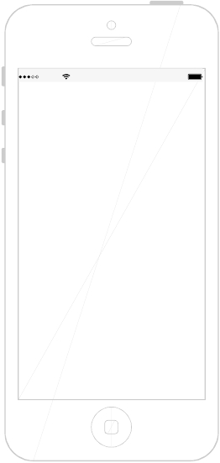

NOTES:

/

NAME: OS: iOS VER: DATE: . . BY:

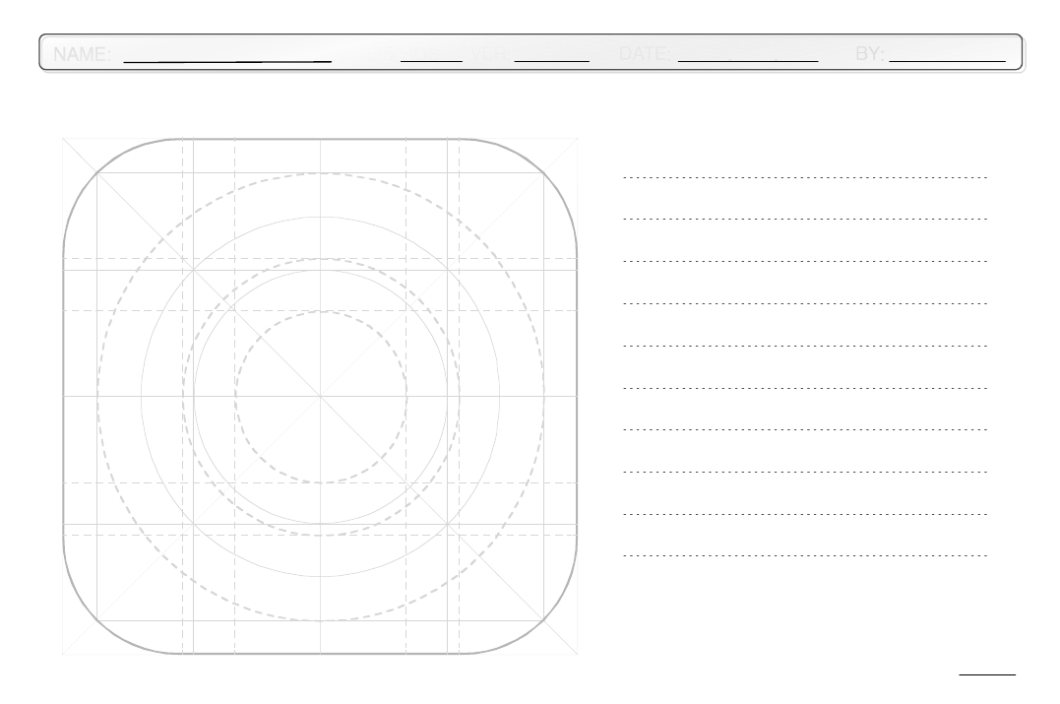

NOTES:

/

NAME: OS: iOS VER: DATE: . . BY:

NOTES:



/

NAME: OS: iOS VER: DATE: . . BY:

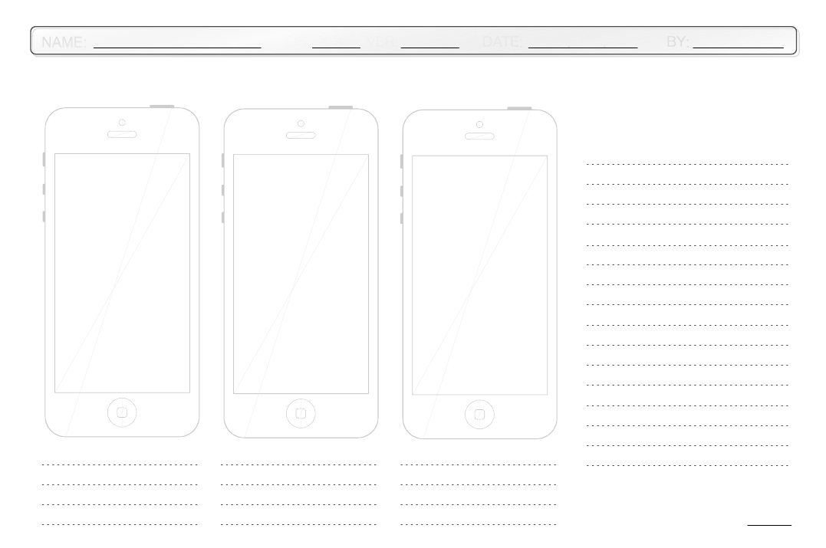

NOTES:

/

NAME: OS: iOS VER: DATE: . . BY:

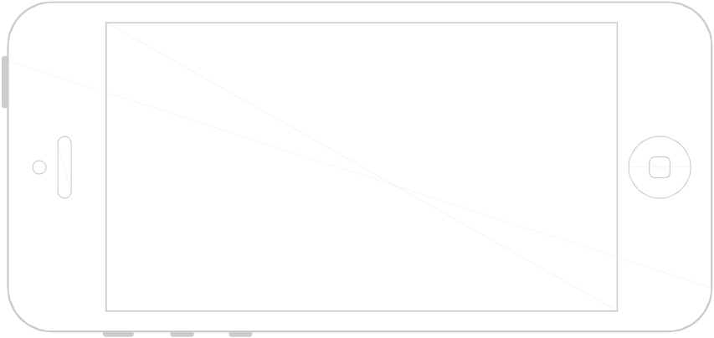

NOTES:

/

NAME: OS: iOS VER: DATE: . . BY:

NOTES:



/

NAME: OS: Android VER: DATE: . . BY:



NOTES:

1:00

/

NAME: OS: Android VER: DATE: . . BY:



NOTES:

/

NAME: OS: Android VER: DATE: . . BY:



NOTES:

/

NAME: OS: Android VER: DATE: . . BY:



NOTES:

/

NAME: OS: Android VER: DATE: . . BY:

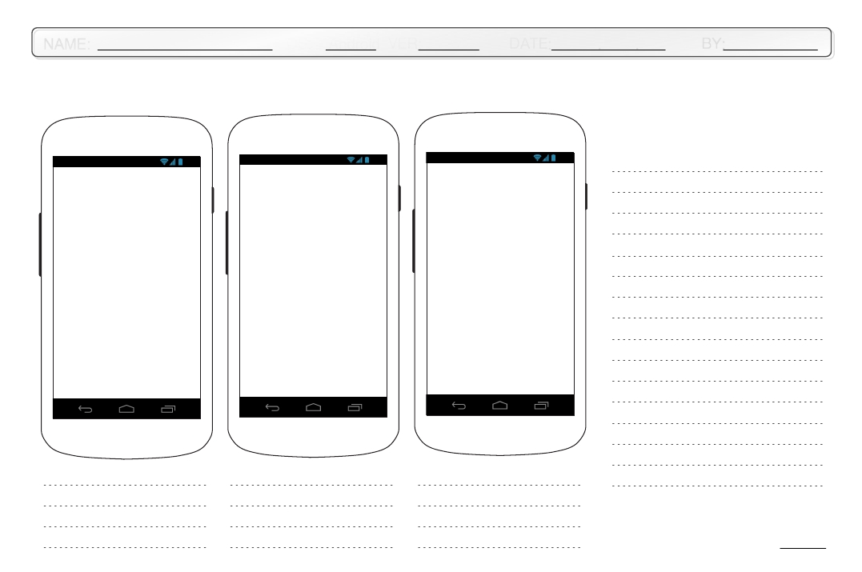

1:00 1:00 1:00

NOTES:

/

NAME: OS: Android VER: DATE: . . BY:

1:00

NOTES:



/

NAME: OS: Android VER: DATE: . . BY:

NOTES:

1:00

1:00

1:00



/

NAME: OS: Windows VER: DATE: . . BY:



NOTES:

/

NAME: OS: Windows VER: DATE: . . BY:



NOTES:

/

NAME: OS: Windows VER: DATE: . . BY:



NOTES:

/

NAME: OS: Windows VER: DATE: . . BY:

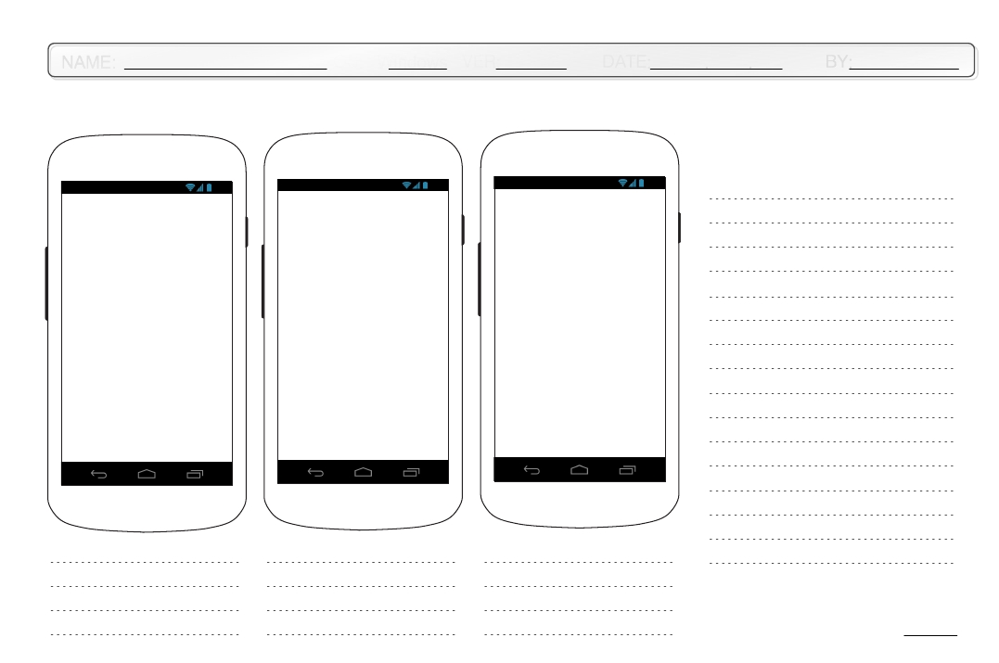

1:00 1:00 1:00

NOTES:

/

NAME: OS: Windows VER: DATE: . . BY:

1:00

NOTES:



/

NAME: OS: Windows VER: DATE: . . BY:

NOTES:

1:00

1:00

1:00



/

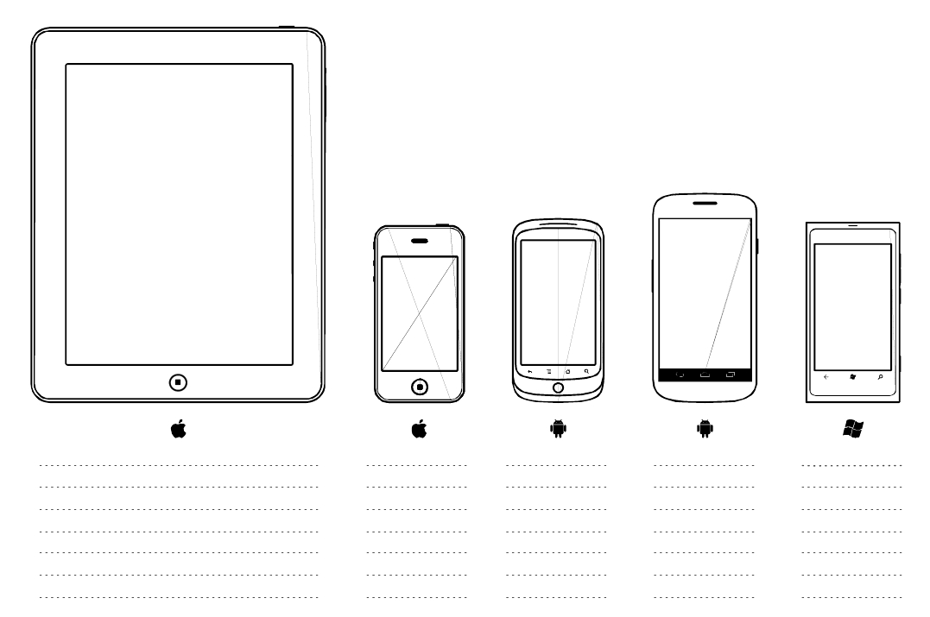

NOTES:

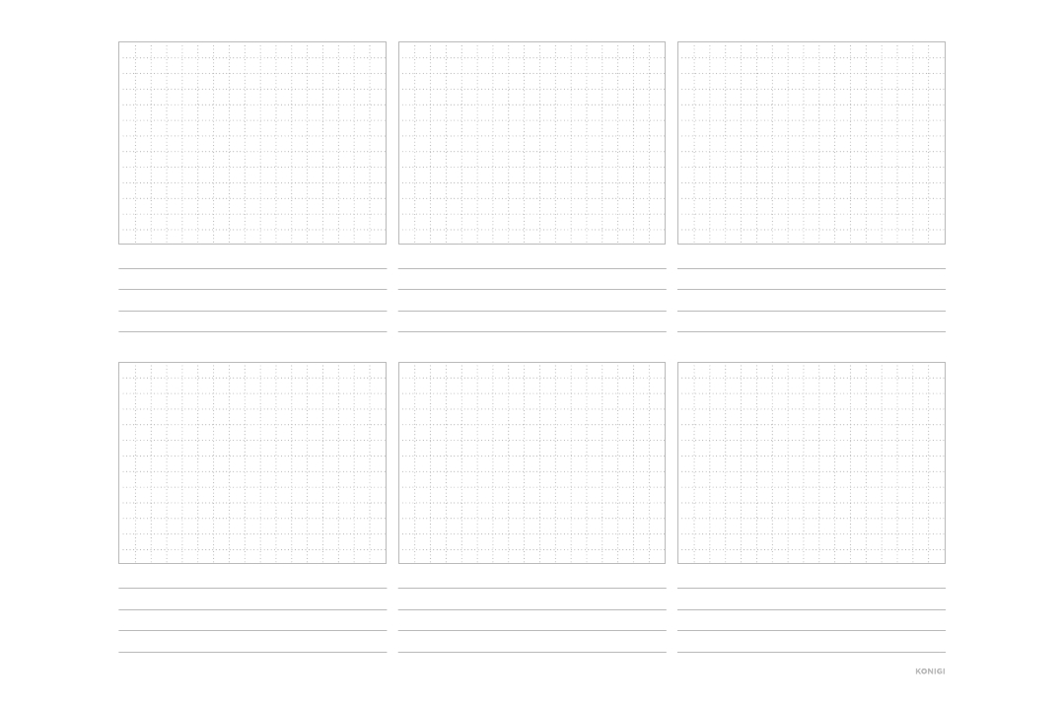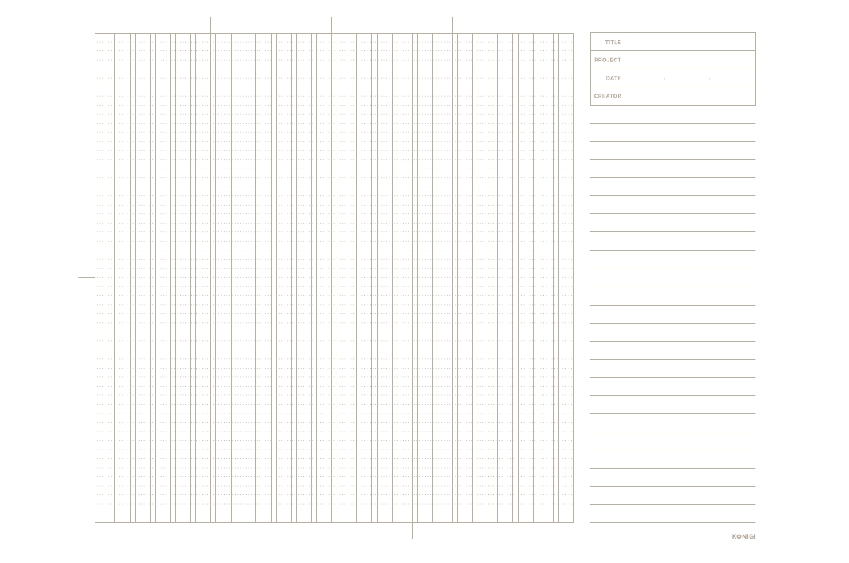

NOTES:

