Multiworker

Multiworker is a software program written in purely C++ language. This is our first attempt to make any graphical software.
The graphics of Multiworker is inspired from the graphics of windows 1.0 released in 1985 by Microsoft Corporation.

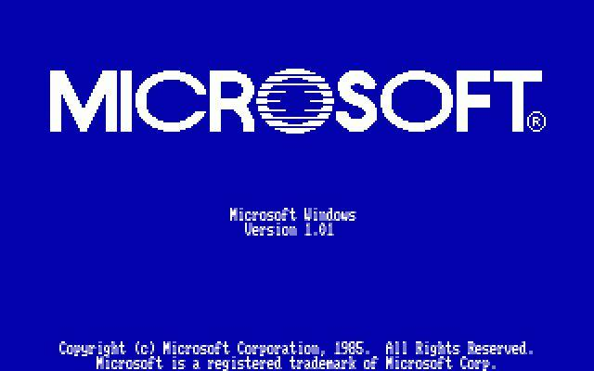

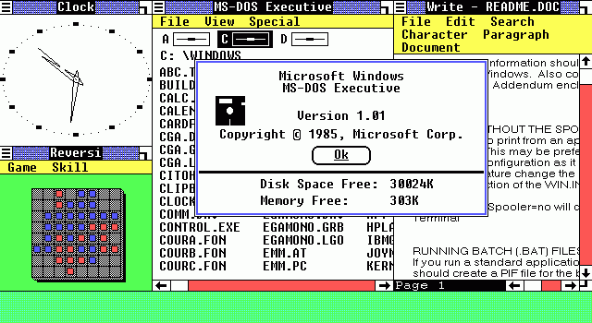
The Screenshots of Windows 1.0 by Microsoft
It name as Multiworker because we provide multiple utilities like calendar, calculator etc in our software.
Starting Date of Project: 29 May 2009.

Completion Date: : 4 Jan 2010.

Platform:
Front End: C++
Back End: C++

Group Members:
1: Shaikh Shahid Ali Mohammad Vakil

2: Ukaye Imaad Kifaytullah.

3: Siddiqui Azim Ahmed Nasim Ahmed.

Source Code:

#include"s2v.h"
int arr[4][4]={{1,4,15,7},{8,10,2,11},{4,3,6,13},{2,9,5,0}};
static char *months[]={"January","February","March","April","May","June","July","August","September","October","November","December"};
int color;
class mw
{
private:
int user;
public:
void ch_pass();
void admin_standard();
void admin_scientific();
void normal_temp_credit();
void temp_calc();
void welcome();
void open_door();
void close_door();
void select_user();
void inventory();
void normal_temp(int color);
void temp_cal();
void cal_temp(int yr,int mo,int fd,int da);
void credit();
void normal();
void normal_inv_msg();
void normal_calc();
void admin_calc();
void admin();
void border();
void admin_login();
void admin_boot();
void normal_menu();
void time();
void game();
void game1();
void admin_game();
void check();
void display();
void boxes();
int getkey();
void msgbox(char title[20],char message[100]);
void calender();
void cal(int yr,int mo,int fd,int da);
void calender_admin();
void cal_admin(int yr,int mo,int fd,int da);
void admin_menu(int cl);
};
struct pass
{
char name[40];
char pass[10];
char or[30];
}e;
void mw::normal_temp_credit()
{
cleardevice();
settextstyle(4,0,7);
setcolor(RED);
setbkcolor(WHITE);
outtextxy(40,30,"Programmed by..");
settextstyle(4,0,6);
setcolor(8);
outtextxy(80,140,"Shahid");
outtextxy(80,220,"Azim");
outtextxy(80,300,"Imaad");
}
void mw::game1()
{
int r=3,c=3,t,ch;
cleardevice();
mw::boxes();
mw::display();
while(1)
{
ch=getkey();
switch(ch)
{
case 80:
if(r==0)
{
printf("\a");
break;
}
t=arr[r][c];
arr[r][c]=arr[r-1][c];
arr[r-1][c]=t;
r--;
mw::display();
break;
case 77:
if(c==0)
{
printf("\a");
break;
}
t=arr[r][c];
arr[r][c]=arr[r][c-1];
arr[r][c-1]=t;
c--;
mw::display();
break;
case 72:
if(r==3)
{
printf("\a");
break;
}
t=arr[r][c];
arr[r][c]=arr[r+1][c];
arr[r+1][c]=t;
r++;
mw::display();
break;
case 75:
if(c==3)
{
printf("\a");
break;
}
t=arr[r][c];
arr[r][c]=arr[r][c+1];
arr[r][c+1]=t;
c++;
mw::display();
break;
case 1:
mw::normal_temp(color);
}
mw:: check();
}
}
void mw::temp_calc()
{
long double x,y;
char ch;
do
{
cleardevice();
mw::border();
gotoxy(10,4);
setbkcolor(0);
setcolor(RED);
outtextxy(50,40,"This is a Calculator containing the following functions:-");
setcolor(BLUE);
rectangle(50,70,300,180);
gotoxy(10,6);
cout<<"-> Addition:";
gotoxy(10,7);
cout<<"-> substraction:";
gotoxy(10,8);
cout<<"-> Multiplication:";
gotoxy(10,9);
cout<<"-> Division:";
gotoxy(10,10);
cout<<"-> Percentage:";
gotoxy(10,11);
cout<<"-> Power";
rectangle(350,70,600,180);
gotoxy(48,6);
cout<<"1:>Type [+] for Addition";
gotoxy(48,7);
cout<<"2:>[-] for Subtraction";
gotoxy(48,8);
cout<<"3:>[*]for Multiplication";
gotoxy(48,9);
cout<<"4:>[/] for Division";
gotoxy(48,10);
cout<<"5:>[%] for Percentage";
gotoxy(10,13);
rectangle(50,220,600,400);
ch=getche();
if(ch=='+')
{
gotoxy(10,15);
cout<<"You are using Addition\n";
gotoxy(10,17);
cout<<"Enter First Number=";
cin>>x;
gotoxy(10,18);
cout<<"Enter Second Number= ";
cin>>y;
gotoxy(10,19);
cout<<"Your answer is \n";
gotoxy(10,20);
cout<<x+y;
getch();
}
if(ch=='-')
{
gotoxy(10,15);
cout<<"You are using Subtraction";
gotoxy(10,17);
cout<<"Enter First Number= ";
cin>>x;
gotoxy(10,18);
cout<<"Enter Second Number= ";
cin>>y;
gotoxy(10,19);
cout<<"Your answer is ";
gotoxy(10,20);
cout<<x-y;
getch();
}
if(ch=='*')
{
gotoxy(10,15);
cout<<"You are using Multiplication\n";
gotoxy(10,17);
cout<<"Enter First Number= ";
cin>>x;
gotoxy(10,18);
cout<<"Enter Second Number= ";
cin>>y;
gotoxy(10,19);
cout<<"Your answer is ";
gotoxy(10,20);
cout<<x*y;
getch();
}
if(ch=='/')
{
gotoxy(10,15);
cout<<"You are using Division ";
gotoxy(10,17);
cout<<"Enter First Number= ";
cin>>x;
gotoxy(10,18);
cout<<"Enter Second Number= ";
cin>>y;
gotoxy(10,19);
cout<<"Your answer is ";
gotoxy(10,20);
cout<<x/y;
getch();
}
if(ch=='%')
{
gotoxy(10,15);
cout<<"You are using Percentage ";
gotoxy(10,17);
cout<<"Enter Number= ";
cin>>x;
gotoxy(10,18);
cout<<"Enter Percentage= ";
cin>>y;
gotoxy(10,19);
cout<<"Your answer is ";
gotoxy(10,20);
cout<<y/100*x;
getch();
}
if(ch=='q')
{
mw::normal_temp(color);
}

}
while(1);

}
void mw::cal_temp(int yr,int mo,int fd,int da)
{
int i,r,c;
char a;
cleardevice();
setbkcolor(0);
rectangle(20,40,550,400);
rectangle(22,38,552,398);
line(20,65,550,65);
line(20,100,550,100);
line(20,250,550,250);
line(20,350,550,350);
gotoxy(25,4);
cout<<months[mo-1]<<yr;
gotoxy(10,6);
cout<<" Mon Tue Wed Thu Fri sat Sun";
r=9;
c=11+6*fd;
for(i=1;i<=da;i++)
{
gotoxy(c,r);
cout<<i;
if(c<=41)
c=c+6;
else
{
c=11;
r=r+1;
}
}
gotoxy(11,18);
cout<<"UP-Next year DOWN-prev. year" ;
gotoxy(11,19);
cout<<"RIGHT-Next month Left-prev months";
gotoxy(26,21);
cout<<"ESC-Go Back To Main Screen";
gotoxy(14,24);
cout<<"This is The Calender of "<<months[mo-1]<<" "<<yr;
}
void mw::admin_scientific()
{
long double x,y;
char ch;
do
{
cleardevice();
mw::border();
gotoxy(10,4);
setbkcolor(0);
setcolor(RED);
outtextxy(50,40,"This is a Calculator containing the following functions:-");
setcolor(BLUE);
rectangle(50,70,300,180);
gotoxy(10,6);
cout<<"-> sin:";
gotoxy(10,7);
cout<<"-> cos:";
gotoxy(10,8);
cout<<"-> tan:";
gotoxy(10,9);
cout<<"-> Power:";
gotoxy(10,10);
cout<<"-> abs:";
gotoxy(10,11);
cout<<"-> Log:";
rectangle(350,70,600,180);
gotoxy(48,6);
cout<<"1:>Type S for Sin Operation";
gotoxy(48,7);
cout<<"2:>Type c for cos Operation";
gotoxy(48,8);
cout<<"3:>Type t for tan operation";
gotoxy(48,9);
cout<<"4:> Type P for Power operation";
gotoxy(48,10);
cout<<"5:>Type a for Absoloute Value";
gotoxy(48,11);
cout<<"6:>Type l for log operation";
gotoxy(10,13);
rectangle(50,220,600,400);
ch=getche();
if(ch=='s')
{
gotoxy(10,15);
cout<<"You are using Sin Function";
gotoxy(10,17);
cout<<"Enter Value";
gotoxy(10,18);
cin>>x;
gotoxy(10,19);
cout<<"Your answer is \n";
gotoxy(10,20);
cout<<sin(x);
getch();
}
if(ch=='c')
{
gotoxy(10,15);
cout<<"You are using Cos function";
gotoxy(10,17);
cout<<"Enter Number= ";
cin>>x;
gotoxy(10,18);
cout<<"Your answer is ";
gotoxy(10,20);
cout<<cos(x);
getch();
}
if(ch=='t')
{
gotoxy(10,15);
cout<<"You are using Tan operation\n";
gotoxy(10,17);
cout<<"Enter Number= ";
cin>>x;
gotoxy(10,18);
cout<<"Your answer is ";
gotoxy(10,20);
cout<<tan(x);
getch();
}
if(ch=='p')
{
gotoxy(10,15);
cout<<"You are using Power Function ";
gotoxy(10,17);
cout<<"Enter First Number= ";
cin>>x;
gotoxy(10,18);
cout<<"Enter Power";
gotoxy(10,19);
cin>>y;
cout<<"Your answer is ";
gotoxy(10,20);
cout<<pow(x,y);
getch();
}
if(ch=='a')
{
gotoxy(10,15);
cout<<"You are using Absolute ";
gotoxy(10,17);
cout<<"Enter Number= ";
cin>>x;
gotoxy(10,18);
cout<<"Your answer is \n";
gotoxy(10,20);
cout<<abs(x);
getch();
}
if(ch=='l')
{
gotoxy(10,15);
cout<<"You are using Log";
gotoxy(10,17);
cout<<"Enter Number= ";
cin>>x;
gotoxy(10,18);
cout<<"Your answer is ";
gotoxy(10,20);
cout<<log(x);
getch();
}
if(ch=='q')
{
mw::admin_calc();
}

}
while(1);
}
void mw::admin_standard()
{
long double x,y;
char ch;
do
{
cleardevice();
mw::border();
gotoxy(10,4);
setbkcolor(0);
setcolor(RED);
outtextxy(50,40,"This is a Calculator containing the following functions:-");
setcolor(BLUE);
rectangle(50,70,300,180);
gotoxy(10,6);
cout<<"-> Addition:";
gotoxy(10,7);
cout<<"-> substraction:";
gotoxy(10,8);
cout<<"-> Multiplication:";
gotoxy(10,9);
cout<<"-> Division:";
gotoxy(10,10);
cout<<"-> Percentage:";
gotoxy(10,11);
cout<<"-> Power";
rectangle(350,70,600,180);
gotoxy(48,6);
cout<<"1:>Type [+] for Addition";
gotoxy(48,7);
cout<<"2:>[-] for Subtraction";
gotoxy(48,8);
cout<<"3:>[*]for Multiplication";
gotoxy(48,9);
cout<<"4:>[/] for Division";
gotoxy(48,10);
cout<<"5:>[%] for Percentage";
gotoxy(10,13);
rectangle(50,220,600,400);
ch=getche();
if(ch=='+')
{
gotoxy(10,15);
cout<<"You are using Addition\n";
gotoxy(10,17);
cout<<"Enter First Number=";
cin>>x;
gotoxy(10,18);
cout<<"Enter Second Number= ";
cin>>y;
gotoxy(10,19);
cout<<"Your answer is \n";
gotoxy(10,20);
cout<<x+y;
getch();
}
if(ch=='-')
{
gotoxy(10,15);
cout<<"You are using Subtraction";
gotoxy(10,17);
cout<<"Enter First Number= ";
cin>>x;
gotoxy(10,18);
cout<<"Enter Second Number= ";
cin>>y;
gotoxy(10,19);
cout<<"Your answer is ";
gotoxy(10,20);
cout<<x-y;
getch();
}
if(ch=='*')
{
gotoxy(10,15);
cout<<"You are using Multiplication\n";
gotoxy(10,17);
cout<<"Enter First Number= ";
cin>>x;
gotoxy(10,18);
cout<<"Enter Second Number= ";
cin>>y;
gotoxy(10,19);
cout<<"Your answer is ";
gotoxy(10,20);
cout<<x*y;
getch();
}
if(ch=='/')
{
gotoxy(10,15);
cout<<"You are using Division ";
gotoxy(10,17);
cout<<"Enter First Number= ";
cin>>x;
gotoxy(10,18);
cout<<"Enter Second Number= ";
cin>>y;
gotoxy(10,19);
cout<<"Your answer is ";
gotoxy(10,20);
cout<<x/y;
getch();
}
if(ch=='%')
{
gotoxy(10,15);
cout<<"You are using Percentage ";
gotoxy(10,17);
cout<<"Enter Number= ";
cin>>x;
gotoxy(10,18);
cout<<"Enter Percentage= ";
cin>>y;
gotoxy(10,19);
cout<<"Your answer is ";
gotoxy(10,20);
cout<<y/100*x;
getch();
}
if(ch=='q')
{
mw::admin_calc();
}

}
while(1);
}
void mw::welcome()
{
mw::open_door();
cleardevice();
mw::border();
setcolor(BLUE);
settextstyle(4,0,6);
outtextxy(100,100,"Welcome");
outtextxy(90,160,"In Multiworker");
setcolor(WHITE);
settextstyle(0,0,2);
outtextxy(100,350,"Press Enter To Continue....");
getch();
mw::admin_boot();
}
void mw::open_door()
{

rectangle(300,20,300,470);
int a=300;
int b=340;
for(int i=1;i<300;i++)
{
delay(4);
cleardevice();
rectangle(a,20,b,470);
a++;
b--;
}
cleardevice();
}
void mw::close_door()
{
int a=599;
int b=41;
setbkcolor(0);
setcolor(WHITE);
rectangle(a,20,b,470);
for(int j=1;j<280;j++)
{
delay(4);
cleardevice();
rectangle(a,20,b,470);
a--;
b++;
}
}
void mw::inventory()
{
FILE *fp,*ft;
char another,choice;
struct emp
{
int id;
char name[40];
int age;
float bs;
char dept[40];
};
struct emp e;
char empname[40];
int temp_id;
long int recsize;
fp=fopen("EMP.DAT","rb+");
if(fp==NULL)
{
fp=fopen("EMP.DAT","wb+");
if(fp==NULL)
{
puts("Cannot open file");
exit(1);
}
}
recsize=sizeof(e);
while(1)
{
cleardevice();
setbkcolor(0);
mw::border();
rectangle(130,90,450,358);
rectangle(132,88,452,360);
line(130,115,450,115);
line(130,117,450,117);
gotoxy(30,7);
printf("Menu of Database:");
gotoxy(30,10);
printf("1.Add Records");
gotoxy(30,12);
printf("2.List Records");
gotoxy(30,14);
printf("3.Modify Records");
gotoxy(30,16);
printf("4.Delete records");
gotoxy(30,18);
printf("5.Make Report");
gotoxy(30,20);
printf("6.Search");
gotoxy(30,22);
printf("0.exit");
fflush(stdin);
choice=getche();
switch(choice)
{
case '1':
{
fseek(fp,0,SEEK_END);
another='y';
cleardevice();
mw::border();
gotoxy(20,3);
printf("Enter Record of employee.");
while(another=='y')
{
gotoxy(20,8);
cout<<"Enter Id";
scanf("%d",&e.id);
gotoxy(20,10);
printf("Enter name:\n");
gotoxy(20,12);
scanf("%s",e.name);
gotoxy(20,14);
printf("Enter age:\n");
gotoxy(20,16);
scanf("%d",&e.age);
gotoxy(20,18);
printf("Enter basic sallery:\n");
gotoxy(20,20);
scanf("%f",&e.bs);
gotoxy(20,22);
cout<<"Enter Department:";
gotoxy(20,24);
scanf("%s",e.dept);
fwrite(&e,recsize,1,fp);
gotoxy(20,26);
printf("Add Another records:[Y/N]\n");
fflush(stdin);
another=getche();
}
break;
}
case '2':
{
rewind(fp);
int i=9;
cleardevice();
mw::border();
gotoxy(20,3);
printf("Record in the database is:");
gotoxy(20,6);
printf("id Name");
gotoxy(20,7);
cout<<"---------------------------------";
while(fread(&e,recsize,1,fp)==1)
{
gotoxy(20,i);
printf("%d %s",e.id,e.name);
i++;
}
getche();
break;
}
case '3':
{
another='y';
gotoxy(20,3);
cleardevice();
printf("Modify The Record");
while(another=='y')
{
cleardevice();
mw::border();
gotoxy(20,8);
printf("Enter ID of Employee to modify:\n");
gotoxy(20,10);
scanf("%d",&temp_id);
rewind(fp);
while(fread(&e,recsize,1,fp)==1)
{
if(temp_id==e.id)
{
gotoxy(20,12);
cout<<"Enter new id";
gotoxy(20,14);
scanf("%d",&e.id);
gotoxy(20,16);
printf("Enter new name:\n");
gotoxy(20,18);
scanf("%s",e.name);
gotoxy(20,20);
printf("Enter new age:\n");
gotoxy(20,22);
scanf("%d",&e.age);
gotoxy(20,24);
printf("Enter new basic sallery:\n");
gotoxy(20,26);
scanf("%f",&e.bs);
gotoxy(20,28);
cout<<"Enter Department:";
scanf("%s",e.dept);
fseek(fp,-recsize,SEEK_CUR) ;
fwrite(&e,recsize,1,fp);
break;
}
}
gotoxy(20,29);
printf("Modify another records:[Y/N]\n");
fflush(stdin);
another=getche();
}
break;
}
case '4':
{
another='y';
cleardevice();
mw::border();
gotoxy(20,3);
printf("Delete an Employee");
while(another=='y')
{
gotoxy(20,8);
printf("Enter id of employee to delete:\n");
gotoxy(20,10);
scanf("%d",&temp_id);
ft=fopen("TEMP.DAT","wb");
rewind(fp);
while(fread(&e,recsize,1,fp)==1)
{
if(temp_id!=e.id)
fwrite(&e,recsize,1,ft);
}
fclose(fp);
fclose(ft);
remove("EMP.DAT");
rename("TEMP.DAT","EMP.DAT");
fp=fopen("EMP.DAT","rb+");
gotoxy(20,12);
printf("Delete another Records[Y/N]:\n");
fflush(stdin);
another=getche();
}
break;
}
case '5':
{
cleardevice();
rectangle(6,20,639,471);
rewind(fp);
int i=5;
while(fread(&e,recsize,1,fp)==1)
{
gotoxy(5,i);
cout<<e.id<<setw(18)<<e.name<<setw(18)<<e.age<<setw(12)<<e.bs<<setw(16)<<e.dept;
i=i++;
}
setcolor(RED);
line(86,20,86,471);
setcolor(GREEN);
line(300,20,300,471);
setcolor(BLUE);
line(350,20,350,471);
setcolor(WHITE);
line(450,20,450,471);
setcolor(YELLOW);
line(6,51,639,51);
setcolor(WHITE);
gotoxy(4,3);
cout<<"EMP-ID";
gotoxy(18,3);
cout<<"EMP-NAME";
gotoxy(40,3);
cout<<"AGE";
gotoxy(46,3);
cout<<"EMP-SALARY";
gotoxy(59,3);
cout<<"EMP-DEPARTMENT";
getch();
break;
}
case '6':
{
cleardevice();
mw::border();
gotoxy(10,10);
cout<<"Enter EMP-ID to search:";
gotoxy(10,12);
cin>>temp_id;
rewind(fp);
int i=15;
gotoxy(12,13);
cout<<"ID"<<setw(10)<<"Name"<<setw(15)<<"Age"<<setw(15)<<"Salary"<<setw(15)<<"Department";
gotoxy(12,14);
cout<<"------------------------------------------------------------";
while(fread(&e,recsize,1,fp)==1)
{
if(temp_id==e.id)
{
gotoxy(12,i);
cout<<e.id<<setw(10)<<e.name<<setw(15)<<e.age<<setw(15)<<e.bs<<setw(15)<<e.dept;
i++;
}
}
getch();
break;

}
case '0':
{
fclose(fp);
admin_menu(color);
}
}
}
}
void mw::ch_pass()
{
FILE *fp;
long int recsize;
char cpass[40],cfpass[40];
cleardevice();
mw::border();
setbkcolor(0);
rectangle(90,400,500,100);
rectangle(88,398,502,102);
line(88,123,502,123);
outtextxy(100,110,"Password Setting Wizard:");
recsize=sizeof(e);
fp=fopen("c:\\windows\\password.DAT","rb+");
gotoxy(15,10);
cout<<"Enter Current Password:";
rectangle(300,140,450,160);
gotoxy(40,10);
cin>>cpass;
rewind(fp);
while(fread(&e,recsize,1,fp)==1)
{
if(strcmp(e.pass,cpass)==0)
{
gotoxy(15,13);
printf("Enter New Password:");
rectangle(300,185,450,209);
gotoxy(40,13);
cin>>e.pass;
gotoxy(15,16);
printf("Confirm Password:");
rectangle(300,230,450,258);
gotoxy(40,16);
char cpass[40];
cin>>cpass;
if(strcmp(e.pass,cpass)!=0)
{
cleardevice();
mw::border();
mw::msgbox("Error","Password Not Match");
getch();
mw::ch_pass();
}
fseek(fp,-recsize,SEEK_CUR) ;
fwrite(&e,recsize,1,fp);
}
else
{
mw::msgbox("Error","Wrong Password !!!");
mw::ch_pass();
}
}
}
void mw::temp_cal()
{
static int days[12]={31,28,31,30,31,30,31,31,30,31,30,31};
long int ndays,ldays,tydays,tdays;
int d,i,m,fday,y;
char ch;
cleardevice();
setbkcolor(0);
gotoxy(2,2);
cout<<"Enter Year (1900) onwards."<<"\n";
cin>>y;
cout<<"Enter months (number):"<<"\n";
cin>>m;
if((y<1900)||(m>12))
{
msgbox("Error","Enter Correct Value");
getch();
mw::temp_cal();
}
else
{
while(1)
{
ndays=(y-1)*365l;
ldays=(y-1)/4-(y-1)/100+(y-1)/400;
tdays=ndays+ldays;
if((y%100==0&&y%400==0)||(y%400==0&&y%100!=0))
days[1]=29;
else
days[1]=28;
d=days[m-1];
tydays=0;
for(i=0;i<=m-2;i++)
tydays=tydays+days[i];
tdays=tydays+tdays;
fday=tdays%7;
mw::cal_temp(y,m,fday,d);
ch=mw::getkey();
switch(ch)
{
case 77:
if(m==12)
{
y++;
m=1;
}
else
m++;
break;
case 72:
y++;
continue;
case 75:
if(m==1)
{
y--;
m=12;
}
else
m--;
break;
case 80:
y--;
continue;
case 1:
mw::normal_temp(color);
}
}
}
}
void mw::normal_temp(int color)
{
cleardevice();
mw::border();
int c;
c=color;
setbkcolor(c);
int ch,ch1;
rectangle(15,30,495,64);
rectangle(15,75,120,105);
rectangle(125,75,240,105);
rectangle(245,75,370,105);
rectangle(375,75,495,105);
rectangle(500,75,630,105);
rectangle(500,30,630,64);
gotoxy(5,6);
printf("1.Menu %c",799);
gotoxy(18,6);
printf("2.Help");
gotoxy(33,6);
printf("3.Credit");
gotoxy(50,6);
printf("4.Setting");
gotoxy(67,6);
printf("5.Exit");
settextstyle(1,0,4);
outtextxy(100,23,"Normal_User");
settextstyle(0,0,0);
rectangle(580,410,626,379);
mw::time();
gotoxy(75,25);
cin>>ch;
switch(ch)
{
case 1:
{
rectangle(14,115,180,315);
gotoxy(5,9);
cout<<"1.Calculator";
gotoxy(5,11);
cout<<"2.Calender";
gotoxy(5,13);
cout<<"3.Inventory";
gotoxy(5,15);
cout<<"4.Games";
gotoxy(5,17);
cout<<"5.Main menu";
rectangle(110,285,170,305);
gotoxy(7,19);
cout<<"Choice";
gotoxy(16,19);
cin>>ch1;
if(ch1==4)
{
mw::game1();
}
if(ch1==1)
{
mw::temp_calc();
}
if(ch1==5)
{
mw::normal_temp(color);
}
if(ch1==3)
{
mw::normal_inv_msg();
mw::normal_temp(color);
}
if(ch1==2)
{
mw::temp_cal();
}
}
case 2:
{
rectangle(125,115,250,315);
gotoxy(18,9);
cout<<"1.Calculator";
gotoxy(18,11);
cout<<"2.Calender";
gotoxy(18,13);
cout<<"3.Inventory ";
gotoxy(18,15);
cout<<"4.Games";
gotoxy(18,17);
cout<<"5.Main menu";
rectangle(200,285,240,305);
gotoxy(18,19);
cout<<"Choice";
gotoxy(27,19);
int sch6;
cin>>sch6 ;
if(sch6==1)
{
cleardevice();
rectangle(6,20,639,471);
settextstyle(1,0,1);
setbkcolor(GREEN);
outtextxy(100,80,"Calculator Help");
gotoxy(10,10);
cout<<char(16)<<"To perform calculation:";
gotoxy(10,12);
cout<<char(16)<<"goto menu-->select 1-->You can see the calculator";
gotoxy(10,14);
cout<<"How to use";
gotoxy(10,16);
cout<<"1. First select the operation (+,-,*,/,^,%)";
gotoxy(10,18);
cout<<"2. Input First Number,second number";
gotoxy(10,20);
cout<<"3. you will see your result";
gotoxy(10,22);
cout<<"for example: for Addition of two Number";
gotoxy(10,24);
cout<<" Enter First number 12";
gotoxy(10,25);
cout<<" Enter Second number 13";
gotoxy(10,26);
cout<<" Result is: 25";
getch();
mw::normal_temp(color);
}
if(sch6==2)
{
cleardevice();
rectangle(6,20,639,471);
settextstyle(1,0,1);
setbkcolor(GREEN);
outtextxy(100,80,"Calender Help");
gotoxy(10,10);
cout<<char(16)<<"To See calender:";
gotoxy(10,12);
cout<<char(16)<<"goto menu-->select 2-->You can see the Calender";
gotoxy(10,14);
cout<<"1. Enter Year within the range (1900 onwards)";
gotoxy(10,16);
cout<<"2. Enter month (in number) like(8 for august)";
gotoxy(10,18);
cout<<"3. You will see the calender of specific year";
getch();
mw::normal_temp(color);
}
if(sch6==3)
{
cleardevice();
rectangle(6,20,639,471);
settextstyle(1,0,1);
setbkcolor(GREEN);
outtextxy(100,80,"Inventory Help");
gotoxy(10,10);
cout<<char(16)<<"Sorry you cant access this utility:";
gotoxy(10,12);
cout<<char(16)<<"Because of some security purpose:";
gotoxy(10,14);
cout<<"If you want to use this utility :";
gotoxy(10,16);
cout<<"Kindly goto setting in main menu";
gotoxy(10,18);
cout<<"Select log out:";
gotoxy(10,20);
cout<<"Log on with administrator";
getch();
mw::normal_temp(color);
}
if(sch6==4)
{
cleardevice();
rectangle(6,20,639,471);
settextstyle(1,0,1);
setbkcolor(GREEN);
outtextxy(100,80,"GAME Help");
gotoxy(10,10);
cout<<char(16)<<"To Open game:";
gotoxy(10,12);
cout<<char(16)<<"Goto menu-->select 4-->You will Enjoy the game";
gotoxy(10,10);
cout<<"This is Shuffle Game";
gotoxy(10,12);
cout<<"1. Use arrow keys to move the number";
gotoxy(10,14);
cout<<"2. UP ARROW:- move the number Upward";
gotoxy(10,16);
cout<<"3. DOWN ARROW:- Move the number downward";
gotoxy(10,18);
cout<<"4. LEFT ARROW:- Move the left";
gotoxy(10,20);
cout<<"5. RIGHT ARROW:- Move the Right";
getch();
mw::normal_temp(color);
}
if(sch6==5)
{
mw::normal_temp(color);
}
}
case 3:
{
mw::normal_temp_credit();
getch();
mw::normal_temp(color);
}
case 4:
{
rectangle(375,115,540,260);
gotoxy(49,9);
cout<<"1.Color Setting.";
gotoxy(49,11);
cout<<"2.Logout.";
gotoxy(49,13);
cout<<"3.Main Menu.";
gotoxy(49,15);
cout<<"Your Choice";
rectangle(480,220,526,240);
gotoxy(62,15);
int sch;
cin>>sch;
if(sch==2)
{
cleardevice();
mw::select_user();
}
if(sch==1)
{
cleardevice();
setbkcolor(0);
rectangle(6,20,639,471);
settextstyle(3,0,5);
setcolor(RED);
outtextxy(40,30,"Color Setting:");
gotoxy(10,8);
cout<<"List of colors:";
gotoxy(10,10);
cout<<"Color names"<<" Code.";
gotoxy(12,12);
cout<<char(16)<<" Black"<<" 0";
gotoxy(12,13);
cout<<char(16)<<" Blue"<<" 1";
gotoxy(12,14);
cout<<char(16)<<" Green"<<" 2";
gotoxy(12,15);
cout<<char(16)<<" Cyan" <<" 3";
gotoxy(12,16);
cout<<char(16)<<" Red"<<" 4";
gotoxy(12,17);
cout<<char(16)<<" Magenta"<<" 5";
gotoxy(12,18);
cout<<char(16)<<" Light Gray"<<" 7";
gotoxy(12,19);
cout<<char(16)<<" Brown"<<" 6";
gotoxy(12,20);
cout<<char(16)<<" Dark Gray"<<" 8";
gotoxy(12,21);
cout<<char(16)<<" Light Blue"<<" 9";
gotoxy(12,22);
cout<<char(16)<<" Light Green"<<" 10";
gotoxy(12,23);
cout<<char(16)<<" Light Cyan"<<" 11";
gotoxy(12,24);
cout<<char(16)<<" Light Red"<<" 12";
gotoxy(12,25);
cout<<char(16)<<" Light Magenta"<<" 13";
gotoxy(12,26);
cout<<char(16)<<" Yellow"<<" 14";
gotoxy(12,27);
cout<<char(16)<<" White"<<" 15";
rectangle(330,170,500,300);
gotoxy(44,13);
cout<<"Enter color code:";
rectangle(345,220,435,240);
int color;
gotoxy(47,15);
cin>>color;
mw::normal_temp(color);
}
if(sch==3)
{
mw::normal_temp(color);
}
}
case 5:
{
mw::msgbox("Alert","Are you sure?");
outtextxy(220,200,"Press Y/N");
char ans;
ans=getche();
if(ans=='y')
{
textmode(4);
gotoxy(8,8);
printf("Exiting From Program\n\n\n Thanks for using application");
getch();
exit(0);
}
else
{
mw::normal_temp(color);
}
}
}
}
void mw::credit()
{
cleardevice();
settextstyle(4,0,7);
setcolor(RED);
setbkcolor(WHITE);
outtextxy(40,30,"Programmed by..");
settextstyle(4,0,6);
setcolor(8);
outtextxy(80,140,"Shahid");
outtextxy(80,220,"Azim");
outtextxy(80,300,"Imaad");
}
void mw::normal_inv_msg()
{
rectangle(190,180,480,350);
rectangle(188,178,482,352);
line(188,202,482,202);
line(188,204,482,204);
int a=204;
int b=204;
for(int i=1;i<147;i++)
{
setcolor(7);
line(191,a,479,b);
a++;
b++;
}
setcolor(WHITE);
outtextxy(200,187,"MESSAGE");
outtextxy(200,240,"This Utility is Only For Admin");
outtextxy(200,260,"For More information:");
outtextxy(200,280,"Goto -> HELP -> Select 3");
getch();
}
void mw::admin_calc()
{
cleardevice();
mw::border();
setbkcolor(0);
setcolor(GREEN);
rectangle(150,158,470,340);
gotoxy(21,11);
cout<<"Enter Type Of Calculator:";
rectangle(150,180,470,340);
gotoxy(28,14);
cout<<"1. Standard Calculator.";
gotoxy(28,16);
cout<<"2. Scientific Calculator.";
gotoxy(28,18);
cout<<"3. Back To Main menu";
gotoxy(28,20);
cout<<"Enter Choice: ";
int ch;
cin>>ch;
switch(ch)
{
case 1:
{
mw::admin_standard();
}
case 2:
{
mw::admin_scientific();
}
case 3:
{
mw::admin_menu(color);
}
}
}
void mw::normal_calc()
{
long double x,y;
char ch;
do
{
cleardevice();
mw::border();
gotoxy(10,4);
setbkcolor(0);
setcolor(RED);
outtextxy(50,40,"This is a Calculator containing the following functions:-");
setcolor(BLUE);
rectangle(50,70,300,180);
gotoxy(10,6);
cout<<"-> Addition:";
gotoxy(10,7);
cout<<"-> substraction:";
gotoxy(10,8);
cout<<"-> Multiplication:";
gotoxy(10,9);
cout<<"-> Division:";
gotoxy(10,10);
cout<<"-> Percentage:";
gotoxy(10,11);
cout<<"-> Power";
rectangle(350,70,600,180);
gotoxy(48,6);
cout<<"1:>Type [+] for Addition";
gotoxy(48,7);
cout<<"2:>[-] for Subtraction";
gotoxy(48,8);
cout<<"3:>[*]for Multiplication";
gotoxy(48,9);
cout<<"4:>[/] for Division";
gotoxy(48,10);
cout<<"5:>[%] for Percentage";
gotoxy(48,11);
cout<<"6:>[^] forPower";
gotoxy(10,13);
rectangle(50,220,600,400);
ch=getche();
if(ch=='+')
{
gotoxy(10,15);
cout<<"You are using Addition\n";
gotoxy(10,17);
cout<<"Enter First Number=";
cin>>x;
gotoxy(10,18);
cout<<"Enter Second Number= ";
cin>>y;
gotoxy(10,19);
cout<<"Your answer is \n";
gotoxy(10,20);
cout<<x+y;
getch();
}
if(ch=='-')
{
gotoxy(10,15);
cout<<"You are using Subtraction";
gotoxy(10,17);
cout<<"Enter First Number= ";
cin>>x;
gotoxy(10,18);
cout<<"Enter Second Number= ";
cin>>y;
gotoxy(10,19);
cout<<"Your answer is ";
gotoxy(10,20);
cout<<x-y;
getch();
}
if(ch=='*')
{
gotoxy(10,15);
cout<<"You are using Multiplication\n";
gotoxy(10,17);
cout<<"Enter First Number= ";
cin>>x;
gotoxy(10,18);
cout<<"Enter Second Number= ";
cin>>y;
gotoxy(10,19);
cout<<"Your answer is ";
gotoxy(10,20);
cout<<x*y;
getch();
}
if(ch=='/')
{
gotoxy(10,15);
cout<<"You are using Division ";
gotoxy(10,17);
cout<<"Enter First Number= ";
cin>>x;
gotoxy(10,18);
cout<<"Enter Second Number= ";
cin>>y;
gotoxy(10,19);
cout<<"Your answer is ";
gotoxy(10,20);
cout<<x/y;
getch();
}
if(ch=='%')
{
gotoxy(10,15);
cout<<"You are using Percentage ";
gotoxy(10,17);
cout<<"Enter Number= ";
cin>>x;
gotoxy(10,18);
cout<<"Enter Percentage= ";
cin>>y;
gotoxy(10,19);
cout<<"Your answer is ";
gotoxy(10,20);
cout<<y/100*x;
getch();
}
if(ch=='^')
{
gotoxy(10,15);
cout<<"You are using Power";
gotoxy(10,17);
cout<<"Enter Number= ";
cin>>x;
gotoxy(10,18);
cout<<"Enter Power= ";
cin>>y;
gotoxy(10,19);
cout<<"Your answer is ";
gotoxy(10,20);
cout<<pow(x,y);
getch();
}
if(ch=='q')
{
normal_menu();
}

}
while(1);
}
void mw::admin_menu(int cl)
{
cleardevice();
mw::border();
setbkcolor(cl);
int ch,ch1;
rectangle(15,30,495,64);
rectangle(15,75,120,105);
rectangle(125,75,240,105);
rectangle(245,75,370,105);
rectangle(375,75,495,105);
rectangle(500,75,630,105);
rectangle(500,30,630,64);
gotoxy(5,6);
printf("1.Menu %c",799);
gotoxy(18,6);
printf("2.Help");
gotoxy(33,6);
printf("3.Credit");
gotoxy(50,6);
printf("4.Setting");
gotoxy(67,6);
printf("5.Exit");
settextstyle(1,0,4);
outtextxy(100,23,e.or);
settextstyle(0,0,0);
rectangle(580,410,626,379);
mw::time();
gotoxy(75,25);
cin>>ch;
switch(ch)
{
case 1:
{
rectangle(14,115,180,315);
gotoxy(5,9);
cout<<"1.Calculator";
gotoxy(5,11);
cout<<"2.Calender";
gotoxy(5,13);
cout<<"3.Inventory";
gotoxy(5,15);
cout<<"4.Games";
gotoxy(5,17);
cout<<"5.Main menu";
rectangle(110,285,170,305);
gotoxy(7,19);
cout<<"Choice";
gotoxy(16,19);
cin>>ch1;
if(ch1==4)
{
mw::admin_game();
}
if(ch1==1)
{
mw::admin_calc();
}
if(ch1==5)
{
mw::admin_menu(color);
}
if(ch1==3)
{
mw::inventory();
}
if(ch1==2)
{
mw::calender_admin();
}
}
case 2:
{
rectangle(125,115,250,315);
gotoxy(18,9);
cout<<"1.Calculator";
gotoxy(18,11);
cout<<"2.Calender";
gotoxy(18,13);
cout<<"3.Inventory ";
gotoxy(18,15);
cout<<"4.Games";
gotoxy(18,17);
cout<<"5.Main menu";
rectangle(200,285,240,305);
gotoxy(18,19);
cout<<"Choice";
gotoxy(27,19);
int sch6;
cin>>sch6 ;
if(sch6==1)
{
cleardevice();
rectangle(6,20,639,471);
settextstyle(1,0,1);
setbkcolor(GREEN);
outtextxy(100,80,"Calculator Help");
gotoxy(10,10);
cout<<char(16)<<"To perform calculation:";
gotoxy(10,12);
cout<<char(16)<<"goto menu-->select 1-->You can see the calculator";
gotoxy(10,14);
cout<<"How to use";
gotoxy(10,16);
cout<<"1. First select the Type of Calculator.";
gotoxy(10,18);
cout<<"2. According to Your Choice the calculato is open.";
gotoxy(10,20);
cout<<"3. Select The operation and see the result:--> 'q'for Exit";
gotoxy(10,22);
cout<<"for example: for Addition of two Number";
gotoxy(10,24);
cout<<" Enter First number 12";
gotoxy(10,25);
cout<<" Enter Second number 13";
gotoxy(10,26);
cout<<" Result is: 25";
getch();
mw::admin_menu(color);
}
if(sch6==2)
{
cleardevice();
rectangle(6,20,639,471);
settextstyle(1,0,1);
setbkcolor(GREEN);
outtextxy(100,80,"Calender Help");
gotoxy(10,10);
cout<<char(16)<<"To See calender:";
gotoxy(10,12);
cout<<char(16)<<"goto menu-->select 2-->You can see the Calender";
gotoxy(10,14);
cout<<"1. Enter Year within the range (1900 onwards)";
gotoxy(10,16);
cout<<"2. Enter month (in number) like(8 for august)";
gotoxy(10,18);
cout<<"3. You will see the calender of specific year";
getch();
mw::admin_menu(color);
}
if(sch6==3)
{
cleardevice();
rectangle(6,20,639,471);
settextstyle(1,0,1);
setbkcolor(GREEN);
rectangle(6,20,639,471);
settextstyle(1,0,1);
setbkcolor(GREEN);
outtextxy(100,80,"inventory Help");
gotoxy(10,10);
cout<<char(16)<<"To Open inventory:";
gotoxy(10,12);
cout<<char(16)<<"Goto menu-->select 3-->You can see the Inventory";
gotoxy(10,14);
cout<<"This inventory Help you to save employees information:";
gotoxy(10,16);
cout<<"Press 1 for add the record";
gotoxy(10,18);
cout<<"press 2 for list the saved record";
gotoxy(10,20);
cout<<"press 3 for update the saved record";
gotoxy(10,22);
cout<<"Press 4 for delete record";
gotoxy(10,24);
cout<<"Press 5 to Generate the report.";
gotoxy(10,26);
cout<<"Press 6 to perform search.";
gotoxy(10,28);
cout<<"press ESC To close the inventory";
getch();
mw::admin_menu(color);
}
if(sch6==4)
{
cleardevice();
rectangle(6,20,639,471);
settextstyle(1,0,1);
setbkcolor(GREEN);
outtextxy(100,80,"GAME Help");
gotoxy(10,10);
cout<<char(16)<<"To Open game:";
gotoxy(10,12);
cout<<char(16)<<"Goto menu-->select 4-->You will Enjoy the game";
gotoxy(10,10);
cout<<"This is Shuffle Game";
gotoxy(10,12);
cout<<"1. Use arrow keys to move the number";
gotoxy(10,14);
cout<<"2. UP ARROW:- move the number Upward";
gotoxy(10,16);
cout<<"3. DOWN ARROW:- Move the number downward";
gotoxy(10,18);
cout<<"4. LEFT ARROW:- Move the left";
gotoxy(10,20);
cout<<"5. RIGHT ARROW:- Move the Right";
getch();
mw::admin_menu(color);
}
if(sch6==5)
{
mw::admin_menu(color);
}
}

case 4:
{
rectangle(375,115,540,280);
gotoxy(49,9);
cout<<"1.Password Setting:";
gotoxy(49,11);
cout<<"2.Color Setting.";
gotoxy(49,13);
cout<<"3.Logout.";
gotoxy(49,15);
cout<<"4.Main Menu.";
gotoxy(49,17);
cout<<"Your Choice";
rectangle(480,255,526,275);
gotoxy(62,17);
int sch;
cin>>sch;
if(sch==1)
{
mw::ch_pass();
mw::admin_menu(color);
}
if(sch==3)
{
cleardevice();
mw::select_user();
}
if(sch==2)
{
cleardevice();
setbkcolor(0);
rectangle(6,20,639,471);
settextstyle(3,0,5);
setcolor(RED);
outtextxy(40,30,"Color Setting:");
gotoxy(10,7);
cout<<"List of colors:";
gotoxy(10,9);
cout<<"Color names"<<" Code.";
gotoxy(12,10);
cout<<char(16)<<" Black"<<" 0";
gotoxy(12,11);
cout<<char(16)<<" Blue"<<" 1";
gotoxy(12,12);
cout<<char(16)<<" Green"<<" 2";
gotoxy(12,13);
cout<<char(16)<<" Cyan" <<" 3";
gotoxy(12,14);
cout<<char(16)<<" Red"<<" 4";
gotoxy(12,15);
cout<<char(16)<<" Magenta"<<" 5";
gotoxy(12,16);
cout<<char(16)<<" Light Gray"<<" 7";
gotoxy(12,17);
cout<<char(16)<<" Brown"<<" 6";
gotoxy(12,18);
cout<<char(16)<<" Dark Gray"<<" 8";
gotoxy(12,19);
cout<<char(16)<<" Light Blue"<<" 9";
gotoxy(12,20);
cout<<char(16)<<" Light Green"<<" 10";
gotoxy(12,21);
cout<<char(16)<<" Light Cyan"<<" 11";
gotoxy(12,22);
cout<<char(16)<<" Light Red"<<" 12";
gotoxy(12,23);
cout<<char(16)<<" Light Magenta"<<" 13";
gotoxy(12,24);
cout<<char(16)<<" Yellow"<<" 14";
gotoxy(12,25);
cout<<char(16)<<" White"<<" 15";
rectangle(330,170,500,300);
gotoxy(44,13);
cout<<"Enter color code:";
rectangle(345,220,435,240);
gotoxy(47,15);
int cl;
cin>>cl;
color=cl;
mw::admin_menu(color);
}
if(sch==4)
{
mw::admin_menu(color);
}
}
case 3:
{
mw::credit();
getch();
mw::admin_menu(color);
}
case 5:
{
mw::msgbox("Alert","Are you sure?");
outtextxy(220,200,"Press Y/N");
char ans;
ans=getche();
if(ans=='y')
{
mw::close_door();
textmode(4);
gotoxy(8,8);
printf("Exiting From Program\n\n\n Thanks for using application");
getch();
exit(0);
}
else
{
mw::admin_menu(color);
}
}
}
}
void mw::cal_admin(int yr,int mo,int fd,int da)
{
int i,r,c;
char a;
cleardevice();
setbkcolor(0);
mw::border();
rectangle(20,40,550,400);
rectangle(22,38,552,398);
line(20,65,550,65);
line(20,100,550,100);
line(20,250,550,250);
line(20,350,550,350);
gotoxy(25,4);
cout<<months[mo-1]<<yr;
gotoxy(10,6);
cout<<" Mon Tue Wed Thu Fri sat Sun";
r=9;
c=11+6*fd;
for(i=1;i<=da;i++)
{
gotoxy(c,r);
cout<<i;
if(c<=41)
c=c+6;
else
{
c=11;
r=r+1;
}
}
gotoxy(11,18);
cout<<"UP-Next year DOWN-prev. year" ;
gotoxy(11,19);
cout<<"RIGHT-Next month Left-prev months";
gotoxy(26,21);
cout<<"ESC-Go Back To Main Screen";
gotoxy(14,24);
cout<<"This is The Calender of "<<months[mo-1]<<" "<<yr;
}
void mw::cal(int yr,int mo,int fd,int da)
{
int i,r,c;
char a;
cleardevice();
setbkcolor(0);
rectangle(20,40,550,400);
rectangle(22,38,552,398);
line(20,65,550,65);
line(20,100,550,100);
line(20,250,550,250);
line(20,350,550,350);
gotoxy(25,4);
cout<<months[mo-1]<<yr;
gotoxy(10,6);
cout<<" Mon Tue Wed Thu Fri sat Sun";
r=9;
c=11+6*fd;
for(i=1;i<=da;i++)
{
gotoxy(c,r);
cout<<i;
if(c<=41)
c=c+6;
else
{
c=11;
r=r+1;
}
}
gotoxy(11,18);
cout<<"UP-Next year DOWN-prev. year" ;
gotoxy(11,19);
cout<<"RIGHT-Next month Left-prev months";
gotoxy(26,21);
cout<<"ESC-Go Back To Main Screen";
gotoxy(14,24);
cout<<"This is The Calender of "<<months[mo-1]<<" "<<yr;
}
void mw::calender_admin()
{
static int days[12]={31,28,31,30,31,30,31,31,30,31,30,31};
long int ndays,ldays,tydays,tdays;
int d,i,m,fday,y;
char ch;
cleardevice();
setbkcolor(0);
gotoxy(2,2);
cout<<"Enter Year (1900) onwards."<<"\n";
cin>>y;
cout<<"Enter months (number):"<<"\n";
cin>>m;
if((y<1900)||(m>12))
{
msgbox("Error","Enter Correct Value");
getch();
mw::calender_admin();
}
else
{
while(1)
{
ndays=(y-1)*365l;
ldays=(y-1)/4-(y-1)/100+(y-1)/400;
tdays=ndays+ldays;
if((y%100==0&&y%400==0)||(y%400==0&&y%100!=0))
days[1]=29;
else
days[1]=28;
d=days[m-1];
tydays=0;
for(i=0;i<=m-2;i++)
tydays=tydays+days[i];
tdays=tydays+tdays;
fday=tdays%7;
mw::cal(y,m,fday,d);
ch=mw::getkey();
switch(ch)
{
case 77:
if(m==12)
{
y++;
m=1;
}
else
m++;
break;
case 72:
y++;
continue;
case 75:
if(m==1)
{
y--;
m=12;
}
else
m--;
break;
case 80:
y--;
continue;
case 1:
mw::admin_menu(color);
}
}
}
}
void mw::calender()
{
static int days[12]={31,28,31,30,31,30,31,31,30,31,30,31};
long int ndays,ldays,tydays,tdays;
int d,i,m,fday,y;
char ch;
cleardevice();
setbkcolor(0);
gotoxy(2,2);
cout<<"Enter Year (1900) onwards."<<"\n";
cin>>y;
cout<<"Enter months (number):"<<"\n";
cin>>m;
if((y<1900)||(m>12))
{
msgbox("Error","Enter Correct Value");
getch();
mw::calender();
}
else
{
while(1)
{
ndays=(y-1)*365l;
ldays=(y-1)/4-(y-1)/100+(y-1)/400;
tdays=ndays+ldays;
if((y%100==0&&y%400==0)||(y%400==0&&y%100!=0))
days[1]=29;
else
days[1]=28;
d=days[m-1];
tydays=0;
for(i=0;i<=m-2;i++)
tydays=tydays+days[i];
tdays=tydays+tdays;
fday=tdays%7;
mw::cal(y,m,fday,d);
ch=mw::getkey();
switch(ch)
{
case 77:
if(m==12)
{
y++;
m=1;
}
else
m++;
break;
case 72:
y++;
continue;
case 75:
if(m==1)
{
y--;
m=12;
}
else
m--;
break;
case 80:
y--;
continue;
case 1:
mw::normal_menu();
}
}
}
}
void mw::msgbox(char title[20],char message[100])
{
rectangle(200,270,420,145);
floodfill(201,269,WHITE);
rectangle(200,270,420,120);
gotoxy(27,9);
cout<<title;
setcolor(RED);
settextstyle(0,0,1);
outtextxy(204,180,message);
}
int mw::getkey()
{
union REGS i,o;
while(!kbhit()) ;
i.h.ah=0;
int86(22,&i,&o);
return(o.h.ah);
}
void mw::game()
{
int r=3,c=3,t,ch;
cleardevice();
mw::boxes();
mw::display();
while(1)
{
ch=getkey();
switch(ch)
{
case 80:
if(r==0)
{
printf("\a");
break;
}
t=arr[r][c];
arr[r][c]=arr[r-1][c];
arr[r-1][c]=t;
r--;
mw::display();
break;
case 77:
if(c==0)
{
printf("\a");
break;
}
t=arr[r][c];
arr[r][c]=arr[r][c-1];
arr[r][c-1]=t;
c--;
mw::display();
break;
case 72:
if(r==3)
{
printf("\a");
break;
}
t=arr[r][c];
arr[r][c]=arr[r+1][c];
arr[r+1][c]=t;
r++;
mw::display();
break;
case 75:
if(c==3)
{
printf("\a");
break;
}
t=arr[r][c];
arr[r][c]=arr[r][c+1];
arr[r][c+1]=t;
c++;
display();
break;
case 1:
mw::normal_menu();
}
mw:: check();
}
}
void mw::admin_game()
{
int r=3,c=3,t,ch;
cleardevice();
mw::boxes();
mw::display();
while(1)
{
ch=mw::getkey();
switch(ch)
{
case 80:
if(r==0)
{
cout<<"\a";
break;
}
t=arr[r][c];
arr[r][c]=arr[r-1][c];
arr[r-1][c]=t;
r--;
mw::display();
break;
case 77:
if(c==0)
{
cout<<"\a";
break;
}
t=arr[r][c];
arr[r][c]=arr[r][c-1];
arr[r][c-1]=t;
c--;
mw::display();
break;
case 72:
if(r==3)
{
cout<<"\a";
break;
}
t=arr[r][c];
arr[r][c]=arr[r+1][c];
arr[r+1][c]=t;
r++;
mw::display();
break;
case 75:
if(c==3)
{
cout<<"\a";
break;
}
t=arr[r][c];
arr[r][c]=arr[r][c+1];
arr[r][c+1]=t;
c++;
mw::display();
break;
case 1:
mw::admin_menu(color);
}
mw:: check();
}
}
void mw::time()
{
struct time t;
struct date d;
while(!kbhit())
{
gettime(&t);
getdate(&d);
gotoxy(64,3);
printf("Time:%d: %d: %d",t.ti_hour, t.ti_min, t.ti_sec);
gotoxy(64,4);
printf("Date:%d: %d: %d",d.da_day,d.da_mon,d.da_year);
}
}
void mw::normal_menu()
{
cleardevice();
mw::border();
setbkcolor(RED);
int ch,ch1;
rectangle(15,30,495,64);
rectangle(15,75,120,105);
rectangle(125,75,240,105);
rectangle(245,75,370,105);
rectangle(375,75,495,105);
rectangle(500,75,630,105);
rectangle(500,30,630,64);
gotoxy(5,6);
printf("1.Menu %c",799);
gotoxy(18,6);
printf("2.Help");
gotoxy(33,6);
printf("3.Credit");
gotoxy(50,6);
printf("4.Setting");
gotoxy(67,6);
printf("5.Exit");
settextstyle(1,0,4);
outtextxy(100,23,"Normal_User");
settextstyle(0,0,0);
rectangle(580,410,626,379);
mw::time();
gotoxy(75,25);
cin>>ch;
switch(ch)
{
case 1:
{
rectangle(14,115,180,315);
gotoxy(5,9);
cout<<"1.Calculator";
gotoxy(5,11);
cout<<"2.Calender";
gotoxy(5,13);
cout<<"3.Inventory";
gotoxy(5,15);
cout<<"4.Games";
gotoxy(5,17);
cout<<"5.Main menu";
rectangle(110,285,170,305);
gotoxy(7,19);
cout<<"Choice";
gotoxy(16,19);
cin>>ch1;
if(ch1==4)
{
mw::game();
}
if(ch1==1)
{
mw::normal_calc();
}
if(ch1==5)
{
mw::normal_menu();
}
if(ch1==3)
{
mw::normal_inv_msg();
mw::normal_menu();
}
if(ch1==2)
{
mw::calender();
}
}
case 2:
{
rectangle(125,115,250,315);
gotoxy(18,9);
cout<<"1.Calculator";
gotoxy(18,11);
cout<<"2.Calender";
gotoxy(18,13);
cout<<"3.Inventory ";
gotoxy(18,15);
cout<<"4.Games";
gotoxy(18,17);
cout<<"5.Main menu";
rectangle(200,285,240,305);
gotoxy(18,19);
cout<<"Choice";
gotoxy(27,19);
int sch6;
cin>>sch6 ;
if(sch6==1)
{
cleardevice();
rectangle(6,20,639,471);
settextstyle(1,0,1);
setbkcolor(GREEN);
outtextxy(100,80,"Calculator Help");
gotoxy(10,10);
cout<<char(16)<<"To perform calculation:";
gotoxy(10,12);
cout<<char(16)<<"goto menu-->select 1-->You can see the calculator";
gotoxy(10,14);
cout<<"How to use";
gotoxy(10,16);
cout<<"1. First select the operation (+,-,*,/,^,%)";
gotoxy(10,18);
cout<<"2. Input First Number,second number";
gotoxy(10,20);
cout<<"3. you will see your result";
gotoxy(10,22);
cout<<"for example: for Addition of two Number";
gotoxy(10,24);
cout<<" Enter First number 12";
gotoxy(10,25);
cout<<" Enter Second number 13";
gotoxy(10,26);
cout<<" Result is: 25";
getch();
mw::normal_menu();
}
if(sch6==2)
{
cleardevice();
rectangle(6,20,639,471);
settextstyle(1,0,1);
setbkcolor(GREEN);
outtextxy(100,80,"Calender Help");
gotoxy(10,10);
cout<<char(16)<<"To See calender:";
gotoxy(10,12);
cout<<char(16)<<"goto menu-->select 2-->You can see the Calender";
gotoxy(10,14);
cout<<"1. Enter Year within the range (1900 onwards)";
gotoxy(10,16);
cout<<"2. Enter month (in number) like(8 for august)";
gotoxy(10,18);
cout<<"3. You will see the calender of specific year";
getch();
mw::normal_menu();
}
if(sch6==3)
{
cleardevice();
rectangle(6,20,639,471);
settextstyle(1,0,1);
setbkcolor(GREEN);
outtextxy(100,80,"Inventory Help");
gotoxy(10,10);
cout<<char(16)<<"Sorry you cant access this utility:";
gotoxy(10,12);
cout<<char(16)<<"Because of some security purpose:";
gotoxy(10,14);
cout<<"If you want to use this utility :";
gotoxy(10,16);
cout<<"Kindly goto setting in main menu";
gotoxy(10,18);
cout<<"Select log out:";
gotoxy(10,20);
cout<<"Log on with administrator";
getch();
mw::normal_menu();
}
if(sch6==4)
{
cleardevice();
rectangle(6,20,639,471);
settextstyle(1,0,1);
setbkcolor(GREEN);
outtextxy(100,80,"GAME Help");
gotoxy(10,10);
cout<<char(16)<<"To Open game:";
gotoxy(10,12);
cout<<char(16)<<"Goto menu-->select 4-->You will Enjoy the game";
gotoxy(10,10);
cout<<"This is Shuffle Game";
gotoxy(10,12);
cout<<"1. Use arrow keys to move the number";
gotoxy(10,14);
cout<<"2. UP ARROW:- move the number Upward";
gotoxy(10,16);
cout<<"3. DOWN ARROW:- Move the number downward";
gotoxy(10,18);
cout<<"4. LEFT ARROW:- Move the left";
gotoxy(10,20);
cout<<"5. RIGHT ARROW:- Move the Right";
getch();
mw::normal_menu();
}
if(sch6==5)
{
mw::normal_menu();
}
}
case 3:
{
mw::credit();
getch();
mw::normal_menu();
}
case 4:
{
rectangle(375,115,540,260);
gotoxy(49,9);
cout<<"1.Color Setting.";
gotoxy(49,11);
cout<<"2.Logout.";
gotoxy(49,13);
cout<<"3.Main Menu.";
gotoxy(49,15);
cout<<"Your Choice";
rectangle(480,220,526,240);
gotoxy(62,15);
int sch;
cin>>sch;
if(sch==2)
{
cleardevice();
mw::select_user();
}
if(sch==1)
{
cleardevice();
setbkcolor(0);
rectangle(6,20,639,471);
settextstyle(3,0,5);
setcolor(RED);
outtextxy(40,30,"Color Setting:");
gotoxy(10,8);
cout<<"List of colors:";
gotoxy(10,10);
cout<<"Color names"<<" Code.";
gotoxy(12,12);
cout<<char(16)<<" Black"<<" 0";
gotoxy(12,13);
cout<<char(16)<<" Blue"<<" 1";
gotoxy(12,14);
cout<<char(16)<<" Green"<<" 2";
gotoxy(12,15);
cout<<char(16)<<" Cyan" <<" 3";
gotoxy(12,16);
cout<<char(16)<<" Red"<<" 4";
gotoxy(12,17);
cout<<char(16)<<" Magenta"<<" 5";
gotoxy(12,18);
cout<<char(16)<<" Light Gray"<<" 7";
gotoxy(12,19);
cout<<char(16)<<" Brown"<<" 6";
gotoxy(12,20);
cout<<char(16)<<" Dark Gray"<<" 8";
gotoxy(12,21);
cout<<char(16)<<" Light Blue"<<" 9";
gotoxy(12,22);
cout<<char(16)<<" Light Green"<<" 10";
gotoxy(12,23);
cout<<char(16)<<" Light Cyan"<<" 11";
gotoxy(12,24);
cout<<char(16)<<" Light Red"<<" 12";
gotoxy(12,25);
cout<<char(16)<<" Light Magenta"<<" 13";
gotoxy(12,26);
cout<<char(16)<<" Yellow"<<" 14";
gotoxy(12,27);
cout<<char(16)<<" White"<<" 15";
rectangle(330,170,500,300);
gotoxy(44,13);
cout<<"Enter color code:";
rectangle(345,220,435,240);
gotoxy(47,15);
cin>>color;
mw::normal_temp(color);
}
if(sch==3)
{
mw::normal_menu();
}
}
case 5:
{
mw::msgbox("Alert","Are you sure?");
outtextxy(220,200,"Press Y/N");
char ans;
ans=getche();
if(ans=='y')
{
mw::close_door();
textmode(4);
gotoxy(8,8);
printf("Exiting From Program\n\n\n Thanks for using application");
getch();
exit(0);
}
else
{
mw::normal_menu();
}
}
}
}
void mw::select_user()
{
cleardevice();
mw::border();
setbkcolor(0);
setcolor(GREEN);
settextstyle(0,0,2);
outtextxy(150,120,"Select User To Proceed");
rectangle(150,158,470,320);
rectangle(150,180,470,320);
gotoxy(21,11);
cout<<"Enter User:";
gotoxy(32,14);
cout<<"1. Normal";
gotoxy(32,16);
cout<<"2. admin";
gotoxy(32,18);
cout<<"Enter User: ";
cin>>user;
switch(user)
{
case 1:
mw::normal();
break;
case 2:
mw::admin();
break;
default:
gotoxy(22,27);
mw::msgbox("Error!!!","Invalid User");
getch();
mw::select_user();
}
}
void mw::admin_boot()
{
cleardevice();
setbkcolor(0);
settextstyle(1,0,6);
outtextxy(167,190,"Multiworker");
setcolor(RED);
rectangle(162,302,478,337);
gotoxy(20,23);
cout<<" LOADING . . .";
int y1=308;
int y2=331;
for (int x1=171,x2=171;x1<470,x2<470;x1++,x2++)
{
setcolor(1);
delay(30);
line (x1,y1,x2,y2);
int p;
p=(x1-170)/3;
gotoxy(34,23);
p++;
cout<<p<<" %";
}
mw::select_user();
}
void mw::border()
{
setcolor(WHITE);
rectangle(6,20,639,471);
}
void mw::normal()
{
cleardevice();
mw::normal_menu();
}
void mw::admin()
{
cleardevice();
mw::admin_login();
}
void mw::check()
{
static int move=0;
int k=1,i,j;
move++;
gotoxy(30,24);
printf("No. of moves=%d",move);
for(i=0;i<=3;i++)
{
for(j=0;j<=3;j++)
{
if(arr[i][j]==0)
continue;
else
if(arr[i][j]==k)
k++;
else
return;
}
}
exit(0);
}
void mw::boxes()
{
int r1,c1;
cleardevice();
setbkcolor(0);
for(c1=30;c1<=42;c1++)
{
for(r1=8;r1<=16;r1+=2)
{
gotoxy(c1,r1);
cout<<char(196);
}
}
for(r1=8;r1<=16;r1++)
{
for(c1=30;c1<=42;c1+=3)
{
gotoxy(c1,r1);
cout<<char(179);
}
}
for(c1=33;c1<=39;c1+=3)
{
gotoxy(c1,8);
cout<<char(194);
gotoxy(c1,16);
cout<<char(193);
}
for(r1=10;r1<=14;r1+=2)
{
gotoxy(30,r1);
cout<<char(195);
gotoxy(42,r1);
cout<<char(180);
}
for(r1=10;r1<=14;r1+=2)
{
for(c1=33;c1<=39;c1+=3)
{
gotoxy(c1,r1);
cout<<char(197);
}
}
gotoxy(30,8);
cout<<char(218);
gotoxy(42,8);
cout<<char(191);
gotoxy(30,16);
cout<<char(192);
gotoxy(42,16);
cout<<char(217);
}
void mw::display()
{
rectangle(6,20,639,471);
int r1=9,c1=31,i,j;
for(i=0;i<=3;i++)
{
for(j=0;j<=3;j++)
{
if(arr[i][j]==0)
{
gotoxy(c1,r1);
cout<<" ";
}
else
{
gotoxy(c1,r1);
cout<<arr[i][j];
}
c1=c1+3;
}
r1=r1+2;
c1=31;
}
}
void mw::admin_login()
{
FILE *fp;
char *password,username[10];
long int recsize;
cleardevice();
fp=fopen("c:\\windows\\password.DAT","rb+");
if(fp==NULL)
{
mw::border();
setbkcolor(BROWN) ;
recsize=sizeof(e);
fp=fopen("c:\\windows\\password.DAT","wb+");
gotoxy(10,8);
cout<<"Security Wizard:";
gotoxy(10,9);
cout<<"This wizard Helps you to protect your Data.";
gotoxy(10,10);
cout<<"Enter Your name,password,organistion name.";
gotoxy(10,25);
cout<<"NOTE:This wizard is one time run only,so be careful about password.";
gotoxy(10,12);
cout<<"Enter name:";
cin>>e.name;
gotoxy(10,14);
cout<<"Enter password:";
cin>>e.pass;
gotoxy(10,16);
cout<<"Enter oragnisation name:";
cin>>e.or;
fwrite(&e,recsize,1,fp);
exit(0);
}
if(fp!=NULL)
{
rewind(fp);
setcolor(WHITE);
rectangle(6,20,639,471);
setcolor(1);
bar3d(150,150,450,350,10,1);
setcolor(1);
line(150,151,450,151);
int a=151;
int b=151;
for(int j=1;j<200;j++)
{
line(150,a,450,b);
a++;
b++;
}
setbkcolor(0);
settextstyle(4,0,5);
setcolor(WHITE);
outtextxy(172,92,"Login");
settextstyle(0,0,1);
outtextxy(172,198,"Enter User name:");
gotoxy(40,13);
cin>>username;
gotoxy(25,14);
outtextxy(172,240,"Enter Password:");
password=getpass("");
rewind(fp);
while(fread(&e,recsize,1,fp)==1)
{
if(strcmp(e.pass,password)==0)
{
gotoxy(10,10);
msgbox("Message","Succesfully Log in");
getch();
}
}
if(strcmp(e.pass,password)!=0)
{
msgbox("Error","Invalid password");
getch();
mw::admin_login();
}
}
mw::admin_menu(color);
}
void main()
{
int g=0,d;
mw a;
detectgraph(&g,&d);
initgraph(&g,&d,"graphic");
a.welcome();
a.select_user();
getch();
closegraph();
restorecrtmode();
}

Output:

Welcome Screen:

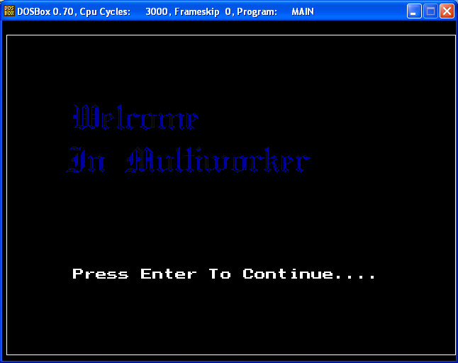

Boot Screen:

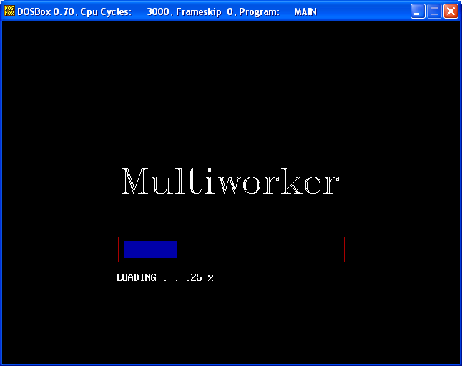

User Selection:

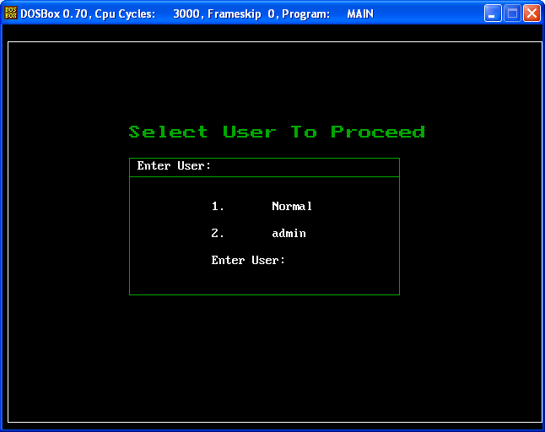

Normal User Screen:

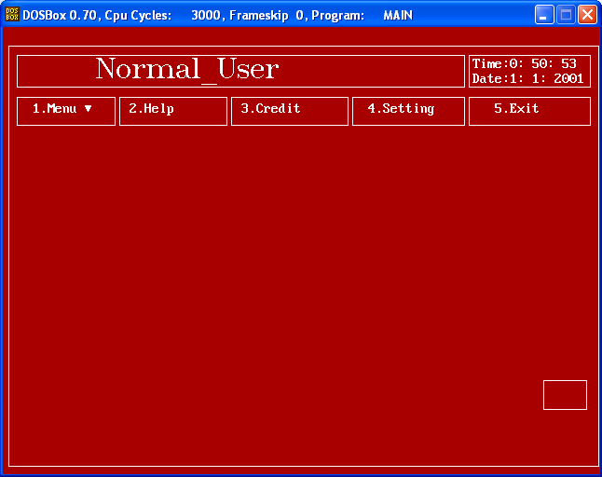

Normal_user Operation:

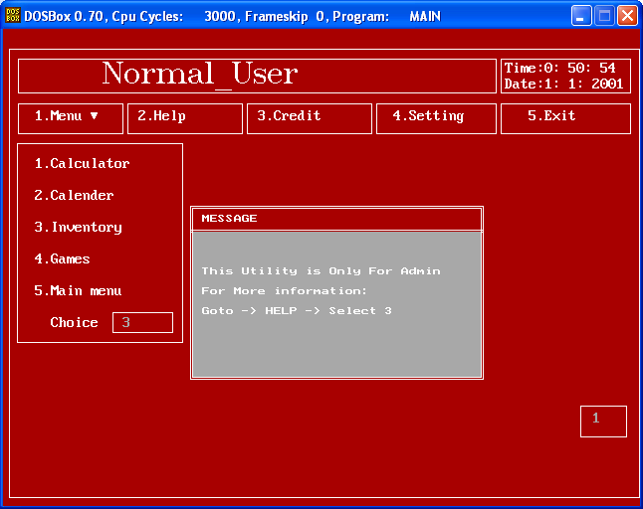

Normal User cant have rights to access the inventory i.e Database

Normal User Setting:

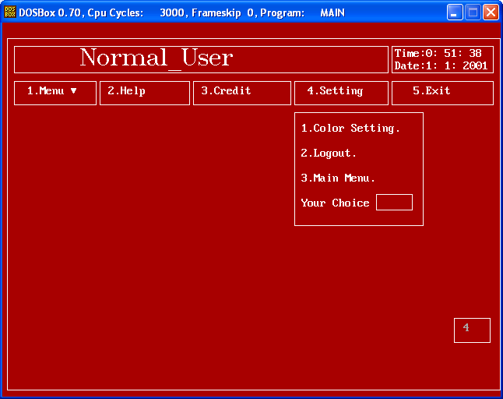

Normal user cant change the password of Admin.

Normal user Calc:

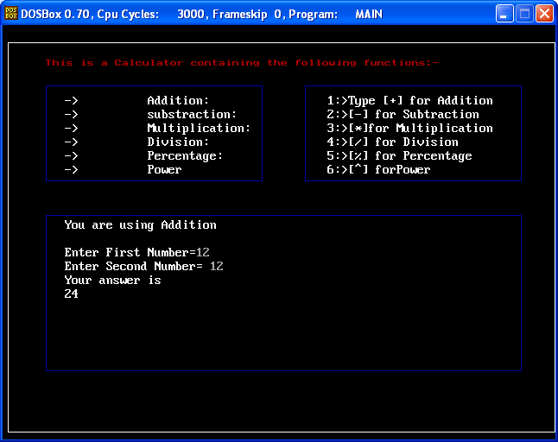

Admin_registration:

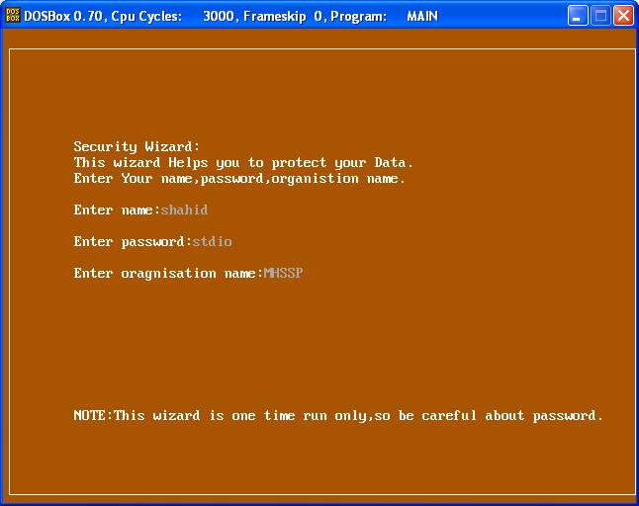

About Us Screen:

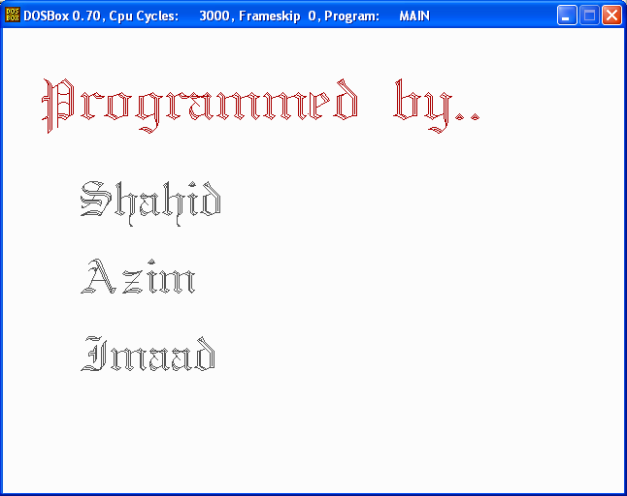

Exit Screen:

