Operating System Lectures April 2008
Lecture-07 B.Sc. Notes

7.1 Memory Management – II - Virtual Memory
Many years ago people were first confronted with programs that were too big to fit in the available memory. The solution usually adopted was to split the program into pieces, called overlays. Overlay 0 would start running first. When it was done, it would call another overlay. Some overlay systems were highly complex, allowing multiple overlays in memory at once. The overlays were kept on the disk and swapped in and out of memory by the operating system, dynamically, as needed.
Although the actual work of swapping overlays in and out was done by the system, the decision of how to split the program into pieces had to be done by the programmer. Splitting up large programs into small, modular pieces was time consuming and boring. It did not take long before someone thought of a way to turn the whole job over to the computer.
The method that was devised has come to be known as virtual memory (Fotheringham, 1961). The basic idea behind virtual memory is that the combined size of the program, data, and stack may exceed the amount of physical memory available for it. The operating system keeps those parts of the program currently in use in main memory, and the rest on the disk. For example, a 512-MB program can run on a 256-MB machine by carefully choosing which 256 MB to keep in memory at each instant, with pieces of the program being swapped between disk and memory as needed.
Virtual memory can also work in a multiprogramming system, with bits and pieces of many programs in memory at once. While a program is waiting for part of itself to be brought in, it is waiting for I/O and cannot run, so the CPU can be given to another process, the same way as in any other multiprogramming system.

7.1.1 Paging
Most virtual memory systems use a technique called paging, which we will now describe. On any computer, there exists a set of memory addresses that programs can produce. When a program uses an instruction like
MOV REG,1000

It does this to copy the contents of memory address 1000 to REG (or vice versa, depending on the computer). Addresses can be generated using indexing, base registers, segment registers, and other ways.
These program-generated addresses are called virtual addresses and form the virtual address space. On computers without virtual memory, the virtual address is put directly onto the memory bus and causes the physical memory word with the same address to be read or written. When virtual memory is used, the virtual addresses do not go directly to the memory bus. Instead, they go to an MMU (Memory Management Unit) that maps the virtual addresses onto the physical memory addresses as illustrated in Fig. 7-1

Figure 7-1. The position and function of the MMU. Here the MMU is shown as being a part of the CPU chip because it commonly is nowadays. However, logically it could be a separate chip and was in years gone by.

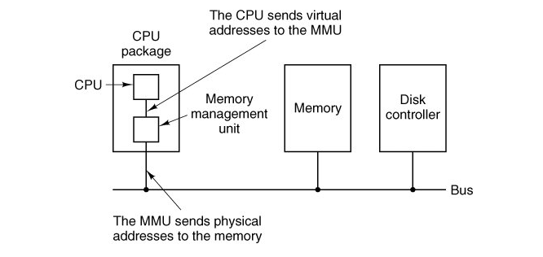
A very simple example of how this mapping works is shown in Fig. 7-2. In this example, we have a computer that can generate 16-bit addresses, from 0 up to 64K. These are the virtual addresses. This computer, however, has only 32 KB of physical memory, so although 64-KB programs can be written, they cannot be loaded into memory in their entirety and run. A complete copy of a program's memory image, up to 64 KB, must be present on the disk, however, so that pieces can be brought in as needed.

The virtual address space is divided up into units called pages. The corresponding units in the physical memory are called page frames. The pages and page frames are always the same size. In this example they are 4 KB, but page sizes from 512 bytes to 1 MB have been used in real systems. With 64 KB of virtual address space and 32 KB of physical memory, we get 16 virtual pages and 8 page frames. Transfers between RAM and disk are always in units of a page.
When the program tries to access address 0, for example, using the instruction
MOV REG,0

Virtual address 0 is sent to the MMU. The MMU sees that this virtual address falls in page 0 (0 to 4095), which according to its mapping is page frame 2 (8192 to 12287). It thus transforms the address to 8192 and outputs address 8192 onto the bus. The memory knows nothing at all about the MMU and just sees a request for reading or writing address 8192, which it honors. Thus, the MMU has effectively mapped all virtual addresses between 0 and 4095 onto physical addresses 8192 to 12287.
Similarly, an instruction
MOV REG,8192

is effectively transformed into
MOV REG,24576

Figure 7-2. The relation between virtual addresses and physical memory addresses is given by the page table.
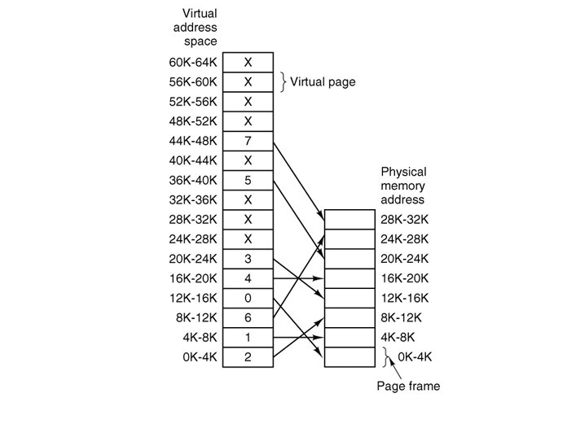
because virtual address 8192 is in virtual page 2 and this page is mapped onto physical page frame 6 (physical addresses 24576 to 28671). As a third example, virtual address 20500 is 20 bytes from the start of virtual page 5 (virtual addresses 20480 to 24575) and maps onto physical address 12288 + 20 = 12308.
By itself, this ability to map the 16 virtual pages onto any of the eight page frames by setting the MMU's map appropriately does not solve the problem that the virtual address space is larger than the physical memory. Since we have only eight physical page frames, only eight of the virtual pages in Fig. 7-2 are mapped onto physical memory. The others, shown as crosses in the figure, are not mapped. In the actual hardware, a present/absent bit keeps track of which pages are physically present in memory.
What happens if the program tries to use an unmapped page, for example, by using the instruction

MOV REG,32780

which is byte 12 within virtual page 8 (starting at 32768)? The MMU notices that the page is unmapped (indicated by a cross in the figure) and causes the CPU to trap to the operating system. This trap is called a page fault. The operating system picks a little-used page frame and writes its contents back to the disk. It then fetches the page just referenced into the page frame just freed, changes the map, and restarts the trapped instruction.
For example, if the operating system decided to evict page frame 1, it would load virtual page 8 at physical address 4K and make two changes to the MMU map. First, it would mark virtual page 1's entry as unmapped, to trap any future accesses to virtual addresses between 4K and 8K. Then it would replace the cross in virtual page 8's entry with a 1, so that when the trapped instruction is re-executed, it will map virtual address 32780 onto physical address 4108.
Now let us look inside the MMU to see how it works and why we have chosen to use a page size that is a power of 2. In Fig. 7-3 we see an example of a virtual address, 8196 (0010000000000100 in binary), being mapped using the MMU map of Fig. 7-2. The incoming 16-bit virtual address is split into a 4-bit page number and a 12-bit offset. With 4 bits for the page number, we can have 16 pages, and with 12 bits for the offset, we can address all 4096 bytes within a page.

Figure 7-3. The internal operation of the MMU with 16 4-KB pages.

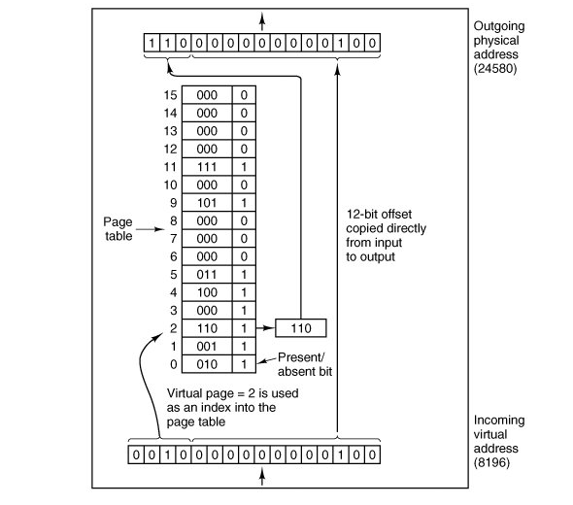
The page number is used as an index into the page table, yielding the number of the page frame corresponding to that virtual page. If the present/absent bit is 0, a trap to the operating system is caused. If the bit is 1, the page frame number found in the page table is copied to the high-order 3 bits of the output register, along with the 12-bit offset, which is copied unmodified from the incoming virtual address. Together they form a 15-bit physical address. The output register is then put onto the memory bus as the physical memory address.

7.1.2 Page Tables
In the simplest case, the mapping of virtual addresses onto physical addresses is as we have just described it. The virtual address is split into a virtual page number (high-order bits) and an offset (low-order bits). For example, with a 16-bit address and a 4-KB page size, the upper 4 bits could specify one of the 16 virtual pages and the lower 12 bits would then specify the byte offset (0 to 4095) within the selected page. However a split with 3 or 5 or some other number of bits for the page is also possible. Different splits imply different page sizes.
The virtual page number is used as an index into the page table to find the entry for that virtual page. From the page table entry, the page frame number (if any) is found. The page frame number is attached to the high-order end of the offset, replacing the virtual page number, to form a physical address that can be sent to the memory.
The purpose of the page table is to map virtual pages onto page frames. Mathematically speaking, the page table is a function, with the virtual page number as argument and the physical frame number as result. Using the result of this function, the virtual page field in a virtual address can be replaced by a page frame field, thus forming a physical memory address.

Despite this simple description, two major issues must be faced:
1. | The page table can be extremely large.
2. | The mapping must be fast.
The first point follows from the fact that modern computers use virtual addresses of at least 32 bits. With, say, a 4-KB page size, a 32-bit address space has 1 million pages, and a 64-bit address space has more than you want to contemplate. With 1 million pages in the virtual address space, the page table must have 1 million entries. And remember that each process needs its own page table (because it has its own virtual address space).
The second point is a consequence of the fact that the virtual-to-physical mapping must be done on every memory reference. A typical instruction has an instruction word, and often a memory operand as well. Consequently, it is necessary to make one, two, or sometimes more page table references per instruction. If an instruction takes, say, 1 nsec, the page table lookup must be done in under 250 psec to avoid becoming a major bottleneck. ( sec= 10¹² picosecond )
The need for large, fast page mapping is a significant constraint on the way computers are built. Although the problem is most serious with top-of-the-line machines that must be very fast, it is also an issue at the low end as well, where cost and the price/performance ratio are critical In this section and the following ones, we will look at page table design in detail and show a number of hardware solutions that have been used in actual computers.
The simplest design (at least conceptually) is to have a single page table consisting of an array of fast hardware registers, with one entry for each virtual page, indexed by virtual page number, as shown in Fig. 7-3. When a process is started up, the operating system loads the registers with the process' page table, taken from a copy kept in main memory. During process execution, no more memory references are needed for the page table. The advantages of this method are that it is straightforward and requires no memory references during mapping. A disadvantage is that it is potentially expensive (if the page table is large). Also, having to load the full page table at every context switch hurts performance.

Multilevel Page Tables
To get around the problem of having to store huge page tables in memory all the time, many computers use a multilevel page table. A simple example is shown in Fig. 7-4. In Fig. 7-4(a) we have a 32-bit virtual address that is partitioned into a 10-bit PT1 field, a 10-bit PT2 field, and a 12-bit Offset field. Since offsets are 12 bits, pages are 4 KB, and there are a total of 2²⁰ of them.

Figure 7-4. (a) A 32-bit address with two page table fields. (b) Two-level page tables.
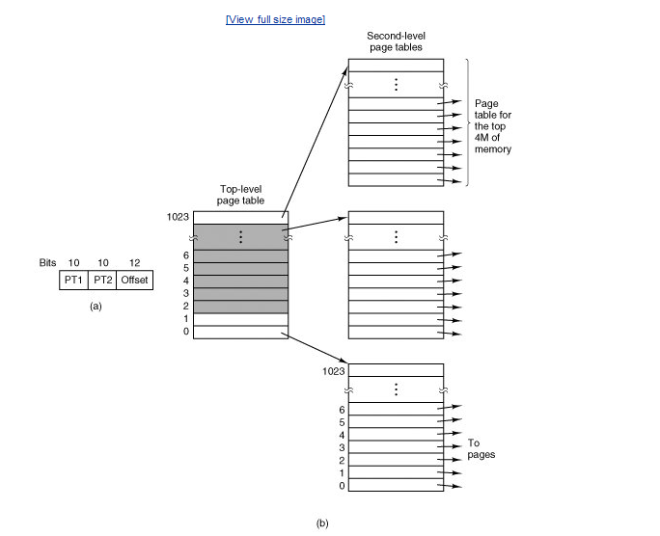
The secret to the multilevel page table method is to avoid keeping all the page tables in memory all the time. In particular, those that are not needed should not be kept around. Suppose, for example, that a process needs 12 megabytes, the bottom 4 megabytes of memory for program text, the next 4 megabytes for data, and the top 4 megabytes for the stack. In between the top of the data and the bottom of the stack is a gigantic hole that is not used.
In Fig. 7-4(b) we see how the two-level page table works in this example. On the left we have the top-level page table, with 1024 entries, corresponding to the 10-bit PT1 field. When a virtual address is presented to the MMU, it first extracts the PT1 field and uses this value as an index into the top-level page table. Each of these 1024 entries represents 4M because the entire 4-gigabyte (i.e., 32-bit) virtual address space has been chopped into chunks of 1024 bytes.
The entry located by indexing into the top-level page table yields the address or the page frame number of a second-level page table. Entry 0 of the top-level page table points to the page table for the program text, entry 1 points to the page table for the data, and entry 1023 points to the page table for the stack. The other (shaded) entries are not used. The PT2 field is now used as an index into the selected second-level page table to find the page frame number for the page itself.
As an example, consider the 32-bit virtual address 0x00403004 (4,206,596 decimal), which is 12,292 bytes into the data. This virtual address corresponds to PT1 = 1, PT2 = 3 , and Offset = 4. The MMU first uses PT1 to index into the top-level page table and obtain entry 1, which corresponds to addresses 4M to 8M. It then uses PT2 to index into the second-level page table just found and extract entry 3, which corresponds to addresses 12,288 to 16,383 within its 4M chunk (i.e., absolute addresses 4,206,592 to 4,210,687). This entry contains the page frame number of the page containing virtual address 0x00403004. If that page is not in memory, the present/absent bit in the page table entry will be zero, causing a page fault. If the page is in memory, the page frame number taken from the second-level page table is combined with the offset (4) to construct a physical address. This address is put on the bus and sent to memory.
The interesting thing to note about Fig. 7-4 is that although the address space contains over a million pages, only four page tables are actually needed: the top-level table, the second-level tables for 0 to 4M, 4M to 8M, and the top 4M. The present/absent bits in 1021 entries of the top-level page table are set to 0, forcing a page fault if they are ever accessed. Should this occur, the operating system will notice that the process is trying to reference memory that it is not supposed to and will take appropriate action, such as sending it a signal or killing it. In this example we have chosen round numbers for the various sizes and have picked PT1 equal to PT2 but in actual practice other values are also possible, of course.

Structure of a Page Table Entry
Let us now turn from the structure of the page tables in the large, to the details of a single page table entry. The exact layout of an entry is highly machine dependent, but the kind of information present is roughly the same from machine to machine. In Fig. 7-5 we give a sample page table entry. The size varies from computer to computer, but 32 bits is a common size. The most important field is the page frame number. After all, the goal of the page mapping is to locate this value. Next to it we have the present/absent bit. If this bit is 1, the entry is valid and can be used. If it is 0, the virtual page to which the entry belongs is not currently in memory. Accessing a page table entry with this bit set to 0 causes a page fault.

Figure 7-5. A typical page table entry.

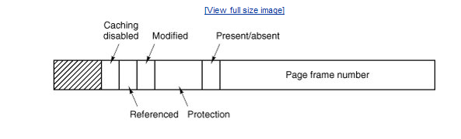
The protection bits tell what kinds of access are permitted. In the simplest form, this field contains 1 bit, with 0 for read/write and 1 for read only. A more sophisticated arrangement is having 3 independent bits, one bit each for individually enabling reading, writing, and executing the page.
The modified and referenced bits keep track of page usage. When a page is written to, the hardware automatically sets the modified bit. This bit is used when the operating system decides to reclaim a page frame. If the page in it has been modified (i.e., is "dirty"), it must be written back to the disk. If it has not been modified (i.e., is "clean"), it can just be abandoned, since the disk copy is still valid. The bit is sometimes called the dirty bit, since it reflects the page's state.
The referenced bit is set whenever a page is referenced, either for reading or writing. Its value is to help the operating system choose a page to evict when a page fault occurs. Pages that are not being used are better candidates than pages that are, and this bit plays an important role in several of the page replacement algorithms that we will study later in this chapter.
Finally, the last bit allows caching to be disabled for the page. This feature is important for pages that map onto device registers rather than memory. If the operating system is sitting in a tight loop waiting for some I/O device to respond to a command it was just given, it is essential that the hardware keep fetching the word from the device, and not use an old cached copy. With this bit, caching can be turned off. Machines that have a separate I/O space and do not use memory mapped I/O do not need this bit.

7.1.3. Translation Look-aside Buffers (TLBs)
In most paging schemes, the page tables are kept in memory, due to their large size. Potentially, this design has an enormous impact on performance. Consider, for example, an instruction that copies one register to another. In the absence of paging, this instruction makes only one memory reference, to fetch the instruction. With paging, additional memory references will be needed to access the page table. Since execution speed is generally limited by the rate the CPU can get instructions and data out of the memory, having to make two page table references per memory reference reduces performance by 2/3. Under these conditions, no one would use it.
Computer designers have known about this problem for years and have come up with a solution. Their solution is based on the observation that most programs tend to make a large number of references to a small number of pages, and not the other way around. Thus only a small fraction of the page table entries are heavily read; the rest are barely used at all. This is an example of locality of reference, a concept we will come back to in a later section.
The solution that has been devised is to equip computers with a small hardware device for rapidly mapping virtual addresses to physical addresses without going through the page table. The device, called a TLB (Translation Look-aside Buffer) or sometimes an associative memory, is illustrated in Fig. 7-6. It is usually inside the MMU and consists of a small number of entries, eight in this example, but rarely more than 64. Each entry contains information about one page, including the virtual page number, a bit that is set when the page is modified, the protection code (read/write/execute permissions), and the physical page frame in which the page is located. These fields have a one-to-one correspondence with the fields in the page table. Another bit indicates whether the entry is valid (i.e., in use) or not.

Figure 7-6. A TLB to speed up paging.
Valid | Virtual page | Modified | Protection | Page frame
1 | 140 | 1 | RW | 31
1 | 20 | 0 | R X | 38
1 | 130 | 1 | RW | 29
1 | 129 | 1 | RW | 62
1 | 19 | 0 | R X | 50
1 | 21 | 0 | R X | 45
1 | 860 | 1 | RW | 14
1 | 861 | 1 | RW | 75

An example that might generate the TLB of Fig. 7-6 is a process in a loop that spans virtual pages 19, 20, and 21, so these TLB entries have protection codes for reading and executing. The main data currently being used (say, an array being processed) are on pages 129 and 130. Page 140 contains the indices used in the array calculations. Finally, the stack is on pages 860 and 861.
Let us now see how the TLB functions. When a virtual address is presented to the MMU for translation, the hardware first checks to see if its virtual page number is present in the TLB by comparing it to all the entries simultaneously (i.e., in parallel). If a valid match is found and the access does not violate the protection bits, the page frame is taken directly from the TLB, without going to the page table. If the virtual page number is present in the TLB but the instruction is trying to write on a read-only page, a protection fault is generated, the same way as it would be from the page table itself.
The interesting case is what happens when the virtual page number is not in the TLB. The MMU detects the miss and does an ordinary page table lookup. It then evicts one of the entries from the TLB and replaces it with the page table entry just looked up. Thus if that page is used again soon, the second time around it will result in a hit rather than a miss. When an entry is purged from the TLB, the modified bit is copied back into the page table entry in memory. The other values are already there. When the TLB is loaded from the page table, all the fields are taken from memory.

7.2. Page Replacement Algorithms
When a page fault occurs, the operating system has to choose a page to remove from memory to make room for the page that has to be brought in. If the page to be removed has been modified while in memory, it must be rewritten to the disk to bring the disk copy up to date. If, however, the page has not been changed (e.g., it contains program text), the disk copy is already up to date, so no rewrite is needed. The page to be read in just overwrites the page being evicted.
While it would be possible to pick a random page to evict at each page fault, system performance is much better if a page that is not heavily used is chosen. If a heavily used page is removed, it will probably have to be brought back in quickly, resulting in extra overhead.
It is worth noting that the problem of "page replacement" occurs in other areas of computer design as well. For example, most computers have one or more memory caches consisting of recently used 32-byte or 64-byte memory blocks. When the cache is full, some block has to be chosen for removal. This problem is precisely the same as page replacement except on a shorter time scale (it has to be done in a few nanoseconds, not milliseconds as with page replacement). The reason for the shorter time scale is that cache block misses are satisfied from main memory, which has no seek time and no rotational latency.
A second example is in a web browser. The browser keeps copies of previously accessed web pages in its cache on the disk. Usually, the maximum cache size is fixed in advance, so the cache is likely to be full if the browser is used a lot. Whenever a web page is referenced, a check is made to see if a copy is in the cache and if so, if the page on the web is newer. If the cached copy is up to date, it is used; otherwise, a fresh copy is fetched from the Web. If the page is not in the cache at all or a newer version is available, it is downloaded. If it is a newer copy of a cached page it replaces the one in the cache. When the cache is full a decision has to be made to evict some other page in the case of a new page or a page that is larger than an older version. The considerations are similar to pages of virtual memory, except for the fact that the Web pages are never modified in the cache and thus are never written back to the web server. In a virtual memory system, pages in main memory may be either clean or dirty.

7.2.1 The Optimal Page Replacement Algorithm
The best possible page replacement algorithm is easy to describe but impossible to implement. It goes like this. At the moment that a page fault occurs, some set of pages is in memory. One of these pages will be referenced on the very next instruction (the page containing that instruction). Other pages may not be referenced until 10, 100, or perhaps 1000 instructions later. Each page can be labeled with the number of instructions that will be executed before that page is first referenced.
The optimal page algorithm simply says that the page with the highest label should be removed. If one page will not be used for 8 million instructions and another page will not be used for 6 million instructions, removing the former pushes the page fault that will fetch it back as far into the future as possible. Computers, like people, try to put off unpleasant events for as long as they can.
The only problem with this algorithm is that it is unrealizable. At the time of the page fault, the operating system has no way of knowing when each of the pages will be referenced next. (We saw a similar situation earlier with the shortest-job-first scheduling algorithm how can the system tell which job is shortest?) Still, by running a program on a simulator and keeping track of all page references, it is possible to implement optimal page replacement on the second run by using the page reference information collected during the first run.
In this way it is possible to compare the performance of realizable algorithms with the best possible one. If an operating system achieves a performance of, say, only 1 percent worse than the optimal algorithm, effort spent in looking for a better algorithm will yield at most a 1 percent improvement.
To avoid any possible confusion, it should be made clear that this log of page references refers only to the one program just measured and then with only one specific input. The page replacement algorithm derived from it is thus specific to that one program and input data. Although this method is useful for evaluating page replacement algorithms, it is of no use in practical systems. Below we will study algorithms that are useful on real systems.

7.2.2 The Not Recently Used Page Replacement Algorithm
In order to allow the operating system to collect useful statistics about which pages are being used and which ones are not, most computers with virtual memory have two status bits associated with each page. R is set whenever the page is referenced (read or written). M is set when the page is written to (i.e., modified). The bits are contained in each page table entry, as shown in Fig. 7-5. It is important to realize that these bits must be updated on every memory reference, so it is essential that they be set by the hardware. Once a bit has been set to 1, it stays 1 until the operating system resets it to 0 in software.
If the hardware does not have these bits, they can be simulated as follows. When a process is started up, all of its page table entries are marked as not in memory. As soon as any page is referenced, a page fault will occur. The operating system then sets the R bit (in its internal tables), changes the page table entry to point to the correct page, with mode READ ONLY, and restarts the instruction. If the page is subsequently written on, another page fault will occur, allowing the operating system to set the M bit as well and change the page's mode to READ/WRITE.
The R and M bits can be used to build a simple paging algorithm as follows. When a process is started up, both page bits for all its pages are set to 0 by the operating system. Periodically (e.g., on each clock interrupt), the R bit is cleared, to distinguish pages that have not been referenced recently from those that have been.
When a page fault occurs, the operating system inspects all the pages and divides them into four categories based on the current values of their R and M bits:

Class 0: not referenced, not modified.
Class 1: not referenced, modified.
Class 2: referenced, not modified.
Class 3: referenced, modified.
Although class 1 pages seem, at first glance, impossible, they occur when a class 3 page has its R bit cleared by a clock interrupt. Clock interrupts do not clear the M bit because this information is needed to know whether the page has to be rewritten to disk or not. Clearing R but not M leads to a class 1 page.
The NRU (Not Recently Used) algorithm removes a page at random from the lowest numbered nonempty class. Implicit in this algorithm is that it is better to remove a modified page that has not been referenced in at least one clock tick (typically 20 msec) than a clean page that is in heavy use. The main attraction of NRU is that it is easy to understand, moderately efficient to implement, and gives a performance that, while certainly not optimal, may be adequate.

7.2.3 The First-In, First-Out (FIFO) Page Replacement Algorithm
Another low-overhead paging algorithm is the FIFO (First-In, First-Out) algorithm. To illustrate how this works, consider a supermarket that has enough shelves to display exactly k different products. One day, some company introduces a new convenience food instant, freeze-dried, organic yogurt that can be reconstituted in a microwave oven. It is an immediate success, so our finite supermarket has to get rid of one old product in order to stock it.
One possibility is to find the product that the supermarket has been stocking the longest (i.e., something it began selling 120 years ago) and get rid of it on the grounds that no one is interested any more. In effect, the supermarket maintains a linked list of all the products it currently sells in the order they were introduced. The new one goes on the back of the list; the one at the front of the list is dropped.
As a page replacement algorithm, the same idea is applicable. The operating system maintains a list of all pages currently in memory, with the page at the head of the list the oldest one and the page at the tail the most recent arrival. On a page fault, the page at the head is removed and the new page added to the tail of the list. When applied to stores, FIFO might remove mustache wax, but it might also remove flour, salt, or butter. When applied to computers the same problem arises. For this reason, FIFO in its pure form is rarely used.

7.2.4 The Second Chance Page Replacement Algorithm
A simple modification to FIFO that avoids the problem of throwing out a heavily used page is to inspect the R bit of the oldest page. If it is 0, the page is both old and unused, so it is replaced immediately. If the R bit is 1, the bit is cleared, the page is put onto the end of the list of pages, and its load time is updated as though it had just arrived in memory. Then the search continues.
The operation of this algorithm, called second chance, is shown in Fig. 7-7. In Fig.7-7(a) we see pages A through H kept on a linked list and sorted by the time they arrived in memory.
Suppose that a page fault occurs at time 20. The oldest page is A, which arrived at time 0, when the process started. If A has the R bit cleared, it is evicted from memory, either by being written to the disk (if it is dirty), or just abandoned (if it is clean). On the other hand, if the R bit is set, A is put onto the end of the list and its "load time" is reset to the current time (20). The R bit is also cleared. The search for a suitable page continues with B.
What second chance is doing is looking for an old page that has not been referenced in the previous clock interval. If all the pages have been referenced, second chance degenerates into pure FIFO. Specifically, imagine that all the pages in Fig. 7-7(a) have their R bits set. One by one, the operating system moves the pages to the end of the list, clearing the R bit each time it appends a page to the end of the list. Eventually, it comes back to page A, which now has its R bit cleared. At this point A is evicted. Thus the algorithm always terminates.

Figure 7-7. Operation of second chance. (a) Pages sorted in FIFO order. (b) Page list if a page fault occurs at time 20 and A has its R bit set. The numbers above the pages are their loading times.

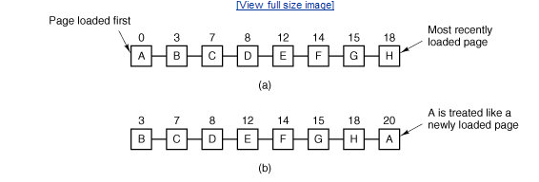

7.2.5 The Clock Page Replacement Algorithm
Although second chance is a reasonable algorithm, it is unnecessarily inefficient because it is constantly moving pages around on its list. A better approach is to keep all the page frames on a circular list in the form of a clock, as shown in Fig. 7-8. A hand points to the oldest page.
When a page fault occurs, the page being pointed to by the hand is inspected. If its R bit is 0, the page is evicted, the new page is inserted into the clock in its place, and the hand is advanced one position. If R is 1, it is cleared and the hand is advanced to the next page. This process is repeated until a page is found with R = 0. Not surprisingly, this algorithm is called clock. It differs from second chance only in the implementation, not in the page selected.

Figure 7-8. The clock page replacement algorithm.

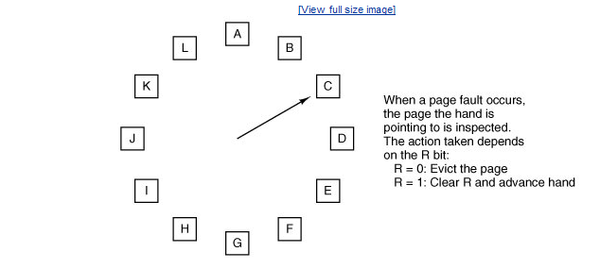

7.2.6 The Least Recently Used (LRU) Page Replacement Algorithm
A good approximation to the optimal algorithm is based on the observation that pages that have been heavily used in the last few instructions will probably be heavily used again in the next few. Conversely, pages that have not been used for ages will probably remain unused for a long time. This idea suggests a realizable algorithm: when a page fault occurs, throw out the page that has been unused for the longest time. This strategy is called LRU (Least Recently Used) paging.
Although LRU is theoretically realizable, it is not cheap. To fully implement LRU, it is necessary to maintain a linked list of all pages in memory, with the most recently used page at the front and the least recently used page at the rear. The difficulty is that the list must be updated on every memory reference. Finding a page in the list, deleting it, and then moving it to the front is a very time-consuming operation, even in hardware (assuming that such hardware could be built).
However, there are other ways to implement LRU with special hardware. Let us consider the simplest way first. This method requires equipping the hardware with a 64-bit counter, C, that is automatically incremented after each instruction. Furthermore, each page table entry must also have a field large enough to contain the counter. After each memory reference, the current value of C is stored in the page table entry for the page just referenced. When a page fault occurs, the operating system examines all the counters in the page table to find the lowest one. That page is the least recently used.
Now let us look at a second hardware LRU algorithm. For a machine with n page frames, the LRU hardware can maintain a matrix of n x n bits, initially all zero. Whenever page frame k is referenced, the hardware first sets all the bits of row k to 1, and then sets all the bits of column k to 0. At any instant, the row whose binary value is lowest is the least recently used; the row whose value is next lowest is next least recently used, and so forth. The workings of this algorithm are given in Fig. 7-9 for four page frames and page references in the order 0 1 2 3 2 1 0 3 2 3

Figure 7-9. LRU using a matrix when pages are referenced in the order 0, 1, 2, 3, 2, 1, 0, 3, 2, 3.
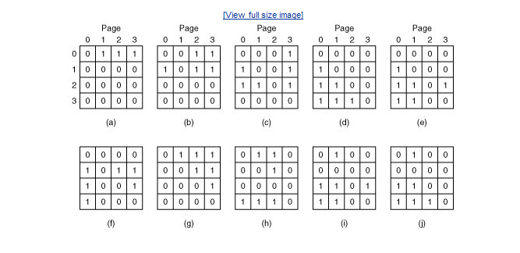
After page 0 is referenced, we have the situation of Fig. 7-9(a). After page 1 is referenced, we have the situation of Fig. 7-9(b), and so forth.

7.2.7 Simulating LRU in Software
Although both of the previous LRU algorithms are realizable in principle, few, if any, machines have this hardware, so they are of little use to the operating system designer who is making a system for a machine that does not have this hardware. Instead, a solution that can be implemented in software is needed. One possible software solution is called the NFU (Not Frequently Used) algorithm. It requires a software counter associated with each page, initially zero. At each clock interrupt, the operating system scans all the pages in memory. For each page, the R bit, which is 0 or 1, is added to the counter. In effect, the counters are an attempt to keep track of how often each page has been referenced. When a page fault occurs, the page with the lowest counter is chosen for replacement.
The main problem with NFU is that it never forgets anything. For example, in a multi-pass compiler, pages that were heavily used during pass 1 may still have a high count well into later passes. In fact, if pass 1 happens to have the longest execution time of all the passes, the pages containing the code for subsequent passes may always have lower counts than the pass 1 pages. Thus the operating system will remove useful pages instead of pages no longer in use.
Fortunately, a small modification to NFU makes it able to simulate LRU quite well. The modification has two parts. First, the counters are each shifted right 1 bit before the R bit is added in. Second, the R bit is added to the leftmost, rather than the rightmost bit.
Figure 7-10 illustrates how the modified algorithm, known as aging, works. Suppose that after the first clock tick the R bits for pages 0 to 5 have the values 1, 0, 1, 0, 1, and 1, respectively (page 0 is 1, page 1 is 0, page 2 is 1, etc.). In other words, between tick 0 and tick 1, pages 0, 2, 4, and 5 were referenced, setting their R bits to 1, while the other ones remain 0. After the six corresponding counters have been shifted and the R bit inserted at the left, they have the values shown in Fig. 7-10(a). The four remaining columns show the values of the six counters after the next four clock ticks, respectively.
When a page fault occurs, the page whose counter is the lowest is removed. It is clear that a page that has not been referenced for, say, four clock ticks will have four leading zeros in its counter and thus will have a lower value than a counter that has not been referenced for three clock ticks.
This algorithm differs from LRU in two ways. Consider pages 3 and 5 in Fig. 7-10(e). Neither has been referenced for two clock ticks; both were referenced in the tick prior to that. According to LRU, if a page must be replaced, we should choose one of these two. The trouble is, we do not know which of these two was referenced last in the interval between tick 1 and tick 2. By recording only one bit per time interval, we have lost the ability to distinguish references early in the clock interval from those occurring later. All we can do is remove page 3, because page 5 was also referenced two ticks earlier and page 3 was not referenced then.

Figure 4-17. The aging algorithm simulates LRU in software. Shown are six pages for five clock ticks. The five clock ticks are represented by (a) to (e).

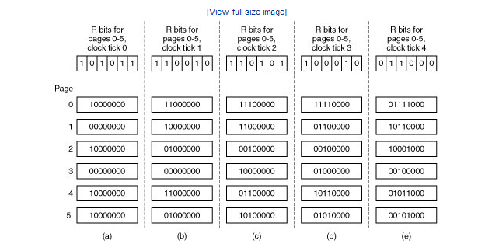
The second difference between LRU and aging is that in aging the counters have a finite number of bits, 8 bits in this example. Suppose that two pages each have a counter value of 0. All we can do is pick one of them at random. In reality, it may well be that one of the pages was last referenced 9 ticks ago and the other was last referenced 1000 ticks ago. We have no way of seeing that. In practice, however, 8 bits is generally enough if a clock tick is around 20 msec. If a page has not been referenced in 160 msec, it probably is not that important.

