**Less Junk, More Happiness, Stronger Community**

A popular maxim in recent years is, “Money can’t buy happiness.” Despite this popular sentiment, consumerism worldwide remains high. The more we buy, we consequently feel less fulfilment and produce more waste. This trend ultimately furthers the capitalist ideal of consumption and effectively damages the environment. Although this manipulation may seem unavoidable, it may be evaded with the right tools.

Living “little” or minimalist is not impossible. In fact, the thoughtful consideration of our lives, the objects we need to survive, and the things that we can’t help but love, can not only help us to live more affordably, but can also help people determine what happiness means to them and how they can support both themselves and their community in pursuit of it. Although in the pursuit of happiness we may find ourselves itching for that new purse or that new toy, only through mindfulness of the specific roles we let objects have in our lives can we come to learn something of their meaning and their overall reusability for maximum benefit.

A minimalist lifestyle advocates for attention to be drawn towards our belongings so that they may be constantly evaluated as to whether they are necessary or unnecessary. If an item is determined to be unnecessary, it may be repurposed or donated for additional use by others who could still draw benefit from it.

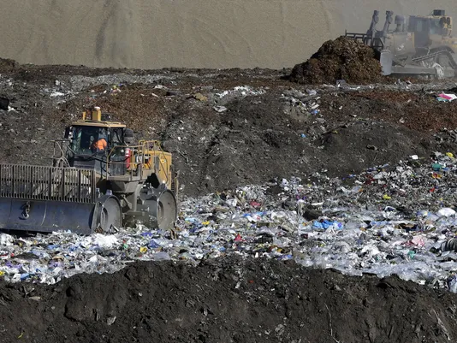

*The Outgamie County Northeast Landfill in Wisconsin*

This idea of an item’s multi-functionality or repurposable nature is very valuable, as it can help to promote the reuse or donation of items that lack their initial novelty for users. Often times, we first look upon new objects as shiny and precious before then coming to later associate them with memories and sentiment. Although these old, unused objects can come to bring comfort or ease past emotional scars, they ultimately serve no physical purpose. If these pains can be relieved in other, more productive ways different from hoarding or accumulation of products, we can grow as individuals in both emotional maturity and in patterns of the way we think and cope. This growth can be physically represented by donating to non-profit organizations that will continue to find purpose for items that have lost their initial sparkle. Rather than being thrown away and forgotten in a landfill to contribute to the toxic methane and carbon dioxide gas emissions, these items will stay useful and benign.

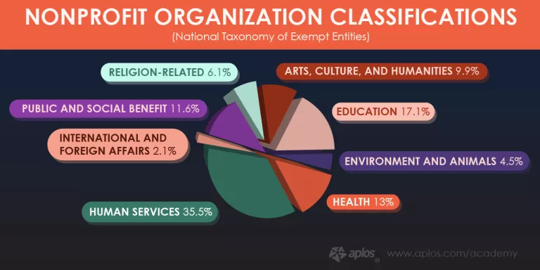

*Local non-profit organizations span a variety of different causes.*

This is where non-profit organizations like Re.Use.Full come in. Re.Use.Full aims to reduce waste and promote a sense of community by connecting donors to local 501(c)3 organizations in need. These organizations function to further all different types of causes, whether it be the support of impoverished people or help for those with specific health conditions. Realistically, one individual’s small, minimalistic lifestyle changes can effectively improve the quality of many people’s lives on planet Earth.

**Tags:** #Re.Use.Full #minimalist #lifestyle #reuse #recycle #happiness #mindfulness #community

Photo Sources

<https://www.postcrescent.com/story/news/local/2017/09/22/outagamie-county-landfill-rise-another-50-70-feet/680382001/>

<https://www.aplos.com/academy/fundraising/fundraising-guide-nonprofit-organizations/>