So Long, Partner

Childhood is fleeting, and growing up is, debatably, the hardest thing one could do. If not for the child, most definitely for the parents. It’s the end of an era and suddenly, you’re longing for the things you thought you’d never miss. Somehow you blink and your sticky-fingered two-year old is seventeen and getting ready to leave for college. This season is both exciting and, albeit, nerve wracking. Though I’ve never experienced this first hand as a parent, I remember what it was like getting ready to move away to college for the first time. The excitement of the promise of a new life in a new city, with absolutely no-one I know. I packed all the essentials into two suitcases and the rest sat in my room in cardboard boxes. And, to be completely honest, because I bought everything I could possibly need when I got to school, that’s where they sat for the next three years.

Let’s face it, growing up is hard. For everyone. Maybe somehow, I thought that if I kept all my stuff in my childhood room, I could come back, as if I hadn’t grown up. But, unfortunately, it doesn’t work that way. There came a time when I realized that there was absolutely nothing wrong with my stuff. Most of it was gently used, some like new. The only problem was that it was all sitting in boxes, and, frankly, my parents wanted them gone so that they didn’t have to look at them anymore. Time can’t be paused. We can’t simply go back to our carefree days when our biggest worry was if we wanted cherry blue raspberry Kool-Aid. Rather, stuff is just stuff. My childhood items can’t create for me new memories, nor can the absence of them take away the memories I have already made. However, they *can* create new memories for other people.

**[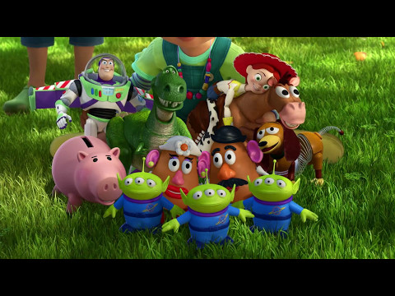](https://www.youtube.com/watch?v=Xq4zWbtgbN8)>>**

This isn’t unique to me. It’s a story as old as time. And it will continue so long as people keep growing up.

The only question is, when it’s your turn, will you leave your stuff sitting in boxes collecting dust or will you let another child create new memories with them?

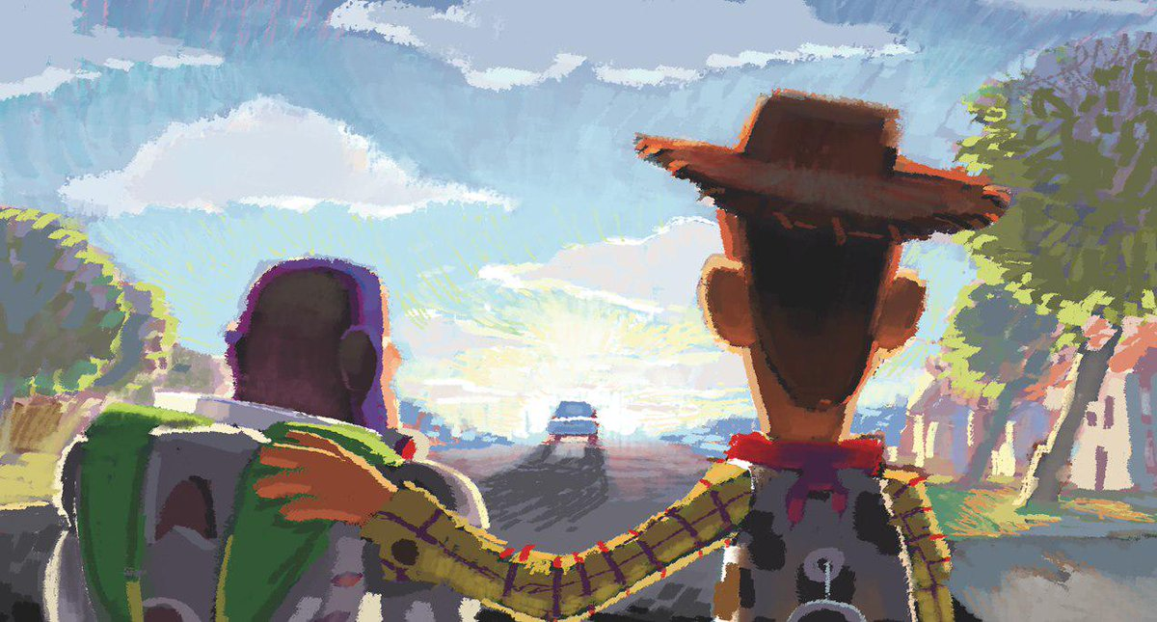  
  
**So long, partner.**

Social Media Blurbs

Sometimes, we try so hard to hold on to our childhood by holding on to our childhood items. But, does that do our possessions any justice? Can we turn the bitter reality of growing up into something a little bittersweet?

“Stuff is just stuff. My childhood items can’t create for me new memories, nor can the absence of them take away the memories I have already made. However, they *can* create new memories for other people.”

Sometimes, our items still spark joy. Sometimes, our items will always spark joy. Maybe because they represent a simpler time. Maybe because they are all we have left of our childhood. But, sometimes, that doesn’t mean we should keep them.